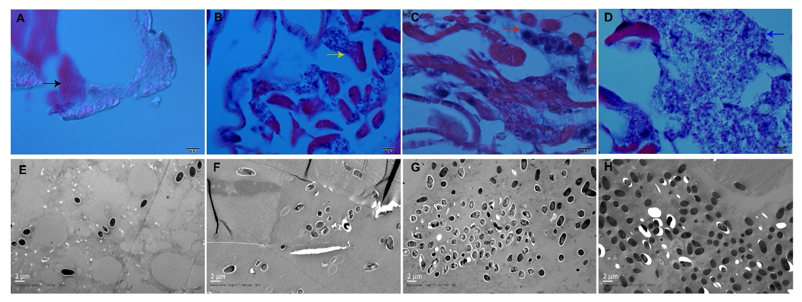
Fig. S1 Validation of the microsporidia spores by H&E staining and TEM in N. bombycis congenitally infected silkworm embryos and larvae.
5-day embryos (A), 1-day larvae (B), 5-day larvae (C), and 10-day larvae (D) from the parent silkworms infected with N. bombycis were used to detect the microsporidia spores by H&E staining; 5-day embryos (E), 1-day larvae (F), 5-day larvae (G), and 10-day larvae (H) from the parent silkworms infected with N. bombycis were used to detect the microsporidia spores by TEM. Black arrow: yolks; Yellow arrow: muscle cells; Red arrow: adipocyte cells; Blue arrow: epidermic cell.
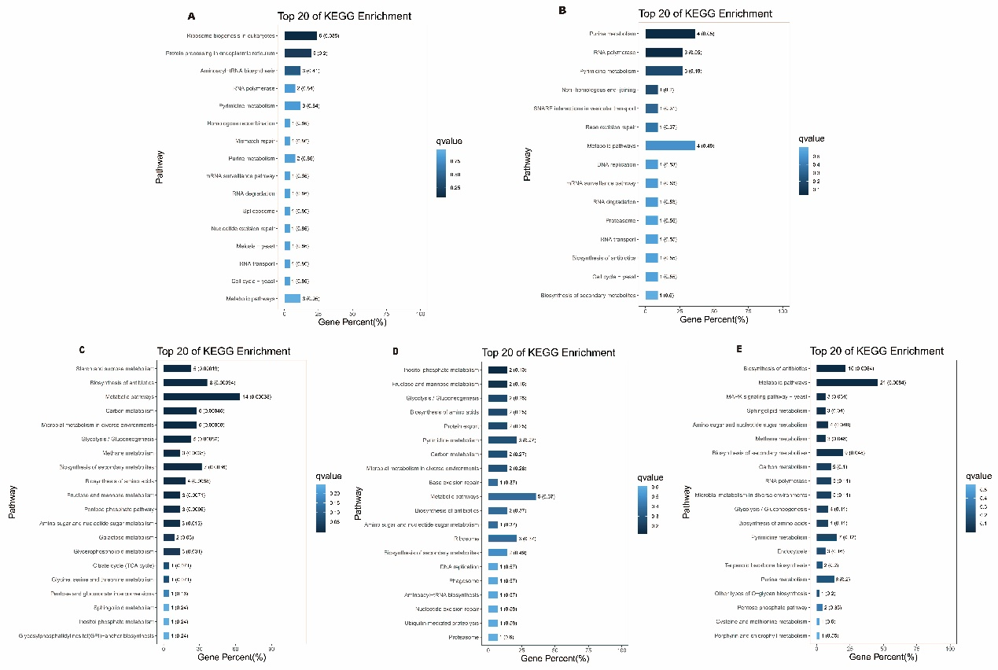
Fig. S2 KEGG enrichment analysis of significant differential microsporidia genes between 5-day embryos, 1-day larvae, 5-day larvae, and 10-day larvae challenged by N. bombycis congenital infection.
A: KEGG enrichment analysis of cluster I microsporidia genes; B: KEGG enrichment analysis of cluster II microsporidia genes; C: KEGG enrichment analysis of cluster III microsporidia genes; D: KEGG enrichment analysis of cluster IV microsporidia genes; E: KEGG enrichment analysis of cluster V microsporidia genes.
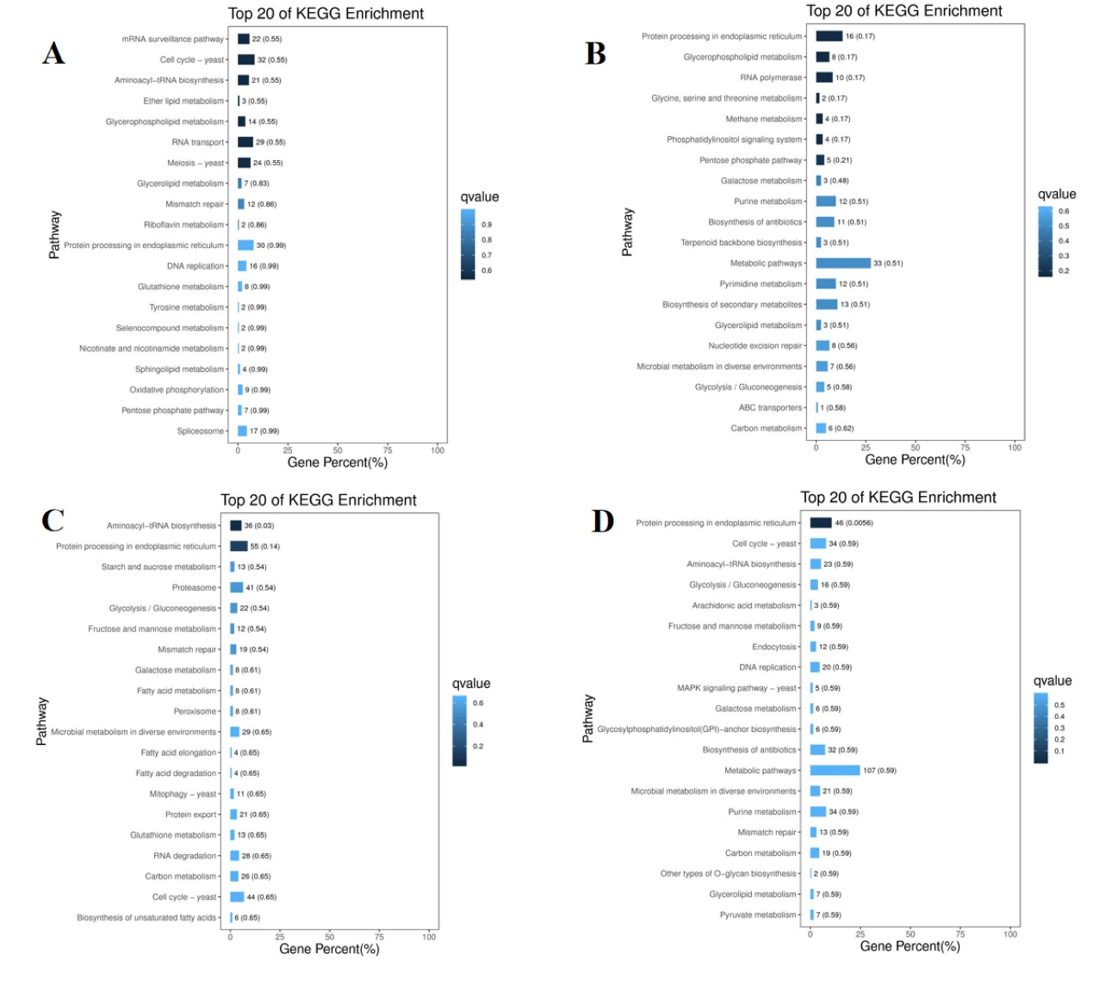
Fig. S3 KEGG enrichment analysis of significant differential microsporidia miRNA target genes between 5-day embryos, 1-day larvae, 5-day larvae, and 10-day larvae challenged by N. bombycis congenital infection.
A: KEGG enrichment analysis of cluster I genes; B: KEGG enrichment analysis of cluster II genes; C: KEGG enrichment analysis of cluster III genes; D: KEGG enrichment analysis of cluster IV genes.
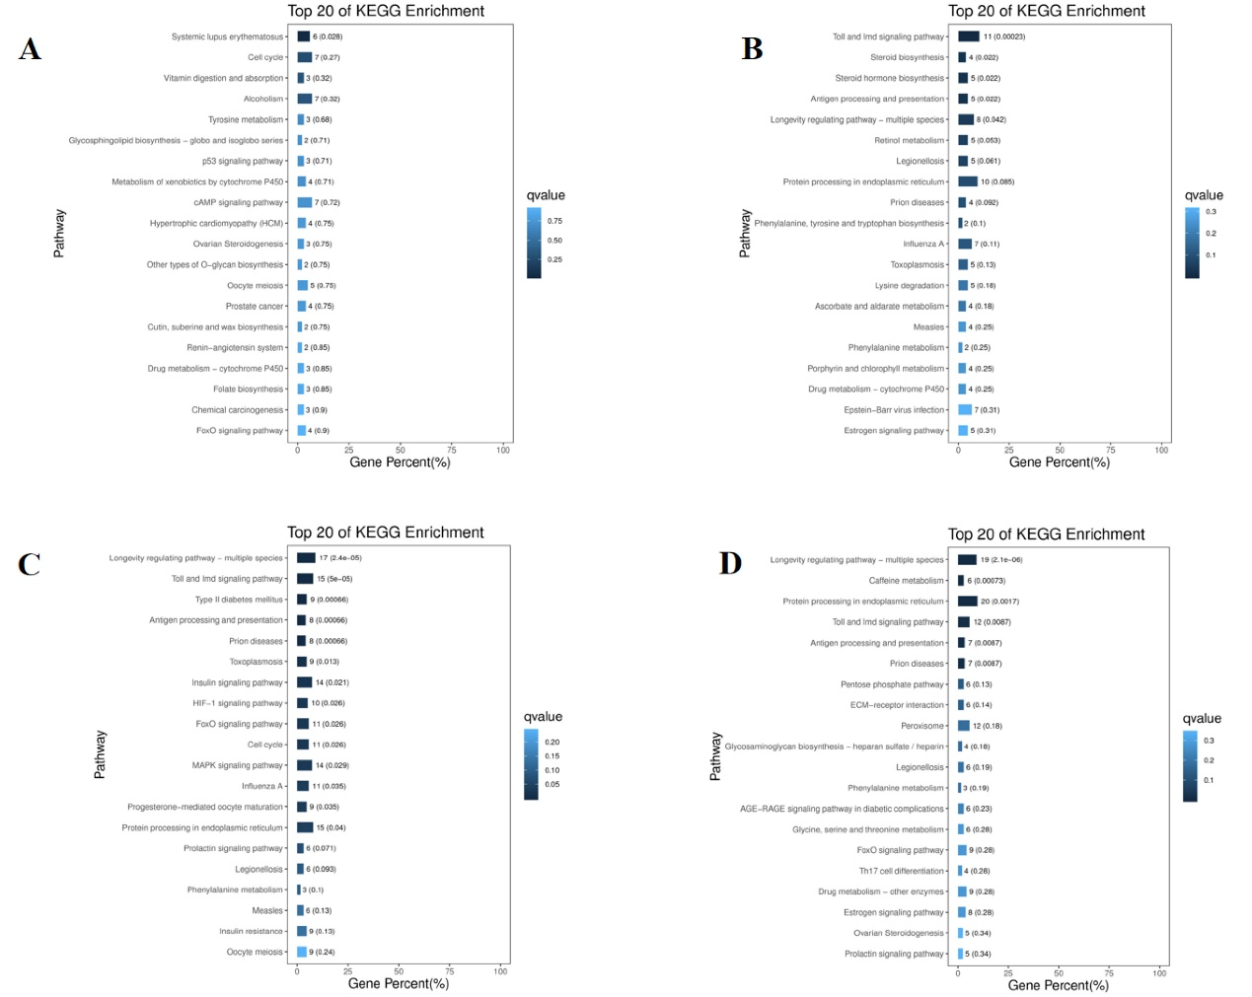
Fig. S4 KEGG enrichment analysis of significant differential B. mori genes in silkworm embryos and larvae during the N. bombycis congenital infection
A: KEGG enrichment analysis of significant differential B. mori mRNAs in silkworm 5-day embryos exposed to N. bombycis congenital challenge; B: KEGG enrichment analysis of significant differential B. mori mRNAs in silkworm 1-day larvae exposed to N. bombycis congenital challenge; C: KEGG enrichment analysis of significant differential B. mori mRNAs in silkworm 5-day larvae exposed to N. bombycis congenital challenge; D: KEGG enrichment analysis of significant differential B. mori mRNAs in silkworm 10-day larvae exposed to N. bombycis congenital challenge.
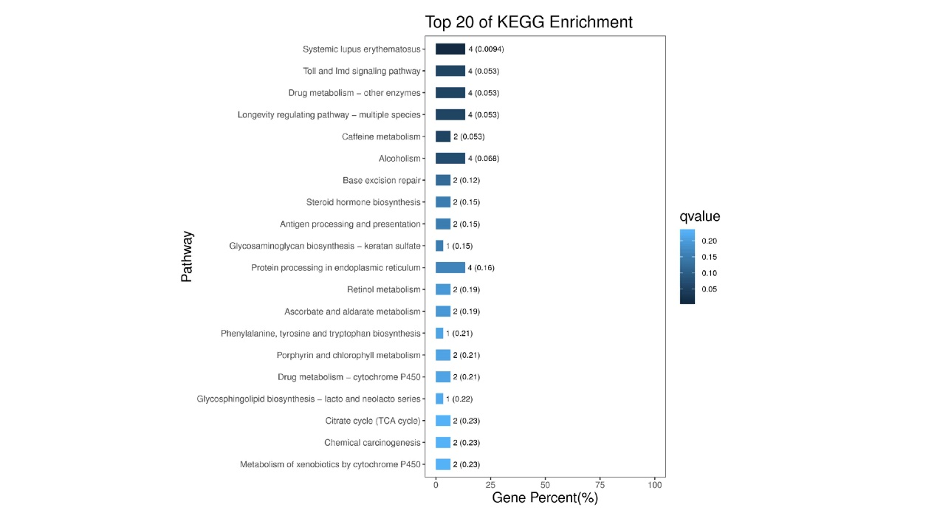
Fig. S5 KEGG enrichment analysis of DE lncRNA cis-target genes in silkworm embryos and larvae during the N. bombycis congenital infection
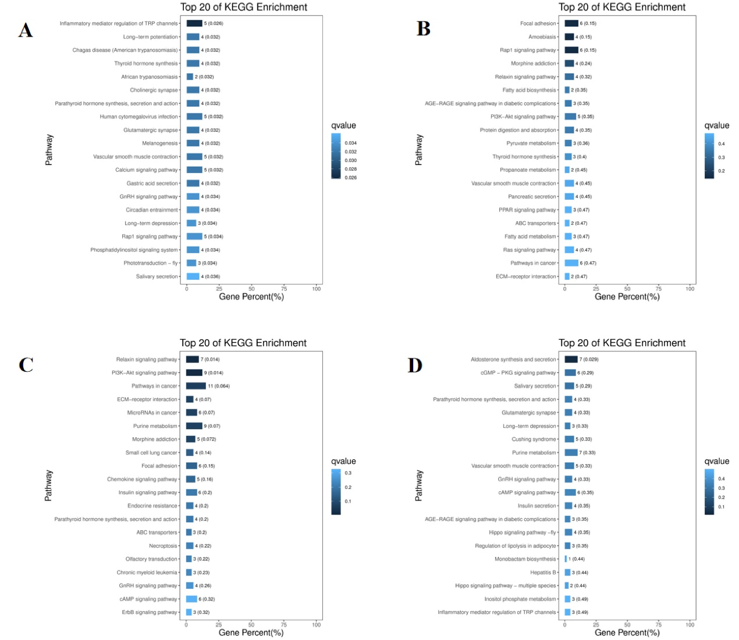
Fig. S6 KEGG enrichment analysis of DE circRNA source genes in silkworm embryos and larvae during the N. bombycis congenital infection
A: KEGG enrichment analysis of DE circRNA source genes in silkworm 5-day embryos during the N. bombycis congenital infection; B: KEGG enrichment analysis of DE circRNA source genes in silkworm 1-day larvae during the N. bombycis congenital infection; C: KEGG enrichment analysis of DE circRNA source genes in silkworm 5-day larvae during the N. bombycis congenital infection; D: KEGG enrichment analysis of DE circRNA source genes in silkworm 10-day larvae during the N. bombycis congenital infection.
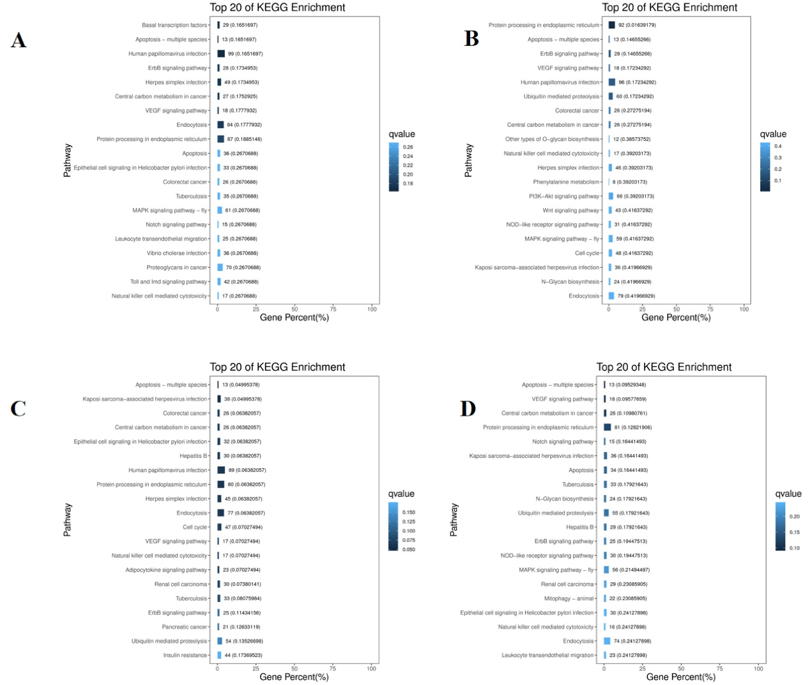
Fig. S7 KEGG enrichment analysis of DE miRNA target genes in silkworm embryos and larvae during the N. bombycis congenital infection
A: KEGG enrichment analysis of DE miRNA target genes in silkworm 5-day embryos during the N. bombycis congenital infection; B: KEGG enrichment analysis of DE miRNA target genes in silkworm 1-day larvae during the N. bombycis congenital infection; C: KEGG enrichment analysis of DE miRNA target genes in silkworm 5-day larvae during the N. bombycis congenital infection; D: KEGG enrichment analysis of DE miRNA target genes in silkworm 10-day larvae during the N. bombycis congenital infection.

