Supporting information

Plasmon-ligand-mediated hydrogen evolution with visible light

Ananta Dey¹, Amal Mendalz¹, Anna Wach², Robert Bericat Vadell¹, Vitor R. Silveira¹, Paul Maurice Leidinger², Thomas Huthwelker², Vitalii Shtender³, Zbynek Novotny², Luca Artiglia², Jacinto Sá^{1,4}*

¹ Department of Chemistry-Ångström, Physical Chemistry division, Uppsala University, Box 532, 751 20 Uppsala, Sweden.
² Paul Scherrer Institut, CH-5232 Villigen PSI, Switzerland.
³ Department of Materials Science and Engineering, division of Applied Materials Science, Uppsala University, 75103 Uppsala, Sweden.
⁴ Institute of Physical Chemistry, Polish Academy of Sciences, Marcina Kasprzaka 44/52, 01-224 Warsaw, Poland.

*Corresponding author. Email: jacinto.sa@kemi.uu.se

Sample preparation:
Au nanoparticles (NPs) synthesis:
Sodium citrate tribasic dihydrate 50 mL (6.6 mM) water solution was taken in a 100 mL round bottom flask and stirred at 70ºC in an oil bath. Then 0.1 mL (2.5 mM) tannic acid was added to the reaction mixture. Finally, 1mL of (25 mM) HAuCl₄ was added instantly. After 5 minutes the reaction mixture colour changed from dark blue to wine. The change in colour confirms the formation of the Au nanoparticles. The synthesized Au nanoparticles were stored in a fridge. The size of the Au nanoparticles was analysed using dynamic light scattering (DLS).

Cobalt catalyst synthesis:
200 mg (1.02 mmol) 1,10-Phenanthrolin-5-amine and 148.42 mg (0.51 mmol) Cobalt(II) nitrate hexahydrate were refluxed in 20 ml ethanol for one hour. After that, the reaction mixture was filtered. The filtrate was placed in a clean beaker at room temperature for a few days without further disturbance and we got a red colour precipitate. Finally, the obtained product was collected through filtration and dried in a vacuum desiccator. The yield 216 mg (73.9%). ATR-IR 3342 cm⁻¹, 3402 cm⁻¹.

Preparation of the thin films:
The preparation and process of NiO film:
The NiO paste was purchased from Solaronix and used as received. A small portion of the NiO paste was placed on a screen, placed on top of the cleaned FTO glass and manually printed on conducting side of the FTO glass. Then the NiO-printed FTO glass plates were annealed at 500ºC for 1 hour at a rate of 10ºC/min.
Assembly of the Au nanoparticles on NiO film:
The synthesised Au nanoparticles were sprayed manually on NiO films and annealed at 500ºC for 1 hour at a rate of 10ºC/min.
Assembly of the catalyst on NiO/Au surface:
The annealed NiO-Au films were dipped into a 4mg/mL water solution of the [Co^{II}(phen-NH₂)₂(H₂O)₂] catalyst for 3 days. Finally, we could get the self-assembled NiO/Au/[Co^{II}(phen-NH₂)₂(H₂O)₂] composite system. For experimental purposes, we have also sprayed Au nanoparticles only on FTO glass.

Samples characterization:
UV-Vis measurements:
The UV-Vis spectra were collected using a Cary 5000 UV-VIS-NIR spectrophotometer.

DLS measurements:
The DLS data was collected in a Malvern Zetasizer nanoS instrument and a total of 3 measurements comprised of 12 scans each time was done.

Fourier-transformed infrared (FT-IR) measurements:
FT-IR data were measured using a universal ATR sampling assembly on a VERTEX 70v instrument.

Electrochemistry measurements:
The electrochemical data were measured using a EmStat potentiostat instrument. For the electrochemical experiments, a typical cylindrical closed cell was used. The FTO films were placed on the side of the cell so that it could face the light.
Bulk electrolysis: In presence of 0.1 M LiCl as a supporting electrolyte, and glassy carbon as a working electrode a Pt wire as counter electrode, Ag)AgCl (3M KCl/water) as reference electrode were used for the bulk electrolysis experiment.

Photo-electrocatalytic chronoamperometry:
The photoelectrode exposed area to light is 0.79 cm². Plasmonic excitation was performed with a 532 nm laser of the intensity of 43.8 mW/cm². Pt wire counter electrode and Ag/AgCl (3M KCl/water) reference electrode were purchased from redoxme and used as received. Lithium chloride purchased from Merck was used as a supporting electrolyte without further purification.
Mass spectroscopy:
Using a quadrupole mass spectrometer (QMS) (HPR 20) from Hiden analytical we measured the gas produced during the photoelectrochemical reaction. During the measurement, there was continuous argon gas flow (15 mL/min) through the cylindrical electrochemical cell. Before applying the electrochemical potential, we saturated the electrochemical cell with argon to get a stable argon signal. Argon, O₂, and H₂ were measured continuously throughout the measurement with the SEM detector.

Inductively coupled plasma - optical emission spectrometry (ICP-OES) measurement:
The ICP-OES was used to estimate the cobalt amount in the sample. The film was digested four a couple of hours in 4 mL of nitric acid (Nitric acid 65%, FisherScientific), small probe was diluted 10 times with milliQ water containing 2% HNO₃ and filtered with 0.2 μm syringe filters (Whatman) before measurement. Avio 200 Scott/Cross-Flow Configuration was used for ICP measurements. A calibration curve was formed for the measurements using a Cobalt Calibration Standard (CPAchem). Concentrations of 0, 0.1, 1 and 10 ppm of the Co were used to create a 4-pointlinear regression. All measured values are within a relative standard deviation (RSD) of 2%.

Transient absorption spectroscopy (TAS)
Briefly, a 40-fs pulsed laser with a 3 kHz repetition rate was generated through the Libra Ultrafast Amplifier System designed by Coherent. An optical parametric oscillator (TOPAS- prime, Light Conversion) was used to generate the excitation beam. The signals were detected with a UV-NIR detector, namely a Newport MS260i spectrograph with interchangeable gratings. The fundamental laser (probe, 795 nm) passes through the delay stage (1-2 fs step size) and is focused in a Sapphire optical window in order to generate visible light from 400 to 750 nm. The instrument response function obtained for our system is ca. 95 fs.

Transient infrared absorption spectroscopy (TIRAS)
Briefly, a 40-fs pulsed laser with a 3 kHz repetition rate was generated through the Libra Ultrafast Amplifier System designed by Coherent. Two optical parametric oscillators (TOPAS- prime, Light Conversion) were used to generate either the excitation beam and/or the probe light in the Mid-IR (3000-10000 nm). The signals were detected with a Horiba iHR 320 spectrometer. The pump laser power was constantly monitored with less than a 2% standard deviation. The timing resolution, i.e., the instrument response function is ca. 100 fs.

NAP-XPS measurements:
Details about the experimental chamber and the three electrode setup used have been described elswhere. NAP-XPS experiments were carried out at the PHOENIX I beamline of the Swiss Light Source Synchrotron (SLS), making use of the solid liquid interface endstation in a three-electrode setup using a gold counter electrode and a Ag/AgCl reference electrode controlled via a potentiostat (BioLogic Science Instruments SP-300)^{.1} Linearly polarized light was used throughout the experiments. The as-introduced sample was first analyzed under high vacuum conditions, in order to acquire reference spectra. Then the chamber was opened and the beaker containing the pre-deaerated electrolyte introduced (see Figure S1). The chamber was pumped down in a controlled way, making use of a needle valve, in order to avoid electrolyte spilling and favor the pressure equilibration (around 20 mbar). Measurements were carried out using an excitation energy of 5000 eV.

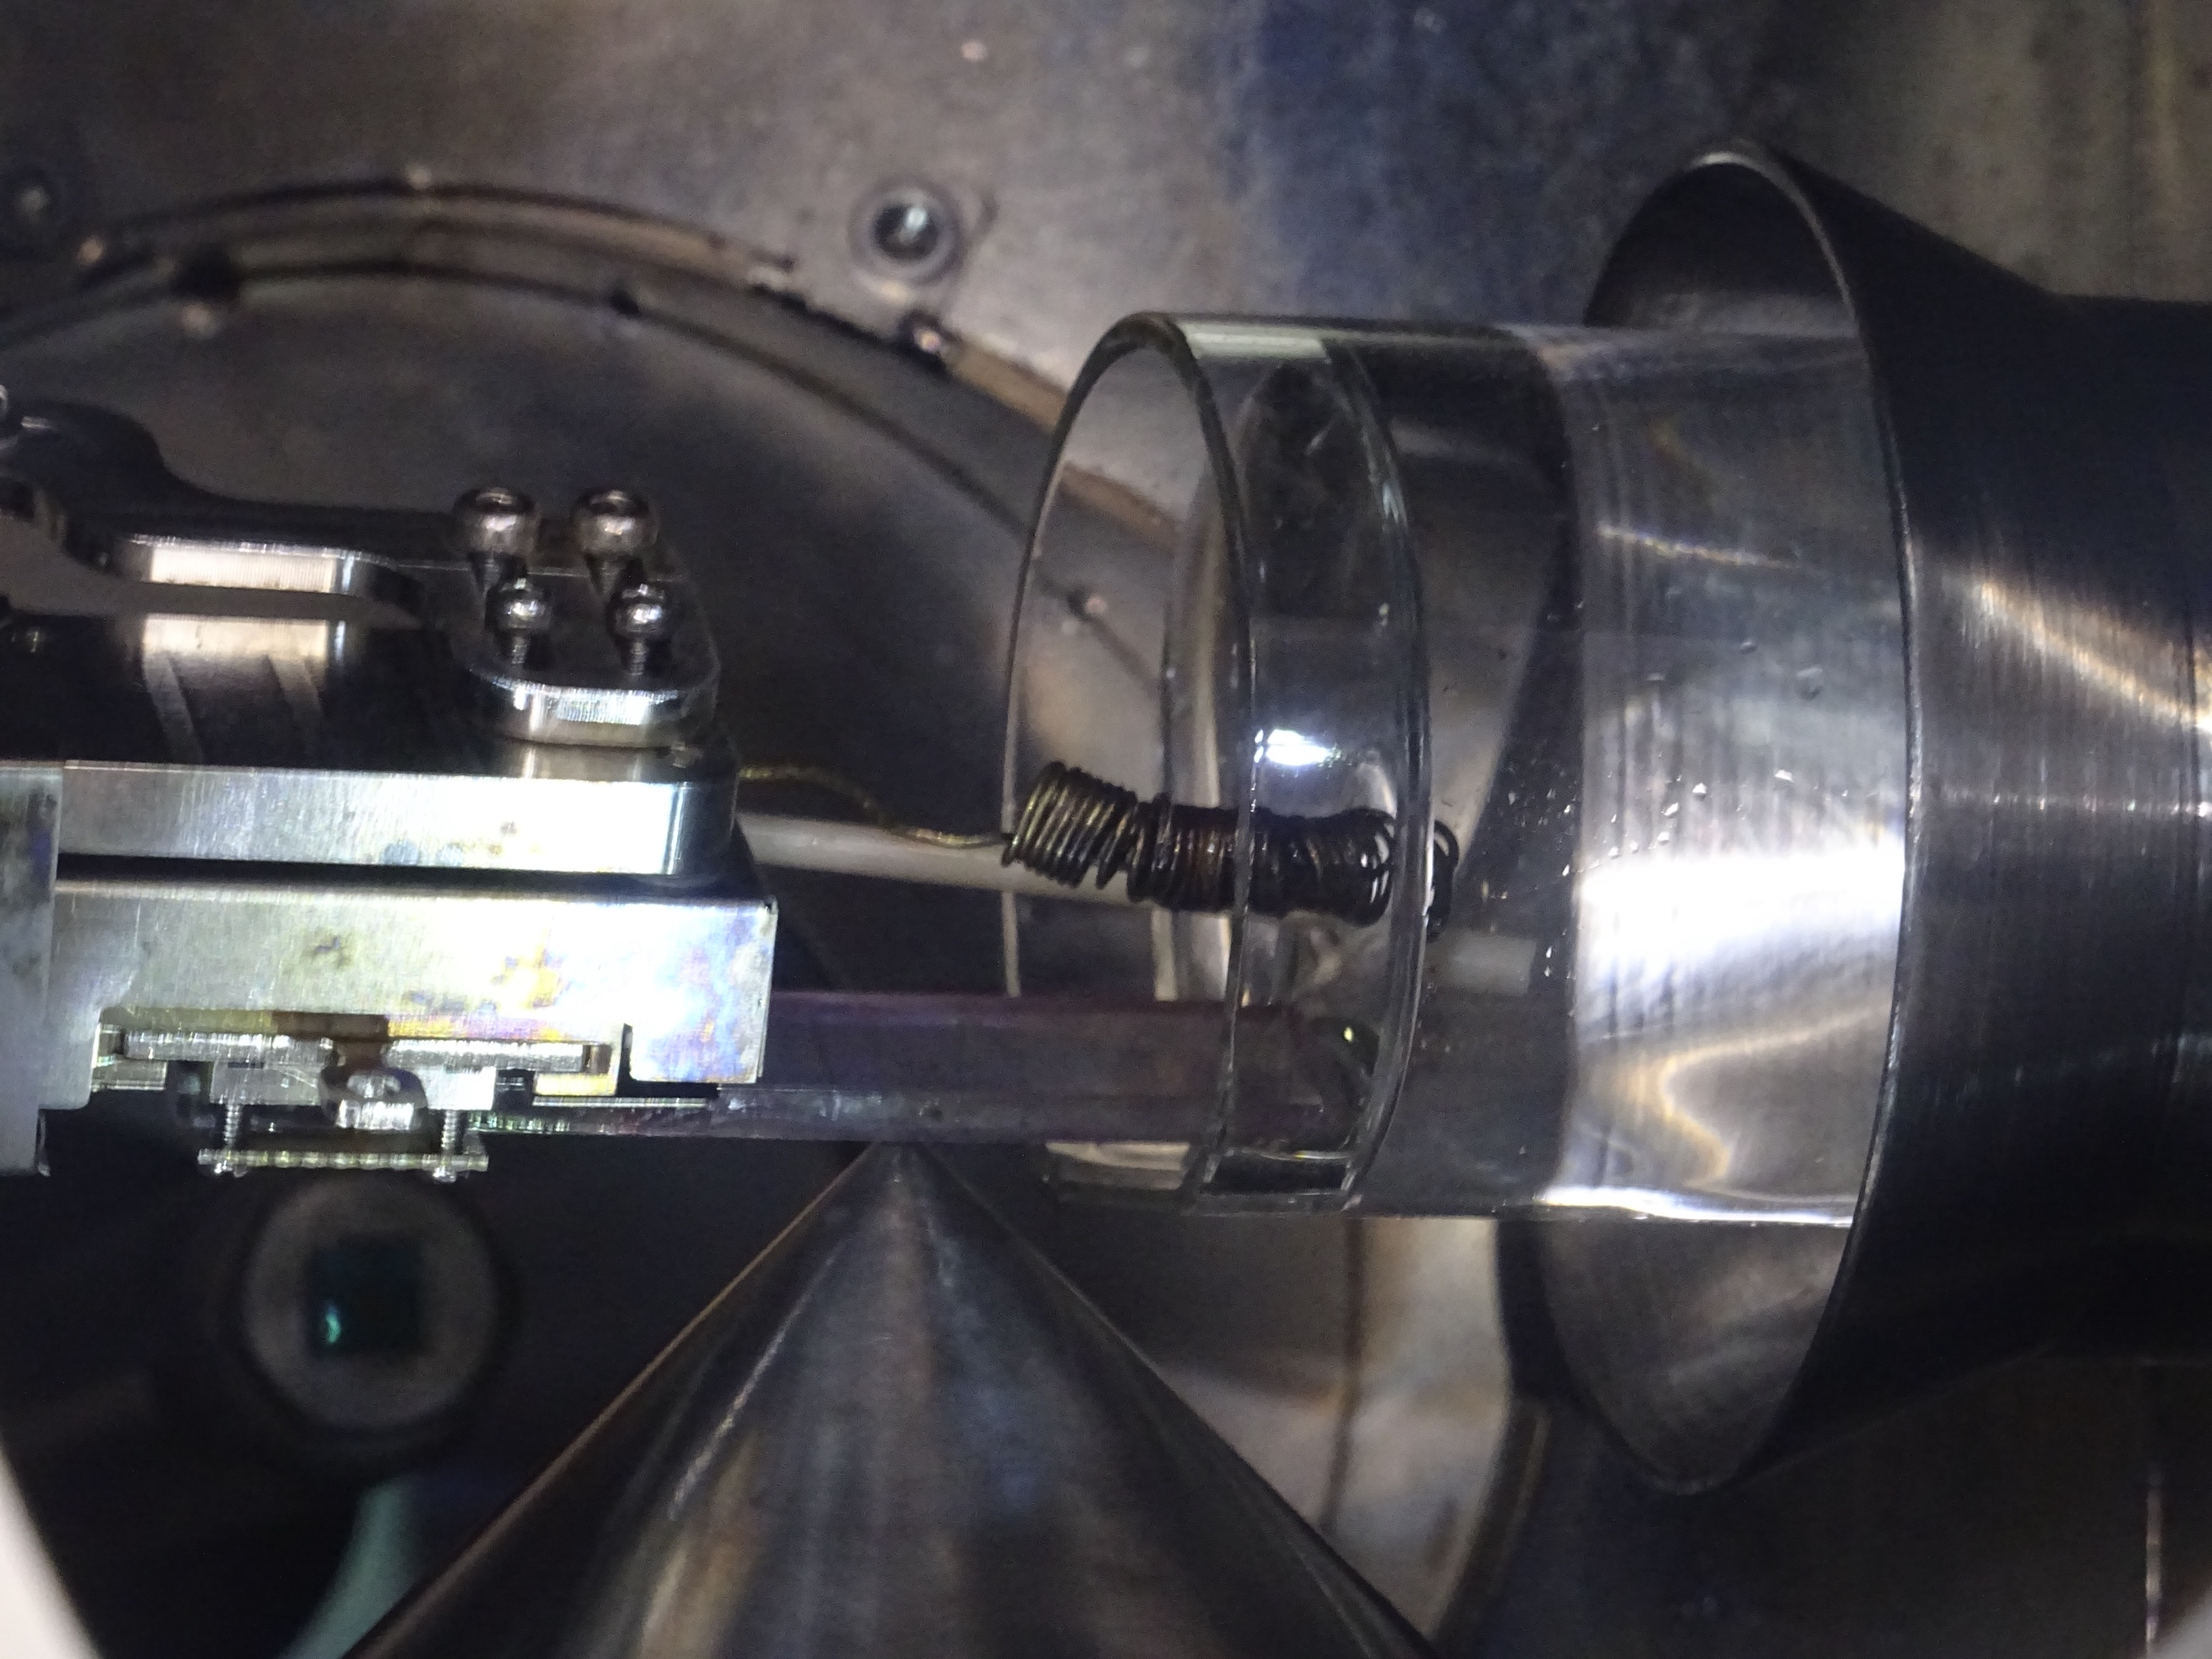
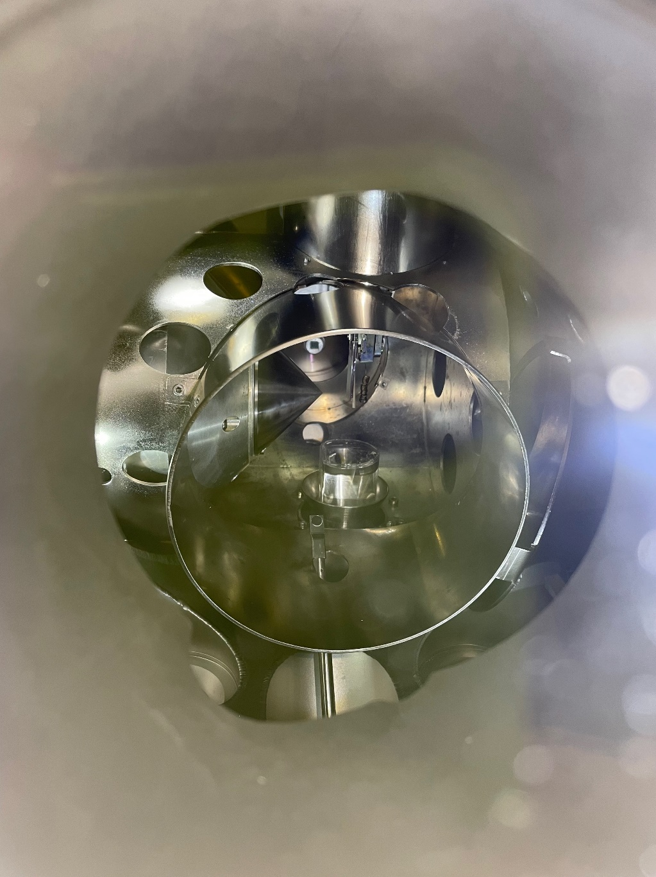
FIGURE S1: Photographs from inside the NAP-XPS chamber showing the beaker with electrolyte, working, reference and counter electrodes. The working electrode is the same system used for the chronoamperometry experiments, namely mesoporous film supported on FTO conductive glass.

Additional data:
FIGURE S2: Optical spectrum of [Co^{II}(phen-NH₂)₂NO₃].NO₃⁻ in dimethylformamide.

FIGURE S3: Dynamic light scattering (DLS) analysis of Au NPs in water.

Light off
Light on
Light off
FIGURE S4: Online detection of H₂ gas by QMS applying -0.65V potential.

FIGURE S5: Representative contour-map plot of TAS data for Au NPs excited at 550 nm.

FIGURE S6: TIRAS contour plot of Au/Co-catalyst after excitation at 550 nm.

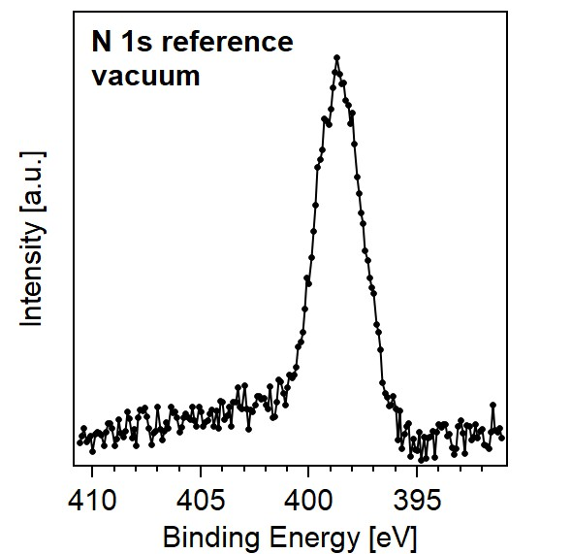
FIGURE S7: N 1s photoemission spectrum of the “as-intoduced” of the NiO/Au/Co-catalyst electrode acquired in vacuum.

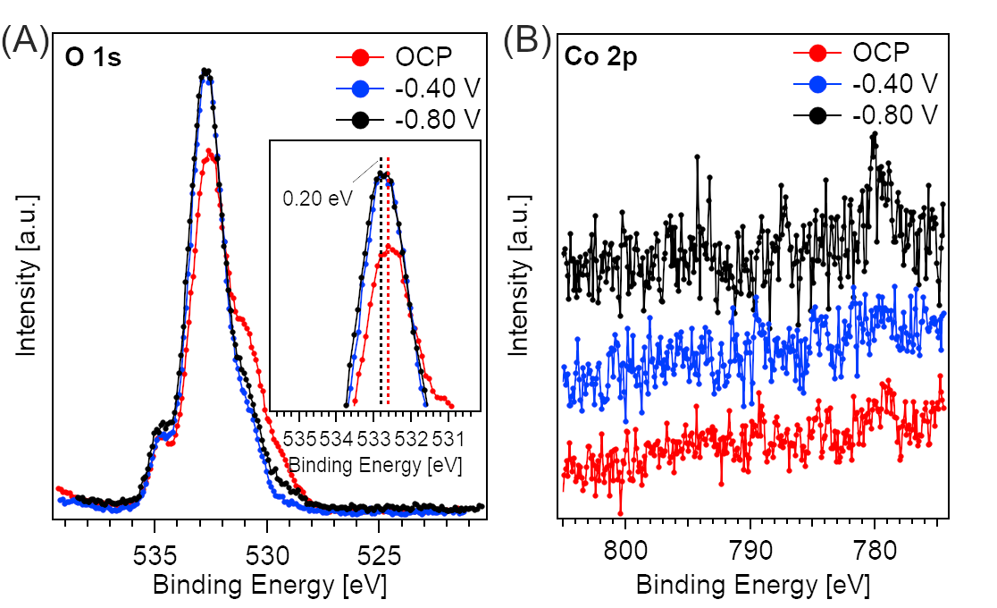
FIGURE S8: In situ NAP-XPS under variable potential of the NiO/Au/Co-catalyst with an X-ray photon energy of 5000 eV. The potentials are vs Ag/AgCl reference electrode. A) O 1s signals (the inset shows a magnification of the main peaks, highlighting the binding energy shift due to the potential applied); B) Co 2p signals.

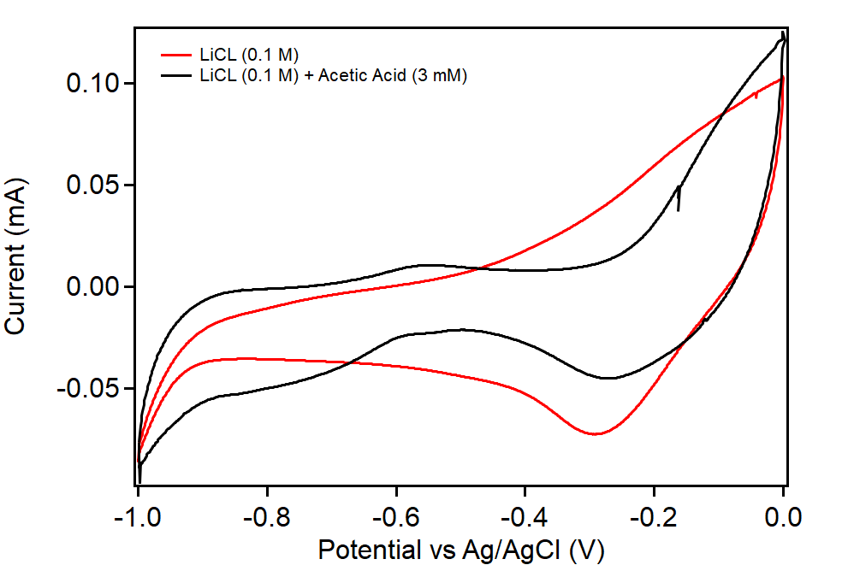
FIGURE S9: Representative cyclic voltammetry of the electrode in absence and presence of acid measured during the NAP-XPS measurements.

References

. Novotny, Z., Aegerter, D., Comini, N., Tobler, B., Artiglia, L., Maier, U., Moehl, T., Fabbri, E., Huthwelker, T., Schmidt, T., Ammann, M., van Bokhoven, J. A., Raabe, J., Osterwalder, J. Probing the solid–liquid interface with tender x rays: A new ambient-pressure x-ray photoelectron spectroscopy endstation at the Swiss Light Source. Rev. Scie. Instrum. 91, 023103 (2020).

