Supplementary information
DFT-based Analysis of Siderophore-Metal Ion Interaction for Efficient Heavy Metal Remediation
Yi-Cheng Xu,ª Nan Li,ª Xiufeng Yan,^{a,*} Hui-Xi Zou ^{a,*}

ª National and Local Joint Engineering Research Center of Ecological Treatment Technology for Urban Water Pollution, Zhejiang Provincial Key Laboratory for Water Environment and Marine Biological Resources Protection, College of Life and Environmental Science, Wenzhou University, Zhong-Xin Street, 325035 Wenzhou, China

* Corresponding authors:
Xiufeng Yan, *Email: yanxiufeng@wzu.edu.cn
Hui-Xi Zou, *Email: zjuzhx@wzu.edu.cn
Tel.: 0086-577-86689078

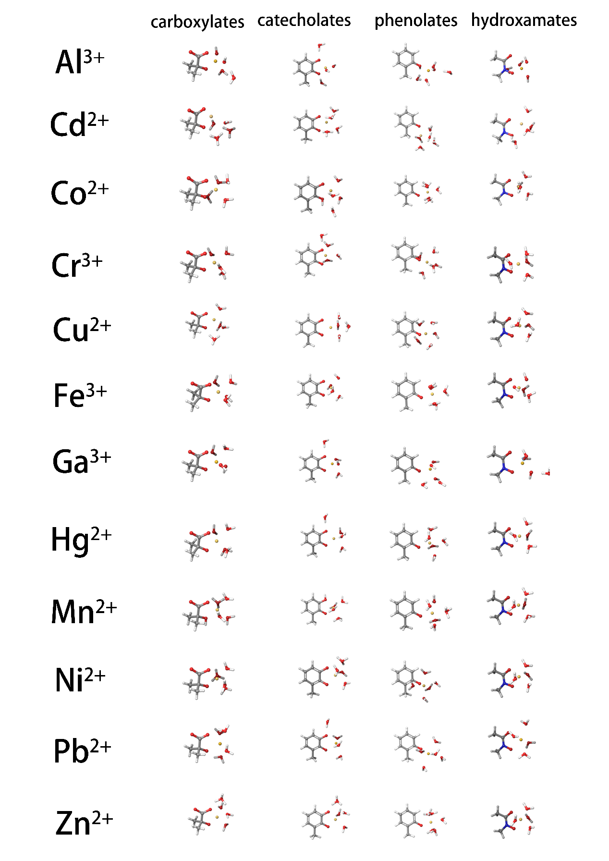
Figure S1. Equilibrium conformations of the metal-siderophore complexes.

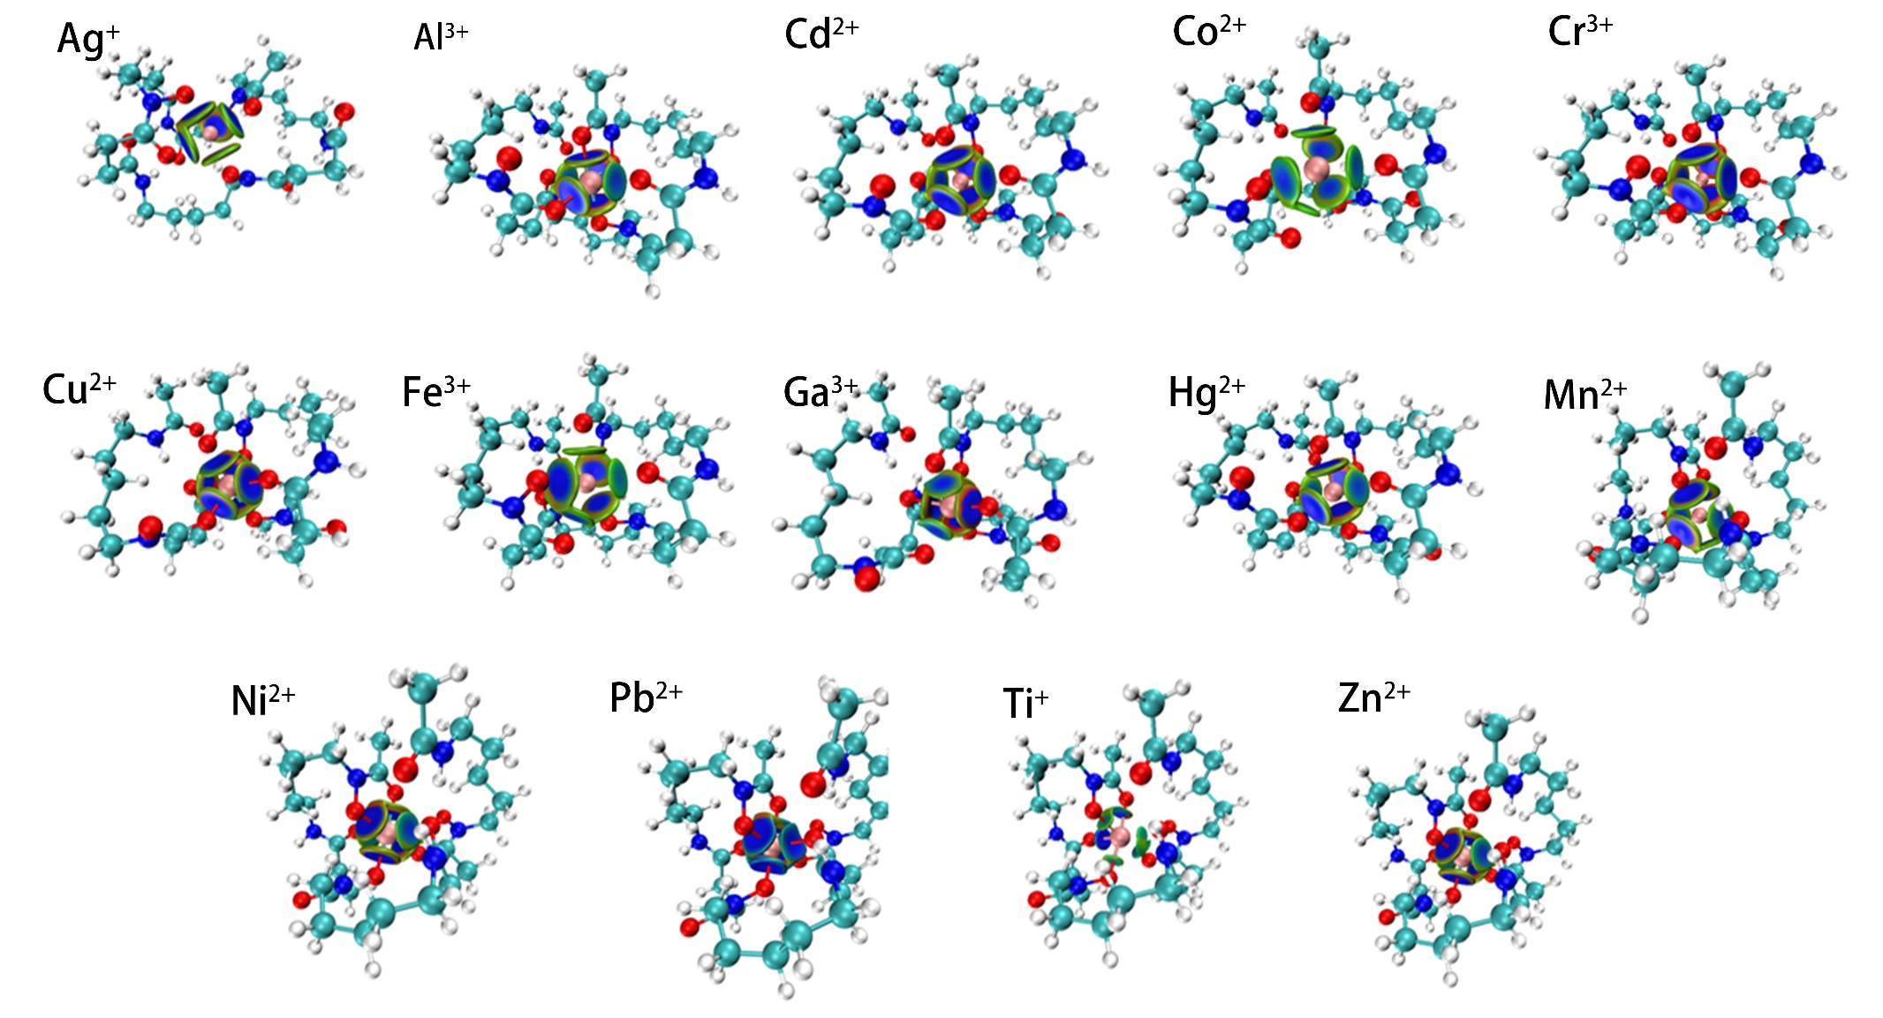
Figure S2. IGMH analysis of the interaction between DFOD1 and each metal ion.
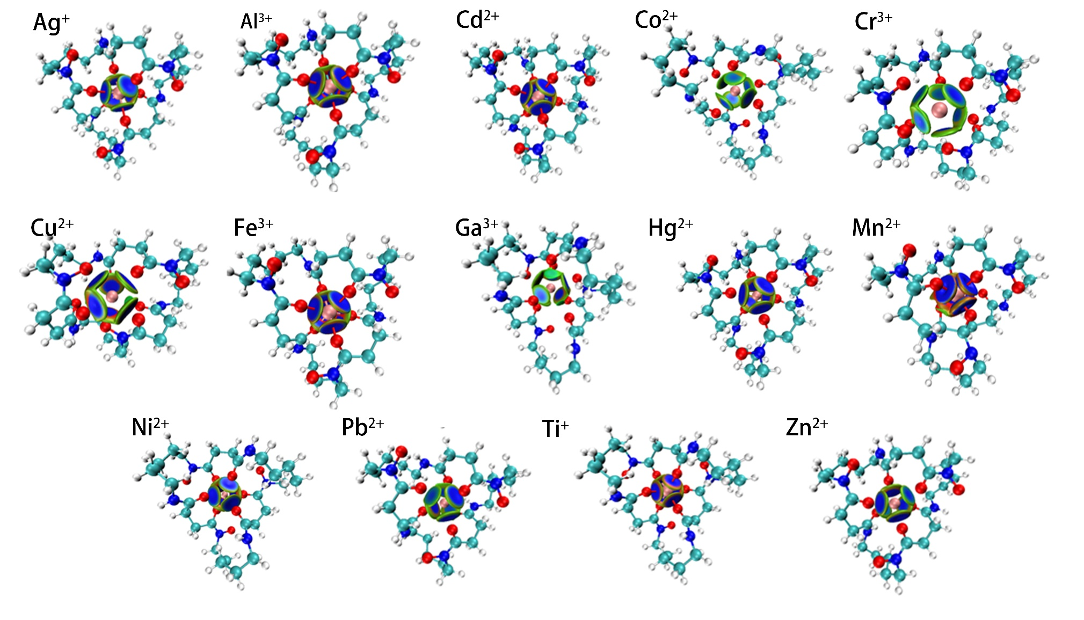
Figure S3. IGMH analysis of the interaction between DFOD2 and each metal ion.
Table S1. Number of coordination teeth of metal cations, pK_{a}, Metal ions in aqueous solution and ionic radius.
Metal ions | Ligand | pK_{a} | Metal ion/H₂O complex | Ionic radius ls/hs (pm)
Al³⁺ | 6 | 5 | [Al(H₂O)₂(OH)₄] ⁻ | 53.5
Co²⁺ | 6 | 9.7 | [Co(H₂O)₅OH]⁺ | 79/88.5
Cu²⁺ | 6 | 8 | [Cu(H₂O)₅OH]⁺ | 73
Fe³⁺ | 6 | 6.33 | [Fe(H₂O)₃(OH)₃]⁰ | 69/78.5
Ga³⁺ | 6 | 4.4 | [Ga(H₂O)₂(OH)₄]⁻ | 76
Mn²⁺ | 6 | 10.6/11.0 | [Mn(H₂O)₆)]²⁺ | 81/97
Ni²⁺ | 6 | 9.86 | [Ni(H₂O)₅(OH)]⁺ | 69
Zn²⁺ | 6 | 9 | [Zn(H₂O)₅(OH]]⁺ | 74
Cd²⁺ | 6 | 10.0/10.1 | [Cd(H₂O)₆]²⁺ | 95
Cr³⁺ | 6 | - | - | 75.5
Hg²⁺ | 6 | - | - | 102
Pb²⁺ | 6 | - | - | 119
Ag⁺ | 4 | - | - | 115
Ti⁺ | 6 | - | - | 100

Table S2. Calculated and experimental bond lengths of coordination bonds formed between different metal ions and water.
Molecule | Calc_{GFN2-xTB} r(M-OH₂) | Calc_{def2-svp} r(M-OH₂) | Exp r(M-OH₂)
[Al(H₂O)₂(OH)₄] ⁻ | 2.08/2.08 | 1.96/1.98 | 1.92
[Co(H₂O)₅OH]⁺ | 2.03/2.11/2.12/2.25/2.26 | 2.05/2.06/2.06/2.27/2.35 | 2.09/2.11
[Cu(H₂O)₅OH]⁺ | 2.06/2.23/2.24/2.25/2.26 | 2.04/2.13/2.14/2.38/2.39 | 1.96(3)/2.05/2.29
[Cd(H₂O)₆]²⁺ | 2.17 | 2.33 | 2.292(5)/2.289
[Fe(H₂O)₃(OH)₃] | 2.13/2.19/2.24 | 2.14/2.19/2.24 | 2.131(3)
[Ga(H₂O)₂(OH)₄]⁻ | 2.02/2.02 | 2.30/2.30 | 1.959(6)
[Mn(H₂O)₆)]²⁺ | 2.13 | 2.05 | 2.177
[Ni(H₂O)₅(OH)]⁺ | 2.02/2.23/2.24/2.25/2.26 | 2.11/2.11/2.12/2.12/2.14 | 2.029(4)−2.049(4)/2.065/2.05
[Zn(H₂O)₅(OH)]⁺ | 2.08/2.11/2.14/2.14/2.15 | 2.17/2.17/2.21/2.21/2.26 | 2.05/2.093/2.10/2.15

Table S3. Energy decomposition of the metal-siderophore complexes.
Metal | Functional group | ΔE_{total} (kcal/mol) | ΔE_{orb} (kcal/mol) | ΔE_{orb}/ΔE_{total} (%) | ΔE_{steric} (kcal/mol) | ΔE_{steric}/ΔE_{total} (%)
Al³⁺ | carboxylates | -1809.31502 | -351.6137179 | 80.57% | -1457.701302 | 80.57%
Al³⁺ | catecholates | -1806.905256 | -410.7598795 | 77.27% | -1396.145376 | 77.27%
Al³⁺ | phenolates | -1879.550708 | -397.747335 | 78.84% | -1481.803373 | 78.84%
Al³⁺ | hydroxamates | -1943.05654 | -382.7007888 | 80.30% | -1560.355751 | 80.30%
Cd²⁺ | carboxylates | -699.0583764 | -268.7527875 | 61.56% | -430.3055889 | 61.56%
Cd²⁺ | catecholates | -747.1430245 | -328.4136303 | 56.04% | -418.7293942 | 56.04%
Cd²⁺ | phenolates | -399.1617465 | -204.0515109 | 48.88% | -195.1102356 | 48.88%
Cd²⁺ | hydroxamates | -228.5309844 | -135.254987 | 40.82% | -93.27599736 | -182.68%
Co²⁺ | carboxylates | -856.8545511 | -946.6704482 | -10.48% | 89.81589711 | -10.48%
Co²⁺ | catecholates | -1011.242656 | -1089.165372 | -7.71% | 77.92271617 | -7.71%
Co²⁺ | phenolates | -635.2362796 | -819.3736465 | -28.99% | 184.1373669 | -28.99%
Co²⁺ | hydroxamates | -654.9985776 | -817.1252518 | -24.75% | 162.1266742 | -24.75%
Cr³⁺ | carboxylates | -1466.818305 | -1359.974174 | 7.28% | -106.8441306 | 7.28%
Cr³⁺ | catecholates | -1424.638275 | -1264.542365 | 11.24% | -160.0959098 | 11.24%
Cr³⁺ | phenolates | -601.8017938 | -241.3872673 | 59.89% | -360.4145265 | 59.89%
Cr³⁺ | hydroxamates | -530.858839 | -647.366143 | -21.95% | 116.507304 | -21.95%
Cu²⁺ | carboxylates | -1018.217618 | -1040.281011 | -2.17% | 22.06339299 | -2.17%
Cu²⁺ | catecholates | -986.9212471 | -641.1128678 | 35.04% | -345.8083793 | 35.04%
Cu²⁺ | phenolates | -604.6695145 | -671.7237147 | -11.09% | 67.05420019 | -11.09%
Cu²⁺ | hydroxamates | -647.655079 | -659.2519758 | -36.23% | 11.59689682 | -36.23%
Fe³⁺ | carboxylates | -1630.921708 | -1050.274182 | 48.68% | -580.6475259 | 48.68%
Fe³⁺ | catecholates | -1697.310446 | -1382.762604 | 18.53% | -314.5478424 | 18.53%
Fe³⁺ | phenolates | -1760.233572 | -483.2314243 | 72.55% | -1277.002148 | 72.55%
Fe³⁺ | hydroxamates | -1789.109135 | -1399.409723 | 21.78% | -389.6994121 | 21.78%
Ga³⁺ | carboxylates | -1839.45125 | -376.4311539 | 79.54% | -1463.020096 | 79.54%
Ga³⁺ | catecholates | -1805.733193 | -439.430181 | 75.66% | -1366.303012 | 75.66%
Ga³⁺ | phenolates | -1922.606679 | -414.9097371 | 78.42% | -1507.696942 | 78.42%
Ga³⁺ | hydroxamates | -1962.977974 | -386.6419407 | 80.30% | -1576.336034 | 80.30%
Hg²⁺ | carboxylates | -743.1159163 | -221.2278995 | 70.23% | -521.8880168 | 70.23%
Hg²⁺ | catecholates | -739.1282785 | -249.4729888 | 66.25% | -489.6552897 | 66.25%
Hg²⁺ | phenolates | -539.1101563 | -206.4630265 | 61.70% | -332.6471297 | 61.70%
Hg²⁺ | hydroxamates | -545.9773747 | -194.1333277 | 64.44% | -351.844047 | 64.44%
Mn²⁺ | carboxylates | -1152.733674 | -1234.080137 | -7.06% | 81.34646308 | -7.06%
Mn²⁺ | catecholates | -967.5775611 | -1062.058461 | -9.76% | 94.4808996 | -9.76%
Mn²⁺ | phenolates | -448.4549788 | -552.3472467 | -23.17% | 103.8922679 | -80.57%
Mn²⁺ | hydroxamates | -509.5540588 | -831.1382879 | -63.11% | 321.5842292 | -63.11%
Ni²⁺ | carboxylates | -1059.134596 | -514.496264 | 51.42% | -544.6383318 | 51.42%
Ni²⁺ | catecholates | -994.7672556 | -531.5238854 | 46.57% | -463.2433702 | 46.57%
Ni²⁺ | phenolates | -644.0511636 | -258.5337986 | 59.86% | -385.517365 | 59.86%
Ni²⁺ | hydroxamates | -691.2430532 | -256.5665028 | 62.88% | -434.6765504 | 62.88%
Pb²⁺ | carboxylates | -682.3885105 | -199.7073451 | 70.73% | -482.6811654 | 70.73%
Pb²⁺ | catecholates | -672.8666111 | -215.1849262 | 68.02% | -457.6816848 | 68.02%
Pb²⁺ | phenolates | -449.1131741 | -158.3699576 | 64.74% | -290.7432165 | 64.74%
Pb²⁺ | hydroxamates | -488.9901168 | -156.0014402 | 68.10% | -332.9886766 | 68.10%
Zn²⁺ | carboxylates | -1009.0785 | -449.1752849 | 55.49% | -559.9032148 | 55.49%
Zn²⁺ | catecholates | -989.1039779 | -826.0669928 | 16.48% | -163.0369851 | -187.30%
Zn²⁺ | phenolates | -620.812021 | -216.2292537 | 65.17% | -404.5827673 | 65.17%
Zn²⁺ | hydroxamates | -634.005356 | -176.6029654 | 72.14% | -457.4023907 | 72.14%

Table S4. Interaction decomposition of the metal-siderophore complexes.
Metal | Functional Group | ΔG_{total} | ΔG_{aq} | ΔG_{direct} | ΔG_{backbone}
Al³⁺ | carboxylates | 2.112316 | 1.153823 | 0.54432 | 0.414173
Al³⁺ | catecholates | 1.759001 | 0.859607 | 0.512102 | 0.387292
Al³⁺ | phenolates | 1.637169 | 1.160317 | 0.249887 | 0.226965
Al³⁺ | hydroxamates | 1.718529 | 1.108118 | 0.356935 | 0.253477
Cd²⁺ | carboxylates | 1.878733 | 0.727895 | 0.72448 | 0.426358
Cd²⁺ | catecholates | 1.998119 | 1.00494 | 0.637579 | 0.355601
Cd²⁺ | phenolates | 2.186561 | 1.313128 | 0.375648 | 0.497785
Cd²⁺ | hydroxamates | 1.463102 | 0.854061 | 0.412385 | 0.196656
Co²⁺ | carboxylates | 2.128764 | 0.99387 | 0.736182 | 0.39871
Co²⁺ | catecholates | 2.100316 | 1.095689 | 0.673844 | 0.330785
Co²⁺ | phenolates | 2.031821 | 1.39854 | 0.365862 | 0.267417
Co²⁺ | hydroxamates | 2.106392 | 1.079233 | 0.68022 | 0.346941
Cr³⁺ | carboxylates | 2.466891 | 1.329539 | 0.754992 | 0.382364
Cr³⁺ | catecholates | 2.272606 | 0.879432 | 0.804774 | 0.588401
Cr³⁺ | phenolates | 1.970146 | 1.380718 | 0.329476 | 0.259953
Cr³⁺ | hydroxamates | 2.264128 | 1.262811 | 0.704325 | 0.296993
Cu²⁺ | carboxylates | 1.978637 | 1.01535 | 0.660311 | 0.302977
Cu²⁺ | catecholates | 1.756853 | 0.808768 | 0.663142 | 0.284945
Cu²⁺ | phenolates | 1.819349 | 1.251031 | 0.322058 | 0.246261
Cu²⁺ | hydroxamates | 1.930949 | 1.051392 | 0.604024 | 0.275532
Fe³⁺ | carboxylates | 2.330038 | 1.164577 | 0.741737 | 0.423726
Fe³⁺ | catecholates | 2.452592 | 1.349763 | 0.726629 | 0.376204
Fe³⁺ | phenolates | 2.689407 | 2.030455 | 0.367929 | 0.291022
Fe³⁺ | hydroxamates | 2.82368 | 1.78086 | 0.67993 | 0.362891
Ga³⁺ | carboxylates | 2.513224 | 1.455759 | 0.655303 | 0.402162
Ga³⁺ | catecholates | 2.209176 | 1.160626 | 0.677838 | 0.370713
Ga³⁺ | phenolates | 2.099966 | 1.561658 | 0.321761 | 0.216549
Ga³⁺ | hydroxamates | 2.1707 | 1.411418 | 0.49453 | 0.26475
Hg²⁺ | carboxylates | 2.34711 | 1.060996 | 0.857204 | 0.42891
Hg²⁺ | catecholates | 1.999368 | 0.791539 | 0.832539 | 0.37529
Hg²⁺ | phenolates | 2.489767 | 1.756385 | 0.448223 | 0.285158
Hg²⁺ | hydroxamates | 2.378224 | 1.281164 | 0.767178 | 0.329884
Mn²⁺ | carboxylates | 1.877544 | 1.057319 | 0.53524 | 0.284986
Mn²⁺ | catecholates | 1.964557 | 1.101497 | 0.552993 | 0.310066
Mn²⁺ | phenolates | 1.921463 | 1.354889 | 0.319261 | 0.247312
Mn²⁺ | hydroxamates | 2.125281 | 1.158177 | 0.634132 | 0.332974
Ni²⁺ | carboxylates | 2.143846 | 0.999762 | 0.733391 | 0.410693
Ni²⁺ | catecholates | 2.110718 | 1.000841 | 0.744102 | 0.365777
Ni²⁺ | phenolates | 1.959422 | 1.26623 | 0.374086 | 0.319104
Ni²⁺ | hydroxamates | 2.070977 | 1.057528 | 0.678636 | 0.33481
Pb²⁺ | carboxylates | 1.712191 | 0.898595 | 0.527714 | 0.285881
Pb²⁺ | catecholates | 1.494472 | 0.664167 | 0.556403 | 0.273903
Pb²⁺ | phenolates | 1.910034 | 1.419751 | 0.274732 | 0.215549
Pb²⁺ | hydroxamates | 1.566549 | 0.867529 | 0.471556 | 0.227463
Zn²⁺ | carboxylates | 1.82217 | 0.977967 | 0.520147 | 0.324056
Zn²⁺ | catecholates | 1.59721 | 0.652714 | 0.615367 | 0.329128
Zn²⁺ | phenolates | 1.814434 | 1.240649 | 0.320648 | 0.253136
Zn²⁺ | hydroxamates | 2.027446 | 1.100906 | 0.5759 | 0.35064

Table S5. Energy decomposition of DFOD1- and DFOD2-metal complexes.
 | DFOD1 |  |  | DFOD2
 | ΔE_{total} (kcal/mol) | ΔE_{orb} (kcal/mol) | ΔE_{steric} (kcal/mol) | ΔE_{total} (kcal/mol) | ΔE_{orb} (kcal/mol) | ΔE_{steric} (kcal/mol)
Ag⁺ | -353.8784287 | -81.47518326 | -272.4032454 | -396.2812874 | -79.3899742 | -316.8913132
Al³⁺ | -1659.690469 | -650.3012565 | -1009.389212 | -1683.069358 | -632.5778369 | -1050.491521
Cd²⁺ | -906.076561 | -228.7710078 | -677.3055532 | -903.283012 | -231.4336087 | -671.8494033
Co²⁺ | -974.4898347 | -963.7511689 | -10.7386658 | -933.4406406 | -865.530191 | -67.91044952
Cr³⁺ | -1668.131294 | -1600.350238 | -67.7810563 | -1660.225421 | -1638.277287 | -21.9481338
Cu²⁺ | -919.6819191 | -1013.728559 | 94.04664042 | -981.3816515 | -962.0773107 | -19.30434081
Fe³⁺ | -1715.989787 | -538.7566692 | -1177.233118 | -1768.314646 | -1727.224592 | -41.09005429
Ga³⁺ | -1661.62207 | -637.7206455 | -1023.901424 | -1681.817538 | -617.3320428 | -1064.485495
Hg²⁺ | -910.2545226 | -268.6990068 | -641.5555157 | -915.6527401 | -270.2274319 | -645.4253081
Mn²⁺ | -900.3721186 | -823.007913 | -77.36420561 | -911.5498915 | -392.9011936 | -518.6486979
Ni²⁺ | -960.0174461 | -325.7719928 | -634.2454533 | -1005.119476 | -349.2500219 | -655.8694545
Pb²⁺ | -801.1603403 | -200.2268461 | -600.9334942 | -795.7734179 | -197.0111841 | -598.7622339
Ti⁺ | -424.2358539 | -645.191415 | 220.9555611 | -574.9892955 | -835.5862192 | 260.5969237
Zn²⁺ | -931.2046342 | -272.1235263 | -659.0811079 | -951.0501399 | -264.8872451 | -686.1628948

Table S6. IGMH analysis of the interaction between DFOD1/DFOD2 and 14 metal ions.
Metal | Siderophore | ΔG_{total} | ΔG_{direct} | ΔG_{backbone}
Ag⁺ | DFOD1 | 1.959872 | 1.007661 | 0.95221
Ag⁺ | DFOD2 | 2.214626 | 1.054364 | 1.160262
Al³⁺ | DFOD1 | 3.061753 | 1.498614 | 1.563136
Al³⁺ | DFOD2 | 2.85182 | 1.466718 | 1.385101
Cd²⁺ | DFOD1 | 2.524717 | 1.34175 | 1.182969
Cd²⁺ | DFOD2 | 2.472471 | 1.233507 | 1.238962
Co²⁺ | DFOD1 | 2.857565 | 1.478188 | 1.379373
Co²⁺ | DFOD2 | 3.028888 | 1.686509 | 1.34238
Cr³⁺ | DFOD1 | 3.249281 | 1.73699 | 1.512288
Cr³⁺ | DFOD2 | 2.985714 | 1.683011 | 1.302704
Cu²⁺ | DFOD1 | 2.263827 | 1.325762 | 0.938069
Cu²⁺ | DFOD2 | 2.462617 | 1.312072 | 1.150544
Fe³⁺ | DFOD1 | 4.621616 | 1.988799 | 2.632819
Fe³⁺ | DFOD2 | 2.769162 | 1.444024 | 1.325137
Ga³⁺ | DFOD1 | 3.103493 | 1.709282 | 1.394214
Ga³⁺ | DFOD2 | 2.988886 | 1.73399 | 1.25489
Hg²⁺ | DFOD1 | 2.866308 | 1.709088 | 1.157224
Hg²⁺ | DFOD2 | 2.877287 | 1.657266 | 1.220018
Mn²⁺ | DFOD1 | 2.846064 | 0.769357 | 2.076711
Mn²⁺ | DFOD2 | 2.643646 | 1.361096 | 1.282549
Ni²⁺ | DFOD1 | 2.644052 | 1.354294 | 1.289756
Ni²⁺ | DFOD2 | 2.422633 | 1.286134 | 1.136497
Pb²⁺ | DFOD1 | 2.338132 | 1.194089 | 1.144047
Pb²⁺ | DFOD2 | 2.235373 | 1.088197 | 1.147173
Ti⁺ | DFOD1 | 3.909764 | 1.879776 | 2.029988
Ti⁺ | DFOD2 | 3.527327 | 1.865412 | 1.661914
Zn²⁺ | DFOD1 | 2.668747 | 1.412653 | 1.256095
Zn²⁺ | DFOD2 | 2.549293 | 1.439127 | 1.110165

Structure of the complex formed by Cr³⁺-catecholate siderophore.

REMARK Generated by Multiwfn, Totally 28 atoms
HETATM 1 CR MOL A 1 -1.074 -0.516 -0.029100.00 22.73 CR
HETATM 2 C MOL B 1 2.506 -0.758 -0.135 1.93 0.44 C
HETATM 3 C MOL B 1 1.171 -0.409 -0.427 9.57 2.17 C
HETATM 4 O MOL B 1 0.298 -1.202 -0.985 18.27 4.15 O
HETATM 5 C MOL B 1 0.708 0.931 -0.174 9.36 2.13 C
HETATM 6 C MOL B 1 1.581 1.875 0.380 1.89 0.43 C
HETATM 7 O MOL B 1 -0.519 1.167 -0.549 17.14 3.90 O
HETATM 8 C MOL B 1 3.326 0.206 0.421 0.66 0.15 C
HETATM 9 O MOL B 1 -1.212 3.887 -0.392 0.31 0.07 O
HETATM 10 O MOL B 1 -1.444 -2.323 1.035 9.12 2.07 O
HETATM 11 C MOL B 1 2.873 1.499 0.676 0.65 0.15 C
HETATM 12 O MOL B 1 -2.967 -0.855 -1.026 8.35 1.90 O
HETATM 13 O MOL B 1 -2.385 0.227 1.474 9.28 2.11 O
HETATM 14 C MOL B 1 2.999 -2.138 -0.448 0.58 0.13 C
HETATM 15 H MOL B 1 4.349 -0.050 0.649 0.09 0.02 H
HETATM 16 H MOL B 1 3.552 2.222 1.103 0.09 0.02 H
HETATM 17 H MOL B 1 1.229 2.881 0.548 0.46 0.10 H
HETATM 18 H MOL B 1 -2.995 -0.394 -1.875 1.99 0.45 H
HETATM 19 H MOL B 1 3.289 -2.658 0.463 0.16 0.04 H
HETATM 20 H MOL B 1 3.876 -2.086 -1.091 0.09 0.02 H
HETATM 21 H MOL B 1 2.223 -2.705 -0.956 0.36 0.08 H
HETATM 22 H MOL B 1 -2.238 -2.874 1.044 1.68 0.38 H
HETATM 23 H MOL B 1 -3.347 0.254 1.362 1.93 0.44 H
HETATM 24 H MOL B 1 -2.003 4.069 -0.908 0.12 0.03 H
HETATM 25 H MOL B 1 -0.820 -2.729 1.648 1.79 0.41 H
HETATM 26 H MOL B 1 -0.993 2.951 -0.552 0.69 0.16 H
HETATM 27 H MOL B 1 -3.329 -1.737 -1.185 1.71 0.39 H
HETATM 28 H MOL B 1 -2.171 0.783 2.233 1.71 0.39 H
END

Decomposition of the interaction of the Cr³⁺-catecholate siderophore complex.

Atomic delta-g indices of fragment 1 and percentage contributions
Atom 28 : 2.272606 ( 100.00 % )

Atomic delta-g indices of fragment 2 and percentage contributions
Atom 3 : 0.415147 ( 18.27 % )
Atom 6 : 0.389627 ( 17.14 % )
Atom 2 : 0.217460 ( 9.57 % )
Atom 4 : 0.212819 ( 9.36 % )
Atom 12 : 0.210884 ( 9.28 % )
Atom 9 : 0.207373 ( 9.12 % )
Atom 11 : 0.189808 ( 8.35 % )
Atom 17 : 0.045334 ( 1.99 % )
Atom 22 : 0.043973 ( 1.93 % )
Atom 1 : 0.043810 ( 1.93 % )
Atom 5 : 0.042863 ( 1.89 % )
Atom 24 : 0.040705 ( 1.79 % )
Atom 27 : 0.038847 ( 1.71 % )
Atom 26 : 0.038836 ( 1.71 % )
Atom 21 : 0.038134 ( 1.68 % )
Atom 25 : 0.015755 ( 0.69 % )
Atom 7 : 0.014887 ( 0.66 % )
Atom 10 : 0.014696 ( 0.65 % )
Atom 13 : 0.013231 ( 0.58 % )
Atom 16 : 0.010494 ( 0.46 % )
Atom 20 : 0.008256 ( 0.36 % )
Atom 8 : 0.007098 ( 0.31 % )
Atom 18 : 0.003547 ( 0.16 % )
Atom 23 : 0.002685 ( 0.12 % )
Atom 19 : 0.002148 ( 0.09 % )
Atom 14 : 0.002109 ( 0.09 % )
Atom 15 : 0.002081 ( 0.09 % )

Atomic pair delta-g indices and percentage contributions (zero terms are not shown)
28 3 : 0.415147 ( 18.27 % )
28 6 : 0.389627 ( 17.14 % )
28 2 : 0.217460 ( 9.57 % )
28 4 : 0.212819 ( 9.36 % )
28 12 : 0.210884 ( 9.28 % )
28 9 : 0.207373 ( 9.12 % )
28 11 : 0.189808 ( 8.35 % )
28 17 : 0.045334 ( 1.99 % )
28 22 : 0.043973 ( 1.93 % )
28 1 : 0.043810 ( 1.93 % )
28 5 : 0.042863 ( 1.89 % )
28 24 : 0.040705 ( 1.79 % )
28 27 : 0.038847 ( 1.71 % )
28 26 : 0.038836 ( 1.71 % )
28 21 : 0.038134 ( 1.68 % )
28 25 : 0.015755 ( 0.69 % )
28 7 : 0.014887 ( 0.66 % )
28 10 : 0.014696 ( 0.65 % )
28 13 : 0.013231 ( 0.58 % )
28 16 : 0.010494 ( 0.46 % )
28 20 : 0.008256 ( 0.36 % )
28 8 : 0.007098 ( 0.31 % )
28 18 : 0.003547 ( 0.16 % )
28 23 : 0.002685 ( 0.12 % )
28 19 : 0.002148 ( 0.09 % )
28 14 : 0.002109 ( 0.09 % )
28 15 : 0.002081 ( 0.09 % )

Sum of all atomic pair delta-g indices: 2.272606

Structure of the complex formed by Cr³⁺-hydroxamate siderophore.

REMARK Generated by Multiwfn, Totally 25 atoms
HETATM 1 CR MOL A 1 0.864 -0.005 0.002100.00 22.64 CR
HETATM 2 C MOL B 1 -3.156 -1.325 -0.010 0.75 0.17 C
HETATM 3 C MOL B 1 -2.818 1.611 -0.001 0.90 0.20 C
HETATM 4 C MOL B 1 -1.819 -0.674 0.000 4.88 1.10 C
HETATM 5 O MOL B 1 -0.745 -1.303 0.011 11.52 2.61 O
HETATM 6 N MOL B 1 -1.733 0.660 0.001 5.23 1.18 N
HETATM 7 O MOL B 1 -0.480 1.117 0.009 19.59 4.44 O
HETATM 8 O MOL B 1 2.353 -1.378 0.000 10.40 2.35 O
HETATM 9 O MOL B 1 2.335 1.522 -0.035 9.27 2.10 O
HETATM 10 O MOL B 1 0.987 -0.157 2.056 10.39 2.35 O
HETATM 11 O MOL B 1 0.983 -0.167 -2.048 10.40 2.35 O
HETATM 12 H MOL B 1 -3.031 -2.404 0.000 0.23 0.05 H
HETATM 13 H MOL B 1 -3.734 -1.022 0.859 0.18 0.04 H
HETATM 14 H MOL B 1 -3.714 -1.036 -0.897 0.19 0.04 H
HETATM 15 H MOL B 1 -2.383 2.608 0.008 0.33 0.08 H
HETATM 16 H MOL B 1 -3.431 1.495 -0.894 0.21 0.05 H
HETATM 17 H MOL B 1 -3.444 1.486 0.882 0.21 0.05 H
HETATM 18 H MOL B 1 2.181 -2.330 -0.002 1.99 0.45 H
HETATM 19 H MOL B 1 2.225 2.209 -0.704 1.96 0.44 H
HETATM 20 H MOL B 1 0.577 -0.876 2.556 1.98 0.45 H
HETATM 21 H MOL B 1 2.609 1.981 0.770 1.85 0.42 H
HETATM 22 H MOL B 1 1.429 0.428 2.686 1.83 0.41 H
HETATM 23 H MOL B 1 1.502 0.366 -2.665 1.84 0.42 H
HETATM 24 H MOL B 1 0.586 -0.897 -2.540 1.99 0.45 H
HETATM 25 H MOL B 1 3.315 -1.252 -0.006 1.90 0.43 H
END

Decomposition of the interaction of the Cr³⁺-hydroxamate siderophore complex.

Atomic delta-g indices of fragment 1 and percentage contributions
Atom 25 : 2.264128 ( 100.00 % )

Atomic delta-g indices of fragment 2 and percentage contributions
Atom 6 : 0.443553 ( 19.59 % )
Atom 4 : 0.260772 ( 11.52 % )
Atom 10 : 0.235483 ( 10.40 % )
Atom 7 : 0.235366 ( 10.40 % )
Atom 9 : 0.235134 ( 10.39 % )
Atom 8 : 0.209784 ( 9.27 % )
Atom 5 : 0.118487 ( 5.23 % )
Atom 3 : 0.110489 ( 4.88 % )
Atom 17 : 0.045146 ( 1.99 % )
Atom 23 : 0.044996 ( 1.99 % )
Atom 19 : 0.044719 ( 1.98 % )
Atom 18 : 0.044442 ( 1.96 % )
Atom 24 : 0.042925 ( 1.90 % )
Atom 20 : 0.041903 ( 1.85 % )
Atom 22 : 0.041591 ( 1.84 % )
Atom 21 : 0.041322 ( 1.83 % )
Atom 2 : 0.020486 ( 0.90 % )
Atom 1 : 0.016984 ( 0.75 % )
Atom 14 : 0.007525 ( 0.33 % )
Atom 11 : 0.005141 ( 0.23 % )
Atom 15 : 0.004768 ( 0.21 % )
Atom 16 : 0.004740 ( 0.21 % )
Atom 13 : 0.004202 ( 0.19 % )
Atom 12 : 0.004171 ( 0.18 % )

Atomic pair delta-g indices and percentage contributions (zero terms are not shown)
25 6 : 0.443553 ( 19.59 % )
25 4 : 0.260772 ( 11.52 % )
25 10 : 0.235483 ( 10.40 % )
25 7 : 0.235366 ( 10.40 % )
25 9 : 0.235134 ( 10.39 % )
25 8 : 0.209784 ( 9.27 % )
25 5 : 0.118487 ( 5.23 % )
25 3 : 0.110489 ( 4.88 % )
25 17 : 0.045146 ( 1.99 % )
25 23 : 0.044996 ( 1.99 % )
25 19 : 0.044719 ( 1.98 % )
25 18 : 0.044442 ( 1.96 % )
25 24 : 0.042925 ( 1.90 % )
25 20 : 0.041903 ( 1.85 % )
25 22 : 0.041591 ( 1.84 % )
25 21 : 0.041322 ( 1.83 % )
25 2 : 0.020486 ( 0.90 % )
25 1 : 0.016984 ( 0.75 % )
25 14 : 0.007525 ( 0.33 % )
25 11 : 0.005141 ( 0.23 % )
25 15 : 0.004768 ( 0.21 % )
25 16 : 0.004740 ( 0.21 % )
25 13 : 0.004202 ( 0.19 % )
25 12 : 0.004171 ( 0.18 % )

Sum of all atomic pair delta-g indices: 2.264128

