Supplementary Content
Manuscript
Machine learning predictions of outcome in Internet-based cognitive behavioral therapy: methodological choices and clinical usefulness
Note
Due to the extensive methodological investigation this supplement contains more details for the main paper.
Contents
Method. Additional methods.
Results. Additional results.
Table 1. Patient baseline characteristics
Figure 1. Accuracy over time
Model 1. Benchmark model.
References. References
Appendix 1. Hyperparameter tuning parameters investigated.

Method. Additional methods.

Data type
The homework variables were extensively feature engineered and consisted of constructing a representation of the text answers using the mean representation of a normalized vector created by Word2Vec (Mikolov et al., 2013) implemented using genism in python. (Řehůřek & Sojka, 2010) This was done first by building the vocabulary on all the answers for the specified homework, then a general representation of the answer was created by taking the mean vector of the representation of the entire answer. For the activity schedule filled in by patients in depression treatment, k-means clustering (Hartigan & Wong, 1979) was used on these general vector representations to be able to classify answers to each specific timeslot in the homework. The answers to all the timeslots were then aggregated again using k-means, yielding one classification per patient. For patients in treatment for social anxiety disorder or panic disorder the cosine-similarity of the answers to questions in regards to their anxiety before and after an exposure exercise was used as the aggregated measure.
Software information
We used Python 2.7.1 and scikit-learn (Pedregosa et al., 2011) for the implementation of the machine learning algorithms, and their evaluation. For visualization we used the ggplot2 (Wickham, 2016) package, and for summary of datasets we used DataMaid (Petersen & Ekstrøm, 2019), both implemented in R. (R Core Team, 2019)

Results. Additional results.

Table 1

Table 1. Baseline characteristics of patients included in analyses
Characteristics | Depression | Panic | Social | Total
No. of patients (%) | 3076 (46) | 1767 (26) | 1852 (28) | 6695
Symptom levelª , mean (SD) | 22.86 (7) | 11.36 (5) | 71.99 (24) | -
Age, mean (SD) | 37.77 (12) | 33.99 (11) | 32.48 (10) | 35.31 (11)
Female, No. (%) | 2027 (66) | 1077 (61) | 1049 (57) | 4153 (62)
Married, No. (%) | 1649 (54) | 1140 (65) | 955 (52) | 3744 (56)
Employment status, No. (%)
Working | 2243 (75) | 1317 (77) | 1261 (70) | 4821 (74)
Student | 306 (10) | 221 (13) | 328 (18) | 855 (13)
Other | 451 (15) | 183 (11) | 212 (12) | 846 (13)
Education level, No. (%)
Primary | 189 (6) | 177 (10) | 154 (9) | 520 (8)
Secondary | 1380 (46) | 911 (53) | 864 (49) | 3155 (49)
Postsecondary | 1424 (48) | 640 (37) | 745 (42) | 2809 (43)
a) Symptom are the primary symptom measure for each treatment before treatment start (PRE). Montgomery-Åsberg Depression Rating Scale Self-report, Panic Disorder Symptom Scale-Self Report, and Leibowitz Social Anxiety Scale-Self report, respectively.

Accuracy over time
There was a general pattern of increasing accuracy of prediction over time see Figure 1. The best performing setup (as measured by balanced accuracy) for timepoint ‘pre’ and imputed data was using all patients, handpicked variables and random forest with evaluative scores (balanced accuracy in cross-validation, balanced accuracy in holdout, r² in cross-validation, r² in holdout) being (72.59%, 69.15%, 0.37, 0.318). However, for the other treatment groupings other setups were superior: for depression linear PCA variable selection with bayesian ridge regression (65.34%, 61.65%, 0.313, 0.228), for social anxiety benchmark variable selection with random forest (71.86%, 74.3%, 0.536, 0.516), and for panic disorder the benchmark variable selection with adaboost regressor (66.37%, 56.37%, 0.239, 0.06).

Figure 1. Accuracy over time
Figure 1. Showing progressive increasing accuracy as a function of time in treatment.
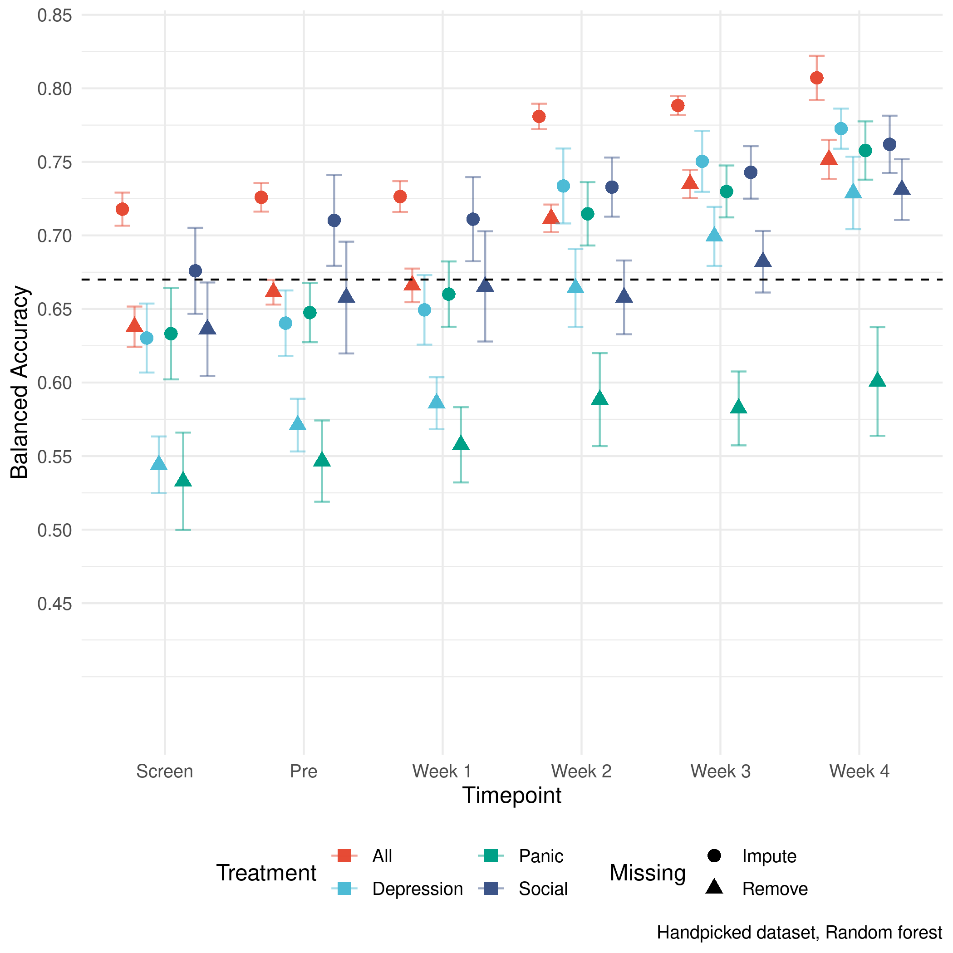
Here Random forest and the handpicked variables were used, but the variation over different methods and variables is limited.

Model 1. Benchmark model.
Predictor | b | b  95% CI  [LL, UL] | sr² | sr²  95% CI  [LL, UL] | Fit
(Intercept) | -0.14** | [-0.16, -0.12]
sex | 0.09** | [0.05, 0.12] | .00 | [.00, .00]
age | -0.01 | [-0.03, 0.01] | .00 | [-.00, .00]
PDSS.SR _SCREEN | 0.06** | [0.04, 0.07] | .00 | [.00, .01]
MADRS _SCREEN | -0.04** | [-0.06, -0.02] | .00 | [.00, .00]
LSAS_SCREEN | 0.09** | [0.07, 0.11] | .01 | [.00, .01]
mainsymptom_PRE | -0.10** | [-0.14, -0.07] | .00 | [.00, .00]
mainsymptom_WEEK01 | 0.08** | [0.05, 0.12] | .00 | [.00, .00]
mainsymptom_WEEK02 | 0.19** | [0.16, 0.23] | .01 | [.00, .01]
mainsymptom_WEEK03 | 0.52** | [0.49, 0.55] | .07 | [.06, .08]
 |  |  |  |  | R² = .539**
 |  |  |  |  | 95% CI[.52,.55]
Note. A significant b-weight indicates the beta-weight and semi-partial correlation are also significant. b represents standardized regression weights. sr2 represents the semi-partial correlation squared. LL and UL indicate the lower and upper limits of a confidence interval, respectively.* indicates p < .05. ** indicates p < .01. Produced by apaTables (Stanley, 2018) implemented in R version 3.6.0 (R Core Team, 2019). All Variables (including outcome) are standardized using z-transformation before training except “sex” where 0 = female and 1 = male. PDSS.SR = Panic Disorder Symptom Scale-Self Report. MADRS = Montgomery-Åsberg Depression Rating Scale-Self report. LSAS = Leibowitz Social Anxiety Scale-Self Report version. Mainsymptom is MADRS for those in depression treatment, PDSS-SR for those in treatment for panic disorder and LSAS-SR for those in treatment for social anxiety disorder. The model reported here have not been evaluated in external samples and because of this the accuracy in novel sample is unknown.

References
Hartigan, J. A., & Wong, M. A. (1979). Algorithm AS 136 A K-Means Clustering Algorithm. Applied Statistics, 28(1), 100. https://doi.org/10.2307/2346830
Mikolov, T., Chen, K., Corrado, G., & Dean, J. (2013). Efficient Estimation of Word Representations in Vector Space. ArXiv:1301.3781 [Cs]. http://arxiv.org/abs/1301.3781
Pedregosa, F., Varoquaux, G., Gramfort, A., Michel, V., Thirion, B., Grisel, O., Blondel, M., Prettenhofer, P., Weiss, R., Dubourg, V., Vanderplas, J., Passos, A., Cournapeau, D., Brucher, M., Perrot, M., & Duchesnay, E. (2011). Scikit-learn: Machine learning in Python. Journal of Machine Learning Research, 12, 2825–2830.
Petersen, A. H., & Ekstrøm, C. T. (2019). dataMaid: Your assistant for documenting supervised data quality screening in R. Journal of Statistical Software, 90(6), 1–38. https://doi.org/10.18637/jss.v090.i06
R Core Team. (2019). R: A Language and Environment for Statistical Computing. R Foundation for Statistical Computing. https://www.R-project.org/
Řehůřek, R., & Sojka, P. (2010). Software framework for topic modelling with large corpora. Proceedings of the LREC 2010 Workshop on New Challenges for NLP Frameworks, 45–50.
Stanley, D. (2018). apaTables: Create american psychological association (APA) style tables. https://CRAN.R-project.org/package=apaTables
Wickham, H. (2016). ggplot2: Elegant Graphics for Data Analysis. Springer-Verlag New York. http://ggplot2.org

Appendix 1

hyperparams = [
(LinearSVR(random_state=0, max_iter=1500), {
'epsilon': [0, 1],
'loss': ['epsilon_insensitive','squared_epsilon_insensitive'],
'C': [1.5, 1, 0.5, 0.2]}),
(LinearRegression(), {
'fit_intercept': [True]}),
(ElasticNet(random_state=0), {
'alpha': [3, 2, 1, 0.1],
'l1_ratio': [0.8, 0.5, 0.2]}),
(Ridge(random_state=0), {
'solver': ['auto', 'svd','saga']}),
(Lasso(random_state=0), {
'alpha': [3, 2, 1, 0.1]}),
(BayesianRidge(), {
'tol': [0.01, 0.001, 0.0001],
'alpha_1': [0.000001],
'alpha_2': [0.000001],
'lambda_1': [0.000001],
'lambda_2':[0.000001]}),
(KNeighborsRegressor(n_jobs= -1), {
'n_neighbors': [25, 15, 10, 5],
'weights': ['uniform', 'distance'],
'algorithm': ['ball_tree','kd_tree','brute','auto'],
'leaf_size': [30, 20, 10, 5]}),
(RandomForestRegressor(random_state=0, n_jobs= -1), {
'n_estimators': [300],
'min_samples_split': [100, 50, 20, 10],
'min_samples_leaf': [50, 25, 10, 5],
'max_features': ['auto', 'sqrt', 'log2']}),
(AdaBoostRegressor(random_state=0), {
'n_estimators': [300],
'learning_rate': [1],
'loss': ['linear', 'square', 'exponential'],
'base_estimator': [RandomForestRegressor(random_state=0,
n_jobs=-1,
min_samples_split=5,
min_samples_leaf=2,
max_features='auto')]}),
(GradientBoostingRegressor(random_state=0), {
'n_estimators': [300],
'learning_rate': [1],
'loss': ['ls', 'lad', 'huber'],
'subsample': [1, 0.8, 0.5],
'min_samples_split': [100, 50, 20, 10],
'min_samples_leaf': [50, 25, 10, 5],
'max_depth': [20, 10, 5, 3]})
]

