Supplementary materials

Table S1 EDX elemental microanalysis (atomic %) of NT and NTG5 samples
S.No | Photocatalyst |  | C (%) | O (%) | Ti (%) | Nb (%)
1 |  | NT | 0.00 | 46.25 | 51.19 | 2.56
2 |  | NTG5 | 28.79 | 47.23 | 22.81 | 1.17

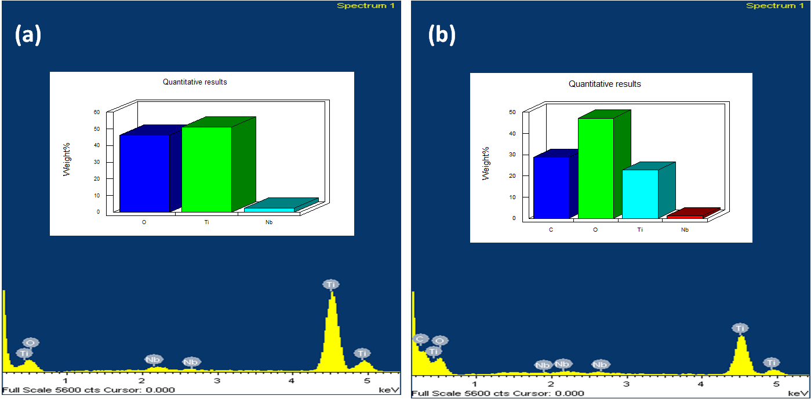
Fig. S1 (a) EDX spectra of NT and (b) NTG5

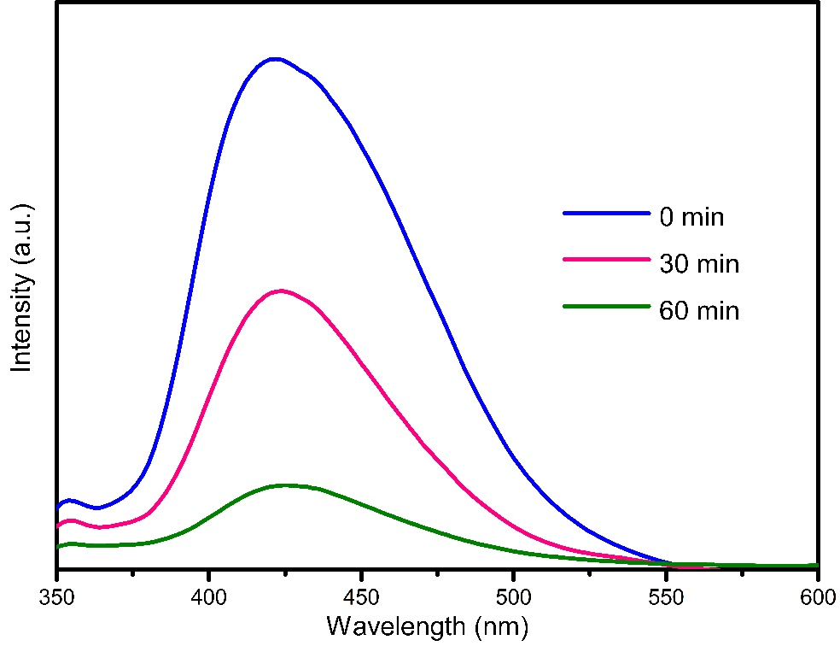
Fig. S2 •OH trapping PL spectra of NTG5

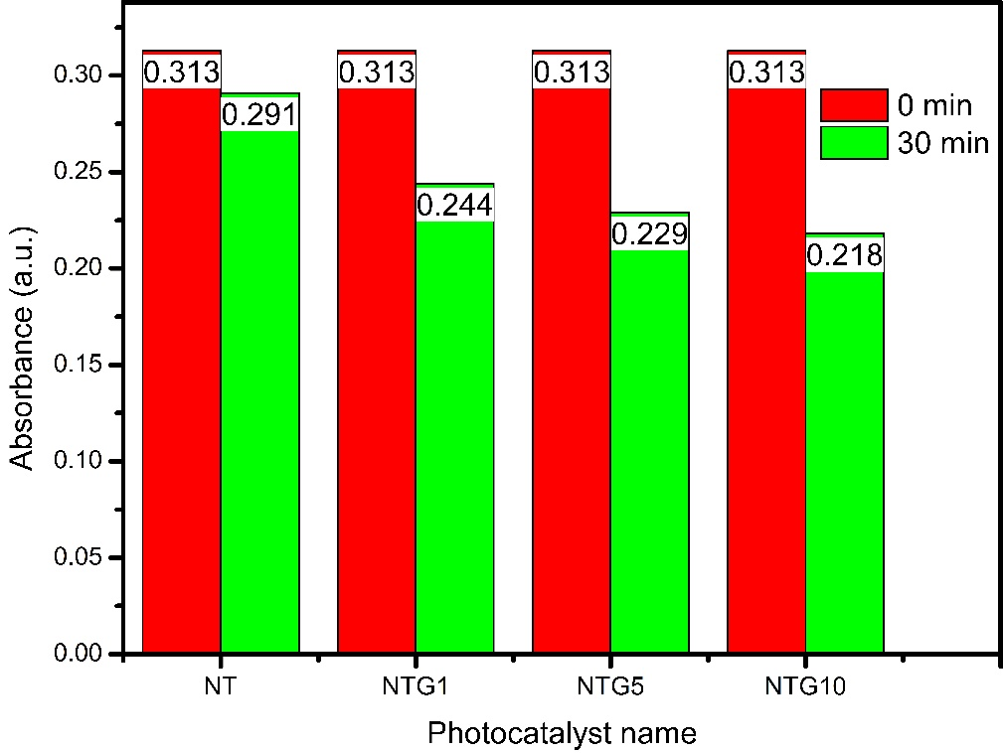
Fig. S3 Adsorbability of NT and NTG nanocomposites
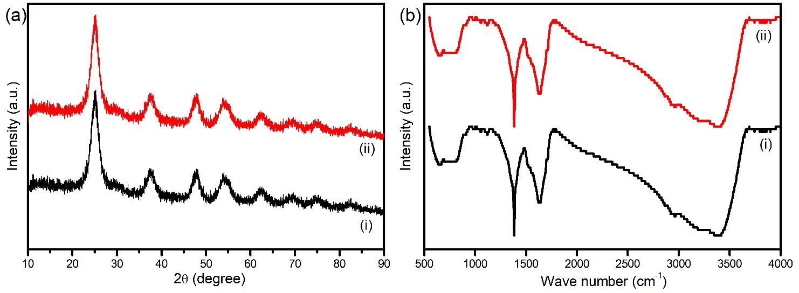
Fig. S4 (a) XRD Spectra and (b) FT-IR Spectra of (i) as-synthesized NTG5 nanocomposite (ii) NTG5 nanocomposite after five runs

