Supplementary Information
Mixed-dimensional stacked structure for a specific wavelength-selectable photodetector with ambipolar photoresponse
Young Jae Park^{a,b,†}, Jaeho Shim^{a,†}, Joo Song Leeª, Kyu Seung Leeª, Dong Su Shinª, Kang Bok Ko^{c}, Sang-Youp Yim^{d}, Seongjun Kim^{b}, Hoon-Kyu Shin^{b}, Donghee Park^{e}, Yong Ju Yun^{f}, and Dong Ick Son^{a,g,}

Table of Contents
1. The fabrication process for the PD devices based on the WSe₂/CdSeS QDs/MoS₂ stacked structures.
2. HAADF STEM image and Spectrum profile scanning EDS of the WSe₂/CdSeS QDs/MoS₂ stacked structures.
3. Schematic diagram and SEM image of the QDs monolayer on the graphene layer in the photodetector devices based on the graphene/QDs/graphene structures.
4. Photoresponse of the photodetector devices based on the graphene/red (or green) QDs monolayer/graphene structures.
5. Simulation of carrier density distribution of the WSe₂/QDs monolayer/MoS₂ structures.
6. TRPL of the QDs/graphene and graphene/QDs/graphene structures.
7. TRPL of the WSe₂/Red, Green, and Blue QDs/MoS₂ structures.
8. Photoresponse data of the graphene/WSe₂/green QDs monolayer/MoS₂/graphene photodetector devices under light irradiation.
9. Device simulation with the WSe₂/Green CdSe QDs/MoS₂ structures for recombination rates inside the active layers under various light irradiation.

Table 1. TRPL of the WSe₂/Red, Green, and Blue QDs/MoS₂ structures.
Table 2. TRPL of the various heterostructures based on WSe₂, CdSeS QDs and MoS₂ materials and the carrier transfer ratios of mixed low dimensional heterostructures to CdSeS QDs.
Table 3. Table of parameters used in optoelectronic devices simulations.

1. The fabrication process for the PD devices based on the WSe₂/CdSeS QDs/MoS₂ stacked structures.

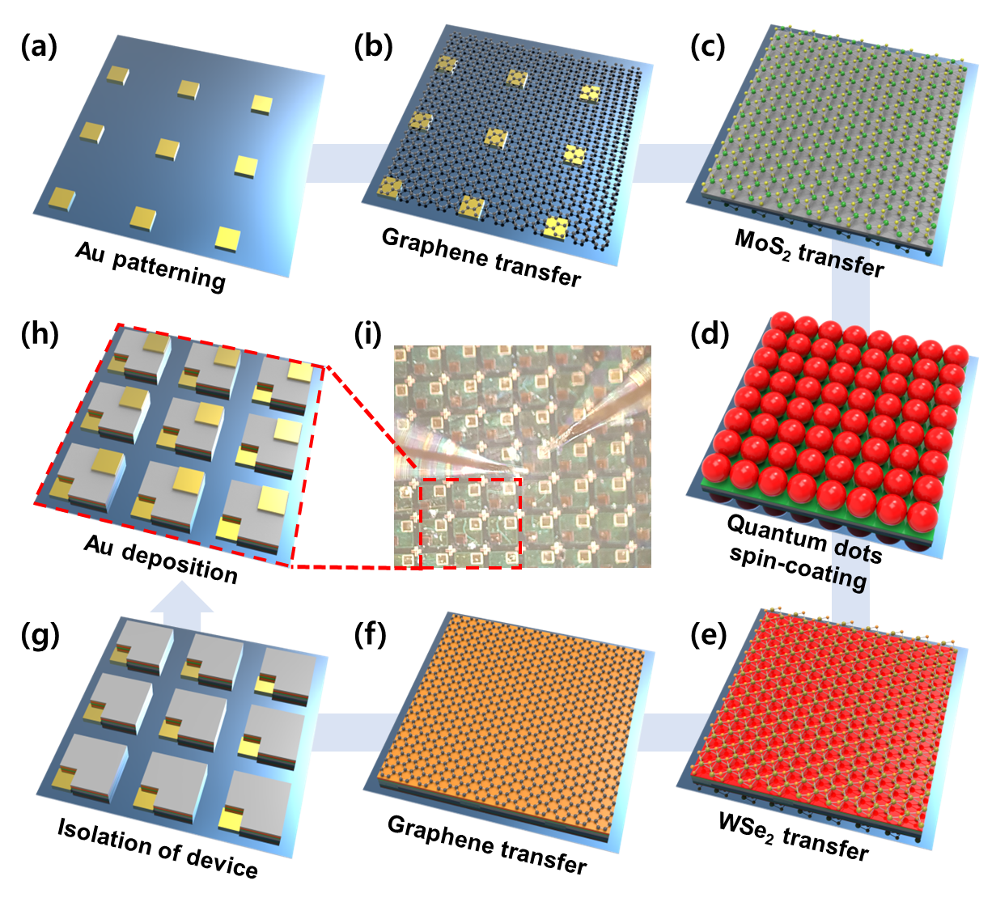
Figure S1. Schematic diagrams of the fabrication process for the PD devices. (a) Au electrode patterning using photolithography technique. (b) Graphene transfer by wet transfer methods. (c) Few-layer MoS₂ formation. (d) CdSeS QDs monolayer formation by a spin coating method. (e) Few-layer WSe₂ transfer onto the QDs monolayer. (f) Graphene formation. (g) Device isolation using RIE technique. (h) Au electrode formation. (i) Photographs of the completed PD device.

Figure S1 shows a schematic of the fabricating processes for the PD based on vertically stacked WSe₂/CdSeS QDs monolayer/MoS₂ stacked structures. C-MOS compatible manufacturing process were used to facilitate large-area integrations of low-dimensional materials. SiO₂/Si substrates were cleaned with acetone, methanol, and deionized water using an ultrasonicator. The patterned gold (Au) bottom electrodes were formed onto the SiO₂ surface using photolithography and electron-beam evaporation (Figure S1a). As a carrier transport layer, graphene was transferred on the patterned Au electrode by the following method. A poly methyl methacrylate (PMMA) layer was spin-coated on the graphene film on Cu for a supporting layer. After the formation of the supporting layer, baking processes were performed on a hot plate at 120°C for 10 min to improve graphene/PMMA contact, followed by Cu etching. The subsequent Cu etching fully removes the Cu and leaves the PMMA/graphene floating on the etchant. The PMMA/graphene film was then washed with deionized water. The PMMA/graphene was transferred onto the patterned Au/SiO₂/Si substrate. The PMMA supporting layer was removed with acetone dipping method. After removing, the graphene film remained on the patterned Au/SiO₂/Si substrate (Figure S1b). The MoS₂ layer was transferred in the same way (Figure S1c). The CdSeS QDs monolayer was formed using spin-coating method on the MoS₂/graphene/Au/SiO₂/Si substrate (Figure S1d). The WSe₂ is transferred onto the prepared QDs monolayer/MoS₂/graphene/Au/SiO₂/Si substrate in a similar way to the formation of MoS₂ (Figure S1e). Subsequently, the top graphene layer was formed onto the prepared WSe₂/QDs monolayer/MoS₂/graphene/Au/SiO₂/Si substrate as a carrier transport layer in the same manner as the bottom graphene layer (Figure S1f). Following a photolithography process with a mask, the prepared structures were etched using the reactive ion etching to produce mesas where chips can be manufactured in the same size on large area (Figure S1g). Finally, patterned Au top electrodes were formed using photolithography and electron-beam evaporation (Figure S1h). Figure S1e shows optical photographs of the final features.

2. HAADF STEM image and Spectrum profile scanning EDS of the WSe₂/CdSeS QDs/MoS₂ stacked structures.
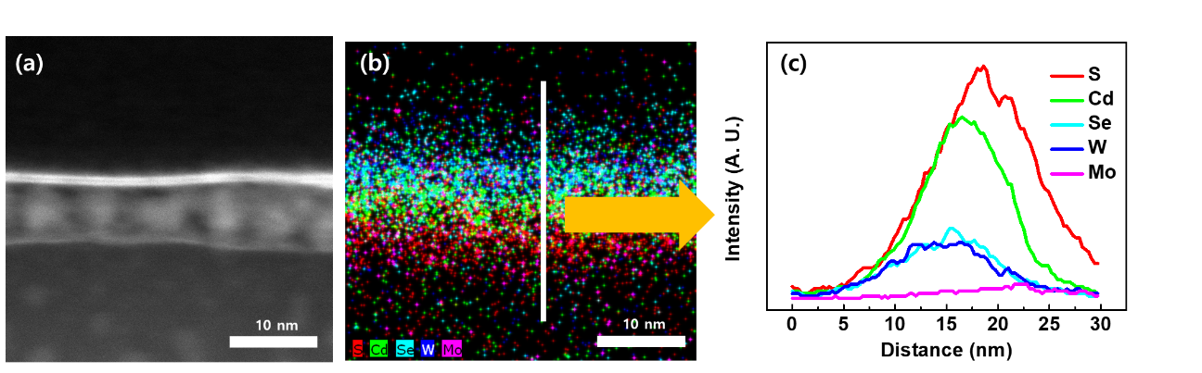
Figure S2. HAADF STEM image (a), EDS mapping (b), and spectrum profile (c) of WSe₂/CdSeS QDs/MoS₂ stacked structures.

3. Schematic diagram and SEM image of the QDs monolayer on the graphene layer in the photodetector devices based on the graphene/QDs/graphene structures.

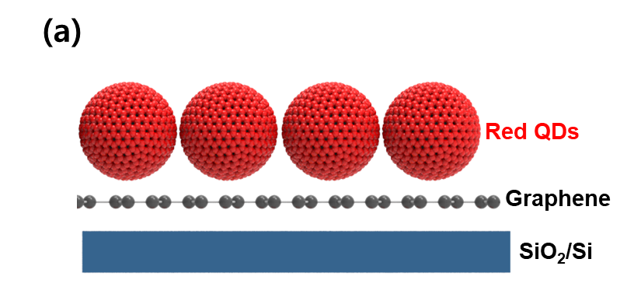
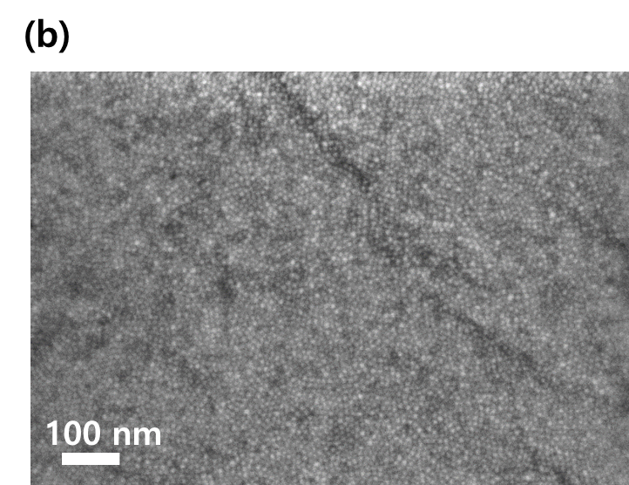

Figure S3. (a) Schematic diagrams of the CdSeS QDs monolayer/graphene structures, and (b) SEM image of CdSeS QDs monolayer on the graphene layer in the graphene/QDs monolayer/graphene structured photodetector devices.

4. Photoresponse of the photodetector devices based on the graphene/red (or green) QDs monolayer/graphene structures.
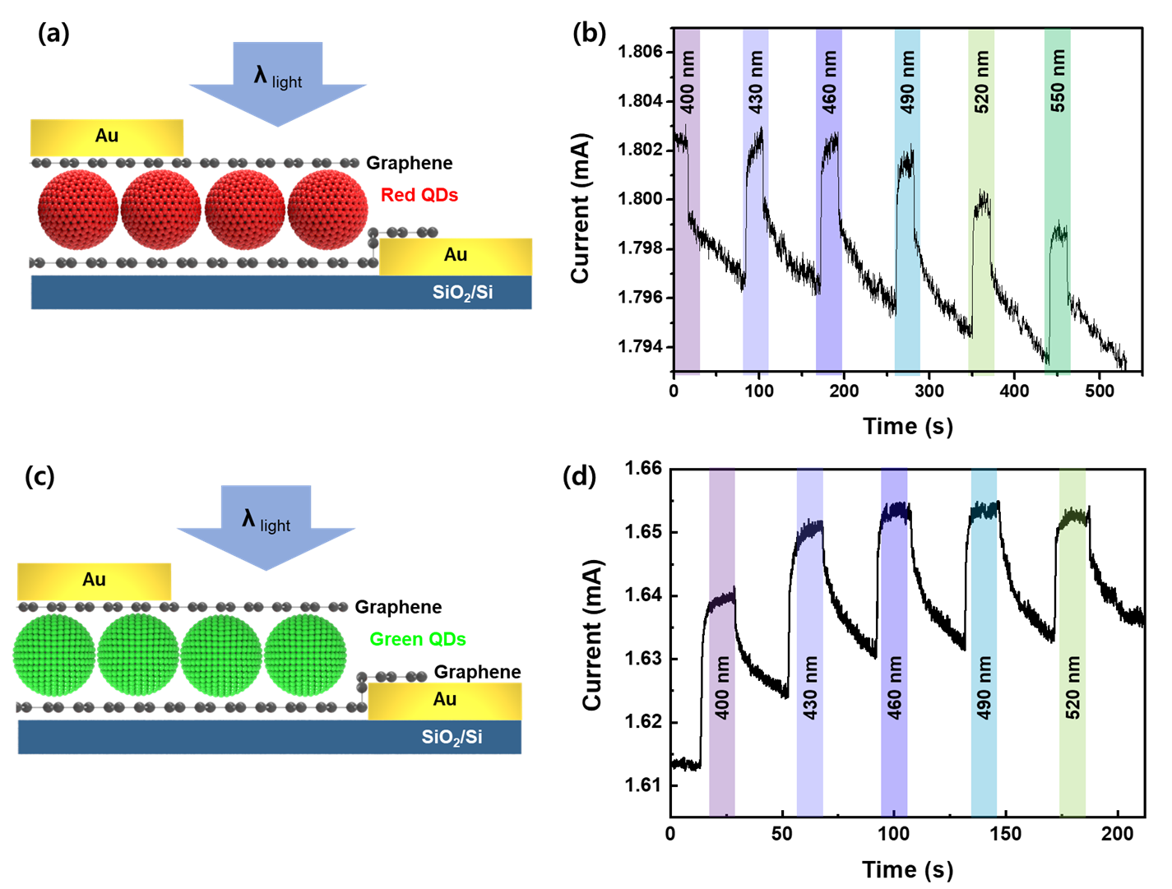

Figure S4. (a) Schematic diagram of the graphene/Red QDs monolayer/graphene structured photodetector devices under light irradiation at 400-550 nm. (b) Current–time plot of the graphene/Red QDs monolayer/graphene structured photodetector devices under light irradiation at 400 nm. (c) Schematic diagram of the graphene/Green QDs monolayer/graphene structured photodetector devices under light irradiation at 400-520 nm. (d) Current–time plot of the graphene/Green QDs monolayer/graphene structured photodetector devices under light irradiation at 400-520 nm.

5. Simulation of carrier density distribution of the WSe₂/QDs monolayer/MoS₂ structures.

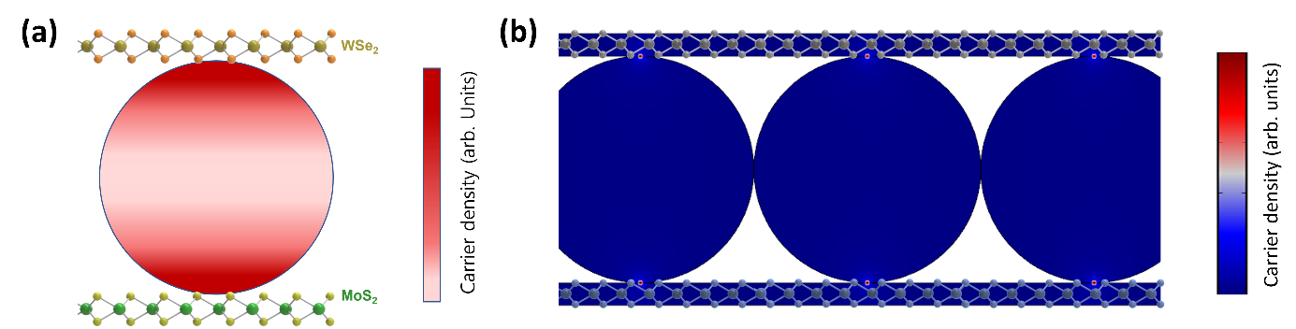

Figure S5. (a) Schematic diagram of carrier density in the WSe₂/QDs monolayer/MoS₂ structure under light irradiation. (b) Simulated carrier density distribution at 1V from 2D Finite-element method simulation.

6. TRPL of the QDs/graphene and the graphene/QDs/graphene structures.
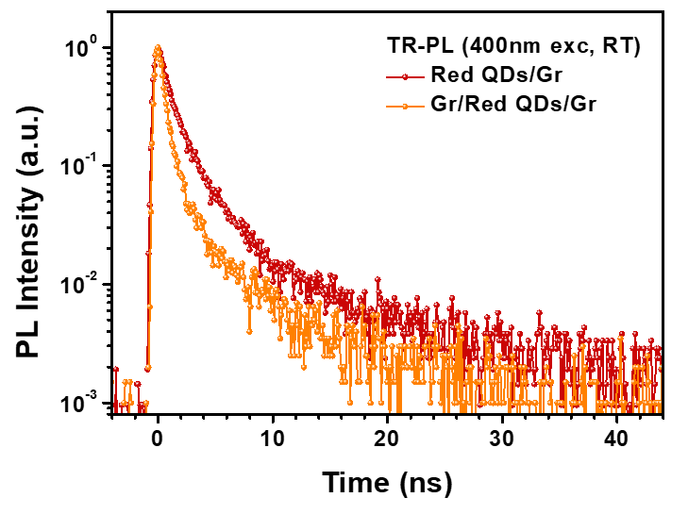

Figure S6. The photoluminescence lifetimes of graphene/Red QDs/graphene and Red QDs /graphene structures.

7. TRPL of the WSe₂/Red, Green QDs/MoS₂ structures.
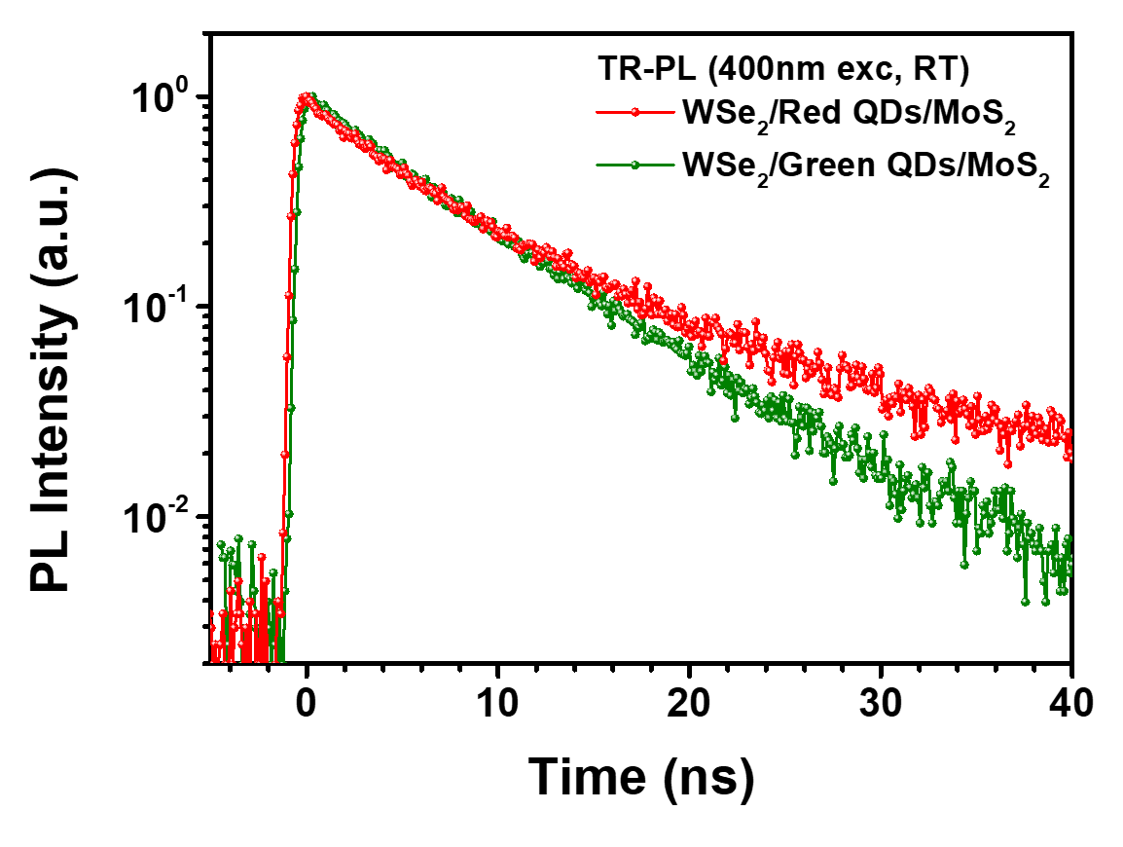
Figure S7. The photoluminescence lifetimes of WSe₂/CdSeS(CdSe) QDs /MoS₂ structures.

8. Photoresponse data of the graphene/WSe₂/Green QDs monolayer/MoS₂/graphene photodetector devices under light irradiation.

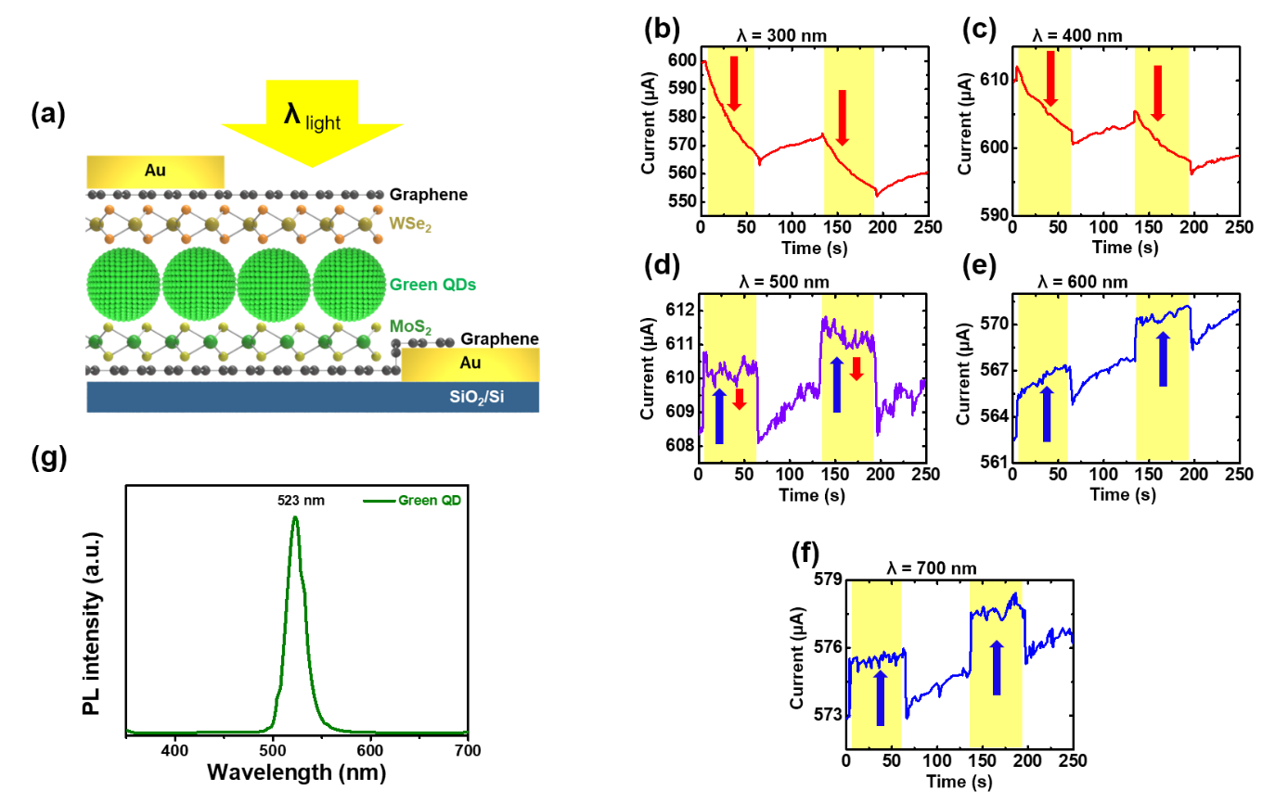
Figure S8. (a) Schematic diagram of the graphene/WSe₂/Green QDs monolayer/MoS₂/graphene photodetector devices under light irradiation. Current–time (I-t) plot of the photodetector devices under light irradiation (b) at 300 nm, (c) at 400 nm, (d) at 500 nm, (e) at 600 nm, and (f) at 700 nm. (g) Photoluminescence of Green CdSe QDs.

9. Optoelectronic devices simulations of recombination rates inside the active layers by different light irradiation for Green CdSe QDs.
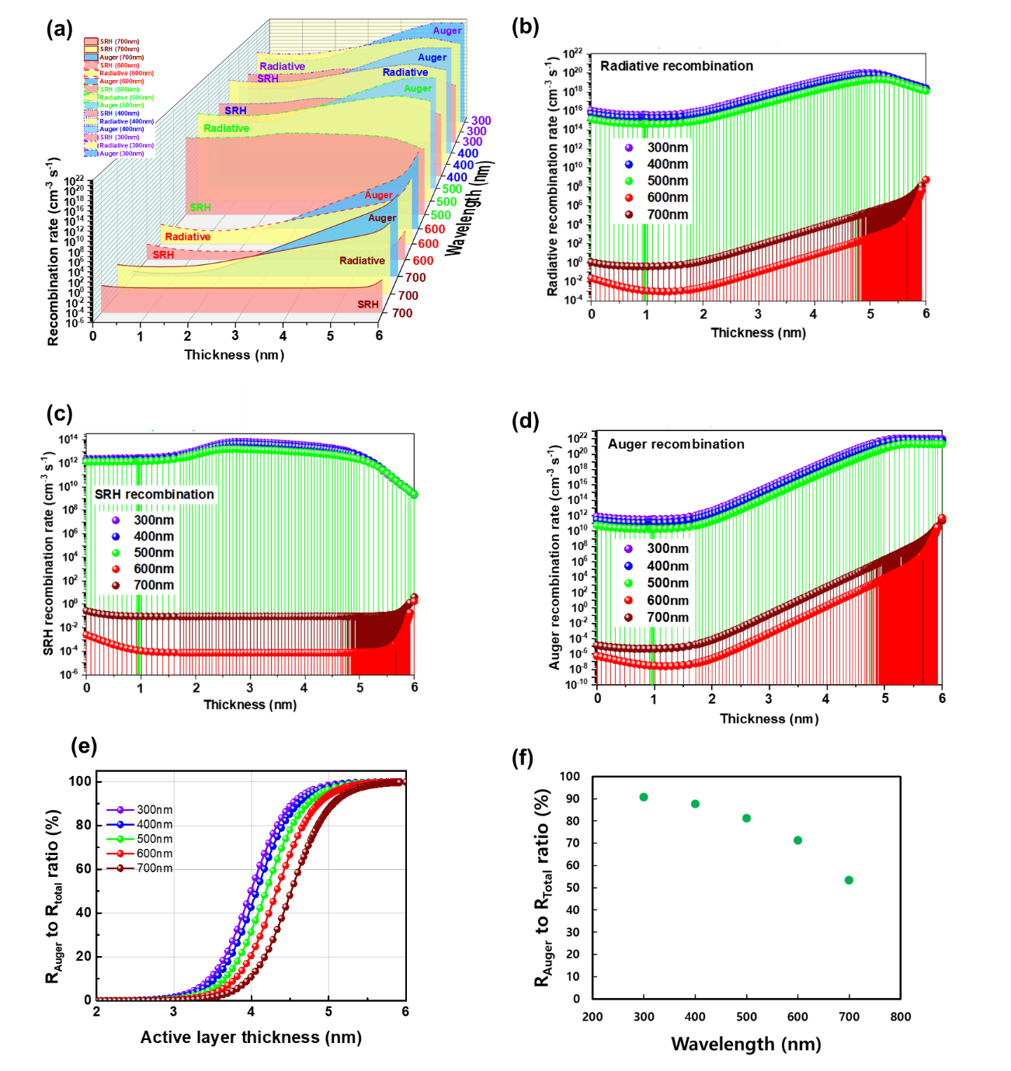
Figure S9. (a) Simulation results for three types (SRH, radiative, and Auger recombination rates) under light wavelengths at 300, 400, 500, 600 and 700 nm. (b) Simulation results of Radiative recombination rates at different wavelengths. (c) Simulation results of SRH recombination rates at different wavelengths. (d) Simulation results of Auger recombination rates at different wavelengths. (e) Auger recombination to total recombination ratio under irradiation with different wavelengths as a function of active layer thickness. (f) Auger recombination to total recombination ratio when the active layer thickness is 4.5 nm.
1. Table of TRPL of the WSe₂/Red and Green QDs/MoS₂ structures.
 | τ₁ (ns) | τ₂ (ns) | A₁ | A₂ | τ_{avg} (ns)
WSe₂/Red QDs/MoS₂ | 3.72 | 13.64 | 0.81 | 0.19 | 10.69
WSe₂/Green QDs/MoS₂ | 4.99 | 8.83 | 0.54 | 0.46 | 7.30

Table S1. PL lifetimes of the WSe₂/Red and Green QDs/MoS₂ structures.

2. Table of TRPL of the various heterostructures based on WSe2, CdSeS QDs and MoS2 materials and the carrier transfer ratios of mixed low dimensional heterostructures to CdSeS QDs.
 | τ₁ (ns) | τ₂ (ns) | A₁ | A₂ | τ_{avg} (ns) | η_{t}
CdSeS QDs | 3.72 | 13.64 | 0.71 | 0.29 | 9.70 | 1
CdSeS QDs/MoS₂ | 1.51 | 6.60 | 0.77 | 0.23 | 4.41 | 0.46
CdSeS QDs/WSe₂ | 0.61 | 8.04 | 0.89 | 0.11 | 5.28 | 0.54
WSe₂/CdSeS QDs/MoS₂ | 3.72 | 13.64 | 0.81 | 0.19 | 10.69 | 1.1
WSe₂/MoS₂ | 0.37 | 1.78 | 0.97 | 0.03 | 0.57 | 0.06
CdSeS QDs/Gr | 1.22 | 5.53 | 0.93 | 0.07 | 2.35 | 0.24
Gr/ CdSeS QDs/Gr | 0.68 | 4.10 | 0.97 | 0.03 | 1.30 | 0.13

Table S2. PL lifetimes of various heterostructures based on WSe₂, CdSeS QDs and MoS₂ materials and the carrier transfer ratios of mixed low dimensional heterostructures to CdSeS QDs.

3. Table of parameters used in optoelectronic devices simulations.
Table S3. All parameters used in optoelectronic simulations.

 | MoS₂ | CdSeS | WSe₂
Eg (eV) | 1.7 [ref 3] | 2.0 [this paper] | ∼1.65 [ref 6]
χ_{e} (eV)  Electron affinity | 4.2 [ref 3] | 4.0 [ref 1] | 3.7 [ref 6]
CB effective density of states, N_{C} (cm⁻³) | 2.2 ×10¹⁸ [ref 3] | 2.2 ×10¹⁸ [ref 2] | 2.2 × 10¹⁸ [ref 4]
VB effective density of states, N_{V} (cm⁻³) | 1.8 ×10¹⁹[ref 3] | 9.1 ×10¹⁸ [ref 2] | 1.8 × 10¹⁹ [ref 4]
Electron mobility  μ_{n} (cm²/V.s) | 100 [ref 3] | 2×10⁻³  [ref 1] | 17.9 [ref 7]
Hole mobility  μ_{p} (cm²/V.s) | 25 [ref 3] | 2×10⁻⁵  [ref 1] | 150 [ref 7]
Relative permittivity | 13.6 [ref 3] | 20 [ref 1] | 8.5 - 17.3 [ref 5]
Electron thermal velocity (сm/s) | 1.0×10⁷ [ref 3] | 7×10¹  [ref 1] | 1.0×10⁷
Hole thermal velocity (сm/s) | 1.0×10⁷ [ref 3] | 7×10⁰  [ref 1] | 1.0×10⁷
Shallow uniform donor density,  N_{D}, сm⁻³ | 0 [ref 3] | 1.1×10¹⁸ [ref 2] | 0 [ref 4]
Shallow uniform acceptor density, N_{A}, сm⁻³ | 1×10¹⁶ [ref 3] | - | 1.0×10¹⁷ [ref 4]
Radiative recombination coefficient  (cm³/s) | - | 5×10⁻¹¹ [ref 1] | -
Auger recombination coefficient  (cm⁶/s) | - | 5×10⁻²⁶ [ref 1] | -
Thickness (nm) | 5 [this paper] | 8 [this paper] | 5 [this paper]

References
1. Li, X., Zhao, Y., Fan, F., Levina, L., Liu, M., Quintero-Bermudez, R., Gong, X., Quan, L. N., Fan, J. Z., Yang, Z., Hoogland, S., Voznyy, O., Lu, Z., and Sargent, E. H., Bright colloidal quantum dot light-emitting diodes enabled by efficient chlorination. Nature Photonics 12, 159–165 (2018).
2. Djinkwi Wanda, M., Ouédraogo, S., Tchoffo, F., Zougmoré, F., and Ndjaka, J. M. B., Numerical Investigations and Analysis of Cu2ZnSnS4 Based Solar Cells by SCAPS-1D. International Journal of Photoenergy 2016, 9 page (2016).
3. Jhuma, F. A., Rashid, M. J., Simulation study to find suitable dopants of CdS buffer layer for CZTS solar cell. Journal of Theoretical and Applied Physics 14, 75–84 (2020).
4. Khatun, Most. M., Sunny, A., Ahmed, S. R. A., Numerical investigation on performance improvement of WS2 thin-film solar cell with copper iodide as hole transport layer. Solar Energy 224, 956–965 (2021)
5. Optical constants of WSe2 (Tungsten diselenide), Refractive Index.INFO, Refractive index database, https://refractiveindex.info/
6. Xiao, J., Zhang, Y., Chen, H., Xu, N., Deng, S., Enhanced Performance of a Monolayer MoS2/WSe2 Heterojunction as a Photoelectrochemical Cathode. Nano-Micro Lett. 10, 60 (2018)
7. Stoeckel, M.-A., Gobbi, M., Leydecker, T., Wang, Y., Eredia, M., Bonacchi, S., Verucchi, R., Timpel, M., Nardi, M. V., Orgiu, E., and Samorì, P., Boosting and Balancing Electron and Hole Mobility in Single- and Bilayer WSe2 Devices via Tailored Molecular Functionalization. ACS Nano 13, 11613−11622 (2019)

Corresponding author e-mail: eastwing33@kist.re.kr; Fax: +82 63 2198129; Tel: +82 63 2198155 †These authors contributed equally to this work.

