Image Database Preview

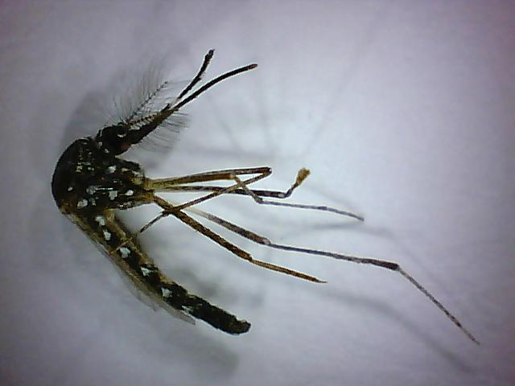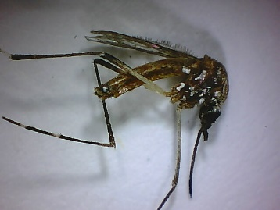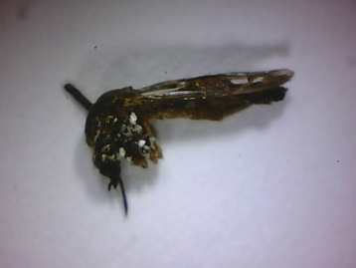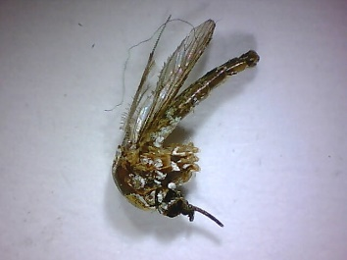
Aedes aegypti: JHU-000538_01m.jpg, JHU-005773_03m.jpg, JHU-005882_02m.jpg, JHU-05983_03m.jpg
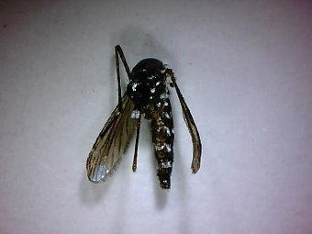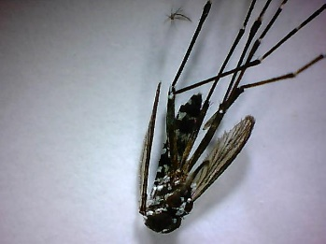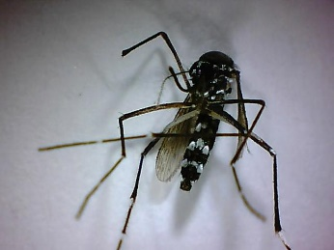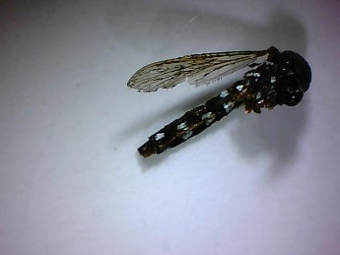
Aedes albopictus: JHU-001320_04m.jpg, JHU-001413_06m.jpg, JHU-001449_01m.jpg, JHU-000373_04m.jpg
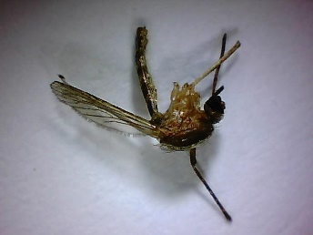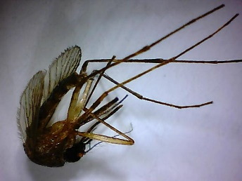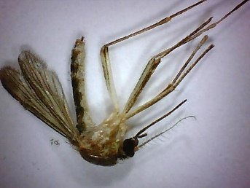
Aedes atlanticus: JHU-00210_01m.jpg, JHU-00519_05m.jpg, JHU-002464_04m.jpg.
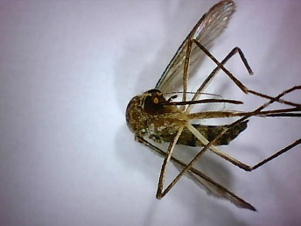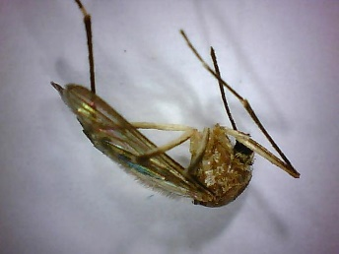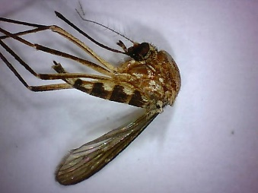
Aedes canadensis: JHU-005270_04m.jpg, JHU-005272_05m.jpg, JHU-005353_05m.jpg
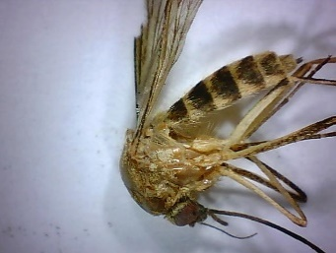
Aedes cantator: JHU-005331_04m.jpg
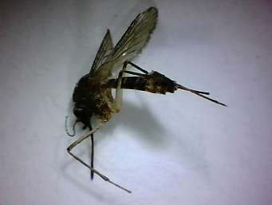
Aedes condolescens: JHU-000460_02m.jpg
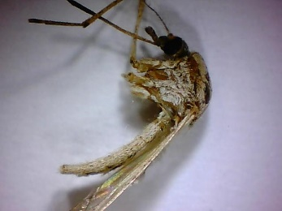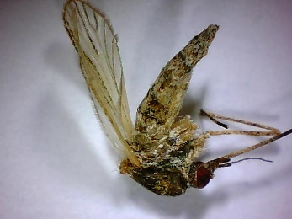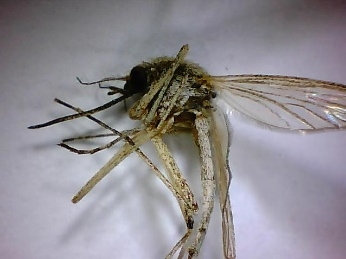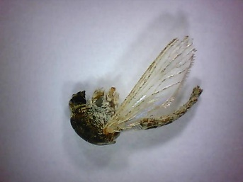
Aedes dorsalis: JHU-001989_04m.jpg, JHU-002093_01m.jpg, JHU-002094_06m.jpg, JHU-005277_01m.jpg
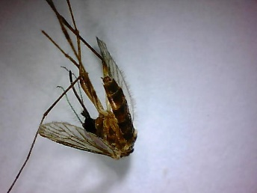
Aedes fairfax-1: JHU-001390_06m.jpg
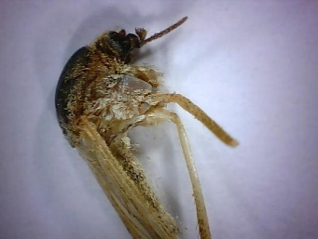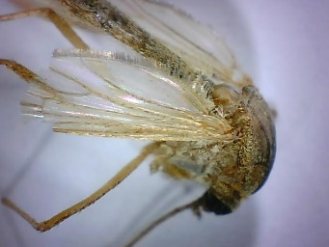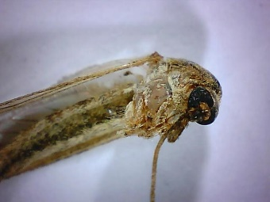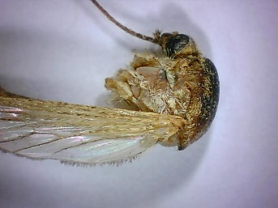
Aedes flavescens: JHU-005313_03m.jpg, JHU-005316_03m.jpg, JHU-005334_02m.jpg, JHU-005335_02m.jpg
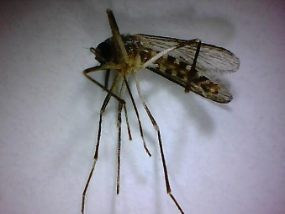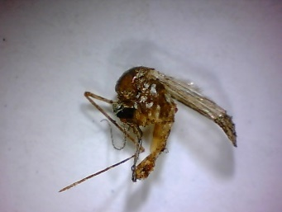
Aedes hendersoni: JHU-001020_02m.jpg, JHU-001176_03m.jpg
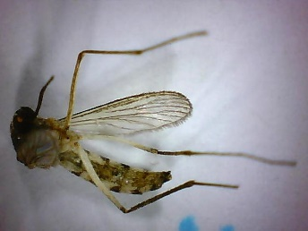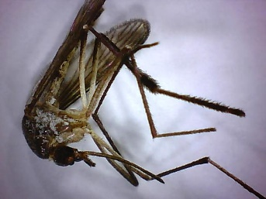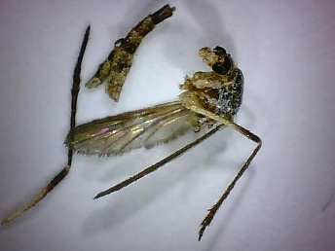
Aedes infirmatus: JHU-002479_01m.jpg, JHU-002489_05m.jpg, JHU-002497_01m.jpg
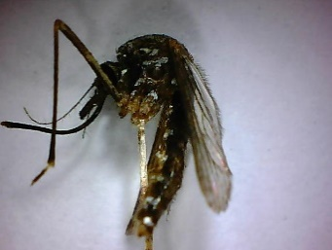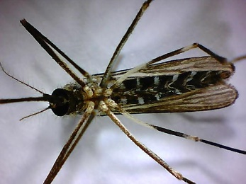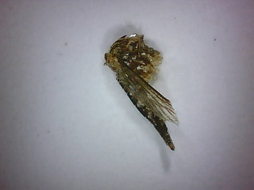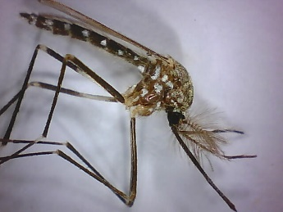
Aedes japonicus: JHU-001307_03m.jpg, JHU-001461_03m.jpg, JHU-007294_03m.jpg, JHU-007395_04m.jpg
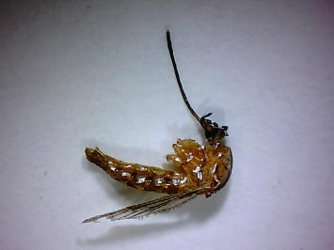
Aedes mediovittatus: JHU-000433_02m.jpg
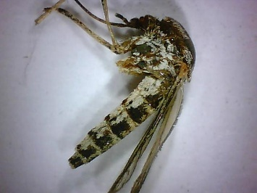
Aedes melanomin: JHU-002407_04m.jpg
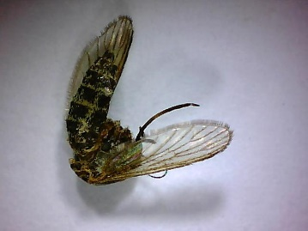
Aedes nigroculis: JHU-002069_01m.jpg
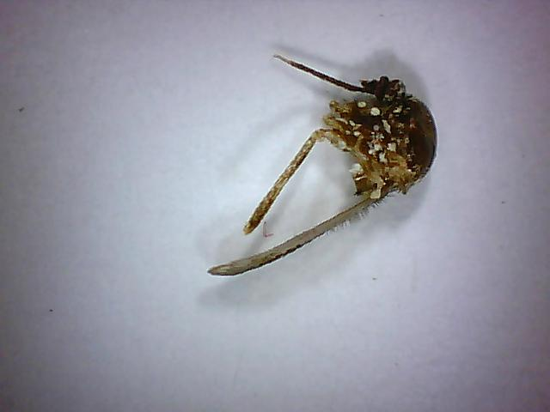
Aedes sierrensis: JHU-005342_08m.jpg
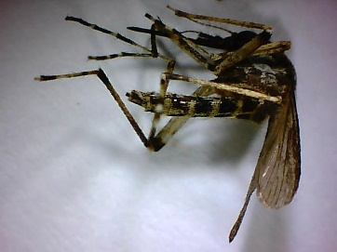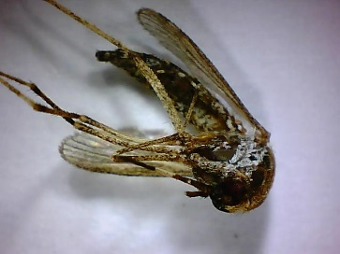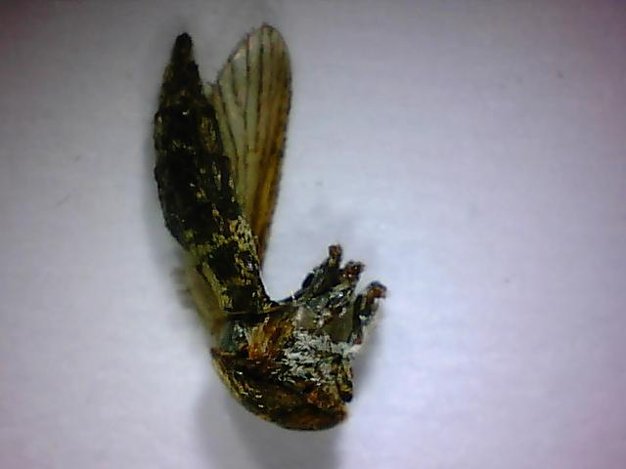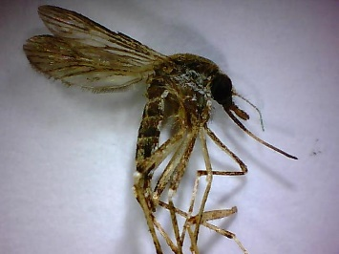
Aedes sollicitans: JHU-000193_01m.jpg, JHU-002011_02m.jpg, JHU-002037_02m.jpg, JHU-002054_01m.jpg
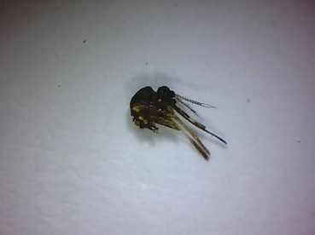
Aedes spilotus: JHU-05846_01m.jpg
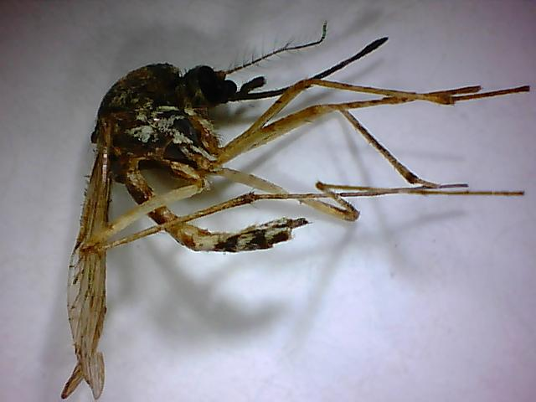
Aedes sticticus: JHU-001117_02m.jpg
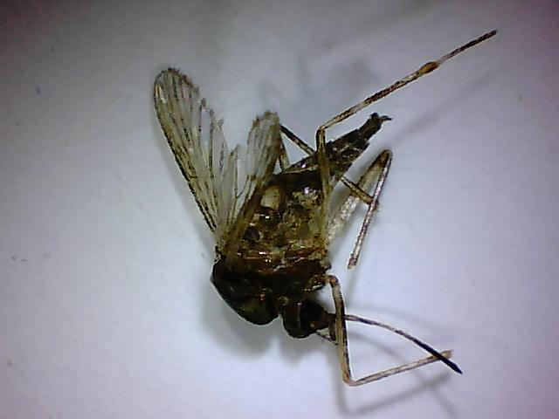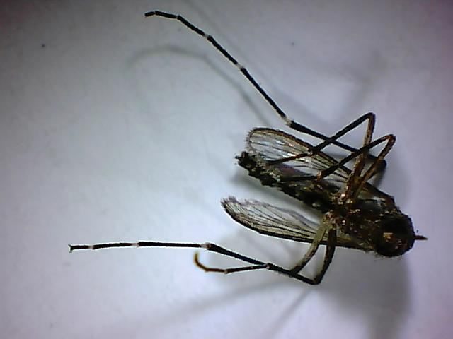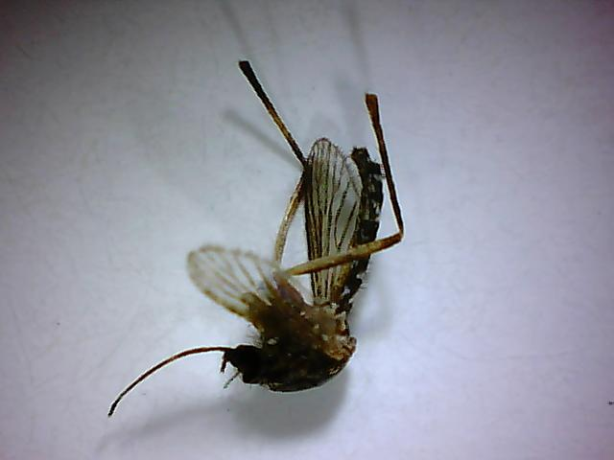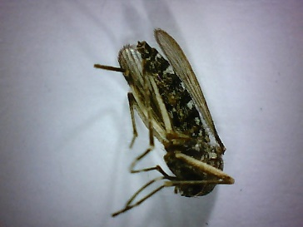
Aedes taeniorhynchus: JHU-000342_05m.jpg, JHU-000439_04m.jpg, JHU-000446_01m.jpg, JHU-000655_01m.jpg
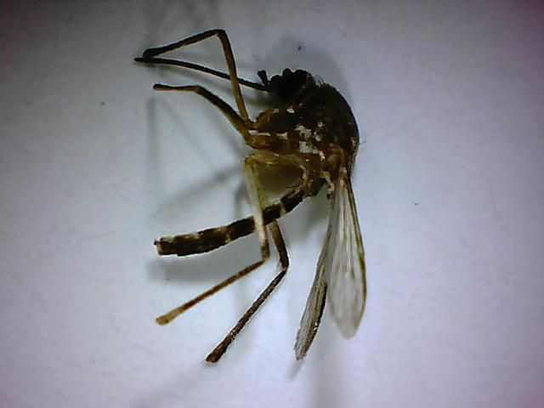
Aedes tortilis: JHU-000459_03.jpg
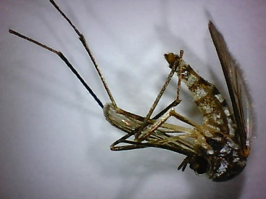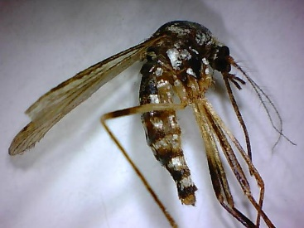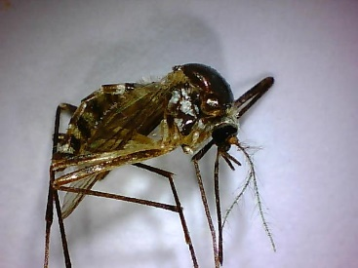
Aedes triseriatus sl: JHU-000643_04m.jpg, JHU-001085_05m.jpg, JHU-001289_06m.jpg
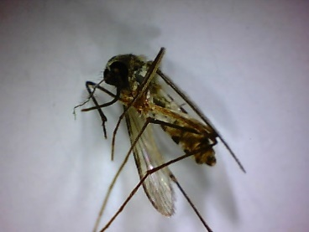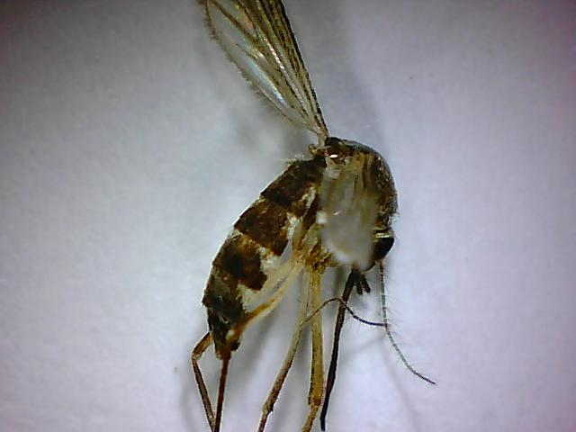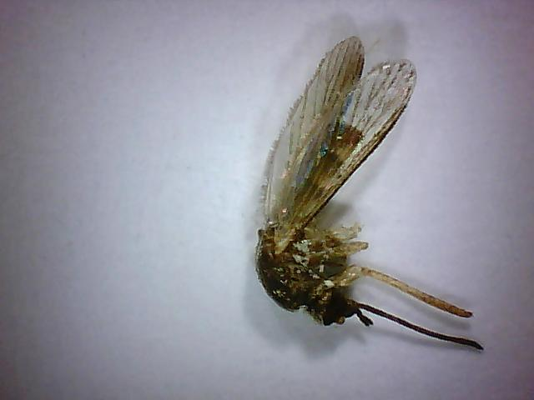
Aedes trivittatus: JHU-001250_04m.jpg, JHU-001471_04m.jpg, JHU-005293_05m.jpg
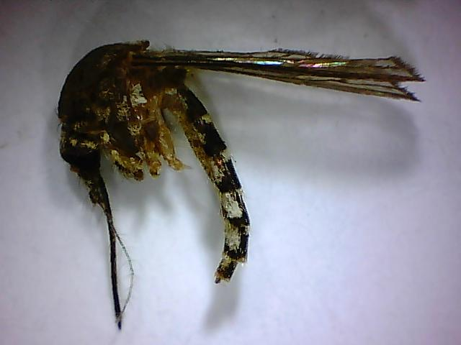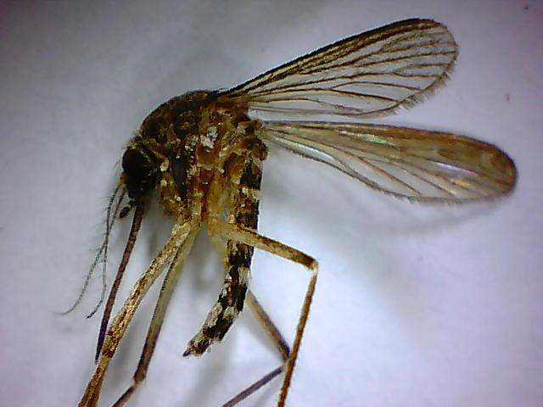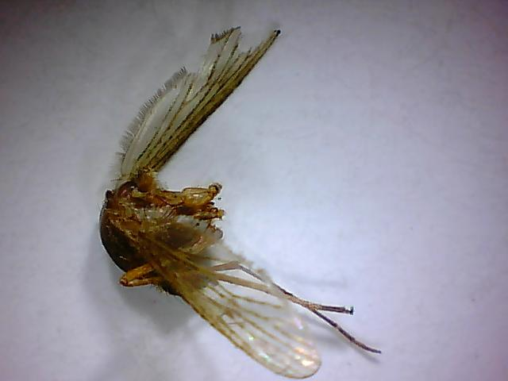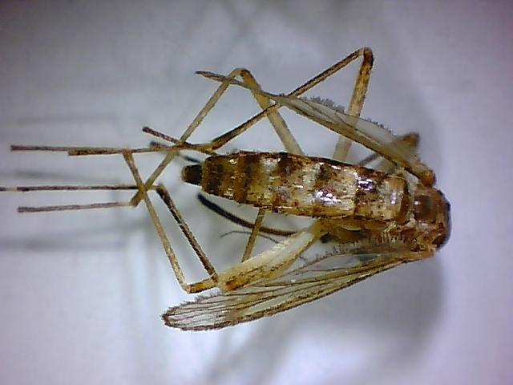
Aedes vexans: JHU-000379_05m.jpg, JHU-001016_02m.jpg, JHU-001092_02m.jpg, JHU-001254_01m.jpg
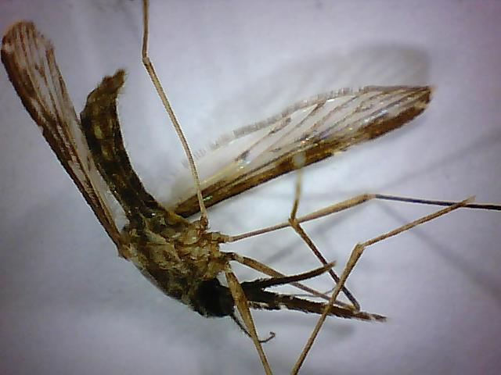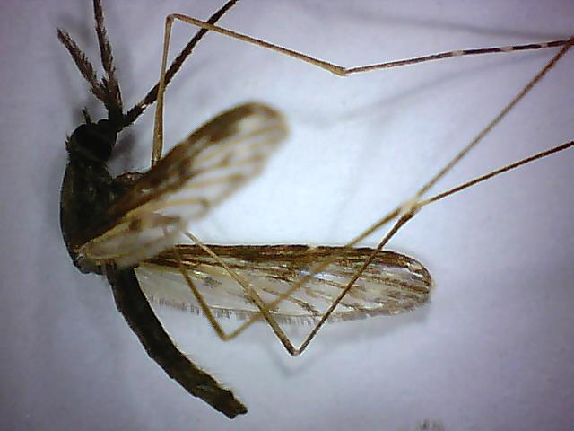
Anopheles cf-coustani: JHU-004414_09m.jpg, JHU-004416_03m.jpg
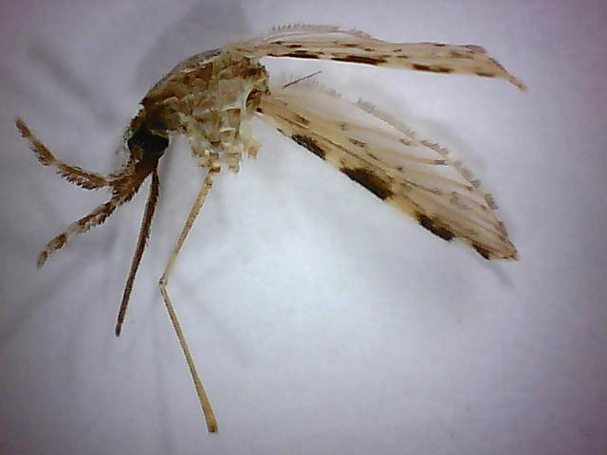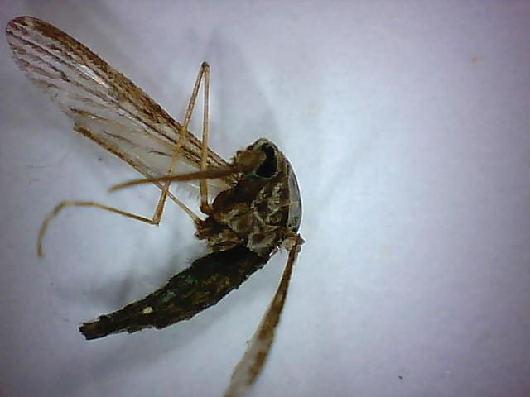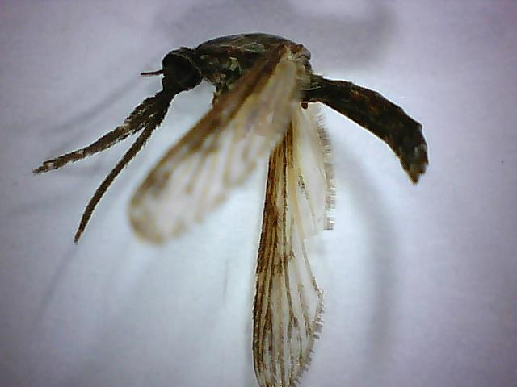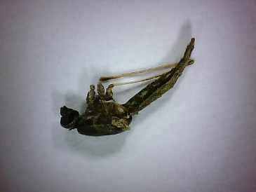
Anopheles coustani: JHU-004408_02m.jpg, JHU-004410_04m.jpg, JHU-004420_08m.jpg, JHU-005609_03m.jpg
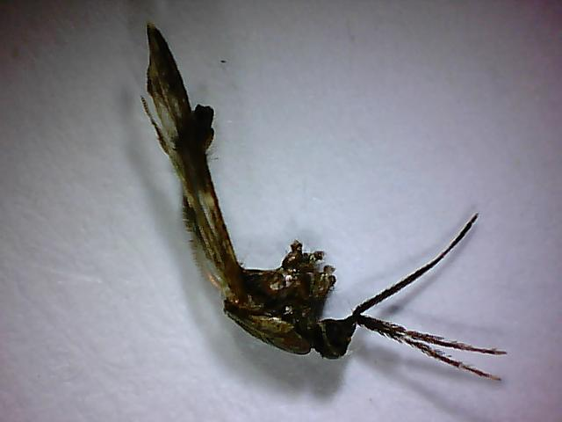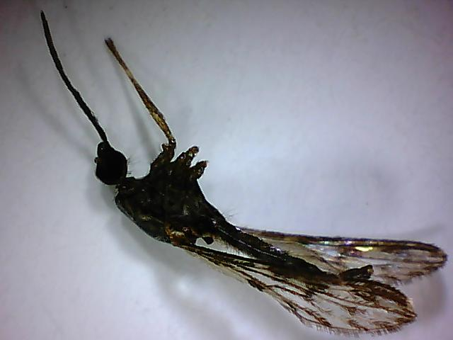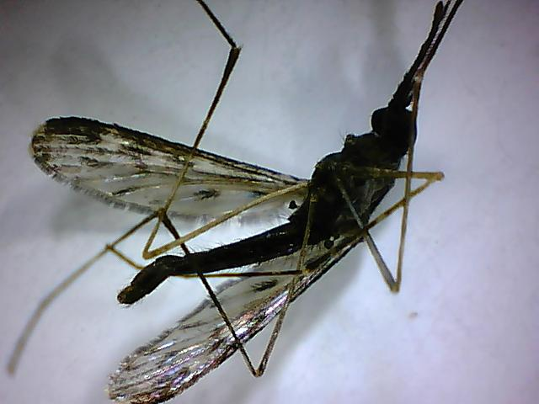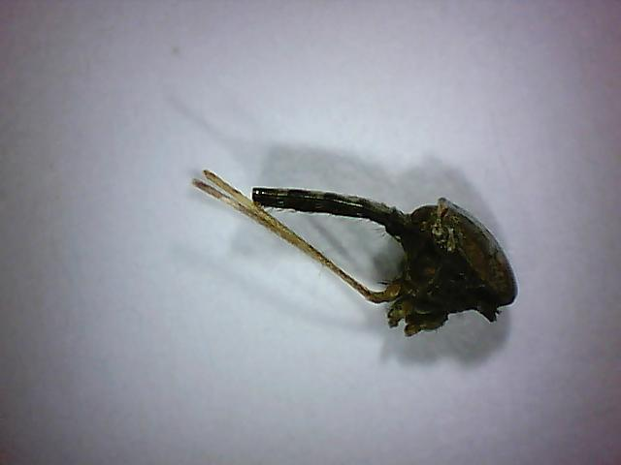
Anopheles crucians sl: JHU-000224_04m.jpg, JHU-000508_05m.jpg, JHU-000514_02m.jpg, JHU-002219_05m.jpg
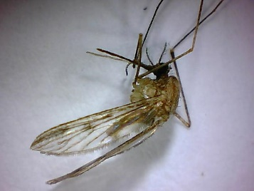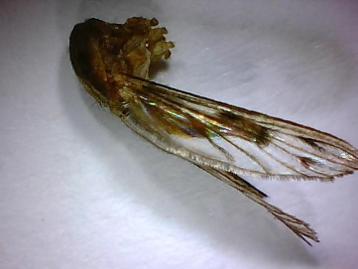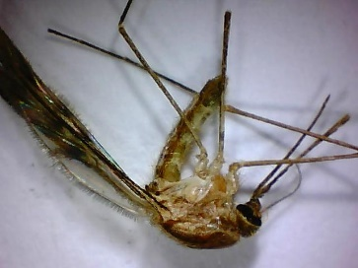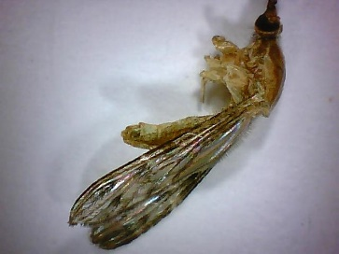
Anopheles freeborni: JHU-002287_01m.jpg, JHU-002291_03m.jpg, JHU-002298_05m.jpg, JHU-002357_04m.jpg
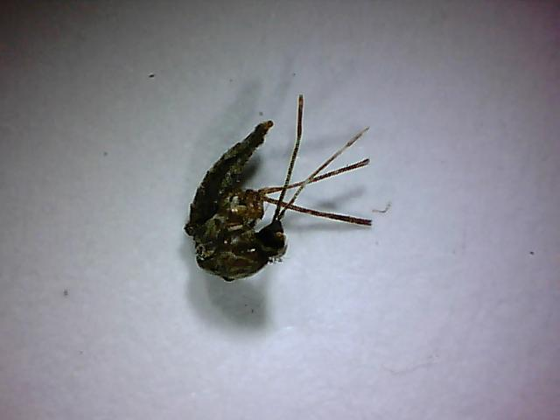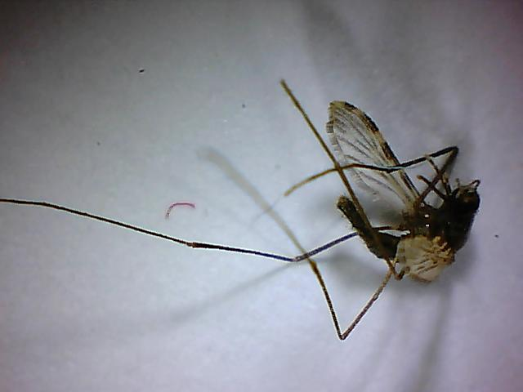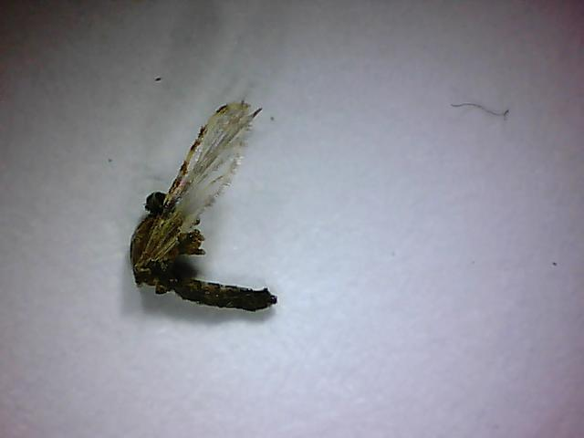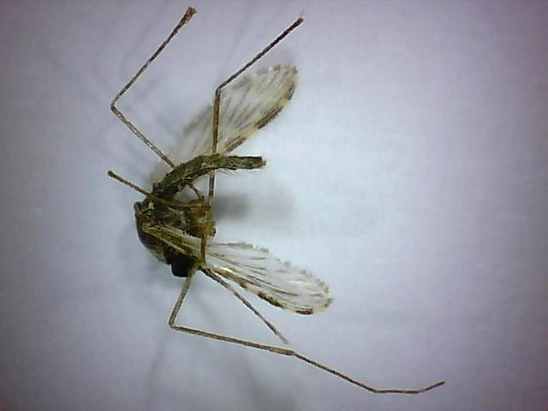
Anopheles funestus sl: JHU-004152_01m.jpg, JHU-004191_03m.jpg, JHU-004232_02m.jpg, JHU-004498_02m.jpg
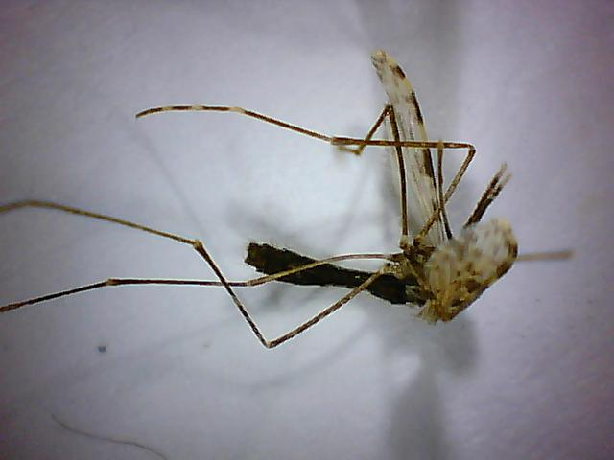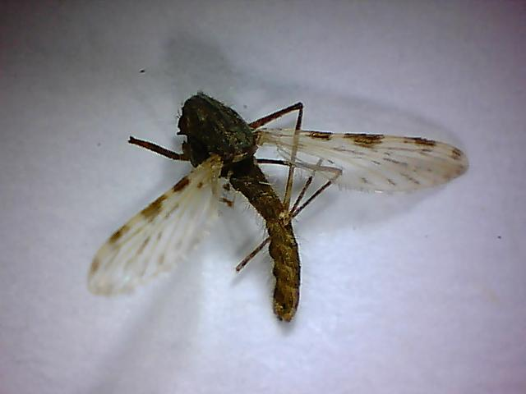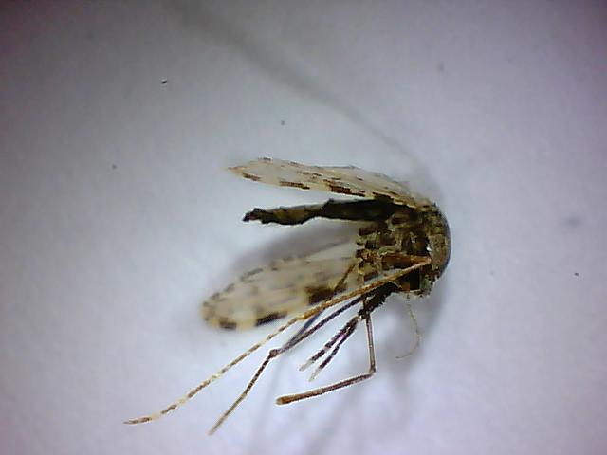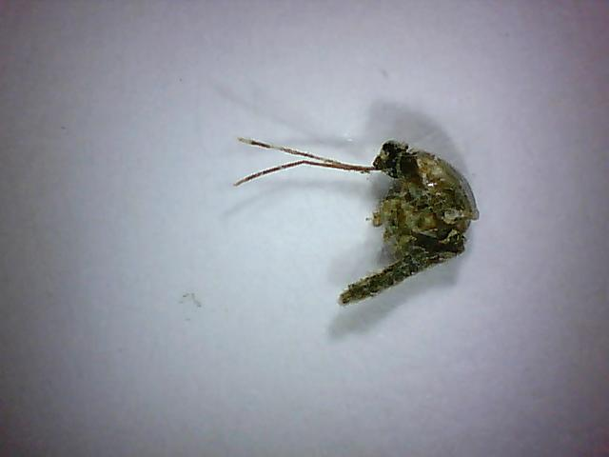
Anopheles gambiae sl: JHU-004337_01m.jpg, JHU-004631_01m.jpg, JHU-004606_09m.jpg, JHU-004342_02m.jpg
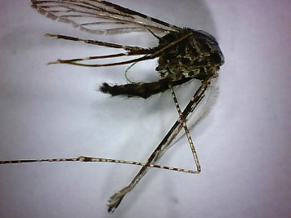
Anopheles maculipalpis: JHU-005667_01m.jpg
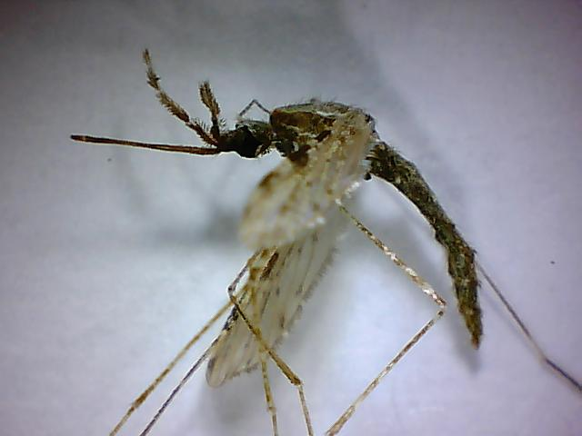
Anopheles pharoensis: JHU-004669_06m.jpg
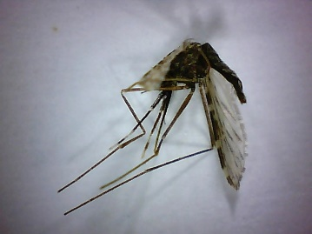
Anopheles pretoriensis: JHU-005614_04m.jpg
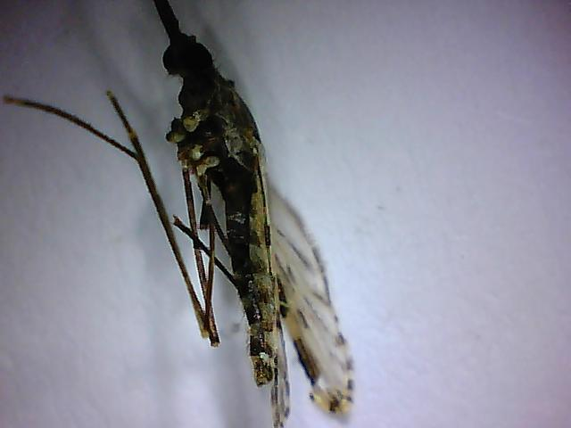
Anopheles pseudopunctipennis: JHU-002281_03m.jpg
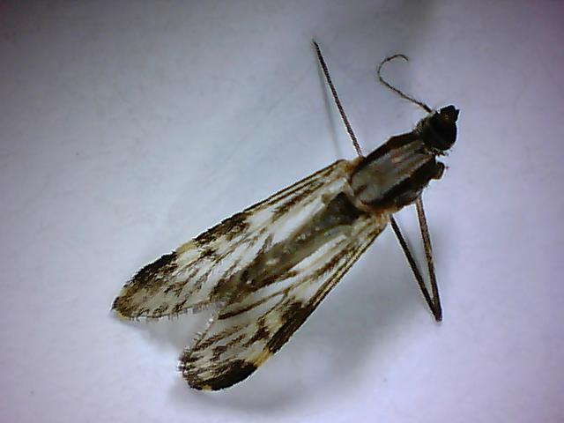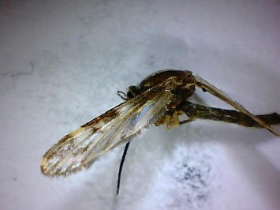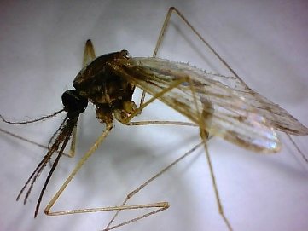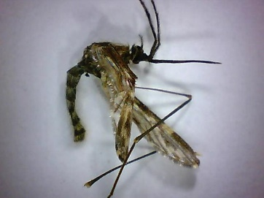
Anopheles punctipennis: JHU-000274_02m.jpg, JHU-001026_03m.jpg, JHU-001218_03m.jpg, JHU-005347_01m.jpg
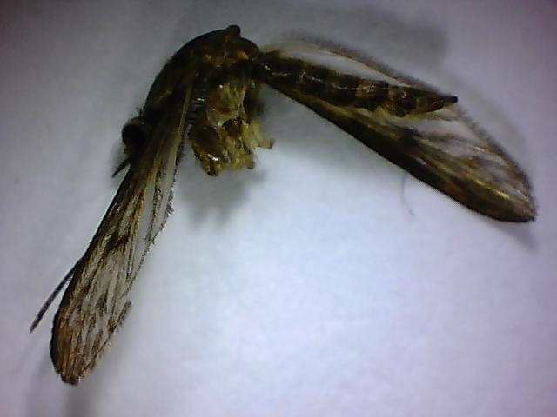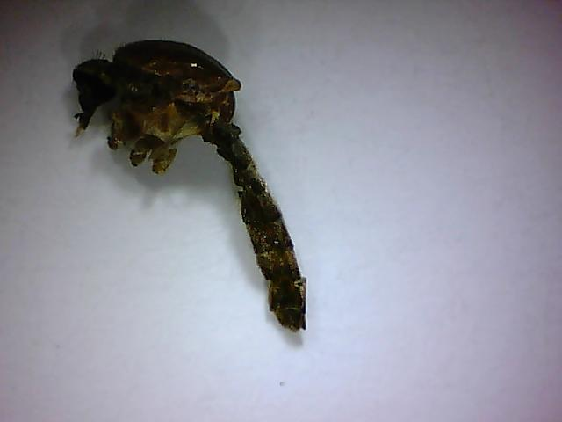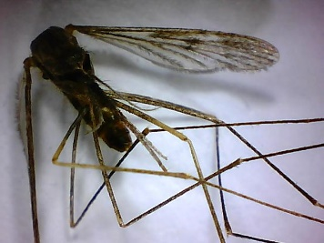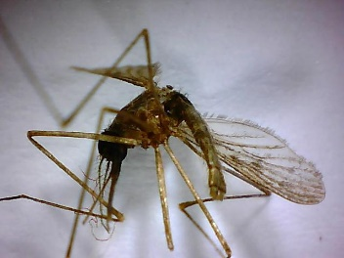
Anopheles quadrimaculatus: JHU-000218_02m.jpg, JHU-000375_04m.jpg, JHU-001464_02m.jpg, JHU-001523_01m.jpg
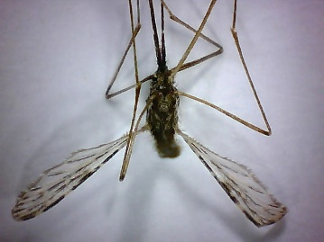
Anopheles rufipes: JHU-005593_02m.jpg
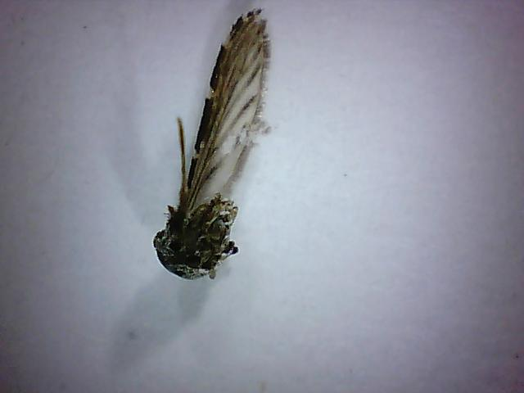
Anopheles squamosus: JHU-004418_02m.jpg,
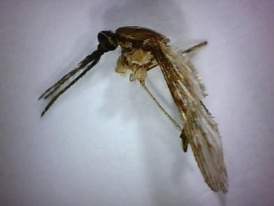
Anopheles tenebrosus: JHU-005583_02m.jpg
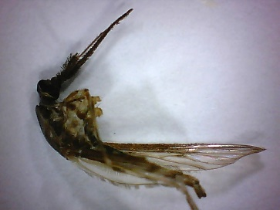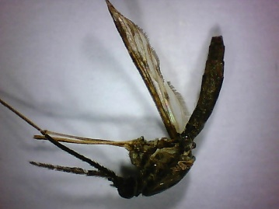
Anopheles ziemanni: JHU-005567_04m.jpg, JHU-005575_03m.jpg
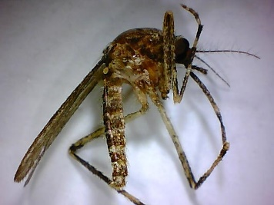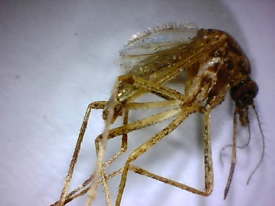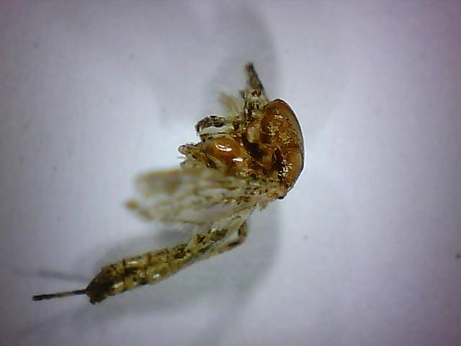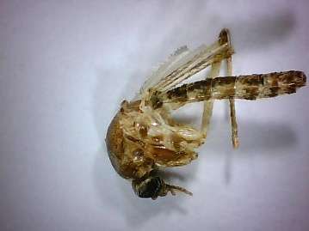
Coquillettidia perturbans: JHU-001195_01m.jpg, JHU-001547_06m.jpg, JHU-002203_03m.jpg, JHU-005299_04m.jpg
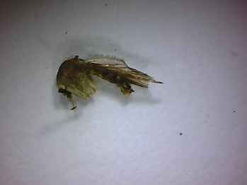
Culex antillummagnorum: JHU-005772_02m.jpg
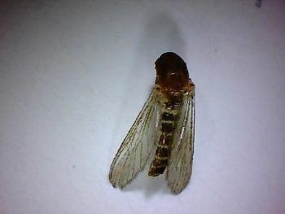
Culex bahamensis: JHU-000360_04m.jpg
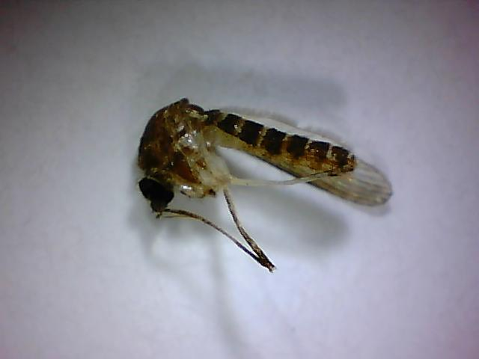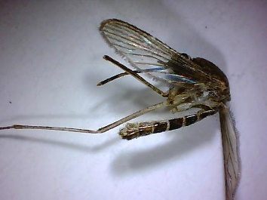
Culex coronator: JHU-000260_02m.jpg, JHU-000501_02m.jpg
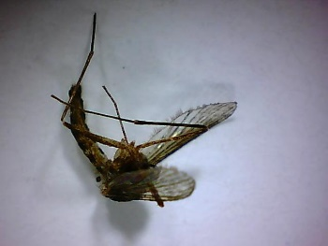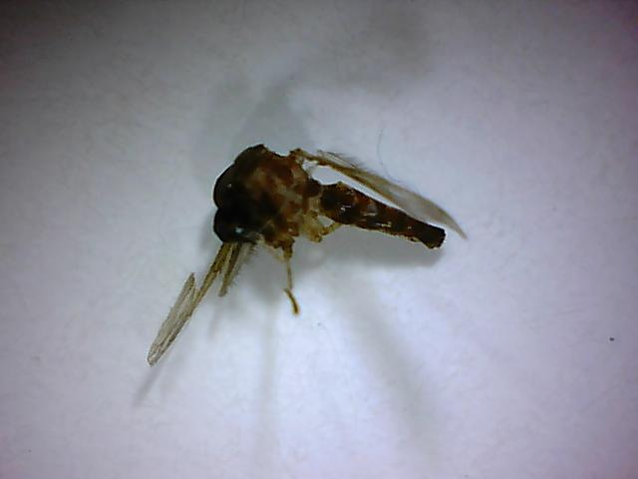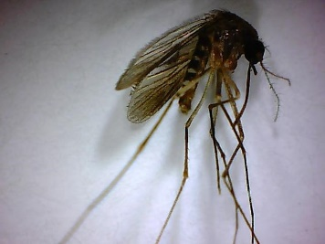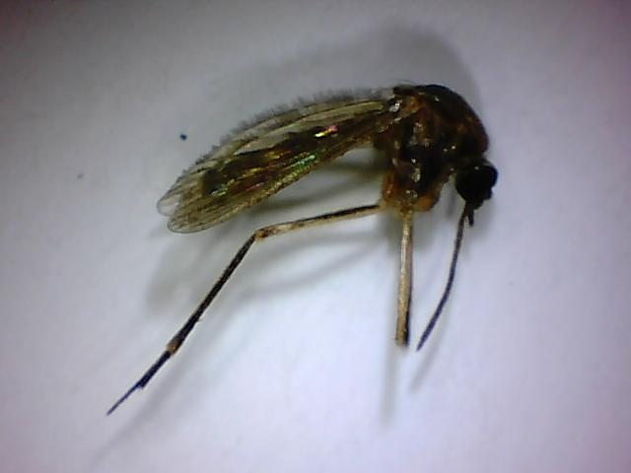
Culex erraticus: JHU-000264_05m.jpg, JHU-000309_03m.jpg, JHU-001027_03m.jpg, JHU-001255_03m.jpg
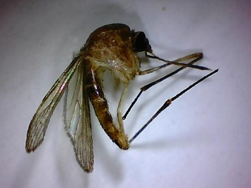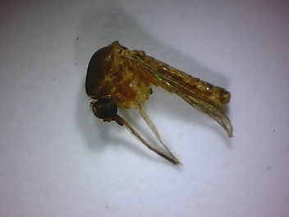
Culex nigripalpis: JHU-000513_04m.jpg, JHU-005877_03m.jpg
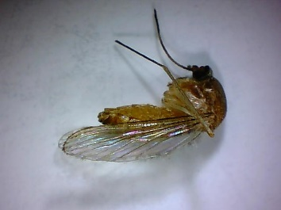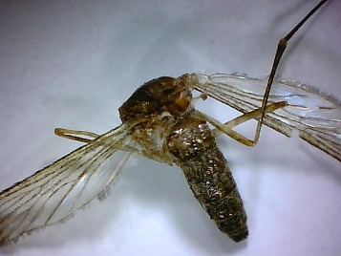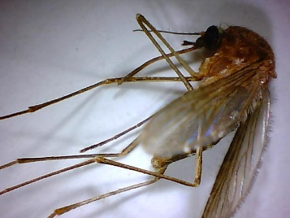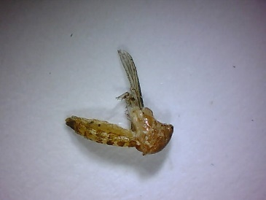
Culex pipiens sl: JHU-000414_03m.jpg, JHU-000426_02m.jpg, JHU-001118_01m.jpg, JHU-005874_05m.jpg
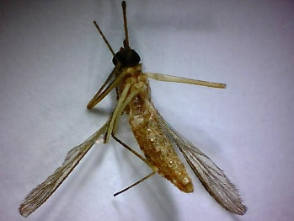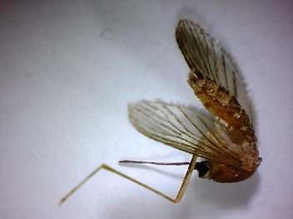
Culex restuans: JHU-000184_01m.jpg, JHU-00316_02m.jpg
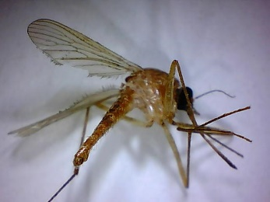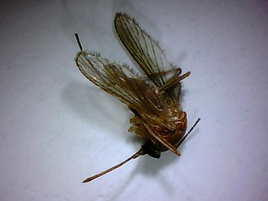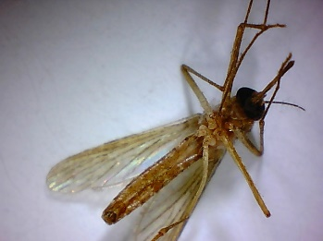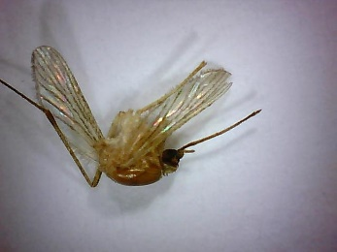
Culex salinarius: JHU-000325_03m.jpg, JHU-000502_01m.jpg, JHU-001234_03m.jpg, JHU-002453_02m.jpg
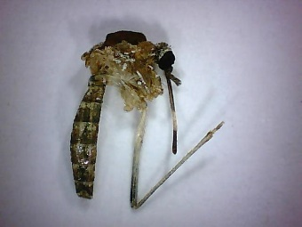
Culex tarsalis: JHU-005349_02m.jpg
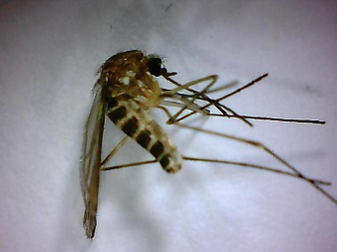
Culex territans: JHU-001507_06m.jpg
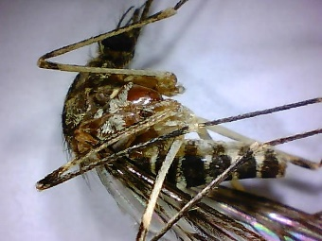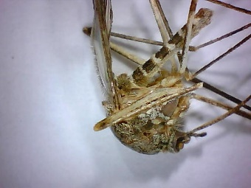
Culiseta incidens: JHU-002116_01m.jpg, JHU-005320_06m.jpg
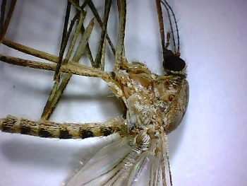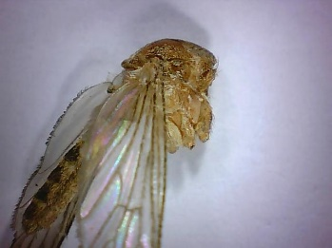
Culiseta inornate: JHU-002115_01m.jpg, JHU-005302_01m.jpg
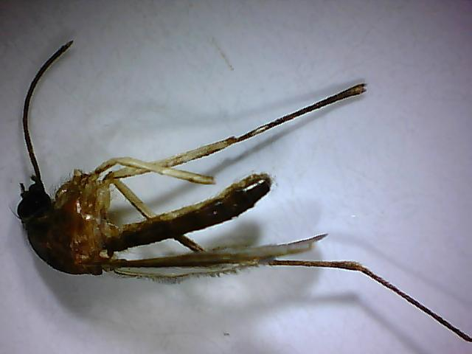
Culiseta melanura: JHU-000521_02m.jpg
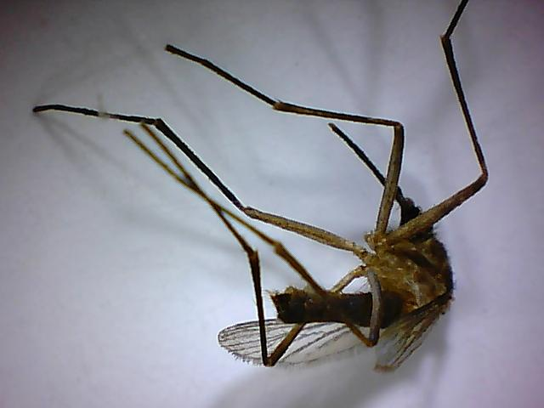
Deinocerites cancer: JHU-000366_01m.jpg
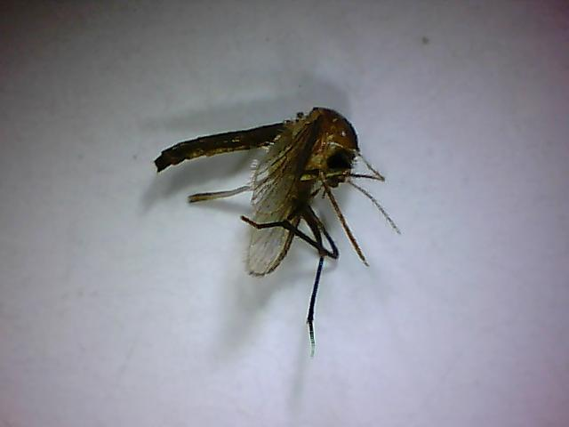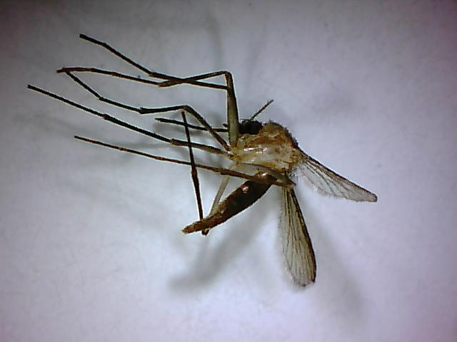
Deinocerites cuba-1: JHU-000440_04m.jpg, JHU-000474_02m.jpg
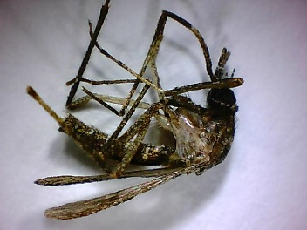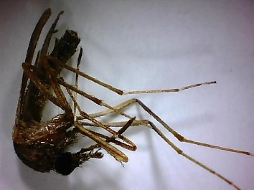
Mansonia titillans: JHU-000208_01m.jpg, JHU-000528_01m.jpg
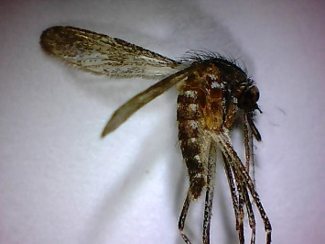
Orthopodomyia signifera: JHU-001504_01m.jpg
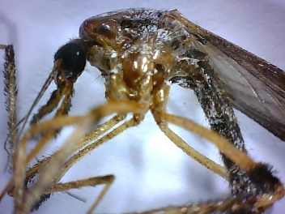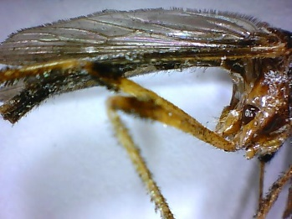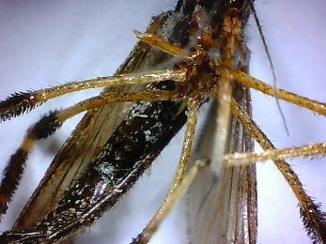
Psorophora ciliata: JHU-000650_01m.jpg, JHU-001452_02m.jpg, JHU-001466_08m.jpg
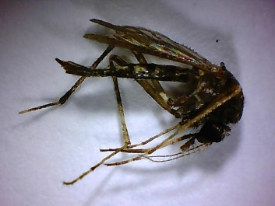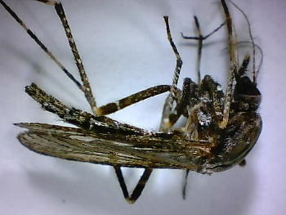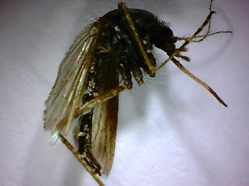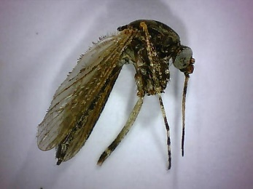
Psorophora columbiae: JHU-000196_02m.jpg, JHU-000237_02m.jpg, JHU-001472_04m.jpg, JHU-002147_05m.jpg
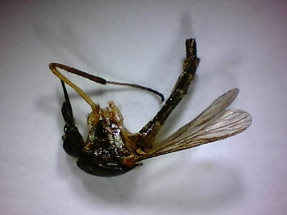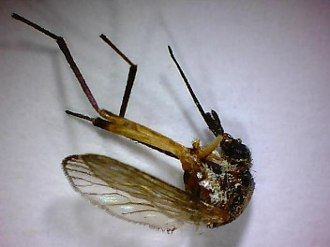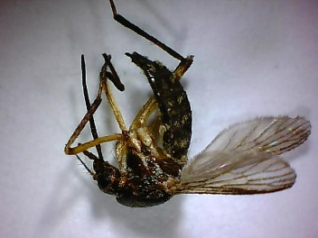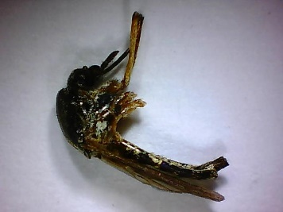
Psorophora cyanescens: JHU-001940_06m.jpg, JHU-0001944_08m.jpg, JHU-001952_08m.jpg, JHU-002015_01m.jpg
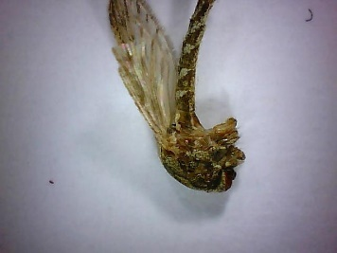
Psorophora discolor: JHU-005274_03m.jpg
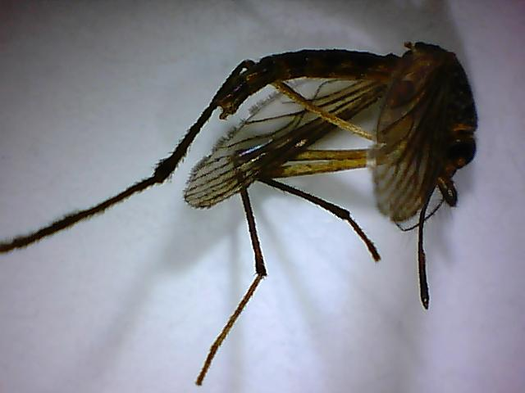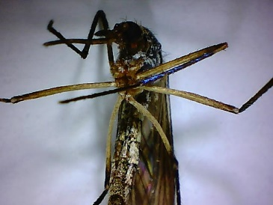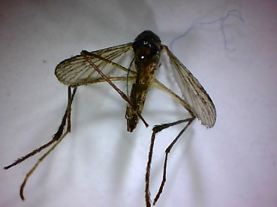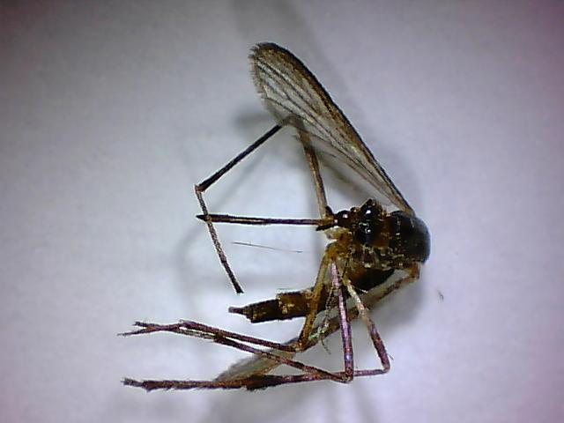
Psorophora ferox: JHU-000297_02m.jpg, JHU-001055_02m.jpg, JHU-001212_03m.jpg, JHU-001391_01m.jpg

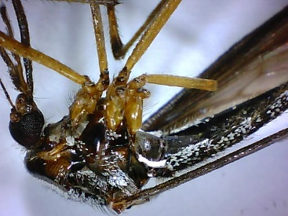
Psorophora howardii: JHU-001010_03m.jpg
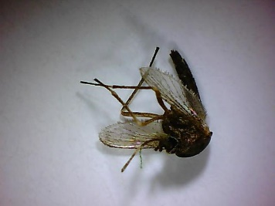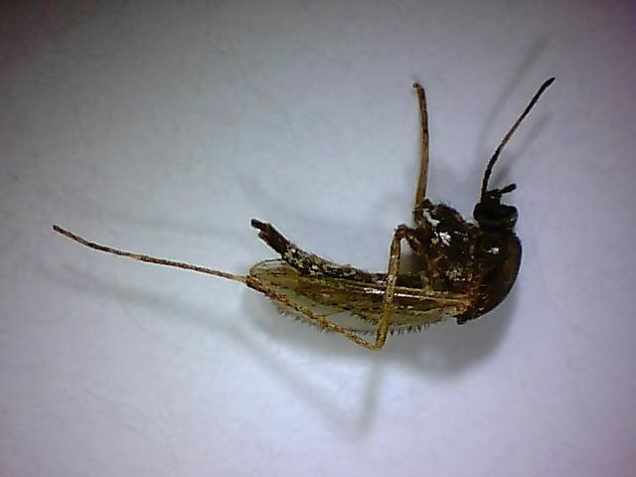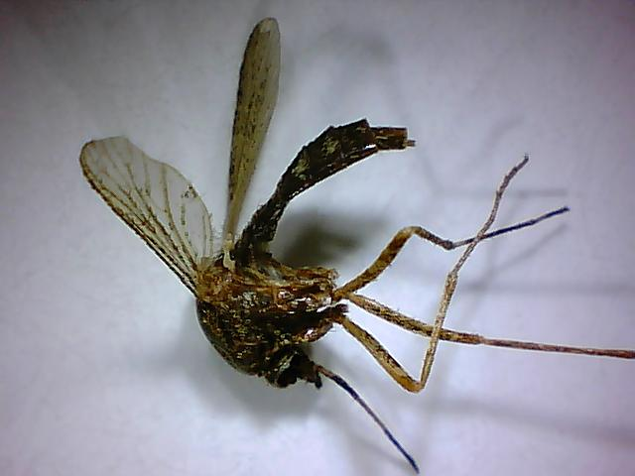
Psorophora pygmaea: JHU-000340_03m.jpg, JHU-000483_04m.jpg, JHU-000483_03m.jpg
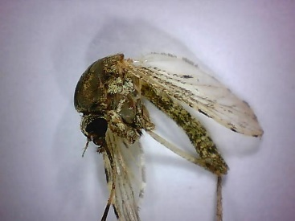
Psorophora signipennis: JHU-005328_03m.jpg
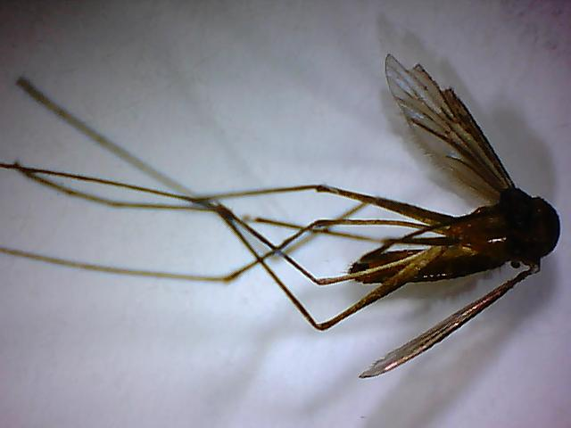
Uranotaenia sapphirina: JHU-000430_01m.jpg

