Appendix 1.

Information Letter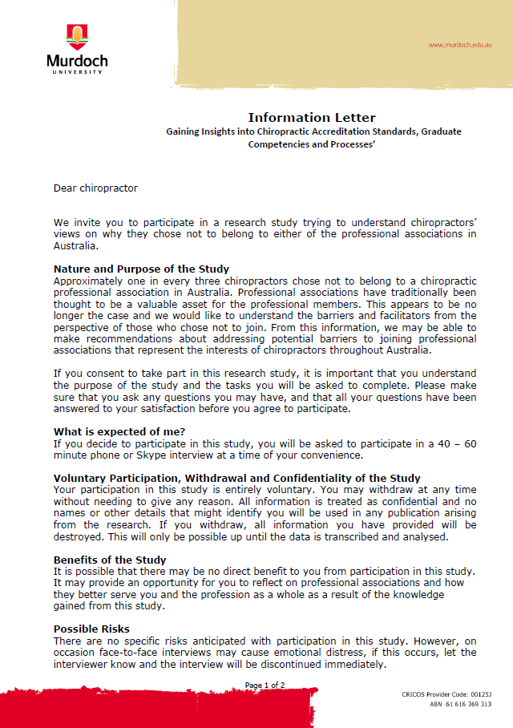
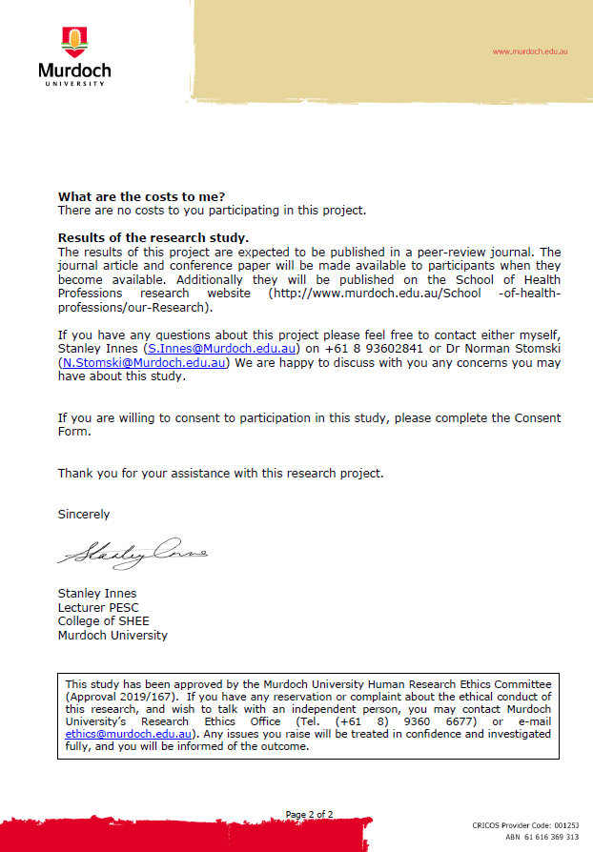

Interview questions / Aide de memoir.
- How do you feel about the chiropractic profession?
- What are your views about chiropractic professional associations?
- What are your thoughts on why chiropractors might choose not to belong to a chiropractic profession association?
- What are your thoughts on things a chiropractic professional association could do to result in more members joining?

After the initial two open-ended questions, probing questions will be used to explore the responses further, these will include:
- How did you feel about...?
- How did you respond to...?
- Could you talk more about...?
- Can you explain that more?

At the conclusion of each interview the following questions will be used:
- How could chiropractic associations be improved to better meet the needs of chiropractors?
- That’s all I would like to ask, is there anything else you’d like to talk about or ask me?

