Figure 1: Comparison of SOD activities (A), GSH levels (B), MDA levels (C), and GPx activities (D) for both P-EC patients and healthy control.

5G

5G

L1
L2
L3
M
L5
L6
L7
L8
L10
L11
L12
L13
L4
L14
L9
4G

4G

5G

5G

5G

4G

5G

100

200

300

400

500

600

700

800

900

100

1100

1200

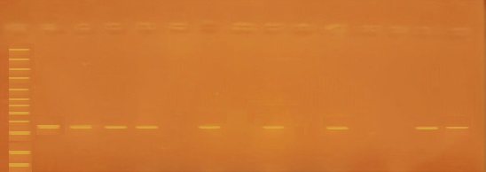
Figure 2: PCR products of the genotype PAI-1 -675 4G/5G in pre-eclampsia, whereas representative PCR products of T-ARMS-PCR resolved by Agarose Gel Electrophoresis to detect the PAI-1 4G/5G Polymorphism. Lane M: represent DNA ladder, Lanes (1, 2, 3, 4, and 13, 14) showing the heterozygote 4G/ 5G genotype where the 4G allele was present in lanes (1,3, and 13) and the 5G allele was present in lanes (2, 4, and 14). Lanes (5, 6, 7, 8, and 9,10) appeared the homozygote 5G/ 5G genotype where the 4G allele was absent in lanes (5, 7, and 9), while the 5G allele was present in lanes (6, 8, and 10). Lanes (11 and 12) were negative control.

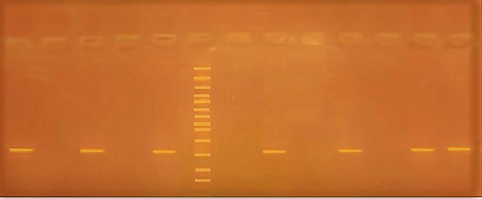
4G

4G

4G

L1
L3
L2
L5
M
L6
L8
L9
L10
L11
L12
L4
L7
4G

4G

4G

5G

312 bp

Figure 3: PCR products of the genotype PAI-1 -675 4G/5G in pre-eclampsia, whereas representative PCR products of T-ARMS-PCR resolved by Agarose Gel Electrophoresis to detect the PAI-1 4G/5G Polymorphism. Lane M: represent the DNA ladder, Lanes (1, 2, 3, 4, 5, 6, 7, 8, and 9,10) appeared 4G / 4G homozygote genotype where the 4G allele was present in lanes (1, 3, 5, 7, and 9), while the 5G allele was absent in lanes (2, 4, 6, 8, and 10). Lanes (11 and 12), showing the heterozygote 4G/ 5G genotype where the 4G allele and the 5G allele were present, the 4G allele appeared in lane 11 and the 5G allele appeared in lane 12.

Figure 4: Correlation between PAI-1 genotype; SOD (A), GSH (B), and GPx (C) in the studied groups.

Figure 5: Correlations between PAI-1 genotype; SBP (A); DBP (B); Serum albumin (C), and RBG (D) in the studied groups.
Figure 6: Correlations between PAI-1 genotype; HB (A); HCT (B); MCV (C), and MPW (D) in the studied groups.

