Supplementary Figure 3: Comparison of mortality; those on BL/BLI or Carbapenem throughout and Switch over group.

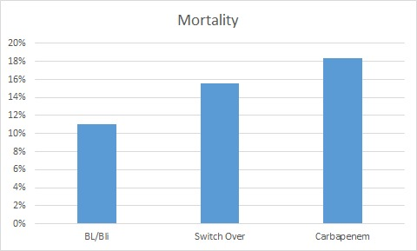
P=0.53
18.4%
15.6%
11%

