Hot–dog structured protective nanocoating for multifunctional cotton fabric through spray assisted layer–by–layer assembly
Fanxin Zeng •Xian Xu •Yueying Shen •Yeping Liu •Xueshi Shan •Zongyi Qin

Fanxin Zeng •Xian Xu •Yueying Shen •Yeping Liu •Xueshi Shan •Zongyi Qin ()
State Key Laboratory for Modification of Chemical Fibers and Polymer Materials, and College of Material Science and Engineering, Donghua University, Shanghai 201620, China
E–mail address: phqin@dhu.edu.cn
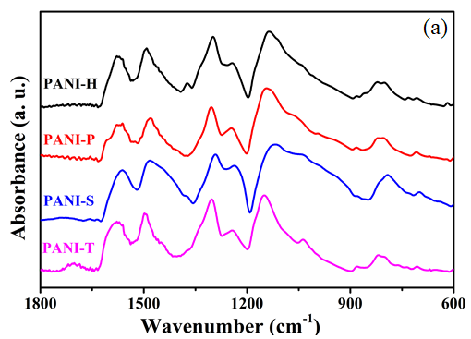
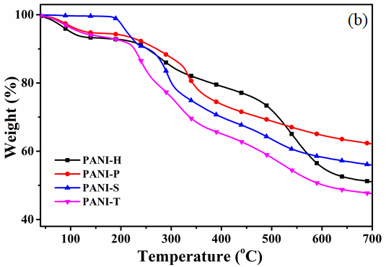
Fig. S1 (a) Infrared spectra and (b) TGA curves under nitrogen atmosphere for PANI nanofibers doped with various organic acids

Table S1 Chemical components for neat CF and coated fabrics containing PANI nanofibers doped with various organic acids.
Sample | XPS (Atomic concentration, %)
Sample | C | O | Si | N | P
CF | 78.75 | 21.25 | 0 | 0 | 0
(H-PANI)₅ | 65.86 | 22.67 | 5.17 | 3.98 | 2.32
(P-PANI)₅ | 61.38 | 26.17 | 1.53 | 5.09 | 5.83
(S-PANI)₅ | 60.98 | 25.02 | 4.38 | 5.95 | 3.67
(T-PANI)₅ | 78.85 | 14.33 | 1.5 | 3.56 | 1.76

Table S2 The LOI values as well as their flammability data for neat CF and coated fabrics containing PANI nanofibers doped with various organic acids.
Sample | LOI  /% | Burning time /s | Afterglow time /s | Char length /cm | pHRR /  (W/g) | THR  /(kJ/g) | Tp /°C
CF | 18.1 | 9 | 17 | 15 | 277.5 ± 5.1 | 14.3 ± 0.38 | 390.8 ± 6.7
(H–PANI)₅ | 31.6 | 0 | 0 | 6.8 | 103.0 ± 2.3 | 8.4 ± 0.17 | 324.3 ± 3.2
(P–PANI)₅ | 35.1 | 0 | 0 | 5.8 | 60.2 ± 1.1 | 7.3 ± 0.09 | 314.7 ± 2.6
(S–PANI)₅ | 33.7 | 0 | 0 | 6.4 | 90.2 ± 1.6 | 7.8 ± 0.12 | 321.4 ± 3.0
(T–PANI)₅ | 30.2 | 0 | 0 | 8.1 | 113.9 ± 2.5 | 10.3 ± 0.22 | 327.2 ± 3.6

