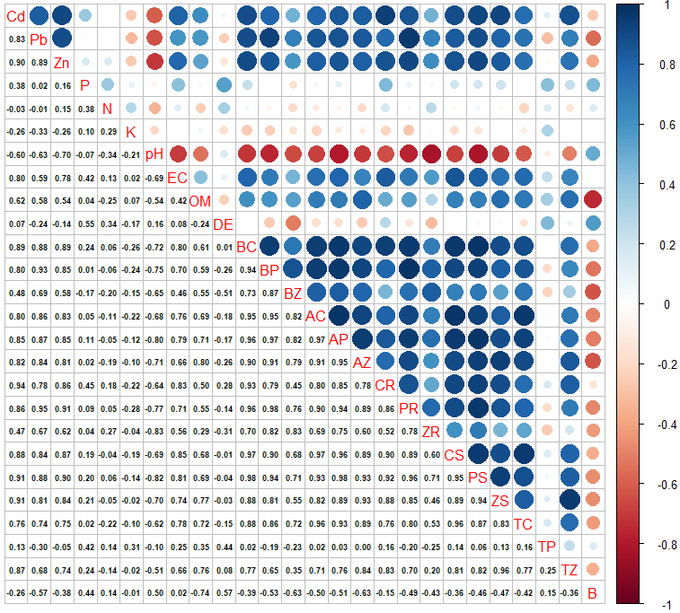
Fig 1. Pearson correlation coefficient between soil and plant variables in M. cuneatum (r < 0.58 (no significance), 0.58 < r < 0.70 (P < 0.05) and r > 0.70 (P < 0.01)). Blue and red colors represent positive and negative correlations, respectively. Abbreviations: B= biomass, TZ= translocation of Zn, TP= translocation of Pb, TC= translocation of Cd, ZS; Zn of shoot, Ps= Pb of Shoot, CS= Cd of shoot, ZR= Zn of root, PR= Pb of root, CR= Cd of root, AZ= AF of Z, AP= AF of Pb, AC= AF of Cd, BZ= BF of Zn, BP= BF of Pb, BC= BF of Cd, DE= dehydrogenase activity.

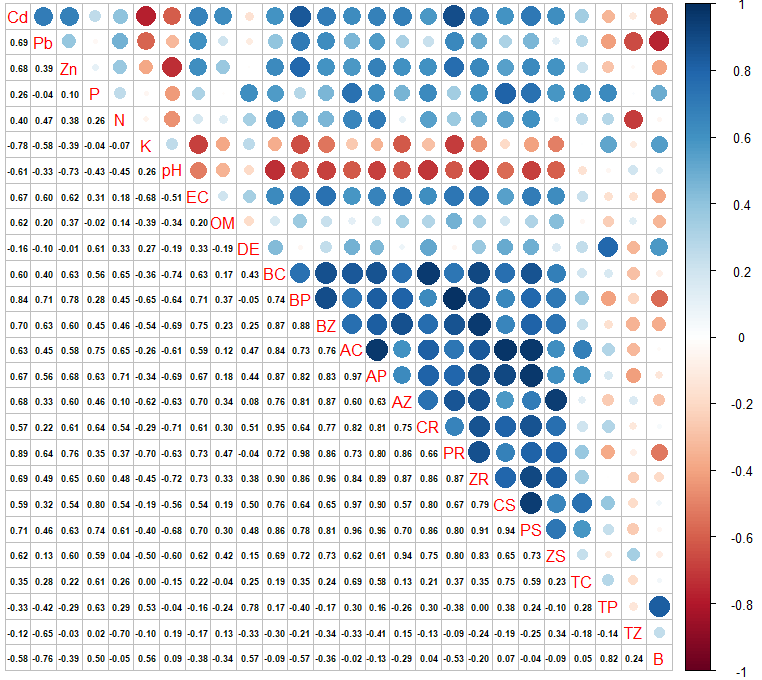
Fig 2. Pearson correlation coefficient between soil and plant variables in V. speciosum (r < 0.58 (no significance), 0.58 < r < 0.70 (P < 0.05) and r > 0.70 (P < 0.01)). Blue and red colors represent positive and negative correlations, respectively. For abbreviation please see Fig. 1.
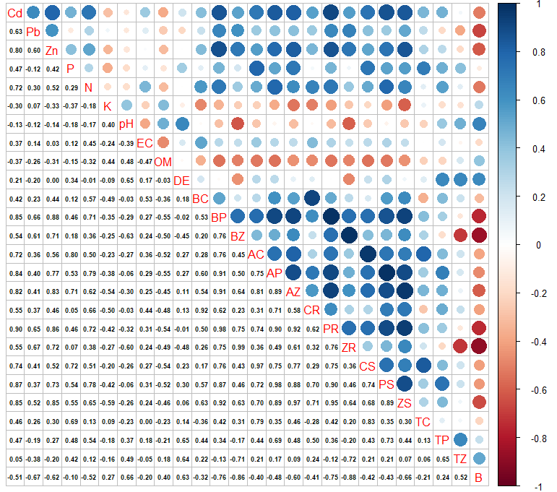
Fig 3. Pearson correlation coefficient between soil and plant variables in S. arabica (r < 0.58 (no significance), 0.58 < r < 0.70 (P < 0.05) and r > 0.70 (P < 0.01)). Blue and red colors represent positive and negative correlations, respectively. For abbreviation please see Fig. 1.

Fig. 4. Correlation among the predicted data obtained from the multiple stepwise regression model and the actual data for species M. cuneatum.

Fig. 5. Correlation among the predicted data obtained from the multiple stepwise regression model and the actual data for species V. speciosum.

Fig. 6. Correlation among the predicted data obtained from the multiple stepwise regression model and the actual data for species S. arabica.

