Supplementary Materials
Supplementary Table 1. Demographic and clinical characteristics of each site.
Supplementary Table 2. Demographic and clinical characteristics of discovery and replication sets.
Supplementary Table 3. Performance of OCD classification applied NeuroComBat harmonization with covariates (age, sex).
Supplementary Table 4. Top 10 features of diagnosis classification models.
Supplementary Table 5. Top 20 features of medication classification models.
Supplementary Table 6. Top 20 features to classify diagnosis derived from LIME.
Supplementary Figure 1. Leave-one-site-out cross-validation.
Author information

Supplementary Table 1. Demographic and clinical characteristics of each site.
Site | OCD/HC (N) | Age | Male | Medicated N (%) | Childhood-onset N (%) | Duration of illness | YBOCS score | Lifetime anxiety N (%) | Lifetime depression N (%)
(a) Adult
Amsterdam | 38/34 | 39.2±10.5 | 16 (42.1) | 0 | 24 (66.7) | 23.7 ± 12.8 | 21.3 ± 6.1 | 16 (42.1) | 18 (47.4)
Bangalore | 158/131 | 28.1±6.2 | 90 (57) | 63 (40) | 47 (29.7) | 7.2 ± 5.2 | 25.5 ± 6.5 | 14 (8.7) | 21 (13.3)
Capetown | 22/26 | 30±10.2 | 11 (47.8) | 9 (39.1) | 17 (73.9) | 17.2 ± 11.5 | 23 ± 4.2 | 0 (0) | 0
Kyoto | 35/41 | 31.3±8.7 | 14 (40) | 0 | 10 (28.6) | 7.7 ± 6.2 | 21.9 ± 6.6 | 3 (8.6) | 0
Milan | 63/65 | 34.3±11.4 | 44 (69.8) | 38 (60.3) | 41 (65.1) | 18.9 ± 11.6 | 31.4 ± 5.2 | 1 (1.6) | 5 (7.9)
NYC | 16/18 | 27.9±6.9 | 5 (31.3) | 13 (81.3) | 13 (81.3) | 15.1 ± 6.7 | 19.9 ± 5.9 | 8 (50) | 3 (18.8)
Munich | 73/60 | 31.1±9.6 | 47 (64.4) | 44 (60.3) | 41 (56.9) | 13.5 ± 10.3 | 20.8 ± 6.2 | 0 (0) | 0
Rome | 77/111 | 36.5±11 | 50 (65.8) | 68 (89.5) | 42 (56.8) | 17.3 ± 12.8 | 23.2 ± 9.3 | 8 (10.5) | 7 (9.2)
Sao Paulo | 37/29 | 36.3±11.7 | 16 (43.2) | 13 (35.1) | 31 (88.6) | 26.3 ± 13.5 | 29.2 ± 6.2 | 25 (67.6) | 28 (75.7)
Seoul | 92/86 | 26±6.5 | 60 (65.2) | 13 (14.1) | 41 (46.1) | 6.2 ± 7 | 25.8 ± 6.9 | 1 (1.1) | 2 (2.17)
Shanghai | 79/45 | 29.2±9.2 | 44 (55.7) | 0 | 21 (26.9) | 6 ± 5.9 | 26.2 ± 4.7 | 0 (0) | 0
Bangalore | 13/12 | 13.7±2.0 | 6 (23.0) | 11 (42.3) |  | 1.46±1.0 | 21±7.6 | 3 (23.1) | 1 (7.7)
Barcelona | 52/27 | 14.9±1.8 | 30 (28.9) | 41 (39.4) |  | 2.64±2.2 | 18.7±7.6 | 15 (28.9) | 3 (5.8)
British Columbia | 13/16 | 13.3±3.2 | 3 (11.5) | 11 (42.3) |  | 3.12±2.7 | 13.4±6.4 | 15 (38.5) | 0
Calgary | 19/18 | 12.2±2.4 | 10 (26.3) | 0 |  |  | 23.1±4.7 | NA | 0
Chiba | 20/6 | 14.3±2.0 | 13 (32.5) | 8 (20) |  | 2.1±1.8 | 26.9±6.2 | 2 (10) | 0
Oxford | 21/23 | 16.3±1.3 | 11 (26.2) | 14 (33.3) |  | 4.46±3.2 | 19.6±7.4 | 7 (33.3) | 5 (23.8)
Yale | 23/22 | 14.3±2.2 | 13 (26.3) | 12 (28.6) |  |  | 26.9±4.5 | 10 (43.5) | 9 (39.1)
Zurich | 14/18 | 15.2±1.5 | 11 (27.7) | 8 (30.0) |  | 4.74±2.3 | 16.1±10.2 | 6 (42.9) | 0
YBOCS Yale-Brown Obsessive–Compulsive Scale, NA not available.

Supplementary Table 2. Demographic and clinical characteristics of discovery and replication sets. (A), Adult sample to classify OCD vs. HC. (B), Adult sample to classify unmedicated OCD vs. HC. (C), Adult sample to classify medicated OCD vs. unmedicated OCD. (D) Pediatric sample to classify OCD vs. HC. (E), Pediatric sample to classify unmedicated OCD vs. HC. (F), Pediatric sample to classify medicated OCD vs. unmedicated OCD.

Adult sample to classify OCD vs. HC.
Characteristics | Train sample for diagnosis in adults |  | Test sample for diagnosis in adults
Characteristics | OCD sample | HC sample | OCD sample | HC sample
Characteristics | (n = 552) | (n = 516) | (n = 138) | (n = 130)
Age (years) | 31.6± 9.78 | 30.8± 9.97 | 30.9±9.71 | 32.1±10.5
OCD illness severity score | 24.9± 7.14 |  | 25.5±7.02
Duration of illness | 12.5± 11.1 |  | 11.8±10.7
 | N (%) | N (%) | N (%) | N (%)
Male | 314 (58.5) | 302 (56.9) | 83 (60.14) | 78 (60)
Medication use at time of scan | 207 (61.8) |  | 54 (39.13)
Childhood-onset | 258 (47.3) |  | 70 (52.2)
Lifetime diagnosis
Anxiety | 61 (73.6) |  | 15(10.87)
Major depression | 70 (12.7) |  | 14 (10.14)
Current comorbid disorders
Anxiety | 55 (10.0) |  | 14 (10.14)
Major depression | 66 (12.0) |  | 11 (7.97)
OCD symptom dimension
Aggressive/checking | 328 (59.42) |  | 83 (60.14)
Contamination/cleaning | 281 (50.91) |  | 74 (53.62)
Symmetry/ordering | 299 (54.17) |  | 71 (51.45)
Sexual/religious | 181 (32.79) |  | 47 (34.06)
Hoarding | 92 (16.7) |  | 22 (15.94)

Adult sample to classify unmedicated OCD vs. HC.
Characteristics | Train sample for classification of unmedicated OCD from HC in adults |  | Test sample for unmedicated OCD from HC in adults
Characteristics | unmedicated OCD sample | HC sample | unmedicated OCD sample | HC sample
Characteristics | (n = 338) | (n = 516) | (n = 85) | (n = 129)
Age (years) | 31.4± 9.61 | 30.5± 9.8 | 29.5±8.26 | 32.1±10.5
OCD illness severity score | 25± 6.39 |  | 25.2±6.5
Duration of illness | 11.4± 11.0 |  | 8.6±8.9
 | N (%) | N (%) | N (%) | N (%)
Male | 183 (54.14) | 303 (58.6) | 48 (56.5) | 77 (59.7)
Medication use at time of scan | 338 (100) |  | 85 (100)
Childhood-onset | 149 (44.5) |  | 32 (37.6)
Lifetime diagnosis
Anxiety | 36 (10.65) |  | 11 (12.94)
Major depression | 38 (11.24) |  | 9 (10.59)
Current comorbid disorders
Anxiety | 33 (9.8) |  | 10 (11.76)
Major depression | 21 (6.2) |  | 7 (8.24)
OCD symptom dimension
Aggressive/checking | 203 (60.06) |  | 43 (50.59)
Contamination/cleaning | 162 (47.93) |  | 39 (45.88)
Symmetry/ordering | 201 (59.47) |  | 50 (58.82)
Sexual/religious | 112 (33.14) |  | 13 (15.29)
Hoarding | 54 (15.98) |  | 20 (23.53)

Adult sample to classify medicated OCD vs. unmedicated OCD.
Characteristics | Train sample for classification of medicated OCD from unmedicated OCD in adults |  | Test sample for medicated OCD from unmedicated OCD in adults
Characteristics | medicated OCD sample | unmedicated OCD sample | medicated OCD sample | unmedicated OCD  sample
Characteristics | (n = 209) | (n = 228) | (n = 52) | (n = 85)
Age (years) | 32.4± 10 | 31± 9.31 | 32.9±10.3 | 30.7±9.68
OCD illness severity score | 24.8± 8.2 | 25.1± 6.38 | 25.1±8.02 | 24.8±6.5
Duration of illness | 15.2± 11.3 | 10.8± 10.4 | 13.8±10.8 | 10.8±11.7
 | N (%) | N (%) | N (%) | N (%)
Male | 129 (61.72) | 184 (84.44) | 33 (63.46) | 47 (55.3)
Medication use at time of scan | 209 (100) |  | 85 (100) | 85 (100)
Childhood-onset | 266 (49.4) |  | 60 (44.1)
Lifetime diagnosis
Anxiety | 22 (10.53) | 35 (10.36) | 5 (9.62) | 12 (14.12)
Major depression | 25 (11.96) | 32 (9.47) | 11 (21.15) | 15 (17.65)
Current comorbid disorders
Anxiety | 20 (9.57) | 31 (9.17) | 5 (9.62) | 12 (14.12)
Major depression | 36 (17.22) | 19 (5.62) | 12 (23.08) | 9 (10.59)
OCD symptom dimension
Aggressive/checking | 128 (61.24) | 200 (59.17) | 33 (63.46) | 46 (54.12)
Contamination/cleaning | 119 (56.94) | 165 (48.82) | 32 (61.54) | 36 (42.35)
Symmetry/ordering | 86 (41.15) | 195 (57.69) | 30 (57.69) | 56 (65.88)
Sexual/religious | 82 (39.23) | 99 (29.29) | 18 (34.62) | 26 (30.59)
Hoarding | 29 (13.88) | 58 (17.16) | 9 (17.31) | 16 (18.82)

Pediatric sample to classify OCD vs. HC.
Characteristics | Train sample for diagnosis in pediatrics |  | Test sample for diagnosis in pediatrics
Characteristics | OCD sample | HC sample | OCD sample | HC sample
Characteristics | (n = 113) | (n = 140) | (n = 35) | (n = 29)
Age (years) | 14.5± 2.24 | 14.4± 2.48 | 14.6±2.35 | 14.2±2.34
OCD illness severity score | 20.8± 8.03 |  | 21.0±8.12
Duration of illness | 3.00± 2.53 |  | 2.98±2.29
 | N (%) | N (%) | N (%) | N (%)
Male | 77 (55) | 20 (59.14) | 83 (60.14) | 78 (60)
Medication use at time of scan | 81 (57.86) |  | 24 (68.57)
Lifetime diagnosis
Anxiety | 38 (27.14) |  | 10 (28.57)
Major depression | 17 (76.43) |  | 1 (2.86)
Current comorbid disorders
Anxiety | 21 (15.0) |  | 8 (22.86)
Major depression | 21 (15.0) |  | 8 (22.86)
OCD symptom dimension
Aggressive/checking | 14 (10.0) |  | 1 (2.86)
Contamination/cleaning | 14 (10.0) |  | 2 (5.71)
Symmetry/ordering | 7 (5.0) |  | 0 (0)
Sexual/religious | 0 (0) |  | 0 (0)
Hoarding | 5 (3.57) |  | 1 (2.86)

Pediatric sample to classify unmedicated OCD vs. HC.
Characteristics | Train sample for classification of unmedicated OCD from HC in pediatrics |  | Test sample for unmedicated OCD from HC in pediatrics
Characteristics | unmedicated OCD sample | HC sample | unmedicated OCD sample | HC sample
Characteristics | (n = 56) | (n = 95) | (n = 14) | (n = 24)
Age (years) | 13.3± 2.31 | 13,9± 2.36 | 14.5±2.32 | 14.1±2.77
OCD illness severity score | 20.8± 8.10 |  | 17.7±8.91
Duration of illness | 2.82± 2.47 |  | 2.9±2.44
 | N (%) | N (%) | N (%) | N (%)
Male | 33 (58.93) | 52 (54.74) | 6 (42.86) | 13 (54.17)
Medication use at time of scan | 0 (0.0) |  | 0 (0.0)
Lifetime diagnosis
Anxiety | 10 (17.86) |  | 2 (14.29)
Major depression | 2 (3.57) |  | 2 (14.29)
Current comorbid disorders
Anxiety | 3 (5.36) |  | 1 (7.14)
Major depression | 0 (0.0) |  | 0 (0.0)
OCD symptom dimension
Aggressive/checking | 7 (12.5) |  | 2 (21.43)
Contamination/cleaning | 8 (14.29) |  | 1 (7.14)
Symmetry/ordering | 3 (5.36) |  | 0 (0.0)
Sexual/religious | 0 (0.0) |  | 0 (0.0)
Hoarding | 0 (0.0) |  | 0 (0.0)

- Pediatric sample to classify medicated OCD vs. unmedicated OCD.
Characteristics | Train sample for classification of medicated OCD from unmedicated OCD in pediatrics |  | Test sample for medicated OCD from unmedicated OCD in pediatrics
Characteristics | medicated OCD sample | unmedicated OCD sample | medicated OCD sample | unmedicated OCD sample
Characteristics | (n = 84) | (n = 56) | (n = 21) | (n = 14)
Age (years) | 15.2± 1.9 | 13.4± 2.4 | 14.5±2.24 | 14.1±2.13
OCD illness severity score | 21.8± 8.10 | 19.7± 8.66 | 18.9±6.42 | 22.2±6.56
Duration of illness | 2.96± 8.10 | 2.65± 1.90 | 18.9±6.42 | 3.89±4.54
 | N (%) | N (%) | N (%) | N (%)
Male | 47 (55.95) | 29 (51.79) | 11 (52.38) | 10 (71.43)
Medication use at time of scan | 84 (100) |  | 21 (100)
Lifetime diagnosis
Anxiety | 56 (55.36) | 31 (55.36) | 8 (38.1) | 1 (7.14)
Major depression | 11 (13.10) | 4 (7.14) | 3 (14.29) | 0 (0.0)
Current comorbid disorders
Anxiety | 19 (22.62) | 4 (7.14) | 6 (28.57) | 0 (0.0)
Major depression | 5 (70.24) | 0 (0.0) | 1 (4.76) | 0 (0.0)
OCD symptom dimension
Aggressive/checking | 5 (5.95) | 6 (10.71) | 1 (4.76) | 3 (21.43)
Contamination/cleaning | 6 (45.24) | 7 (12.5) | 1 (4.76) | 2 (14.29)
Symmetry/ordering | 4 (40.48) | 2 (35.71) | 0 (0.0) | 1 (7.14)
Sexual/religious | 0 (0.0) | 0 (0.0) | 0 (0.0) | 0 (0.0)
Hoarding | 1 (1.19) | 3 (5.36) | 1 (4.76) | 1 (7.14)

Supplementary Table 3. Performance of OCD classification applied NeuroComBat harmonization with covariates (age, sex). (95% confidence interval) (A) Adult sample applied NeuroComBat with covariates (age, sex), (B) Pediatric sample applied NeuroComBat with covariates (age, sex).

Adult sample applied NeuroComBat with covariates (age, sex)
 | OCD (N = 690)  vs. HC (N = 646) |  | unmedicated OCD (N = 429) vs. HC (N = 646) |  | unmedicated OCD (N = 429)  vs. medicated OCD (N = 261)
 | Discovery set | Replication set | Discovery set | Replication set | Discovery set | Replication set
ROC-AUC | 61.61 ± 6.53 | 68.27 ± 3.74 | 67.2 ± 5.82 | 51.35 ± 4.11 | 64.36 ± 9.31 | 61.76 ± 5.02
Accuracy (%) | 63.1 ± 4.69 | 69.63 ± 3.10 | 68.9 ± 6.28 | 55.6 ± 3.83 | 63.26 ± 10.02 | 63.5 ± 5.20
Sensitivity (%) | 64.4 ± 14.44 | 51.8 ± 19.80 | 76.21 ± 8.46 | 56.47 ± 11.39 | 55.44 ± 19.11 | 50 ± 21.58
Specificity (%) | 61.67 ± 17.46 | 81.4 ± 3.98 | 62.82 ± 16.88 | 55.04 ± 14.62 | 82.44 ± 7.68 | 71.8 ± 11.99
For the classification of medication status among OCD patients, some sites (i.e., Amsterdam, Shanghai) containing only unmedicated OCD were excluded from the discovery set.

(B) Pediatric sample, NeuroComBat with covariates (age, sex)
 | OCD (N = 175)  vs. HC (N = 142) |  | unmedicated OCD (N = 70)  vs. HC (N = 142) |  | unmedicated OCD (N = 105)  vs. medicated OCD (N = 70)
 | Discovery set | Replication set | Discovery set | Replication set | Discovery set | Replication set
ROC-AUC | 53.85 ± 11.71 | 63.74 ± 7.12 | 58.02 ± 13.41 | 44.05 ± 10.79 | 63.24 ± 0.34 | 54.76 ± 10.28
Accuracy (%) | 60.15 ± 9.87 | 64.06 ± 6.40 | 58.32 ± 12.80 | 68.42 ± 4.02 | 65.65 ± 0.36 | 60 ± 8.72
Sensitivity (%) | 51.7 ± 22.96 | 65.7 ± 14.60 | 76.83 ± 11.82 | 14.29 ± 43.73 | 70.2 ± 1.69 | 52.38 ± 19.45
Specificity (%) | 69.06 ± 14.87 | 62.07 ± 17.62 | 59.22 ± 2.26 | 100 | 68.96 ± 2.15 | 71.43 ± 14.58
For the classification of medication status among OCD patients, some sites (i.e., Calgary) containing only unmedicated OCD were excluded from the discovery set.

Supplementary Table 4. Top 10 features of diagnosis classification models. (A) Classification of OCD from HC in adult samples (OCD: N = 690, HC: N = 646). (B) Classification of OCD from HC in pediatric samples (OCD: N = 175, HC: N = 142). (C) Classification of unmedicated OCD from HC in adult samples (unmedicated OCD: N = 429, HC: N = 646). (D) Classification of unmedicated OCD from HC in pediatric samples (unmedicated OCD: N = 70, HC: N = 142)

To further investigate the effect of diagnosis and medication effect, we applied a machine learning interpretation method, K-LIME (K-Local Interpretable Model-agnostic Explanation), to the classification models. These interpretation models accounted for the variance of the best machine learning models ranging from 45.69% to 63.8% (Supplementary Table 4, 5)
- Classification of OCD from HC in adult samples (OCD: N = 690, HC: N = 646)
Rank | Feature | DTI Metric | Weight
1 | Right Superior corona radiata | MD | 1.000
2 | Age | . | 0.997
3 | Left Posterior thalamic radiation | FA | 0.978
4 | Genu of corpus callosum | MD | 0.900
5 | Bilateral Posterior thalamic radiation | FA | 0.863
6 | Left Sagittal stratum | FA | 0.716
7 | Bilateral Posterior limb of internal capsule | FA | 0.703
8 | Bilateral Superior longitudinal fasciculus | FA | 0.670
9 | Left Posterior limb of internal capsule | AD | 0.660
10 | Bilateral Superior longitudinal fasciculus | MD | 0.617

(B) Classification of OCD from HC in pediatric samples (OCD: N = 175, HC: N = 142)
Rank | Feature | DTI Metric | Weight
1 | Left Cingulum (hippocampus) | MD | 1.000
2 | Bilateral Uncinate fasciculus | MD | 0.886
3 | Right Fornix and Stria terminalis | FA | 0.833
4 | Right External capsule | AD | 0.829
5 | Bilateral Cingulum (hippocampus) | AD | 0.815
6 | Right Corticospinal tract | FA | 0.788
7 | Left Anterior corona radiata | AD | 0.778
8 | Left Corticospinal tract | FA | 0.730
9 | Bilateral Fornix and Stria terminalis | FA | 0.715
10 | Right Retrolenticular part of internal capsule | MD | 0.707

(C) Classification of unmedicated OCD from HC in adult sample (unmedicated OCD: N = 429, HC: N = 646)
Rank | Feature | DTI Metric | Weight
1 | Age | . | 1.000
2 | Bilateral Fornix and Stria terminalis | RD | 0.908
3 | Genu of corpus callosum | RD | 0.880
4 | Right Posterior limb of internal capsule | FA | 0.748
5 | Right Inferior fronto-occipital fasciculus | AD | 0.739
6 | Bilateral Posterior limb of internal capsule | FA | 0.696
7 | Corpus Callosum | AD | 0.660
8 | Left Posterior limb of internal capsule | AD | 0.642
9 | Left Posterior limb of internal capsule | FA | 0.638
10 | Right Uncinate fasciculus | AD | 0.459

(D) Classification of unmedicated OCD from HC in pediatric samples (unmedicated OCD: N = 70, HC: N = 142)
Rank | Feature | DTI Metric | Weight
1 | Splenium of corpus callosum | FA | 1.000
2 | Bilateral Retrolenticular part of internal capsule | FA | 0.826
3 | Left Inferior fronto-occipital fasciculus | AD | 0.766
4 | Right Sagittal stratum | FA | 0.756
5 | Left Anterior limb of internal capsule | AD | 0.750
6 | Bilateral Sagittal stratum | FA | 0.729
7 | Left Uncinate fasciculus | FA | 0.727
8 | Bilateral Superior fronto-occipital fasciculus | FA | 0.718
9 | Left Posterior limb of internal capsule | FA | 0.715
10 | Left Superior fronto-occipital fasciculus | FA | 0.703

Supplementary Table 5. Top 20 features of medication classification models. (A) Classification model of medicated OCD from unmedicated OCD in adult samples (medicated OCD: N = 261, unmedicated OCD: N = 429). (B) Classification model of medicated OCD from unmedicated OCD in pediatric samples (medicated OCD: N = 70, unmedicated OCD: N = 105)
(A) Classification model of medicated OCD from unmedicated OCD in adult samples (medicated OCD: N = 261, unmedicated OCD: N = 429)
Rank | Feature | DTI Metric | Weight
1 | Corpus Callosum | AD | 1.000
2 | Left Posterior limb of internal capsule | FA | 0.726
3 | Average FA | FA | 0.476
4 | Right Inferior fronto-occipital fasciculus | AD | 0.308
5 | Bilateral Fornix and Stria terminalis | MD | 0.308
6 | Bilateral Cingulum (hippocampus) | RD | 0.267
7 | Genu of corpus callosum | FA | 0.261
8 | Average RD | RD | 0.253
9 | Genu of corpus callosum | AD | 0.228
10 | Right Cingulum (hippocampus) | RD | 0.222

(B) Classification of medicated OCD from unmedicated OCD in pediatric samples (medicated OCD: N = 70, unmedicated OCD: N = 105)
Rank | Feature | DTI Metric | Weight
1 | Bilateral Fornix (cres)/Stria terminalis | AD | 1.000
2 | Left Anterior corona radiata | RD | 0.971
3 | Bilateral Cingulum (cingulate gyrus) | AD | 0.854
4 | Bilateral Uncinate fasciculus | AD | 0.833
5 | Right Cingulum (cingulate gyrus) | AD | 0.800
6 | Bilateral Cingulum (hippocampus) | AD | 0.791
7 | Left Internal capsule | AD | 0.790
8 | Bilateral Posterior limb of internal capsule | FA | 0.722
9 | Right Anterior limb of internal capsule | FA | 0.692
10 | Left Anterior limb of internal capsule | AD | 0.685

Supplementary Table 6. Top 20 features to classify diagnosis derived from LIME. (A) Classification of OCD from HC in adult samples (OCD: N = 690, HC: N = 646), (B) Classification of OCD from HC in pediatric samples (OCD: N = 175, HC: N = 142), (C) Classification of unmedicated OCD (N = 429) and HC (N = 646) in adult samples.

(A) Classification of OCD from HC in adult samples (OCD: N = 690, HC: N = 646)
 | Features positively associated  with adult OCD |  |  | Features negatively associated  with adult OCD
Rank | Feature | DTI  Index | Weight | Feature | DTI  Index | Weight
1 | Bilateral Corticospinal tracts | RD | 0.091 | Corpus callosum | AD | 0.039
2 | Bilateral Posterior limb of internal capsule | FA | 0.069 | Corpus callosum | MD | 0.036
3 | Corpus callosum | FA | 0.050 | Bilateral Superior corona radiata | FA | 0.036
4 | Bilateral Internal capsule | FA | 0.045 | Right Fornix/Stria terminalis | RD | 0.035
5 | Bilateral Corona radiata | FA | 0.044 | Right Corona radiata | AD | 0.035
6 | Bilateral Fornix/Stria terminalis | MD | 0.038 | Bilateral Internal capsule | AD | 0.033
7 | Right Posterior limb of internal capsule | AD | 0.035 | Bilateral Uncinate fasciculus | RD | 0.033
8 | Bilateral Internal capsule | RD | 0.033 | Bilateral Fornix/Stria terminalis | AD | 0.032
9 | Bilateral Anterior corona radiata | RD | 0.030 | Bilateral Superior corona radiata | FA | 0.032
10 | Bilateral Superior corona radiata | AD | 0.029 | Bilateral Anterior corona radiata | AD | 0.031
The interpretation model accounts for 45.69% of the variance

(B) Classification of OCD from HC in pediatric samples (OCD: N = 175, HC: N = 142)
 | Features positively associated  with pediatric OCD |  |  | Features negatively associated  with pediatric OCD
Rank | Feature | DTI  Index | Weight | Feature | DTI  Index | Weight
1 | Left Posterior thalamic radiation | RD | 0.350 | Left Posterior thalamic radiation | AD | 0.370
2 | Right Retrolenticular part of the internal capsule | MD | 0.330 | Right External capsule | AD | 0.310
3 | Left Fornix/Stria terminalis | AD | 0.330 | Bilateral Superior corona radiata | FA | 0.280
4 | Right Posterior thalamic radiation | AD | 0.310 | Left Cingulum cingulate gyrus part | RD | 0.270
5 | Left Uncinate fasciculus | RD | 0.30 | Right Anterior limb of internal capsule | RD | 0.260
6 | Bilateral Inferior fronto-occipital fasciculus | RD | 0.280 | Left Anterior corona radiata | RD | 0.250
7 | Right External capsule | MD | 0.270 | Bilateral Inferior fronto-occipital fasciculus | FA | 0.250
8 | Right External capsule | RD | 0.260 | Right Posterior thalamic radiation | RD | 0.250
9 | Right Cingulum cingulate gyrus part | RD | 0.260 | Left Sagittal stratum | MD | 0.240
10 | Corpus callosum | FA | 0.260 | Left Retro Lenticular part of internal capsule | MD | 0.240
The interpretation model accounts for 47.12% of the variance.

(C) Classification of unmedicated OCD (N = 429) and HC (N = 646) in adult samples
 | Features positively associated  with unmedicated OCD |  |  | Features negatively associated  with unmedicated OCD
Rank | Feature | DTI  Index | Weight | Feature | DTI  Index | Weight
1 | Bilateral Posterior limb of internal capsule | FA | 0.200 | Bilateral Cingulum cingulate gyrus part | MD | 0.130
2 | Bilateral Cingulum hippocampal part | MD | 0.170 | Right Cingulum hippocampal part | RD | 0.130
3 | Bilateral Posterior limb of internal capsule | MD | 0.120 | Left Posterior thalamic radiation | RD | 0.088
4 | Left Posterior thalamic radiation | MD | 0.100 | Right Fornix/Stria terminalis | RD | 0.083
5 | Bilateral Corona radiata | FA | 0.093 | Bilateral Cingulum hippocampal part | AD | 0.080
6 | Bilateral Posterior limb of internal capsule | RD | 0.090 | Bilateral Posterior corona radiata | MD | 0.075
7 | Bilateral Corona radiata | AD | 0.085 | Bilateral Anterior corona radiata | AD | 0.071
8 | Right Posterior limb of internal capsule | RD | 0.080 | Bilateral Fornix/Stria terminalis | MD | 0.068
9 | Right Cingulum cingulate gyrus part | MD | 0.072 | Bilateral Superior corona radiata | FA | 0.064
10 | Right Cingulum hippocampal part | MD | 0.070 | Corpus callosum | MD | 0.056
Note that the target class is unmedicated OCD.
The interpretation model accounts for 63.8% of the variance.

Supplementary Table 7. Top 20 features to differentiate between adult unmedicated OCD (N = 429) and adult medicated OCD (N = 261) derived from LIME.
 | Features positively associated  with OCD medication |  |  | Features negatively associated  with OCD medication
Rank | Feature | DTI  Index | Weight | Feature | DTI  Index | Weight
1 | Bilateral Posterior corona radiata | RD | 0.005 | Corpus callosum | AD | 0.008
2 | Bilateral Posterior limb of internal capsule | RD | 0.004 | Average RD |  | 0.007
3 | Bilateral Superior corona radiata | RD | 0.007 | Left Posterior limb of internal capsule | FA | 0.005
4 | Right Inferior fronto-occipital fasciculus | AD | 0.002 | Corpus callosum | MD | 0.004
5 | Right Posterior corona radiata | MD | 0.002 | Bilateral Anterior corona radiata | MD | 0.003
6 | Splenium of corpus callosum | MD | 0.002 | Right Anterior limb of internal capsule | MD | 0.003
7 | Splenium of corpus callosum | AD | 0.002 | Right Internal capsule | RD | 0.003
8 | Bilateral Superior corona radiata | AD | 0.002 | Bilateral Superior corona radiata | FA | 0.002
9 | Splenium of corpus callosum | RD | 0.002 | Bilateral Corticospinal tract | RD | 0.002
10 | Left Posterior thalamic radiation | MD | 0.002 | Right Fornix/Stria terminalis | FA | 0.002
Note that the target class is medicated OCD.
The interpretation model accounts for 59.8% of the variance.

Supplementary Table 8. Performance of adult-trained models in pediatric OCD prediction – mean with 95% confidence interval.
 | OCD vs. HC
 | Trained, validated  on adult samples | Tested  on pediatric samples
ROC-AUC | 63.91 (52.4-72.3) | 55.81 (49.5-62.2)
Accuracy (%) | 64.81 (57.1-75.0) | 57.41 (51.7-63.4)
Sensitivity (%) | 65.2 (33.2-91.4) | 52.57 (19.4-80)
Specificity (%) | 64.47 (35.8-91.6) | 63.38 (34.5-92.3)

As a secondary analysis, we assessed differences in matter microstructure between adult OCD and pediatric OCD participants. We tested the generalizability of the model trained on the adult samples (N=1,336; OCD: 690, HC: 640) to the pediatric samples (N=317; OCD: 175, HC: 142). The model trained on adult samples showed moderately accurate performance in classifying adult OCD participants from HCs (ROC-AUC = 63.91, 95% CI = 52.4-72.3). This model provided lower performance when applied to pediatric samples (ROC-AUC =55.81, 95% CI =49.5-62.2).
Rank | Feature | DTI | Weight
Rank | Feature | Index | Weight
1 | R Inferior fronto-occipital fasciculus | FA | 1.000
2 | L Posterior thalamic radiation | FA | 0.872
3 | L Posterior limb of internal capsule | AD | 0.826
4 | L Posterior corona radiata | FA | 0.750
5 | L Uncinate fasciculus | FA | 0.377
6 | R Superior longitudinal fasciculus | RD | 0.316

Supplementary Figure 1. Leave-one-site-out cross-validation.

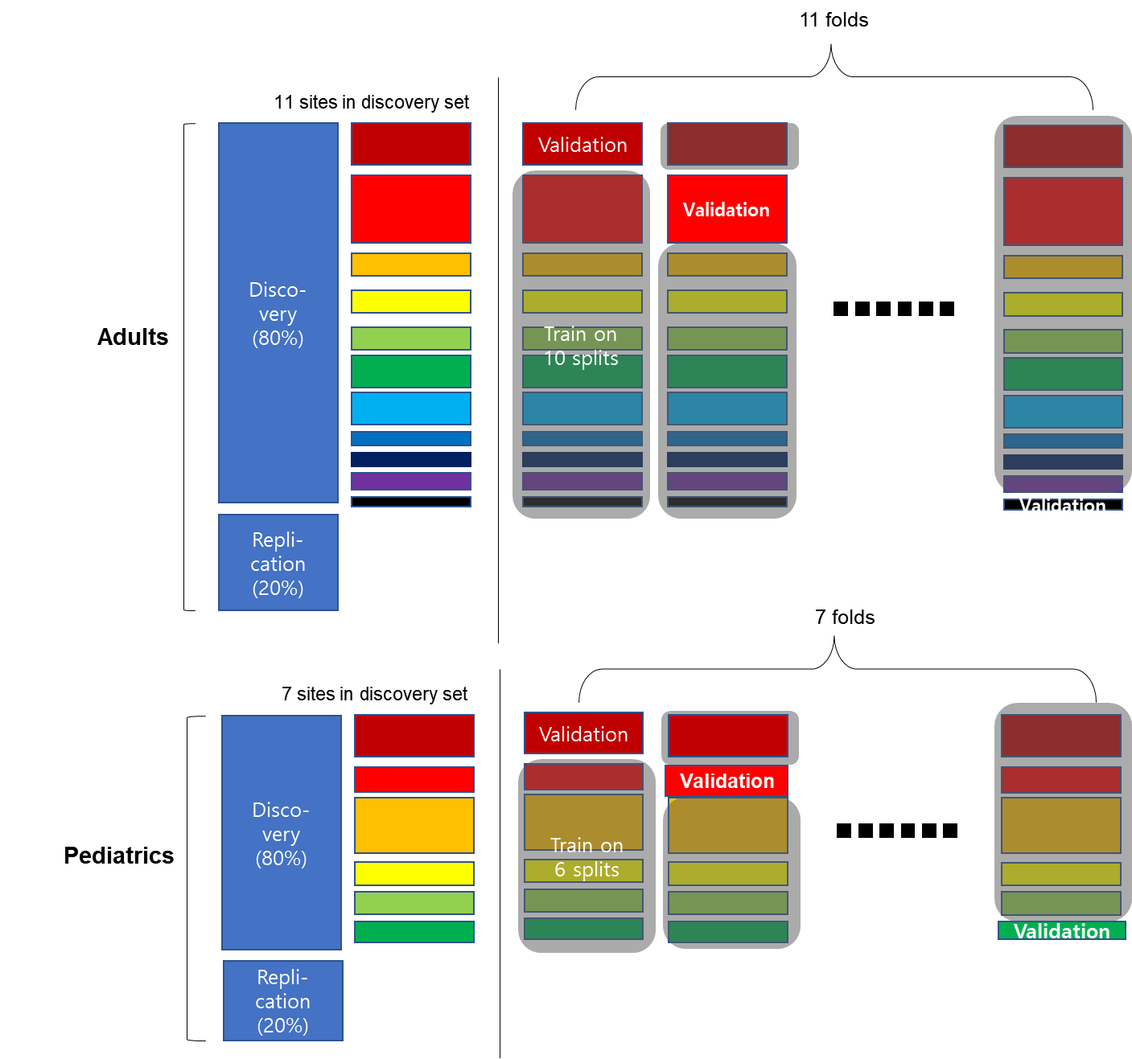

Supplementary Figure 4. Feature importance plot of the diagnosis and medication models in adult (Left) and pediatric (Right) samples. (A), relative importance plot of OCD vs. HC model. (B), the relative importance of unmedicated OCD vs. HC model. (C), relative importance plot of medicated OCD vs. unmedicated OCD model. The top 10 features are represented.
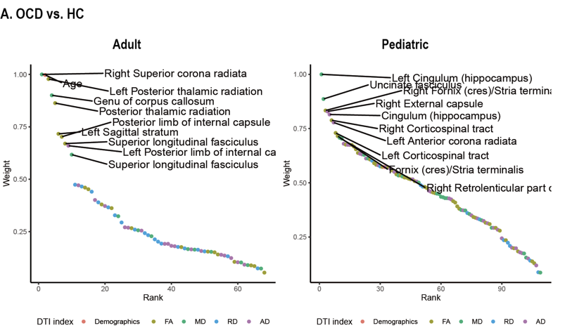
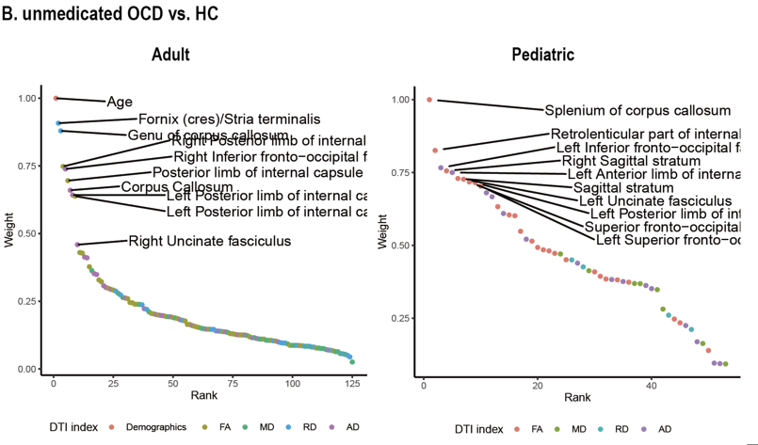
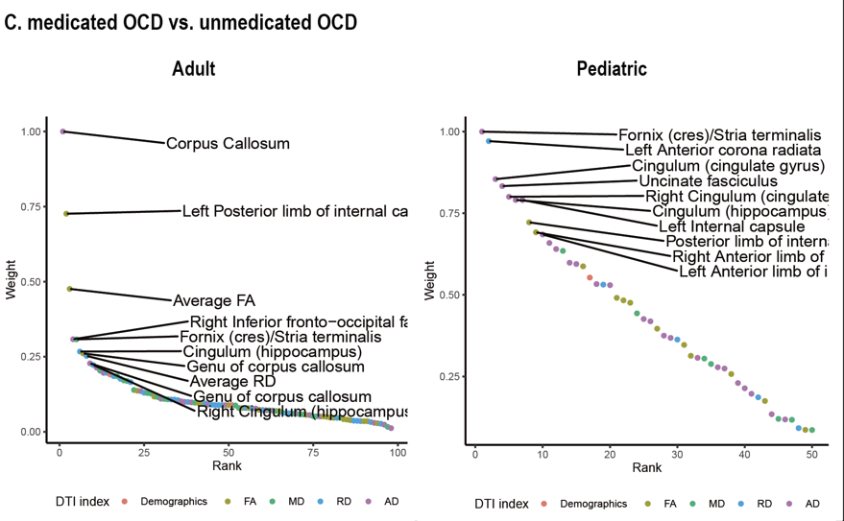

Author Information

ENIGMA-OCD Working Group Consortium
Yoshinari Abe ¹, Pino Alonso ^{2, 3, 4}, Stephanie Ameis ^{5, 6, 7}, Alan Anticevic ⁸, Honami Arai ⁹, Kentaro Araki ⁹, Paul D. Arnold ^{10, 11}, Justin T. Baker ^{12,13}, Srinivas Balachander ¹⁴, Nerisa Banaj ¹⁵, Núria Bargalló ^{16, 17, 18}, Marcelo C. Batistuzzo ^{19, 20}, Francesco Benedetti ^{21, 22}, Sara Bertolín ^{23. 24}, John R. Best ^{25, 26}, Jan-Carl Beucke ^{27, 28, 29}, Premika S.W. Boedhoe ³⁰, Irene Bollettini ²², Sven Bölte ³¹, Vilde Brecke ³², Silvia Brem ^{33, 34}, Brian P. Brennan ^{12, 13}, Willem B. Bruin ^{30, 35}, Jan K. Buitelaar ^{36, 37}, Rosa Calvo ^{24, 38, 39, 40}, Carolina Cappi ⁴¹, Wei Chen ⁴², Yuqi Cheng ⁴³, Ritu Bhusal Chhatkuli ^{9, 44}, Sutoh Chihiro ⁴⁵, Kang Ik Kevin Cho ^{46, 47}, Sunah Choi ⁴⁷, Valentina Ciullo ¹⁵, Ana Coelho ^{48, 49, 50}, Daniel Costa ⁴¹, Beatriz Couto ^{48, 49, 50}, Nan Dai ⁴³, Sara Dallaspezia ⁵¹, Shareefa Dalvie ⁵², Damiaan Denys ⁵³, Juliana B. Diniz ⁴¹, Benjamin A. Ely ⁵⁴, Calesella Federico ²¹, Sónia Ferreira ^{48, 49, 50}, Jamie D. Feusner ⁵⁵, Kate D. Fitzgerald ⁵⁶, Martine Fontaine ⁵⁷, Jean-Paul Fouche ⁵⁸, Egill Axfjord Fridgeirsson ⁵³, Rachael Grazioplene ⁵⁹, Edna Grünblatt ^{33, 34}, Patricia Gruner ⁵⁹, Kristen Hagen ^{32, 60}, Sayo Hamatani ^{9, 44}, Greg Hanna ⁵⁶, Bjarne Hansen ^{32, 61}, Mengxin He ⁴³, Odile A. van den Heuvel ³⁰, Yoshiyuki Hirano ^{9, 44}, Marcelo Q. Höxter ^{19, 41}, Morgan Hough ⁶², Hao Hu ⁶³, Chaim Huyser ^{64, 65}, Keisuke Ikari ⁶⁶, Toshikazu Ikuta ⁶⁷, Jonathan Ipser ⁶⁸, Neda Jahanshad ^{69, 70}, Anthony James ⁷¹, Fern Jaspers-Fayer ^{72, 73}, Hongyan Jiang ⁴³, Linling Jiang ⁴³, Niels T. de Joode ³⁰, Selina Kasprzak ^{30, 74}, Norbert Kathmann ²⁷, Christian Kaufmann ²⁷, Minah Kim ^{75, 76}, Taekwan Kim ^{46, 77}, Hitomi Kitagawa ⁹, Kathrin Koch ^{78, 79}, Masaru Kuno ⁹, Gerd Kvale ^{32, 80}, Yoo Bin Kwak ⁸¹, Jun Soo Kwon ^{76, 82, 83}, Luisa Lazaro ^{84, 85, 86}, Junhee Lee ^{75, 87}, Wieke van Leeuwen ⁵³, Chiang-shan Ray Li ⁸, Na Li ⁴³, Yanni Liu ⁵⁶, Fang liu ⁴³, Christine Lochner ⁸⁸, Antonio Carlos Lopes ⁴¹, Jin Lu ⁴³, Yuri Milaneschi ⁸⁹, Daniela Rodriguez Manrique ^{78, 79, 90}, Hein van Marle ⁹¹, Rachel Marsh ⁵⁷, Ignacio Martínez-Zalacaín ^{2, 4}, Sergi Mas ^{92, 93, 94}, Sergi Mas ^{92, 93, 94}, Yoshitada Masuda ⁹⁵, David Mataix-Cols ⁹⁶, Maria Alice de Mathis ⁴¹, Koji Matsumoto ⁹⁵, Maria Paula Mazieiro ^{98, 99}, Sarah Medland ⁹⁹, Renata Melo ⁴¹, Jose M Menchón ^{2, 3, 4}, Euripedes C. Miguel ⁴¹, Luciano Minuzzi ^{100, 101}, Pedro Silva Moreira ^{48, 49, 102}, Astrid Morer ^{93, 103, 104}, Pedro Morgado ^{48, 49, 50}, Alessandro S. De Nadai ¹⁰⁵, Tomohiro Nakao ⁶⁶, Janardhanan C. Narayanaswamy ¹⁴, Jin Narumoto ¹⁰⁶, Masato Nihei ⁹, Luke Norman ¹⁰⁷, Erika L. Nurmi ¹⁰⁸, Joseph O’Neil ¹⁰⁸, Sanghoon Oh ^{76, 109}, Sho Okawa ⁴⁵, Ana E. Ortiz ^{39, 84}, Junko Ota ^{9, 44}, Jose C. Pariente ¹⁷, Chris Perriello ¹¹⁰, John C. Piacentini ¹⁰⁸, Maria Picó-Pérez ^{48, 111}, Federica Piras ¹⁵, Fabrizio Piras ¹⁵, Christopher Pittenger ^{59, 112, 113, 114}, Sara Poletti ²², Eva Real ^{23, 24}, Y.C.Janardhan Reddy ¹⁴, Natalia Rodriguez ⁹², Daan van Rooij ¹¹⁵, Yuki Sakai ^{116, 117}, João R. Sato ^{118, 119}, Cinto Segalas ^{3, 4, 23}, Roseli G. Shavitt ⁴¹, Zonglin Shen ⁴³, Eiji Shimizu ^{9, 44, 120}, Venkataram Shivakumar ¹²¹, Renata Silva ¹⁹, H. Blair Simpson ⁵⁷, Noam Soreni ^{122, 123}, Carles Soriano-Mas ^{3, 23, 124}, Nuno Sousa ^{47, 48, 49}, Mafalda Machado Sousa ^{48, 49, 50}, Gianfranco Spalletta ^{15, 125}, Dan J. Stein ^{126, 127}, Emily R. Stern ^{128, 129}, Michael Stevens ^{130, 131}, S. Evelyn Stewart ^{25, 132, 133}, Anouk van der Straten ⁵³, Philip R. Szeszko ^{134, 135}, Jumpei Takahashi ⁹, Tais Tanamatis ⁴¹, Jinsong Tang ¹³⁶, Rajat Thomas ⁵³, Sophia I. Thomopoulos ⁶⁹, Paul M. Thompson ¹³⁷, Anders Lillevik Thorsen ^{32, 61}, David Tolin ^{130, 131}, Anne Uhlmann ¹³⁸, Benedetta Vai ²², Ysbrand D. van der Werf ¹³⁹, Daniela Vecchio ¹⁵, Dick J. Veltman ³⁰, Ganesan Venkatasubramanian ¹⁴, Chris Vriend ^{30, 74}, Susanne Walitza ^{33, 34}, Zhen Wang ¹⁴⁰, Jicai Wang ⁴³, Anri Watanabe ¹¹⁷, Cees J. Weeland ³⁰, Guido A van Wingen ^{30, 35}, Stella J. de Wit ³⁰, Nicole Wolff ¹⁴¹, Lidewij Wolters ¹⁴², Jian Xu ¹⁴³, Xiufeng Xu ⁴³, Kei Yamada ¹⁴⁴, Tokiko Yoshida ^{9, 44}, Je-Yeon Yun ^{145, 146}, Mojtaba Zarei ¹⁴⁷, Fengrui Zhang ⁴², Qing Zhao ¹⁴⁰, Xi Zhu ^{148, 149}

Affiliation
- Graduate School of Medical Science, Kyoto Prefectural University of Medicine, Department of Psychiatry, Kyoto City, Japan
- Bellvitge Biomedical Research Insitute-IDIBELL, Bellvitge University Hospital, Barcelona, Spain
- Department of Clinical Sciences, Bellvitge Biomedical Research Institute-IDIBELL, CIBERSAM, Bellvitge University Hospital, Barcelona, Spain
- Department of Clinical Sciences, University of Barcelona, Barcelona, Spain
- The Margaret and Wallace McCain Centre for Child, Youth & Family Mental Health and Campbell Family Mental Health Research Institute, Centre for Addiction and Mental Health, Toronto, ON, Canada
- Department of Psychiatry, University of Toronto, Toronto, Ontario
- Program in Neurosciences and Mental Health, The Hospital for Sick Children, Toronto, ON, Canada
- Departments of Psychiatry and Neuroscience, Yale University, New Haven, CT
- Research Center for Child Mental Development, Chiba University, Chiba, Japan
- The Mathison Centre for Mental Health Research & Education, Hotchkiss Brain Institute, Cumming School of Medicine, University of Calgary, Calgary, AB, Canada
- Departments of Psychiatry and Medical Genetics, Cumming School of Medicine, University of Calgary, Calgary, AB, Canada
- McLean Hospital, Belmont, MA, USA
- Department of Psychiatry, Harvard Medical School, Boston, MA, USA
- OCD clinic, Department of Psychiatry, National Institute of Mental Health And Neurosciences (NIMHANS), Bangalore, India
- Laboratory of Neuropsychiatry, Department of Clinical and Behavioral Neurology, IRCCS Santa Lucia Foundation, Rome, Italy
- Center of Image Diagnostic. Hospital Clínic de Barcelona, Spain
- Magnetic Resonance Image Core Facility, Institut d'Investigacions Biomèdiques August Pi i Sunyer (IDIBAPS), Spain
- Magnetic Resonance Image Core Facility, Institut d'Investigacions Biomèdiques August Pi i Sunyer (IDIBAPS), Image Diagnostic Center, Hospital Clinic of Barcelona, Barcelona, Spain
- Departamento e Instituto de Psiquiatria do Hospital das Clinicas, IPQ HCFMUSP, Faculdade de Medicina, Universidade de Sao Paulo, SP, Brazil
- Department of Methods and Techniques in Psychology, Pontifical Catholic University, São Paulo, SP, Brazil
- Vita-Salute San Raffaele University, Milano, Italy
- Psychiatry & Clinical Psychobiology, Division of Neuroscience, IRCCS Scientific Institute Ospedale San Raffaele, Milano
- Bellvitge Biomedical Research Institute-IDIBELL, Bellvitge University Hospital, Barcelona, Spain
- CIBERSAM, Barcelona, Spain
- Department of Psychiatry, University of British Columbia, Vancouver, Canada
- Department of Gerontology, Simon Fraser University, Burnaby, Canada
- Department of Psychology, Humboldt-Universitat zu Berlin, Berlin, Germany
- Department of Clinical Neuroscience, Centre for Psychiatric Research and Education, Karolinska Institutet, Stockholm, Sweden
- Department of Medical Psychology, Medical School Hamburg, Hamburg, Germany
- Amsterdam UMC, Vrije Universiteit Amsterdam, Department of Psychiatry, Department of Anatomy & Neurosciences, Amsterdam Neuroscience, Amsterdam, The Netherlands
- Department of Women's & Children's Health,Center for Psychiatry Research, Karolinska Institutet, Stockholm, Sweden
- Bergen Center for Brain Plasticity, Haukeland University Hospital, Bergen, Norway
- Department of Child and Adolescent Psychiatry and Psychotherapy, University Hospital of Psychiatry Zurich, University of Zurich, Switzerland
- Neuroscience Center Zurich, University of Zurich and ETH Zurich, Switzerland
- Amsterdam Neuroscience, Amsterdam, The Netherlands
- Radboudumc, Department of Cognitive Neuroscience, Nijmegen, The Netherlands
- Karakter Child and Adolescent Psychiatry University Center, Nijmegen, The Netherlands
- Department of Child and Adolescent Psychiatria and Psychology. Hospital Clinic of Barcelona. Institute of Neuroscience.
- Institut d'Investigacions Biomèdiques August Pi i Sunyer (IDIBAPS), Spain
- Universitat de Barcelona
- Departamento de Psiquiatria, Hospital das Clinicas HCFMUSP, Faculdade de Medicina, Universidade de Sao Paulo, Sao Paulo, SP, BR.
- Magnetic Resonance Image Center, First Affiliated Hospital of Kunming Medical University
- Department of Psychiatry, First Affiliated Hospital of Kunming Medical University
- United Graduate School of Child Development, Osaka University, Kanazawa University, Hamamatsu University, Chiba University and University of Fukui, Suita, Japan
- Department of Cognitive Behavioral Physiology, Graduate School of Medicine and School of Medicine, Chiba University, Chiba, Japan
- Psychiatry Neuroimaging Laboratory, Department of Psychiatry, Brigham and Women's Hospital, Harvard Medical School, Boston, MA, USA
- Department of Brain and Cognitive Sciences, College of Natural Sciences, Seoul National University, Seoul, Republic of Korea
- Life and Health Sciences Research Institute (ICVS), School of Medicine, University of Minho, Braga, Portugal
- ICVS/3B's, PT Government Associate Laboratory, Braga/Guimaraes, Portugal.
- Clinical Academic Center - Braga, Braga, Portugal
- Psychiatry & Clinical Psychobiology Unit, Division of Neuroscience, Scientific Institute Ospedale San Raffaele, Milano, Italy
- SA MRC Unit on Risk & Resilience in Mental Disorders, Department of Psychiatry and Mental Health, University of Cape Town, Cape Town, South Africa
- Amsterdam UMC, University of Amsterdam, Department of Psychiatry, Amsterdam Neuroscience, Amsterdam, The Netherlands
- Department of Psychiatry and Behavioral Sciences, Albert Einstein College of Medicine, Bronx, NY, United States
- Division of Adult Psychiatry, Jane & Terry Semel Institute For Neurosciences, University of California, Los Angeles, CA, USA
- Department of Psychiatry, University of Michigan Medical School, Ann Arbor, MI
- Columbia University Medical College, Columbia University, New York, NY, U.S.A.
- SAMRC Genomics of Brain Disorders Unit, Department of Psychiatry, Cape Town, South Africa
- Department of Psychiatry, Yale University, New Haven, CT
- Hospital of Molde, Møre og Romsdal Hospital Trust, Molde, Norway
- Centre for Crisis Psychology, University of Bergen, Bergen, Norway
- Highfield Unit Oxford, Warneford Hospital, Warneford Lane, Headington, Oxford, Oxfordshire, OX3 7JX
- Shanghai Mental Health Center
- Levvel, academic center for child and adolescent care, Amsterdam, The Netherlands
- Department of Child and Adolescent Psychiatry, Amsterdam UMC, Amsterdam, The Netherlands
- Department of Neuropsychiatry, Graduate School of Medical Sciences, Kyushu University
- Department of Communication Sciences and Disorders, University of Mississippi, MS, USA
- Department of Psychiatry and Mental Health and Neuroscience Institute, Brain Behaviour Unit, University of Cape Town, Cape Town, South Africa
- Imaging Genetics Center, Mark and Mary Stevens Neuroimaging and Informatics Institute, Keck School of Medicine of USC, Marina del Rey, California
- Imaging Genetics Center, Mark and Mary Stevens Institute for Neuroimaging & Informatics, Keck School of Medicine of the University of Southern California, Marina del Rey, U.S.A.
- Department of Psychiatry University of Oxford, Warneford Hospital, OX3 7JX, UK
- Department of Psychiatry, University of British Columbia, BC, Canada
- BC Children's Hospital Research Institute, BC, Canada
- Amsterdam Neuroscience, Compulsivity, Impulsivity & Attention program, Amsterdam, The Netherlands
- Department of Neuropsychiatry, Seoul National University Hospital, Seoul, Republic of Korea
- Department of Psychiatry, Seoul National University College of Medicine, Seoul, Republic of Korea
- Korea Advanced Institute of Science and Technology, Department of Bio and Brain Engineering, Daejeon, Republic of Korea
- TUM-Neuroimaging Center (TUM-NIC) of Klinikum rechts der Isar, Technische Universitat Munchen, Germany
- Department of Diagnostic and Interventional Neuroradiology, School of Medicine, Technical University of Munich
- Department of Clinical Psychology, University of Bergen, Norway
- Department of Brain and Cognitive Sciences, Seoul National University College of Natural Science, Seoul, Republic of Korea
- Department of Brain and Cognitive Sciences, Seoul National University College of Natural Sciences, Seoul, Republic of Korea
- Institute of Human Behavioral Medicine, SNU-MRC, Seoul, Republic of Korea
- Department of Child and Adolescent Psychiatry and Psychology, Hospital Clinic, Barcelona, Spain. CIBERSAM
- Department of Medicine, University of Barcelona, Spain
- Mental Health Research Networking Center (CIBERSAM), Madrid, Spain
- Department of Psychiatry, Uijeongbu Eulji Medical Center, Uijeongbu, Republic of Korea
- SAMRC Unit on Risk & Resilience in Mental Disorders, Department of Psychiatry, Stellenbosch University, Stellenbosch, South Africa
- Amsterdam UMC, Vrije Universiteit Amsterdam, Department of Psychiatry, Amsterdam Neuroscience, Amsterdam, The Netherlands
- Graduate School of Systemic Neurosciences (GSN), Ludwig-Maximilians-Universitat
- Amsterdam UMC, Vrije Universiteit, Department of Psychiatry, Amsterdam Neuroscience, Amsterdam, The Netherlands
- Department of Basic Clinical Practice, Pharmacology Unit, University of Barcelona, Spain
- IDIBAPS
- Centro de Investigación Biomédica en Red de salud mental (CIBERSAM), Spain
- Chiba University Hospital, Chiba University, Chiba, Japan
- Department of Clinical Neuroscience, Centre for Psychiatric Research and Education, Karolinska Institutet, Stockholm, Sweden
- LIM 23, Instituto de Psiquiatria, Hospital das Clinicas da Faculdade de Medicina da Universidade de Sao Paulo, Sao Paulo, Brazil
- Faculty of Medicine, City University of Sao Paulo, Sao Paulo, Brazil
- QIMR Berghofer Medical Research Institute, Brisbane, QLD, Australia
- Anxiety Treatment and Research Clinic, St. Joseph's Hamilton Healthcare, Hamilton, Ontario, Canada
- Dapartmente of Psychiatry and Behavioural Neurosciences, McMaster University, Hamilton, Ontario, Canada
- Psychological Neuroscience Lab, CIPsi, School of Psychology, University of Minho, Braga, Portugal
- Department of Child and Adolescent Psychiatry and Psychology, Hospital Clínic of Barcelona, Spain. CIBERSAM
- Department of Medicine. University of Barcelona, Spain
- Texas State University, Austin, TX, USA
- Department of Psychiatry, Graduate School of Medical Science, Kyoto Prefectural University of Medicine
- NIH
- Division of Child and Adolescent Psychiatry, Jane & Terry Semel Institute For Neurosciences, University of California, Los Angeles, CA, USA
- Department of Psychiatry, Uijeongbu Eulji Medical Center, Uijeongbu, Republic of Korea.
- University of Illinois at Urbana-Champaign, Champaign, IL, USA
- ICVS/3B's, PT Government Associate Laboratory, Braga/Guimarães, Portugal
- Department of Psychology, Yale University, New Haven, CT
- Child Study Center, Yale University, New Haven, CT
- Center for Brain and Mind Health, Yale University, New Haven, CT
- Radboud University Medical Center, Donders Institute for Brain, Cognition and Behavior, Department of Cognitive Neuroscience, Nijmegen, The Netherlands.
- ATR Brain Information Communication Research Laboratory Group, Kyoto, Japan
- Department of Psychiatry, Graduate School of Medical Science, Kyoto Prefectural University of Medicine, Kyoto, Japan
- Center of Mathematics, Computing and Cognition, Universidade Federal do ABC, Santo André, Brazil.
- Big Data, Hospital Israelita Albert Einstein, São Paulo, Brazil
- Department of Cognitive Behavioral Physiology, Graduate School of Medicine, Chiba University, Chiba, Japan
- National Institute of Mental Health and Neurosciences, Department of Integrative Medicine, Bengaluru, India
- Pediatric OCD Consultation Service, Hamilton, Ontario, Canada
- Offord Center for Child Studies, McMaster University, Hamilton, Ontario, Canada
- Department of Social Psychology and Quantitative Psychology, Universitat de Barcelona-UB, Barcelona, Spain
- Division of Neuropsychiatry, Menninger Department of Psychiatry and Behavioral Science, Baylor College of Medicine, Houston, TX, USA
- Department of Psychiatry and Mental Health, University of Cape Town, South Africa
- SAMRC Unit on Risk & Resilience in Mental Disorders, South Africa
- Department of Psychiatry, New York University School of Medicine, New York, NY
- Clinical Research, Nathan Kline Institute for Psychiatric Research, Orangeburg, NY
- Institute of Living, Hartford, CT, USA
- Yale University School of Medicine, New Haven, USA
- British Columbia Children's Hospital, Psychiatry, Vancouver, Canada
- British Columbia Mental Health and Substance Use Services Research Institute, Vancouver, Canada
- Departments of Psychiatry and Neuroscience, Icahn School of Medicine at Mount Sinai, NY, NY USA
- Mental Illness Research, Education and Clinical Center, James J. Peters VA Medical Center, Bronx, NY USA
- Department of Psychiatry, Zhejiang University School of Medicine, Hangzhou, China
- Imaging Genetics Center, Stevens Neuroimaging & Informatics Institute, Keck School of Medicine, University of Southern California, Marina del Rey, CA, USA
- Department of Child and Adolescent Psychiatry and Psychotherapy, TU Dresden, Dresden, Germany
- Amsterdam UMC, Vrije Universiteit Amsterdam, Department of Anatomy & Neurosciences, Amsterdam Neuroscience, Amsterdam, The Netherlands
- Shanghai Mental Health Center, Shanghai Jiao Tong University School of Medicine
- Department of Child and Adolescent Psychiatry and Psychotherapy, Faculty of Medicine, Technische Universität Dresden
- Norwegian University of Science and Technology (NTNU), Faculty of Medicine, Regional Centre for Child and Youth Mental Health and Child Welfare (RKBU Central Norway), Klostergata 46, 7030 Trondheim, Norway
- Department of Internal Medicine, First Affiliated Hospital of Kunming Medical University
- Department of Radiology, Graduate School of Medical Science, Kyoto Prefectural University of Medicine
- Seoul National University Hospital, Seoul, Republic of Korea
- Yeongeon Student Support Center, Seoul National University College of Medicine, Seoul, Republic of Korea
- Institute of Medical Science and Technology, Shahid Beheshti University, Tehran, Iran
- Department of Psychiatry, Columbia University Irving Medical Center, New York, USA
- New York State Psychiatric Institute, New York, USA

