Supplementary information
Highly accurate enzyme turnover number prediction
and enzyme engineering with PreKcat
Han Yu^{1,2,3,4,†}, Huaxiang Deng^{1,3,4,†}, Jiahui He^{1,3,4}, Jay D. Keasling^{4,5,6,7,8}, Xiaozhou Luo^{1,2,3,4, *}

¹ Shenzhen Key Laboratory for the Intelligent Microbial Manufacturing of Medicines, Shenzhen Institute of Advanced Technology, Chinese Academy of Sciences, Shenzhen 518055, China
² University of Chinese Academy of Sciences, Beijing 100049, China
³ CAS Key Laboratory of Quantitative Engineering Biology, Shenzhen Institute of Synthetic Biology, Shenzhen Institute of Advanced Technology, Chinese Academy of Sciences, Shenzhen 518055, China
⁴ Center for Synthetic Biochemistry, Shenzhen Institute of Synthetic Biology, Shenzhen Institutes of Advanced Technology, Chinese Academy of Sciences, Shenzhen 518055, China
⁵ Joint BioEnergy Institute, Emeryville, CA, 94608, USA
⁶ Biological Systems and Engineering Division, Lawrence Berkeley National Laboratory, Berkeley, CA, 94720, USA
⁷ Department of Chemical and Biomolecular Engineering & Department of Bioengineering, University of California, Berkeley, CA, 94720, USA
⁸ Novo Nordisk Foundation Center for Biosustainability, Technical University of Denmark, 2800, Kgs. Lyngby, Denmark

† These authors contributed equally to the article.
* To whom correspondence should be addressed. Xiaozhou Luo. Email: xz.luo@siat.ac.cn

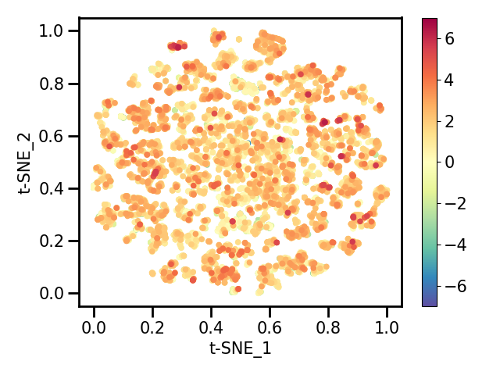
Supplementary Figure 1. Scatter plots showing t-distributed Stochastic Neighbor Embedding (t-SNE) of the DLKcat dataset. The color gradient represents experimentally measured k_{cat} values (logarithm with base 10) of data points, ranging from blue (-7) to red (7). The embedded vectors have been normalized to a range of 0 to 1.
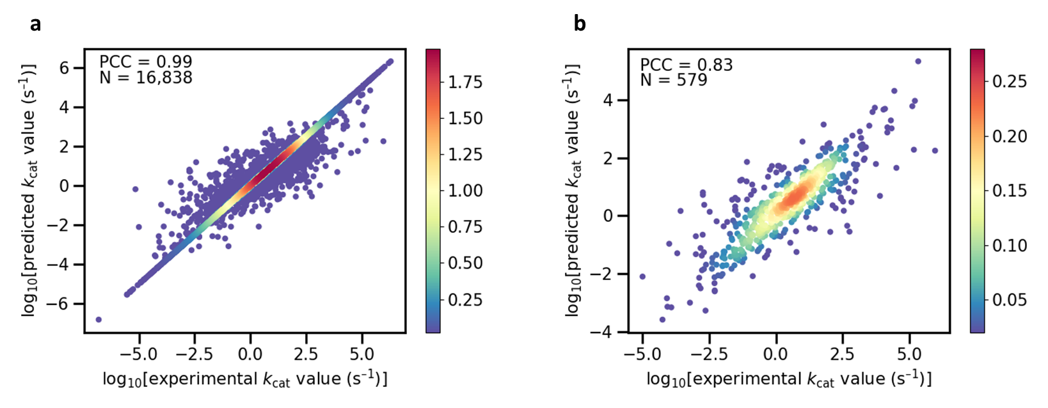
Supplementary Figure 2. a,b) Scatter plot illustrating the Pearson coefficient correlation (PCC) between experimentally measured k_{cat} values and predicted k_{cat} values of PreKcat for the entire dataset (a) (N=16,838) and strict test set (b) (N=579). The color gradient represents the density of data points, ranging from blue (0.02) to red (1.98 or 0.28).
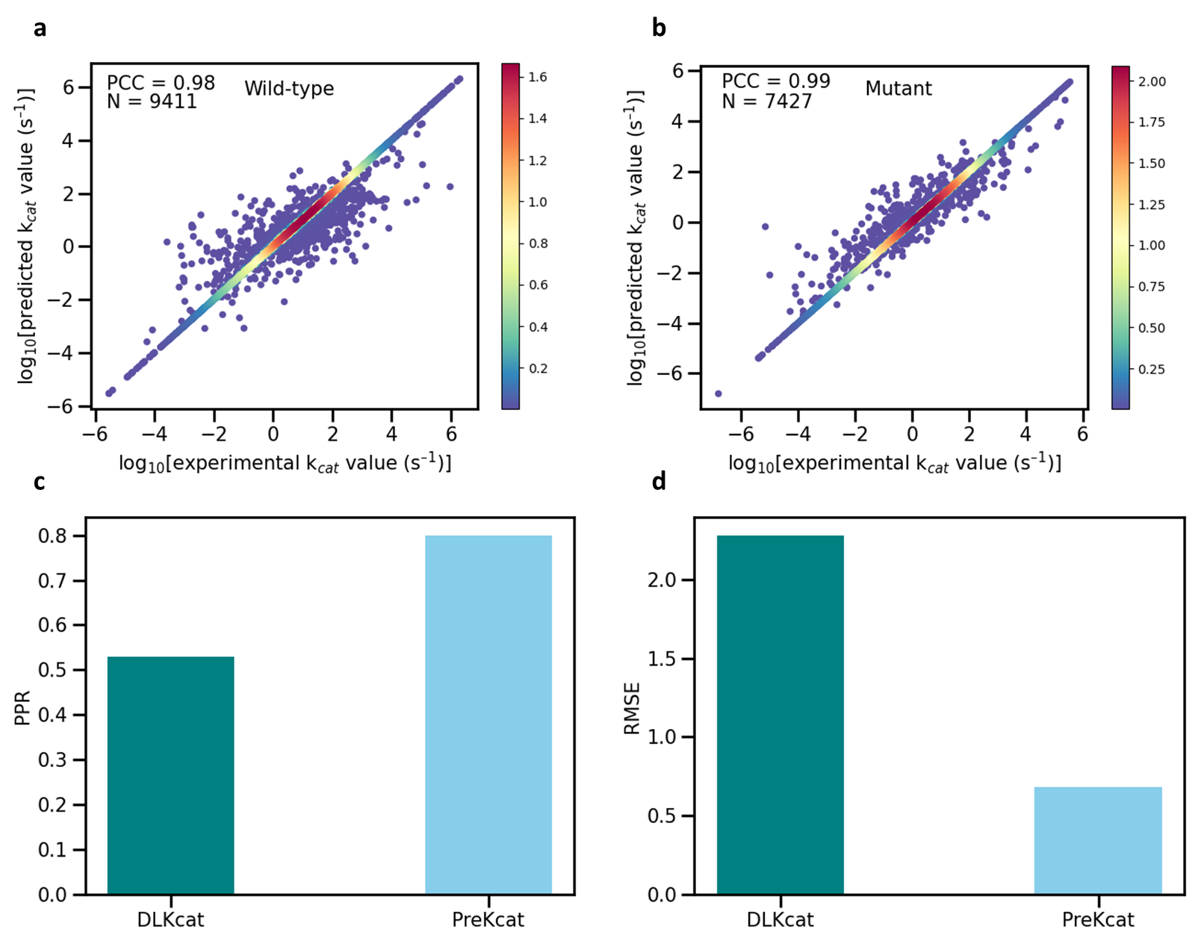
Supplementary Figure 3. a,b) Scatter plot illustrating the Pearson coefficient correlation (PCC) between experimentally measured k_{cat} values and predicted k_{cat} values enzymes of PreKcat for the of wild-type (a) (N=9,411) and mutated enzymes (b) (N=7,427). The color gradient represents the density of data points, ranging from blue (0.02) to red (1.98). c) The proportion of predicted accuracy (PPR) values on the test set of DLKcat and PreKcat. Dark bars represent PPR values of DLKcat and light bars for PreKcat. PPR is defined as the proportion of predicted values consistent with the actual values. d) Comparison of the root mean square error (RMSE) between experimentally measured kcat values and predicted k_{cat} values of DLKcat and PreKcat for pAcF aminoacyl-tRNA synthetase and its variants. Dark bars represent RMSE of DLKcat and light bars for PreKcat.

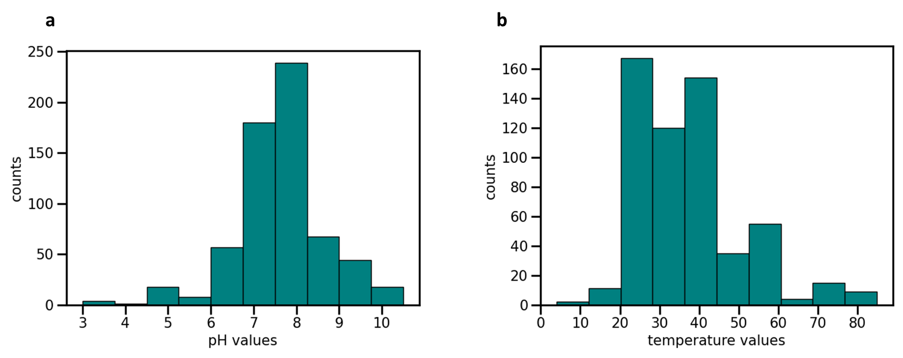
Supplementary Figure 4. a) Histogram of the distribution of pH values in the pH dataset. b) Histogram of the Distribution of temperature values in the temperature dataset.

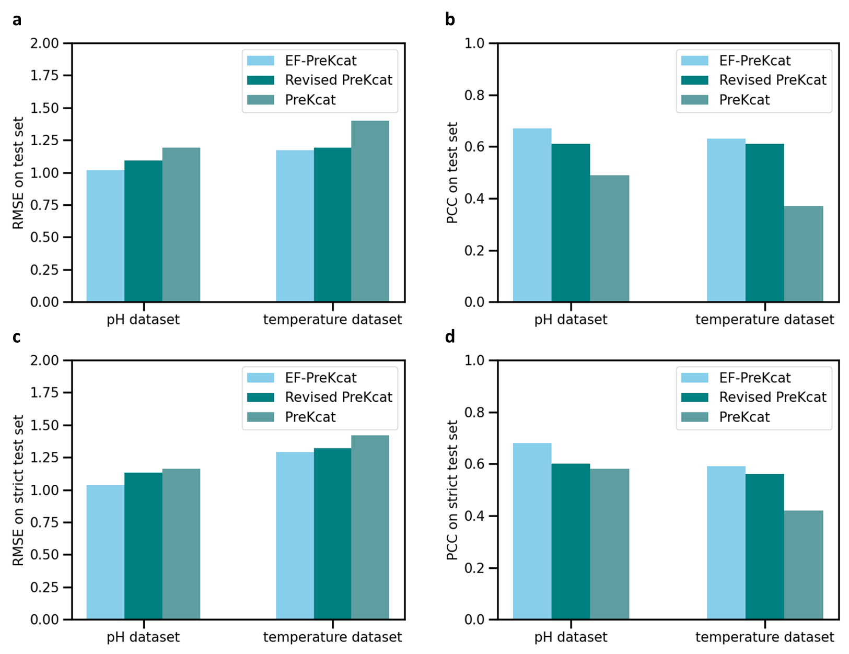
Supplementary Figure 5. a,b) Root mean square error (RMSE) (a) and Pearson coefficient correlation (PCC) (b) values between experimentally measured k_{cat} values and predicted k_{cat} values on pH and temperature test sets of EF-PreKcat, Revised PreKcat and PreKcat. Light bars represent values of EF-PreKcat, dark bars for Revised PreKcat and darkish bars for PreKcat. c,d) RMSE (c) and PCC (d) values between experimentally measured k_{cat} values and predicted k_{cat} values on more strict pH and temperature test sets of EF-PreKcat, Revised PreKcat and PreKcat. Light bars represent values of EF-PreKcat, dark bars for Revised PreKcat and darkish bars for PreKcat.

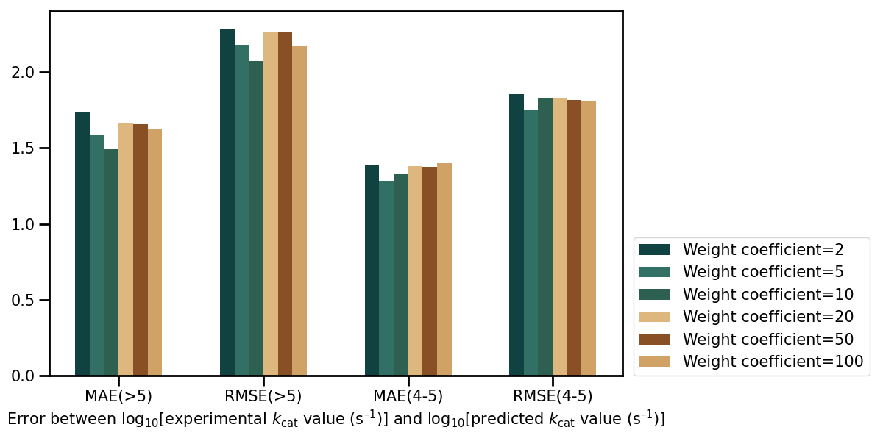
Supplementary Figure 6. Prediction errors (MAE and RMSE) of DMW method with different parameters in k_{cat} intervals between 4-5 and above 5 (>5).

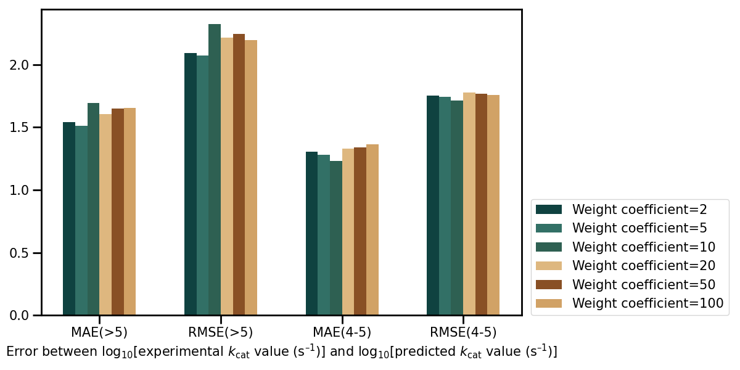
Supplementary Figure 7. Prediction errors (MAE and RMSE) of normalized DMW method with different parameters in k_{cat} intervals between 4-5 and above 5 (>5).

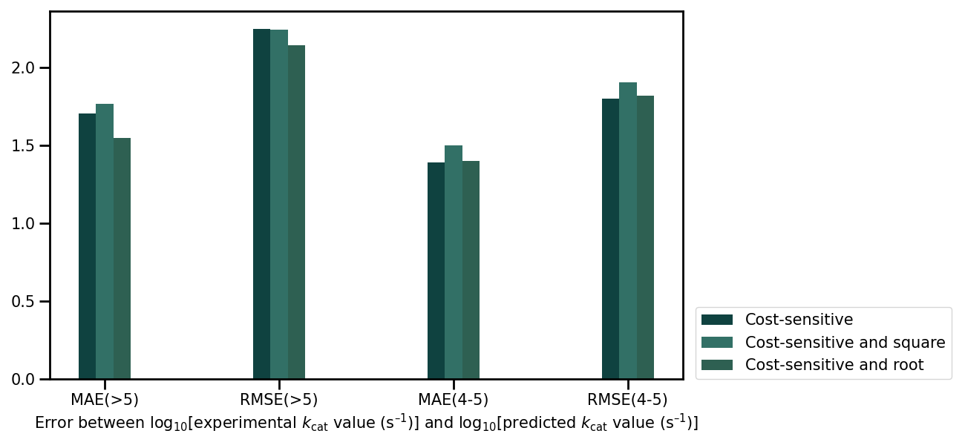
Supplementary Figure 8. Prediction errors (MAE and RMSE) of CSW method with different parameters in k_{cat} intervals between 4-5 and above 5 (>5).

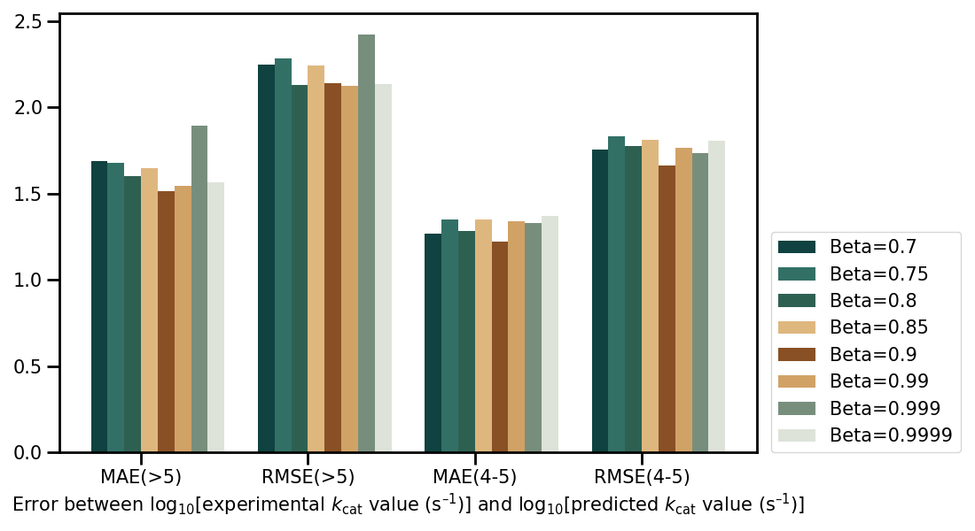
Supplementary Figure 9. Prediction errors (MAE and RMSE) of CBW method with different parameters in k_{cat} intervals between 4-5 and above 5 (>5).

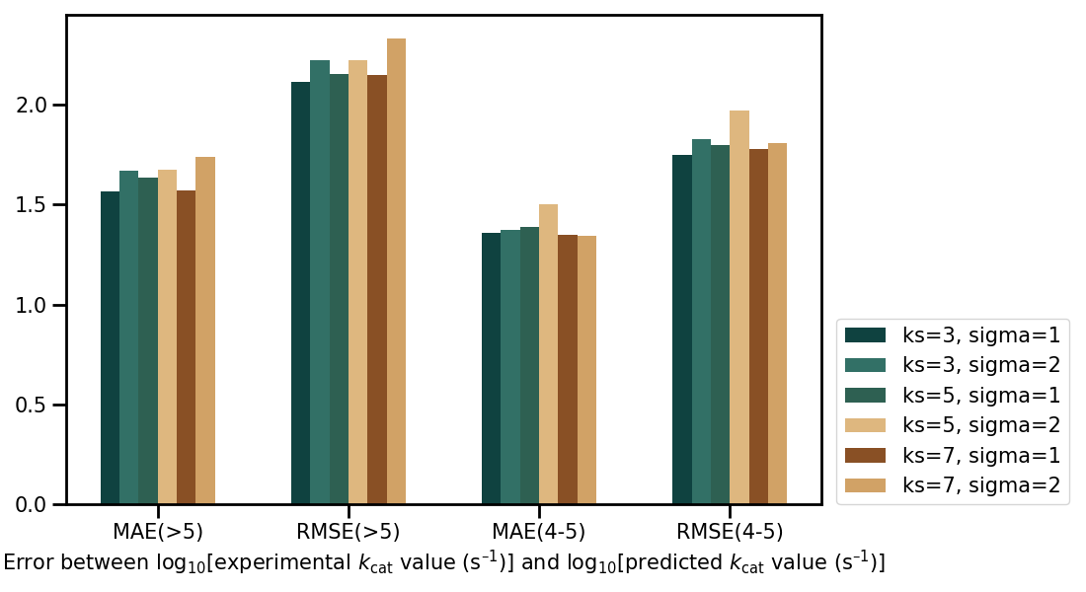
Supplementary Figure 10. Prediction errors (MAE and RMSE) of LDS method with different parameters in k_{cat} intervals between 4-5 and above 5 (>5).

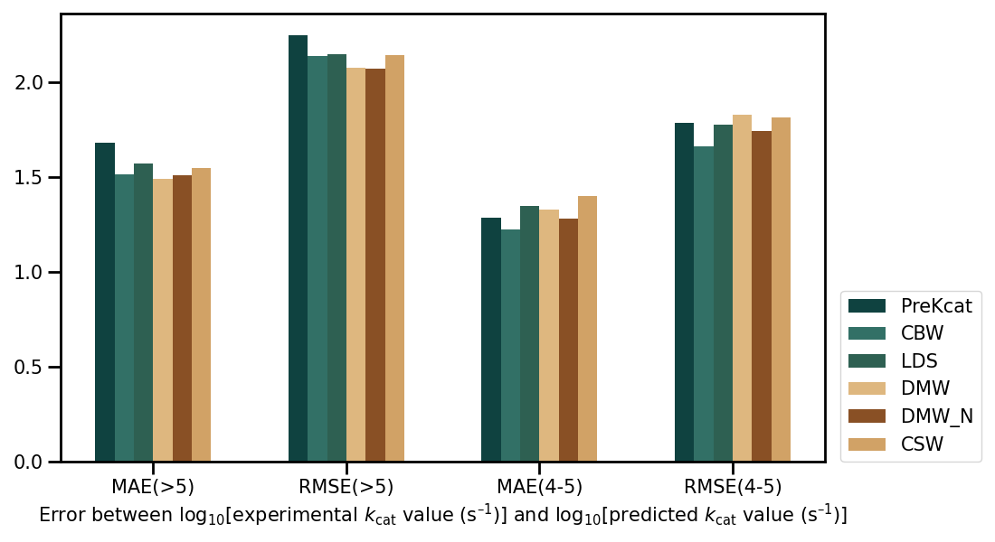
Supplementary Figure 11. Errors between the predicted and experimentally measured k_{cat} values in k_{cat} intervals between 4-5 and above 5 (>5) using various re-weighting methods and the initial PreKcat model.

Supplementary Table 1. Strains used in this study.
Strains | Relevant information | Sources
DH5α | F-ф80dlacZ△M15 △(lacZYAIargF)U169deoRrecA1endA1hsdR17(r_{K}⁻ m_{K}⁺) phoA△supE44thi-1gyrA96 relA1 | New England Biolabs
BL21(DE3) | F⁻ ompThsdS_{B} (rB⁻mB⁻) galdcm (DE3) | Invitrogen
T4SI | BL21(DE3) with plasmid pCDF_TAL_4CL_CHS_CHI | Lab stock
T4S_S8cK | BL21(DE3) with plasmids pCDF-T4S and pBbS8c_RFP | Lab stock
T4S_S8c_RgTAL | BL21(DE3) with plasmids pCDF-T4S and pBbS8c_RgTAL | Lab stock
T4S_S8c_AsTAL | BL21(DE3) with plasmids pCDF-T4S and pBbS8c_ AsTAL | This study
T4S_a8cK | BL21(DE3) with plasmids pCDF-T4S and pbba8c_RFP | Lab stock
T4S_a8c_RgTAL | BL21(DE3) with plasmids pCDF-T4S and pbba8c_RgTAL | Lab stock
T4S_a8c_ AsTAL | BL21(DE3) with plasmids pCDF-T4S and pbba8c_ AsTAL | This study
T4S_b8aK | BL21(DE3) with plasmids pCDF-T4S and pbbb8a_GFP | Lab stock
T4S_b8a_RgTAL | BL21(DE3) with plasmids pCDF-T4S and pbbb8a_RgTAL | Lab stock
T4S_b8a_AsTAL | BL21(DE3) with plasmids pCDF-T4S and pbbb8a_AsTAL | This study
T4S-E5KK | BL21(DE3) with plasmids pCDF-T4S and pBbE5K_RFP | Lab stock
T4S-E5K_RgTAL | BL21(DE3) with plasmids pCDF-T4S and pBbE5K_pBAD_RgTAL | Lab stock
T4S-E5K_AsTAL | BL21(DE3) with plasmids pCDF-T4S and pBbE5K_pBAD_AsTAL | This study
T4S-RSFK | BL21(DE3) with plasmids pCDF-T4S and pRSF_Duet-1 | Lab stock
T4S-RSF_RgTAL | BL21(DE3) with plasmids pCDF-T4S and pRSF_pBAD_ RgTAL | Lab stock
T4S-RSF_AsTAL | BL21(DE3) with plasmids pCDF-T4S and pRSF_pBAD_AsTAL | This study

Supplementary Table 2. Plasmids used in this study.
Plasmids | Relevant information | Notes
pBbS8c_RFP | Cm^{R}, SC101 origin of replication | [1]
pBbS8C-RgTAL | TAL was cloned into pBbS8C plasmid | Lab stock
pBbS8C-AsTAL | AsTAL was cloned into pBbS8C plasmid | This study
pBba8C_RFP | Cm^{R}, p15a origin of replication | [1]
pBba8C-RgTAL | TAL was cloned into pBba8C plasmid | Lab stock
pBba8C-AsTAL | AsTAL was cloned into pBba8C plasmid | This study
pBbb8a_RFP | Amp^{R}, BBR1 1 origin of replication | [1]
pBbb8a-RgTAL | TAL was cloned into pBbb8a plasmid | Lab stock
pBbb8a-AsTAL | AsTAL was cloned into pBbb8a plasmid | This study
pBbE5K-pBAD | Kana^{R}, colE1 origin of replication | [1]
pBbE5K-pBAD-RgTAL | The cassette containing pBAD promoter and TAL gene were cloned into pBbE5K plasmid | Lab stock
pBbE5K-pBAD-AsTAL | The cassette containing pBAD promoter and AsTAL gene were cloned into pBbE5K plasmid | This study
pRSFDuet-1 | Kana^{R}, RSF origin of replication | Novagen
RSF-pBAD-RgTAL | The cassette containing pBAD promoter and TAL gene were cloned into RSF plasmid | Lab stock
RSF-pBAD-AsTAL | The cassette containing pBAD promoter and AsTAL gene were cloned into RSF plasmid | This study
pCDFDuet-1 | Str^{R}, CloDF13 origin of replication | Novagen
pCDF-T4SI | TAL, 4CL, CHS and CHI were cloned into the CDF plasmid | This study
pCDF-4SI | 4CL, CHS and CHI were cloned into the CDF plasmid | This study
pET32a | Amp^{R}, pBR322origin of replication | Novagen
pET32a-RgTAL | Amp^{R}, pBR322origin of replication | Lab stock
pET32a-HiTAL | Amp^{R}, pBR322origin of replication | This study
pET32a-PcTAL | Amp^{R}, pBR322origin of replication | This study
pET32a-SsTAL | Amp^{R}, pBR322origin of replication | This study
pET32a-AsTAL | Amp^{R}, pBR322origin of replication | This study
pET32a-IsTAL | Amp^{R}, pBR322origin of replication | This study
pET32a-LiTAL | Amp^{R}, pBR322origin of replication | This study
pET32a- TaTAL | Amp^{R}, pBR322origin of replication | This study

Supplementary Table 3. Primers used in this study.
Primers | Nucleotides
S8C_fwd | gaaactgtaaGGATCCAAACTCGAGTAAG
S8C_rev | tcgccggcatATGTATATCTCCTTCTTAAAAGATC
S8C_ AsTAL_fwd | agatatacatATGCCGGCGAGTGTGTTC
S8C_ AsTAL_rev | gtttggatccTTACAGTTTCACATGCGGCAG
a8c_fwd | gaaactgtaaGGATCCAAACTCGAGTAAG
a8c_rev | tcgccggcatAAGCTTATGTATATCTCCTTC
a8C_ AsTAL_fwd | acataagcttATGCCGGCGAGTGTGTTC
a8C_ AsTAL_rev | gtttggatccTTACAGTTTCACATGCGGCAG
b8a_fwd | gaaactgtaaGGATCCAAACTCGAGTAAG
b8a_rev | tcgccggcatATGTATATCTCCTTCTTAAAAGATC
b8a_ AsTAL_fwd | agatatacatATGCCGGCGAGTGTGTTC
b8a_ AsTAL_rev | gtttggatccTTACAGTTTCACATGCGGCAG
e5k_fwd | gaaactgtaaGGATCCAAACTCGAGTAAG
e5k_rev | tcgccggcatATGTATATCTCCTTCTTAAAAGATC
e5k_ AsTAL_fwd | agatatacatATGCCGGCGAGTGTGTTC
e5k_ AsTAL_rev | gtttggatccTTACAGTTTCACATGCGGCAG
RSF_fwd | gaaactgtaaGGATCCAAACTCGAGTAAG
RSF_rev | tcgccggcatATGTATATCTCCTTCTTAAAAGATC
RSF_ AsTAL_fwd | agatatacatATGCCGGCGAGTGTGTTC
RSF_ AsTAL_rev | gtttggatccTTACAGTTTCACATGCGGCAG

REFERENCES
1. Lee, Taek Soon, et al. BglBrick vectors and datasheets: a synthetic biology platform for gene expression. Journal of biological engineering 5, 1-14 (2011).

