Supplementary figures

Supplementary figure 1
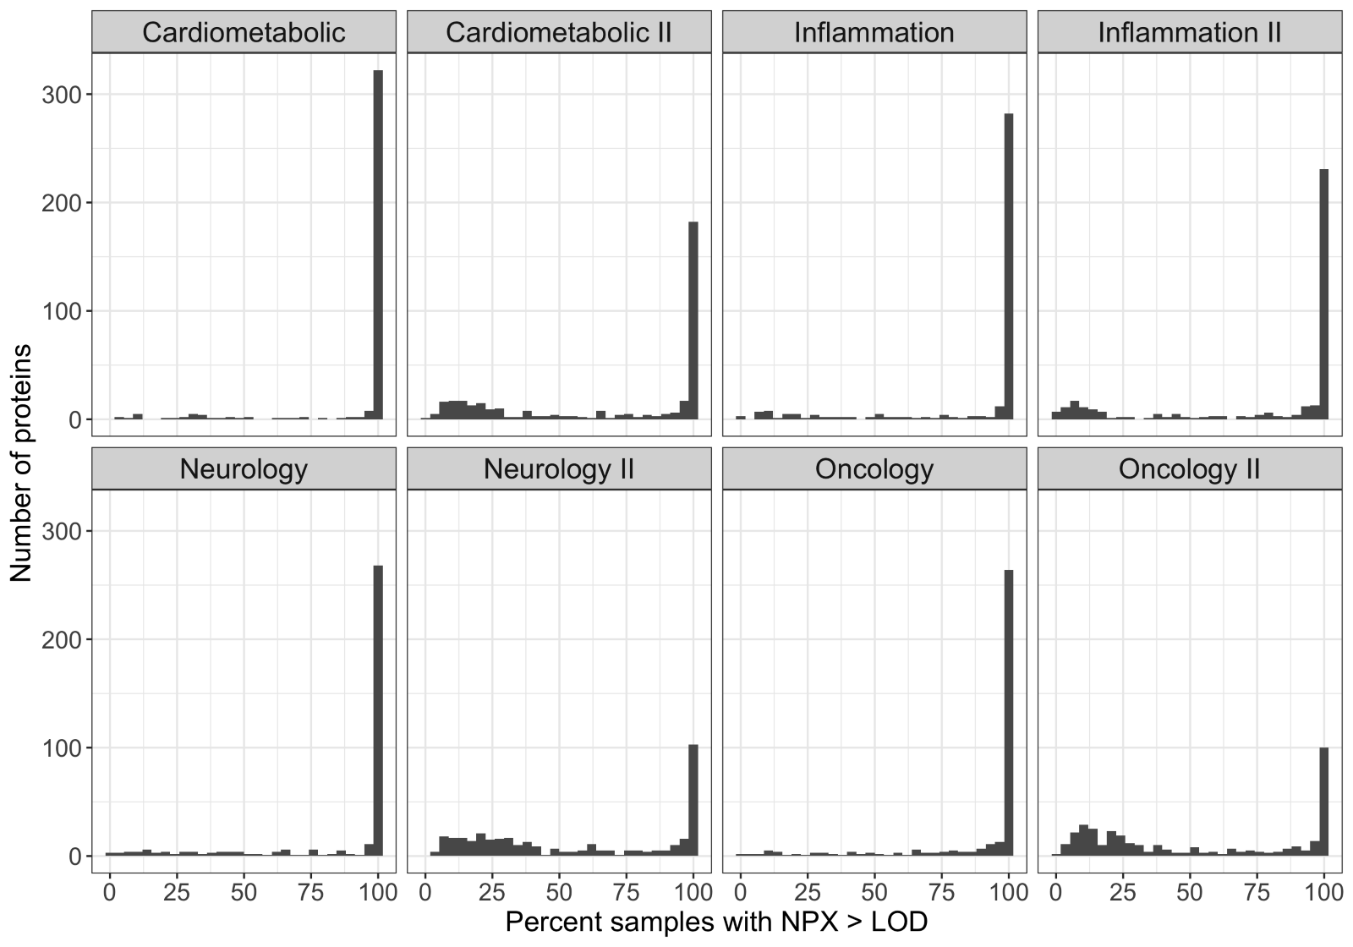
Supplementary Figure 1: Histograms showing the percent of samples with NPX above the limit of detection (x-axis) per protein. The number of proteins in each bin are indicated on the y-axis. Each figure-panel corresponds to one of the 8 panels into which the ~3K proteins are grouped.

Supplementary figure 2

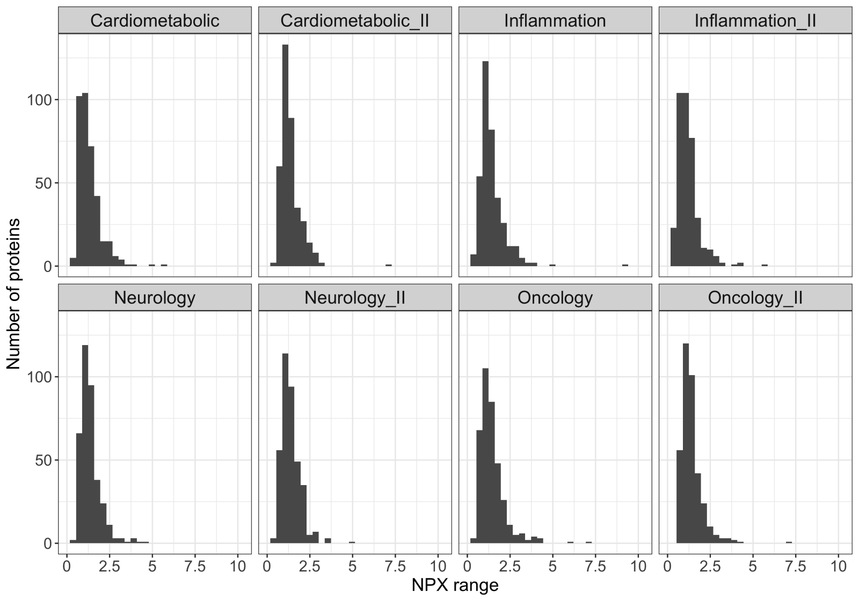
Supplementary figure 2: Histograms showing the range of NPX values (x-axis), defined as the 90th percentile - the 10th percentile, per protein. The number of proteins in each bin are indicated on the y-axis. Each figure-panel corresponds to one of the 8 panels into which the ~3K proteins are grouped. The ranges per protein (calculated as the 90th percentile - the 10th percentile to avoid outlier effects) varied between 0.17NPX and 9.27NPX, with an average of 1.36NPX, corresponding to a 2^1.36 ~2.6-fold difference in protein abundance between 10th and 90th percentiles (supplementary figure 2).

Supplementary figure 3

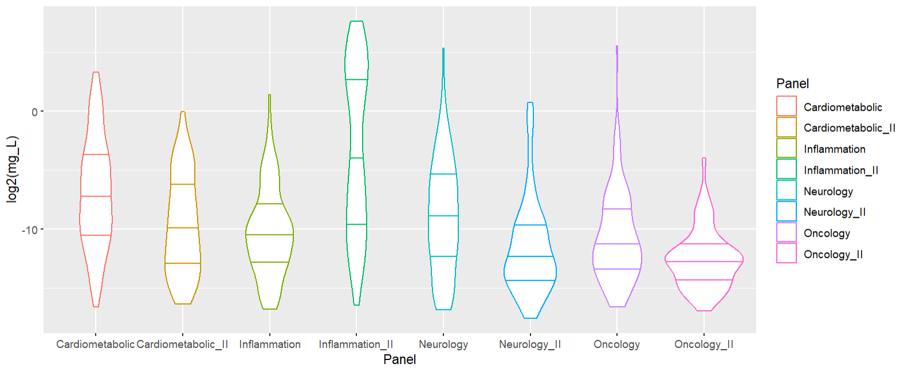
Supplementary figure 3: Violin plots showing the plasma protein abundance for proteins that overlap with the Olink Explore PEA assay. The data were based on mass spectrometry analysis from the Human Protein Atlas project and is publicly available (www.proteinatlas.org).

Supplementary figure 4

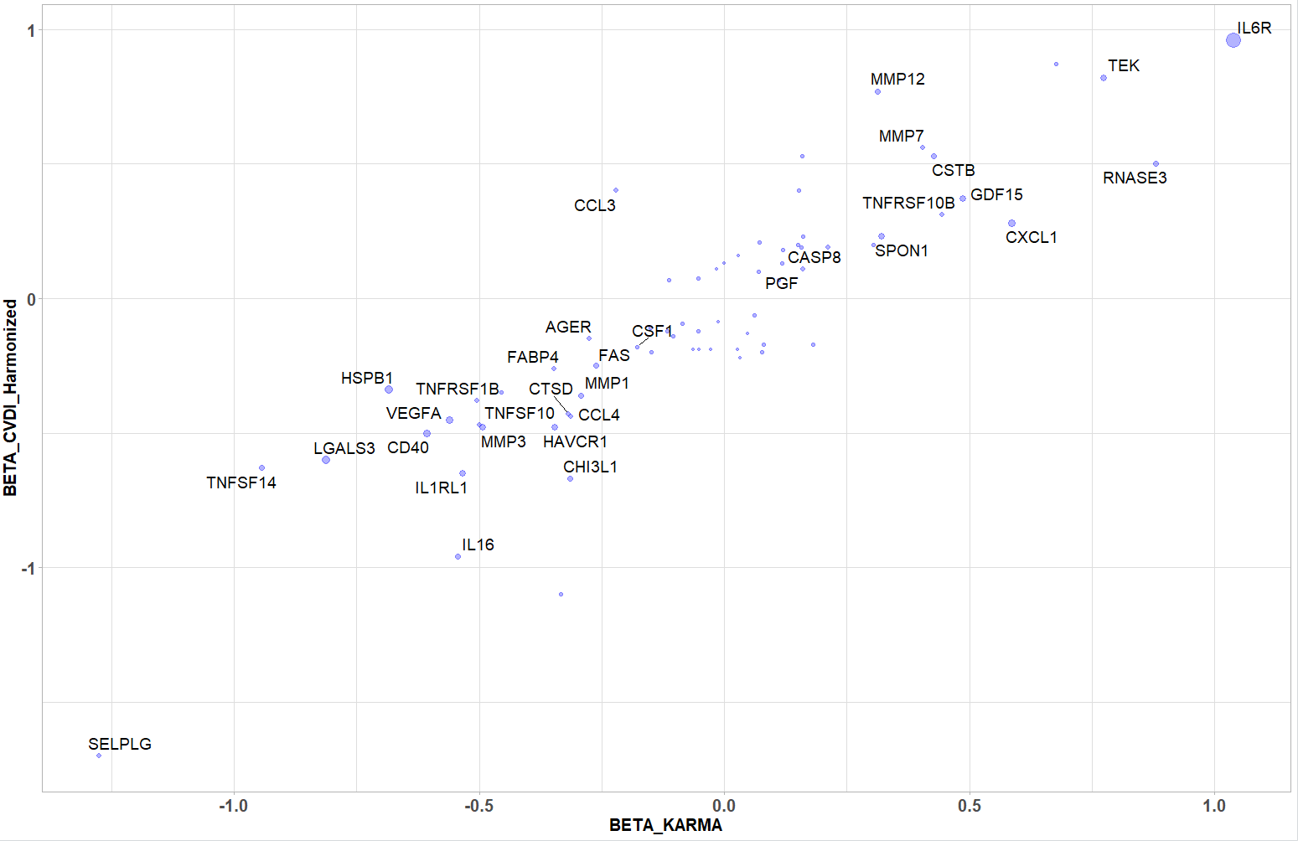
Supplementary figure 4. The beta-estimates for cis-pQTL identified in a previous study (Folkersen et al Nat. Metab. 2020) were compared with the beta-estimates of the same cis-pQTL in the KARMA study. The R2 correlation coefficient for the subset of pQTL with nominal significance (p<0.05) was 0.91.

Supplementary figure 5

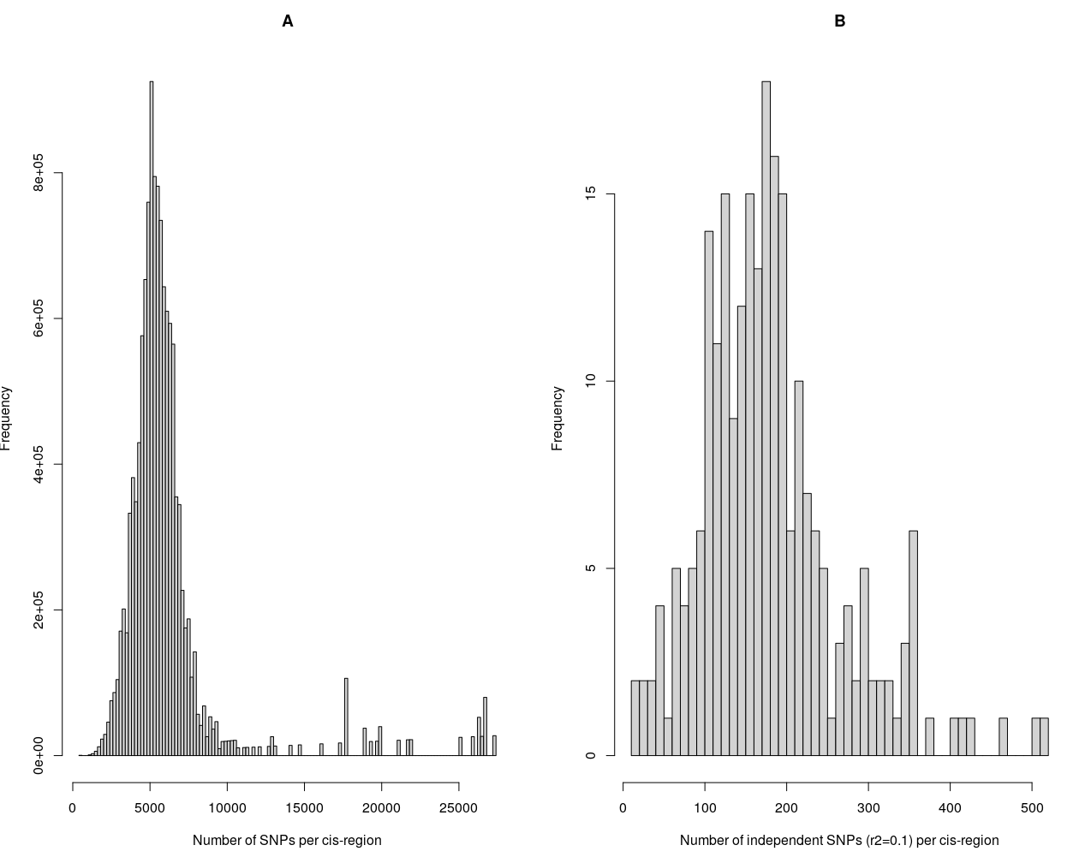
Supplementary Figure 4A and 4B. Histograms of number of tested SNPs per cis-region for all proteins with less than 75% missingness. Panel (a) shows the distribution of total number of SNPs per cis-region with the average number of SNPs equal to 6249.3. Panel (b) shows the distribution of number of independent SNPs (r² =0.1, xxx kb) per cis-region with the average number of SNPs equal to 180.4 (min,max 12-511), corresponding to a Bonferroni p-value of 2.77E-04. Across all cis-associations FDR (Q value) estimate at FDR 5% corresponds to a nominal p-value < 5.54E-04, FDR 1% to a nominal p-value < 7.63E-05.

Supplementary figure 6
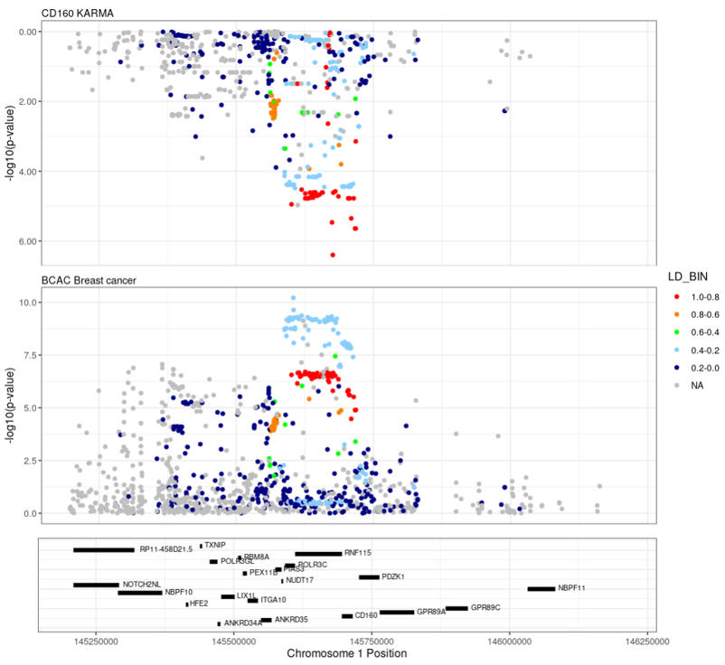

Supplementary Figure 6. Mirror plot showing the genomic region of the CD160 cis-pQTL from the KARMA association analysis, and the same region in the BCAC breast cancer case/control analysis. The Y-axis shows the -log(10) p-value, the X-axis shows genomic position. LD stands for linkage disequilibrium.

Supplementary figure 7
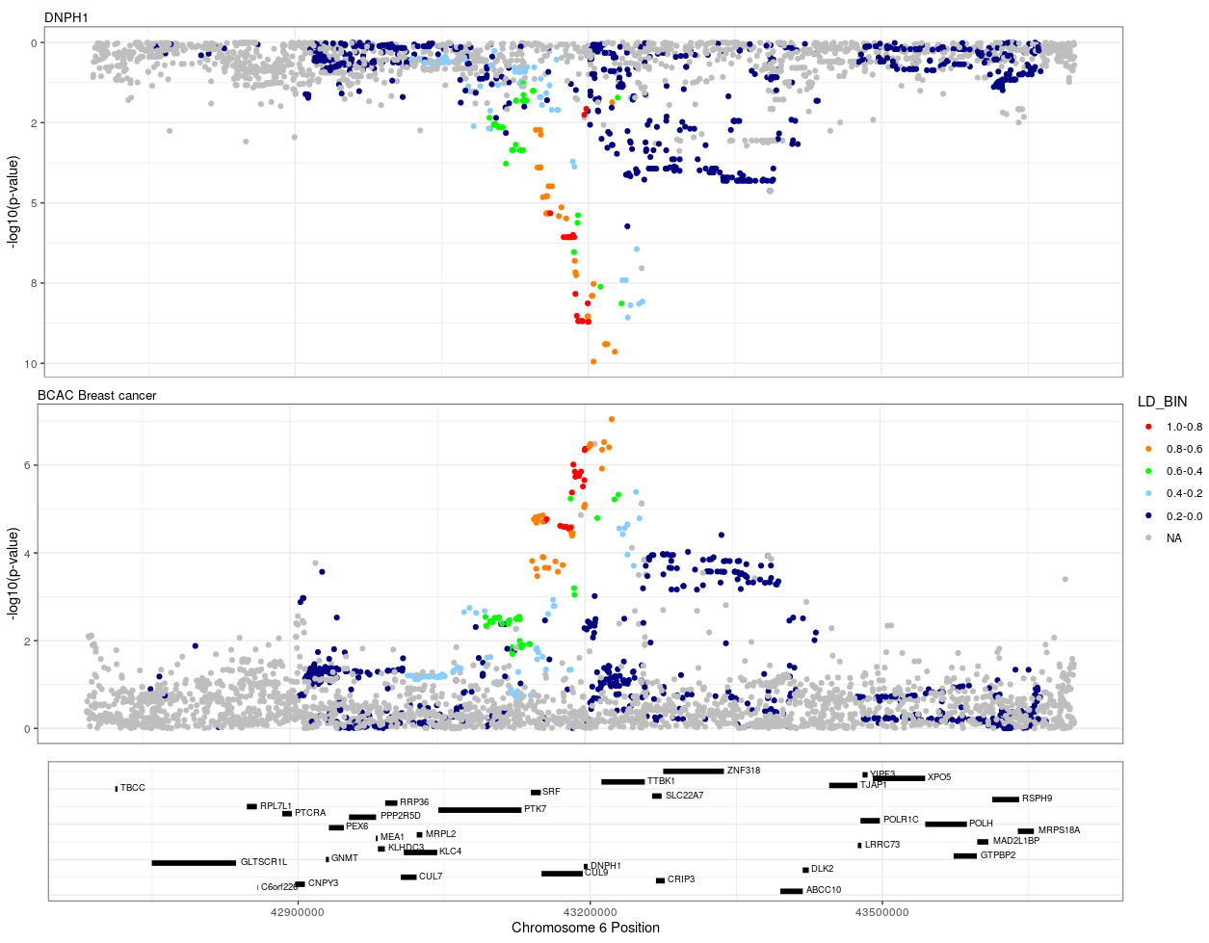
Supplementary Figure 7. Mirror plot showing the genomic region of the DNPH1 cis-pQTL from the KARMA association analysis, and the same region in the BCAC breast cancer case/control analysis. The Y-axis shows the -log(10) p-value, the X-axis shows genomic position. LD stands for linkage disequilibrium.

Supplementary figure 8
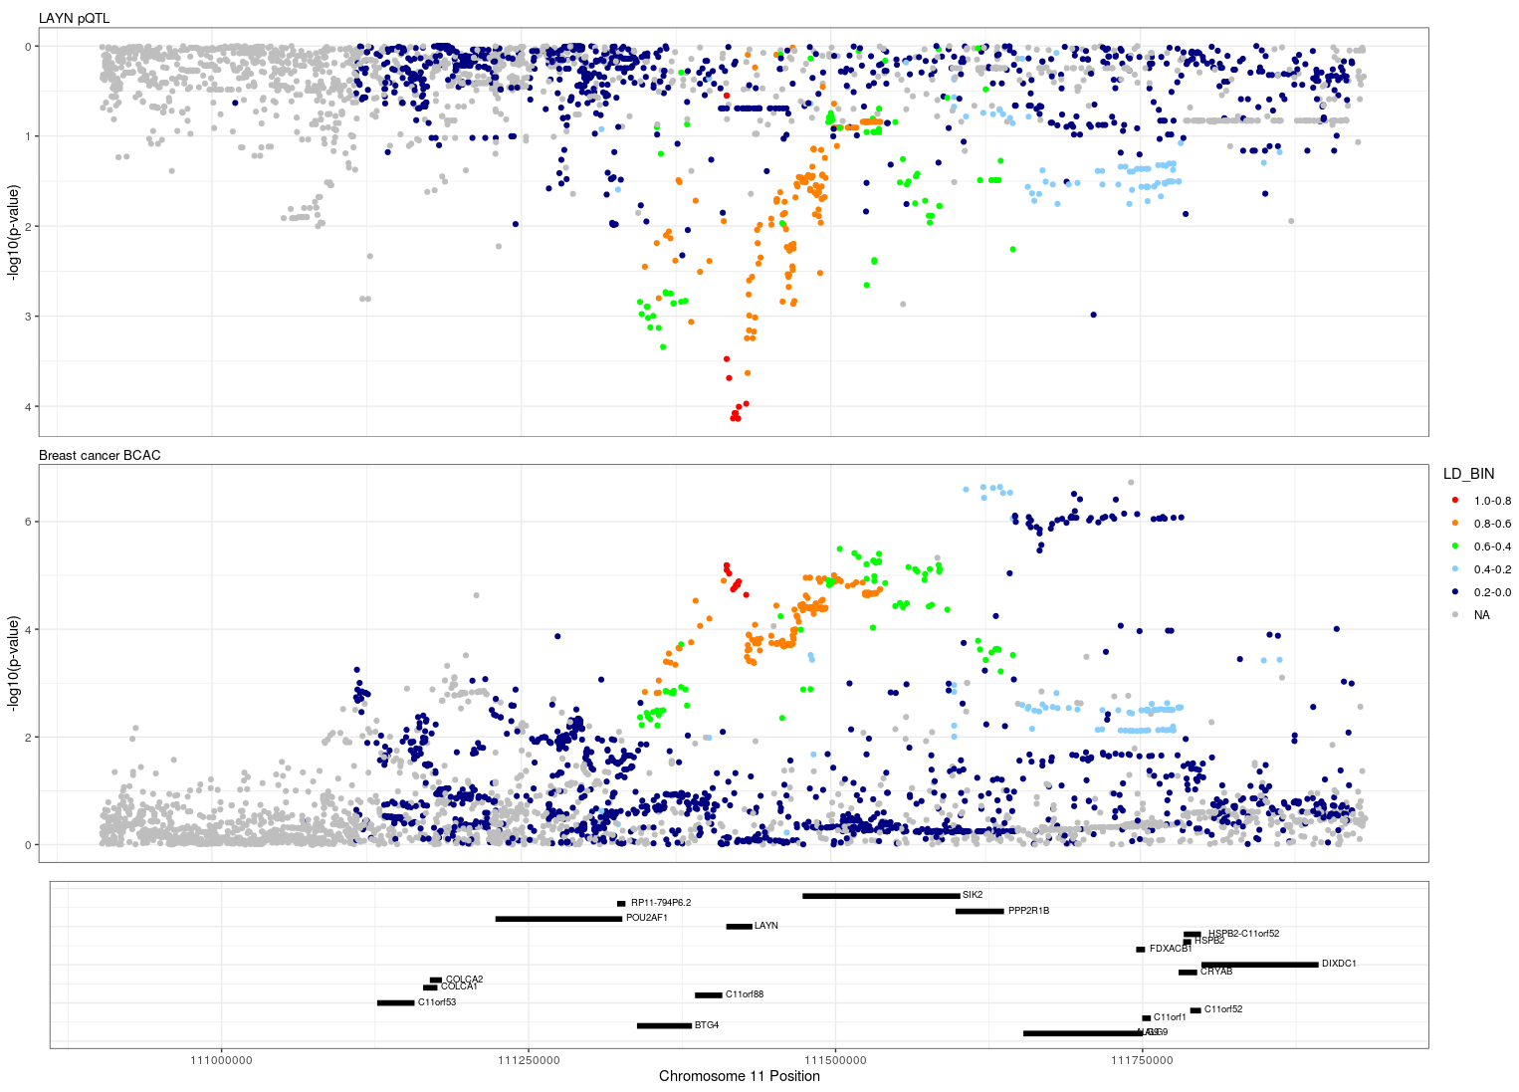
Supplementary Figure 8. Mirror plot showing the genomic region of the LAYN cis-pQTL from the KARMA association analysis, and the same region in the BCAC breast cancer case/control analysis. The Y-axis shows the -log(10) p-value, the X-axis shows genomic position. LD stands for linkage disequilibrium.

Supplementary figure 9

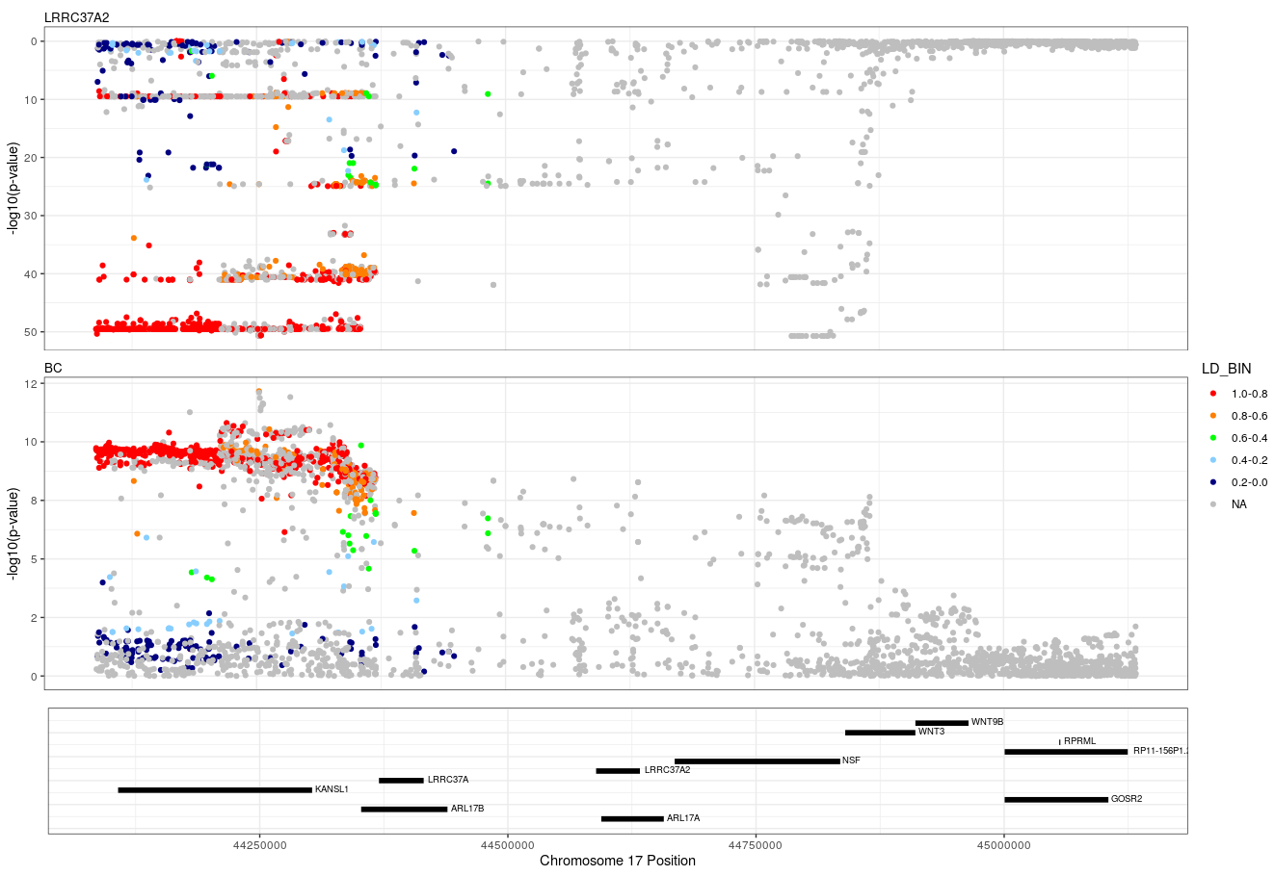
Supplementary Figure 9. Mirror plot showing the genomic region of the LRRC37A2 cis-pQTL from the KARMA association analysis, and the same region in the BCAC breast cancer case/control analysis. The Y-axis shows the -log(10) p-value, the X-axis shows genomic position. LD stands for linkage disequilibrium.

Supplementary figure 10

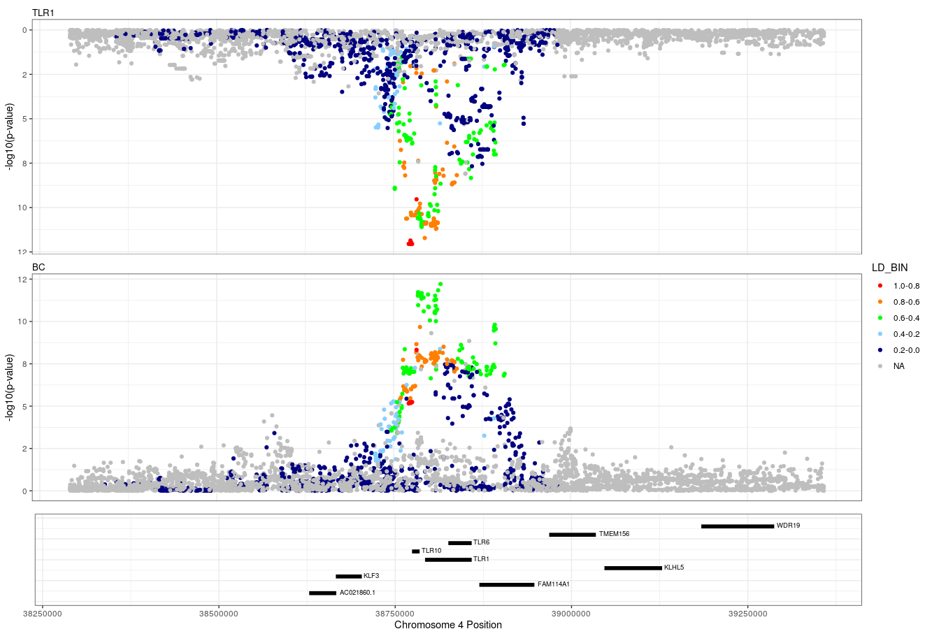
Supplementary Figure 10. Mirror plot showing the genomic region of the TLR1 cis-pQTL from the KARMA association analysis, and the same region in the BCAC breast cancer case/control analysis. The Y-axis shows the -log(10) p-value, the X-axis shows genomic position. LD stands for linkage disequilibrium.

