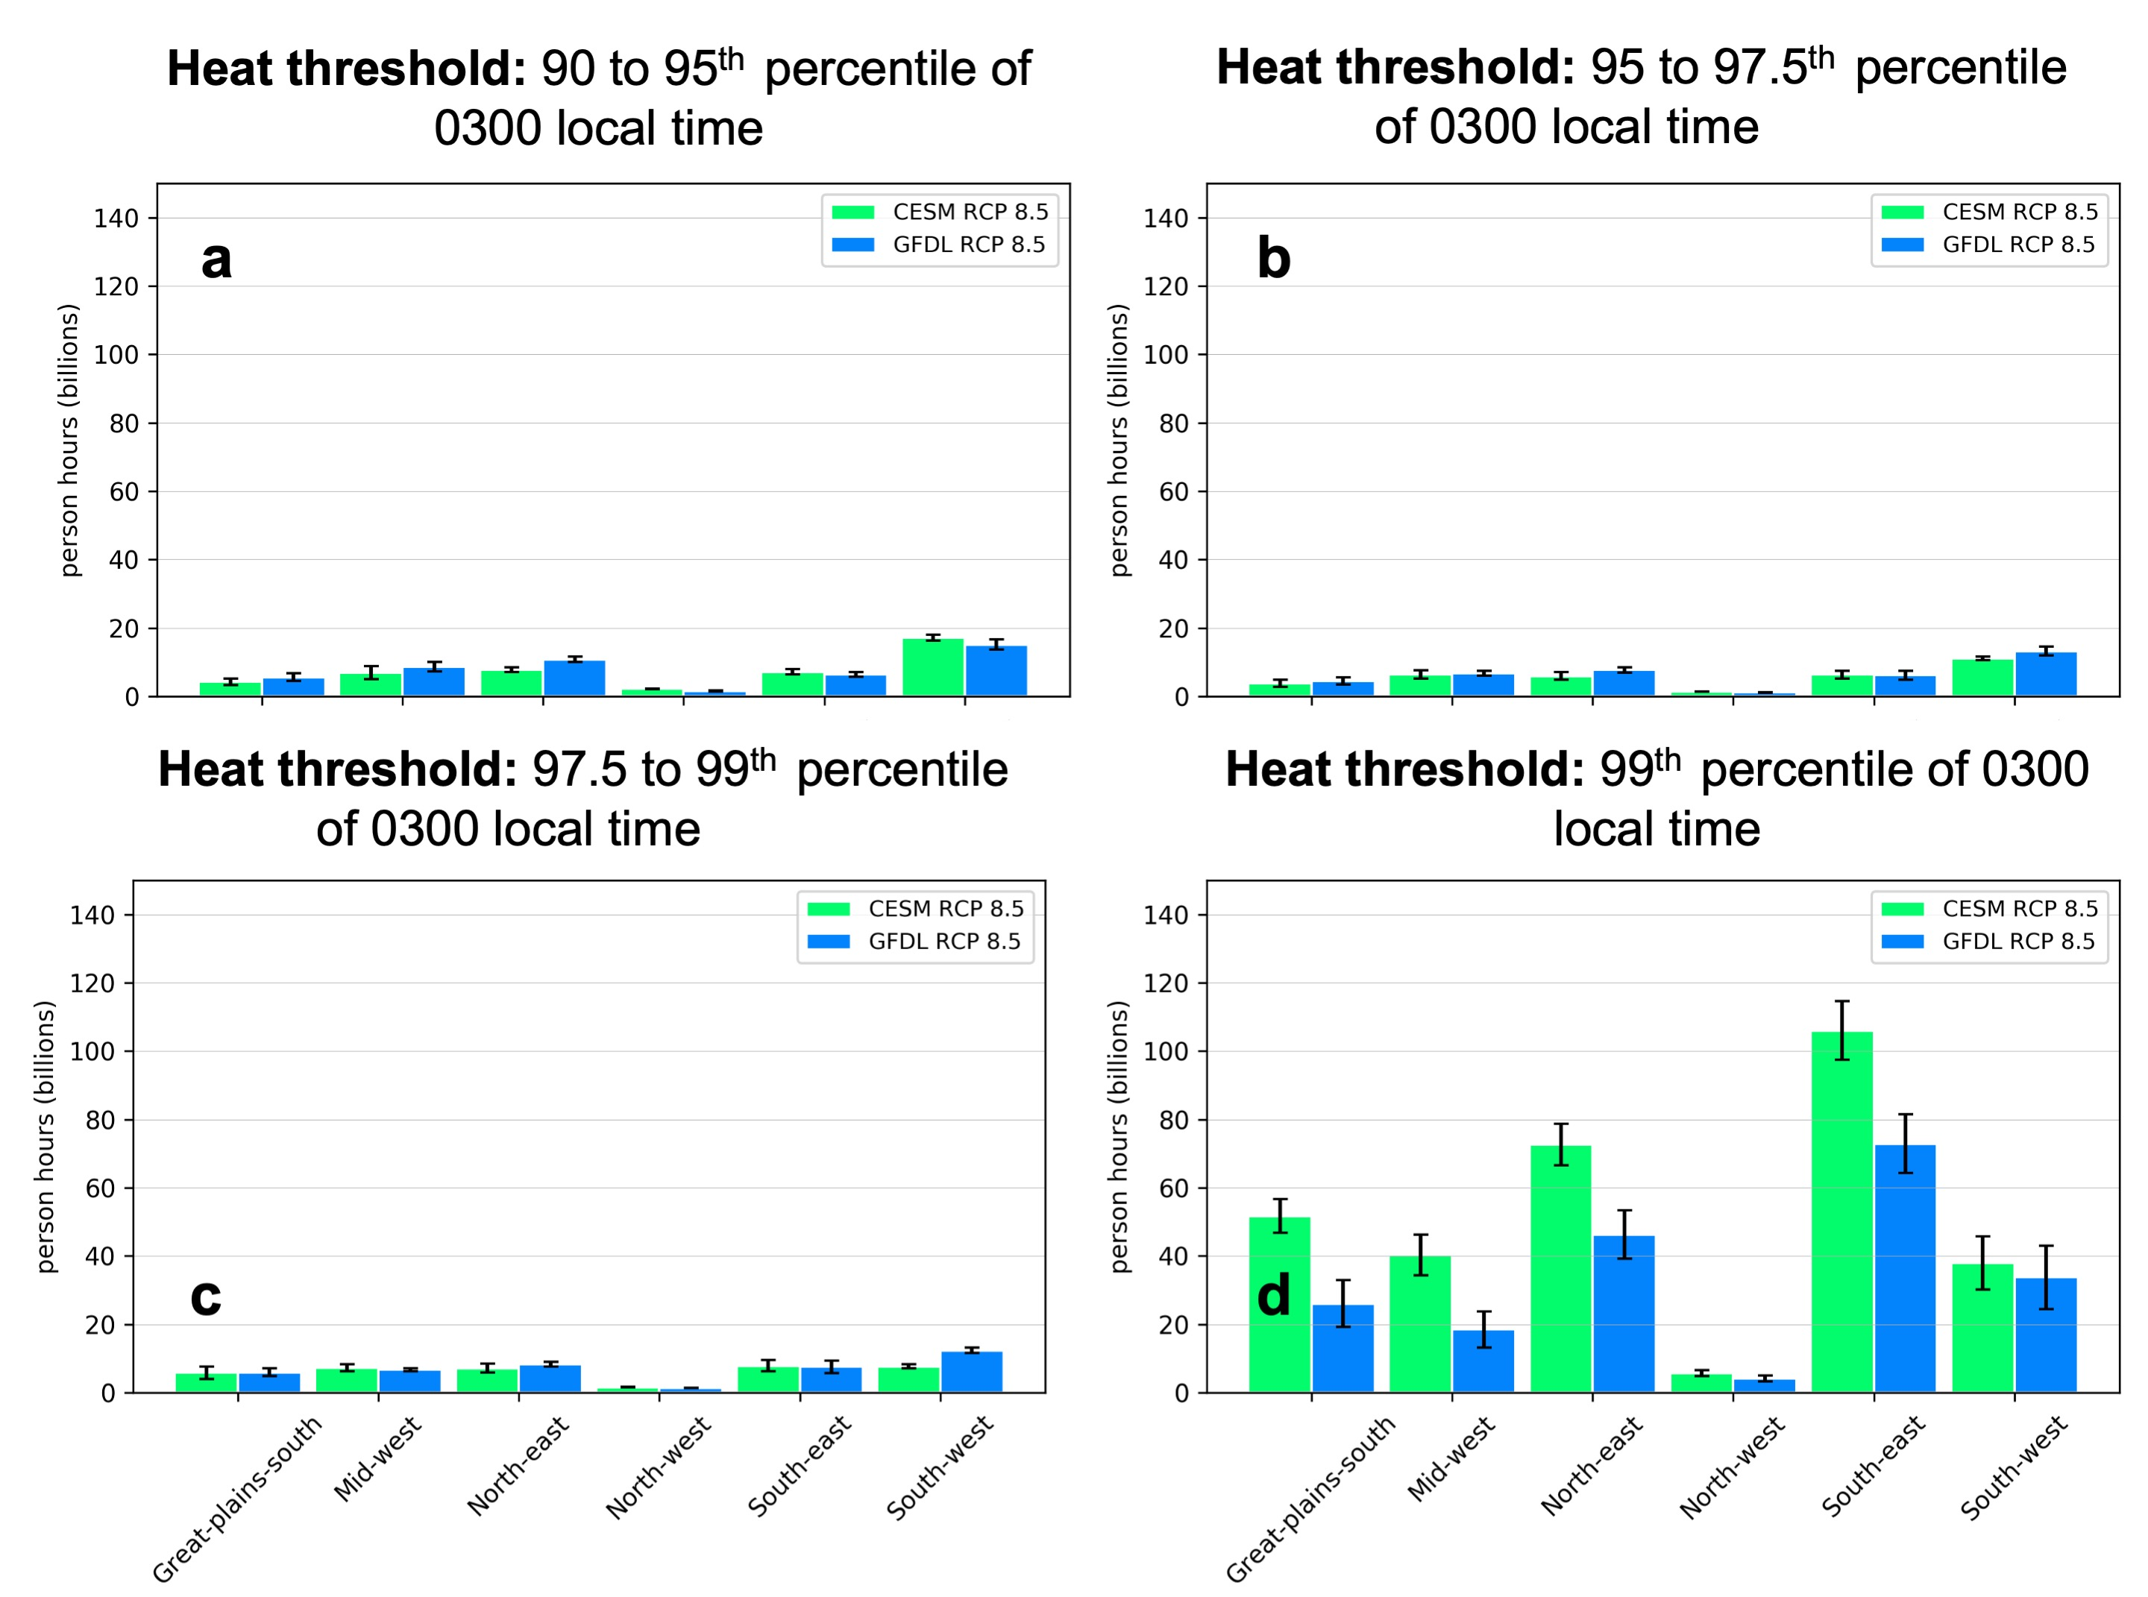
Supplemental Figure 1. As Figure 1 but for 0300 local time defined nighttime extreme heat thresholds.
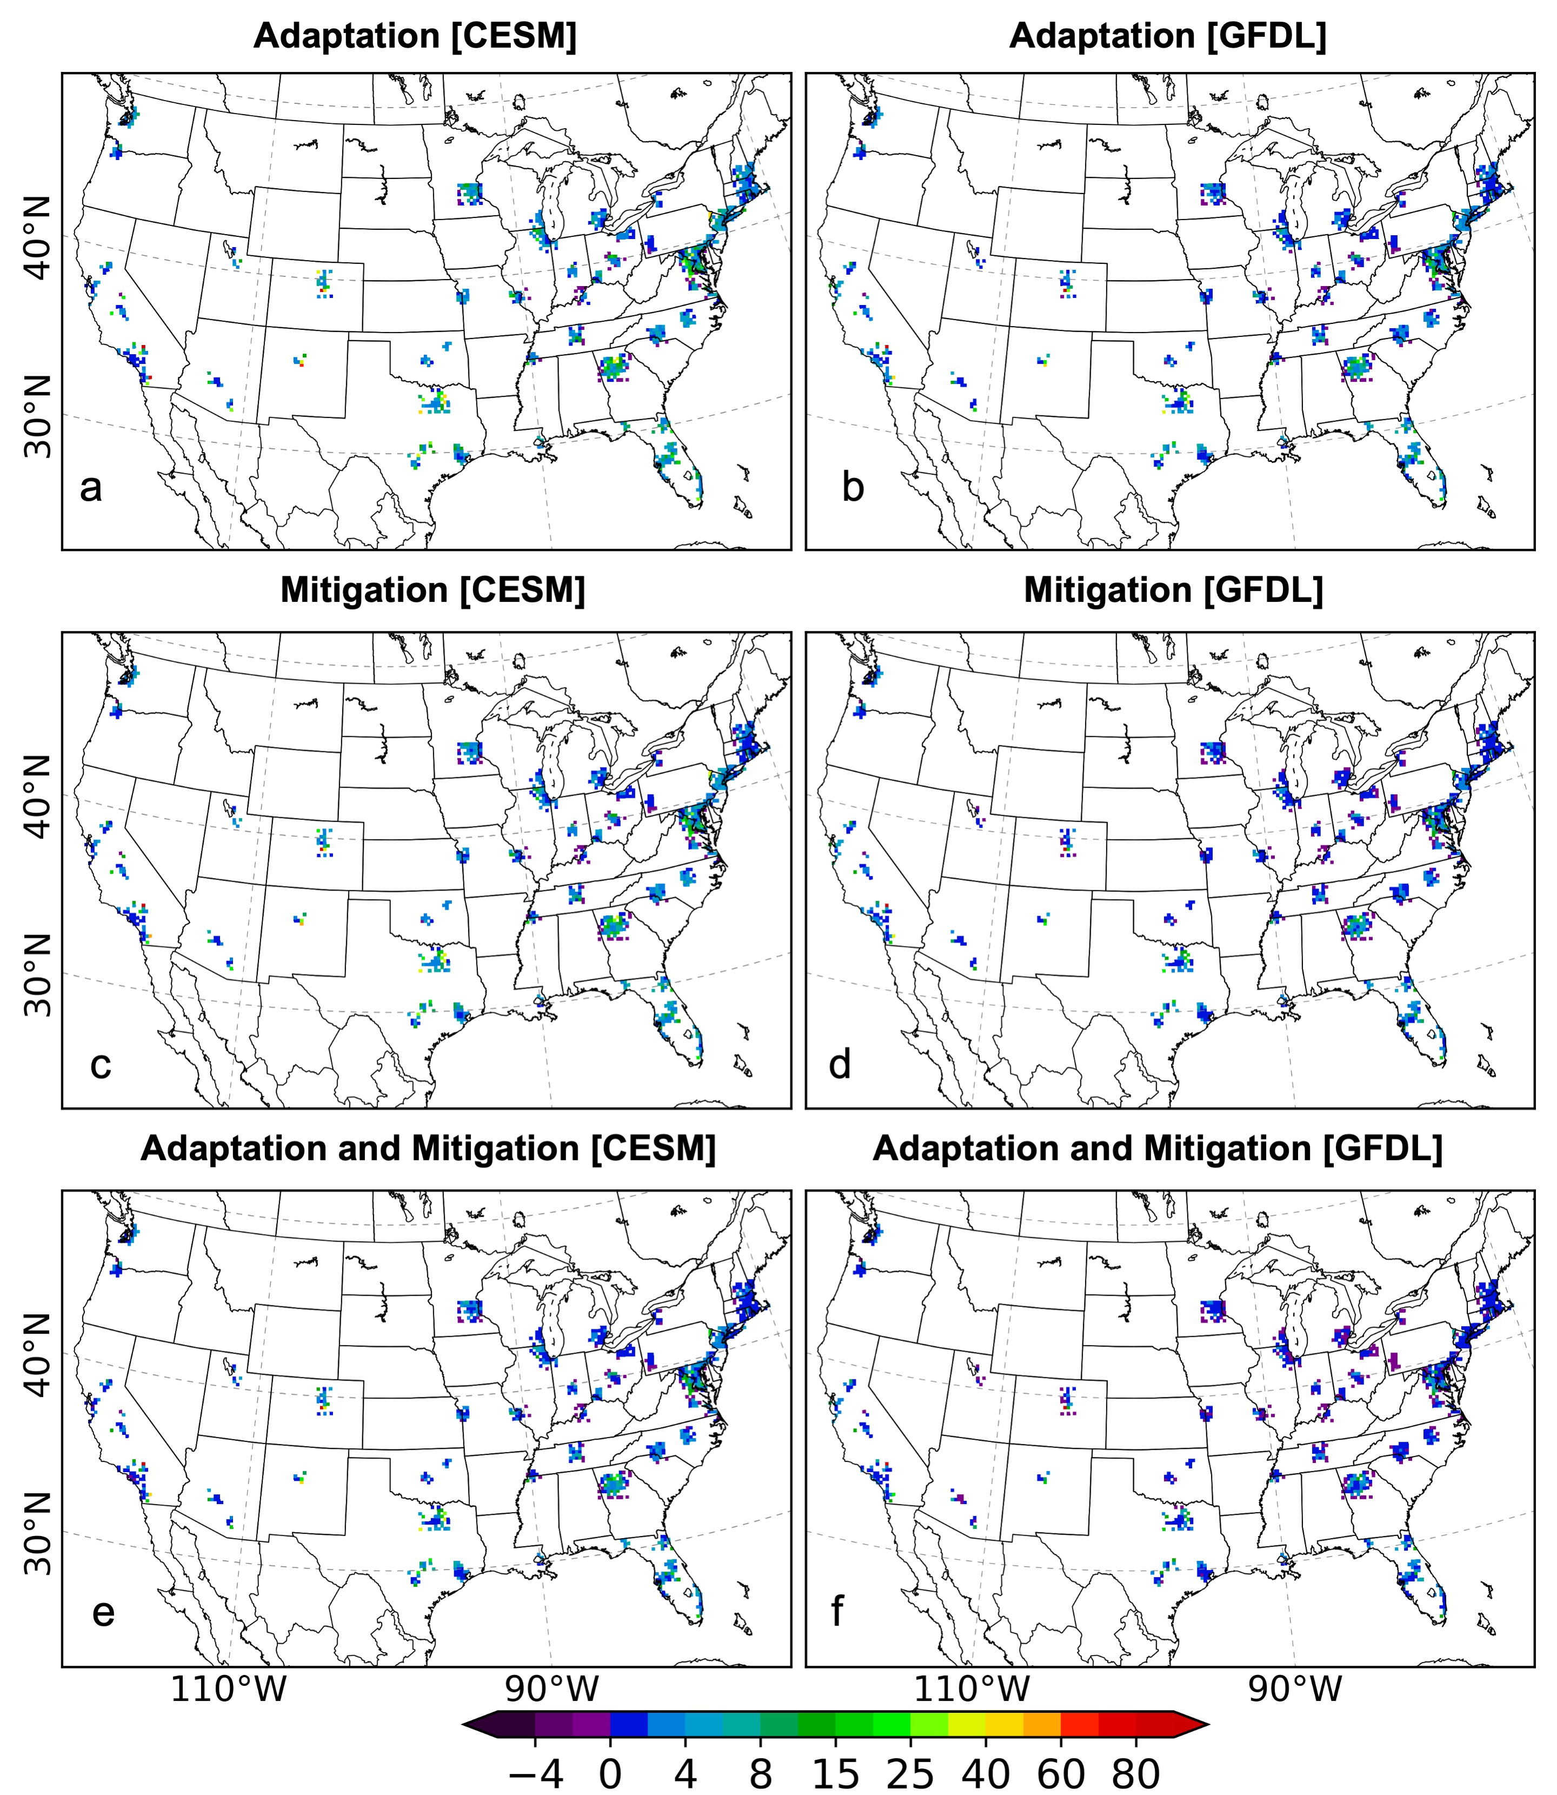Supplemental Figure 2. As Figure 2 but for 0300 local time defined nighttime extreme heat thresholds.
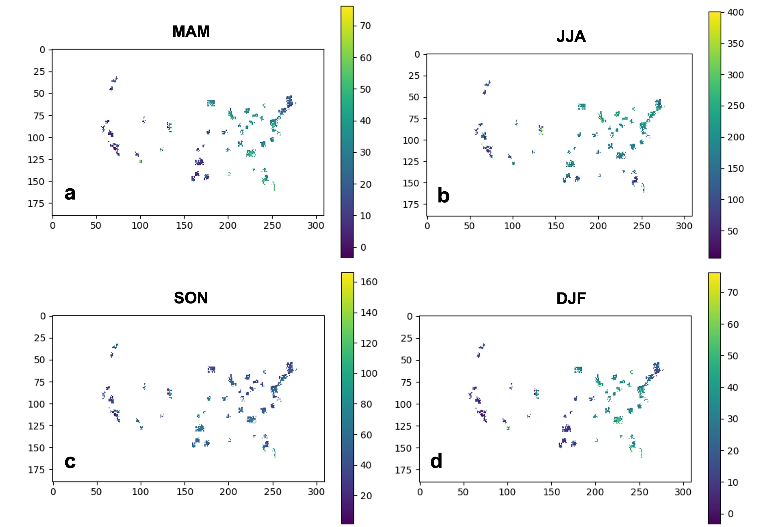Supplemental Figure 3. Average seasonal (MAM: March-April-May; JJA: June-July-August; SON: September-October-November; DJF: December-January-February) change in 90th to <95th percentile of 1500 local time hot hours for the CESM-driven WRF simulations.
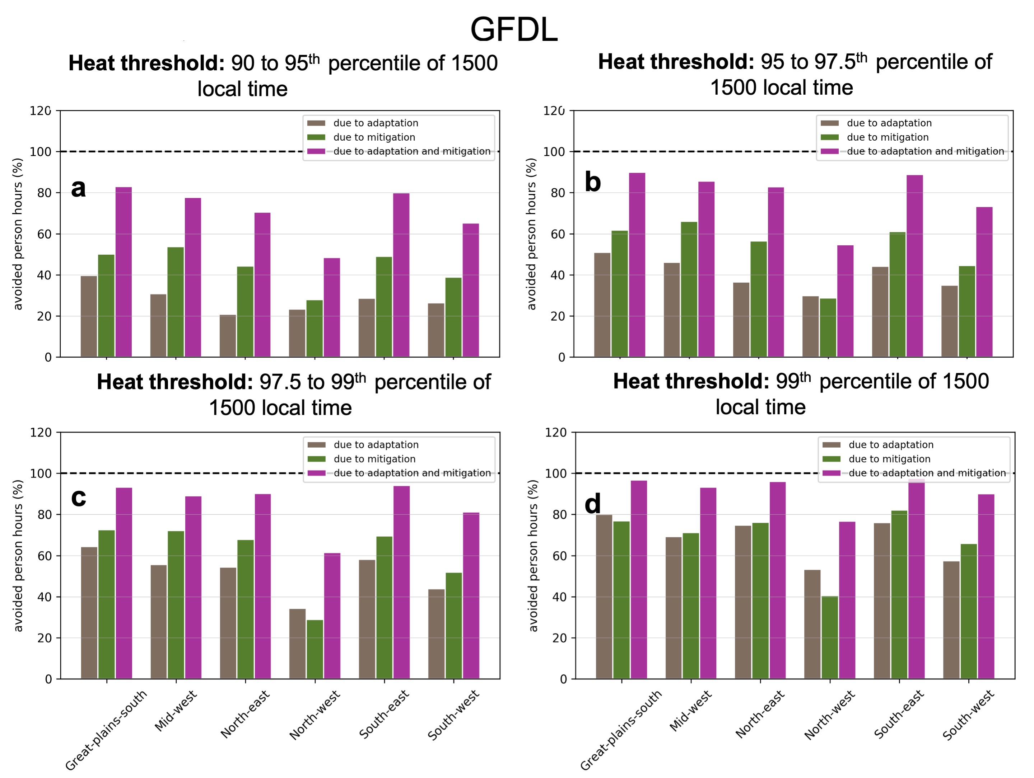Supplemental Figure 4. As in Figure 3 but for the GFDL-driven WRF simulations.
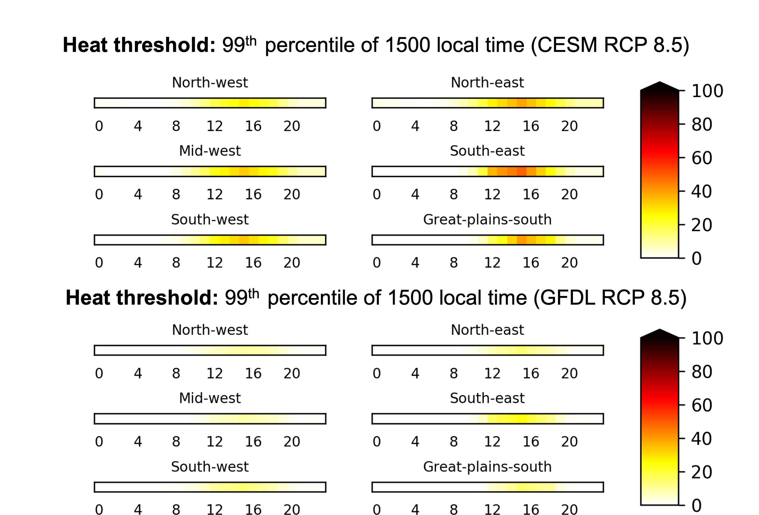

Supplemental Figure 5. Change in the number and timing of occurrence of daytime extreme heat hours (99th percentile of 1500 local time) per year for a worst-case scenario (i.e., RCP 8.5 GHG emissions and urban development) for dynamically downscaled simulations using the CESM (top) and GFDL (bottom) GCMs. The x-axes depict the hour of the day.
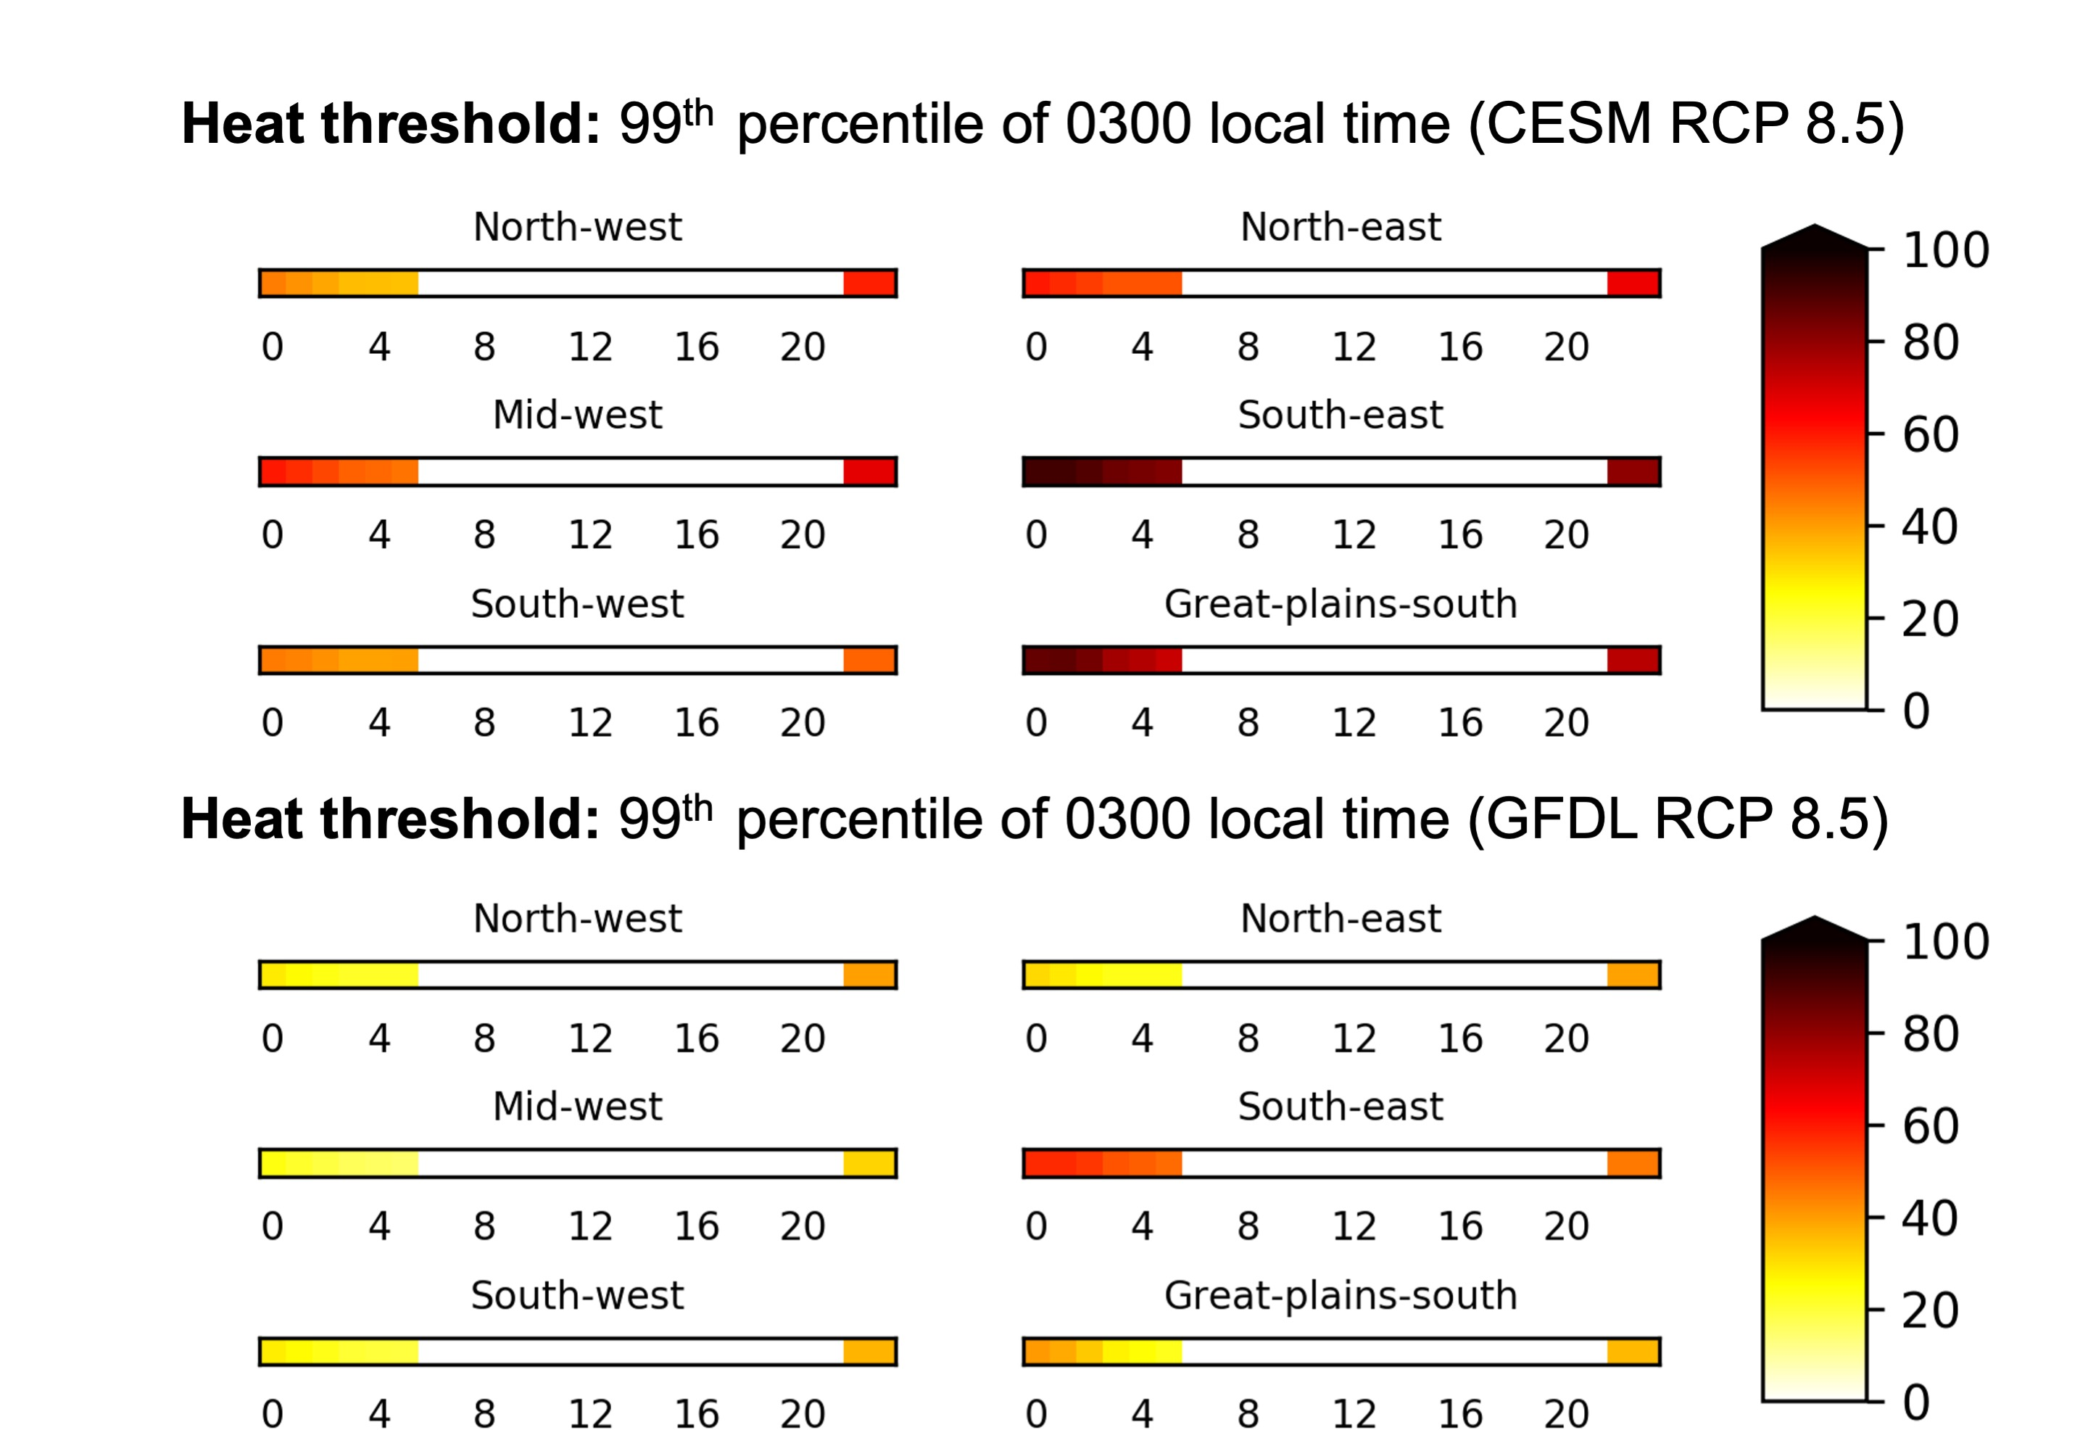

Supplemental Figure 6. Change in the number and timing of occurrence of nighttime extreme heat hours (99th percentile of 0300 local time) per year for a worst-case scenario (i.e., RCP 8.5 GHG emissions and urban development) for dynamically downscaled simulations using the CESM (top) and GFDL (bottom) GCMs. The x-axes depict the hour of the day. Note that only extreme heat hours occurring between 22 local time and 0600 local time are counted.
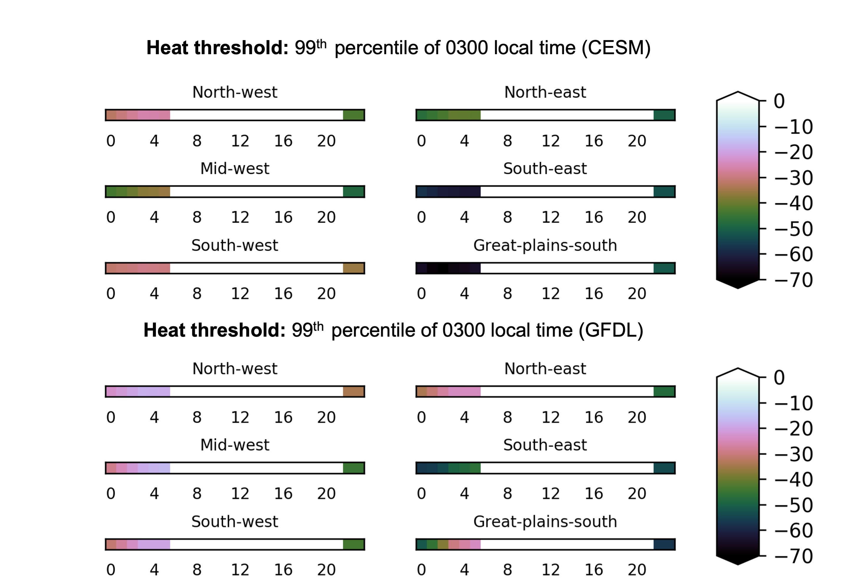

Supplemental Figure 7. Change in the number and timing of occurrence of nighttime extreme heat hours (99th percentile of 0300 local time) per year due to adaptation and mitigation for dynamically downscaled simulations using the CESM (top) and GFDL (bottom) GCMs. The x-axes depict the hour of the day. Note that only extreme heat hours occurring between 22 local time and 0600 local time are counted.
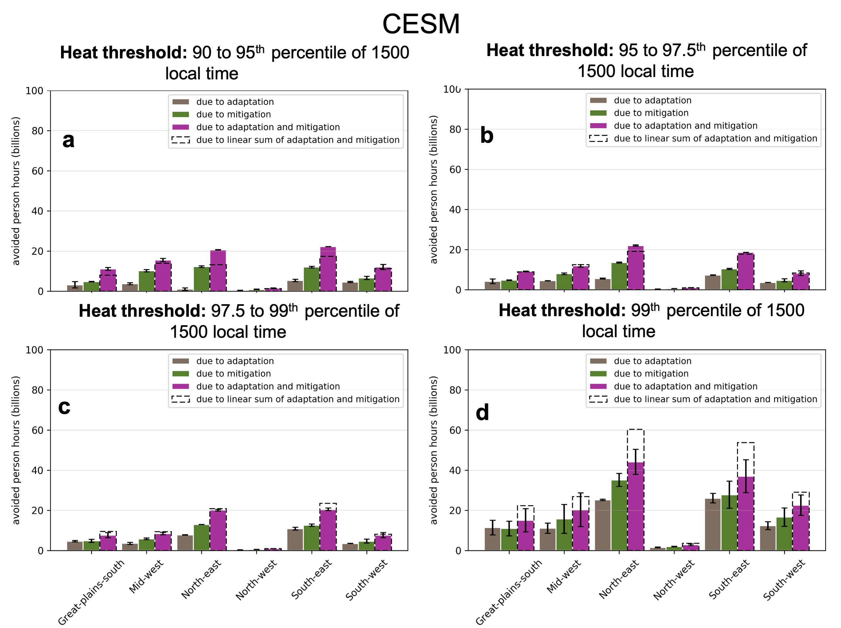Supplemental Figure 8. The total end-of-century extreme heat person hours avoided for a worst-case scenario (i.e., CESM RCP 8.5 GHG emissions and intensive urban development) due to GHG mitigation (i.e., shift from RCP 8.5 to RCP 4.5) and adaptation for locally-defined (a) 90th to <95th percentile, (b) 95th to <97.5th, (c) 97.5th to <99th, and (d) 99th percentile of 1500 local time. Error bars show the annual variation of person hours.
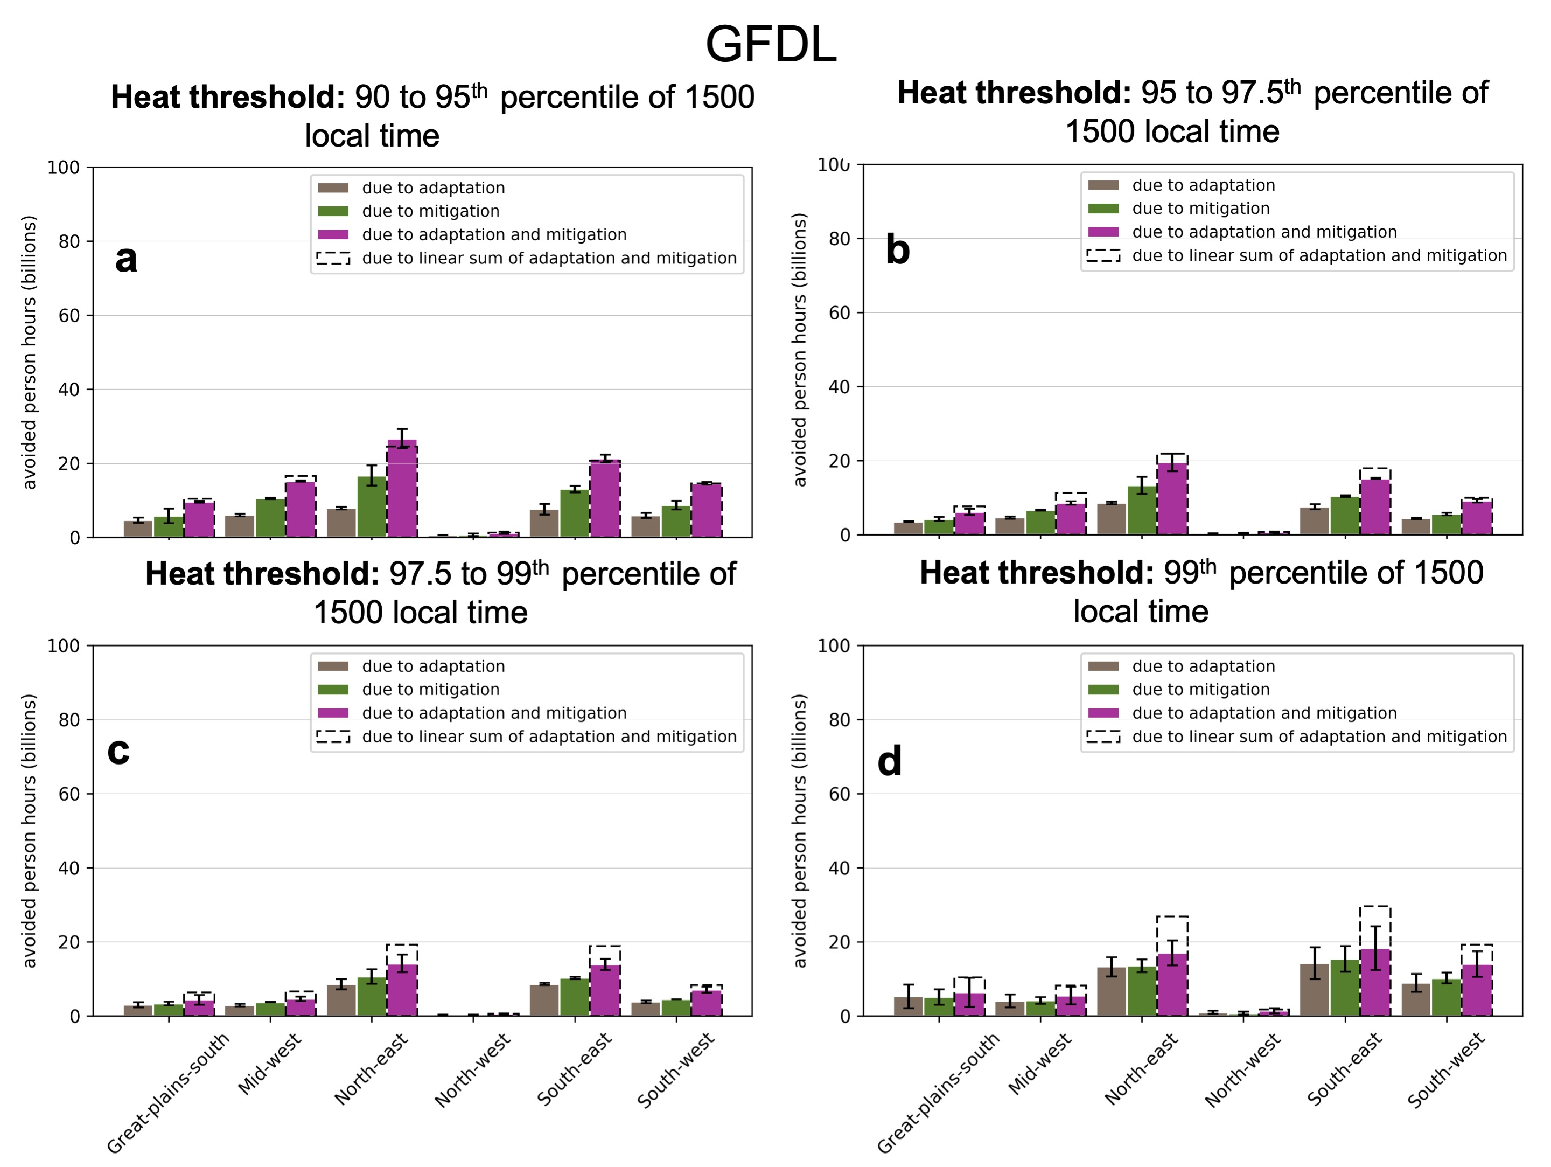Supplemental Figure 9. As Supplementary Figure 8 but for the GFDL-driven WRF simulations.
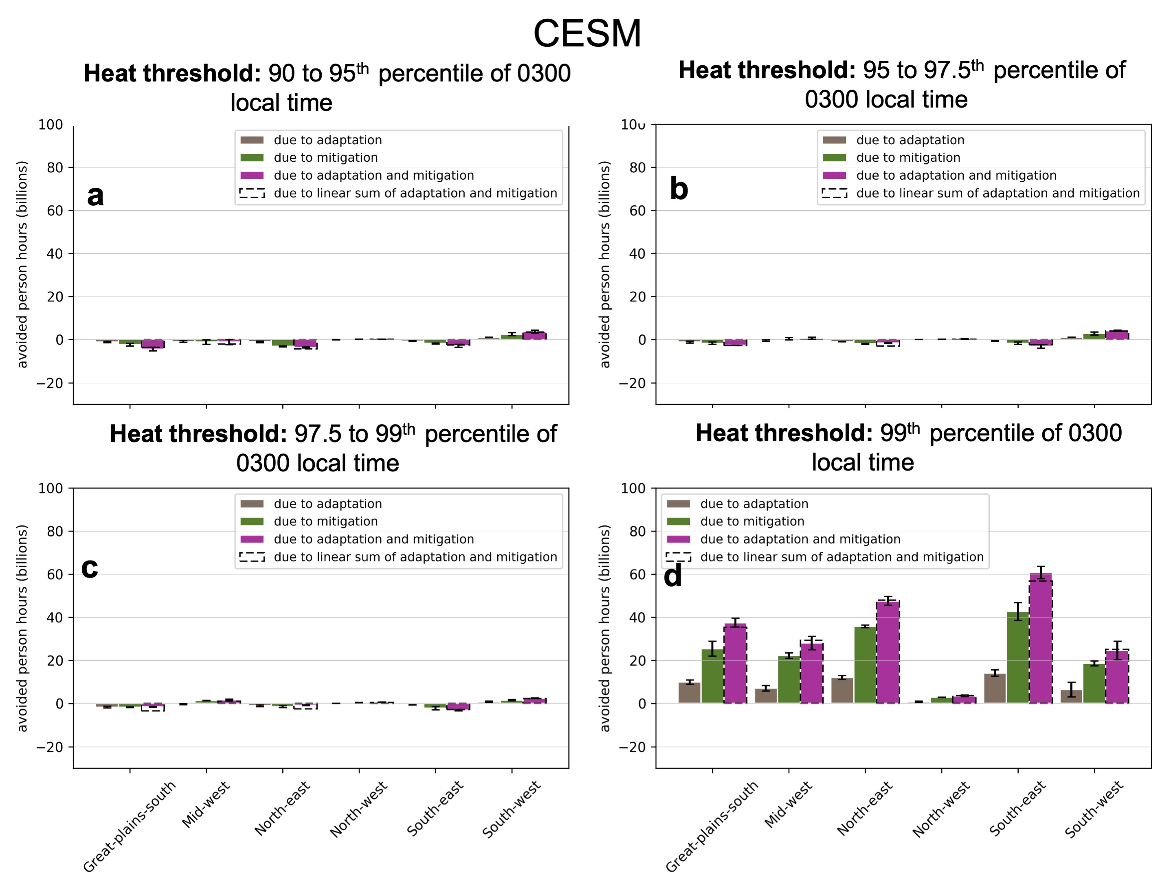Supplemental Figure 10. As Supplementary Figure 8 but for locally-defined (a) 90th to <95th percentile, (b) 95th to <97.5th, (c) 97.5th to <99th, and (d) 99th percentile of 0300 local time.
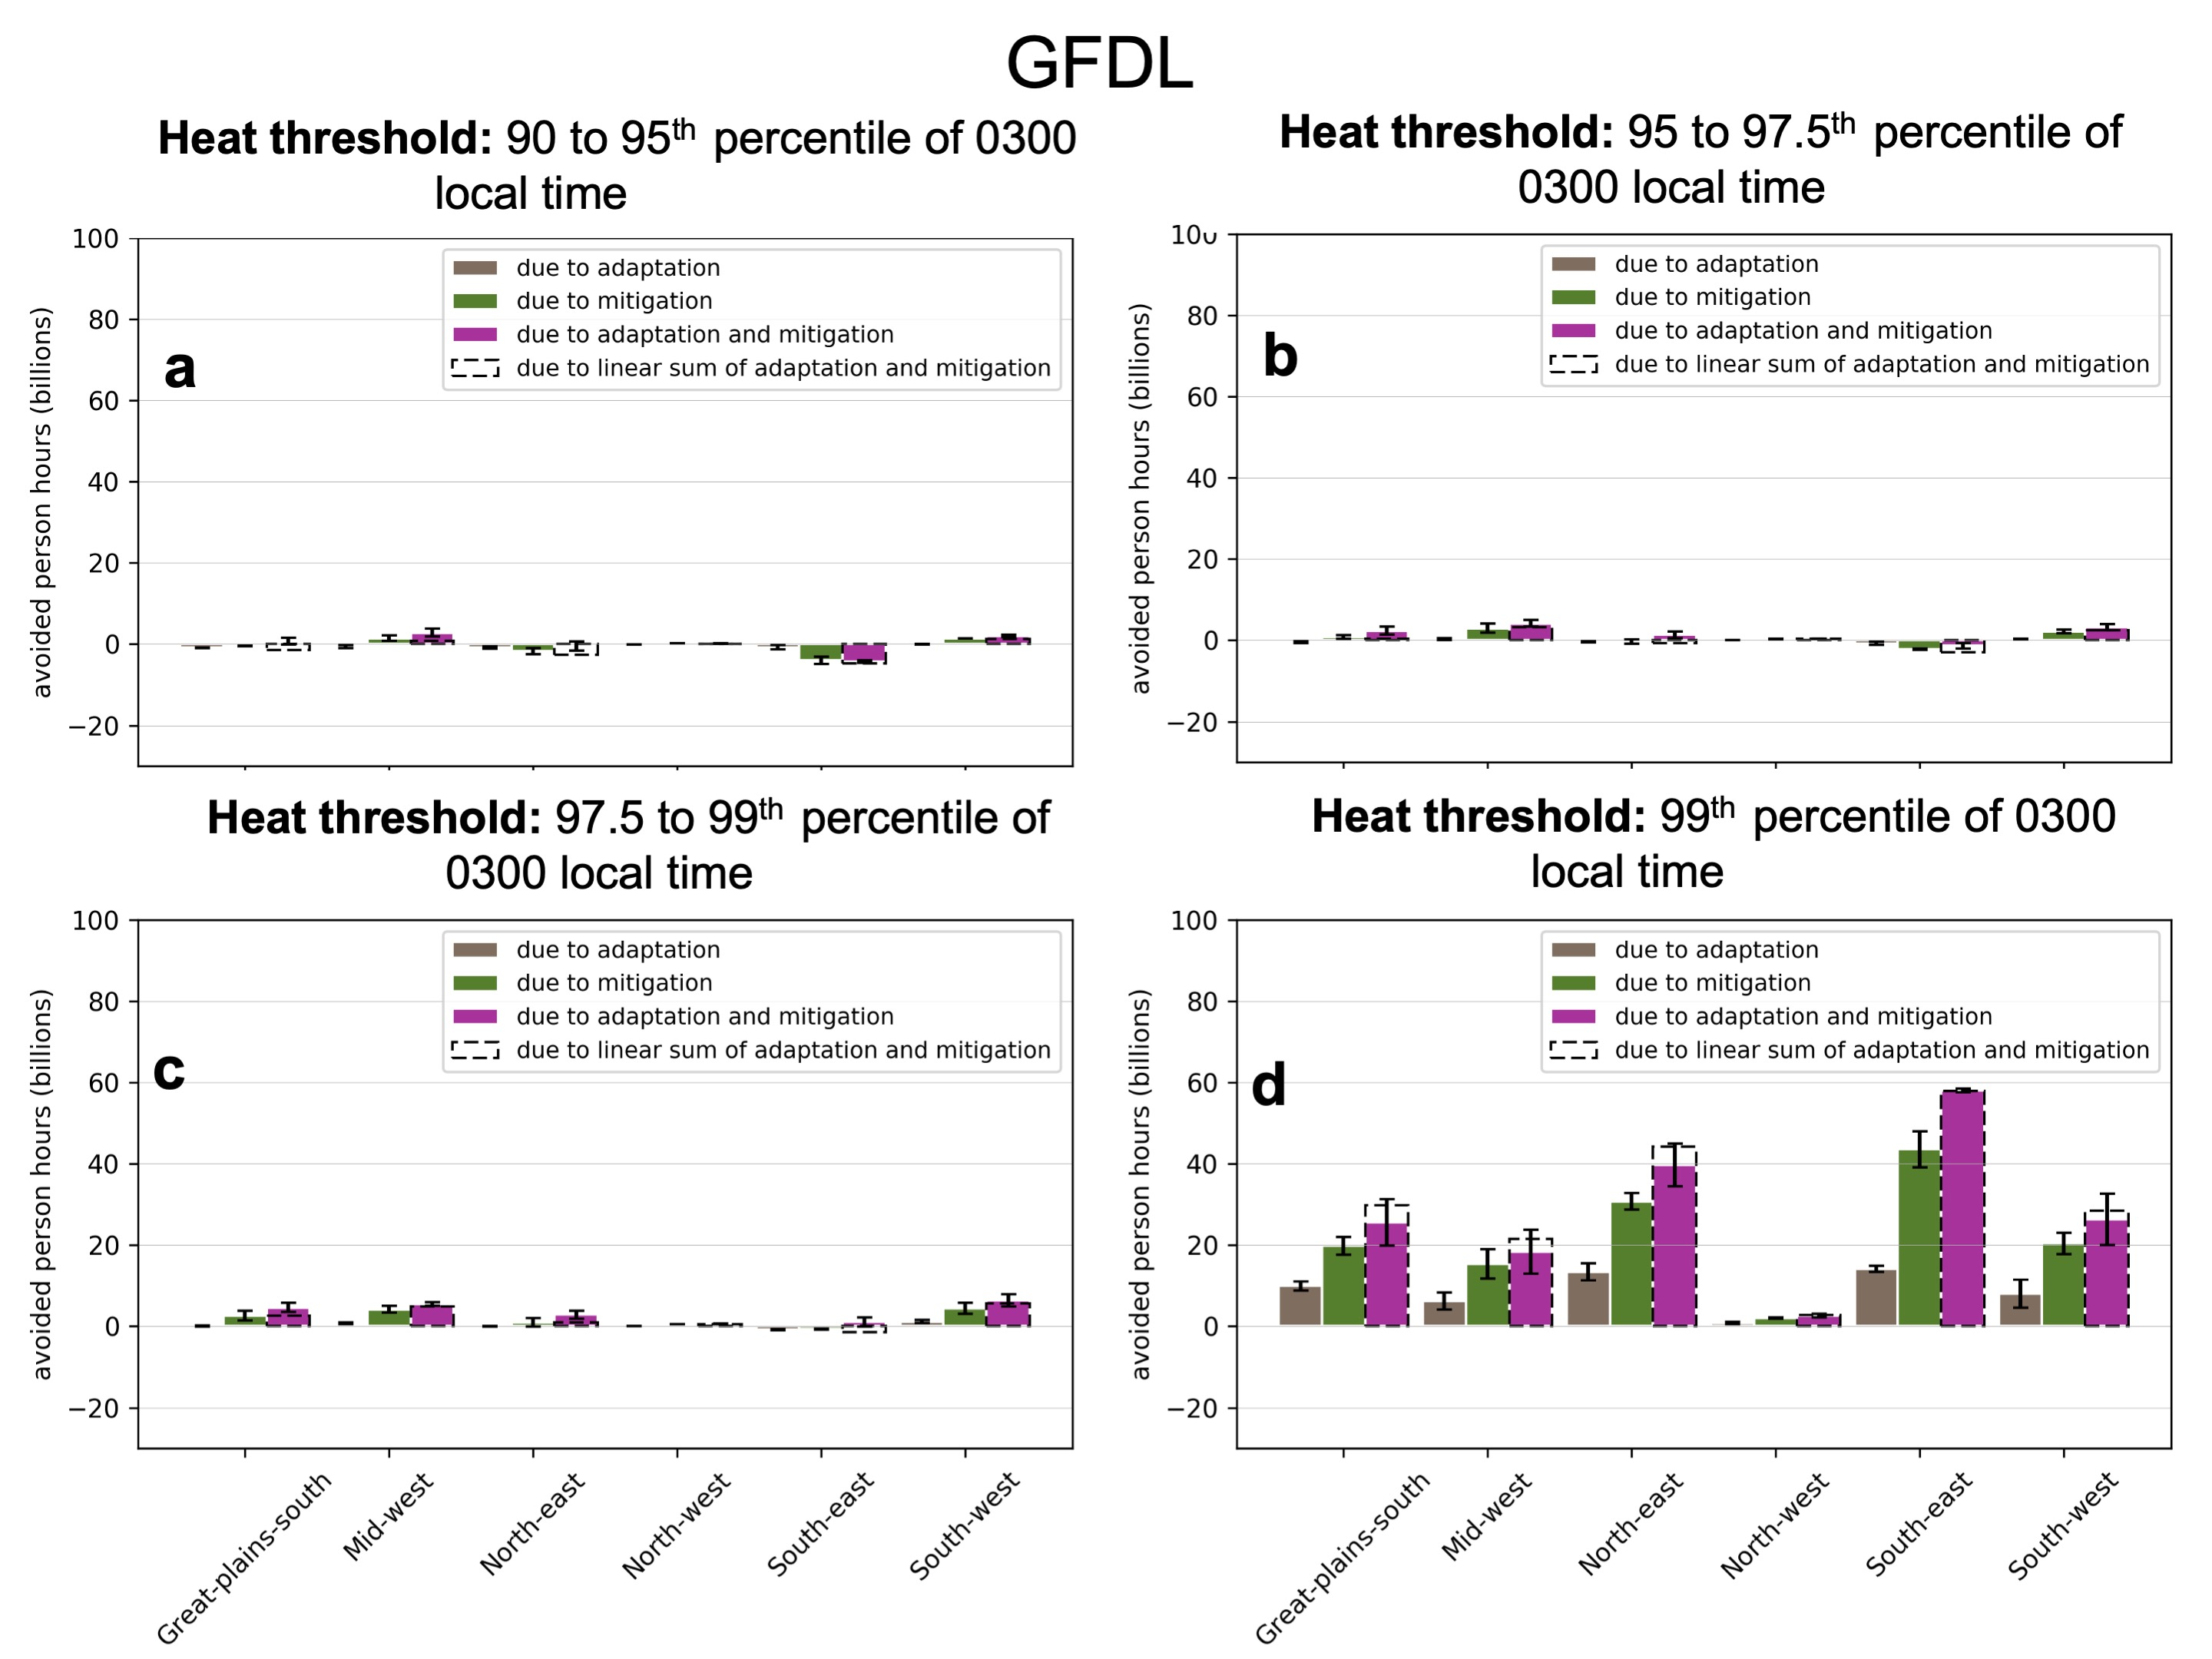Supplemental Figure 11. As Supplementary Figure 10 but for the GFDL-driven WRF simulations.

