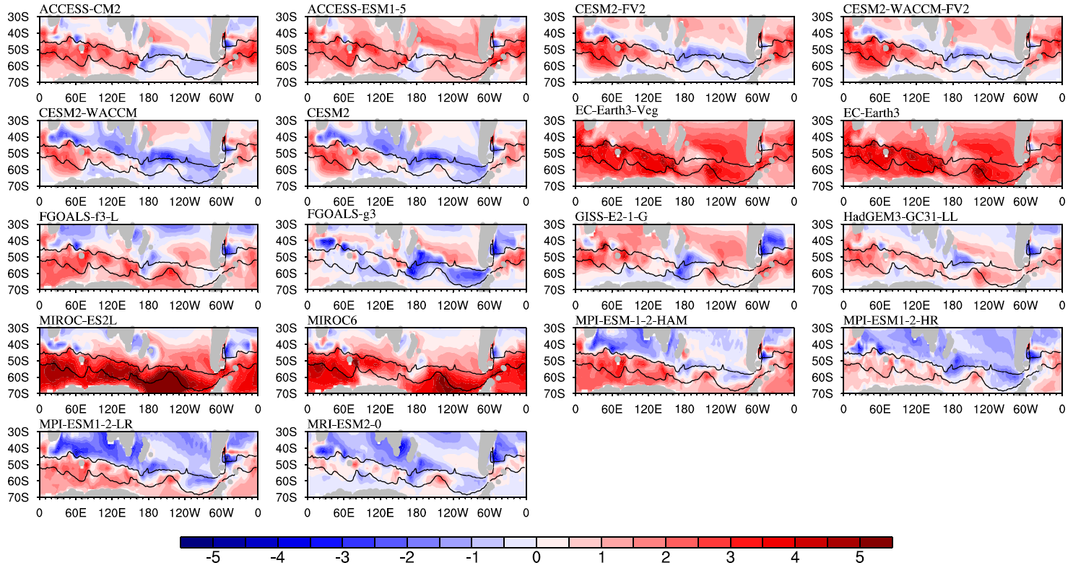
Supplementary Fig. S1 SO SST biases in each CMIP6 model.

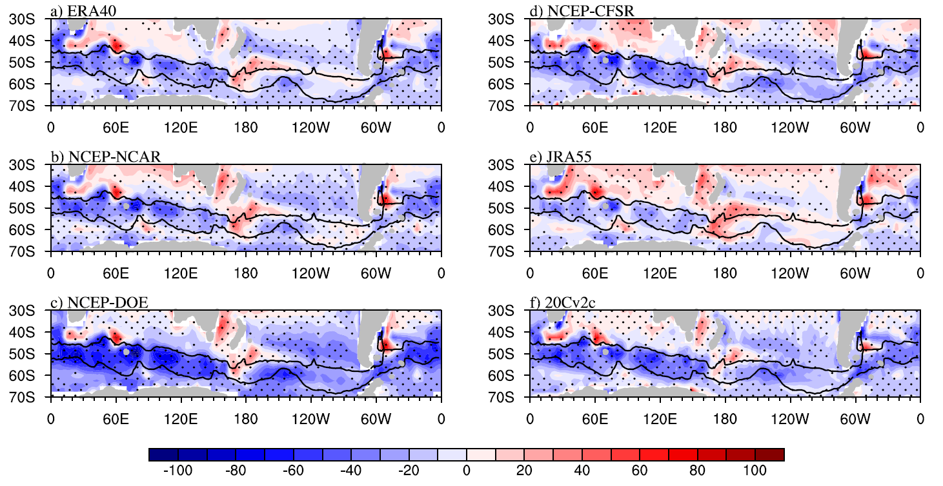
Supplementary Fig. S2 MMM Qnet biases obtained from six observational/reanalysis datasets, a) ERA40, b) NCEP-NCAR, c) NCEP-DOE, d) NCEP-CFSR, e) JRA55, and f) 20Cv2c.

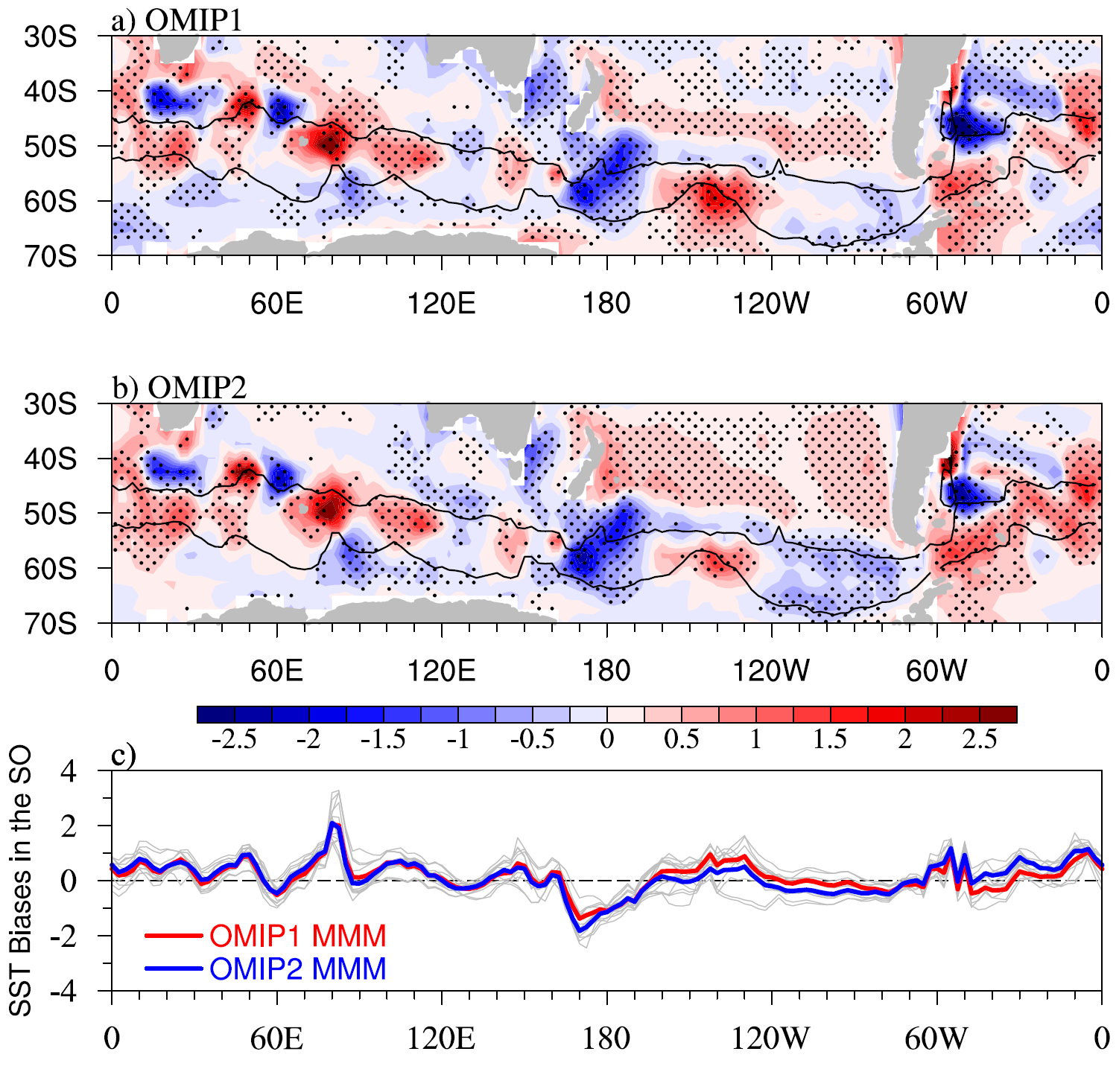
Supplementary Fig. S3 SO SST bias in OMIP1 and OMIP2 models. MMM SST bias from a) OMIP1 and b) OMIP2 models. c) The meridionally-averaged SST bias within the observational SAF and SACCF in each OMIP1/2 model (grey lines), OMIP1 MMM (red line), and OMIP2 MMM (blue line).

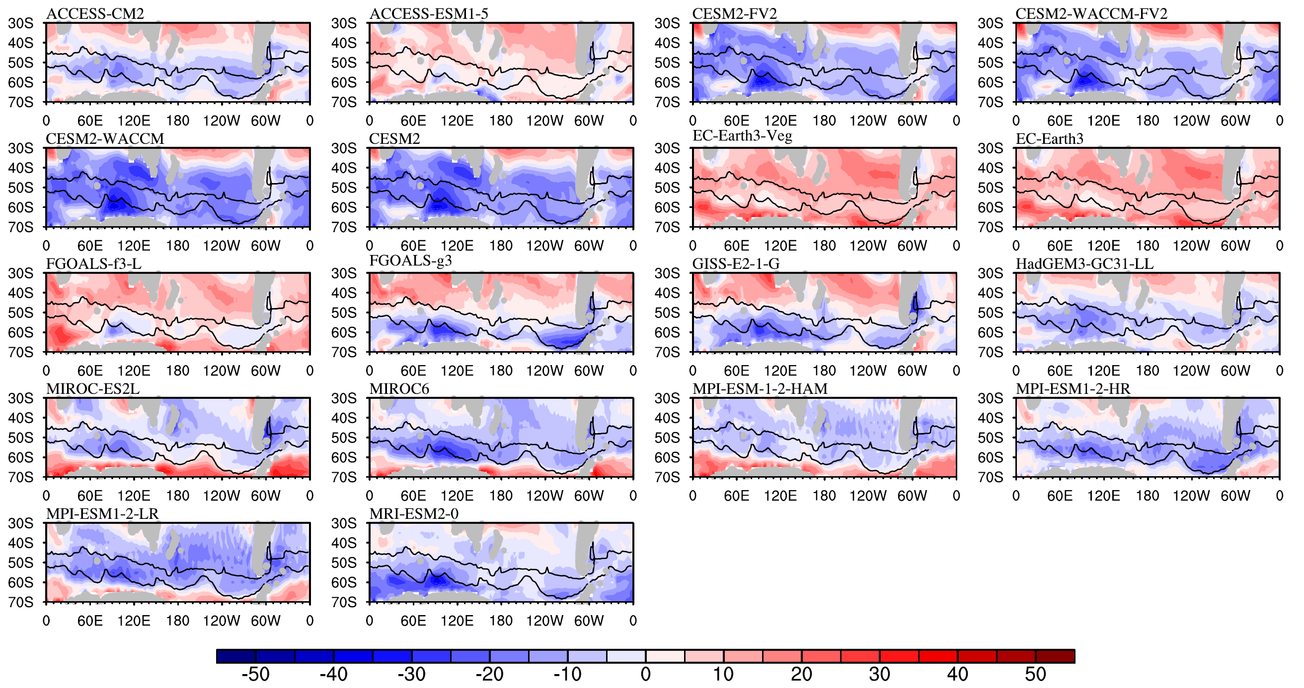
Supplementary Fig. S4 SW biases in each CMIP6 model.
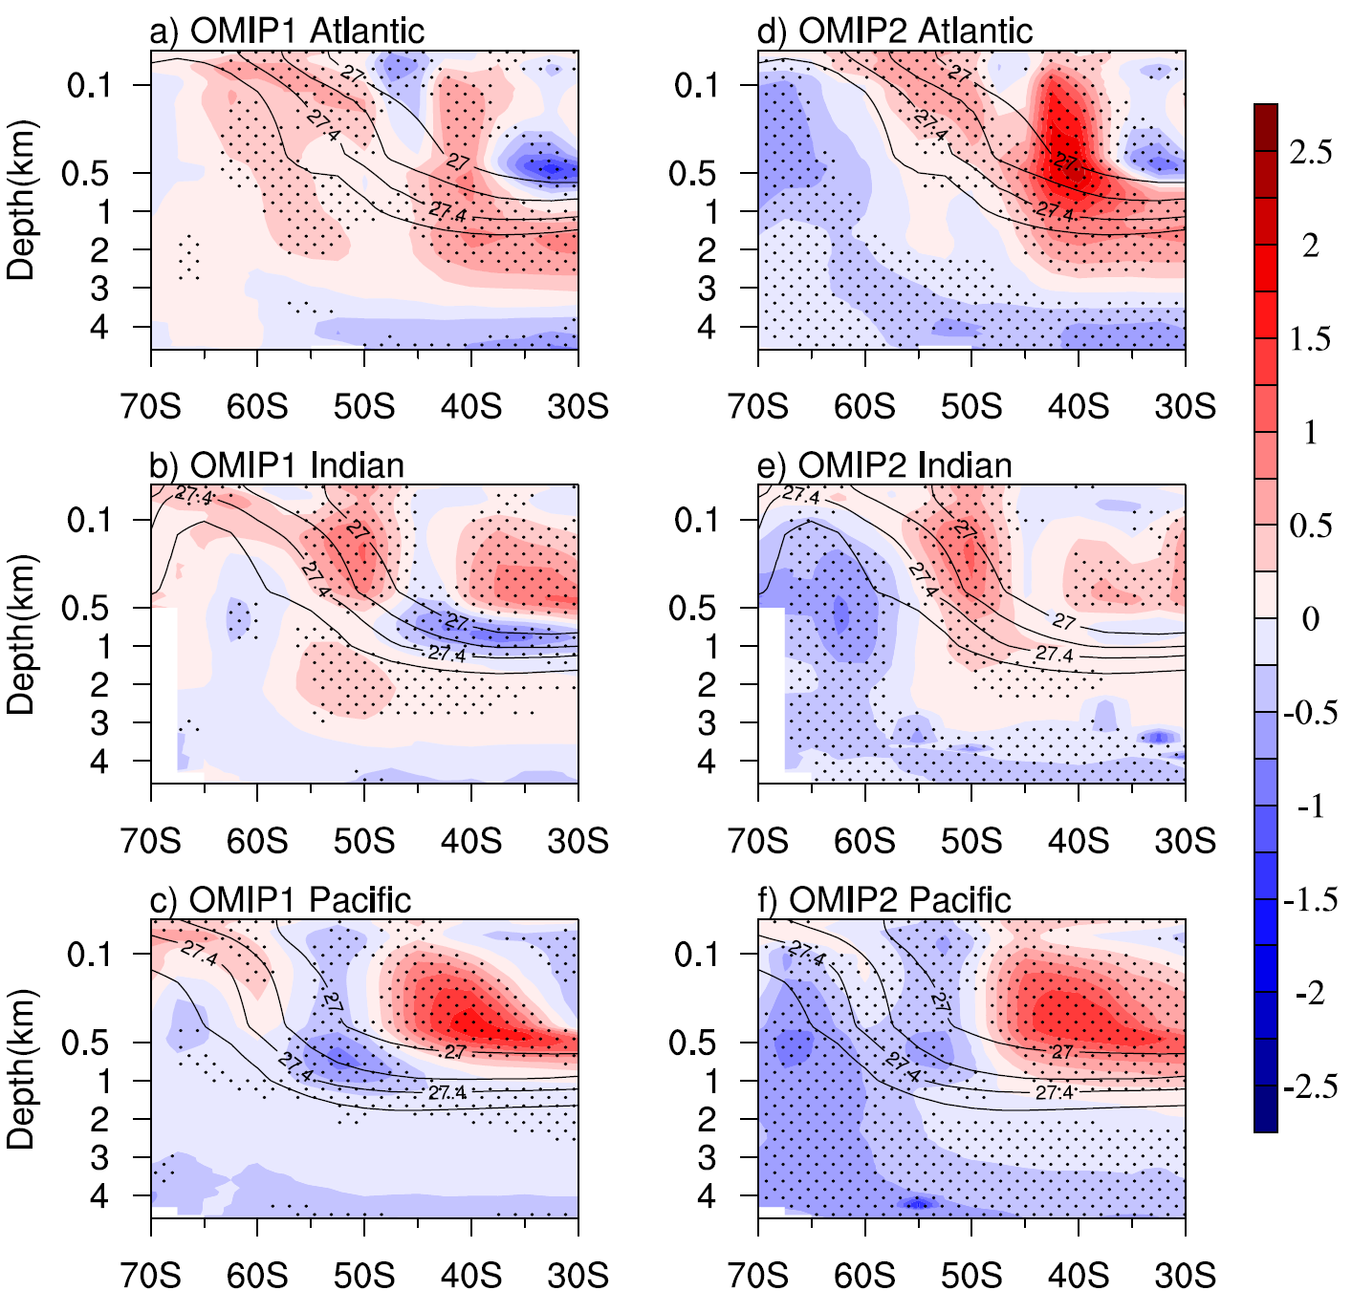
Supplementary Fig. S5. MMM zonal mean temperature biases in the three ocean sectors for a-c) OMIP1 and d-f) OMIP2 models.

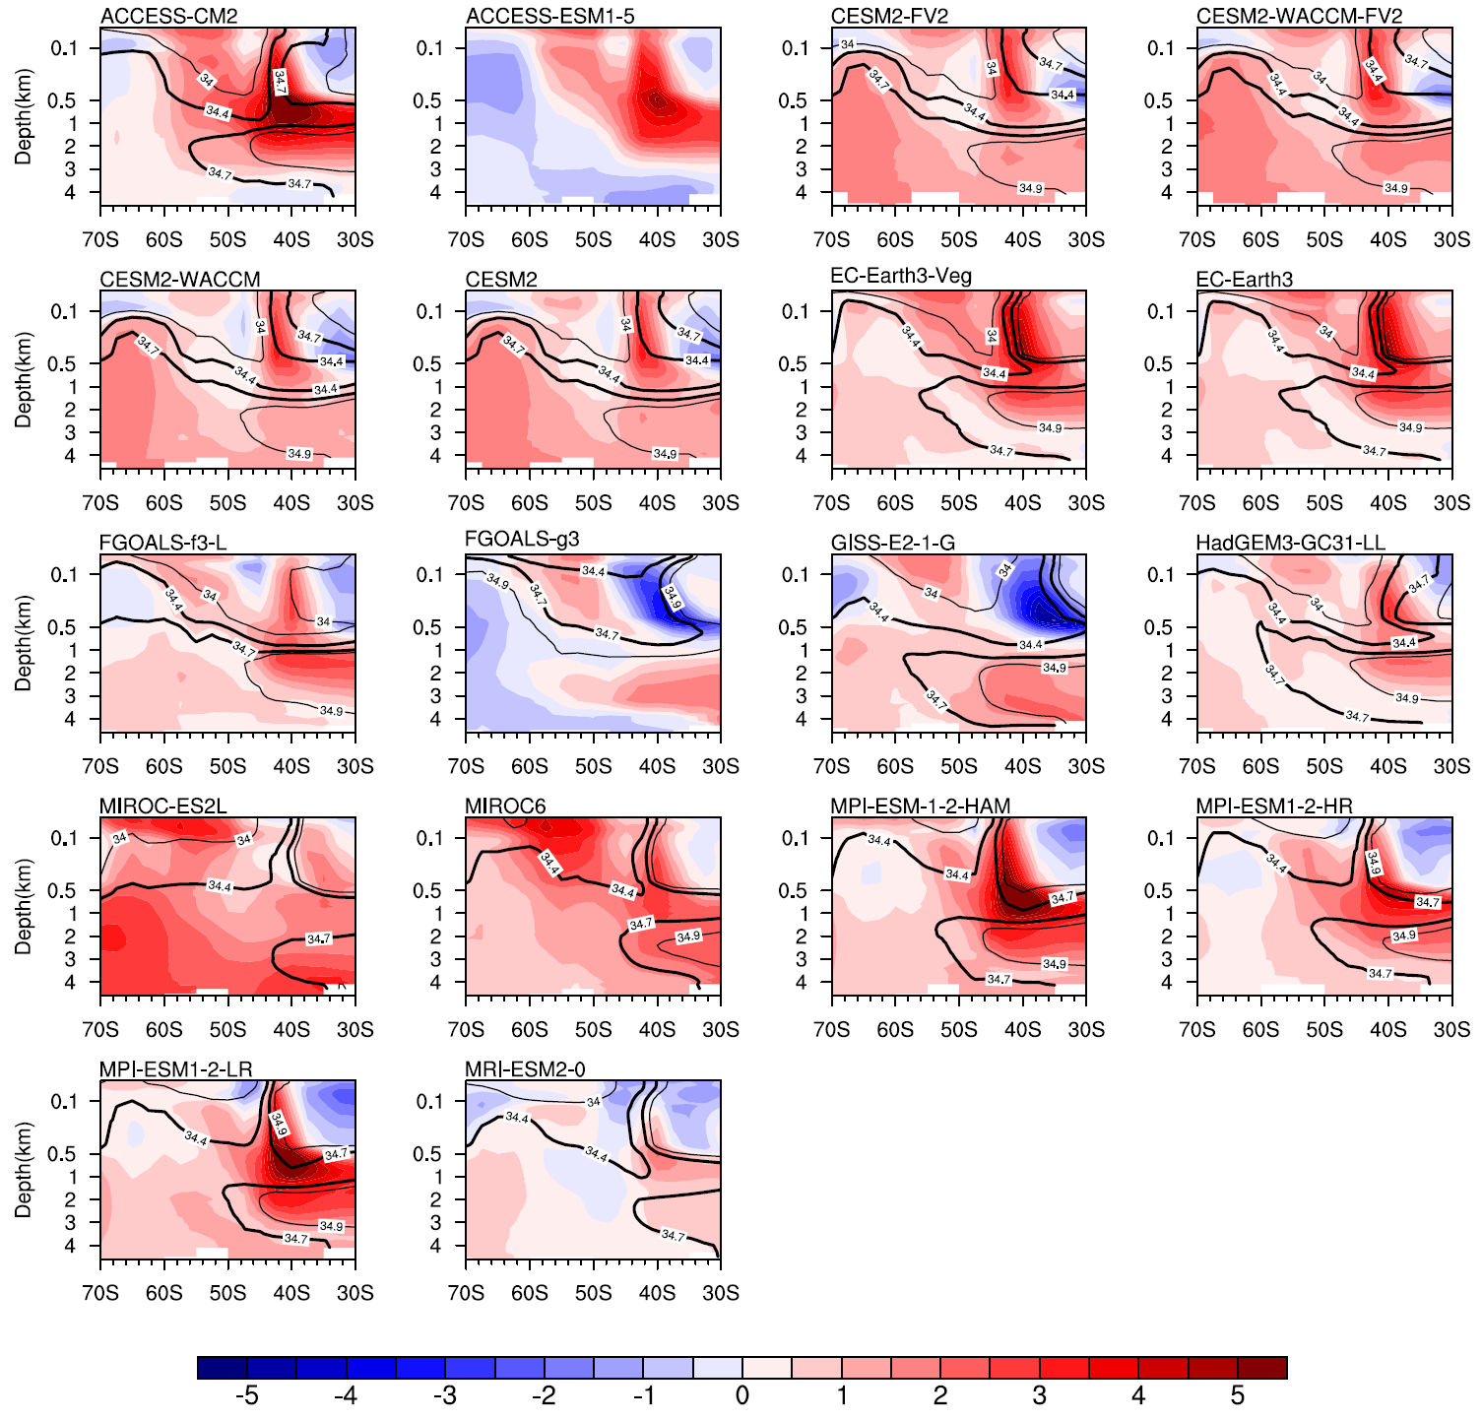
Supplementary Fig. S6 Zonal mean temperature biases in the Atlantic ocean sector in each CMIP6 model. The black contours in each plot are the ocean salinity(units: psu). Note that salinity for ACCESS-ESM1-5 is unavailable.

