  - Supplementary Information for
Programming structural and magnetic anisotropy for tailored interaction and control of soft microrobots

The PDF file includes
Supplementary Fig. S1. Size distribution of magnetic precursor droplet under different flow pressure ratios between the discrete and continuous phase
Supplementary Fig. S2. a Set-up of the droplet-based microfluidics system. b Generation of magnetic precursor droplets in microfluidic channels. A discrete phase of PEGDA solution (A₁ and A₂) and a continuous phase of HFE oil (B). The two inlets for PEGDA served as a backup for each other, reducing the risk of channel clogging. c Set-up of on-chip gelation system. d On-chip gelation process involves the focused exposure of UV irradiation in the junction area of droplet-based microfluidic channels using an optical lens while ensuring a surrounding area of nitrogen protection. This approach enables the triggering of photopolymerization, while also allowing the resulting structures to maintain their desired aspect ratio.
Supplementary Fig. S3. Fabrication scheme to achieve structures containing tailored magnetic supradomains and distinct shapes, depending on the concentrations of MNPs and PEGDA, and different types of magnetic stimuli. The process involves a combination of off-chip gelation and controlled photopolymerization under magnetic fields, which results in the production of homogenous, multi-chain, multi-bundle, and multi-disk as well as double microrobots. By implementing on-chip gelation, a variety of aspect ratios for ellipsoidal microrobots can be achieved.
Supplementary Fig. S4. Characterization of the motorized Halbach cylinder. a Variation of magnetic field strength along the x-axis. b Variation of magnetic field strength along the y-axis. c Relationship between the frequency of RMF and the input voltage. d Configuration of permanent magnets in the motorized Halbach cylinder device.
Supplementary Fig. S5. Analysis of magnetic torque on magnetic supradomains with tuneable aspect ratios.
Supplementary Fig. S6. Hydrodynamic simulation of multi-disk microrobot clusters in dynamic steady state under RMF.
Supplementary Fig. S7. Simulation of the magnetization and hydrodynamics of microrobot pairs consisting of doublet and spherical microrobots.
Supplementary Fig. S9. Transmission electron microscopy (TEM) image of the employed commercial magnetic nanoparticles (EMG-700, Ferrotec).
Other Supplementary Material for this manuscript includes the following:
Supplementary Movie. 1. Programmable collective behaviour tailored by distinct magnetic anisotropy under RMF.
Supplementary Movie. 2. Fabrication process of spherical and elongated microrobots via droplet-based microfluidics.
Supplementary Movie. 3. Simulation of MNPs assembly in precursor droplets under magnetic actuation.
Supplementary Movie. 4. Experiments and simulations of pair systems with distinct magnetic anisotropy, i.e multi-chain and multi-disk microrobots, and homogeneous pairs.
Supplementary Movie. 5. Comparing the motion behaviors of multi-disk and homogeneous microrobots under RMF.
Supplementary Movie. 6. Experiment and simulation of pairs with distinct structural anisotropy: doublet and spherical microrobot.
Supplementary Movie. 7. Experimental and computational analysis of structural anisotropy effects in swarms
Supplementary Movie. 8. Testing of magnetic anisotropy effects in mixed swarms

Supplementary Fig. S1
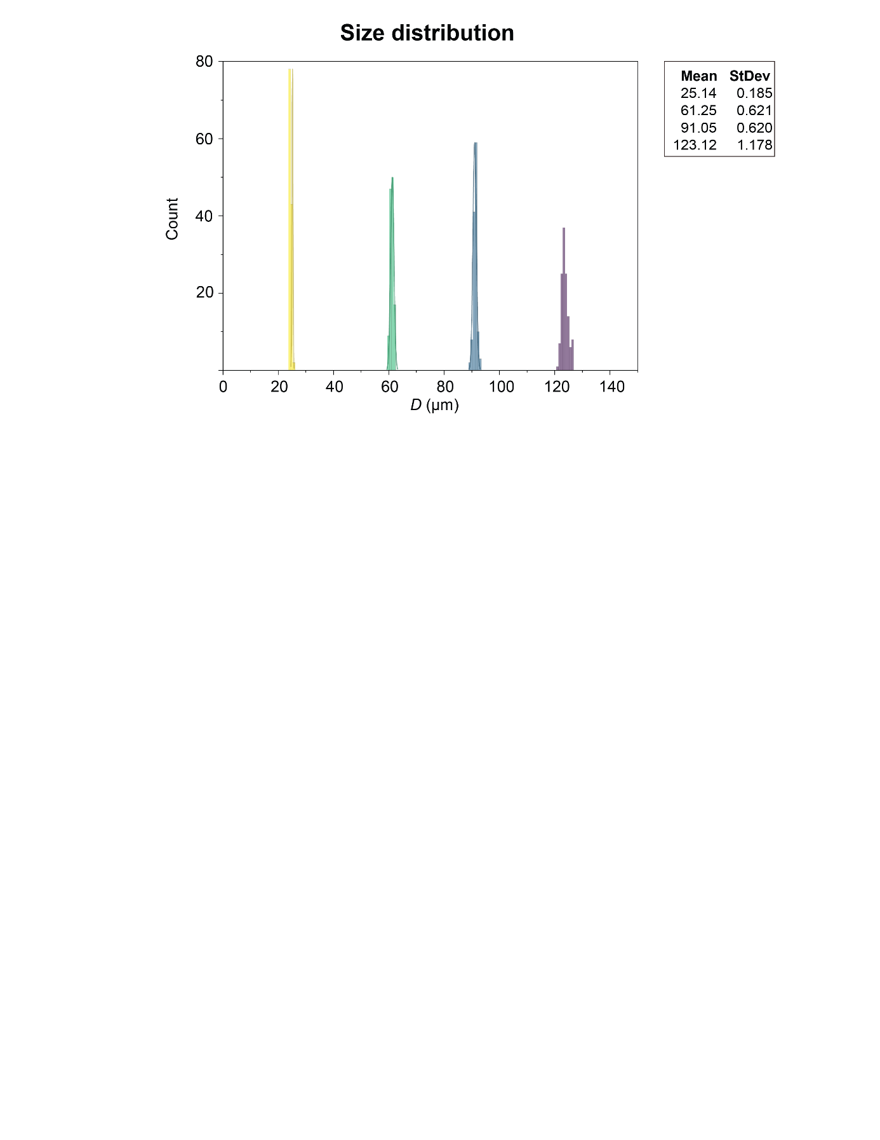

Supplementary Fig. S2
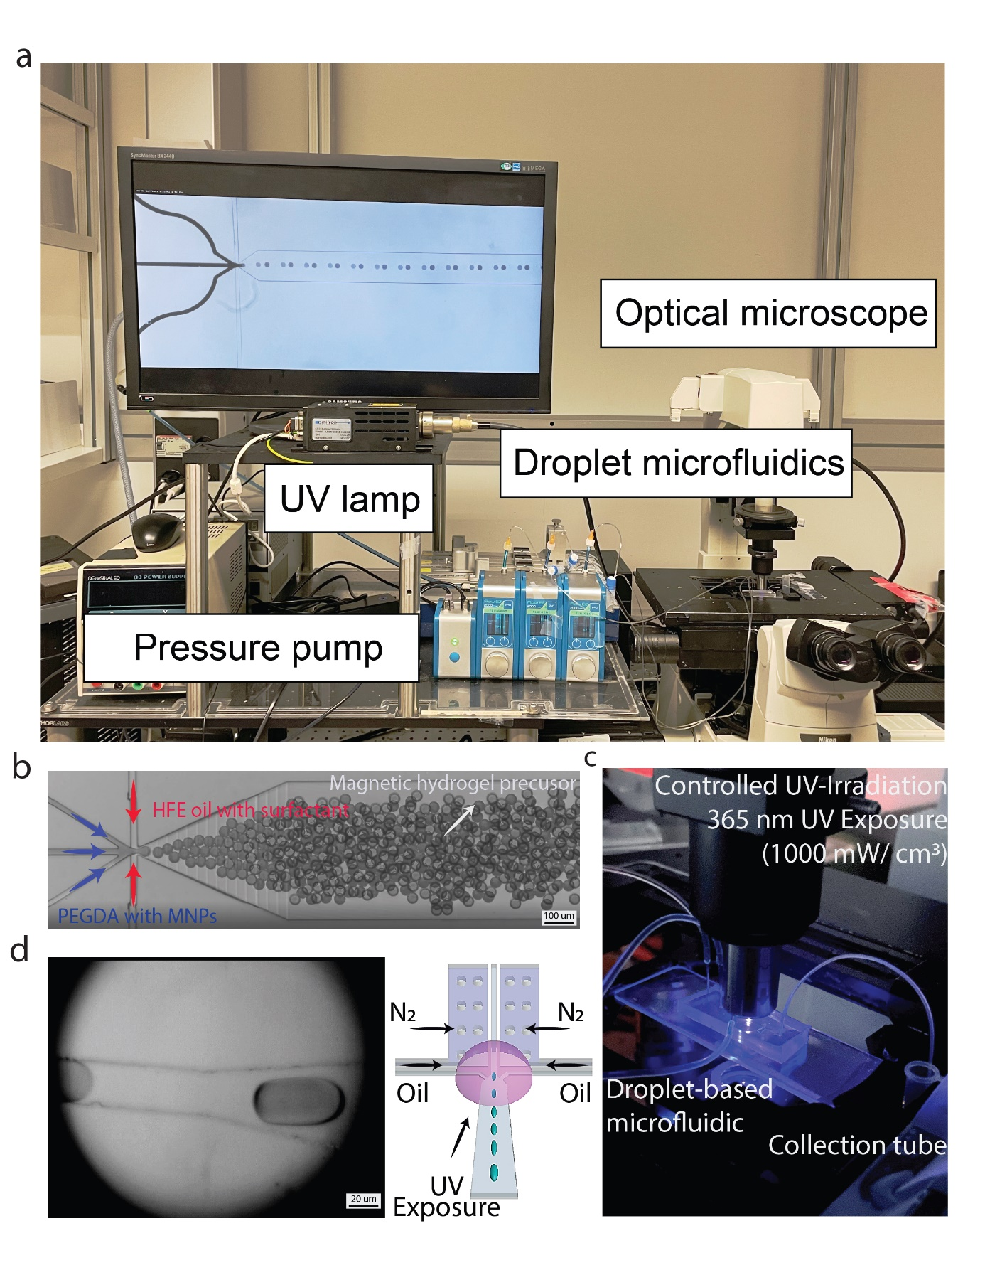

Supplementary Fig. S3
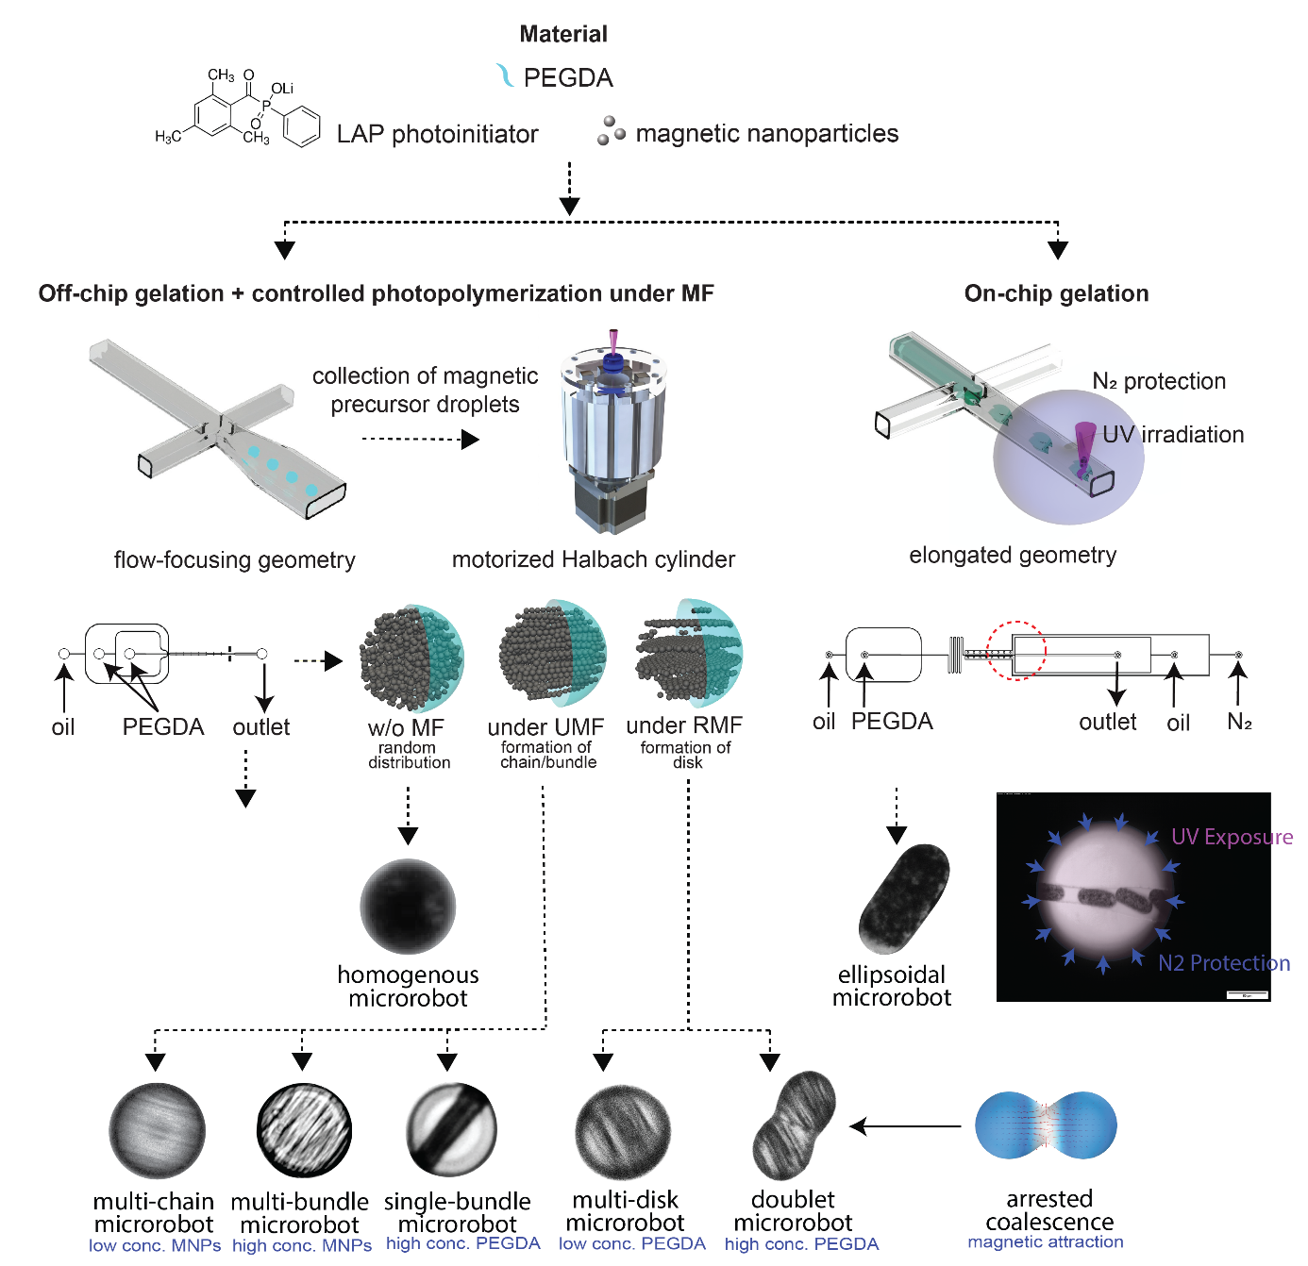

Supplementary Fig. S4
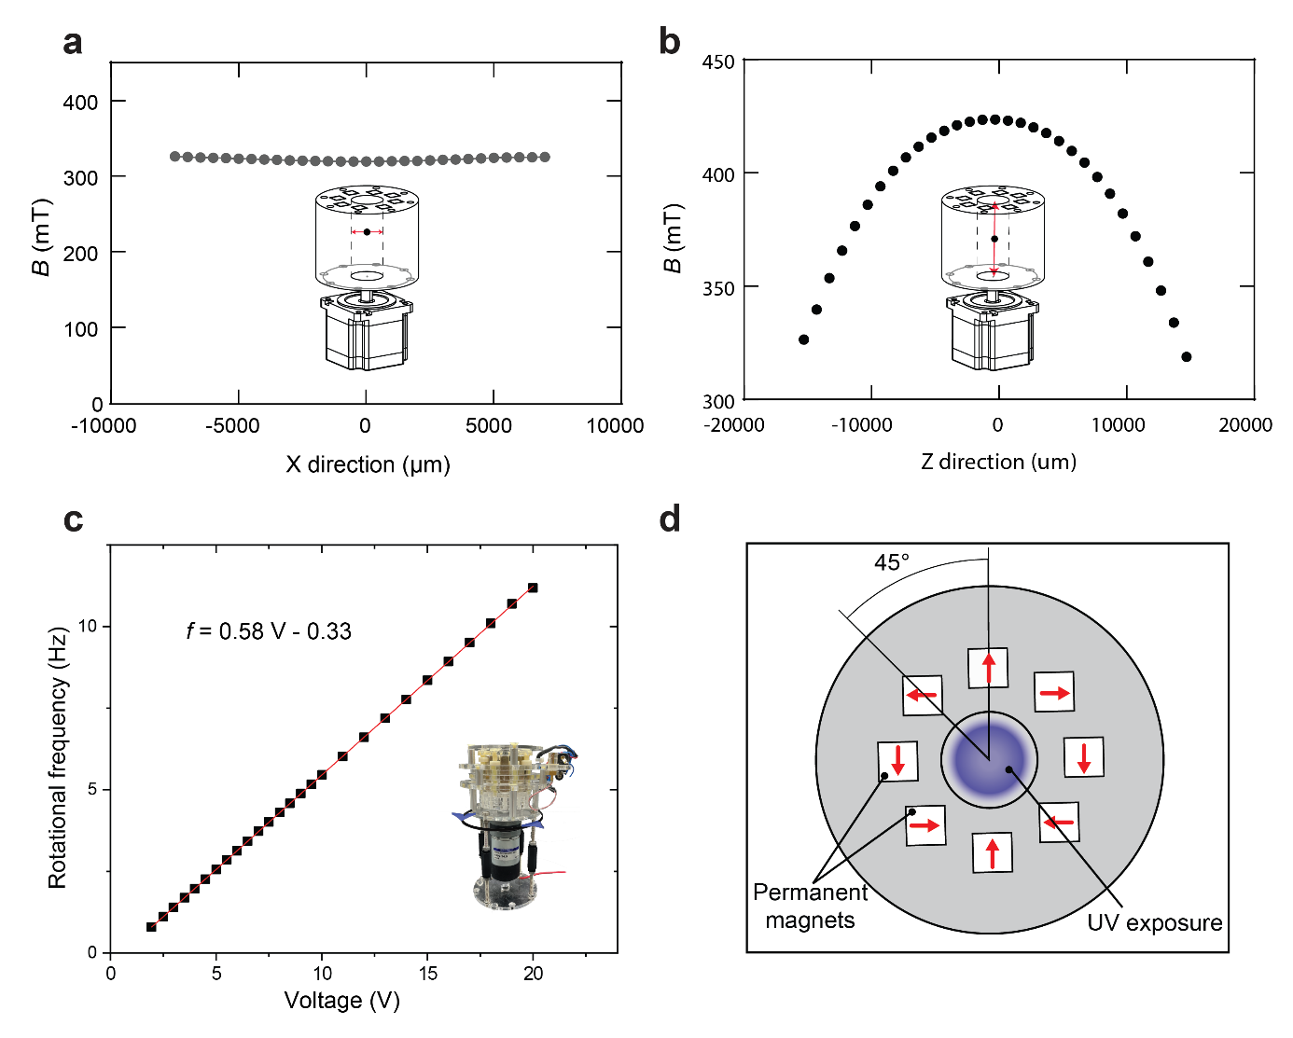

Supplementary Fig. S5
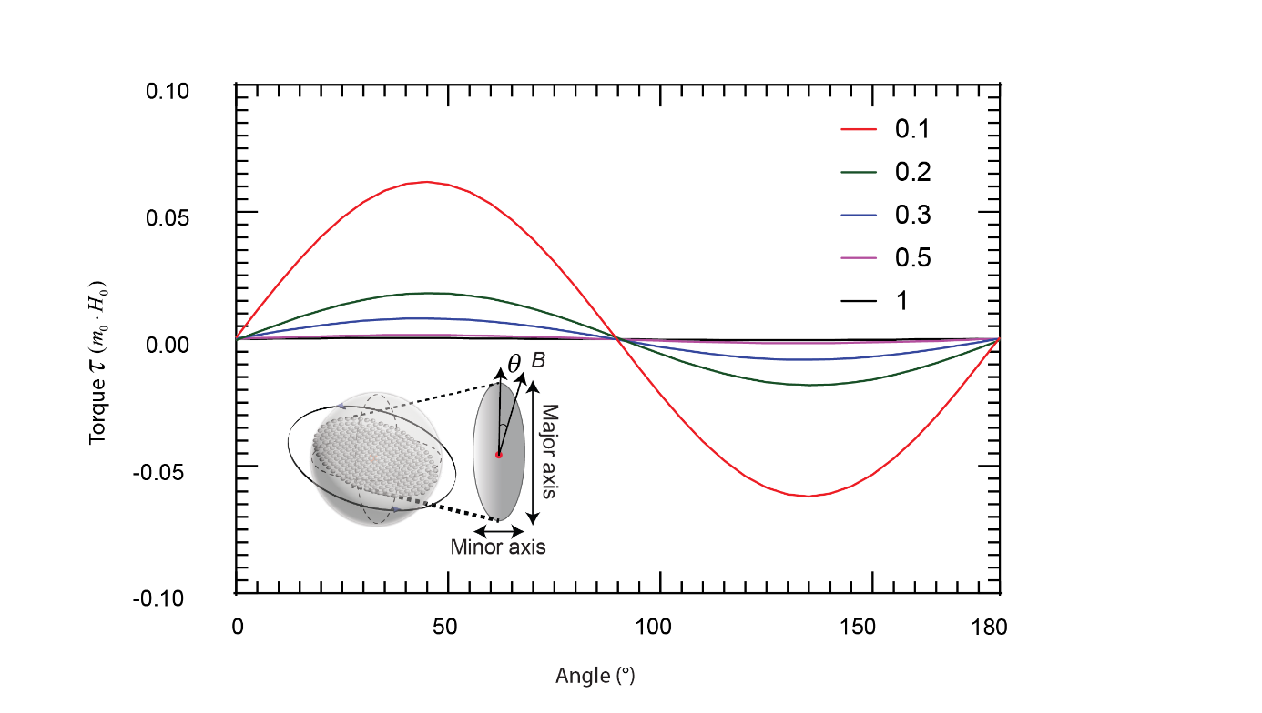

Supplementary Fig. S6
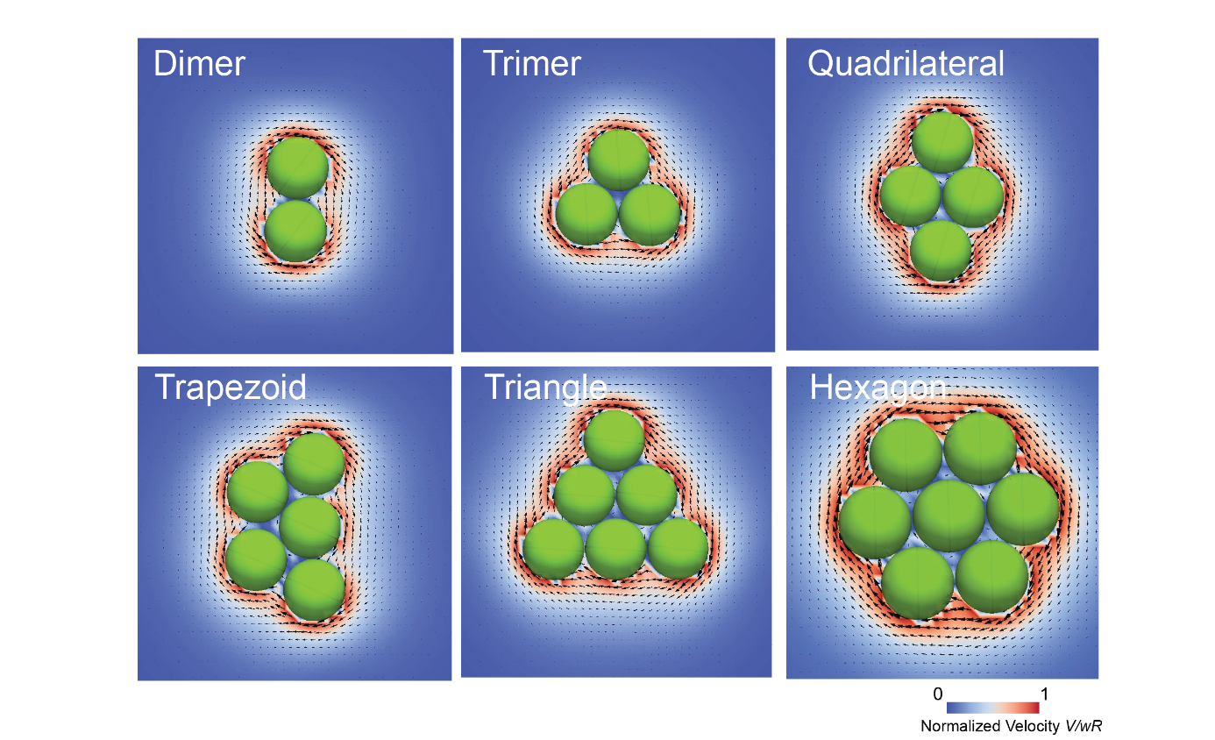

Supplementary Fig. S7
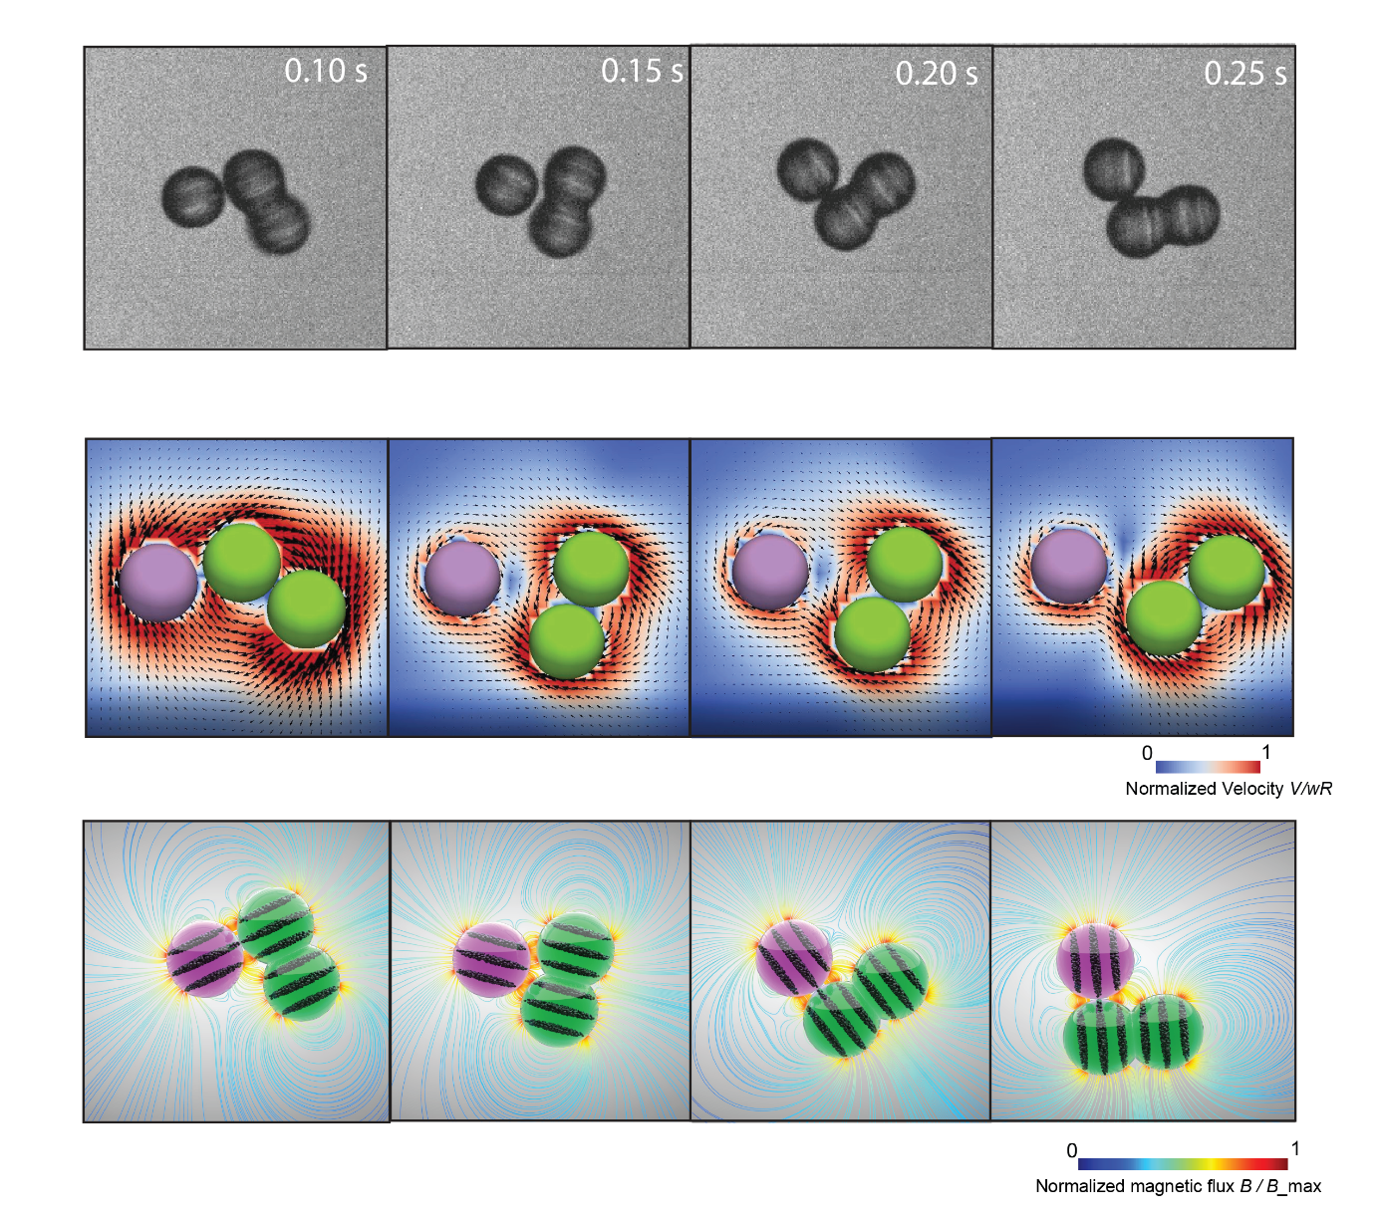

Supplementary Fig. S8
