Abbreviations:
Uf_HPP= Unfair offer from High-Power Posture character
Uf_LPP= Unfair offer from Low-Power Posture character
Fa_HPP= Fair offer from High-Power Posture character
Fa_LPP= Fair offer from Low-Power Posture character
HPP= High-Power Posture
LPP= Low-Power Posture

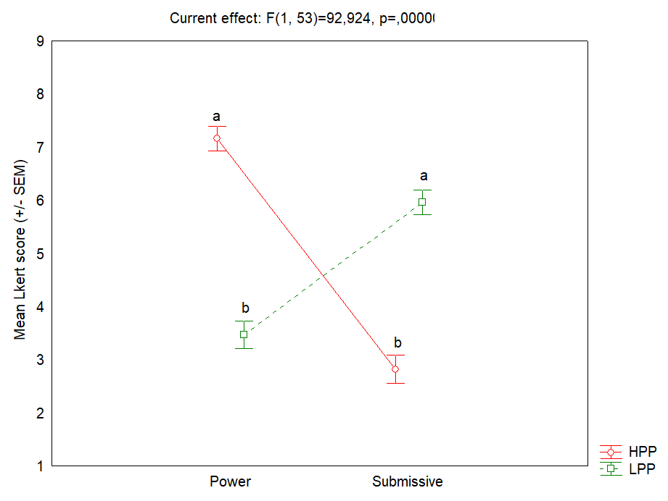
Supplementary figure 1. 2 x 2 repeated measures analysis of variance (ANOVA), with Posture (LPP, HPP) and the two questions related to Power and Submissiveness as within factors

 | Uf_HPP | Uf_LPP | Fa_HPP | Fa_LPP
Median | 0.088 | 0.149 | 0.951 | 0.896
Min | 0.000 | 0.000 | 0.000 | 0.000
Max | 1.000 | 1.000 | 1.000 | 1.000
25% | 0.000 | 0.000 | 0.951 | 0.896
95% | 0.088 | 0.500 | 1.000 | 0.942

Supplementary table 1. Descriptive data from Figure 2 (Experiment 1-Responder).

 | Female |  | Male |  | Statistics
 | N | M | N | M | Z | p-level | Z-adjusted | p-level
Uf_HPP | 59 | 0.128 | 21 | 0.299 | 0.591 | 0.555 | 0.445 | 0.656
Uf_LPP | 59 | 0.260 | 21 | 0.362 | -0.284 | 0.776 | 0.139 | 0.890
Fa_HPP | 59 | 0.850 | 21 | 0.879 | -0.284 | 0.776 | 0.139 | 0.890
Fa_LPP | 59 | 0.855 | 21 | 0.790 | 0.591 | 0.555 | 0.445 | 0.656

Supplementary table 2. Statistical report of the Wald-Wolfowitz runs test to evaluate gender differences in acceptance rate to character’s offer (Experiment 1-Responder). No significant difference is observed.

 | HPP | LPP
Median | 40 | 35
Min | 22.5 | 20
Max | 50 | 50
25% | 35 | 28.75
95% | 45 | 42.5

Supplementary table 3. Descriptive data from Figure 4 (Experiment 2-Proposer)

 | Female |  | Male |  | Statistics
 | N | M | N | M | Z | p-level | Z-adjusted | p-level
HPP | 58 | 38.920 | 22 | 42.273 | 0.028 | 0.977 | -0.113 | 0.910
LPP | 58 | 36.006 | 22 | 35.341 | -2.236 | 0.025 | 2.095 | 0.036

Supplementary table 4. Statistical report of the Wald-Wolfowitz runs test to evaluate gender differences on proposer’s mean offers (Experiment 2-Proposer). The mean offer of female to LPP character is significantly higher than male offer (p=0.036).

