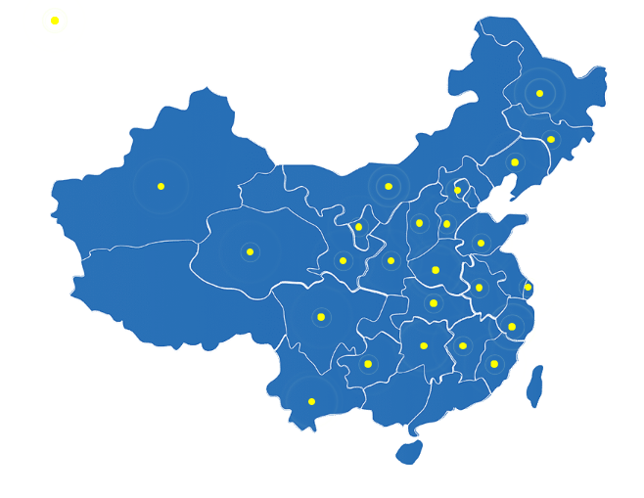
Figure S2 Branches of CARDPC

Branches of CARDPC in China

