Supplementary material: 10 most important features by models.
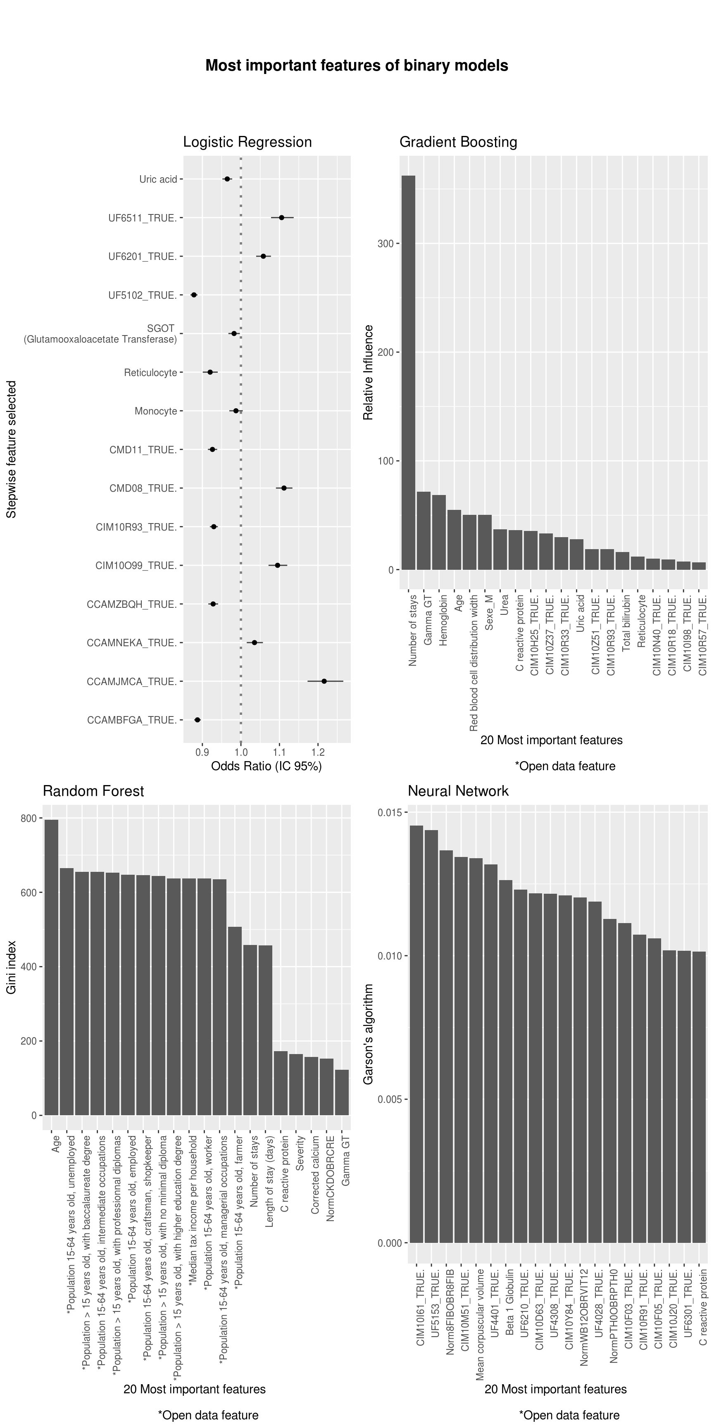
, in Rennes.
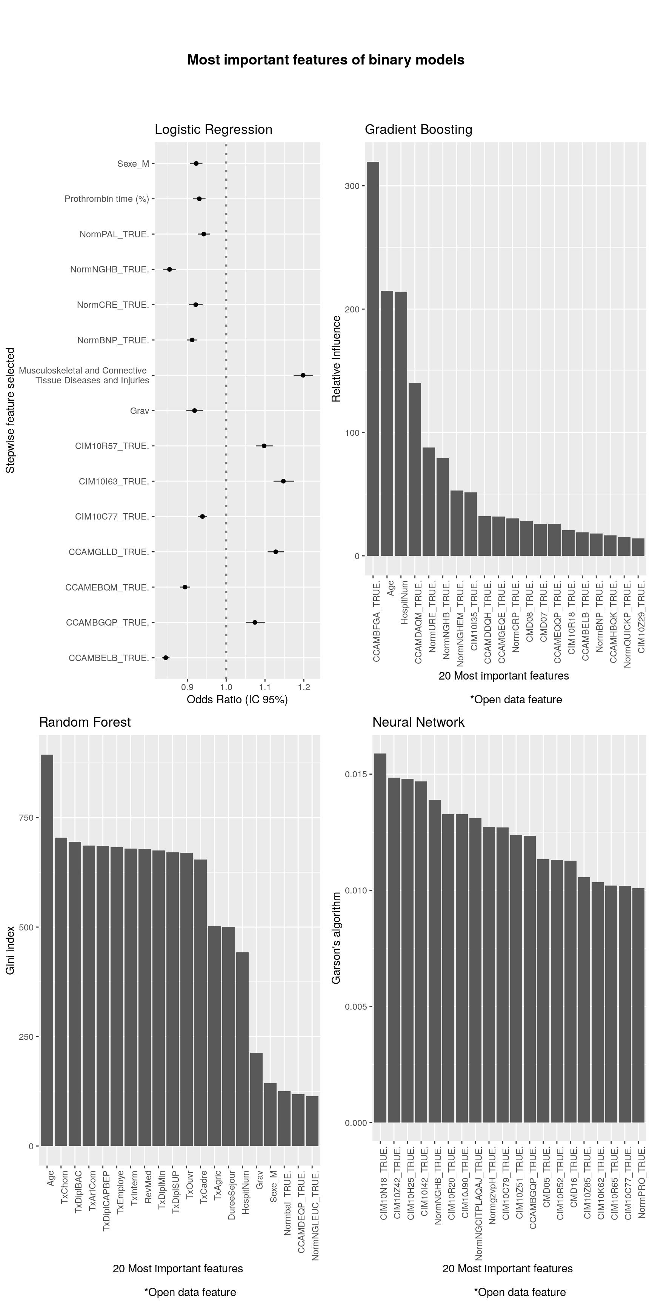
, in Tours.

