Supplementary Material

Enhancement of the classification and recovery process of fine mineral particles via a newly developed volute feed hydrocyclone

Wenjie Lvª, Qi Weiª, Yujie Jiª, Bing Liuª, Hongpeng Ma^{b}, Yuan Huang^{c}, Haitao Huangª, Hualin Wangª, Pengbo Fu^{a*}

ª National Engineering Research Center of Industrial Wastewater Detoxication and Resource Recovery, East China University of Science and Technology, Shanghai, 200237, China
^{b} Key Laboratory of Special Functional and Smart Polymer Materials of Ministry of Industry and Information Technology, Northwestern Polytechnical University, Shaan Xi, 710072, PR China
^{c} Institute of Environmental Pollution and Heath, School of Environmental and Chemical Engineering, Shanghai University, Shanghai 200444, PR China

Totally 13 pages containing 5 Texts, 8 Tables and 12 Figures.
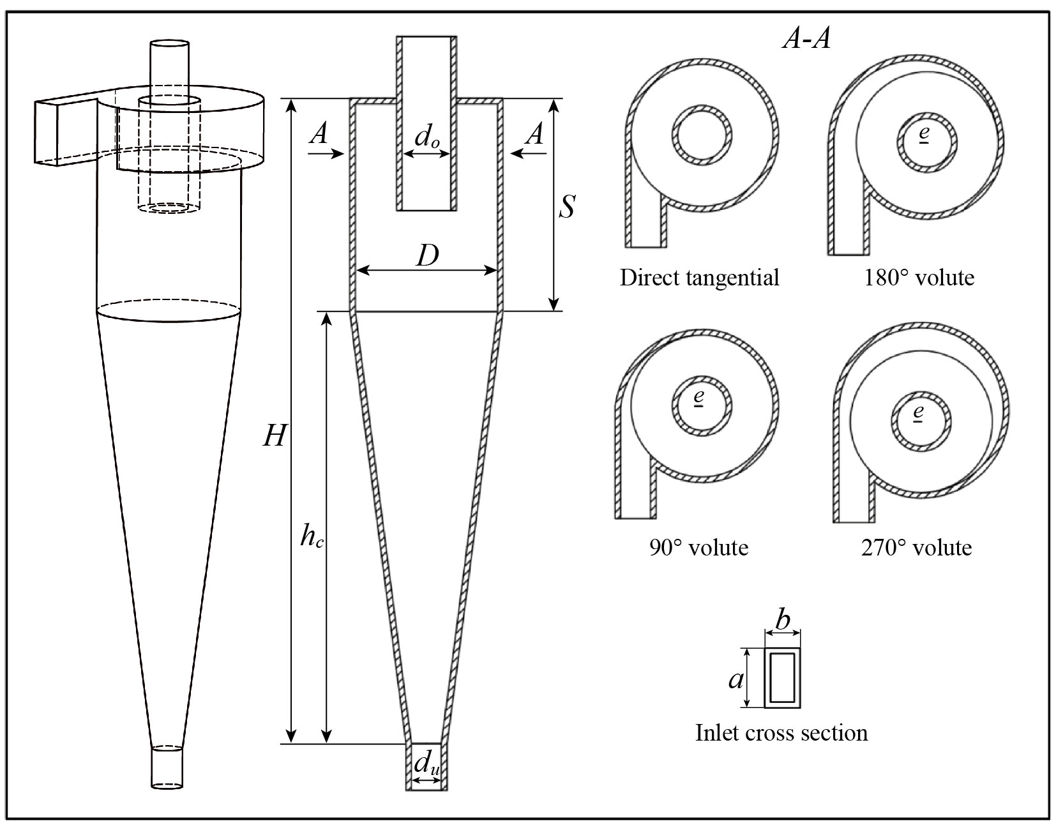
Fig. S1. The physical model of the hydrocyclone with various feed structures.

Table S1. Structural variables of the hydrocyclone.
unite: mg/L
Geometrical parameter | Value
Diameter of the outer cylinder (D)  Overflow diameter (d₀)  Underflow diameter (d_{u}) /mm  Insertion depth of the overflow outlet (S)  Length of the outer cylinder (H)  Cone length (h_{c})  Height of inlet (a)  Width of inlet (b)  Eccentric distance (e) | 75  20  10  57  342  231  30  16  6

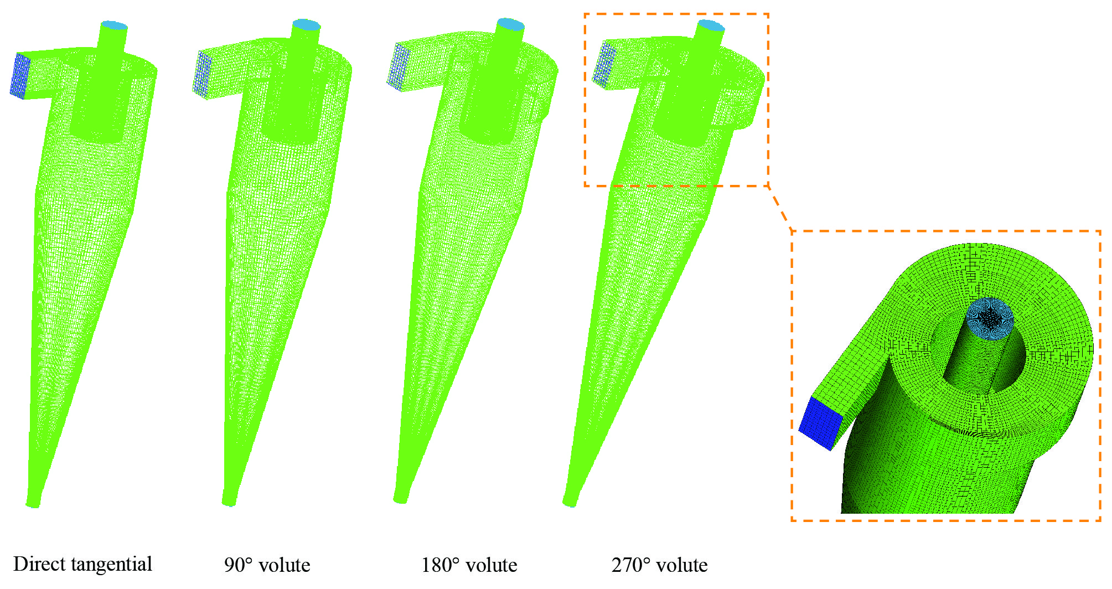
Fig. S2. Mesh division of the hydrocyclone with various feed structures.
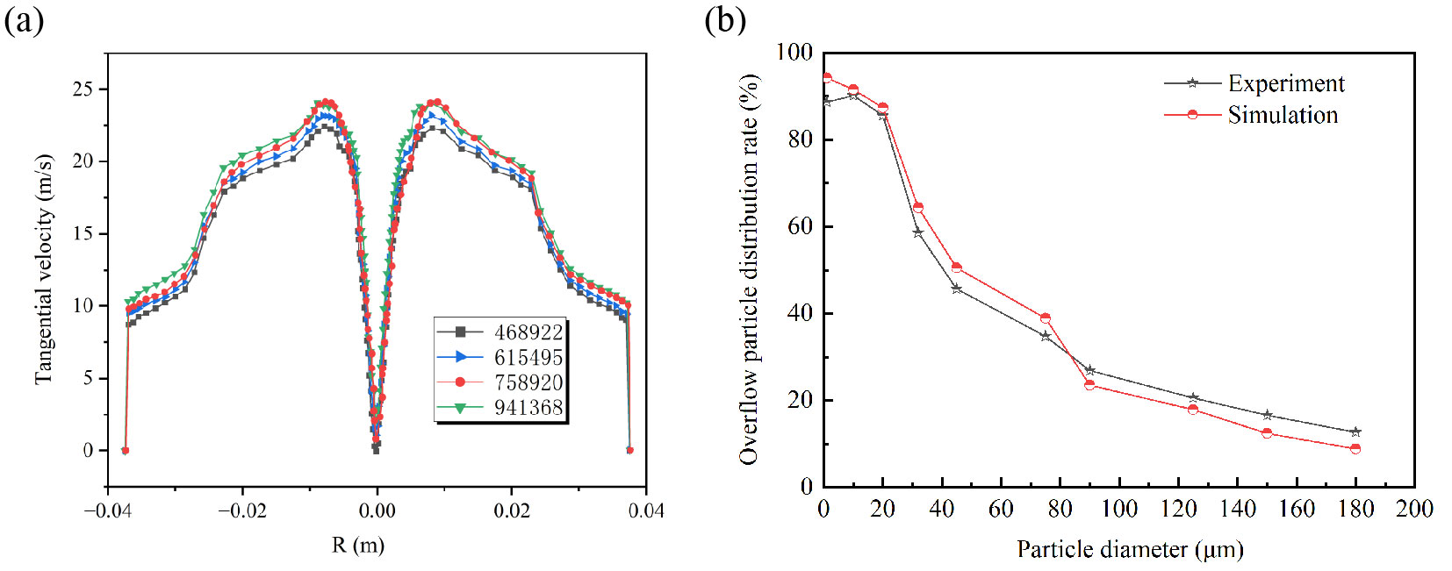
Fig. S3. Some comparison studies: (a) Comparison of the tangential velocity distribution along a diameter for various mesh densities, (b) Comparison of the overflow particle distribution rate between experimental tests and numerical simulations.
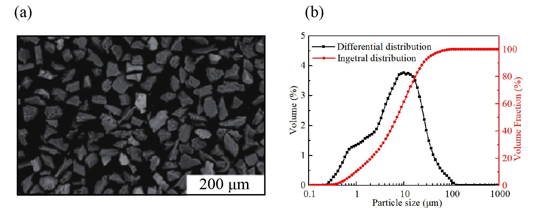
Fig. S4. Iron tailings: (a) 200μm SEM image, (b) particle size of iron tailings.

Text S1. Particle sizes analysis of experimental materials
The iron tailings were screened according to various particle sizes. As demonstrated in Fig. S5, the particle sizes of iron tailings are mainly concentrated in the range of less than 180 μm, accounting for 98.56%, and 75.32% of P₂O₅ is distributed in the range of 45-180 μm, 85.47% of SiO₂, 61.49% of Al₂O₃, and 78.15% of Fe₂O₃ are distributed in the range of more than 20 μm. The content of Fe₂O₃ and P₂O₅ in iron tailings gradually lessens with the decrease of particle size, and most metal minerals gradually magnify with the decrease of particle size. The metal mineral content is the highest in the range of 20-180 μm.
Fig. S5. The content of SiO2、Fe2O3、Al2O3、P2O5 and TiO2 in iron tailings with different grain size.

Text S2. Component analysis of experimental materials
The experimental material is iron tailings from Xincun Mine in Chengde Longhua County, Hebei Province. The main chemical components of the iron tailings were obtained by X-ray fluorescence spectrometry. As illustrated in Table S2, the tailings mainly contain Fe, Si, Al, Mg, Na, Ti, Ca, Mn, K, P, V, S, Ni , and other elements.
Table S2. The main chemical composition of iron tailings.
Composition | SiO₂ | CaO | Fe₂O₃ | Al₂O₃ | FeO | Na₂O | P₂O₅
Content /% | 40.12 | 5.02 | 13.78 | 11.37 | 9.22 | 0.61 | 9.78
Composition | Ni | MgO | TiO₂ | V₂O₅ | K₂O | SO₃
Content /% | 0.04 | 3.08 | 3.73 | 0.21 | 0.72 | 2.32

The mineral components of iron tailings were analyzed by X-ray diffraction analysis and electron microscopy. The main mineral components have been presented in Table S3. A scanning electron microscope photograph of iron tailings has been illustrated in Fig. S6, revealing the characteristics of irregular shape, porosity and easy adhesion of argillated minerals to particle pores and surfaces. The XRD analysis spectrum of iron tailings has been demonstrated in Fig. S7.
Table S3. The main mineral composition of iron tailings.
Mineral component | Ilmenite |  | Magnetite |  | Pyrrhotite |  | Plagioclase |  | Pyroxene &  Hornblende |  | Mica chlorite |  | Others
Content /% | 3.5 | 1.5 |  | 1.2 |  | 35 |  | 40.1 |  | 9.2 |  | 9.5

Fig. S6. SEM images of iron tailings.
Fig. S7. XRD pattern of iron tailings.
Table S4. The main experimental equipment.
Experimental equipment | Specification | Characteristic | Manufactures
Frequency conversion cabinet  Slurry pump  Flow meter  Pressure gauge  Stirring tank  New volute feed hydrocyclone | FG35-2  FG35-2  LZB-4  TB-100 | 1.45m³  D=75mm | Baoding Sinuo Fluid Technology Co., Ltd.  Xi'an Automation Instrument Factory  Nanjing Shunlaida Instrumentation Co., Ltd  Self-designed  Self-designed

Text S3. The particle self-rotation and revolution coupling centrifugal force
The radius of the spherical particles is negligible compared with the distance from the plane where the particles are located to the axis of the hydrocyclone. Therefore, the spherical particles and the fine particles on the surface or in the pores of the particles can be regarded as mass point when analyzing the force of the particles. When the particles rotate at high speed with the fluid in the hydrocyclone, a variety of external forces will act on the fine particles on the surface or in the pores of the particles. The expression of the revolution centrifugal force can be obtained as:
(1)
In the above formula, r_{o} represents the radius of the fine particles, r represents the distance between the spherical particles and the axis of the hydrocyclone, ρ represents the density of the fluid, ρ₁ represents the density of the fine particles, and ω_{e} represents the angular velocity of the particle as it rotates with the fluid.
The component force of the revolution centrifugal force on the fine particle along the radius of the spherical particle is expressed as：
(2)
In the above formula, α denotes the angle between the revolution centrifugal force and the radial direction.
When the spherical particles are subjected to tangential strain of the fluid in the flow field, they will generate self-rotation motion, and the fine particles adsorbed in the spherical particles will be subjected to the action of self-rotation centrifugal force. The expression is as follows:
(3)
In the above formula, r_{po} denotes the distance between fine particles and spherical particles, and ω_{z} denotes the angular velocity of particle self-rotation motion.
Therefore, the expression of self-rotation and revolution coupling centrifugal force acting on fine particles on the surface or in the pores of the spherical particles can be obtained as follows:
(4)
It can be seen from the above formula that increasing the self-rotation speed of the particles can strengthen the interface turbulence, reduce the oscillation period, make the oscillation rate faster, and the self-rotation and revolution coupling centrifugal force acting on the fine particles also increases, and the amplitude of the oscillation increases accordingly, which is conducive to the rapid desorption of fine particles.

Text S4.
Fig. S8 presents the classification efficiency comparison of traditional and new hydrocyclones in different particle size ranges. For particles whose sizes are less than 3, 5, 11, 14, 21, 26, and 31 μm, the classification efficiency of the new hydrocyclone in each particle size range is about 10-18% higher than that of the traditional hydrocyclone, which means that the new hydrocyclone greatly enhances the classification efficiency of fine particles. At the same time, for particles less than 38 μm, the classification efficiency of the new hydrocyclone is only 5% higher than that of the traditional hydrocyclone. The obtained results reveal that adding a volute at the inlet of the hydrocyclone to improve the classification efficiency, will be more effective for fine particles than coarse ones. Fig. S9(a) illustrates the morphology of mineral particles in iron tailings before treatment, and a large number of ultrafine particles are adsorbed on the surface and pore of mineral particles. According to Fig. S9(b), the surface and pores of the mineral particles after cyclone separation are relatively clean, and there is no fine particle or impurity attachment, which confirms the effectiveness of the new volute feed hydrocyclone for the desorption of fine particles on the surface or pores of tailings, strengthens the separation of coarse and fine particles, and improves the classification efficiency of fine mineral particles.
Fig. S8. Comparison of classification efficiencies of traditional-type and new-type hydrocyclones for different size ranges.
Fig. S9. The mineral particle morphology before and after cyclone separation.

Text S5. The results of cyclone classification experimental
The following experimental results are the arithmetic mean values obtained after repeated experiments.
For the case of the slurry concentration of iron tailings of 10.72%, the feeding pressure of 0.15 Mpa, the overflow diameter was preliminarily selected as 20 mm, and the underflow diameter was adjusted. The experiments were carried out under the conditions of 6 mm, 10 mm, 14 mm, and 18 mm, respectively. During the experiment, the concentration and particle size distribution of the underflow and overflow of iron tailings are analyzed and measured from the hydrocyclone underflow and overflow outlets, and the underflow concentration yield has been calculated. The experimental results for various underflow conditions have been presented in Table S5.
Table S5. Experimental equipment of various underflow diameters.
Underflow diameter  /mm | Underflow concentration /% | Overflow concentration /% | Underflow concentration yield /% | Particle content less than 20 μm in overflow /% | Particle content less than 20 μm in underflow /%
6 | 62.87 | 7.17 | 37.77 | 83.47 | 25.01
10 | 59.94 | 7.02 | 39.09 | 84.14 | 26.51
14 | 24.82 | 6.34 | 54.88 | 87.26 | 46.43
18 | 17.16 | 5.96 | 68.03 | 88.21 | 56.79
When the underflow diameter has been determined as 10 mm, the influence of volute hydrocyclone on the cyclone classification of iron tailings particles was investigated for the case of the slurry concentration of iron tailings of 10.72 %, the feeding pressure of 0.15 MPa, the underflow diameter of 10 mm, and the overflow diameter in order were 15 mm, 20 mm, 22 mm, and 25 mm. The experimental results for various overflow conditions have been illustrated in Table S6.
Table S6. Experimental equipment of various overflow diameters.
Overflow diameter /mm | Underflow concentration /% | Overflow concentration /% | Overflow concentration yield /% | Particle content less than 20 μm in overflow /% | Particle content less than 20 μm in underflow /%
15 | 34.86 | 6.06 | 47.38 | 85.38 | 38.02
20 | 59.94 | 7.02 | 60.91 | 84.14 | 26.51
22 | 61.47 | 7.56 | 65.74 | 83.67 | 24.53
25 | 62.85 | 8.05 | 71.43 | 82.14 | 22.69
When the overflow diameter was chosen as 20 mm, the influence of volute hydrocyclone on the cyclone classification of iron tailings particles was investigated for the case of the feed pressure of iron tailings of 0.15 MPa, the underflow diameter of 10 mm, the overflow diameter of 20 mm, and the feed concentration was 8.49%, 10.72%, 11.53%, and 12.06%, respectively. The experimental results for various feed concentrations have been presented in Table S7.
Table S7. Experimental equipment of various feed concentration.
Feed con-  centration /% | Underflow concentration /% |  | Overflow concentration /% |  | Overflow concentration yield /% |  | Particle content less than 20 μm in overflow /% |  | Particle content less than 20 μm in underflow /%
8.49 |  | 46.29 |  | 6.46 |  | 58.21 |  | 87.61 |  | 23.33
10.72 |  | 59.94 |  | 7.02 |  | 60.91 |  | 84.14 |  | 26.51
11.53 |  | 61.71 |  | 7.11 |  | 61.27 |  | 83.48 |  | 26.94
12.06 |  | 62.38 |  | 7.19 |  | 61.85 |  | 83.14 |  | 27.21
When the feed concentration has been determined as 10.72%, the influence of volute hydrocyclone on the cyclone classification of iron tailings particles was investigated for the case of the underflow diameter of 10 mm, the overflow diameter of 20 mm, the feed concentration of 10.72 %, and the feed pressure of iron tailings in order were 0.05 MPa, 0.08 MPa, 0.12 MPa, and 0.15 MPa. The experimental results for various feed pressures have been demonstrated in Table S8.
Table S8. Experimental equipment of various feed pressure.
Feed pressure /MPa | Underflow concentration /% | Overflow concentration /% | Overflow concentration yield /% | Particle content less than 20 μm in overflow /% | Particle content less than 20 μm in underflow /%
0.05 | 47.40 | 7.67 | 66.06 | 80.26 | 28.88
0.08 | 53.29 | 7.35 | 63.53 | 82.12 | 27.38
0.12 | 56.71 | 7.11 | 61.50 | 83.48 | 26.54
0.15 | 59.94 | 7.02 | 60.91 | 84.14 | 26.51

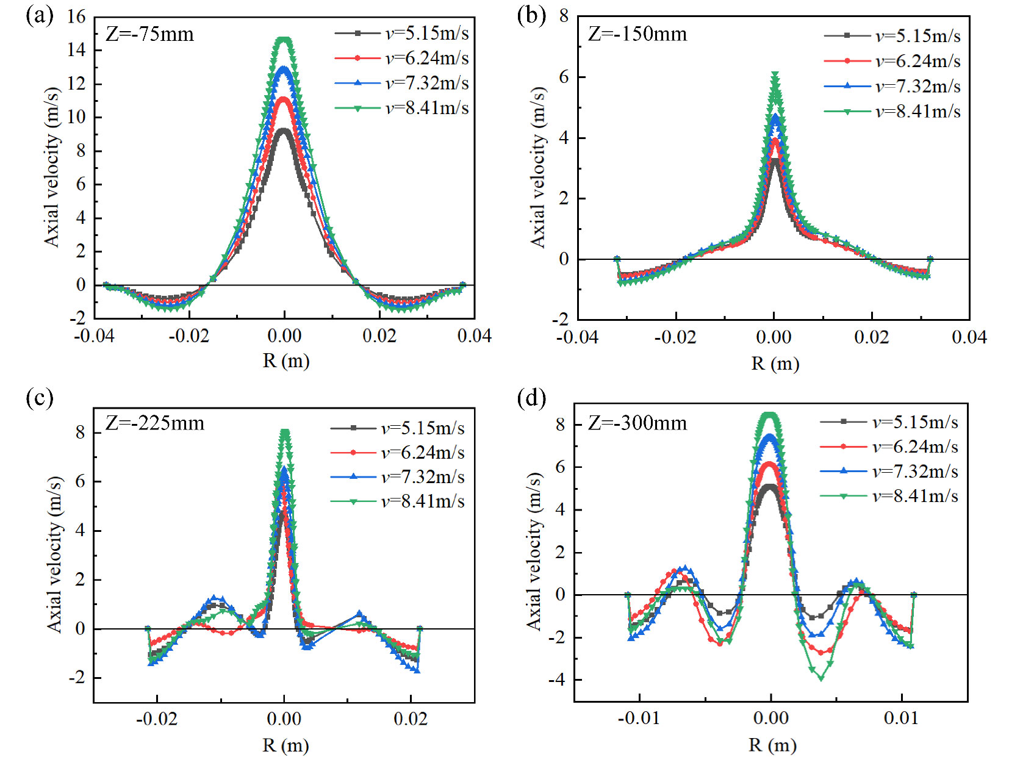
Fig. S10. The axial velocity distribution in the swirl field subjected to different feed flow rates.

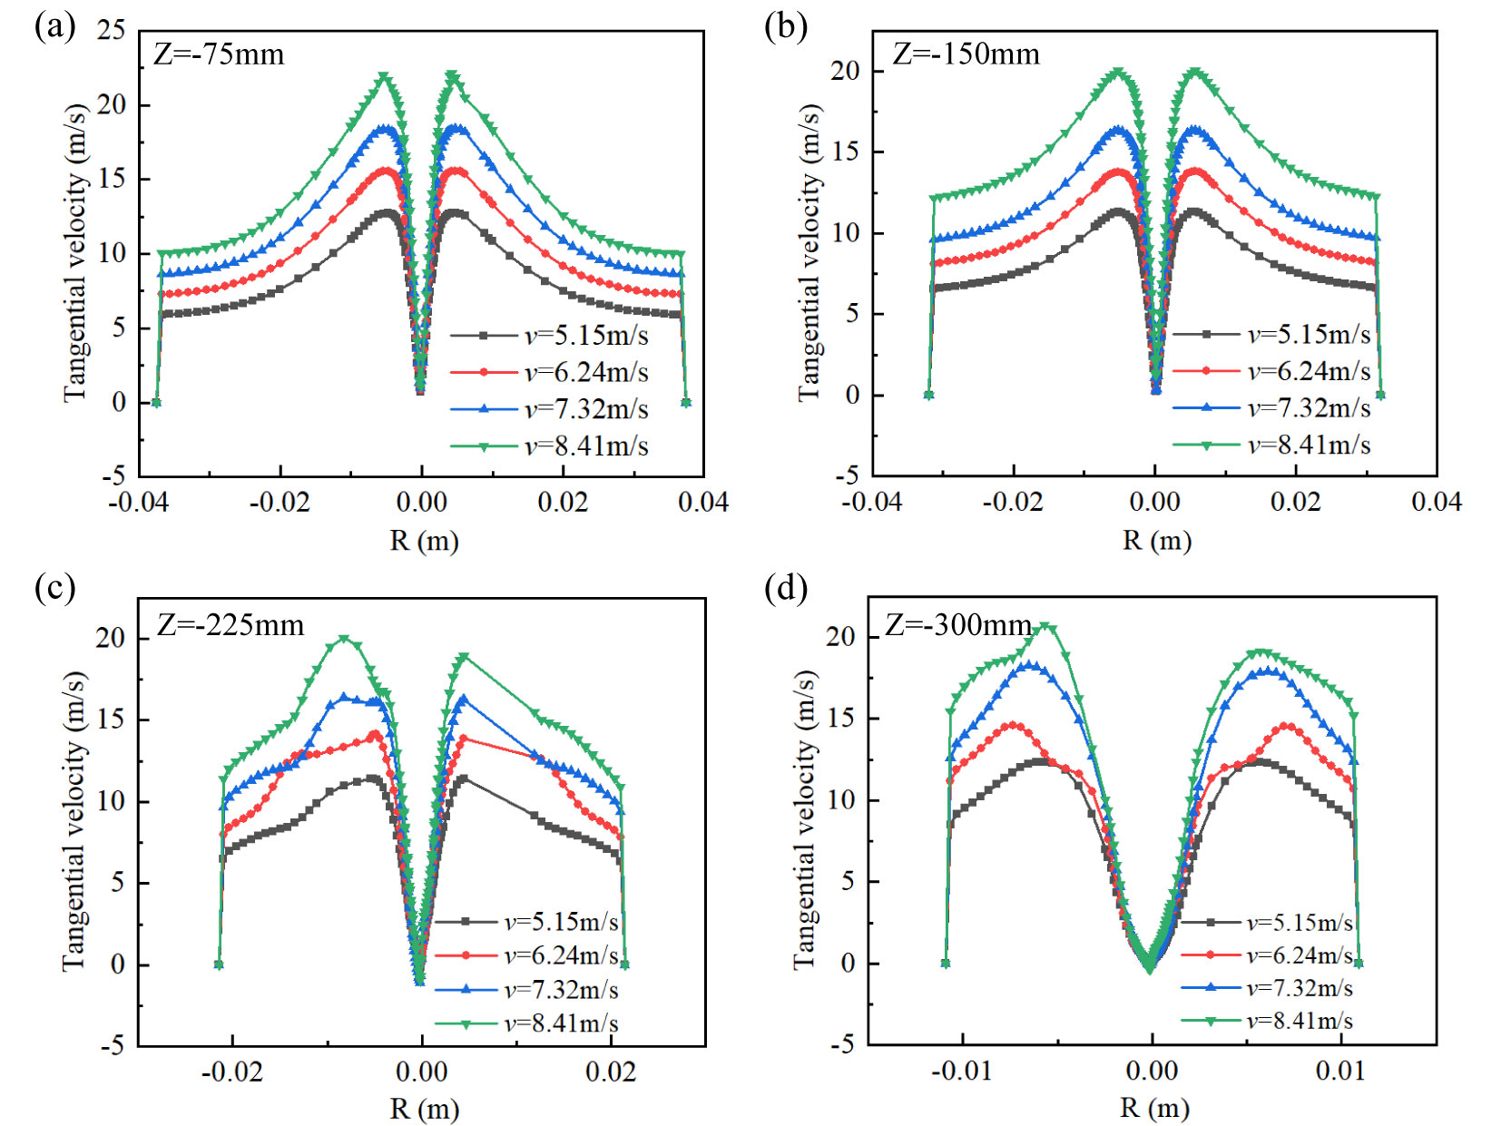
Fig. S11. The tangential velocity distribution in the swirl field due to various feed flow rates.
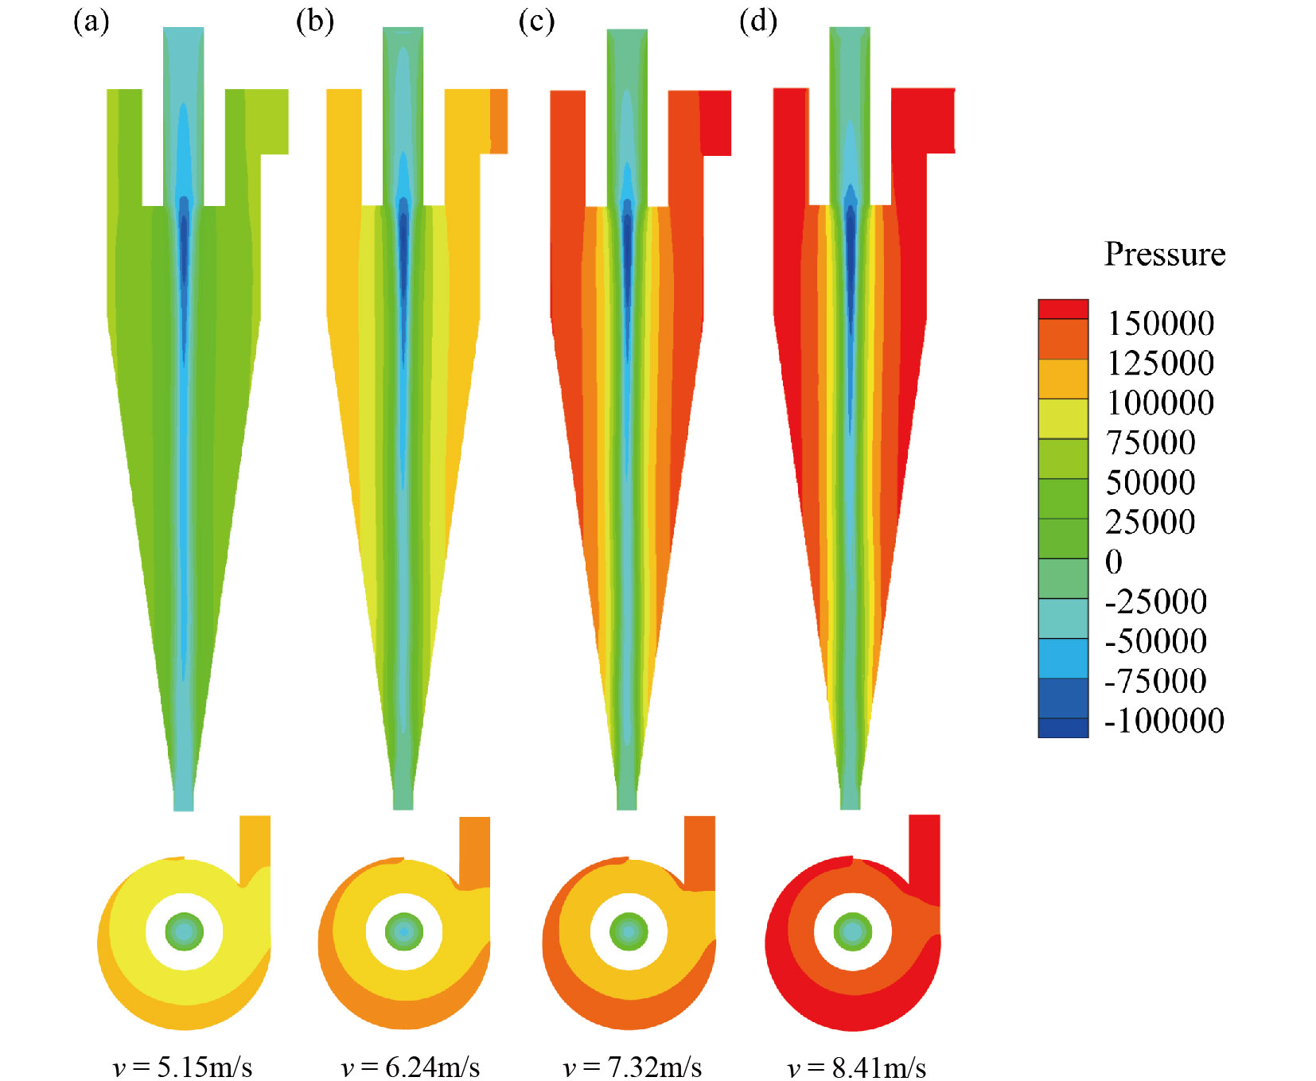
Fig. S12. The pressure contours of the hydrocyclone due to various feed flow rates.

