Supplementary Table 1: Models 1.0, 1.1, 1.2, and 1.3 investigating the impact of reward value, harshness, and variability on participants’ likelihood of switching jars. a) WAIC estimates and standard error comparison. b) Model estimates and 95% credible intervals. c) Contrasted predictions between Harsh and Not Harsh conditions for responsive and elective switching, characterized by switching after finding rewards between 0-45 and 55-100 units, respectively, from the best fit model. d) Contrasted predictions between Harsh and Not Harsh conditions for responsive switching, characterized by switching after finding rewards between 0-25, from the best fit model.
a) |  | WAIC diff | se | 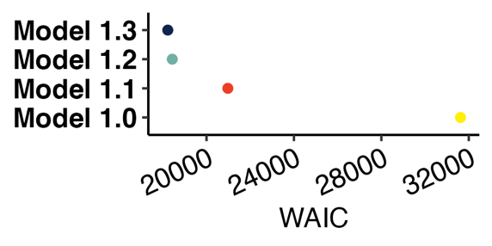  `
 | Model 1.3 | 0 | 0
 | Model 1.2 | 204.91 | 30.19
 | Model 1.1 | 2747.89 | 101.41
 | Model 1.0 | 13394.45 | 192.48
b) | Model 1.0 |  | Model 1.1 |  | Model 1.2 |  | Model 1.3
 | Odds Ratios | CI (95%) | Odds Ratios | CI (95%) | Odds Ratios | CI (95%) | Odds Ratios | CI (95%)
Intercept | -1.11 | -1.27 – -0.94 | 4.24 | 3.80 – 4.68 | 7.36 | 6.67 – 8.11 | 6.96 | 6.26 – 7.73
Harsh vs Not Harsh |  |  | -0.08 | -0.09 – -0.08 | -0.13 | -0.14 – -0.12 | -0.12 | -0.13 – -0.11
Variable vs Stable |  |  |  |  | 0.11 | -0.31 – 0.53 | 0.74 | 0.09 – 1.39
Reward Value |  |  |  |  | -3.85 | -4.58 – -3.17 | -3.38 | -4.12 – -2.66
Harshness : Variability |  |  |  |  | 0 | -0.01 – 0.00 | -0.01 | -0.02 – -0.00
Harshness : Reward Value |  |  |  |  | 0.06 | 0.05 – 0.07 | 0.05 | 0.04 – 0.06
Variability : Reward Value |  |  |  |  |  |  | -0.65 | -1.22 – -0.08
Harshness : Variability :Reward Value |  |  |  |  |  |  | 0.01 | -0.00 – 0.01
c) |  |  | HDP 5% | HDP 95% |  |  | HDP 5% | HDP 95%
 | Stable Responsive (0-45) |  | -0.04 | 0 | Stable Elective (55-100) |  | -0.06 | 0.02
 | Variable Responsive (0-45) |  | -0.02 | 0.05 | Variable Elective (55-100) |  | -0.01 | 0.09
d) |  |  | HDP 5% | HDP 95%
 | Stable Responsive (0-25) |  | -0.01 | 0
 | Variable Responsive (0-25) |  | -0.02 | 0.02

Supplementary Table 2: Models 2.0, 2.1, 2.2, and 2.3 investigating the impact of reward value, harshness, and variability on participants’ likelihood of switching jars including age, sex, and specific reward schedule. a) WAIC estimates and standard error comparison. b) Model estimates and 95% credible intervals. c) Contrasted predictions between Harsh and Not Harsh conditions for responsive and elective switching, characterized by switching after finding rewards between 0-45 and 55-100 units, respectively, from the best fit model.
a) |  | WAIC diff | se | 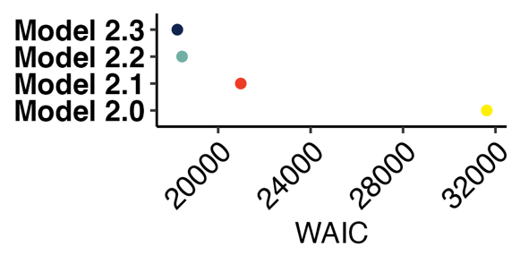  `
 | Model 2.3 | 0 | 0
 | Model 2.2 | 203.52 | 30.35
 | Model 2.1 | 2745.72 | 101.5
 | Model 2.0 | 13390.43 | 192.52
b) | Model 2.0 |  | Model 2.1 |  | Model 2.2 |  | Model 2.3
 | Odds Ratios | CI (95%) | Odds Ratios | CI (95%) | Odds Ratios | CI (95%) | Odds Ratios | CI (95%)
Intercept | -1.11 | -1.27 – -0.94 | 4.17 | 3.52 – 4.82 | 7.21 | 6.39 – 8.07 | 6.78 | 5.98 – 7.64
Reward Value |  |  | -0.08 | -0.09 – -0.08 | -0.13 | -0.14 – -0.12 | -0.12 | -0.13 – -0.11
Age |  |  | -0.02 | -0.24 – 0.19 | 0.01 | -0.19 – 0.21 | 0.02 | -0.17 – 0.21
Sex |  |  | 0.09 | -0.33 – 0.53 | 0.32 | -0.08 – 0.73 | 0.36 | -0.05 – 0.74
Schedule 1 vs 2 |  |  | 0.06 | -0.64 – 0.78 | 0.15 | -0.53 – 0.81 | 0.2 | -0.47 – 0.85
Schedule 1 vs 3 |  |  | 0.04 | -0.62 – 0.72 | -0.26 | -0.89 – 0.36 | -0.36 | -0.98 – 0.27
Schedule 1 vs 4 |  |  | -0.3 | -0.96 – 0.36 | -0.32 | -0.95 – 0.32 | -0.3 | -0.93 – 0.30
Schedule 1 vs 5 |  |  | 0.28 | -0.32 – 0.93 | 0.34 | -0.27 – 0.93 | 0.36 | -0.24 – 0.94
Harsh vs Not Harsh |  |  |  |  | 0.11 | -0.30 – 0.54 | 0.76 | 0.10 – 1.43
Variable vs Stable |  |  |  |  | -3.85 | -4.59 – -3.17 | -3.37 | -4.10 – -2.64
Harshness : Variability |  |  |  |  | 0 | -0.01 – 0.00 | -0.01 | -0.02 – -0.00
Harshness : Reward Value |  |  |  |  | 0.06 | 0.05 – 0.07 | 0.05 | 0.04 – 0.06
Variability : Reward Value |  |  |  |  |  |  | -0.67 | -1.24 – -0.09
Harshness : Variability :Reward Value |  |  |  |  |  |  | 0.01 | -0.00 – 0.01
c) |  |  | HDP 5% | HDP 95% |  |  | HDP 5% | HDP 95%
 | Stable Responsive (0-45) |  | -0.04 | 0 | Stable Elective (55-100) |  | -0.06 | 0.02
 | Variable Responsive (0-45) |  | -0.02 | 0.05 | Variable Elective (55-100) |  | -0.01 | 0.1

Supplementary Table 3: Models 3.0, 3.1, 3.2, and 3.3 investigating the impact of reward value, harshness, and variability on participants’ likelihood of switching jars for participants who reported that the Harsh condition was more stressful than the Not Harsh condition. a) WAIC estimates and standard error comparison. b) Model estimates and 95% credible intervals. c) Contrasted predictions between Harsh and Not Harsh conditions for responsive and elective switching, characterized by switching after finding rewards between 0-45 and 55-100 units, respectively, from the best fit model.
a) |  | WAIC diff | se | 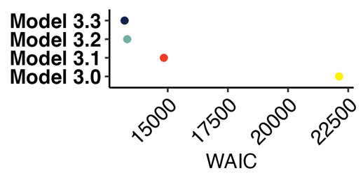  `
 | Model 3.3 | 0 | 0
 | Model 3.2 | 109.14 | 23.14
 | Model 3.1 | 1630.97 | 78.28
 | Model 3.0 | 8913.82 | 159.82
b) | Model 3.0 |  | Model 3.1 |  | Model 3.2 |  | Model 3.3
 | Odds Ratios | CI (95%) | Odds Ratios | CI (95%) | Odds Ratios | CI (95%) | Odds Ratios | CI (95%)
Intercept | -1.12 | -1.28 – -0.94 | 4.2 | 3.72 – 4.68 | 7.05 | 6.29 – 7.87 | 6.61 | 5.85 – 7.45
Harsh vs Not Harsh |  |  | -0.08 | -0.09 – -0.08 | -0.12 | -0.13 – -0.11 | -0.11 | -0.13 – -0.10
Variable vs Stable |  |  |  |  | 0.04 | -0.37 – 0.43 | 0.75 | 0.08 – 1.41
Reward Value |  |  |  |  | -3.47 | -4.25 – -2.72 | -3.05 | -3.86 – -2.28
Harshness : Variability |  |  |  |  | -0.01 | -0.01 – 0.00 | -0.01 | -0.02 – -0.00
Harshness : Reward Value |  |  |  |  | 0.05 | 0.04 – 0.06 | 0.05 | 0.03 – 0.06
Variability : Reward Value |  |  |  |  |  |  | -0.61 | -1.19 – -0.03
Harshness : Variability :Reward Value |  |  |  |  |  |  | 0 | -0.01 – 0.01
c) |  |  | HDP 5% | HDP 95% |  |  | HDP 5% | HDP 95%
 | Stable Responsive (0-45) |  | -0.04 | 0 | Stable Elective (55-100) |  | -0.03 | 0.05
 | Variable Responsive (0-45) |  | -0.02 | 0.07 | Variable Elective (55-100) |  | 0.01 | 0.13

Supplementary Table 4: Models 4.0, 4.1, 4.2, and 4.3 investigating the impact of reward value, harshness, and variability on participants’ likelihood of switching jars for the first round of data collection with heavy sampling bias (see addendum to the preregistration: Pope, 2021b). a) WAIC estimates and standard error comparison. b) Model estimates and 95% credible intervals. c) Contrasted predictions between Harsh and Not Harsh conditions for responsive and elective switching, characterized by switching after finding rewards between 0-45 and 55-100 units, respectively, from the best fit model.
a) |  | WAIC diff | se | 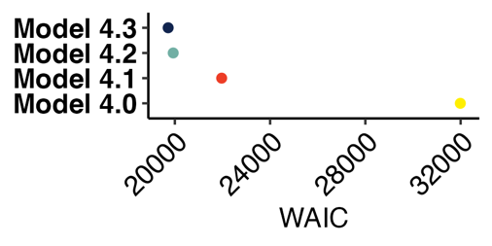
 | Model 4.3 | 0 | 0
 | Model 4.2 | 211.87 | 29.99
 | Model 4.1 | 2246.64 | 93.38
 | Model 4.0 | 12268.42 | 191.29
b) | Model 4.0 |  | Model 4.1 |  | Model 4.2 |  | Model 4.3
 | Odds Ratios | CI (95%) | Odds Ratios | CI (95%) | Odds Ratios | CI (95%) | Odds Ratios | CI (95%)
Intercept | -1.12 | -1.24 – -0.99 | 4.01 | 3.65 – 4.37 | 6.93 | 6.28 – 7.65 | 6.62 | 5.96 – 7.33
Harsh vs Not Harsh |  |  | -0.08 | -0.08 – -0.07 | -0.12 | -0.13 – -0.11 | -0.11 | -0.12 – -0.10
Variable vs Stable |  |  |  |  | 0.11 | -0.26 – 0.46 | 0.39 | -0.15 – 0.93
Reward Value |  |  |  |  | -3.35 | -4.02 – -2.74 | -2.9 | -3.56 – -2.26
Harshness : Variability |  |  |  |  | 0 | -0.01 – 0.00 | -0.01 | -0.01 – 0.00
Harshness : Reward Value |  |  |  |  | 0.04 | 0.04 – 0.05 | 0.04 | 0.03 – 0.05
Variability : Reward Value |  |  |  |  |  |  | -0.48 | -1.01 – 0.04
Harshness : Variability :Reward Value |  |  |  |  |  |  | 0.01 | -0.00 – 0.02
c) |  |  | HDP 5% | HDP 95% |  |  | HDP 5% | HDP 95%
 | Stable Responsive (0-45) |  | -0.02 | 0 | Stable Elective (55-100) |  | -0.02 | 0.04
 | Variable Responsive (0-45) |  | -0.02 | 0.04 | Variable Elective (55-100) |  | -0.03 | 0.04

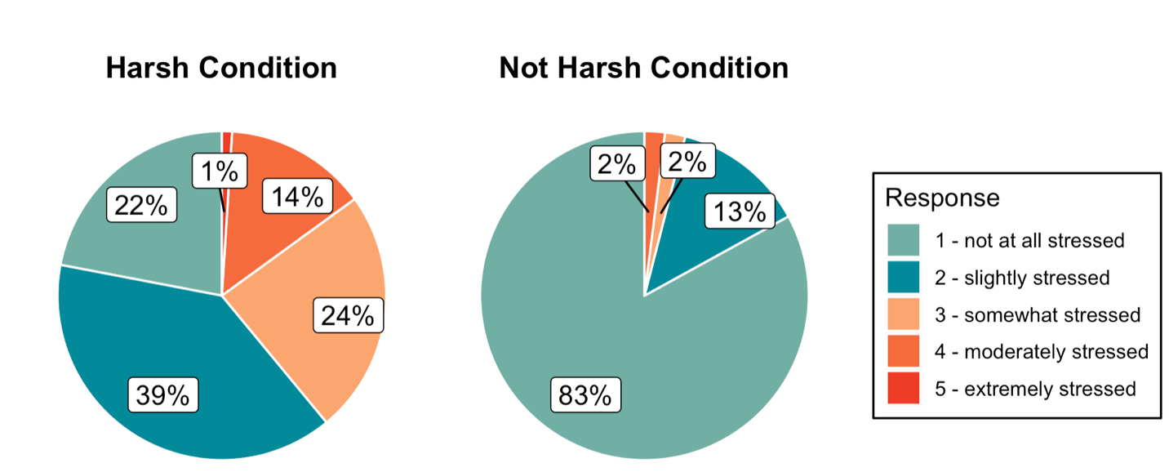
Supplementary Figure 1. Participants’ self-reported feelings of stress during the Harsh and Not Harsh Conditions.

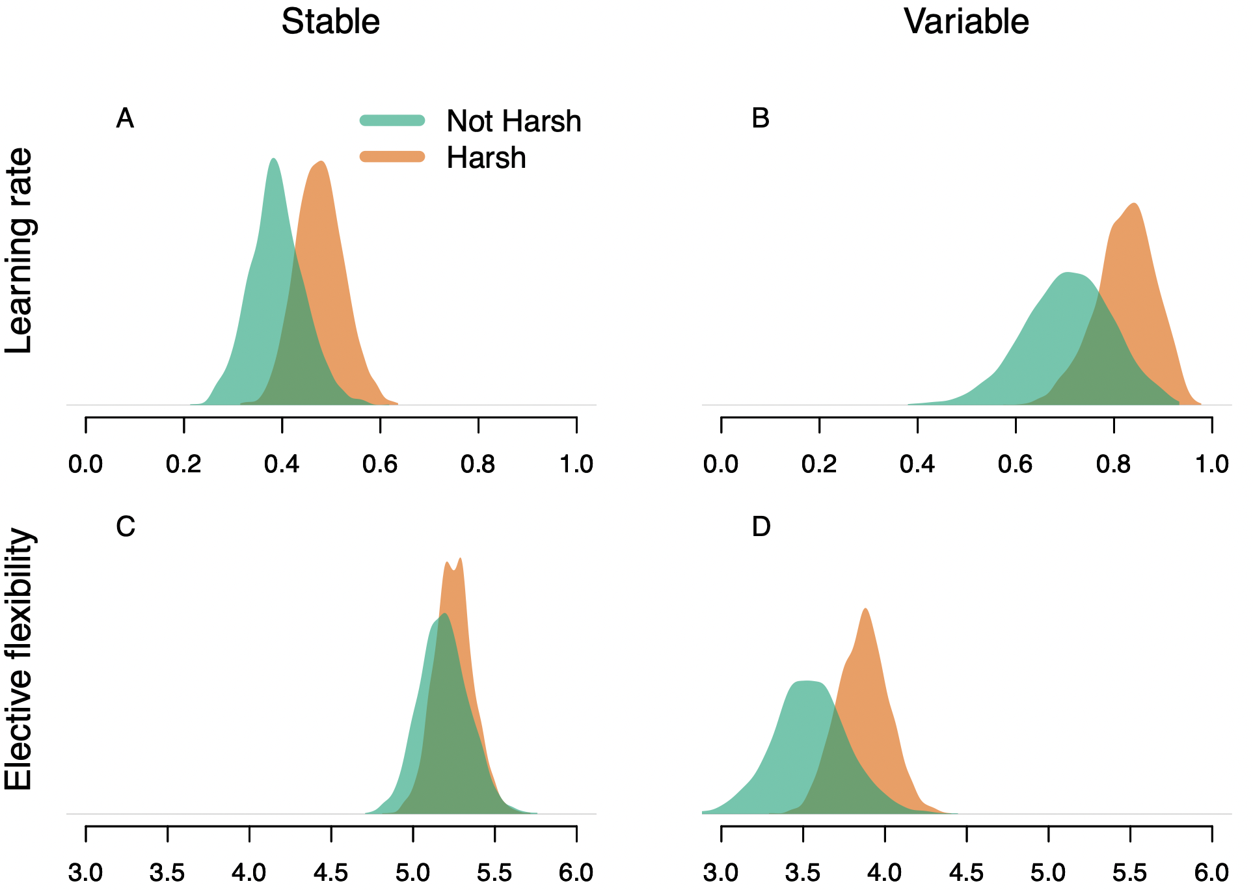
Supplementary Figure 2. Reinforcement Learning Model results for participants’ who reported that the Harsh condition was more stressful than the Not Harsh condition. Participants’ learning rates (A-B) and elective flexibility parameter (C-D) under Not Harsh and Harsh conditions in Stable and Variable environments.

