Event Cache:
An Independent Component in Working Memory
Hui Zhou¹*, Jinglan Wu¹*, Jiaofeng Li¹, Zhihe Pan¹, Jinying Lu¹,
Mowei Shen^{1#}, Tengfei Wang^{1#}, Yuzheng Hu^{1,2,3#}, Zaifeng Gao^{1#}
Supplementary materials
Contents
- Table S1. Descriptive statistics for WM tasks
- Table S2. Correlations among WM tasks
- Figure S1. Latent variable models integrating biological movements and non-biological movements into visuo-spatial sketchpad, episodic buffer, and object cache, respectively
- Figure S2. Prediction performance of three components with more thresholds
- Table S3. Brain regions within each network
- Table S4. The relative degree of each network in prediction model.
- Figure S3. Node degrees of brain regions within networks important for prediction of the three WM components.
- Table S5. The most important nodes within the essential networks
- Figure S4. Node degree illustration for the all networks of each WM component
- Figure S5. Prediction performance of OBJECT component after removing one brain network
- Figure S6. Prediction performance of CE component after removing one brain network
- Figure S7. A schematic illustration of a single trial in PLDs biological movement task and stimuli used in WM tasks
Table S1. Descriptive statistics for WM tasks (N = 206)
Measure | M | SD | Skew | Kurtosis | Reliability
1. PLDBM | 2.68 | 0.77 | 0.29 | -0.42 | 0.61^{b}
2. SolidBM | 3.28 | 0.92 | -0.13 | 0.27 | 0.70^{b}
3. CirMove | 3.22 | 0.99 | -0.35 | -0.01 | 0.79^{b}
4. RecMove | 2.66 | 0.87 | 0.25 | 0.01 | 0.64^{b}
5. Color | 2.72 | 0.81 | 0.31 | -0.14 | 0.52^{b}
6. Shape | 2.42 | 0.90 | 0.34 | -0.33 | 0.68^{b}
7. Location | 4.56 | 1.39 | -0.21 | 0.17 | 0.77^{b}
8. ColorLoc | 2.88 | 0.88 | 0.28 | 0.09 | 0.59^{b}
9. ColorLet | 2.42 | 0.77 | 0.52 | -0.01 | 0.57^{b}
10. Ospan | 50.67 | 19.08 | -0.30 | -0.35 | 0.74ª
11. Sspan | 22.37 | 11.60 | 0.08 | -0.49 | 0.70ª
12. Anti | 0.67 | 0.14 | -0.26 | -0.75 | 0.77ª
13. Nback | 0.73 | 0.11 | -0.09 | -0.88 | 0.89ª
14. MOT | 3.53 | 0.95 | -0.08 | 0.23 | 0.75^{b}
Note. PLDBM = point-light display biological movement; SolidBM = solid biological movement; CirMove = circle movement; RecMove = rectangle movement; ColorLoc = color-location binding; ColorLet = color-letter binding; Ospan = operation span; Sspan = symmetry span; Anti = anti-saccade; MOT = multiple object tracking.
The dependent variable was the number of lists that all letters were recalled correctly for Ospan and Sspan tasks, accuracy for Anti and Nback, and K for other tasks.
ª Reliability was calculated using Cronbach’s alpha.
^{b} Reliability was calculated using Spearman-brown split-half reliability.

Table S2. Correlations among WM tasks (N = 206)
Measure | 1 | 2 | 3 | 4 | 5 | 6 | 7 | 8 | 9 | 10 | 11 | 12 | 13 | 14
1. PLDBM | 1
2. SolidBM | .34** | 1
3. CirMove | .35** | .36** | 1
4. RecMove | .27** | .37** | .49** | 1
5. Color | .10 | .08 | .28** | .19** | 1
6. Shape | .11 | .10 | .29** | .18** | .31** | 1
7. Location | .27** | .27** | .41** | .29** | .14* | .34** | 1
8. ColorLoc | .21** | .10 | .40** | .20** | .40** | .35** | .28** | 1
9. ColorLet | .16* | .17* | .38** | .24** | .31** | .38** | .37** | .46** | 1
10. Ospan | .13 | .05 | .16* | .07 | .21** | .19** | .16* | .09 | .12 | 1
11. Sspan | .17* | .03 | .16* | .16* | .17* | .21** | .23** | .26** | .34** | .42** | 1
12. Anti | .16* | .15* | .20** | .29** | .17* | .36** | .15* | .30** | .21** | .21** | .26** | 1
13. Nback | .09 | .06 | .27** | .23** | .06 | .14* | .23** | .15* | .25** | .12 | .24** | .19** | 1
14. MOT | .25** | .16* | .34** | .28** | .17* | .25** | .35** | .33** | .27** | .15* | .27** | .25** | .26** | 1
Note. *p < .05. **p < .01.

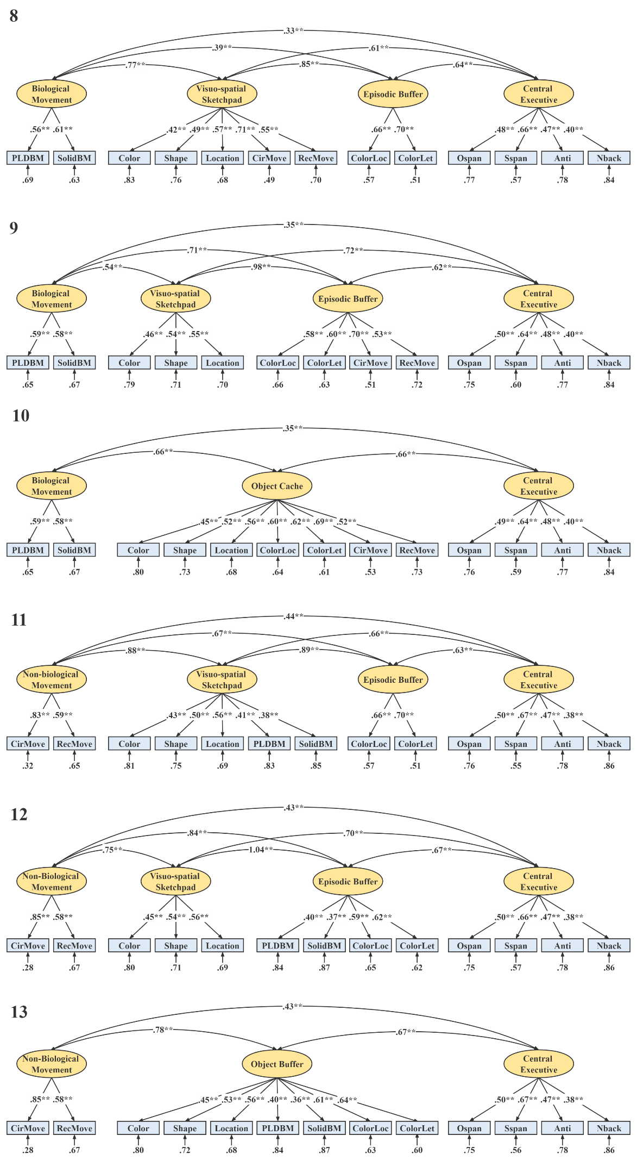
Figure S1. Latent variable models integrating biological movements and non-biological movements into visuo-spatial sketchpad, episodic buffer and object cache, respectively. PLDBM = PLDs biological movement; SolidBM = solid biological movement; CirMove = circle movement; RecMove = rectangle movement; ColorLoc = color-location binding; ColorLet = color-letter binding; Ospan = operation span; Sspan = symmetry span; Anti = anti-saccade. Asterisks indicate significant paths or loadings (** p <.01).

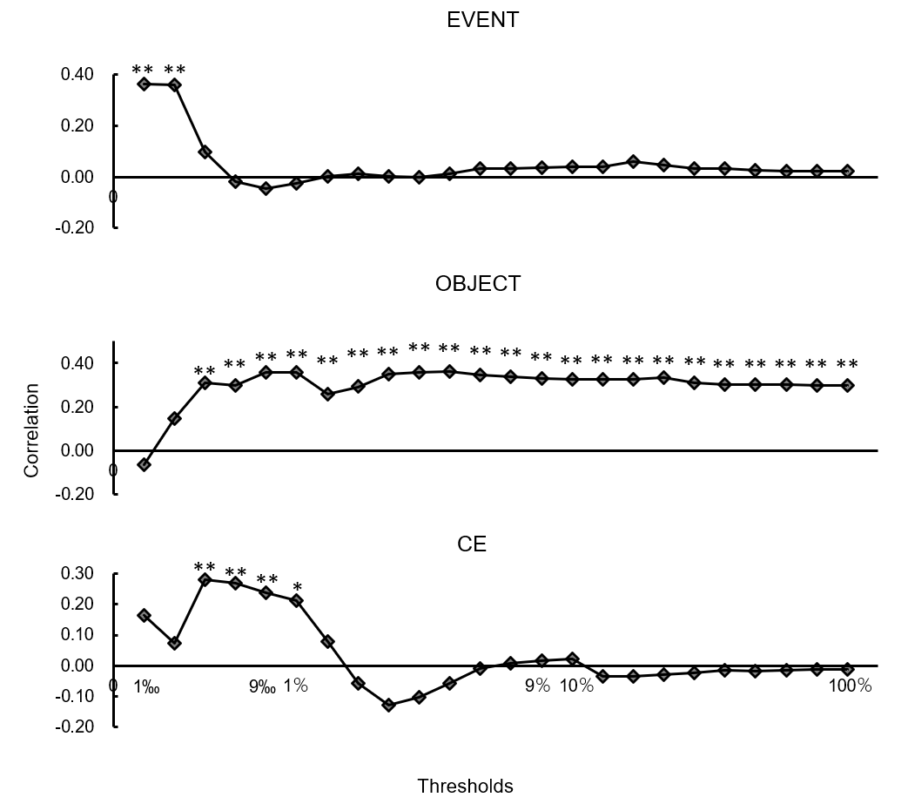
Figure S2. Prediction performance of three components with more thresholds. Threshold ranges from 1‰~9‰, with a step of 2‰, then from 1％~9％, with a step of 1％, then form 10％~100％, with a step of 10％. *0.01< p <0.05. ** p < 0.01. (without correcting for multiple comparisons). CE = central executive.

Table S3. Brain regions within each network
network name | Cerebellum |  | Default mode
brain region (AAL) | Cerebelum_8_L | Cerebelum_8_R | Frontal_Med_Orb_L | Frontal_Med_Orb_R
brain region (AAL) | Cerebelum_6_L | Cerebelum_6_R | Precuneus_L | Precuneus_R
brain region (AAL) | Cerebelum_Crus1_L | Cerebelum_Crus1_R | Occipital_Mid_L | Occipital_Mid_R
brain region (AAL) | Cerebelum_9_L | Cerebelum_9_R | Temporal_Mid_R | Frontal_Mid_R
brain region (AAL) | Cerebelum_Crus2_R | Cerebelum_4_5_R | ParahHippocampal_R | cerebellum_9_R
network name | Frontoparietal |  | Medial frontal
brain region (AAL) | Frontal_Mid_L | Frontal_Mid_R | Frontal_Sup_Medial_L | Frontal_Sup_Medial_R
brain region (AAL) | Frontal_Inf_Tri_L | Parietal_Inf_L | Frontal_Mid_L | Frontal_Sup_L
brain region (AAL) | Angular_R | Frontal_Mid_Orb_R | Supp_Motor_Area_L | Frontal_Inf_Orb_L
brain region (AAL) | Temporal_Inf_L | Temporal_Inf_R | Rectus_L | Temporal_Mid_R
brain region (AAL) | Cerebelum_Crus2_L | Cerebelum_Crus2_R | Temporal_Mid_L | Temporal_Mid_R
network name | Frontal-parietal-temporal associative |  | Salience
brain region (AAL) | Precentral_L | Precentral_R | Insula_L | Insula_R
brain region (AAL) | Postcentral_L | Postcentral_R | Precuneus_L | Precuneus_R
brain region (AAL) | Temporal_Sup_L | Temporal_Sup_R | Frontal_Mid_L | Frontal_Mid_R
brain region (AAL) | Temporal_Mid_L | Insula_R | Supp_Motor_Area_R | Caudate_L
brain region (AAL) | SupraMarginal_R | Cerebelum_8_R | Cerebelum_4_5_L | Cerebelum_6_R
network name | Subcortical |  | Visual A
brain region (AAL) | Hippocampus_L | Hippocampus_R | Fusiform_L | Fusiform_R
brain region (AAL) | ParaHippocampal_L | ParaHippocampal_R | Lingual_L | Lingual_R
brain region (AAL) | Putamen_L | Putamen_R | Calcarine_L | Calcarine_R
brain region (AAL) | Fusiform_L | Thalamus_R | Cuneus_L | Cuneus_R
brain region (AAL) | Caudate_R | Olfactory_R | Occipital_Sup_L | Precuneus_R
network name | Visual B |  | Visual Association
brain region (AAL) | Lingual_L | Lingual_R | Occipital_Mid_L | Occipital_Mid_R
brain region (AAL) | Occipital_Mid_L | Occipital_Mid_R | Occipital_Inf_L | Postcentral_R
brain region (AAL) | Occipital_Sup_L | Occipital_Inf_R | Temporal_Inf_L | Temporal_Inf_R
brain region (AAL) | Calcarine_L | Cerebelum_Crus2_R | Parietal_Sup_L | Parietal_Sup_R
brain region (AAL) | Cerebelum_Crus1_L | Cerebelum_Crus1_R | Cerebelum_8_L | Fusiform_R

Table S4. The relative degree of each network in prediction model.
EVENT | Medial frontal | Frontoparietal | Default mode | FPT associative | Visual A
EVENT | 0.083 | 0.083 | 0.083 | 0.167 | 0.083
EVENT | Visual B | Visual association | Salience | Subcortical | Cerebellum
EVENT | 0.083 | 0.167 | 0.000 | 0.000 | 0.250
OBJECT | Medial frontal | Frontoparietal | Default mode | FPT associative | Visual A
OBJECT | 0.138 | 0.121 | 0.086 | 0.138 | 0.052
OBJECT | Visual B | Visual association | Salience | Subcortical | Cerebellum
OBJECT | 0.069 | 0.138 | 0.138 | 0.052 | 0.069
CE | Medial frontal | Frontoparietal | Default mode | FPT associative | Visual A
CE | 0.154 | 0.179 | 0.179 | 0.103 | 0.026
CE | Visual B | Visual association | Salience | Subcortical | Cerebellum
CE | 0.128 | 0.051 | 0.026 | 0.051 | 0.103
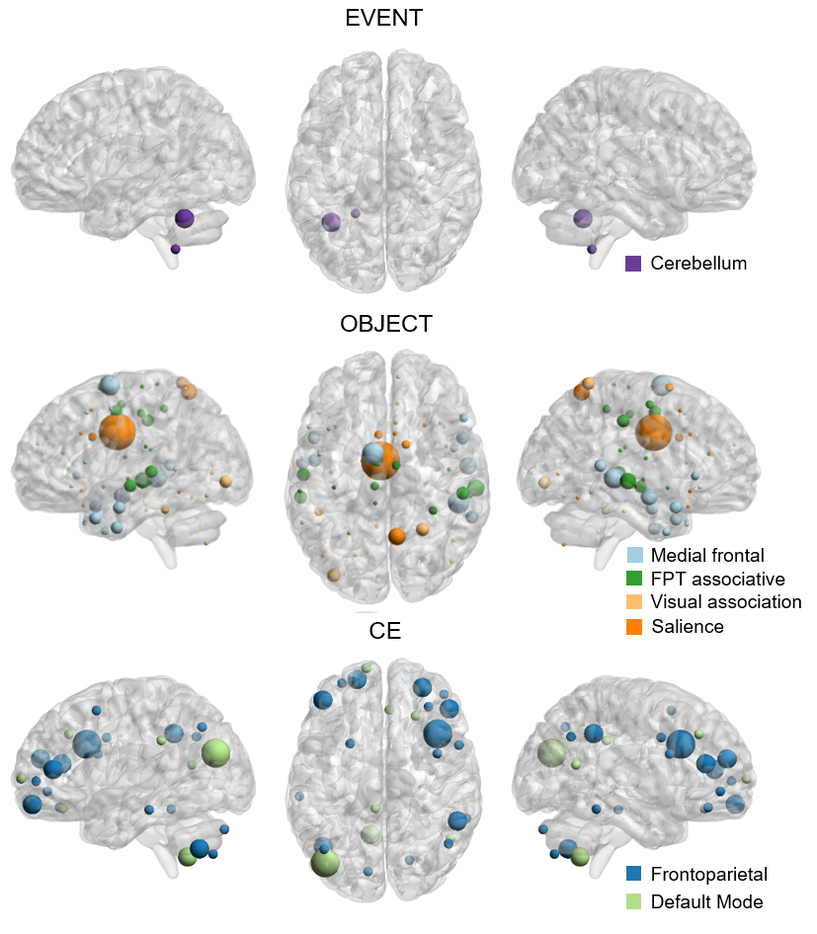
Figure S3. Node degrees of brain regions within networks important for prediction of the three WM components. The physical size of a node within each chart is proportional to its node degree. FPT associative = frontal-parietal-temporal associative; CE = central executive.
Table S5. The most important nodes within the essential networks
CE
 | Region | X | Y | Z | Degree
Frontoparietal | R_MFG，BA9/46 | 40 | 18 | 29 | 3
Default Mode | L_MOG/MTG/Angular/precuneus, BA19 | -41 | -75 | 23 | 3
EVENT
 | Region | X | Y | Z | Degree
Cerebellum | L_cereb_crus1/fusiform | -37 | -53 | -31 | 2
OBJECT
 | Region | X | Y | Z | Degree
Medial Frontal | L_SMA/SFG/MFG | -9 | 0 | 67 | 5
Medial Frontal | R_MTG/STG | 50 | -34 | 0 | 5
FPT associative | R_MTG/STG | 62 | -24 | -3 | 4
Visual Association | L_IOG/MOG | -36 | -84 | -4 | 3
Visual Association | R_PoCG/SPL | 25 | -52 | 68 | 3
Salience | MCC | -4 | -5 | 33 | 9
Abbreviations: R = right; L = left; MFG = middle frontal gyrus; MOG = middle occipital gyrus; MTG = middle temporal gyrus; SMA = supplementary area; SFG = superior frontal gyrus; STG = superior temporal gyrus; IOG = inferior occipital gyrus; PoCG = postcentral gyrus; SPL = superior parietal lobule; MCC = middle cingulate cortex.
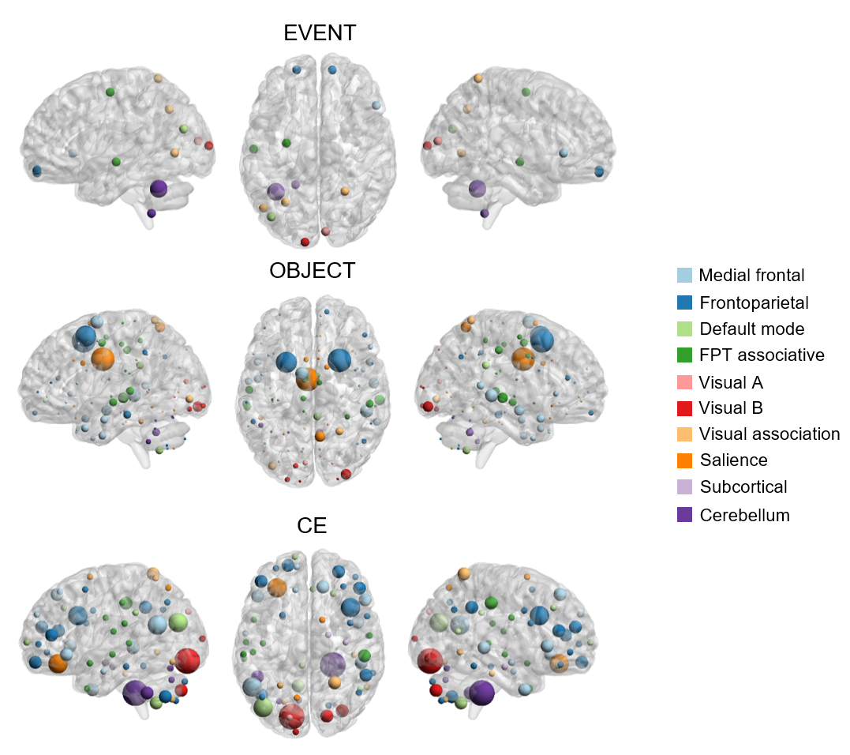
Figure S4. Node degree illustration for all networks of each WM component. Abbreviations: FPT associative = frontal-parietal-temporal associative; CE = central executive.
Figure S5. Prediction performance of OBJECT component after removing one brain network. The OBJECT component could be predicted no matter which network was removed. *0.01< p <0.05. ** p < 0.01. FPT associative = frontal-parietal-temporal associative. (without correcting for multiple comparisons)

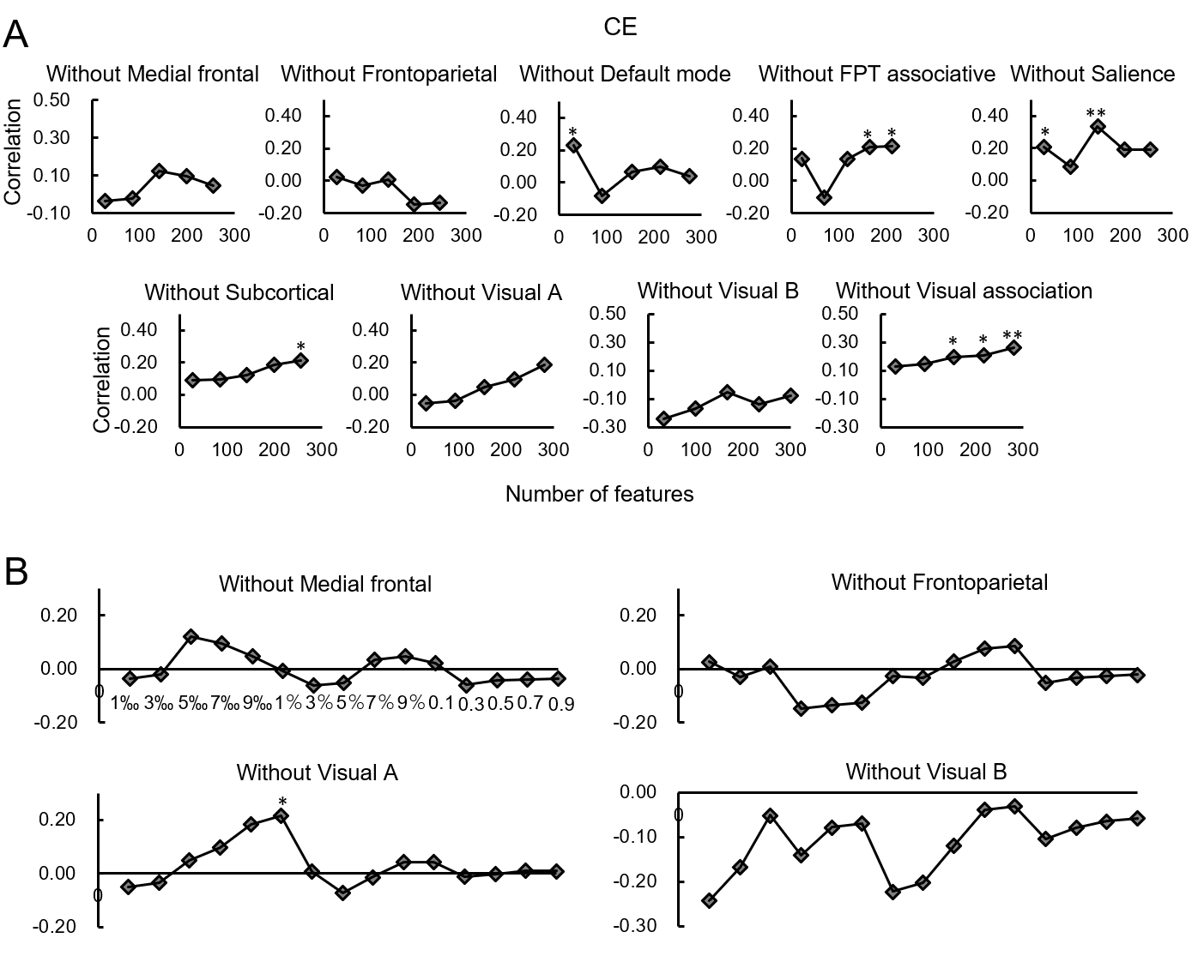
Figure S6. Prediction performance of CE component after removing one brain network. (A). Prediction performance with a threshold of 1‰~9‰. CE component could not be predicted when the medial frontal, frontoparietal, visual A, or Visual B network was removed. (B). Prediction performance with a threshold of 1‰~90％. Without medial frontal, frontoparietal, or Visual B network, the CE component could not be predicted, whereas under a threshold of 1％, the CE component could still be predicted when the Visual A network was removed. *0.01< p <0.05. ** p < 0.01. FPT associative = frontal-parietal-temporal associative. (without correcting for multiple comparisons)

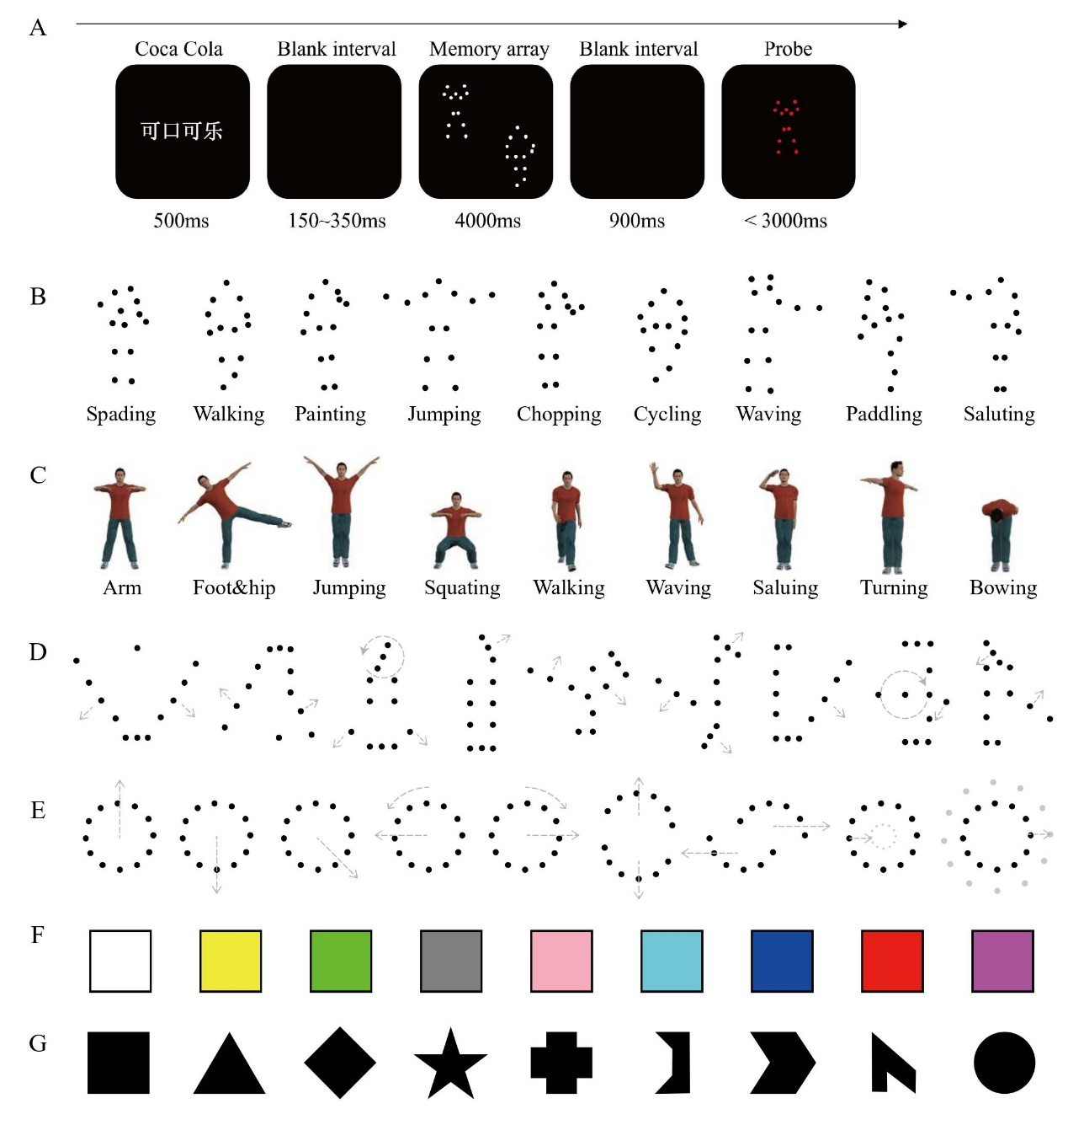
Figure S7. A schematic illustration of a single trial in PLDs biological movement task (A) and stimuli used in WM tasks (B-G). Example frames for the PLDs biological movement (BM) stimuli (B), solid biological movement (C), movements of rectangles (D), and movement of circles (E). The grey arrow was used to illustrate the moving direction and did not appear in the experiment.

