Here is a summary of all the supplementary figures. The original images have been uploaded to the supplementary materials folder.

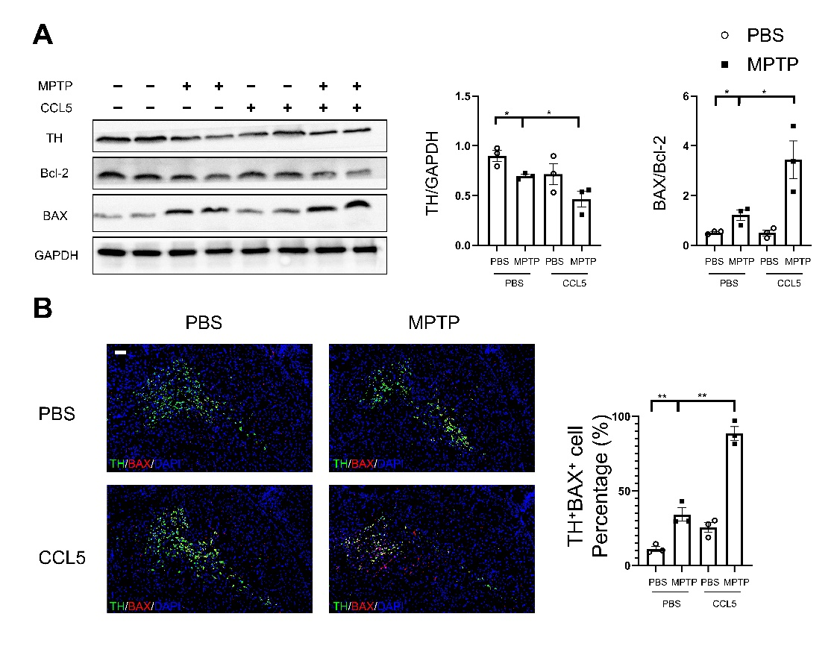
Fig. S1: CCL5 promoted the expression of apoptosis-related proteins in DA neurons from the mouse SNpc. (A) Western blot analysis was used to detect TH, BAX and Bcl-2 levels in the brain SNpc of mice, and the data were quantified using ImageJ. n = 3 per group. (B) Immunofluorescence was used to calculate the ratio of TH⁺BAX⁺ cells in the SNpc, which were stained for TH and BAX. The ratio of TH⁺BAX⁺ cells in the SNpc was calculated using ImageJ and GraphPad software. n = 3 per group. Scale bars = 100 μm. Data are presented as the means ± SEMs. *p < 0.05, **p < 0.01.

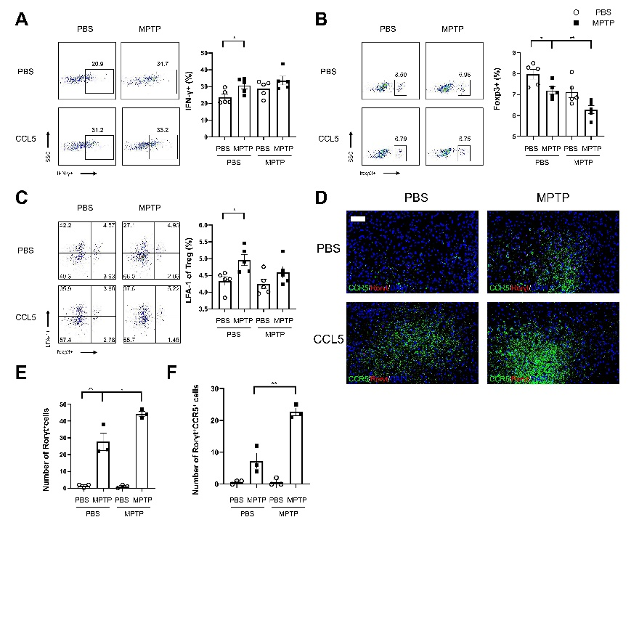
Fig. S2: CCL5 could not promote the differentiation of Th1 cells in the mouse spleen or the expression of LFA-1 on Treg cells but could promote the accumulation of CCR5 in Th17 cells in the mouse SNpc at the inflammatory site. (A) Flow cytometry and FlowJo software were used to analyse PBMCs from mice. The proportions of IFN-γ⁺, foxp3⁺, foxp3 ⁺ and LFA-1⁺ cells among CD4-positive cell populations were calculated. n=5 per group. (B, C) Immunofluorescence was used to count Rorγt⁺CCR5⁺ cells in the SNpc, which were stained for Rorγt and CCR5. The Rorγt⁺ cells and Rorγt⁺CCR5⁺ cells in the SNpc were counted using ImageJ and GraphPad software. n = 3 per group. Scale bars = 200 μm. Data are presented as the means ± SEMs. *p < 0.05, **p < 0.01.
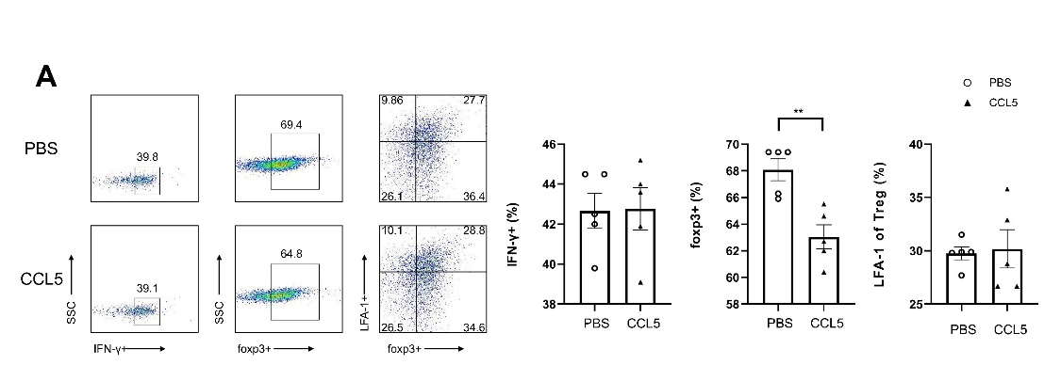
Fig. S3: Although CCL5 could reduce the ratio of naive CD4⁺ T cells to Treg cells, it did not affect the ratio of naive CD4⁺ T cells to Th1 cells or the expression of LFA-1 on the surface of Treg cells. Naive CD4⁺ T cells from the spleens of C57BL/6J mice were purified by magnetic beads in vitro and induced to differentiate into Th1 or Treg cells by PBS/CCL5 (1 µg/ml) treatment. After 3 days, the cells were collected. (A) Flow cytometry and FlowJo software were used to analyse the cells. The proportions of IFN-γ⁺, foxp3⁺, foxp3 ⁺ and LFA-1 ⁺ cells among CD4 ⁺ cell populations were calculated. n=5 per group. Data are presented as the means ± SEMs. *p < 0.05, **p < 0.01.

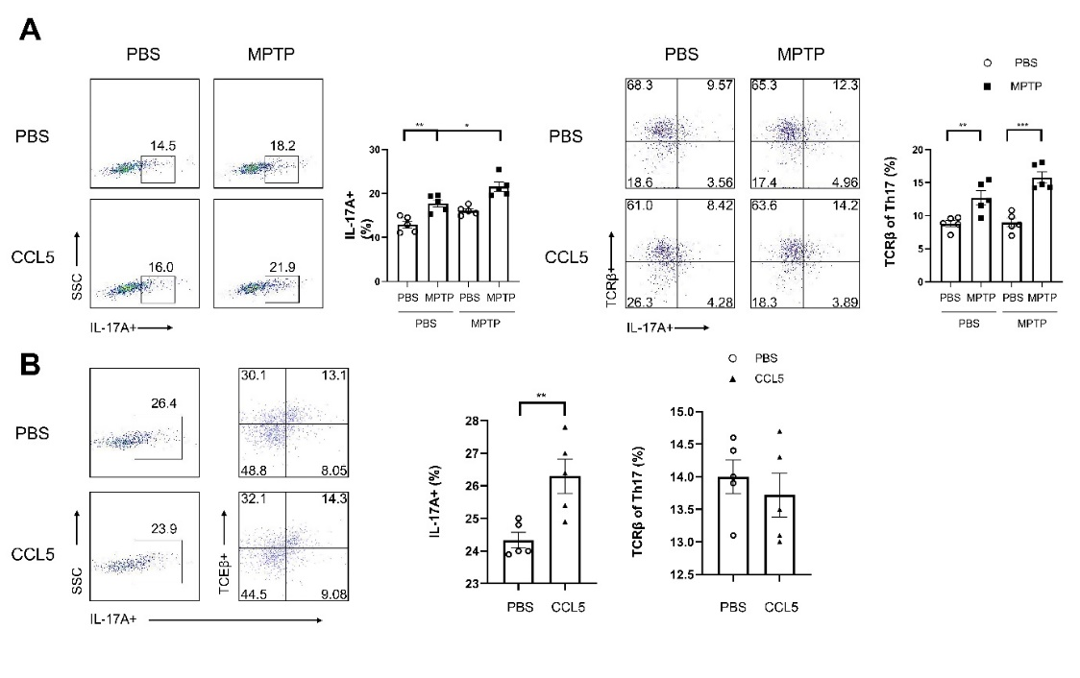
Fig. S4: The expression ratio of the TCRβ protein on Th17 cells was not affected by CCL5. (A) Flow cytometry and FlowJo software were used to analyse PBMCs from mice. The proportions of IL-17A⁺, IL-17A⁺ and TCRβ⁺ cells among CD4 ⁺ cell populations were calculated. n=5 per group. (B) Naive CD4⁺ T cells from the spleens of C57BL/6J mice were purified by magnetic beads in vitro and induced to differentiate into Th17 cells by PBS/CCL5 (1 µg/ml) treatment. After 3 days, the cells were collected. Flow cytometry and FlowJo software were used to analyse the cells. The proportions of IL-17A ⁺, IL-17A ⁺ and TCRβ⁺ cells among CD4 ⁺ cell populations were calculated. n=5 per group. Data are presented as the means ± SEMs. *p < 0.05, **p < 0.01, ***p < 0.001.

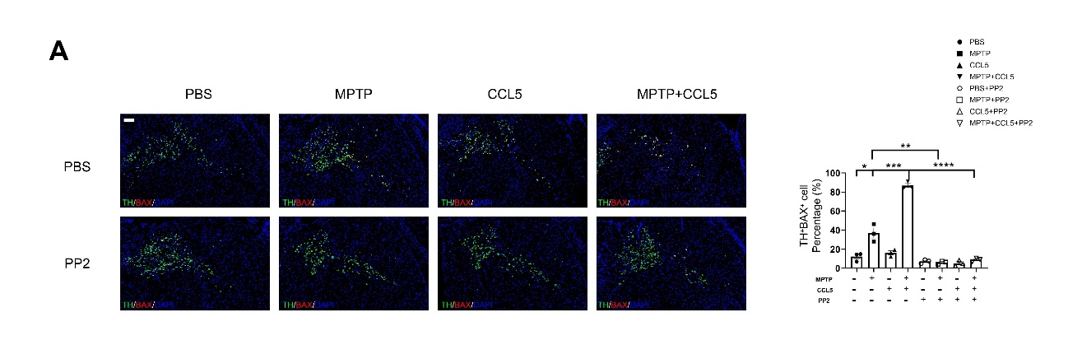
Fig. S5: PP2 inhibited the expression of apoptosis-related proteins in DA neurons in the SNpc of mice. (A) Immunofluorescence was used to calculate the ratio of TH⁺BAX⁺ cells in the SNpc, which were stained for TH and BAX. The ratio of TH⁺BAX⁺ cells in the SNpc was calculated using ImageJ and GraphPad software. n = 3 per group. Scale bars = 100 μm. Data are presented as the means ± SEMs. *p < 0.05, **p < 0.01, ***p < 0.001, ****p < 0.0001.

