Unusual flexibility of transparent poly(methylsilsesquioxane) aerogels by surfactant-induced mesoscopic fiber assembly

Ryota Ueoka,^{a,‡} Yosuke Hara,^{a,‡} Ayaka Maeno,^{b} Hironori Kaji,^{b} Kazuki Nakanishi,^{c,d} and Kazuyoshi Kanamoriª*

- Department of Chemistry, Graduate School of Science Kyoto University Kitashirakawa, Sakyo-ku, Kyoto 606-8502 (Japan)
- Institute for Chemical Research, Kyoto University, Gokasho, Uji-city, Kyoto 611-0011 (Japan)
- Institute of Materials and Systems for Sustainability Nagoya University Furo-cho, Chikusa-ku, Nagoya, Aichi 464-8601 (Japan)
- Institute for Integrated Cell-Material Sciences, Kyoto University Yoshida, Sakyo-ku, Kyoto 606-8501 (Japan)

‡ These authors contributed equally to this work.
* Corresponding author, E-mail: kanamori@kuchem.kyoto-u.ac.jp

Results and Discussion
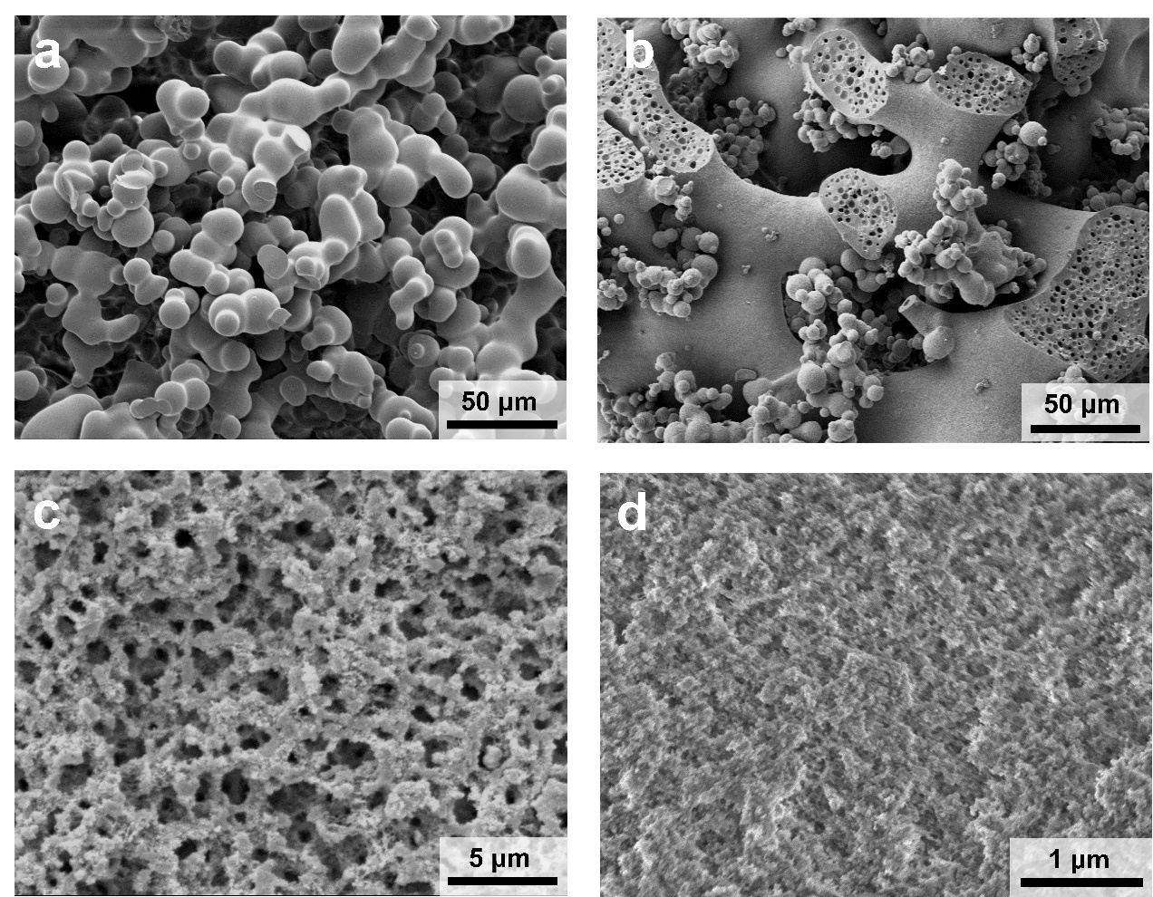
Figure S1. SEM images of the PMSQ aerogels prepared with varied amount of F127; (a) 0 g, (b) 0.32 g, (c) 0.36 g and (d) 0.40 g.

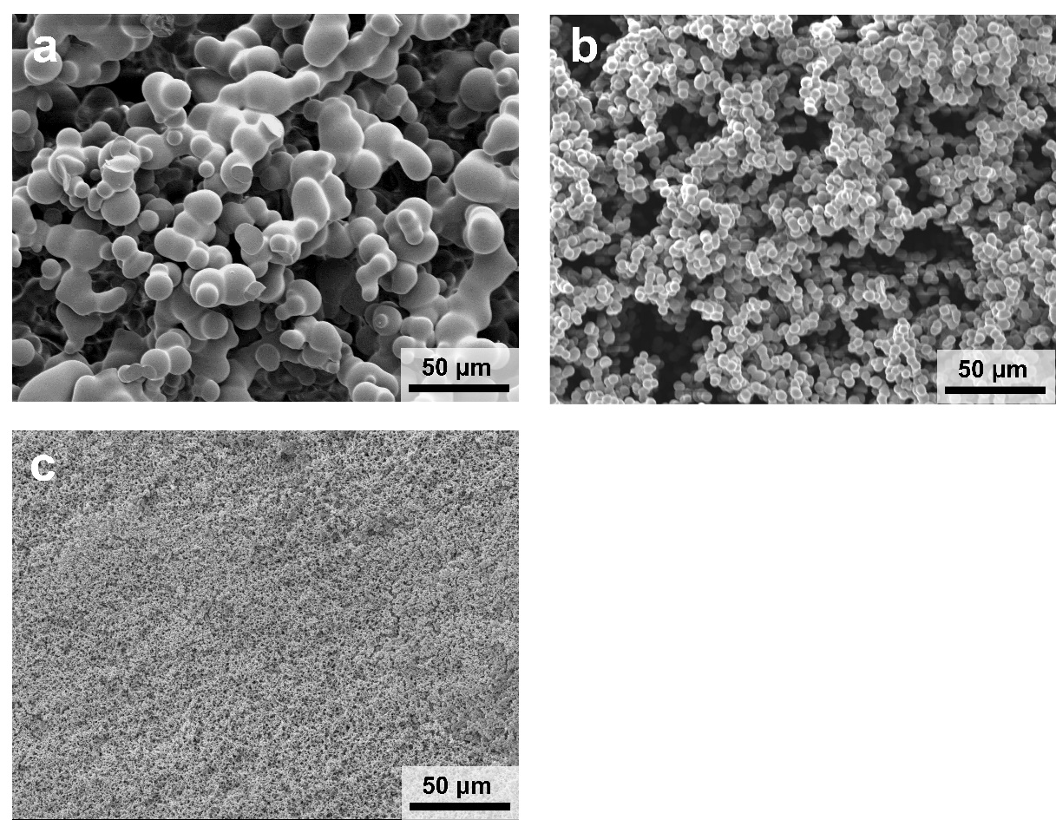

Figure S2. SEM images of the PMSQ aerogels prepared with varied amount of CTAC; (a) 0 g, (b) 0.01 g and (c) 0.03 g.

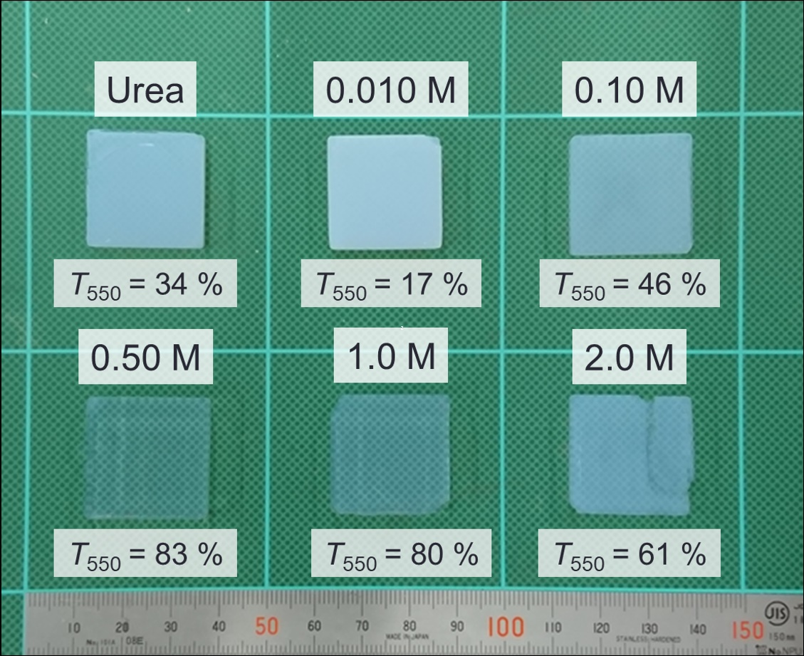
Figure S3. Appearance of the PMSQ aerogels prepared in the presence of F127. The base catalyst (source) for polycondensation is urea or varied concentration of TMAOH.

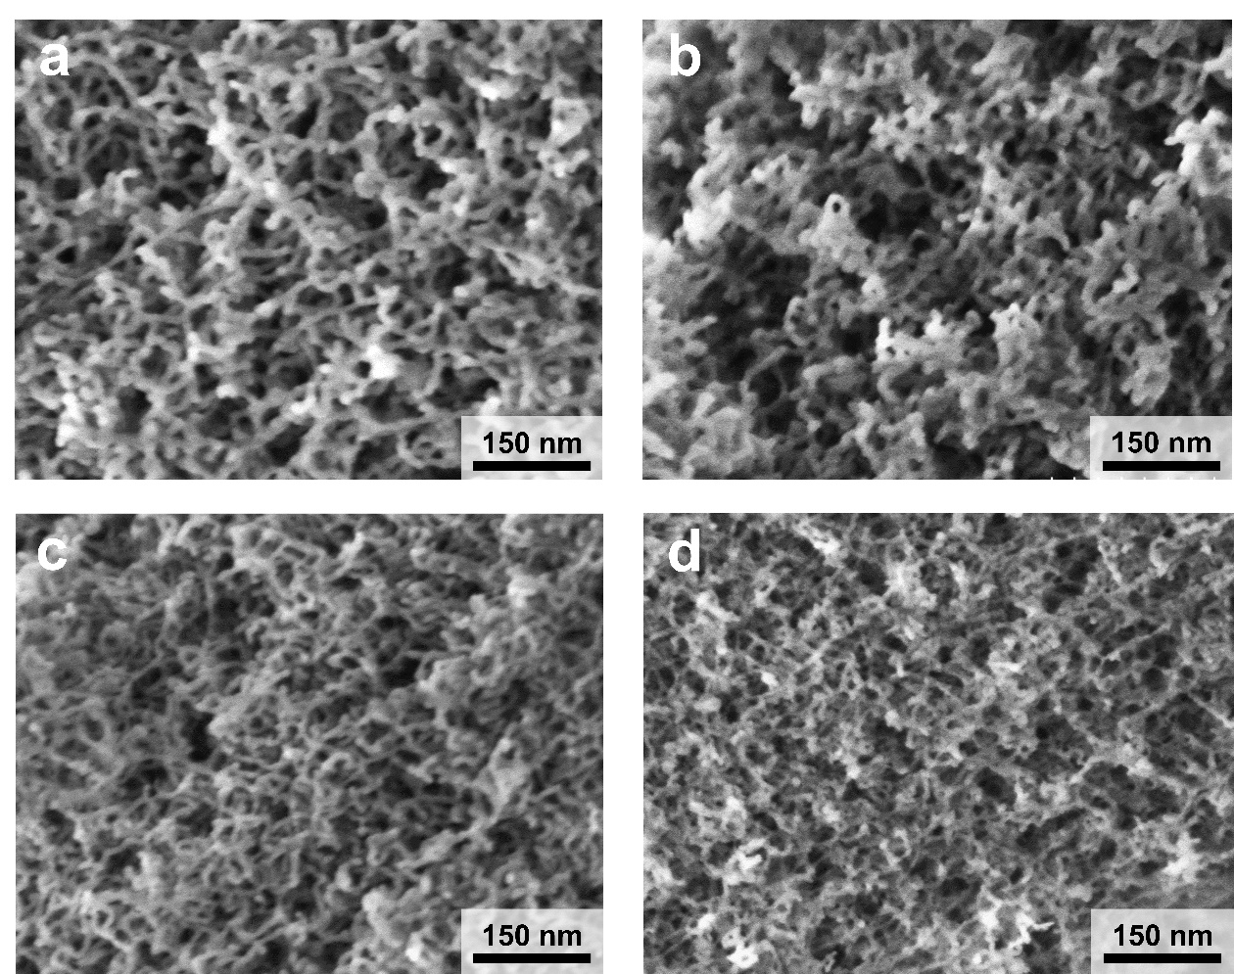

Figure S4. FE-SEM images of the PMSQ aerogels in Figure S3; the base (source) is (a) urea and (b) 0.010 M, (c) 0.50 M and (d) 2.0 M TMAOH.

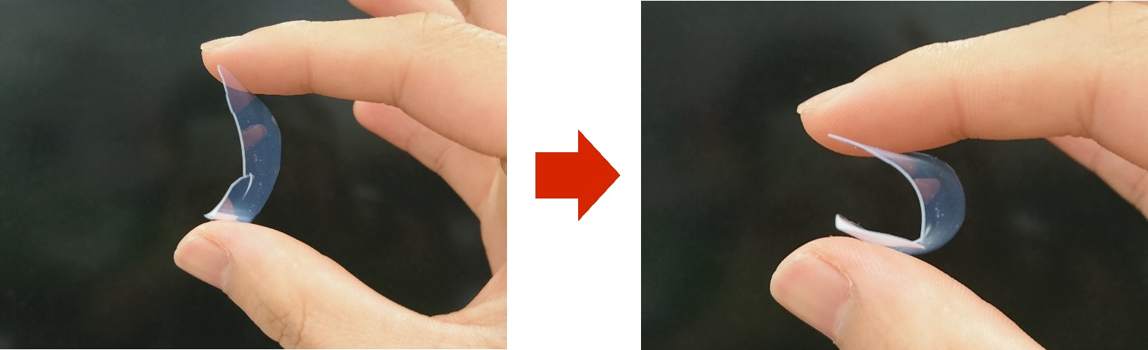

Figure S5. Photographs of hand bending of a PMSQ aerogel film with 1-mm thickness. The sample was prepared according to the literature (the same as the sample name “MF10-7a” in Ref. 1).

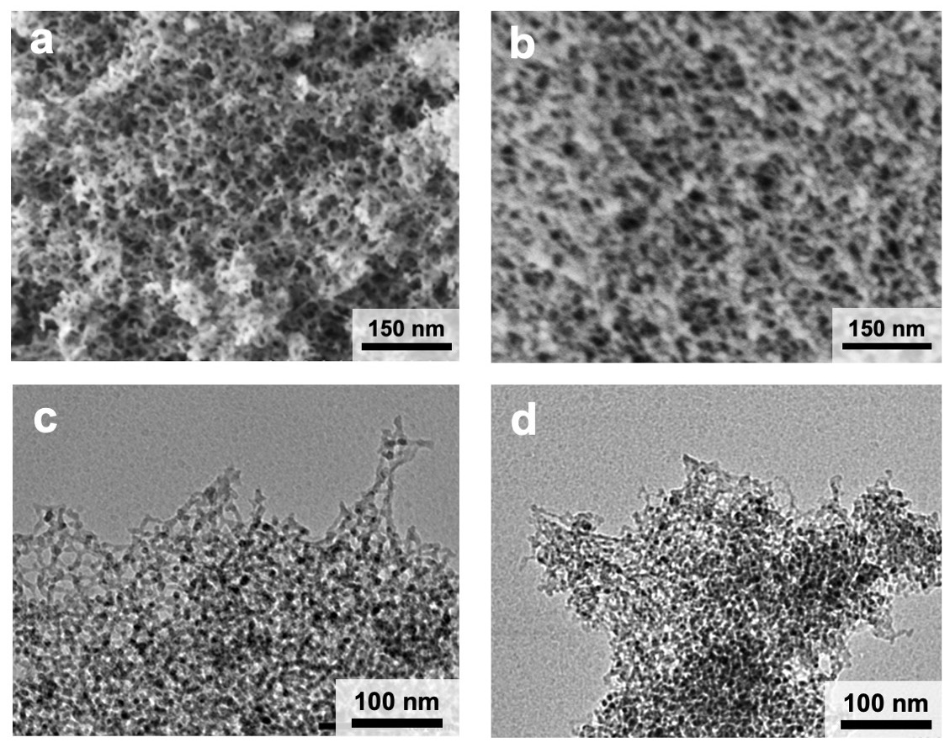
Figure S6. (a-b) SEM and (c-d) TEM images of the PMSQ samples PMSQ-previous work and PMSQ-P105DMF, respectively.

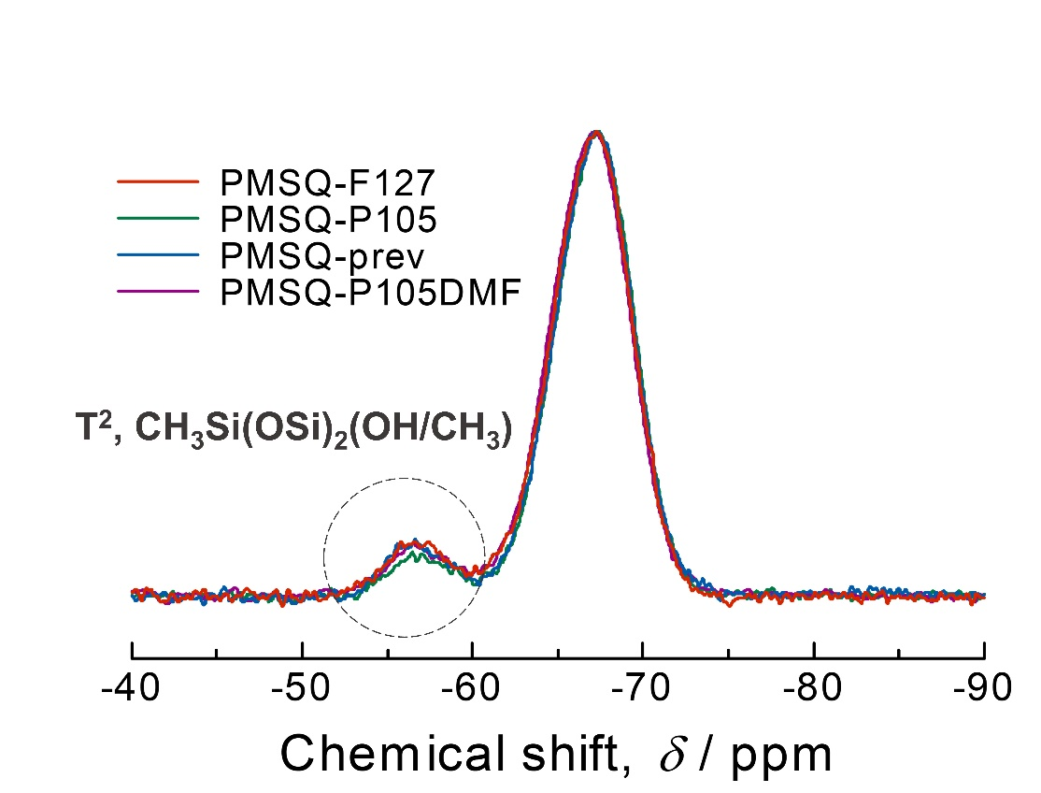

Figure S7. ²⁹Si CP/MAS NMR spectra of the PMSQ samples.

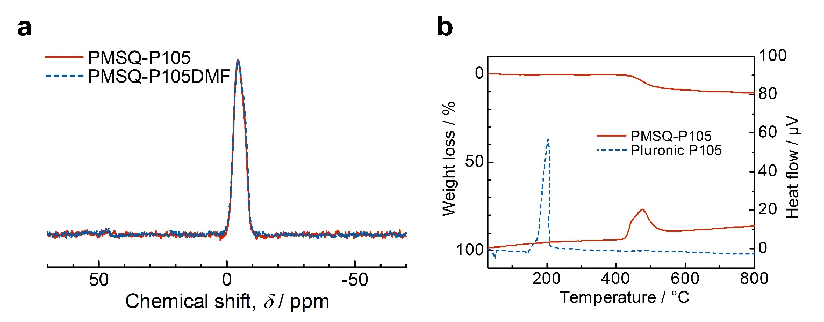

Figure S8. (a) ¹³C CP/MAS NMR spectra of PMSQ-P105 and PMSQ-P105DMF. (b) TG and DTA curves of the aerogel PMSQ-P105 and the surfactant P105.

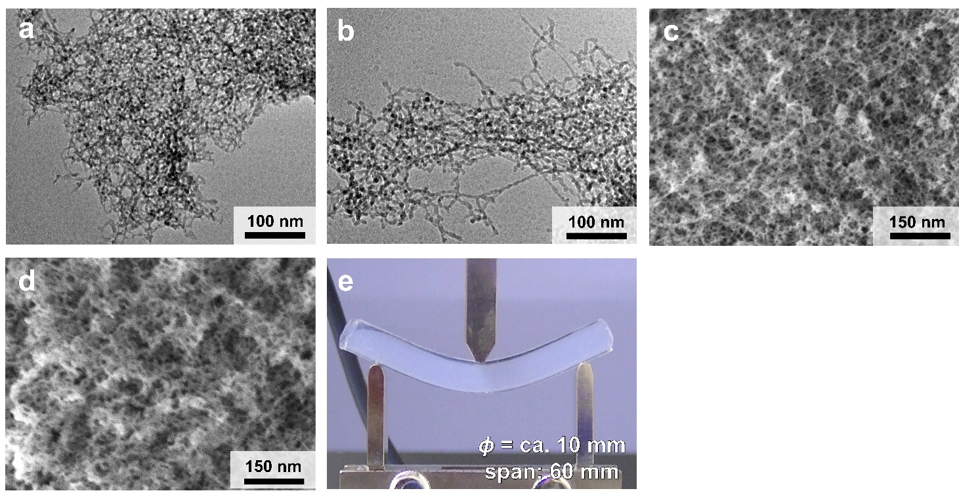
Figure S9. TEM images of (a) PMSQ-L64 and (b) PMSQ-F68. FE-SEM images of (c) PMSQ-L64 and (d) PMSQ-F68. (e) Photograph of three-point bending test on PMSQ-F68.

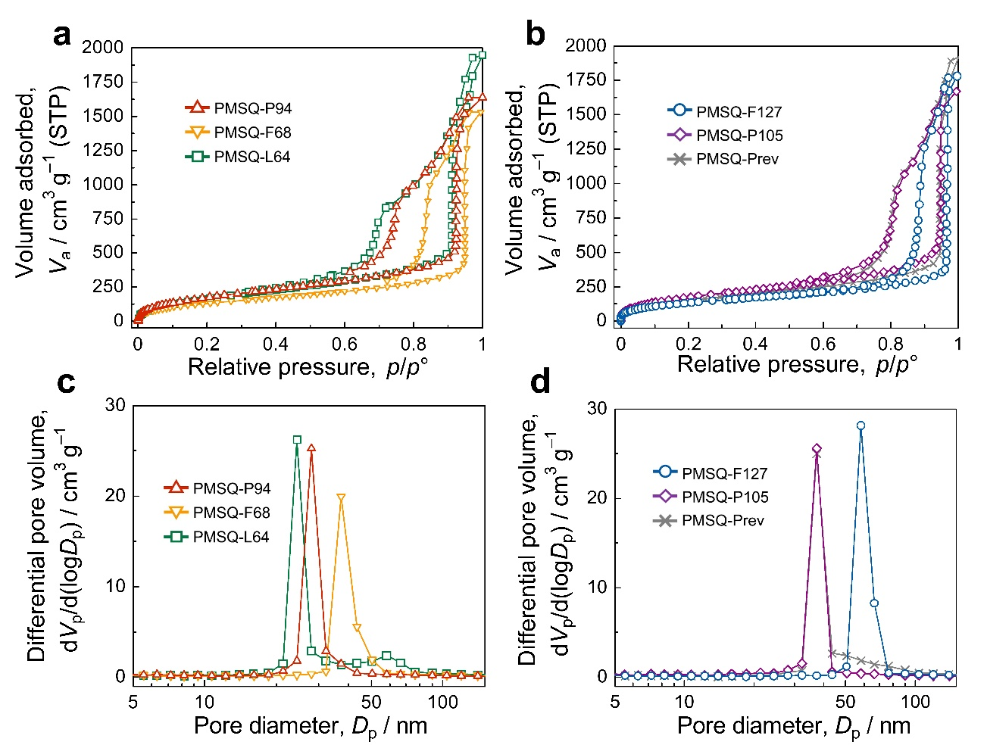

BET surface area
/m² g⁻¹
PMSQ-F127 | 479
PMSQ-P105 | 634
PMSQ-P94 | 680
PMSQ-F68 | 504
PMSQ-64 | 674
PMSQ-prev | 591

Figure S10. (a-b) Nitrogen adsorption-desorption isotherms and (c-d) BJH pore size distributions of the samples. Inserted table is BET surface area of the samples derived from the nitrogen sorption isotherms at 77 K.

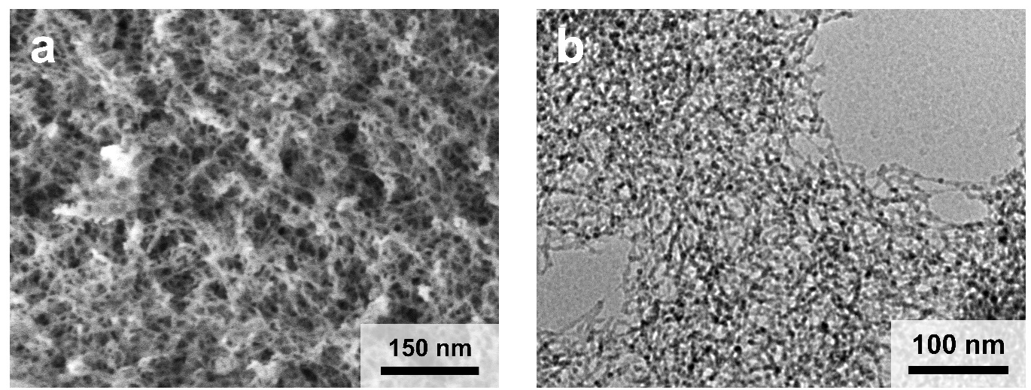
Figure S11. (a) FE-SEM and (b) TEM images of PMSQ-P94

Table S1. Structure and properties of PEO-b-PPO-b-PEO-type triblock copolymers employed in this study.

Surfactant | Molecular structure | Molecular weight | HLB value
F68 | EO₇₆PO₂₉EO₇₆ | 8 400 | > 24
F127 | EO₁₀₆PO₇₀EO₁₀₆ | 12 600 | 18-23
P105 | EO₃₇PO₅₆EO₃₇ | 6 500 | 12-18
P94 | EO₂₆PO₄₈EO₂₆ | 5 000 | 13.5
L64 | EO₁₃PO₃₀EO₁₃ | 2 900 | 12-18

Table S2. Starting compositions of PMSQ aerogels prepared with different surfactants.

 | MTMS/mL | 5 mM HOAc/mL | Surfactant/g | Water/mL | 0.50 M TMAOH/mL
PMSQ-F127 | 5.0 | 5.0 | 1.1 | 4.0 | 3.0
PMSQ-P105 | 5.0 | 5.0 | 2.7 | 4.0 | 3.0
PMSQ-P94 | 5.0 | 5.0 | 3.25 | 4.0 | 3.0
PMSQ-F68 | 5.0 | 5.0 | 1.5 | 4.0 | 3.0
PMSQ-L64 | 5.0 | 5.0 | 3.15 | 0.0 | 7.0

Table S3. Size parameters of the porous structure in the PMSQ aerogels

Sample | Skeleton length  /nm | Node size  /nm | Skeleton thickness /nm | Pore size  /nm | Skeletal ratio
PMSQ-F127 | 28.1±3.1 | 11.2±0.5 | 8.0±0.4 | 16.4±1.4 | 2.5
PMSQ-P105 | 25.3±2.0 | 9.2±0.5 | 6.6±0.3 | 16.4±1.4 | 2.8
PMSQ-P94 | 15.8±1.3 | 8.2±0.4 | 4.2±0.4 | 9.0±0.6 | 1.9
PMSQ-F68 | 16.4±1.3 | 10.0±0.4 | 5.6±0.4 | 11.4±0.8 | 1.6
PMSQ-prev | 11.6±0.8 | 9.6±0.5 | 6.2±0.4 | 10.8±0.8 | 1.2

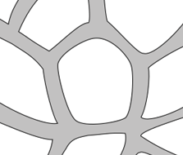
Node size
Skeleton length
Pore size
Skeleton thickness

These data were obtained by digitally measuring on TEM (30 points) and FE-SEM (50 points) images of these samples using a software “Click Measure” with a 95% confidence interval. The skeleton length is the distance between the centers of two neighbor nodes. Pore size is the maximum length of a pore. Skeletal ratio is defined as (skeleton length)/(node size).

References
[1] Kanamori, K., Kodera, Y., Hayase, G., Nakanishi, K. & Hanada, T. Transition from transparent aerogels to hierarchically porous monoliths in polymethylsilsesquioxane sol–gel system. Journal of Colloid and Interface Science 357, 336-344, doi:https://doi.org/10.1016/j.jcis.2011.02.027 (2011).

