Traditional Chinese medicine and its derivatives |  | Source | Structure | Target | References
Berberine | Ginkgo biloba |  | 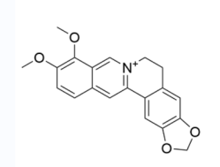 | CSN5 | 33
Quercetin |  |  | 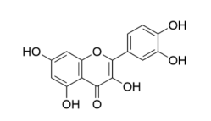 | HER2  PI3K-AKT | 36
Astragaloside IV | Radix astragali |  | 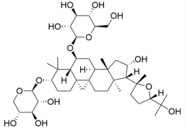 | miR-195-5p↓  EMT | 39
Oleanolic acid | Nvzhenzi |  | 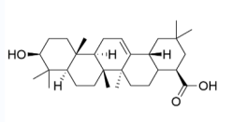 | IL-1β/NF-κB/TET3 | 41
Paclitaxel | Axus brevifolia Nutt. |  | 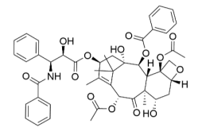 |  | 4647
Table 1

Table 3

Traditional Chinese medicine and its derivatives |  | Source | Structure | Target | References
Camptothecin |  |  | 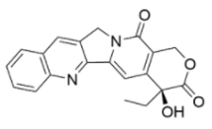 | NF-κB | 57
Salvia plebeia R.Br | Salvia |  |  |  | 62
PG2 | A. membranaceus |  |  | AKT/mTOR/p70S6K | 6364
Licochalcone A | Licochalcone |  | 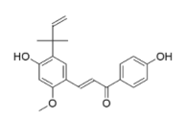 | P65  Ras | 67
Curcumin |  |  | 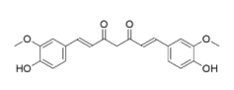 |  | 70
Ziziphus jujuba Mill. | Jujuba |  |  | SCFAs↑ | 71
A. eriantha polysaccharide | A. eriantha |  |  | TNFα  IFNγ | 73
Resveratrol |  |  | 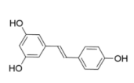 | NF-κB | 74
Piceatannol |  |  | 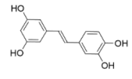 | NF-κB | 74

