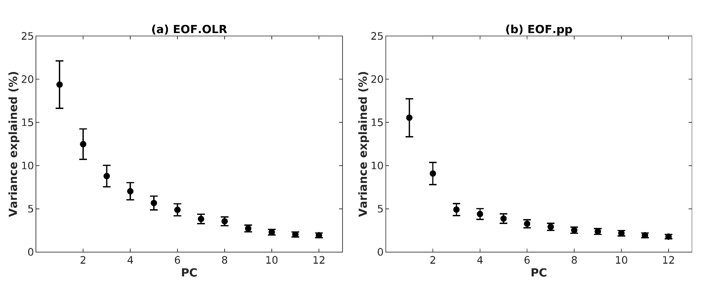
Fig. S1 North et al. 1982’s diagram with eigenvalue spectrum for the Empirical Orthogonal Functions (EOF) analysis of 30-90 day filtered anomalies of (a) Outgoing Longwave Radiation and (b) precipitation in the period from 2002 to 2018.

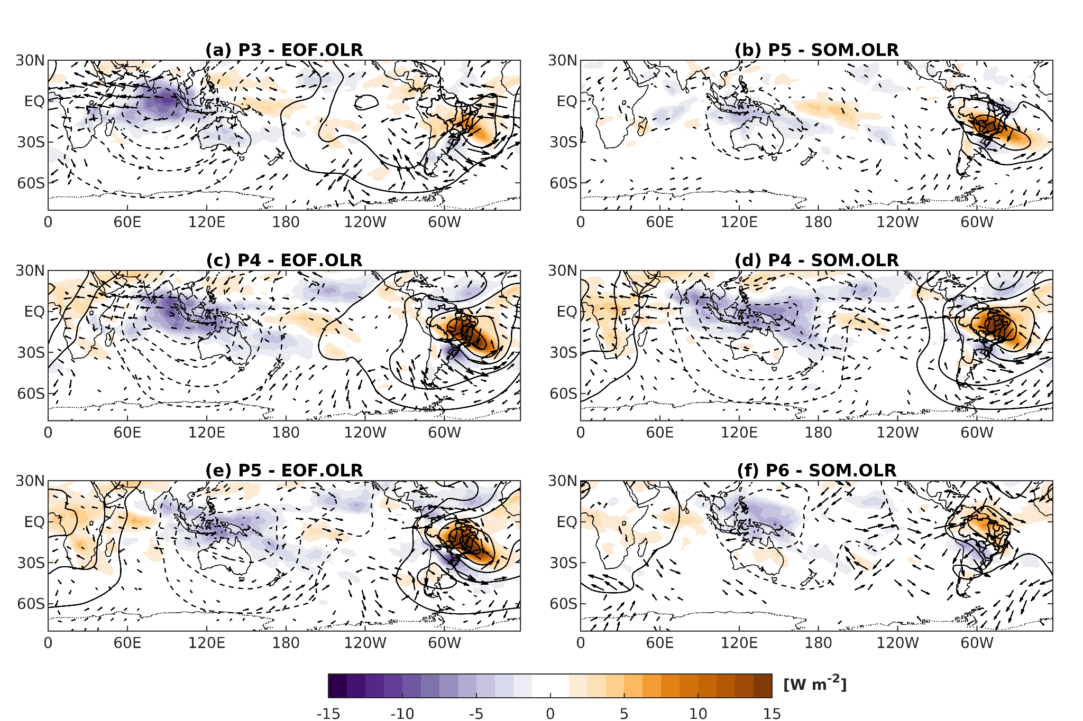
Fig. S2 Composite maps of intraseasonal (30-90 days band) anomalies of Outgoing Longwave Radiation (OLR, shaded), 200-hPa velocity potential (contours) and 200-hPa wind (vectors) for the EOF.OLR (left column) and SOM.OLR (right column) indices phases favorable to suppressed convection in the South Atlantic Convergence Zone (SAZC) for the wet period (October to April), from 1980 to 2018. The velocity potential contour interval is 5 x 10⁵ m² s⁻¹. Positive (negative) contours are solid (dashed). Wind vectors are plotted only where the zonal and meridional wind components are significant at the 95% level. The Brazilian watersheds are highlighted by thicker black contours.

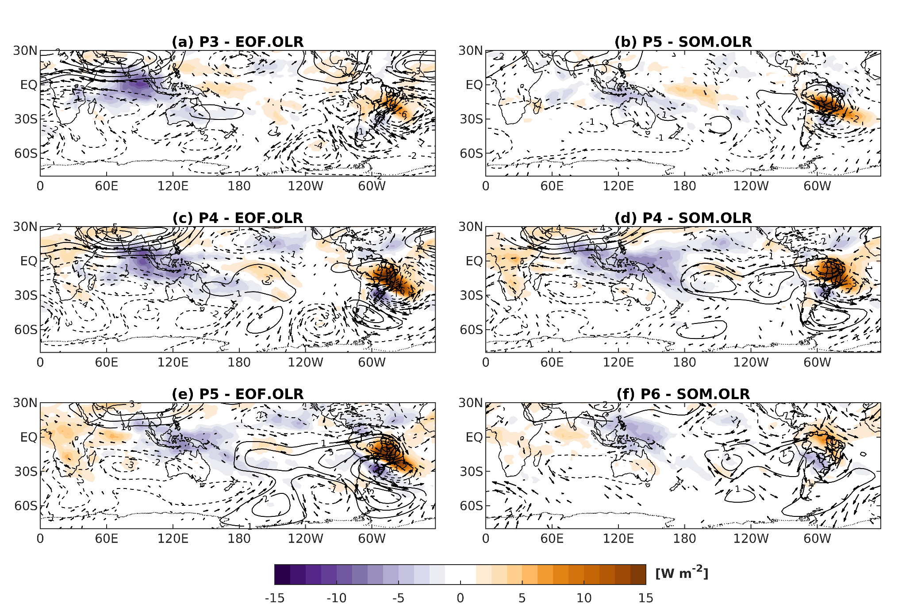
Fig. S3 As in Fig. S2, but for intraseasonal anomalies of Outgoing Longwave Radiation (OLR, shaded), 200-hPa stream function (contours) and 200-hPa wind (vectors). The stream function contour interval is 5 x 10⁶ m² s⁻¹. Positive (negative) contours are solid (dashed). Wind vectors are plotted only where the zonal and meridional wind components are significant at the 95% level. The Brazilian watersheds are highlighted by thicker black contours.

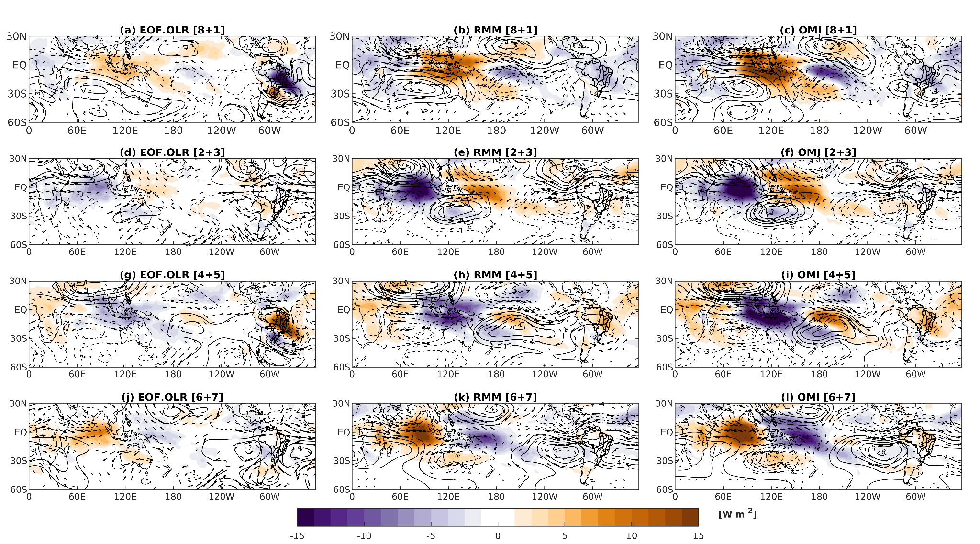
Fig. S4 Composite maps of intraseasonal (30-90 days band) anomalies of Outgoing Longwave Radiation (OLR, shaded), 200-hPa velocity potential (contours) and 200-hPa wind (vectors) for the EOF.OLR, RMM and OMI indices phases for the wet period (October to April), from 1980 to 2018. The velocity potential contour interval is 5 x 10⁵ m² s⁻¹. Positive (negative) contours are solid (dashed). Wind vectors are plotted only where the zonal and meridional wind components are significant at the 95% level. The Brazilian watersheds are highlighted by thicker black contours.

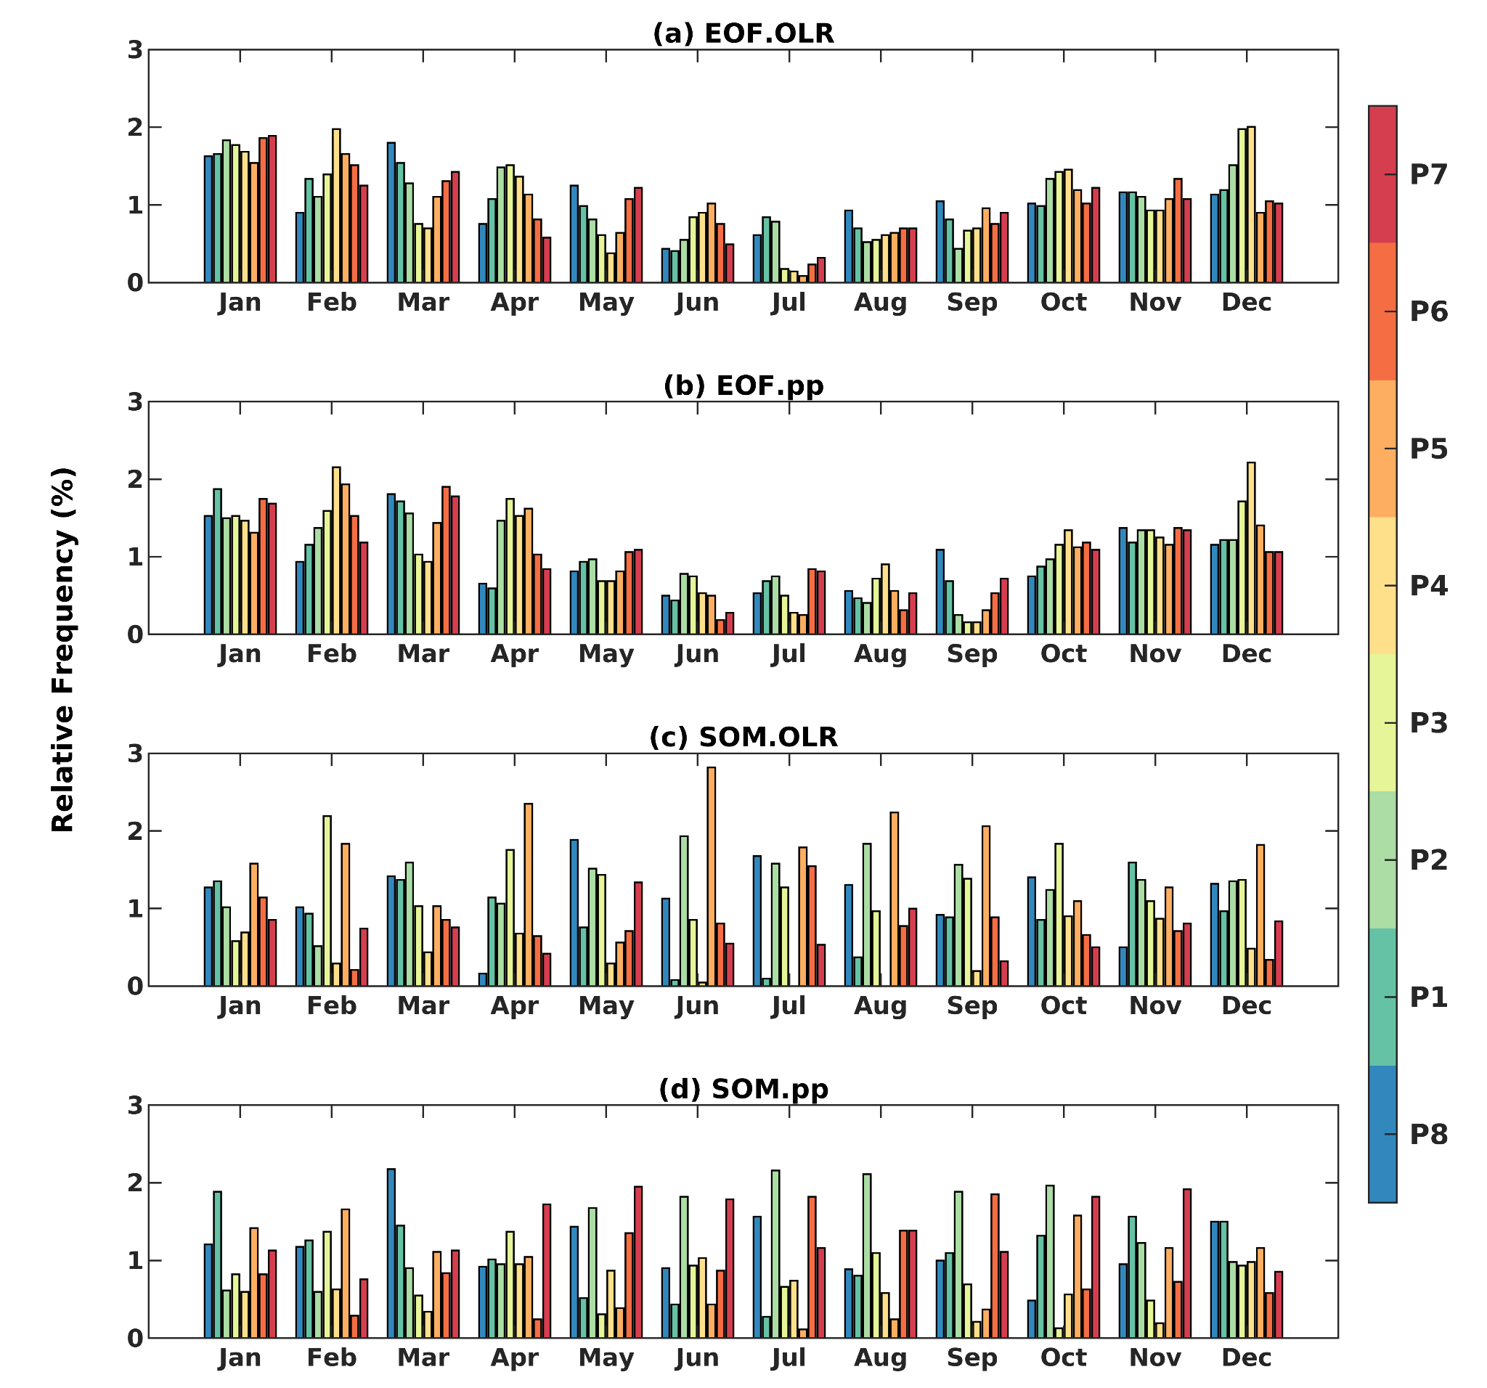
Fig. S5 Relative frequency (%) of the phases of each South American Intraseasonal Oscillation index through the year: (a) EOF.OLR, (b) EOF.pp, (c) SOM.OLR, and (d) SOM.pp.

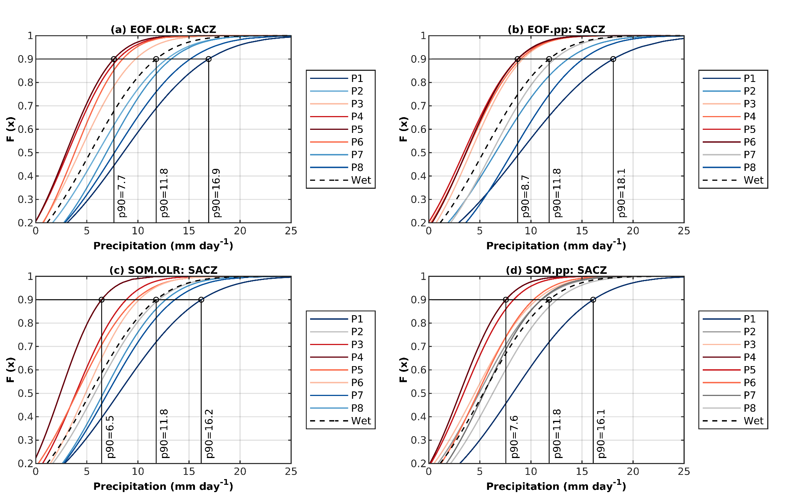
Fig. S6 Cumulative Density Function (CDF) based on the normal distribution applied to rainfall data in the South Atlantic Convergence Zone (SACZ) region for each phase of the regional indices for the wet season (October to April) and 2002 to 2018 period. The black dashed curve is the climatological CDF for this period. The curves in blue (red) shades indicate phases of the indices with a greater probability of producing rain above (below) the climatological average in this region. The 90% probability for some phases is also highlighted.

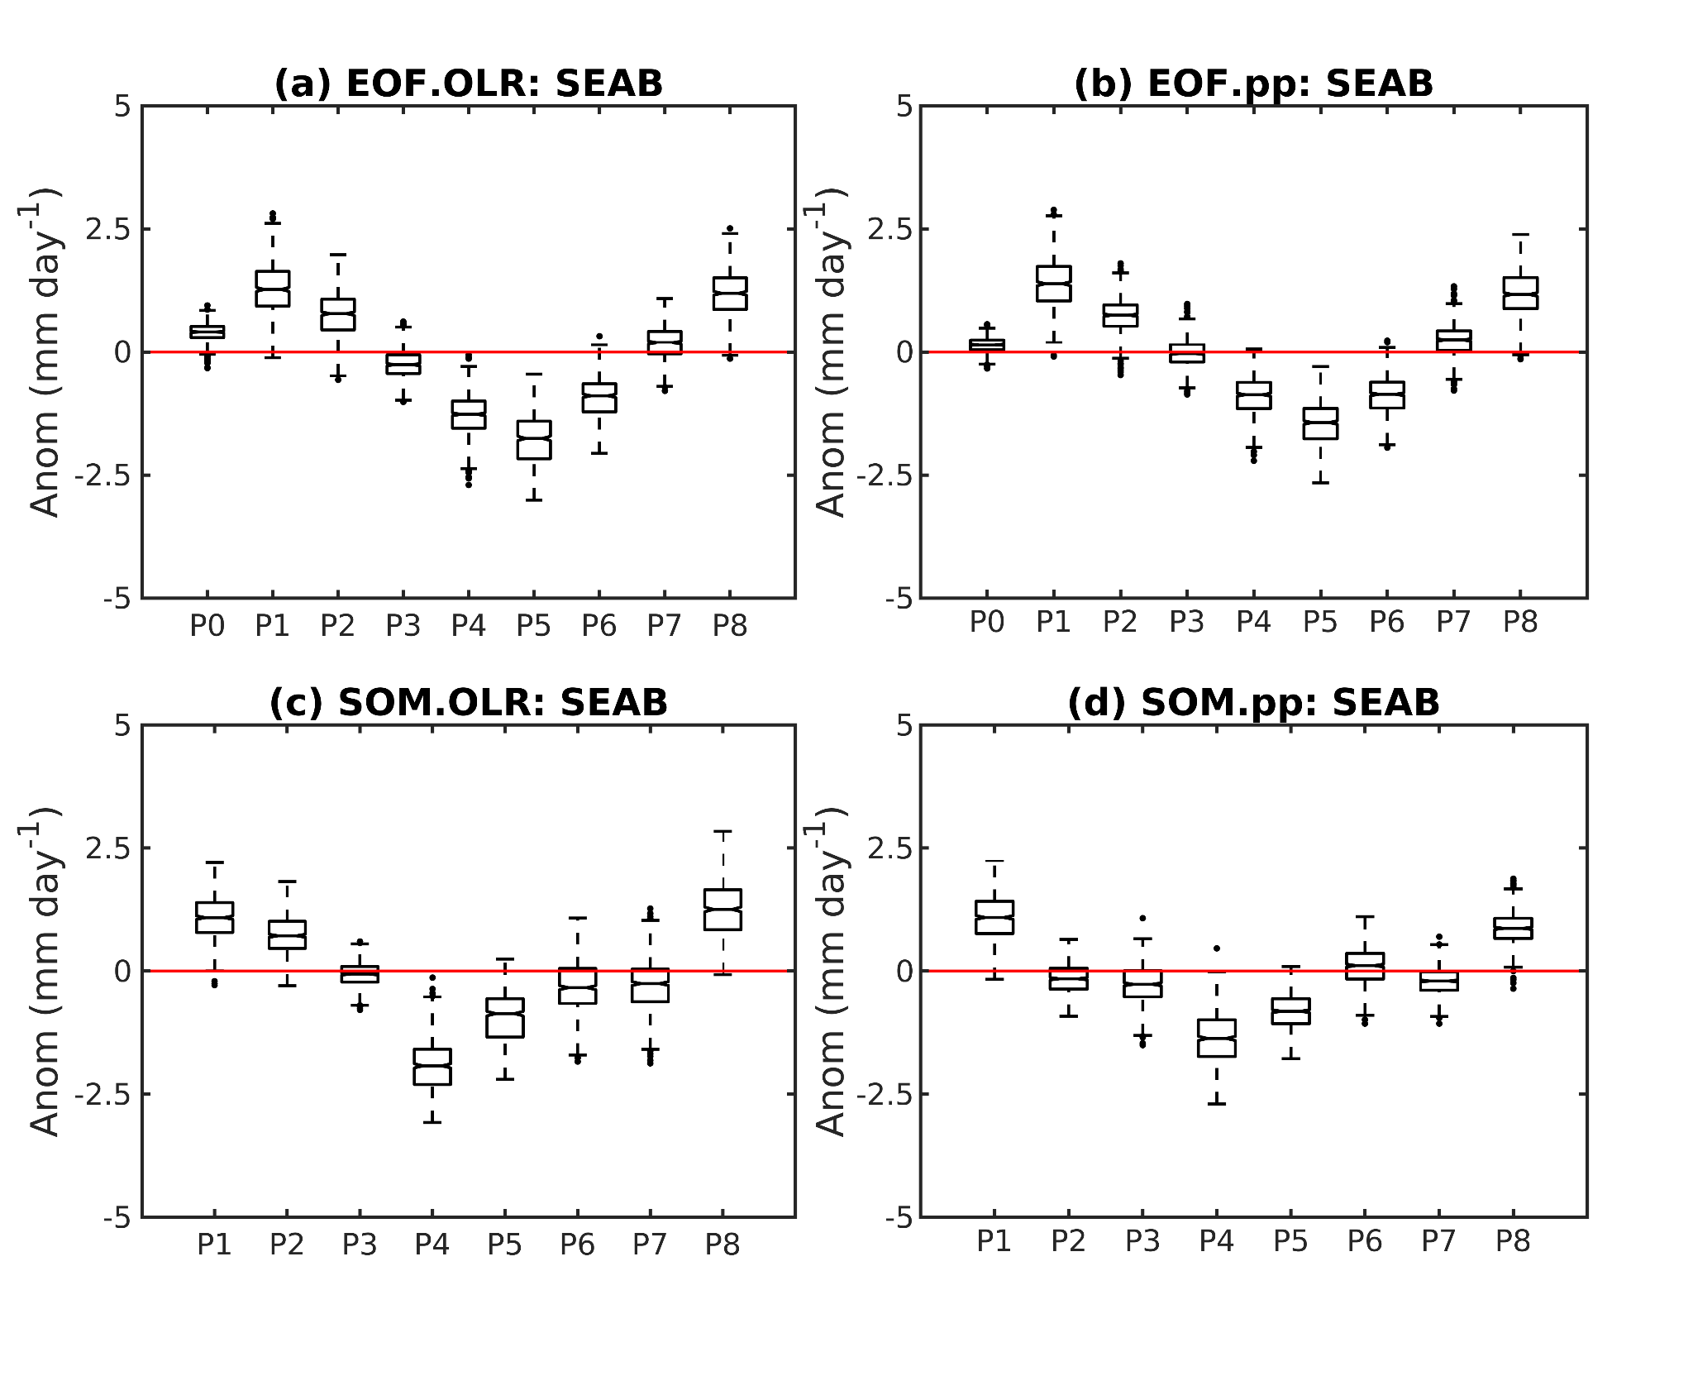
Fig. S7 Boxplot of intraseasonal precipitation anomalies (30-90 days) and the wet period (October to April) for each index phases for the Southeastern Amazon Basin (SEAB) region (13.4ºS-8.4ºS, 60.8ºW-52.3ºW): (a) EOF.OLR, (b) EOF.pp, (c) RMM, and (d) SOM.OLR.

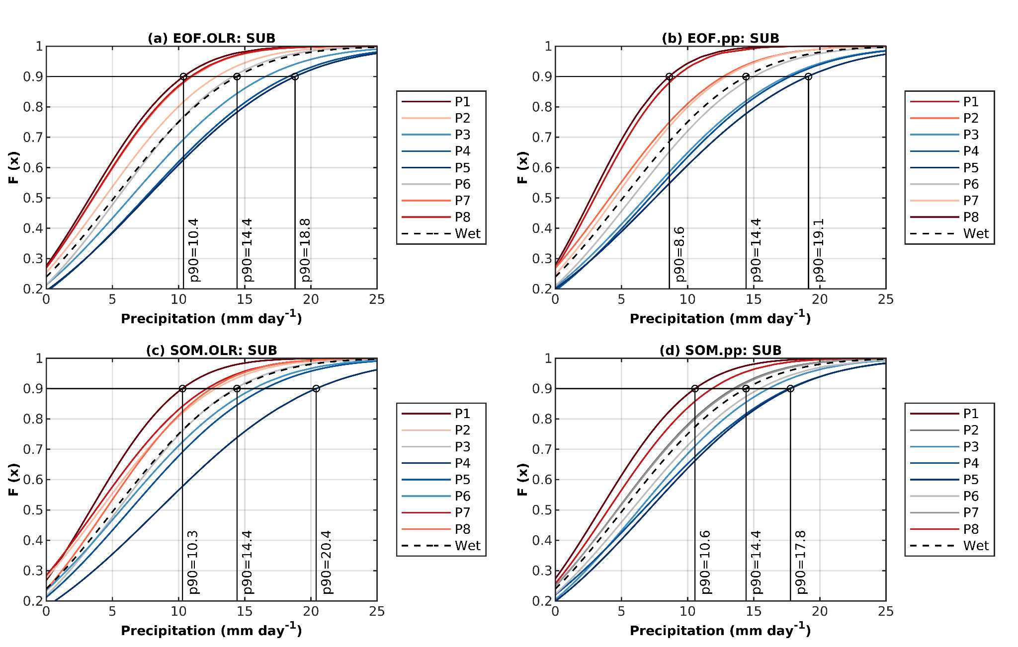

Fig. S8 As in Fig. S6, but for the Southern Brazil (SUB) region.

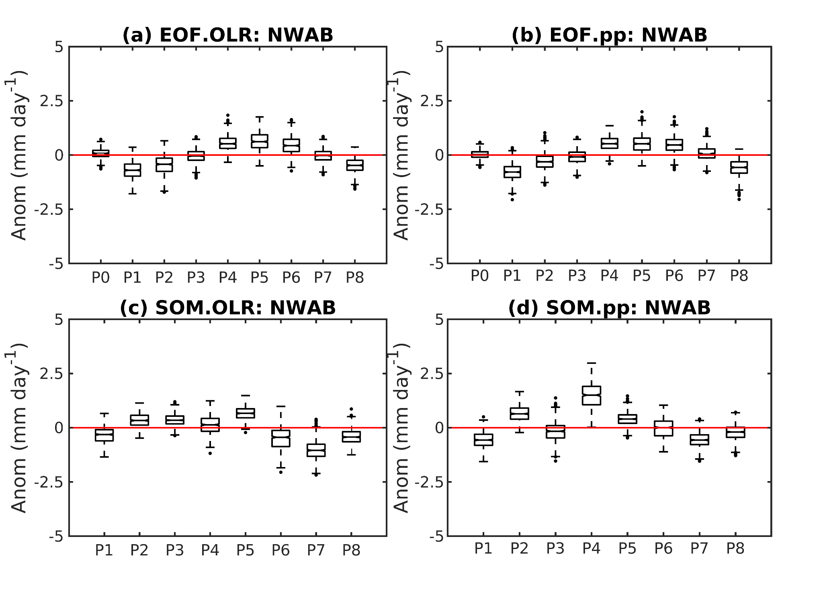
Fig. S9 As in Fig. S6, but for the Northwesterm Amazon Basin (NWAB) region (4.9ºS-2.4ºN, 70.3ºW-63.4ºW).

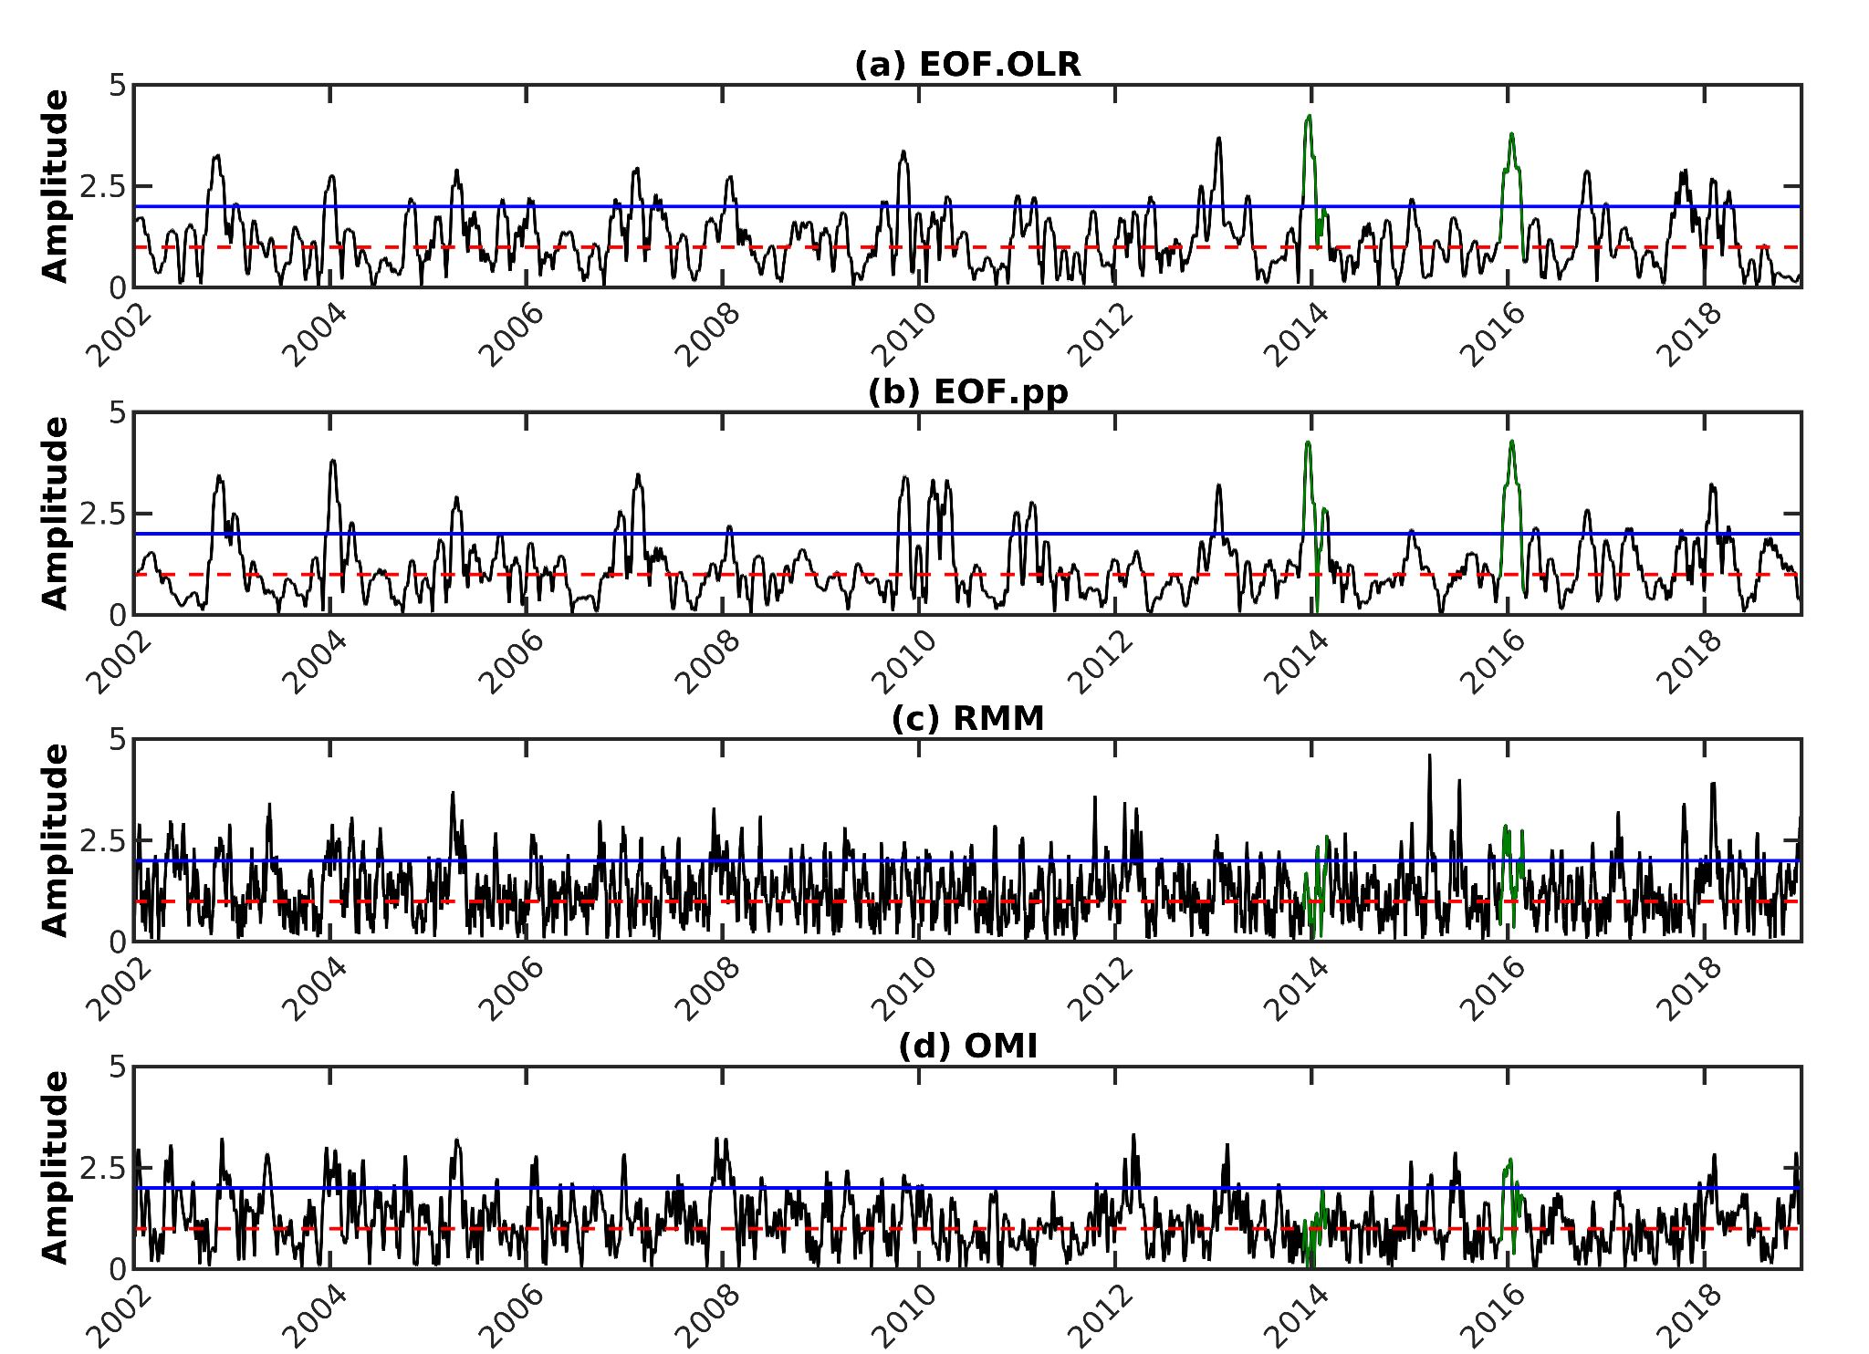

Fig. S10 Time series of the amplitude of (a) EOF.OLR, (b) EOF.pp, (c) RMM, and (d) OMI indices. The red dashed line indicates the amplitude=1 and the blue line the amplitude=2. The periods selected for the case studies are highlighted in green (December to February 2013/14 and December to February 2015/16).

