Supplementary Information

Visualization of π-hole in molecules by means of Kelvin probe force microscopy

B. Mallada^{1,2,4†}, M. Ondráček^{1†}, M. Lamanec^{3,4†}, A. Gallardo¹, A. Jiménez-Martín^{1,2}, B. de la Torre^{1,2*}, P. Hobza^{3,5*}, P. Jelínek^{1,2*}
¹Institute of Physics, Academy of Sciences of the Czech Republic, Prague, Czech Republic.
²Regional Centre of Advanced Technologies and Materials, Czech Advanced Technology and Research Institute (CATRIN), Palacký University Olomouc, 78371 Olomouc, Czech Republic.
³Institute of Organic Chemistry and Biochemistry, Czech Academy of Sciences, Flemingovo Námĕstí 542/2, 16000 Prague, Czech Republic
⁴Department of Physical Chemistry, Palacký University Olomouc, tr. 17. listopadu 12, 771 46 Olomouc, Czech Republic.
⁵ IT4Innovations, VŠB – Technical University of Ostrava, 17. listopadu 2172/15, 708 00 Ostrava-Poruba, Czech Republic

This supplementary information contains the following contents:
- Figures S1-S8
- Tables S1-S3

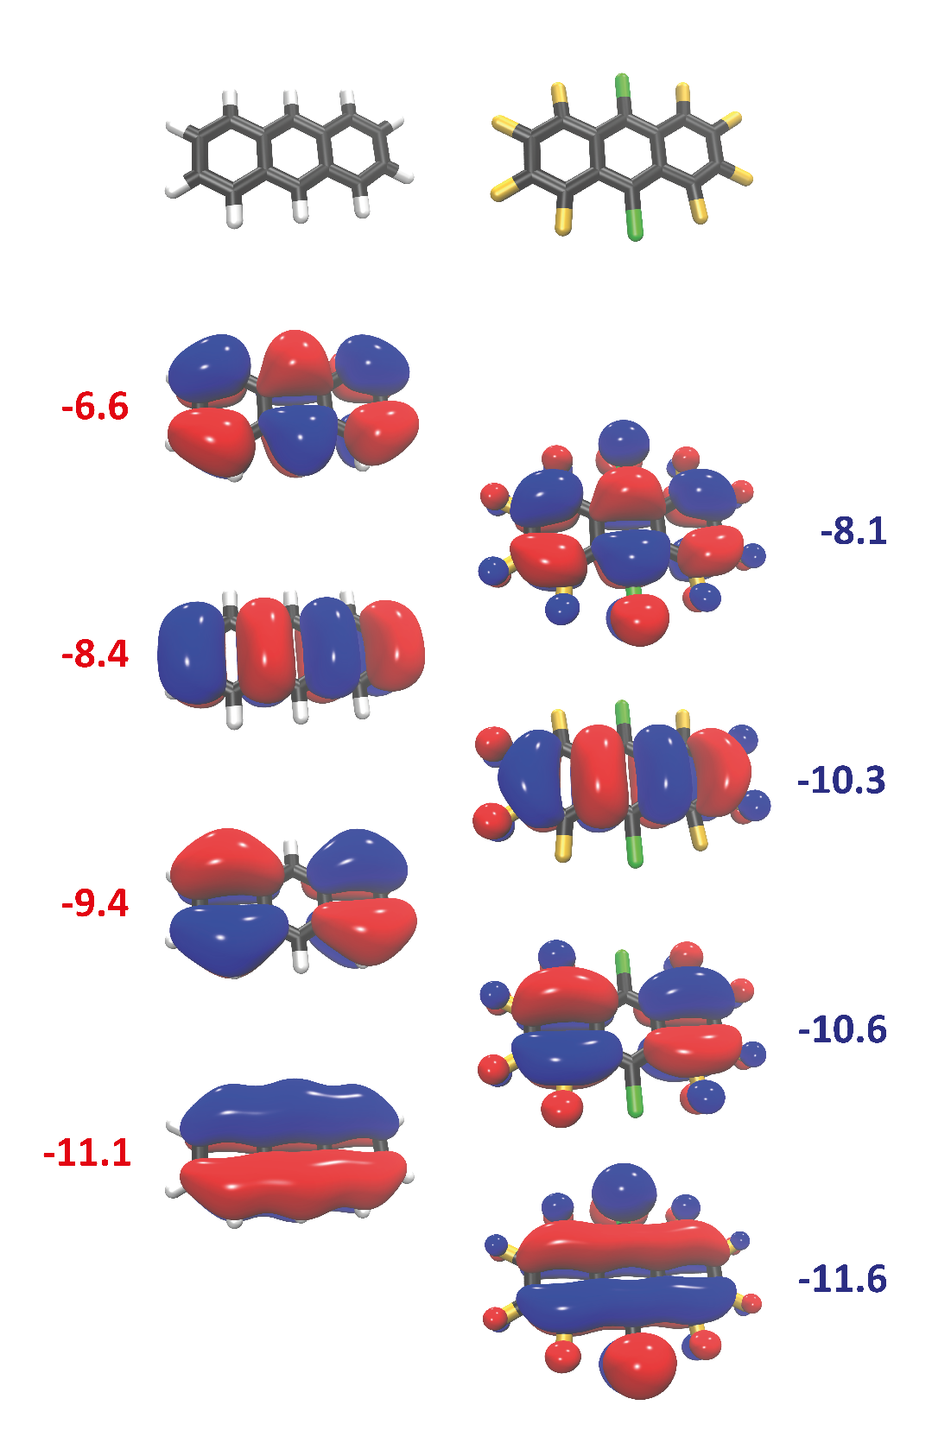

Fig. S1 Frontiers orbitals HOMO, HOMO -1, HOMO -2 and HOMO -3 for free-standing An (left) and FCl-An (right) with corresponding energies (eV) calculated at HF/cc-pVTZ level.

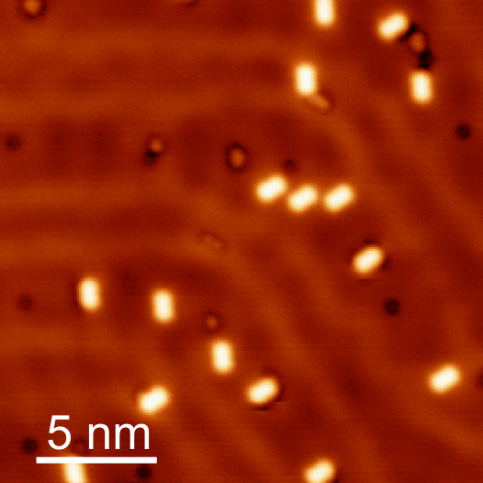

Fig. S2 | STM topography of single anthracene molecules on Au (111) (V_{Bias}=10 mV, I_{tunnel}=5 pA)

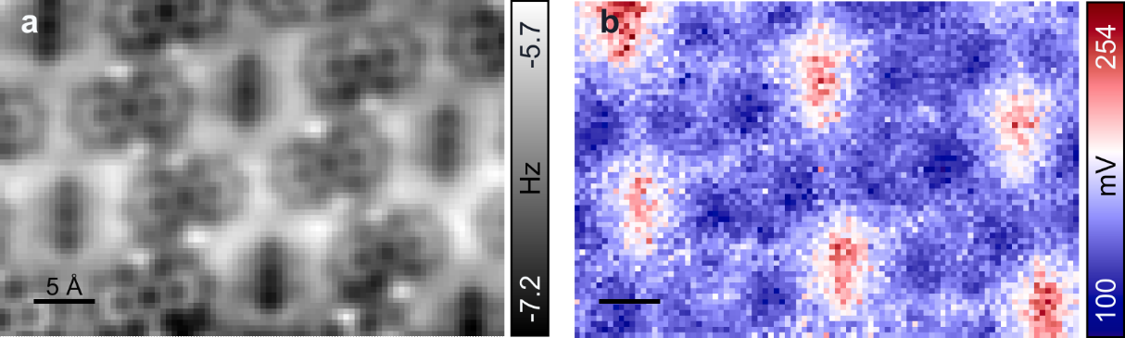

Fig. S3 | 𝛥f* and LCPD maps of an area including a full unit cell of the ordered assembly of anthracene and fluorinated anthracene.

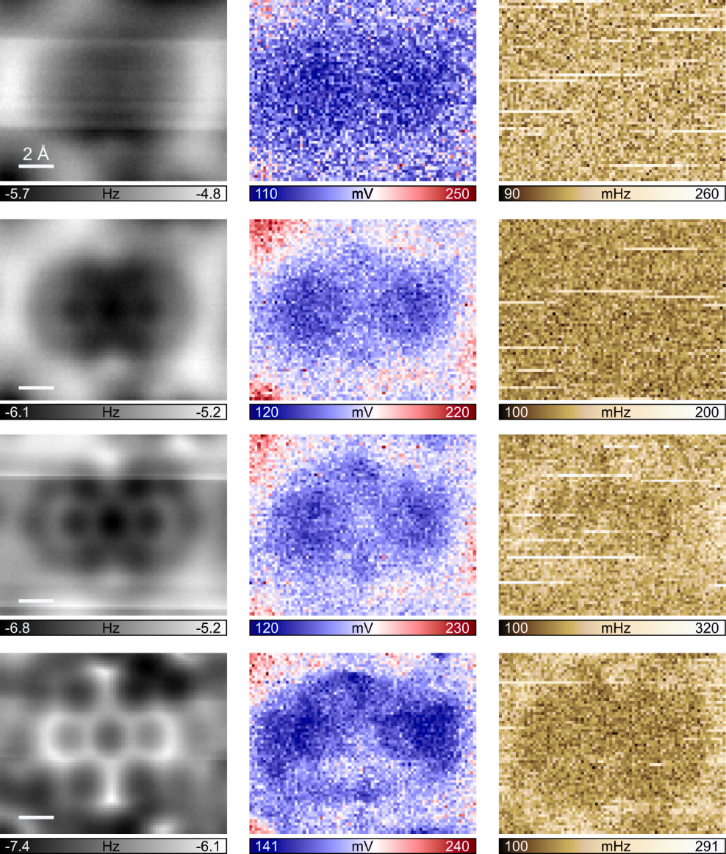

Fig. S4| KPFM dataset from far-tip sample distances to close distances. First column represents the Δf * parameter of the parabolic fit and provides information on the relative distance between tip and a FCl-An molecule. In the second column is displayed the LCPD map corresponding to the corresponding Δf* images. The third column represents the average RMS fit residual of each KPFM curve. This map provides information of the parabolic fit's quality, as any systematic errors in the fit would be observed as distinct features in the RMS map.

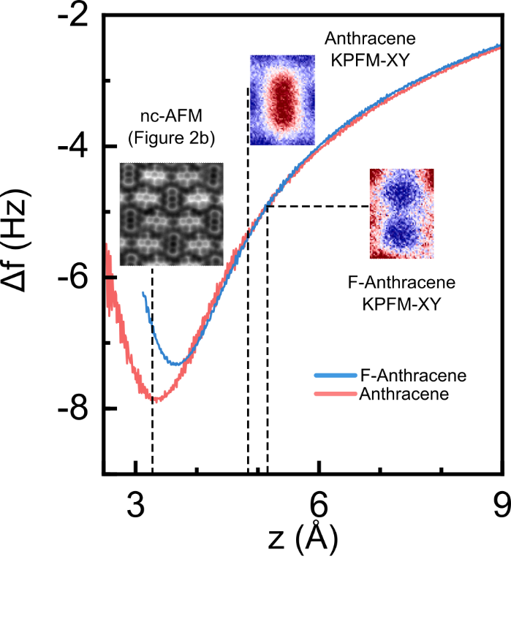

Fig. S5 | Relative heights of the LCPD maps. Point force spectroscopy measured on the central hexagon of anthracene (red) and fluorinated anthracene (blue) showing the relative z positions of the LCPD maps.
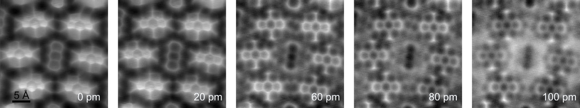

Fig. S6 | AFM vs z. Series of nc-AFM images with CO tip in constant height mode of the same area of the molecular assembly with tip-sample distance steps of Δz = 20 pm.

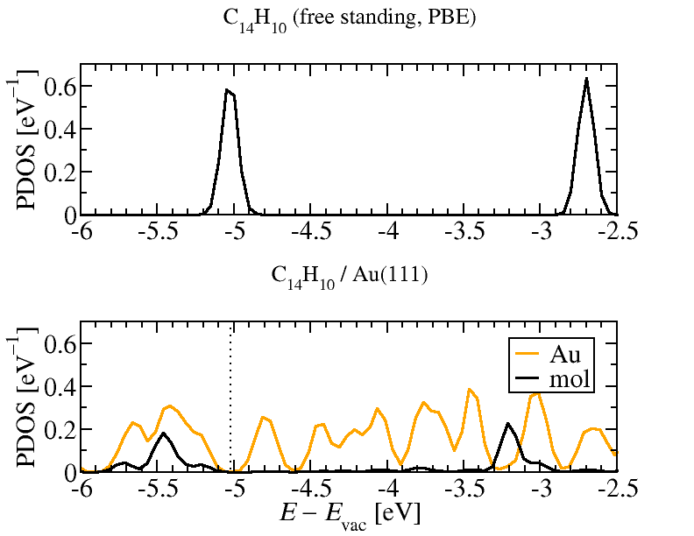

Fig. S7 | Projected density of states of free-standing C₁₄H₁₀ molecule and C₁₄H₁₀ on Au(111) surface revealing a negligible hybridization of frontiers HOMO and LUMO orbitals as well as a slight downshift of HOMO orbital from -5 eV (free-standing) to -5.4 eV on the Au(111) surface.

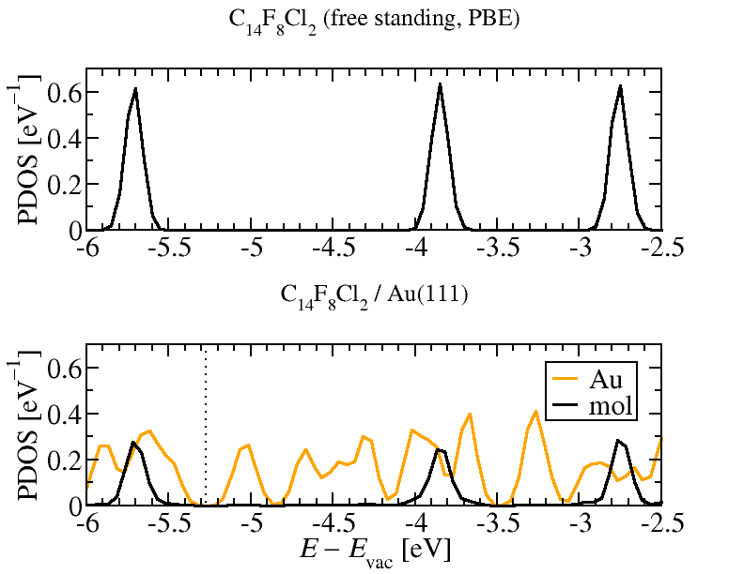

Fig. S8 | Projected density of states of free-standing C₁₄F₈Cl₂ molecule and C₁₄ F₈Cl₂ on Au(111) surface revealing a negligible hybridization of frontiers HOMO and LUMO orbitals as well as a slight renormalization of molecular band gap upon adsorption on the Au(111) surface.

 | DFT slab/  single molecule | DFT cluster/  single molecule | DFT slab/  Supramolecular assembly
C₁₄H₁₀/Au(111) | 326 | 314 | 329
C₁₄F₁₀/Au(111) | 347 | 320 | -
C₁₄Cl₂F₁₀/Au(111) | 340 | 321 | 349

Table S1 | Adsorption height of C₁₄H₁₀,C₁₄F₁₀ and C₁₄Cl₂F₁₀ on Au(111) surface for different calculation models. The values of the adsorption height are provided in picometers.
 | SAPT0 cluster | DFT cluster | DFT slab
C₁₄H₁₀/Au(111) | -50.50 | -41.40 | -39.63
C₁₄F₁₀/Au(111) | -42.18 | -38.13 | -41.23
C₁₄Cl₂F₁₀/Au(111) | -48.51 | -42.12 | -44.50

Table S2 | Adsorption energies of C₁₄H₁₀, C₁₄F₁₀ and C₁₄Cl₂F₁₀ on Au(111) surface for different calculation models. The values of energy terms are provided in kcal/mol.
 | Electrostatics | Exchange-repulsion | Induction | Dispersion | Total ΔE
C₁₄H₁₀···Au₃₈ | -43.02 | 84.09 | -11.49 | -80.08 | -50.50
C₁₄F₁₀···Au₃₈ | -38.07 | 77.77 | -7.98 | -73.90 | -42.18
C₁₄Cl₂F₁₀···Au₃₈ | -42.90 | 86.88 | -8.50 | -83.99 | -48.51

Table S3 | SAPT0 interaction energy decomposition for cluster models of C₁₄H₁₀,C₁₄F₁₀ and C₁₄Cl₂F₁₀ on Au(111) surface . The values of energy terms are provided in kcal/mol.

