Supplementary Materials for

Novel brain-penetrant inhibitor of G9a methylase blocks Alzheimer’s disease proteopathology for precision medication
Ling Xie¹†, Ryan N. Sheehy³†, Yan Xiong⁵†, Adil Muneer¹†, John A. Wrobel¹, Kwang-Su Park⁵, Julia Velez⁵, Jing Liu⁵, Yan-Jia Luo^{3,4}, Ya-Dong Li^{3,4}, Luis Quintanilla^{3,4}, Yongyi Li³, Chongchong Xu⁶, Mohanish Deshmukh^{4,7}, Zhexing Wen⁶, Jian Jin⁵*, Juan Song,^{3,4}* & Xian Chen^{1, 2}‡*

Corresponding author: xianc@email.unc.edu (X.C.); juansong@email.unc.edu (J.S.); jian.jin@mssm.edu (J.J.)

The PDF file includes:

Figs. S1 to S6

Other Supplementary Materials for this manuscript include the following:

Data File S1

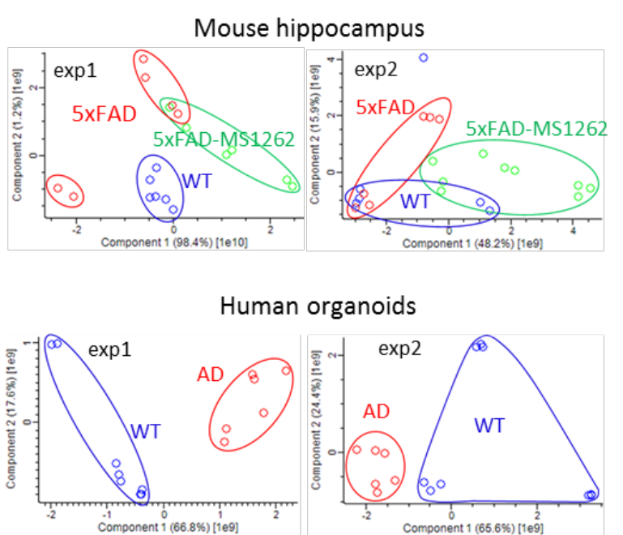

Figure S1. PCA plots of ChaC pull-downs by UNC0965 from mouse hippocampus and human organoids.

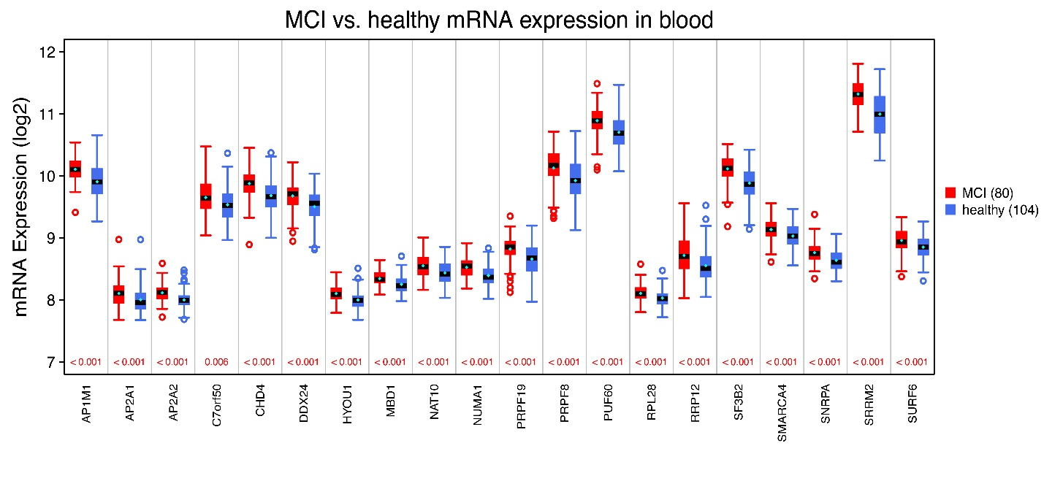
Figure S2. ChaC-identified G9a interactors show the interaction-correlated overexpression patterns in MCI or AD patients. Box plots showing the statistically significant (p values < 0.05), patient-specifically altered mRNA expression for indicated interactor genes. The distribution of mRNA expression for MCI patients (n=80) is in red, and for healthy individuals (n=104) is in blue. Standard error of the mean (SEM) in cyan is in ± 0.01-0.04.

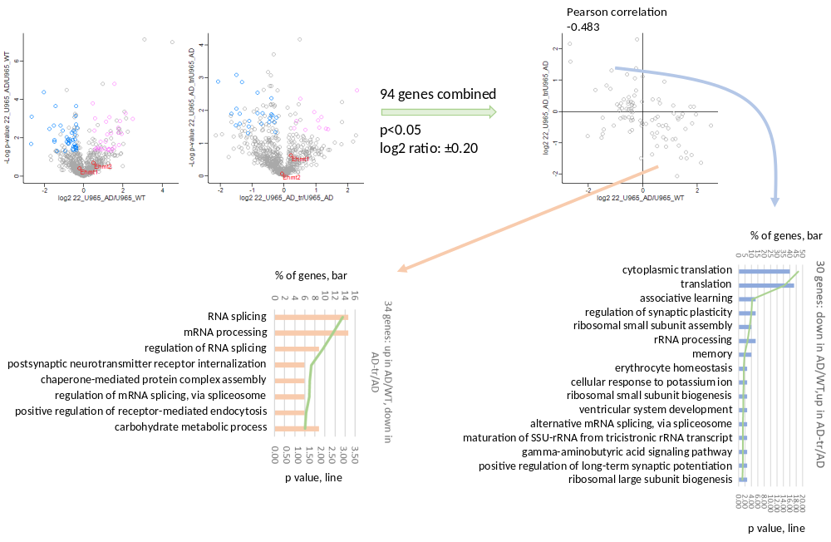
Figure S3. Function categorization of ChaC-MS identifications of G9a interactors from the hippocampus of 5XFAD mice with versus without MS1262 treatment.

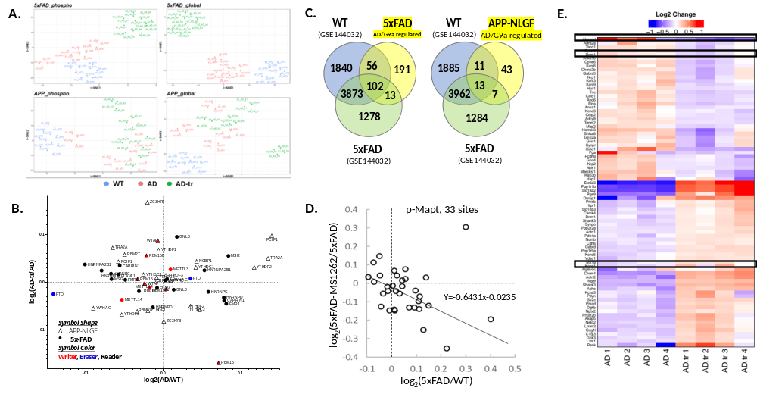
Figure S4. (A) t-SNE visualization showing clear separation between and reproducibility among replicates in the proteomic and phospho-proteomic datasets. ‘WT’– age-matched wild type mice; ‘AD’– 5x-FAD/APP-NLGF mice at mid/late stages of AD; ‘AD-tr’ – the AD mice treated by MS1262. (B) Scatter plot showing difference in expression for various m6A readers (black), writers (red) and erasers (blue) for indicated comparisons: AD vs WT (x-axis) and AD-tr vs AD (y-axis). Global proteomics data from 5x-FAD (circles) and APP-NLGF (triangles) mice. (C) Venn diagram showing overlap among AD-dysregulated/MS1262-reversed (‘AD/G9a coregulated’) proteins from the two mouse models (this study) and m6A-modified transcripts in WT and 5x-FAD mice identified using m6A-Seq (GSE144032). (D) Scatter plot showing effect of MS1262 treatment on phosphorylation of 33 sites on MAPT protein in 5x-FAD mice. (E) Heatmap of select AD/G9a coregulated proteins of interest. Median of 4 replicates is plotted.

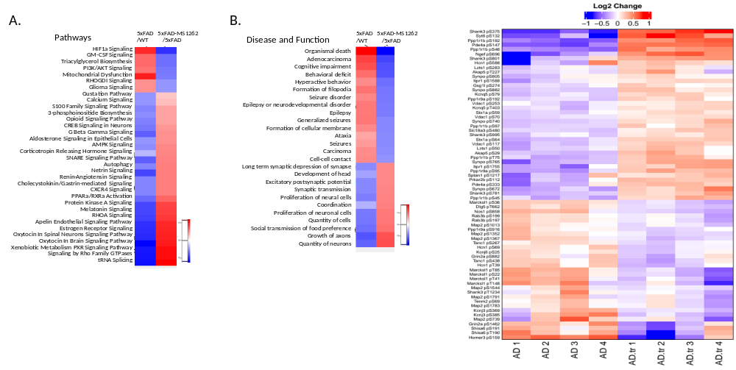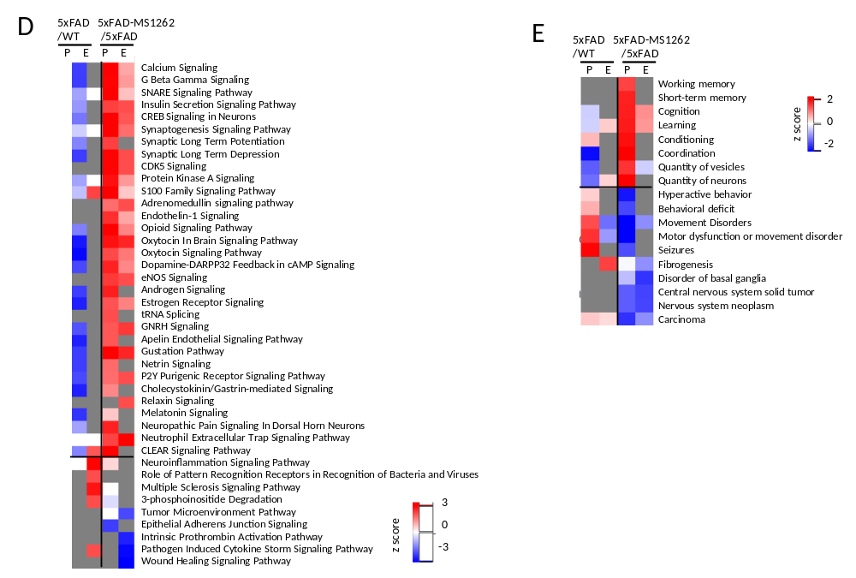
Figure S5. Effect of MS1262 treatment in 5xFAD mice. (A-B) Heatmaps summarizing pathway enrichment (A) & disease and function (B) activity analysis results calculated using differentially regulated phosphoproteins for the indicated comparisons (i.e., 5xFAD-vs-WT and 5xFAD-MS1262 vs 5xFAD). (C) Heatmap showing MS1262-regulated phosphoprotein products for AD-risk genes (p value < 0.05) (Nature genetics 51.3 (2019): 414-430). Midian of 4 technical replicates is plotted for each biological replicate. (D-E) Heatmaps summarizing pathway enrichment (A) & disease and function (B) activity analysis results calculated using differentially regulated proteins (Expression, ‘E’) & phosphoproteins (‘p’) for the indicated comparisons (i.e., 5xFAD-vs-WT and 5xFAD-MS1262 vs 5xFAD).
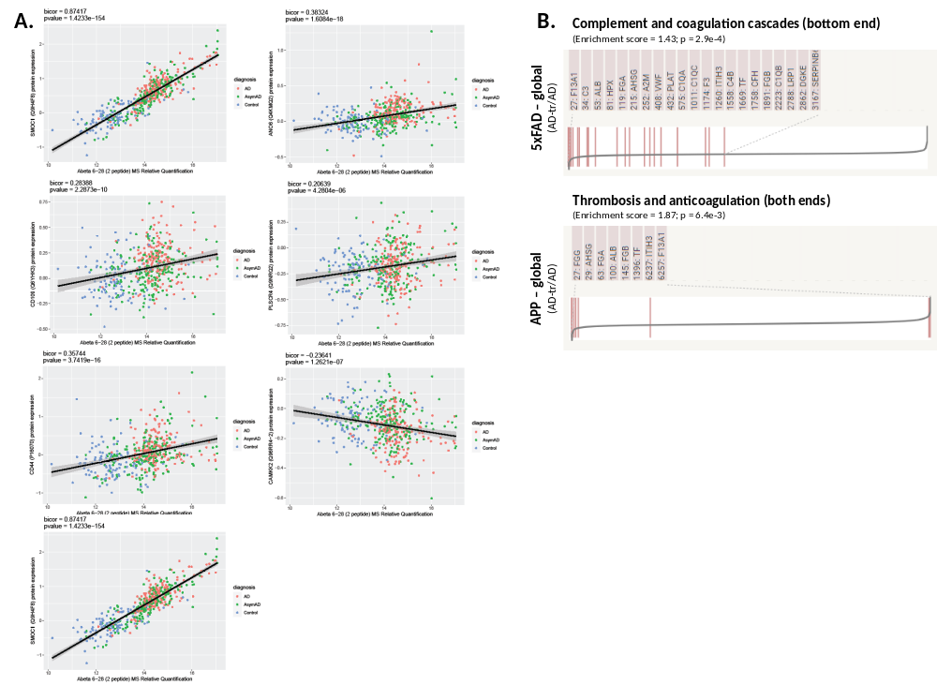

Figure S6. (A) Correlation plots between expression of indicated proteins and A$β$ peptides (residues 6-28) in the hippocampus of AD patients (n = 488; Nature Neuroscience 25, 213-225 (2022)). Linear regression line with 95% CI is shown. Points are colored based on diagnosis of individual patients: ‘AD’ - Symptomatic AD patient; ‘AsymAD’ - asymptomatic AD patient; ‘Control’ control patients. The biweight midcorrelation (bicor) and corresponding p-value is shown on top and was calculated using the bicorAndPvalue function from the WGCNA R package. (B) MS1262 treatment leads to downregulation of coagulation related factors in both 5x-FAD and APP-NLGF mice.

Data File S1. (Table 1) List of ChaC-MS identifications of UNC0965 pulled down proteins from human organoids.
Data File S1. (Table 2) List of ChaC-MS identifications of UNC0965 pulled down proteins from the hippocampus of wild type or 5xFAD mice with or without MS1262 treatment, which are labeled as 'WT', 'AD', 'AD-tr' in the Table.
Data File S1. (Table 3) List of protein and phosphoprotein identifications in the hippocampus of age matched wildtype controls (WT) or 5xFAD/APP-NLFG mice (AD) or AD mice with MS1262-treatment (AD-tr).
Data File S1. (Table 4) Tables summarizing activity scores for overrepresented pathways and diseases & biological functions calculated using differentially expressed proteins/phosphoproteins listed in Table 3
Data File S1. (Table 5) AD/G9a-corregulated proteins/phosphor-proteins whose expression shows significant correlation with Abeta peptide (6-28) in the hippocampus of AD patients.

