Supplementary Materials

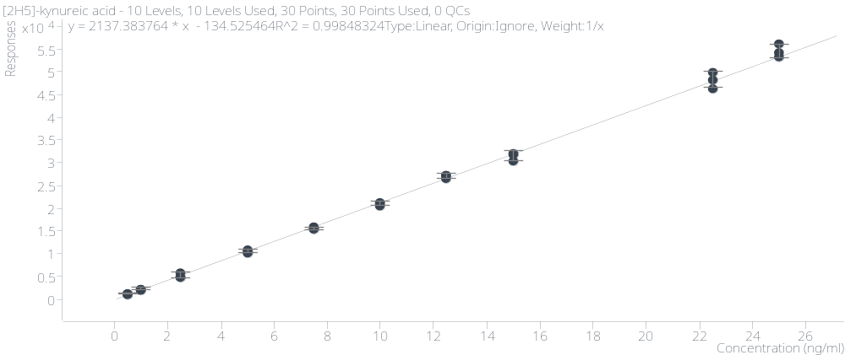
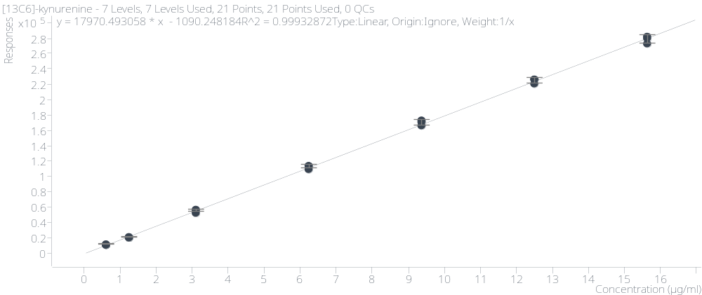
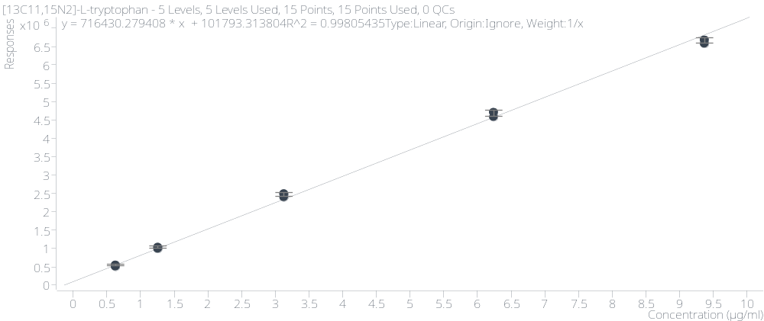
KYNA
KYN
TRP

TRP

Figure S1: Representative examples of calibration curves of the placenta homogenate.
TRP
KYN

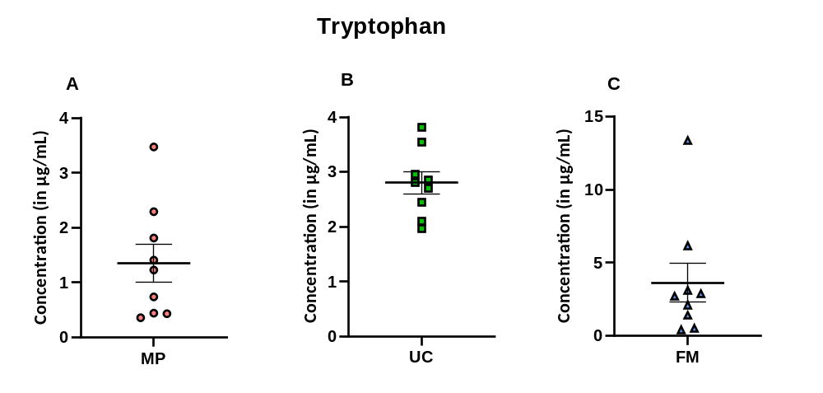
Figure S2. Concentration of tryptophan in maternal placenta (A), umbilical cord (B) and fetal membrane (C). Data are presented as a mean ± SEM, number of subjects = 9 per group. FM-fetal membrane, MP-maternal placenta, UC-umbilical cord.

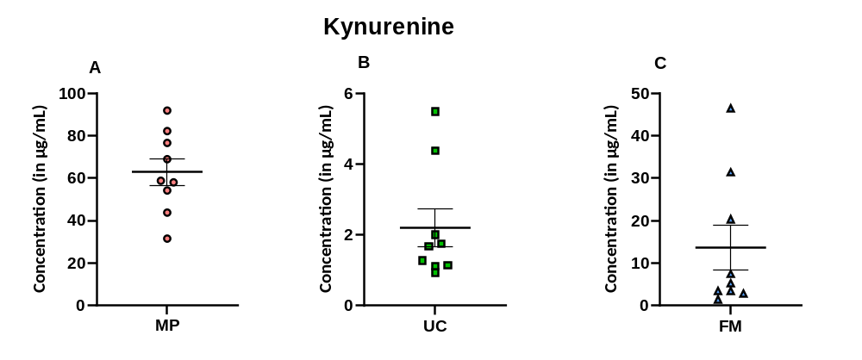
Figure S3. Concentration of kynurenine in maternal placenta (A), umbilical cord (B) and fetal membrane (C). Data are presented as a mean ± SEM, number of subjects = 9 per group. FM-fetal membrane, MP-maternal placenta, UC-umbilical cord.

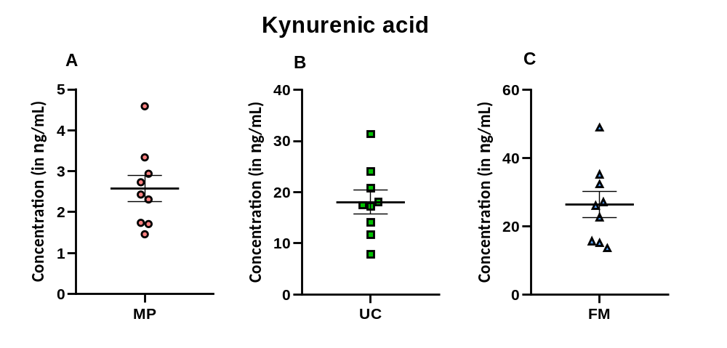
Figure S4. Concentration of kynurenic acid in maternal placenta (A), umbilical cord (B) and fetal membrane (C). Data are presented as a mean ± SEM, number of subjects = 9 per group. FM-fetal membrane, MP-maternal placenta, UC-umbilical cord.

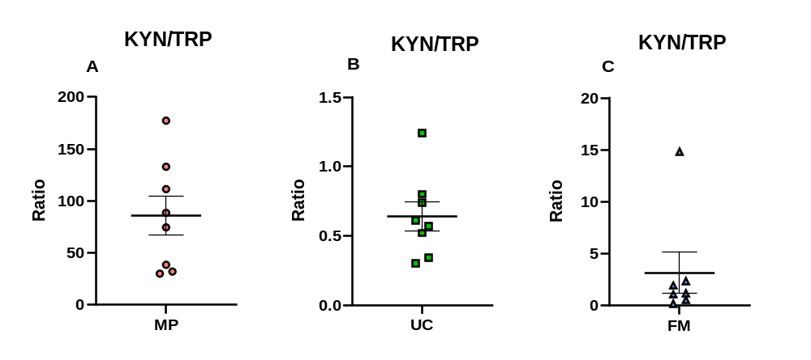
Figure S5. Kynurenine/tryptophan ratio in maternal placenta (A), umbilical cord (B) and fetal membrane (C). Data are presented as a mean ± SEM, number of subjects = 7-8 per group. FM-fetal membrane, KYN-kynurenine, MP-maternal placenta, TRP-tryptophan, UC-umbilical cord.

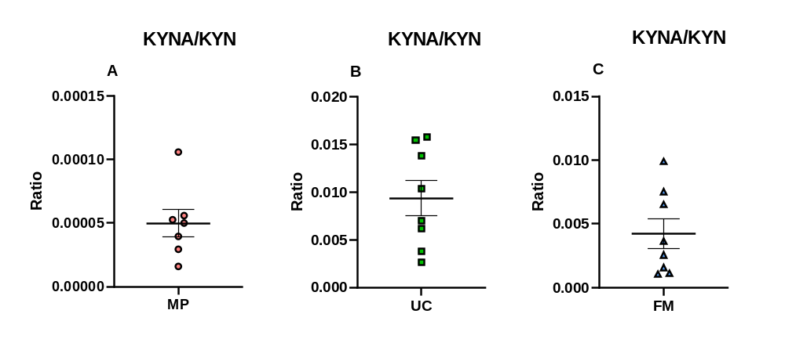
Figure S6. Kynurenic acid/kynurenine ratio in maternal placenta (A), umbilical cord (B) and fetal membrane (C). Data are presented as a mean ± SEM, number of subjects = 7-8 per group. FM-fetal membrane, KYN-kynurenine, KYNA-kynurenic acid, MP-maternal placenta, UC-umbilical cord.

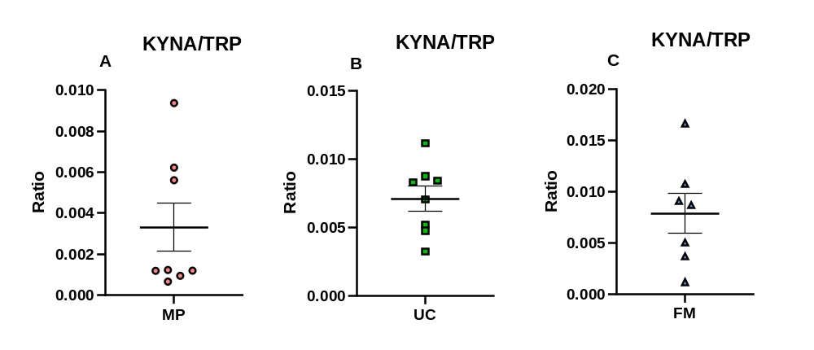
Figure S7. Kynurenic acid/tryptophan ratio in maternal placenta (A), umbilical cord (B) and fetal membrane (C). Data are presented as a mean ± SEM, number of subjects = 7-8 per group. FM-fetal membrane, KYNA-kynurenic acid, MP-maternal placenta, TRP-tryptophan, UC-umbilical cord.

