Western Blot:
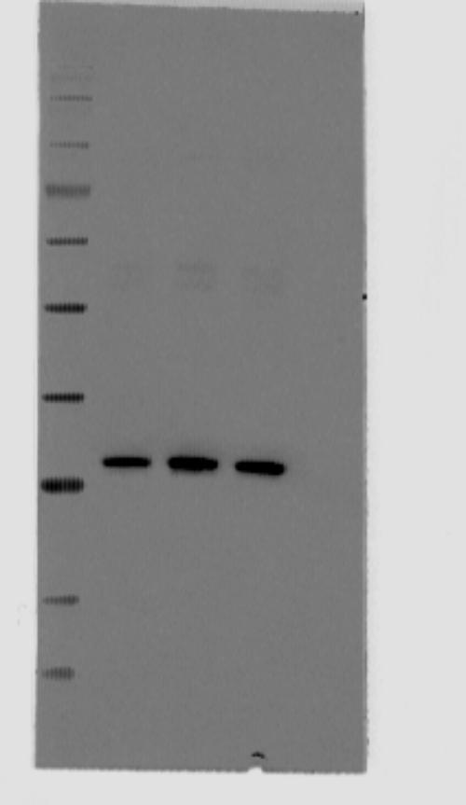Supplementary Figure 1.
The operation steps are as follows: (1) Sample preparation: Configure ASC protein solution at a concentration of 0.2 μg/μL and heat at 100°C for 5 min. (2) Electrophoresis: Prepared gel with 4-20% SDS-PAGE was used for electrophoresis, and 10 μL of the sample was added to each well. 80V constant pressure electrophoresis was performed for about 10-20 minutes, and when bromophenol blue was pressed into a straight line and was about to enter the separation gel, it was adjusted to 100V constant pressure electrophoresis, and electrophoresis was stopped when bromophenol blue was near the bottom of the separation gel. (3) Transfer: Cover the NC film on the prefabricated gel, and transfer the film at 4°C for 50 minutes with 250mA constant current (voltage control at 90-120V). (4) Closure: Wash the NC membrane with deionized double-distilled water, put it into Western Closure Solution, and place it on a shaker for 30 minutes at room temperature. (5) Incubate primary antibody: Remove NC membrane and add (AL177) antibody against ASC(1:10,00 dilution in PBST solution), , place on a shaker at 4°C overnight, and rinse 3 times with PBST solution for 5 minutes each time. (6) Incubate secondary antibody: incubate goat anti-human IRDye 800CW fluorescent secondary antibody (1:10,000 dilution in PBST solution) for 60 minutes at room temperature, protected from light, and rinse 3 times with PBST solution for 5 minutes each time. (9) Use the Odyssey fluorescence gel imager to sweep the membrane and analyze the images.

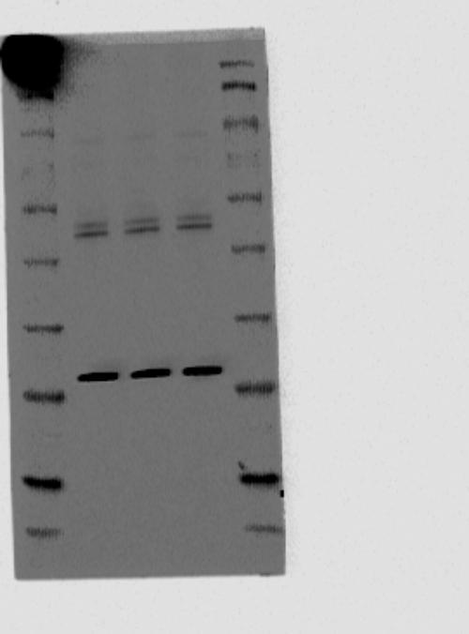Supplementary Figure 2.
The operation steps are as follows: (1) Sample preparation: Configure ASC protein solution at a concentration of 0.2 μg/μL and heat at 100°C for 5 min. (2) Electrophoresis: Prepared gel with 4-20% SDS-PAGE was used for electrophoresis, and 10 μL of the sample was added to each well. 80V constant pressure electrophoresis was performed for about 10-20 minutes, and when bromophenol blue was pressed into a straight line and was about to enter the separation gel, it was adjusted to 100V constant pressure electrophoresis, and electrophoresis was stopped when bromophenol blue was near the bottom of the separation gel. (3) Transfer: Cover the NC film on the prefabricated gel, and transfer the film at 4°C for 50 minutes with 250mA constant current (voltage control at 90-120V). (4) Closure: Wash the NC membrane with deionized double-distilled water, put it into Western Closure Solution, and place it on a shaker for 30 minutes at room temperature. (5) Incubate primary antibody: Remove NC membrane and add (ab155970) antibody against ASC(1:10,00 dilution in PBST solution), place on a shaker at 4°C overnight, and rinse 3 times with PBST solution for 5 minutes each time. (6) Incubate secondary antibody: incubate goat anti-human IRDye 800CW fluorescent secondary antibody (1:10,000 dilution in PBST solution) for 60 minutes at room temperature, protected from light, and rinse 3 times with PBST solution for 5 minutes each time. (9) Use the Odyssey fluorescence gel imager to sweep the membrane and analyze the images.

Supplementary Figure 3.
The operation steps are as follows: (1) Sample preparation: Configure ASC protein solution at a concentration of 0.2 μg/μL and 0.5 μg/μL and heat at 100°C for 5 min. (2) Electrophoresis: Prepared gel with 4-20% SDS-PAGE was used for electrophoresis, and 10 μL of the sample was added to each well. 80V constant pressure electrophoresis was performed for about 10-20 minutes, and when bromophenol blue was pressed into a straight line and was about to enter the separation gel, it was adjusted to 100V constant pressure electrophoresis, and electrophoresis was stopped when bromophenol blue was near the bottom of the separation gel. (3) Transfer: Cover the NC film on the prefabricated gel, and transfer the film at 4°C for 50 minutes with 250mA constant current (voltage control at 90-120V). (4) Closure: Wash the NC membrane with deionized double-distilled water, put it into Western Closure Solution, and place it on a shaker for 30 minutes at room temperature. (5) Incubate primary antibody: Remove NC membrane and add the appropriate amount of subject plasma , place on a shaker at 4°C overnight, and rinse 3 times with PBST solution for 5 minutes each time. (6) Incubate secondary antibody: incubate goat anti-human IRDye 800CW fluorescent secondary antibody (1:10,000 dilution in PBST solution) for 60 minutes at room temperature, protected from light, and rinse 3 times with PBST solution for 5 minutes each time. (9) Use the Odyssey fluorescence gel imager to sweep the membrane and analyze the images.

Supplementary Figure 1.

Cut with Photoshp at the linear mark, and then make the 1a of Fig. 1
Supplementary Figure 3.

Cut with Photoshp at the linear mark, and then make the 1a of Fig. 1.(adjusted by Photoshop for contrast and brightness, so stripes more clearly in 1a of Fig. 1)

Supplementary Figure 2.

Cut with Photoshp at the linear mark, and then make the 1a of Fig. 1

ELISA :The steps are as follows: (1) dilution of standards: dilute to 5 standards by concentration; (2) sample addition: set up blank wells (blank control wells without sample and enzyme standard reagents, the rest of the steps are the same), standard wells, and wells for samples to be tested. Add 50μl of the standard to the enzyme plate, 40ul of sample dilution to the sample wells, and then add 10μ of the sample to be tested (the final dilution of the sample is 5 times). Add the sample to the bottom of the well of the enzyme plate without touching the wall of the well as far as possible, and shake gently and evenly. (3) Warming: Seal the plate with sealing film and incubate at 37℃ for 30 minutes. (4) Preparation: Dilute the 30-fold concentrated washing solution 30 times with distilled water and prepare it for use. (5) Washing: Carefully remove the sealing membrane, discard the liquid, shake dry, fill each well with washing solution, let stand for 30 seconds and then discard, repeat 5 times, and pat dry. (6) Enzyme addition: Add 50 μl of enzyme reagent to each well, except for white wells. (7) Warming: Same as 3. (8) Washing: Same as 5. (9) Color development: Add 50pl of chromogenic agent A and 50ul of chromogenic agent B to each well, shake gently and mix well, and develop for 10 minutes at 37℃ and avoid light. (10) Termination: Add 50μ of termination solution to each well to terminate the reaction (the blue color turns yellow at this time). (11) Determination: Zero the blank wells and measure each well’s absorbance (OD) sequentially at 450 nm. The measurement should be performed within 15 minutes after the addition of the termination solution.

