Supplemental digital information

Title page:

- Title: Severity and Mortality of Acute Respiratory Failure in Pediatrics: A Prospective Cohort at 2,600 Meters Above Sea Level
- Authors: Catalina Vargas-Acevedo MD¹ (https://orcid.org/0000-0003-0326-2180), Mónica Botero Marín MD¹, Catalina Jaime Trujillo MD¹, Laura Jimena Hernández MD¹, Melisa Naranjo Vanegas MD, MPH, MSC², Andrea Ramírez Varela MD, MPH, phD², Sergio Mauricio Moreno MSC, phD², Paola Rueda-Guevara MSC², Juan Gabriel Piñeros MD¹, Olga Baquero MD³, Carolina Bonilla MD¹, María Lucía Mesa MD, MSC¹, Sonia Restrepo MD¹, Pedro Barrera MD, MSC¹, Luz Marina Mejía MD ⁴ on behalf of FARA Group.
- Affiliations:
¹Pediatrics residency program, Universidad de los Andes and Department of Pediatrics, Hospital Universitario Fundación Santa Fe de Bogotá. Bogotá, Colombia.
²Faculty of Medicine, Universidad de los Andes. Bogotá, Colombia.
³Department of Pediatrics Clínica Infantil Colsubsidio. Bogotá, Colombia.
⁴Department of Pediatrics Instituto Roosevelt. Bogotá, Colombia.
- Institutions where the work was performed: Hospital Universitario Fundación Santa Fe de Bogotá, Clínica Infantil Colsubsidio and Instituto Roosevelt, all in Bogotá, Colombia.
- Keywords: acute respiratory failure, mortality, pediatric, intubation, mechanical ventilation, respiratory therapy.
- Corresponding author: Catalina Vargas-Acevedo
Carrera 7#116-5, piso 4, Universidad de Los Andes Faculty of Medicine.
Phone number: +573142969367
Email: cv.acevedo@uniandes.edu.co

Table of Contents
Title page: 1
Supplemental Table 1. Variables associated with mortality 3
Supplemental Table 2. Variables associated with PICU length of stay 4
Supplemental Figure 1. Kaplan Meier Survival Estimate for PICU length of stay in ARF. 5
Supplemental Table 3. Variables associated with IMV 6
Supplemental Table 4. Associated factors included in bivariate analysis. 7

Supplemental Table 1. Variables associated with mortality

Supplemental Table 1. Variables associated with mortality
 | RR | 𝑝 value | 95% CI
Sex
Female | 0.977 | 0.966 | 0.336 | 2.830
Age (years) | 0.990 | 0.848 | 0.891 | 1.100
Immunizations (vaccines)
Incomplete | 1.460 | 0.670 | 0.482 | 4.440
Nutritional deficiency
Yes | 0.919 | 0.904 | 0.234 | 3.610
Environmental exposures (Smokers)
Yes | 0.388 | 0.245 | 0.079 | 1.910
Comorbidities
Respiratory | 1.050 | 0.942 | 0.318 | 3.430
Neurological | 8.020 | 0.001 | 2.910 | 22.10
Pediatric Assessment Triangle
Potentially unstable | 0.464 | 0.286 | 0.113 | 1.900
Unstable | 5.130 | 0.011 | 1.440 | 18.20
Blood count (Anemia)
Yes | 0.956 | 0.942 | 0.283 | 3.230
Microbiological isolation (Respiratory sincytial virus)
Yes | 0.925 | 0.906 | 0.255 | 3.360
Vital signs
Oxygen saturation | 1.040 | 0.120 | 0.990 | 1.090
Inspired fraction of oxygen | 1.030 | 0.001 | 1.010 | 1.050
Glasgow
9 to 15 | 2.280 | 0.256 | 0.550 | 9.470

Supplemental Table 2. Variables associated with PICU length of stay

Supplemental Table 2. Variables associated with PICU length of stay
 | HZ | p value | 95% CI
Sex
Female | 0.875 | 0.302 | 0.678 | 1.128
Age groups
Preschoolers (2-5 years) | 1.746 | 0.001 | 1.259 | 2.422
School children (6-12 years) | 0.878 | 0.495 | 0.603 | 1.277
Adolescents (13-18 years) | 0.705 | 0.104 | 0.462 | 1.074
Immunizations (vaccines)
Incomplete | 0.777 | 0.208 | 0.524 | 1.151
Environmental exposures (Smokers)
Yes | 1.584 | 0.011 | 1.113 | 2.255
Comorbilities
Respiratory | 1.630 | 0.002 | 1.188 | 2.236
Pediatric Assessment Triangle
Potentially unstable | 1.200 | 0.257 | 0.876 | 1.644
Unstable | 0.826 | 0.402 | 0.527 | 1.293
Blood count (Anemia)
Yes | 0.818 | 0.253 | 0.580 | 1.154
Microbiological isolation (Respiratory sincytial virus)
Yes | 1.350 | 0.078 | 0.967 | 1.884
Vital signs
Oxygen saturation | 0.984 | 0.491 | 0.941 | 1.030

Supplemental Figure 1. Kaplan Meier Survival Estimate for PICU length of stay in ARF.
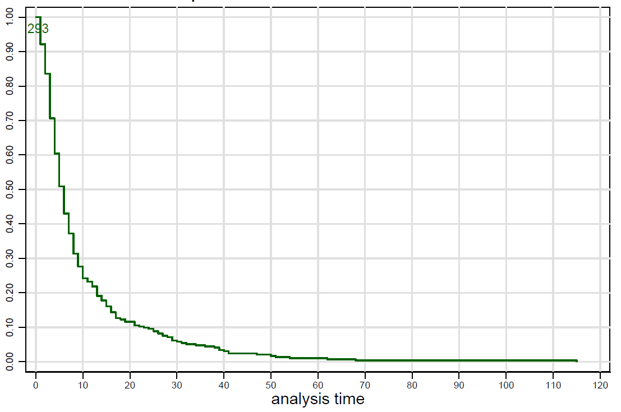

Supplemental Table 3. Variables associated with IMV

Supplemental Table 3. Variables associated with IMV
 | RR | 𝑝 value | 95% CI
Sex
Female | 1.186 | 0.353 | 0.827 | 1.700
Age groups
Preschoolers (2-5 years) | 0.443 | 0.007 | 0.245 | 0.798
School children (6-12 years) | 1.030 | 0.908 | 0.620 | 1.713
Adolescents (13-18 years) | 0.932 | 0.782 | 0.568 | 1.531
Immunizations (vaccines)
Incomplete | 0.813 | 0.493 | 0.449 | 1.470
Nutritional status
Malnutrition | 1.017 | 0.951 | 0.586 | 1.766
Obesity | 1.730 | 0.017 | 1.101 | 2.720
Environmental exposures (Smokers)
Yes | 0.685 | 0.154 | 0.407 | 1.152
Comorbidities
Respiratory | 0.759 | 0.287 | 0.456 | 1.262
Pediatric Assessment Triangle
Potentially unstable | 0.813 | 0.439 | 0.482 | 1.372
Unstable | 2.198 | 0.004 | 1.288 | 3.750
Blood count (Anemia)
Yes | 1.592 | 0.020 | 1.074 | 2.358
Microbiological isolation (Respiratory sincytial virus)
Yes | 0.729 | 0.268 | 0.416 | 1.276
Vital signs
Oxygen saturation | 1.046 | 0.166 | 0.982 | 1.114
Glasgow
9 to 15 | 0.426 | 0.000 | 0.276 | 0.658

Supplemental Table 4. Associated factors included in bivariate analysis.
Demographic characteristics
Age, age group
Sex
Presence of comorbidities
Incomplete vaccination schedule
Environmental exposures (Smokers)
Exclusive breastfeeding
Nutritional status
IMV in the last year
Etiology of ARF
Clinical and hemodynamic variables
SaO2
FiO2
Pediatric Assessment Triangle
Glasgow Coma Scale
Wheezing
Microbiological isolation
Initial high-flow oxygen device

