Supplementary Figure 2
A: P4551_219T - chr22 copy number profile displaying multiple SVs
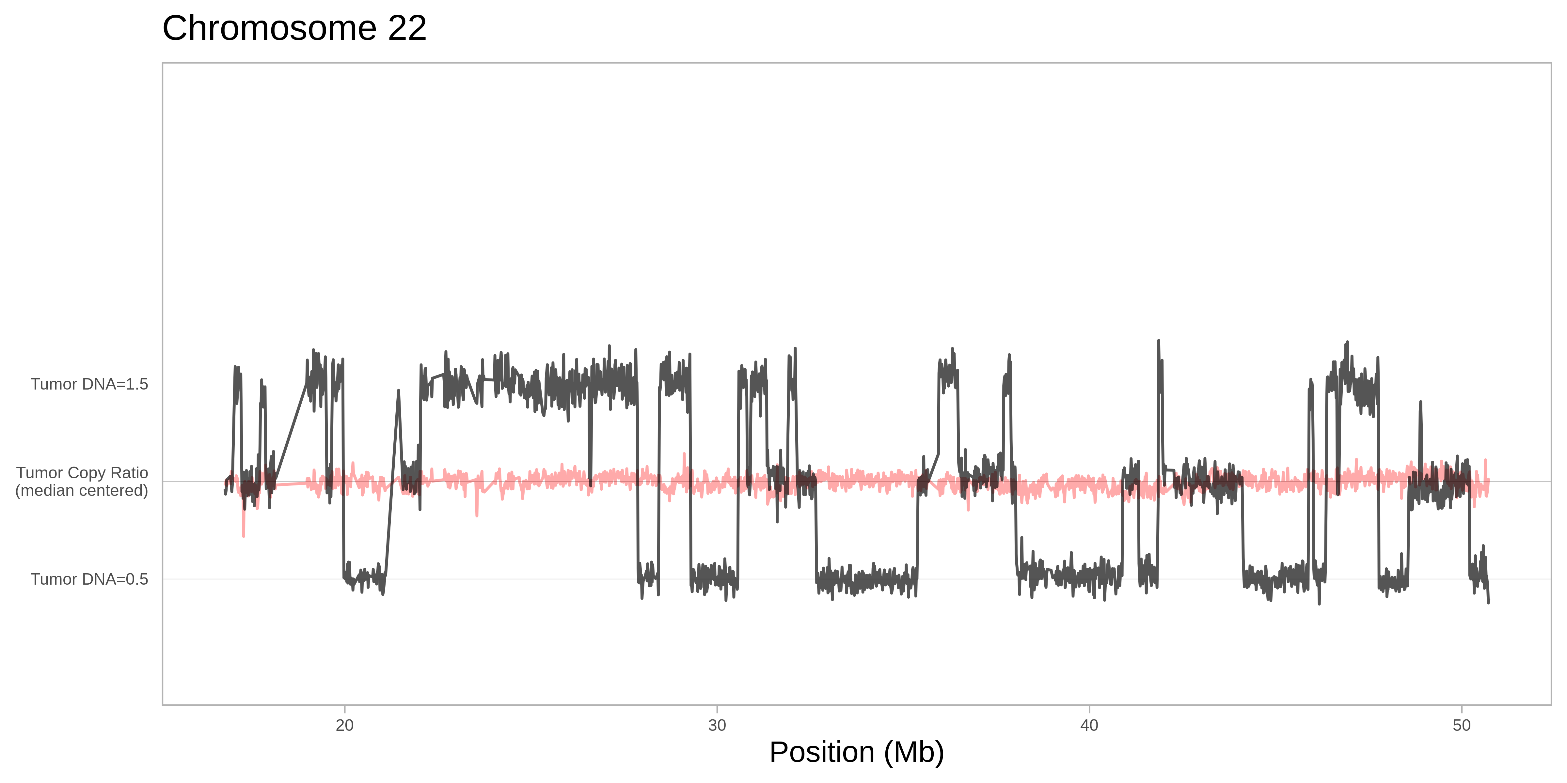
B: P4551_218T - chr8 copy number profile showing a focal duplication on 8p11.23-p11.22 forming FGFR1-TACC1 fusion 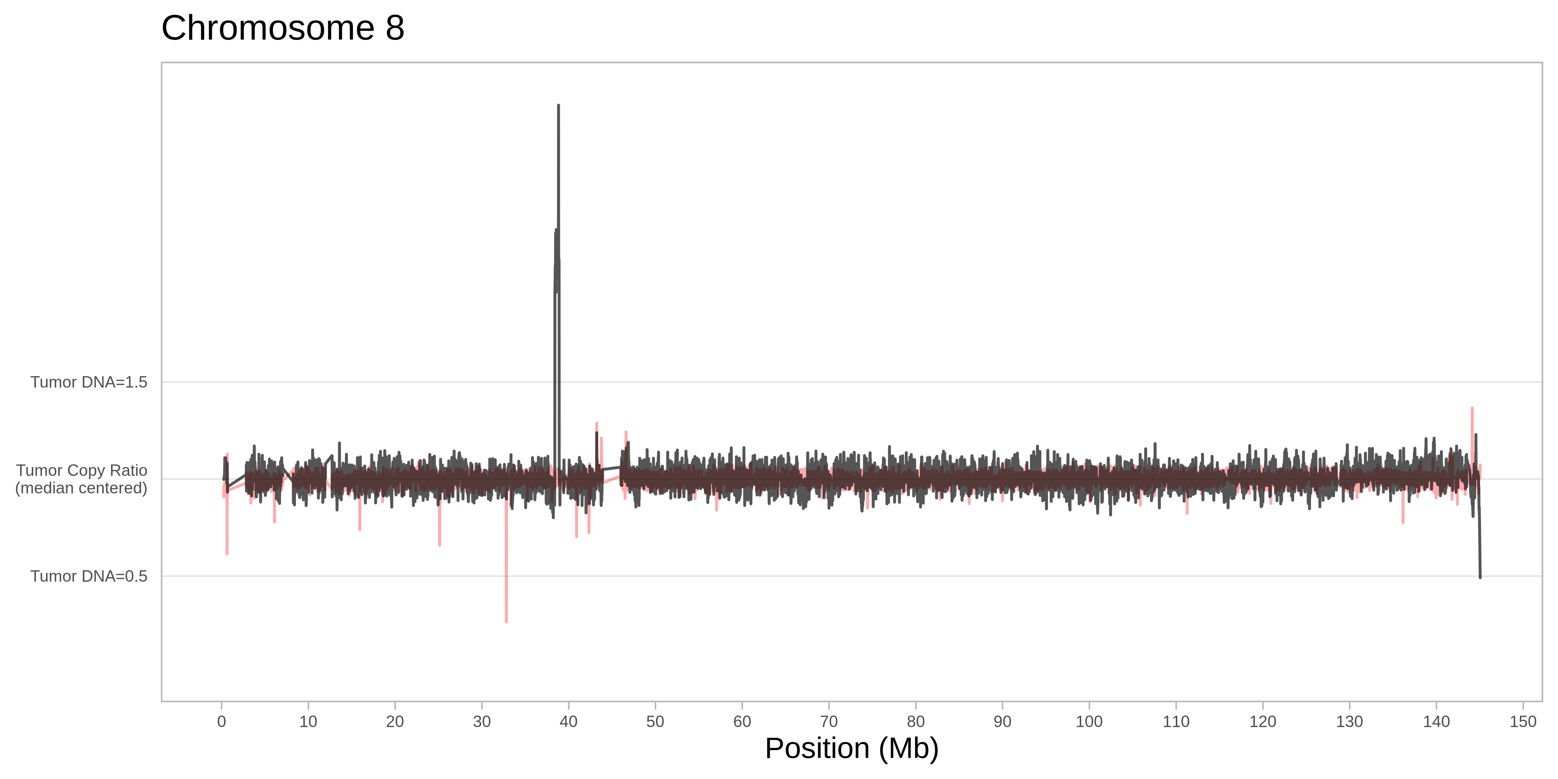
C: P7708_105T - chr8 copy number profile showing a focal duplication on 8p11.23-p11.22 forming FGFR1-TACC1 fusion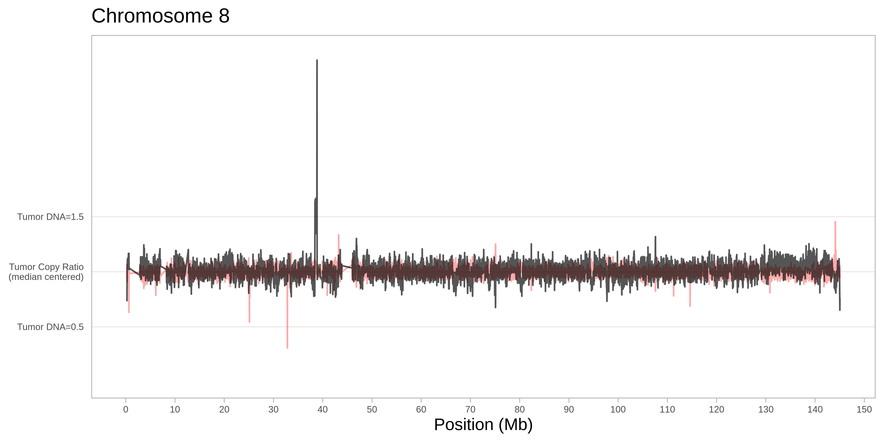
D: FAM2T – chr12 copy number profile showing focal amplification of BORCS5 and LMO3 in a MB SHH 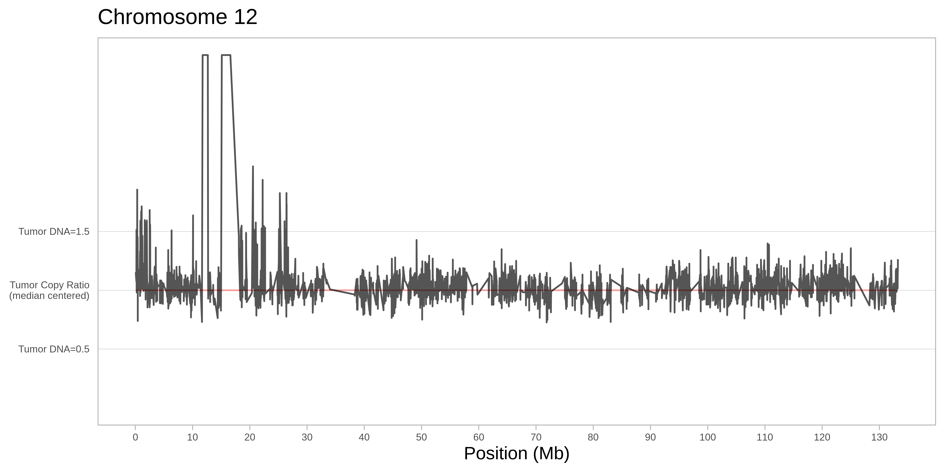
E: FAM2T - chr10 copy number profile showing a focal homozygous deletion of SUFU gene in a MB SHH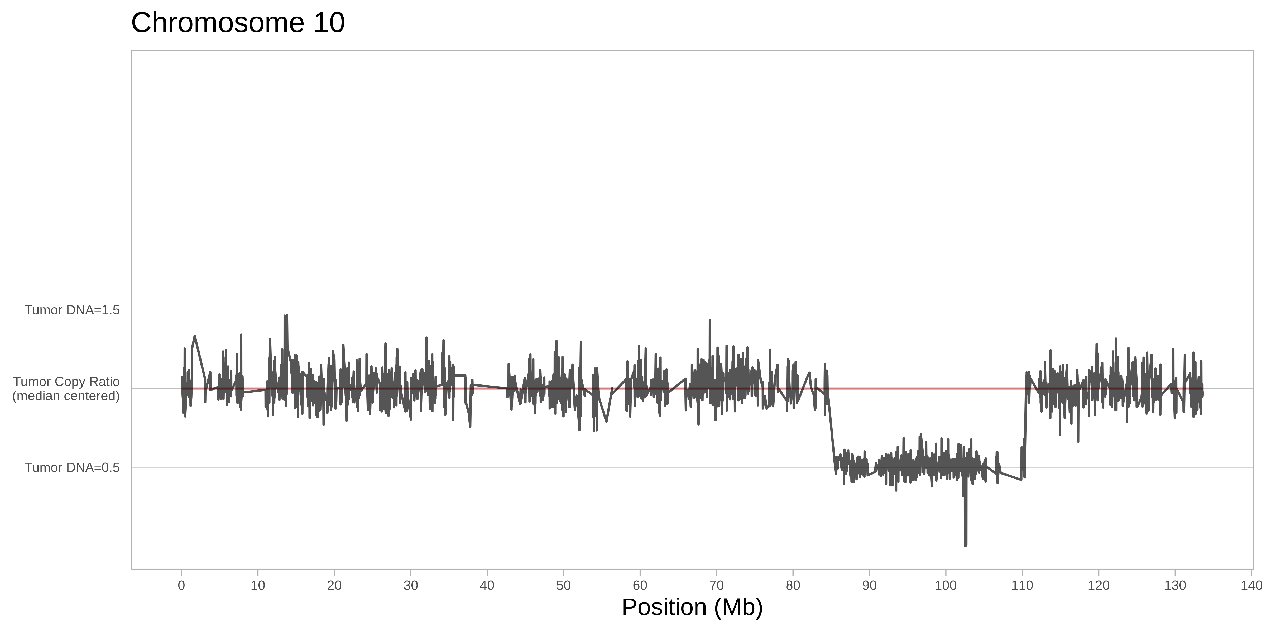
F: P4551_210T – chr20 copy number profile showing focal amplifications in a MB sample
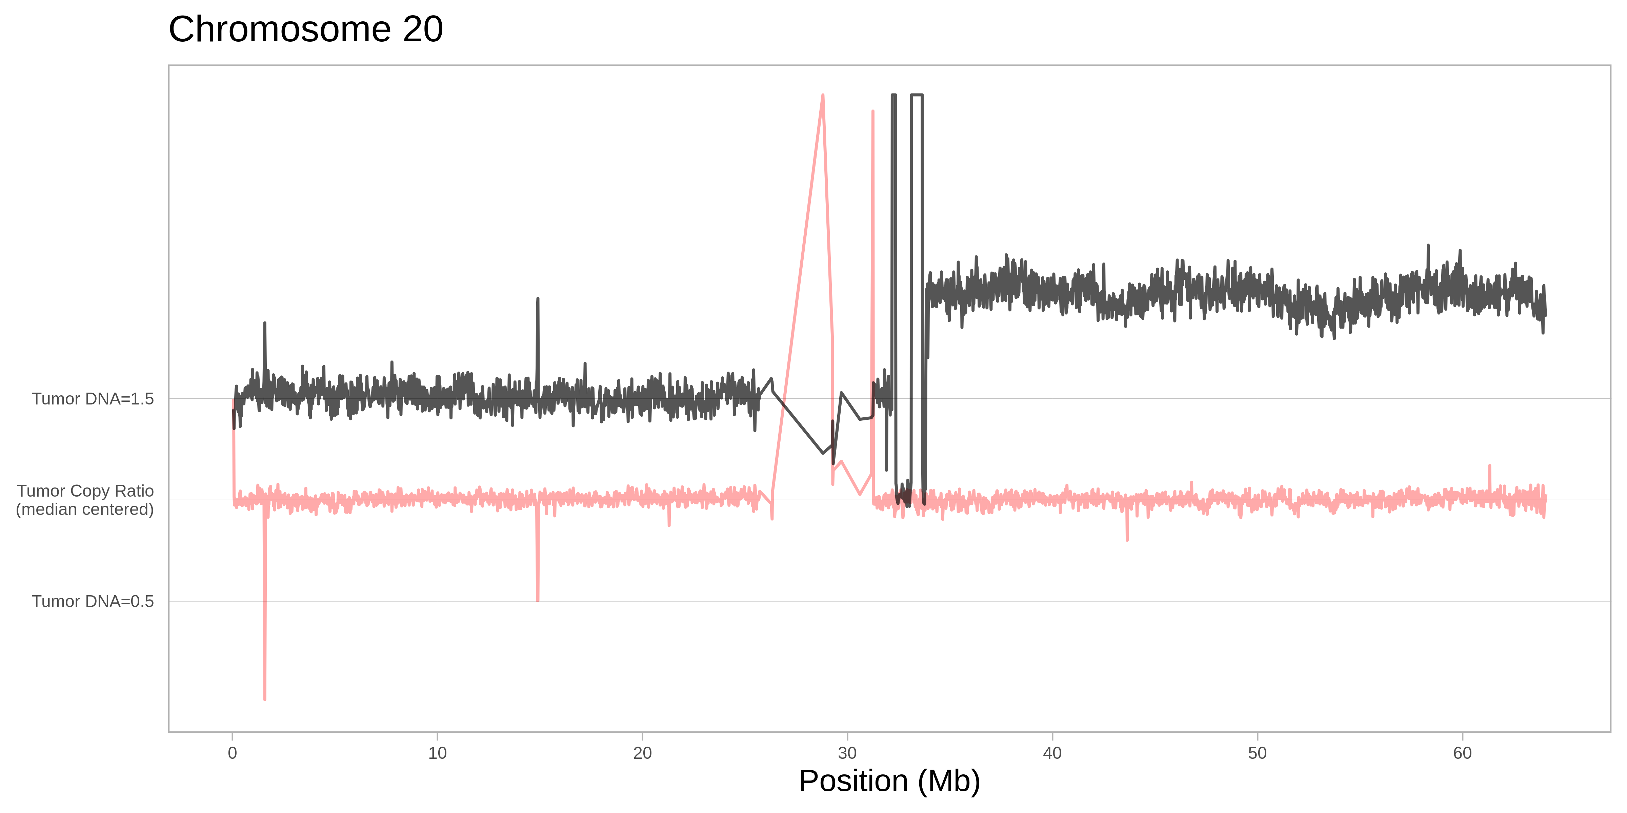

G: P7708_114T – chr11 copy number profile in a RELA class ependymoma
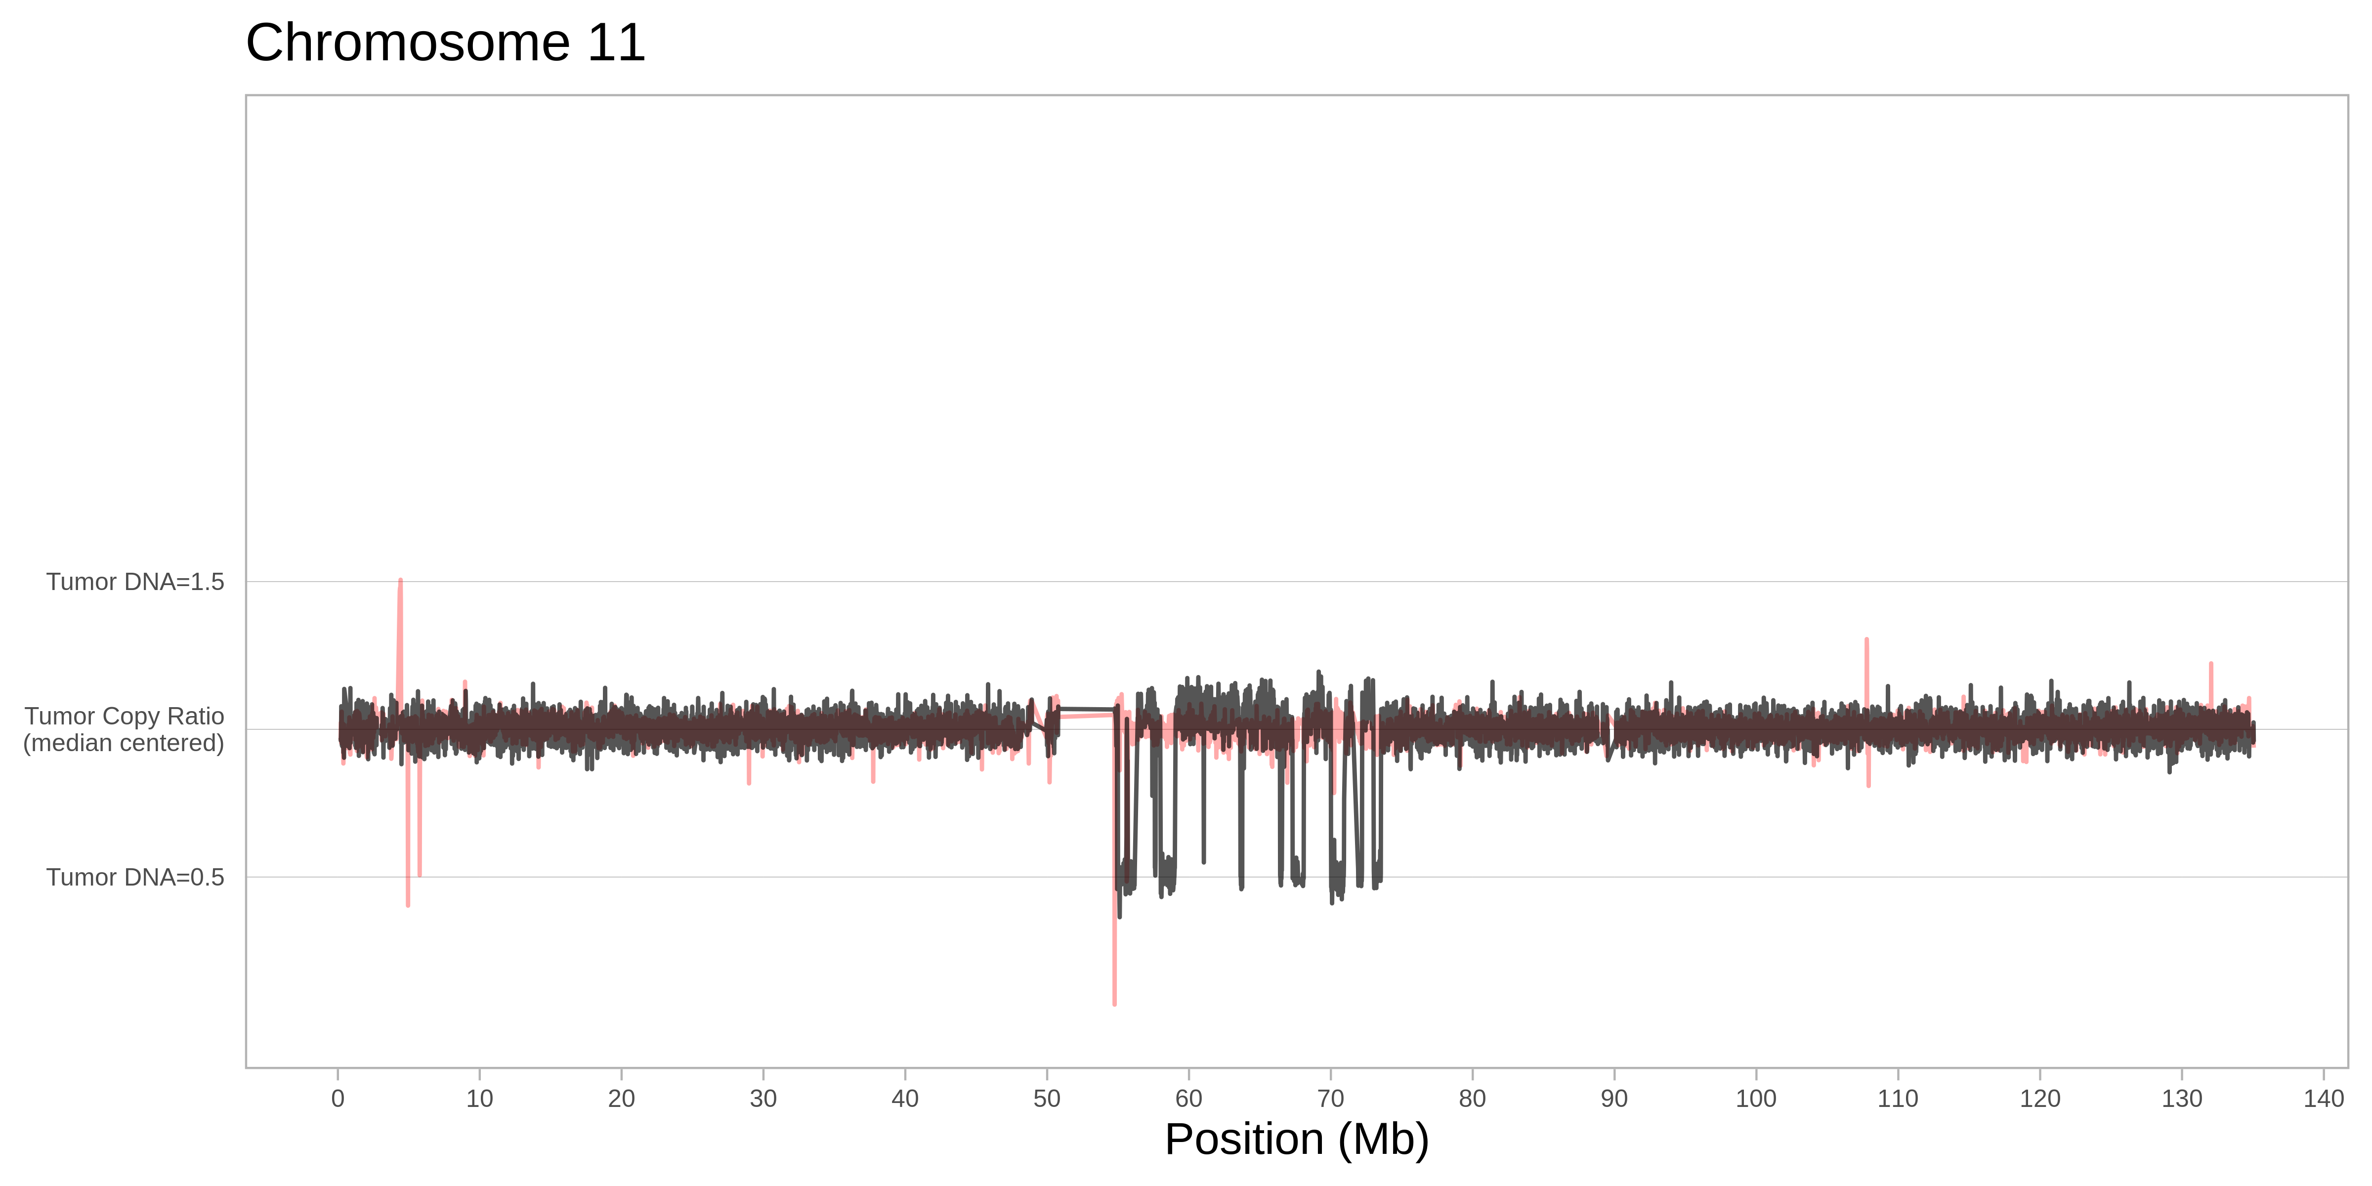
H: P4551_201T - chr19 copy number profile of an embryonal tumor with multilayered rosettes displaying amplification of the C19MC miRNA cluster on 19q13.42
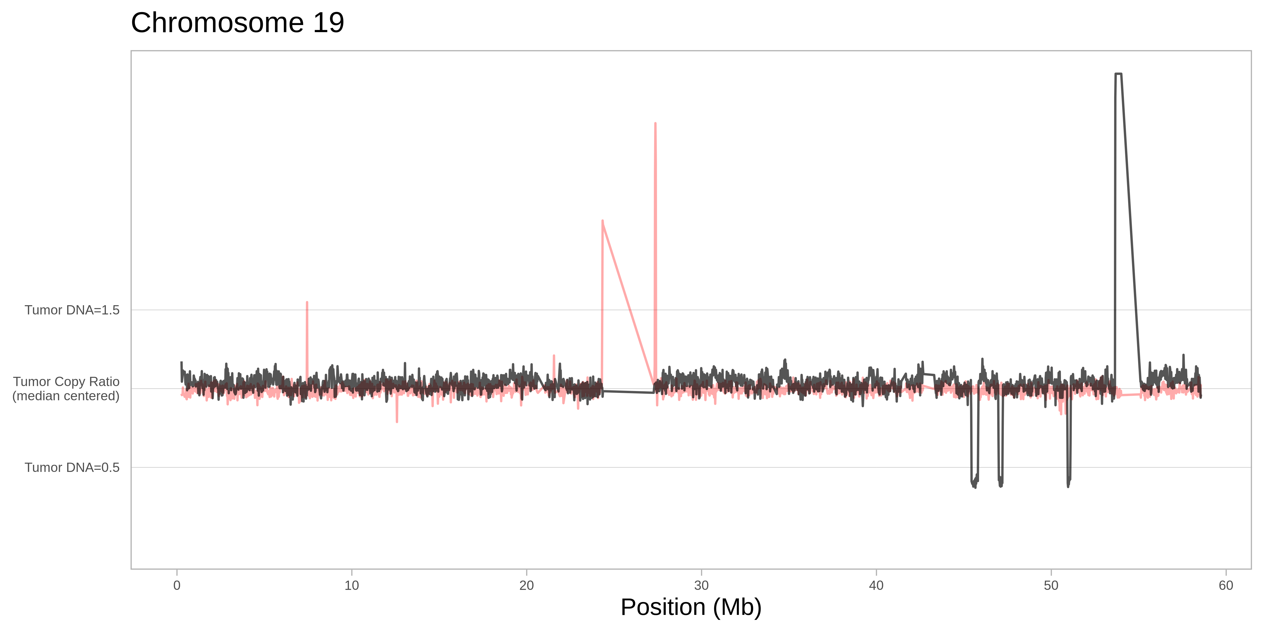

I: P7708_101T - chr19 copy number profile of an embryonal tumor with multilayered rosettes displaying amplification of the C19MC miRNA cluster on 19q13.42
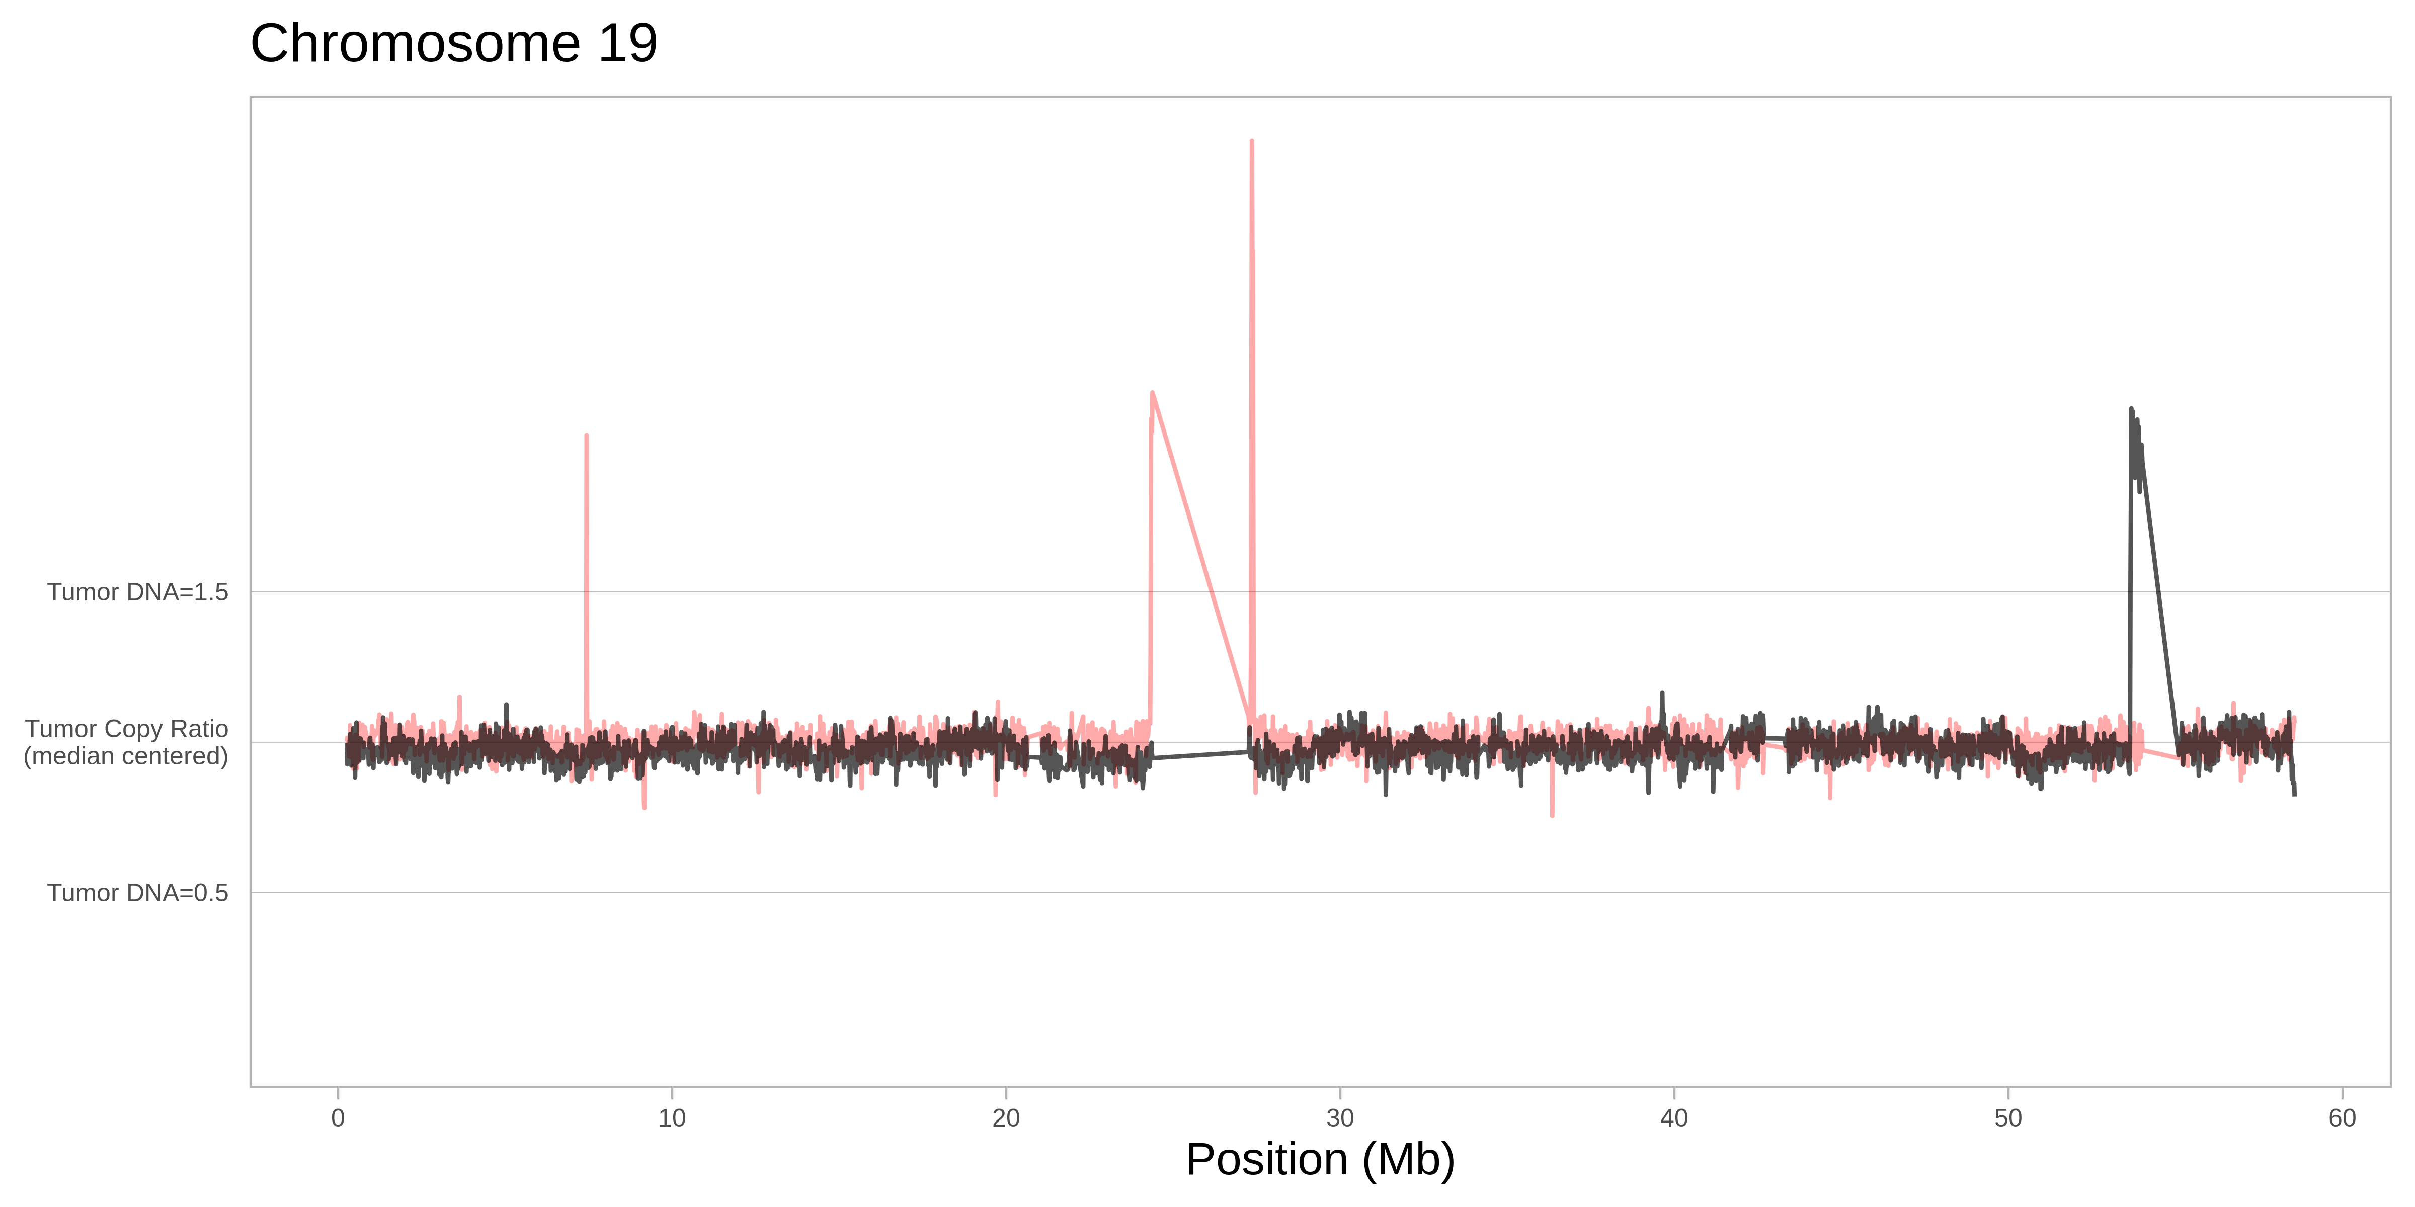
J: P2233_112T - chr11 copy number profile showing chromothripsis in a pineoblasatoma group B
