Supplementary Figure 3

A: P2233_101T - A CNS-PNET with highly rearranged genome profile.
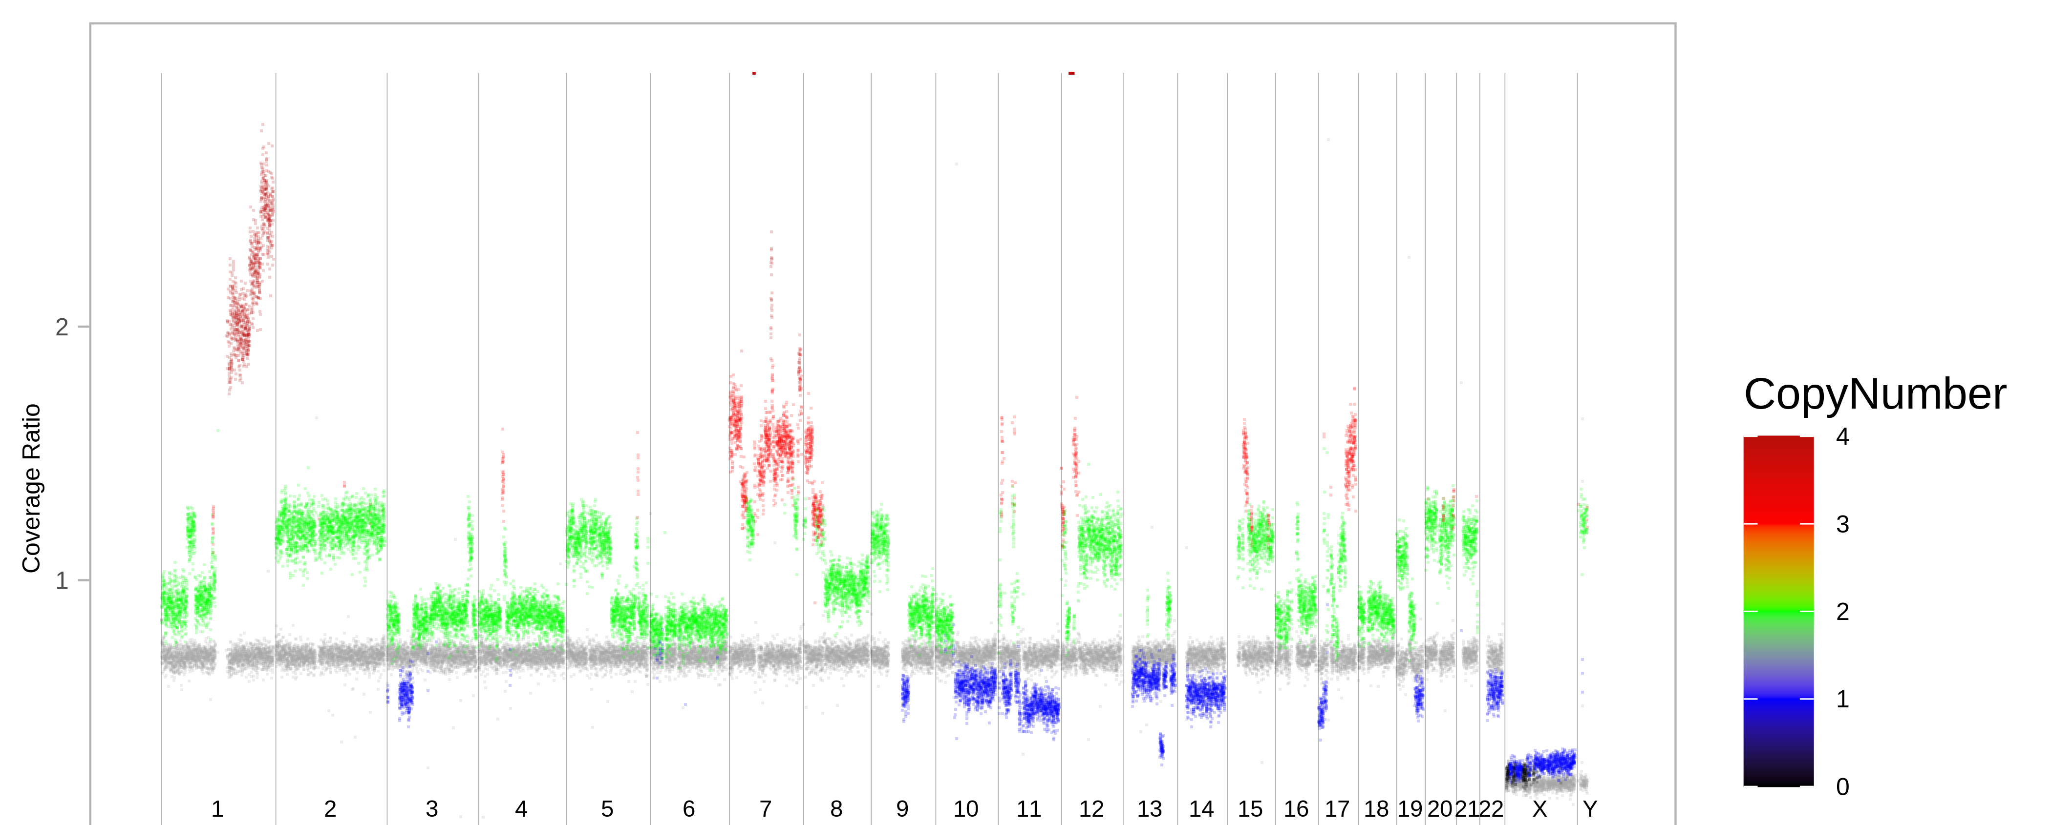
B: P2233_118T – Whole genome copy number profile in a glioblastoma showing various chromosomal rearrangements
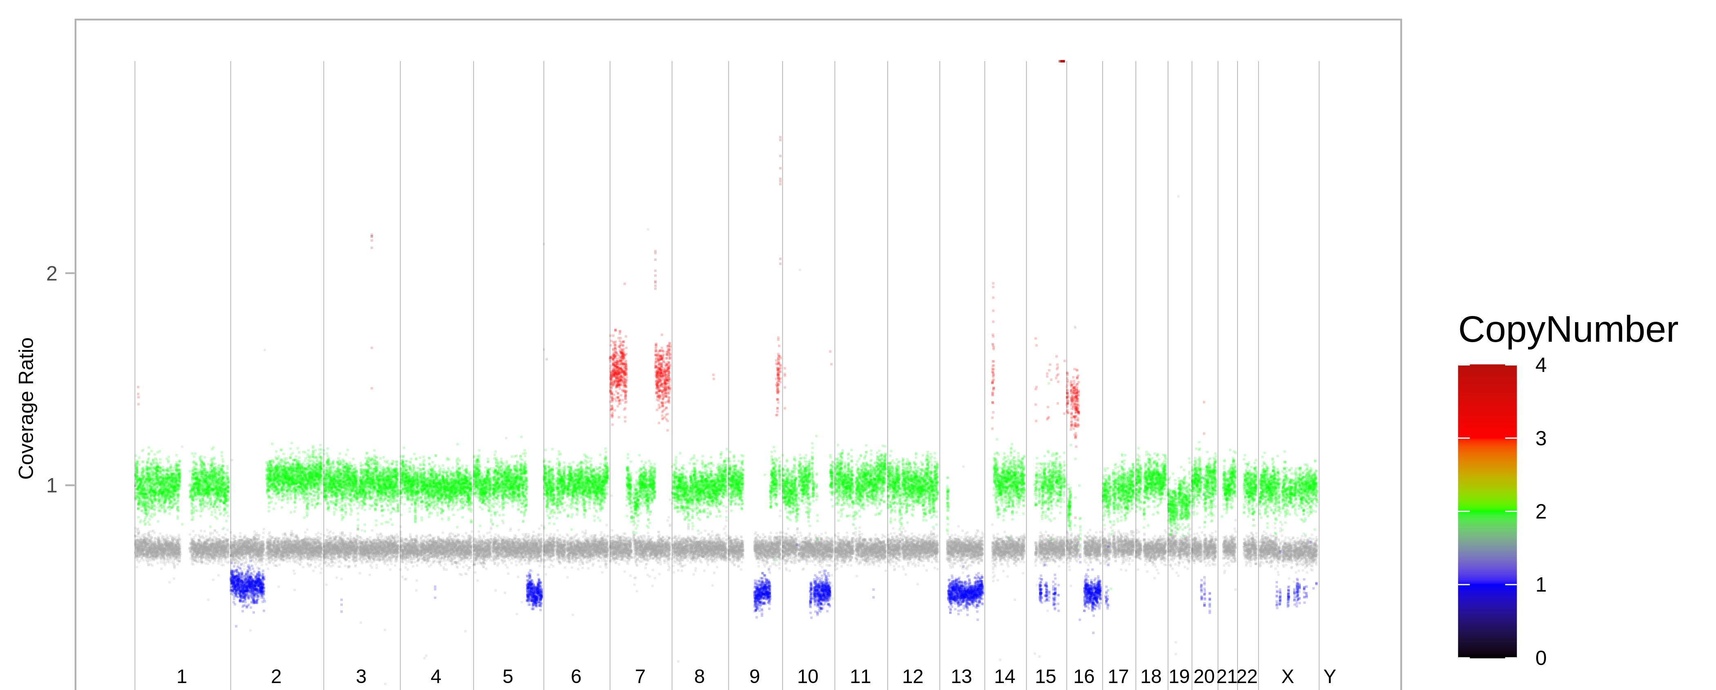
C: P2233_116T - Whole genome copy number profile of an atypical meningioma displaying several copy number aberrations
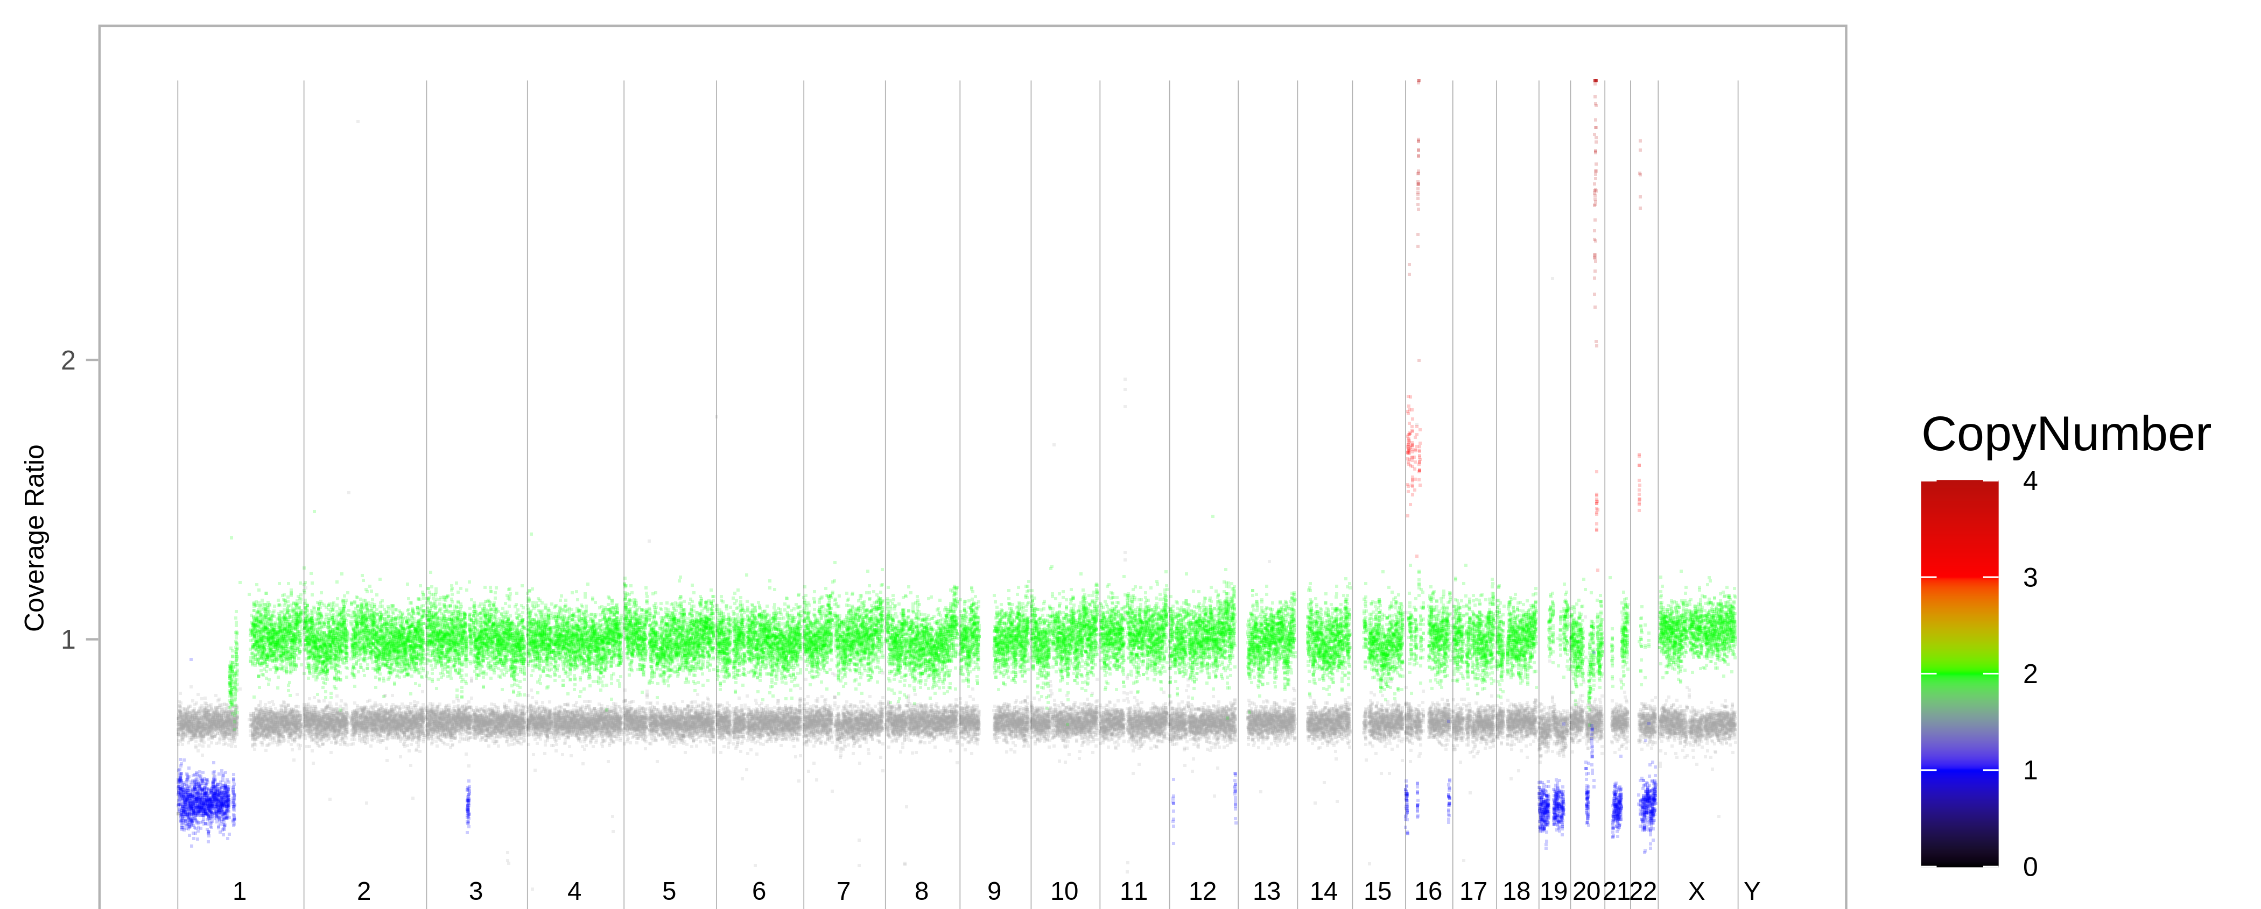

D: P2233_106T - A rhabdoid meningioma with highly rearranged genome profile
