Table S1. Strains and plasmids used in this study.
Strains and Plasmids | Description
E. coil DH5a | Purchased from Vazyme
T. oedocephalis | Obtained from ATCC
TORKD | Co-expression of OsRpiB, XKS and XDH genes
PET28a | LacI, T7 promoter, KanR
PYES2 | T7 promoter, CYC1 terminator, AmpR
PET28aR | OsRpiB gene in PET28a
PYES2R | OsRpiB gene in PYES2
PYES2RK | XKS gene in PYES2-GAL1-OsRpiB
PYES2RKD | XDH gene in PYES2-GAL1-OsRpiB-GAL1-XKS

Table S2. Primers and sequences used in this study.
Name | Primer sequences (5’ to 3’)
GAL1-O-F | ACCGGAATTCACGGATTAGAAGCCGCCGAGC
GAL1-O-R | TGCTACTGCTACTTTCATCATAATATTCCCTATAGTGAGTCG
OsRPiB-F | CGACTCACTATAGGGAATATTATGATGAAAGTAGCAGTAGCA
OsRPiB-R | TTGCGGCCGCTCAGCCCTTGTTGTACTTCGC
XKS-F | CCCAAGCTTATGTCGGCTACCAGTTCCTC
XKS-R | CGGGATCCAACTAGTTGTTGGTACCGATG
GAL1-D-F | GATCCACTAGTAACGGCCGCACGGATTAGAAGCCGCCG
GAL1-D-R | TGGGTTGTTGATCACGGCCATAATATTCCCTATAGTGAGTCG
XDH-F | CGACTCACTATAGGGAATATTATGGCCGTGATCAACAACCCA
XDH-R | CCGTGAATTCCAGCACACTGTTAAGCCAATTCAGCAGTTGCA
PYES2-F | CAGTGTGCTGGAATTCACGG
PYES2-R | GCGGCCGTTACTAGTGGATCC

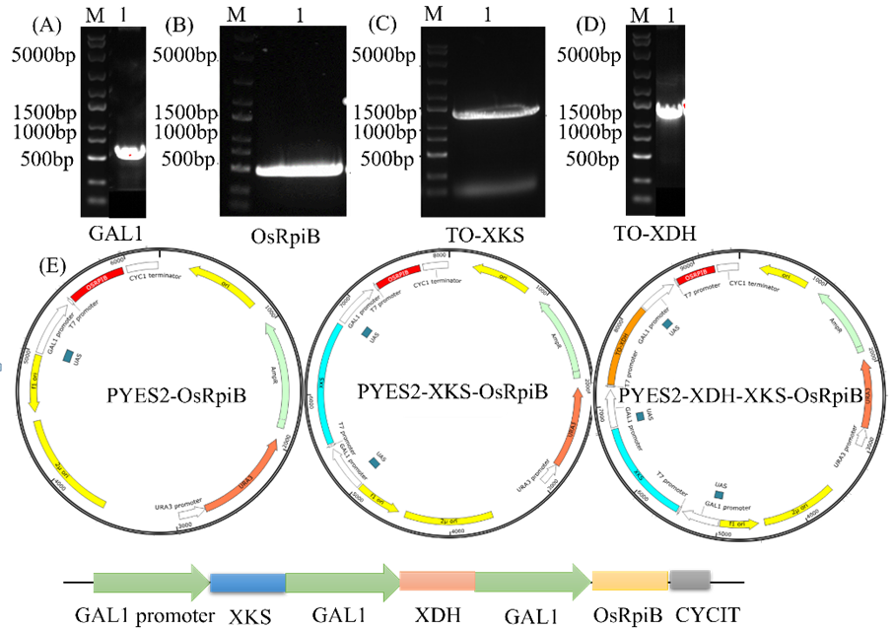
Figure S1. Construction of expression vectors.
A) agarose gel analysis of GAL1, B) OsRpiB, C) xylulose kinase, and D) xylitol dehydrogenase genes; E) plasmid diagram of three vectors that contain OsRpiB, OsRpiB+ xylulose kinase, and OsRpiB+ xylulose kinase+ xylitol dehydrogenase genes respectively.

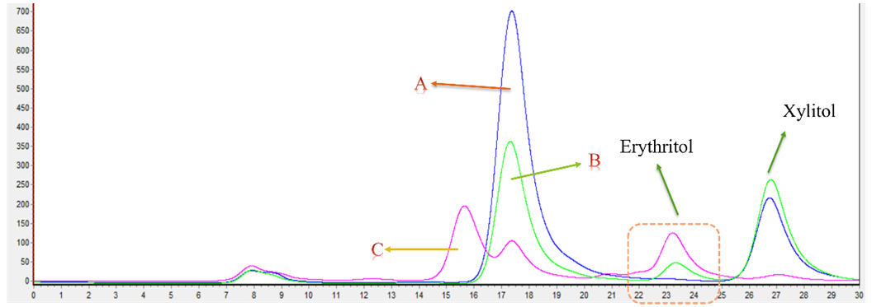
Figure S2. HPLC diagram of product analysis.
A) wild type; B) xylose fermentation; C) xylose-glucose cofermentation; the retention time of glucose, xylose, erythritol and xylitol is 15.7 min, 17.5 min, 23.3 min and 26.9 min.

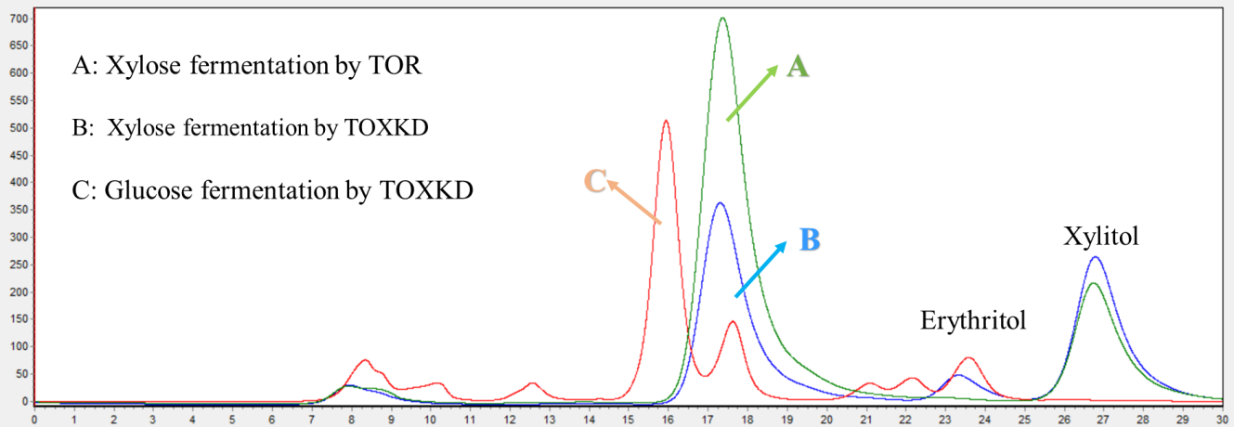
Figure S3. HPLC diagram of product purity.

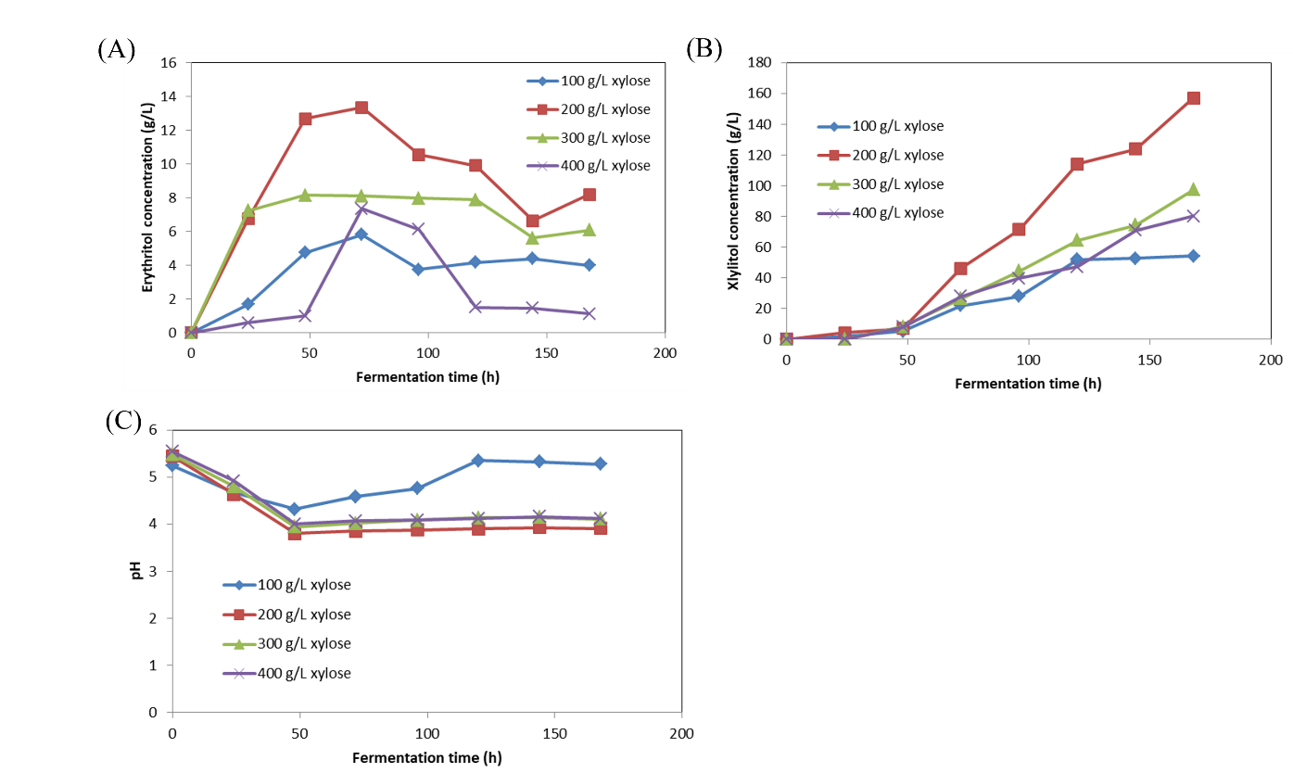
Figure S4. Time courses of parameters in xylose concentration optimization.
A) erythritol production, B) xylitol production, and C) variation of pH.

