Supplementary Information

Additional file 1
 | Initial sample (n=100)
 | ASD  n=84 (14F) | TD  n=16 (7F) | p
Age  M(±SD) | 3.55 (±1.11) | 3.31 (±1.17) | 0.433
MSEL Total¹ | 77.49 (±23.05) | 114.8 (±14.1) | <0.001
ADOS-2  Total² | 6.92 (±1.74) | 1.27 (±0.59) | <0.001
Table A1. Cross-sectional sample demographics

Additional file 2

Analysis of automated emotion recognition
FER (Facial Emotion Recognition) is a python library based on face detection and alignment using multitask cascaded convolutional neural network (https://ieeexplore.ieee.org/document/7553523) and real-time convolutional neural network for emotion and gender classification [60]. FER is an effective tool which carries out face detection alignment using multitask cascaded convolutional neural network and carries out a convolutional neural network-based emotion classification. For each of the video clips, we extract the individual frames in the form of PNG images and run the face detection and alignment convolutional neural network and emotion recognition convolutional neural network to detect the most dominant emotion among a variety of them (i.e., angriness, disgust, fear, happiness, sadness, surprise, and neutrality). The emotion detection convolutional neural network provides a confidence probability for the presence of each of the 7 emotions in cases where there is the presence of mixed emotions. We then use these emotion probabilities for individual frames and find the mean confidence probability across all the frames for a video clip to obtain the final mean confidence for each of the 7 emotions. Using this method, we estimate neutral emotions to have the highest mean confidence probability and were predominantly identified throughout all stimuli.

Plots of analysis of automated emotion recognition
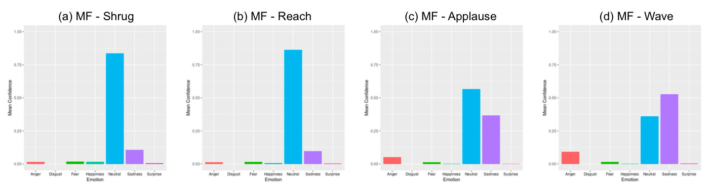
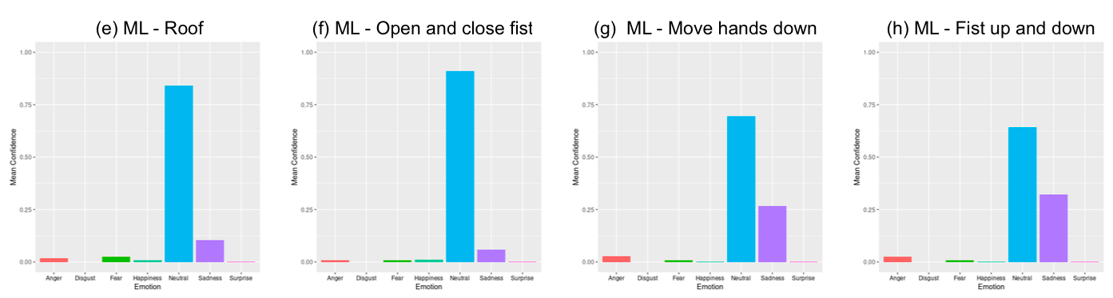
Figure A2. Histogram of automated emotion recognition for each gesture: (a) Shrug meaningful hand gesture; (b) Reach meaningful hand gesture; meaningful hand gesture; (c) Applause meaningful hand gesture; (d) Wave meaningful hand gesture; (e) Roof meaningless hand gesture; (f) Open and close fist meaningless hand gesture; (g) Move hands down meaningless hand gesture; (h) Fist up and down meaningless hand gesture

Additional file 3

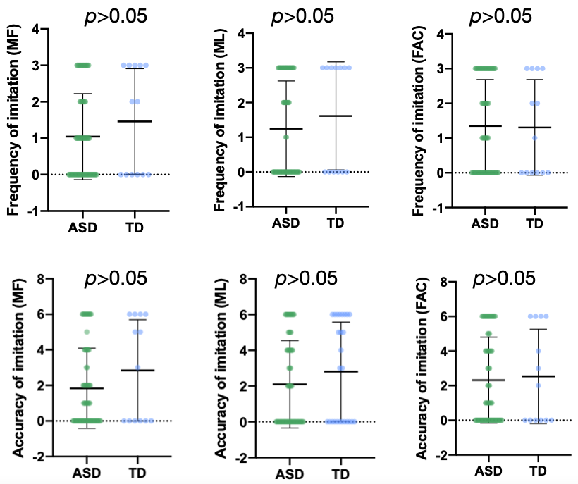
Figure A3. Comparison of imitation frequency and accuracy scores by type of gestures between the ASD and the TD groups.

Additional file 4
 | ASD
 | Imitators | Non-imitators | p
n | 45 | 19
Age | 3.70 | 3.01 | 0.024
ADOS-2 Total Severity Score | 6.91 | 6.84 | >0.05
ADOS-2 SA Severity Score | 5.84 | 5,53 | >0.05
ADOS-2 RRB Severity Score | 8.96 | 9.26 | >0.05
MSEL EL DQ | 69.70 | 58.03 | >0.05
MSEL RL DQ | 75.80 | 76.50 | >0.05
MSEL FM DQ | 86.57 | 79.59 | >0.05
MSEL VR DQ | 90.80 | 89.99 | >0.05
Table A4. Comparison of imitators and non-imitators in the ASD and the TD groups.

Additional file 5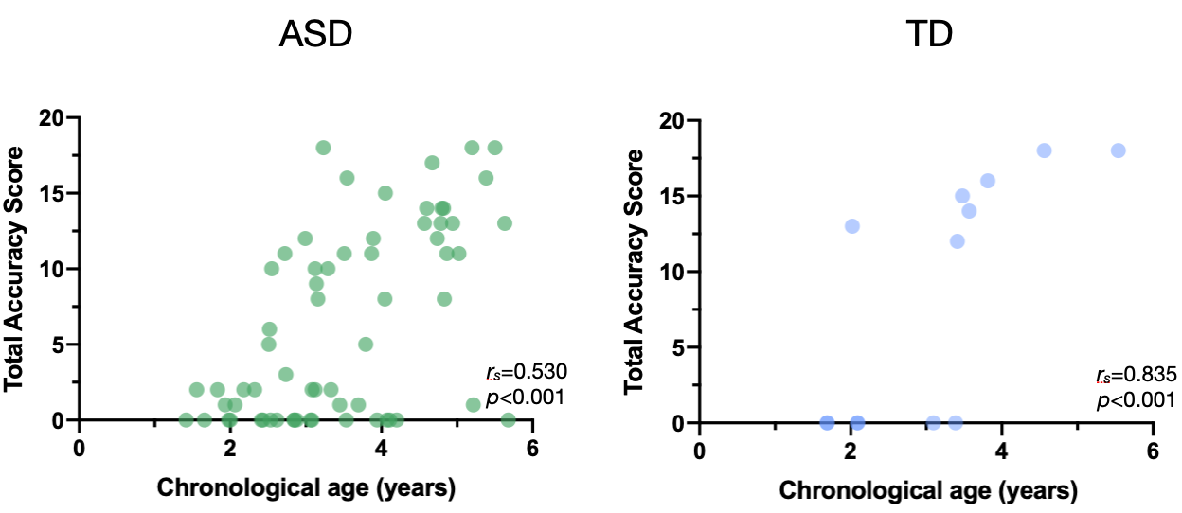
Figure A5. Correlation between chronological age and total accuracy imitation score.
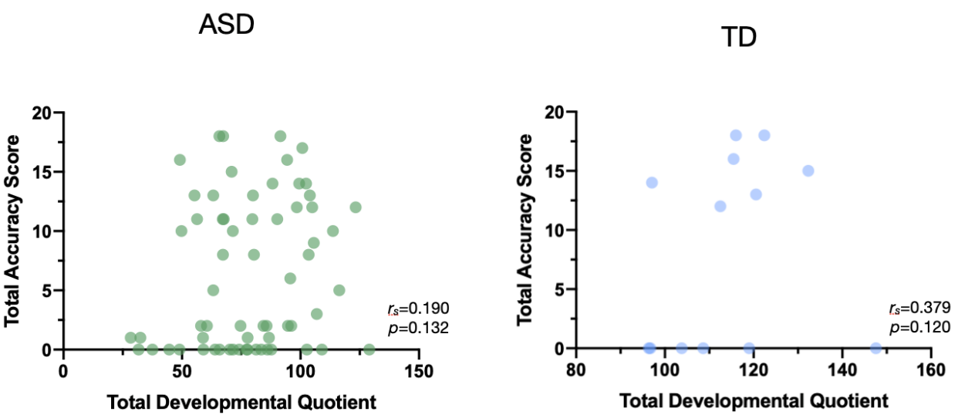
Figure A6. Correlation between developmental age and total accuracy imitation score.

Additional file 6

 |  | Demonstrations of MF gestures | Demonstrations of ML gestures | Demonstrations of FAC gestures
MF gestures | Frequency score | r_{s} = 0.125  p = 0.360
MF gestures | Accuracy score | r_{s} = 0.116  p = 0.393
ML gestures | Frequency score |  | r_{s} = 0.124  p = 0.416
ML gestures | Accuracy score |  | r_{s} = 0.04  p = 0.773
FAC gestures | Frequency score |  |  | r_{s} = 0.057  p = 0.705
FAC gestures | Accuracy score |  |  | r_{s} = -0.043  p = 0.774
Table A7. Correlations between frequency and accuracy scores of MF, ML, and FAC gestures and fixation duration to the demonstrations of MF, ML, and FAC gestures.

Additional file 7
 | Accuracy of imitation
 | MF hand gestures | ML hand gestures | FAC gestures
ADOS-2  SA¹ | r = -0.320  p = 0.011 | r = -0.110  p = 0.412 | r = 0.110  p = 0.391
ADOS-2  RRB¹ | r = 0.160  p = -0.213 | r = -0.110  p = 0.386 | r = -0.240  p = 0.056
ADOS-2  Total¹ | r = -0.390  p = 0.001 | r = -0.100  p = 0.443 | r = 0.01  p = 0.937
MSEL  VR² | r = 0.140  p = 0.278 | r = 0.330  p = 0.009 | r = 0.220  p = 0.089
MSEL  FM² | r = 0.210  p = 0.097 | r = 0.330  p = 0.008 | r = 0.320  p = 0.010
MSEL  RL² | r = 0.160  p = 0.219 | r = 0.240  p = 0.059 | r = 0.210  p = 0.098
MSEL  EL² | r = 0.05  p = 0.697 | r = 0.250  p = 0.047 | r = 0.230  p = 0.075
VABS-II  Com³ | r = 0.150  p = 0.232 | r = 0.310  p = 0.014 | r = 0.300  p = 0.016
VABS-II  Soc³ | r = 0.170  p = 0.176 | r = 0.210  p = 0.091 | r = 0.250  p = 0.046
VABS-II  Dai³ | r = 0.230  p = 0.066 | r = 0.220  p = 0.087 | r = 0.290  p = 0.021
VABS-II  Mot³ | r = 0.170  p = 0.195 | r = 0.310  p = 0.015 | r = 0.270  p = 0.030
Table A8. Partial correlations between accuracy imitation scores for each type of gesture and clinical measures. ¹ADOS-2, Autism Diagnostic Observation Schedule, 2nd edition; SA, Social Affect Severity Score; RRB, Restricted and Repetitive Behaviors; Total, Total Severity Score. ²MSEL, Mullen Scales of Early Learning; VR, Visual Reception; FM, Fine Motor; RL, Receptive Language; EL, Expressive Language. ³ VABS-II, Vineland Adaptive Behavior Scales, 2nd edition; Com, Communication Standard Score; Soc, Socialization Standard Score; Dai, Daily Living Skills Standard Score; Mot, Motor Skills Standard Score. Correlations in bold survive FDR correction.

