Supplementary Materials

Supplementary Table 1. Pathologic outcomes of patients who underwent RNU

Feature | Number (%)
Total | 54
pTstage
pTa | 1 (1.9)
pT1 | 2 (3.7)
pT2 | 2 (3.7)
pT3 | 33 (61)
pT4 | 15 (28)
Tumor size (mm)
Median (IQR) | 29 (17-47)
Tumor grade
G1 | 2 (3.7)
G2 | 22 (41)
G3 | 27 (50)
Positive margin | 5 (9.3)
Lymph node dissection | 42 (78)
pN stage
pN0 | 12 (22)
pN1 | 13 (24)
pN2 | 21 (39)
Variant histology
glandular differentiation | 1 (1.9)
squamous differentiation | 2 (3.7)

Supplementary Table 2. Cox regression analysis for possible prognostic factors of overall survival in patients who underwent RNU including pathologic stages as variates

Variates | Univariable |  | Multivariable
 | HR (95%CI) | P-value | HR (95%CI) | P-value
Age (continuous) | 1.02 (0.98-1.07) | 0.31
G8 score (≤14 vs. >15) | 4.74 (1.97-11.4) | <0.001 | 32.7 (2.72-392.2) | 0.006
Cytology (Positive vs. Negative) | 1.86 (0.73-4.72) | 0.19
Location (Ureter vs. Pelvis) | 3.96 (1.47-10.6) | 0.006 | 232.4 (3.90-13870) | 0.009
Pathological T stage (≥pT4 vs. <pT3) | 2.66 (1.12-6.34) | 0.027 | 6.05 (0.75-48.7) | 0.091
Pathological N stage (pN2 vs. <pN1) | 3.10 (1.19-8.07) | 0.02 | 1.00 (0.18-5.40) | 1
Pretreatment serum albumin (<3.0 vs. ≥3.0) | 1.36 (0.18-10.2) | 0.77
Pretreatment hemoglobin (<LLN vs. ≥LLN) | 1.56 (0.67-3.63) | 0.31
Pretreatment serum creatinine (≥ULN vs. <ULN) | 1.30 (0.56-3.02) | 0.55
Pretreatment LDH (≥1.5*ULN vs. <1.5*ULN) | 0.80 (0.11-6.00) | 0.83
Pretreatment CRP (≥2.5 vs. <2.4) | 1.68 (0.69-4.12) | 0.25 | 32.5 (1.65-637.8) | 0.022
Pretreatment NLR (≥3.0 vs. <3.0) | 3.46 (1.04-11.5) | 0.04 | 2.34 (0.33-16.6) | 0.39
Pembrolizumab (No vs. Yes) | 1.39 (0.51-3.85) | 0.52 | 0.71 (0.08-6.67) | 0.77
RNU: Radical nephroureterectomy, HR: Hazard ratio, CI: Confidence interval, LLN: Lower Limit of Normal, ULN: Upper Limit of Normal, LDH: Lactate Dehydrogenase, CRP: C-reactive Protein, NLR: Neutrophil-to-lymphocyte ratio

Supplementary Figure 1. Kaplan-Meyer projection showing overall survival stratified by clinical N stage in the entire cohort.

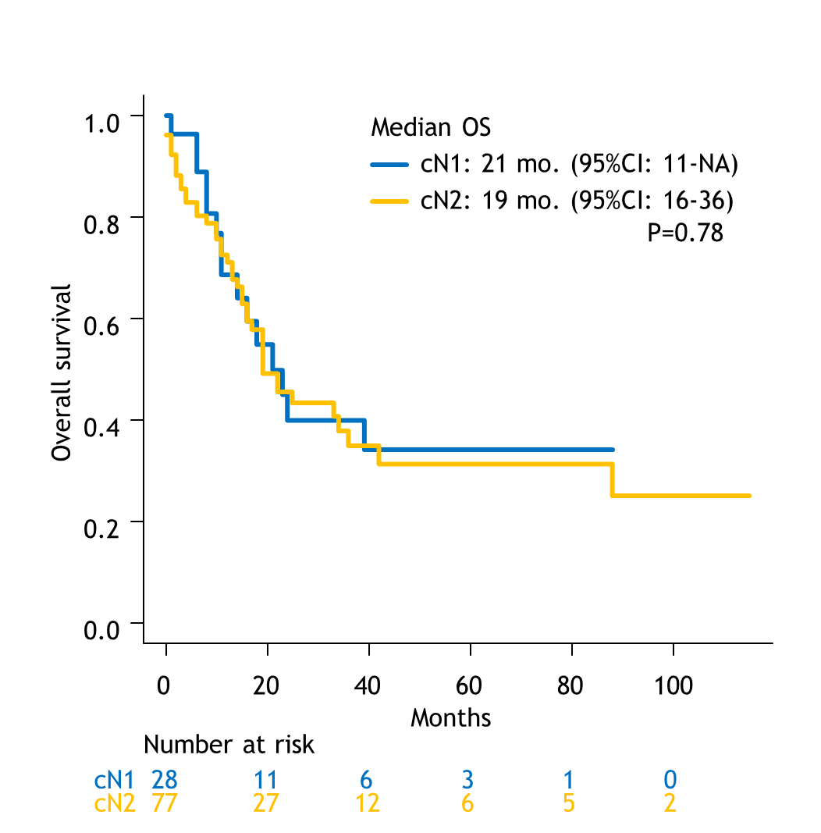

Supplementary Figure 2. Kaplan-Meyer projection showing overall survival stratified by patients treated with presurgical induction chemotherapy or not in RNU cohort.

