Direct C-H bond activation using visible light and a donor-acceptor polymer with tunable valence band
Authors: Shi-Nan Zhang, Qi-Yuan Li, Yun-Xiao Lin, Si-Yuan Xia, Dong Xu, Jie-Sheng Chen and Xin-Hao Li*
Affiliations:
School of Chemistry and Chemical Engineering, Frontiers Science Center for Transformative Molecules, Shanghai Jiao Tong University, Shanghai 200240, P. R. China.
*Correspondence to: xinhaoli@sjtu.edu.cn (X.-H. L.)
Contents
1. Experimental section 4
2. Figures S1-S18 9
Figure S1. Scanning electron microscopy images of p-D_{x}A_{y} samples 9
Figure S2. Transmission electron microscopy images of p-D_{x}A_{y} samples 10
Figure S3. FT-IR spectra of synthesized p-D_{x}A_{y} samples 11
Figure S4. The UV-Vis spectra of p-D_{x}A_{y} samples and corresponding Tauc curves. 12
Figure S5. Mott-Schottky plots of p-D_{x}A_{y} 13
Figure S6. Cyclic voltammogram of paraxylene 14
Figure S7. TOF values of PX oxidation over p-D₂A₃ photocatalyst under O₂ or air atmosphere. 15
Figure S8. The top views of all proposed intermediate configurations for PX oxidation over the p-D₂A₃ photocatalyst model. 16
Figure S9. The top views of the proposed intermediate configurations for the rate-determining step of PX oxidation over p-D_{x}A_{y} photocatalyst models. 17
Figure S10. The slices of calculated electron density difference along the plane across the downward adsorbed H-C-H over p-D_{x}A_{y} photocatalyst models 18
Figure S11. The adsorption energy of PX molecular on the surface of p-D_{x}A_{y} models.. 19
Figure S12. Identification of reaction mechanism 20
Figure S13. Singlet oxygen trapping experiments with 3,3',5,5'-Tetramethylbenzidine (TMB). 21
Figure S14. Singlet oxygen trapping experiments with 1,3-diphenylisobenzofuran (DPBF). 22
Figure S15. FT-IR spectra of p-D₂A₃ photocatalyst and p-D₂A₃ photocatalyst after 12h photoreaction 23
Figure S16. GC spectrum of the solution after photocatalytic PX oxidation at the standard conditions. 24
Figure S17. GC spectra of 1,3,5-trimethoxybenze and the solution after photocatalytic C-C, C-N and C-Br coupling reactions over p-D₂A₃ at the standard conditions. 25
Figure S18. GC spectrum of the solution after photocatalytic PX coupling reaction under argon atmosphere over p-D₂A₃ photocatalyst at the standard conditions. 26
3. Table S1-S3 27
Table S1. N and C contents of p-D_{x}A_{y} samples via element analysis 27
Table S2. BET surface areas of p-D_{x}A_{y} samples 28
Table S3. Photocatalytic paraxylene oxidation over p-D₂A₃ and other reported metal-free photocatalysts at ambient conditions. 29
4. Reference 30

1. Experimental section
Materials
Paraxylene, 1,3-Diphenylisobenzofuran, pyrazole and NBu₄PF₆ were purchased from Sigma-Aldrich. Dodecane, Na₂SO₄ and mannitol were obtained from TCI. All other reagents used in this work were gained from Adamas. All gas were from Air Liquide. All reagents were used as received without further purification.
Preparation of p-D_{x}A_{y} photocatalysts
300 mg of 2,4,6-Tris(4-aminophenyl)-1,3,5-triazine was added into a 250 mL beaker with 100 mL m-cresol solution. Then, 560 mg of pyromellitic dianhydride was added with stirring for 1 hour at 0 °C. Then, 0.15 mL isoquinoline were added. The reaction was carried out at 80 °C for 1 h and 120 °C for 12 h under argon atmosphere. Afterward, the mixture was cooled to room temperature and washed sequentially with ethanol and water. Finally, the powder was heated at 60 °C in vacuum for 24 h. The as-obtained material was p-D₂A₃ sample. p-D₁A₁ and p-D₂A₁ samples were prepared by the same procedure with different feed ratios. For p-D₁A₁ sample, 600 mg of 2,4,6-Tris(4-aminophenyl)-1,3,5-triazine and 560 mg of pyromellitic dianhydride were used. For p-D₂A₁ sample, 900 mg of 2,4,6-Tris(4-aminophenyl)-1,3,5-triazine and 187 mg of pyromellitic dianhydride were used.
Preparation of g-CN photocatalyst
20 g of melamine was sealed in a covered crucible and heated at a temperature of 600 °C for 4 h (ramp: 2.5 °C min^{–1}). After cooling naturally to room temperature, the as-obtained samples were used for further study.
Characterizations
Element analysis (EA) was conducted CHNS element analyzer (Vario EL Cube). The electron paramagnetic resonance (EPR) spectra were obtained Bruker MicroESR. The transient-state photoluminescence (PL) spectra were obtained from PTI time-resolved Fluorescence Spectrofluorometer with an excitation wavelength of 390 nm. UV-Vis spectra were recorded on a Shimadzu UV-2450 UV-Vis spectrophotometer. Conversions and selectivity of all substrates were determined by gas chromatography-mass spectrometry (GC-MS QP2010 SE SHIMADZU) equipped with Rtx-5 Sil MS column (30 m × 0.25 μm × 0.25 μm). Scanning electron microscopy (SEM) images were acquired on Nova NanoSEM 450 field emission scanning electron microscope (FEI, USA). Transmission electron microscopy (TEM) images were recorded via a JEM2100F microscope. Solid-state nuclear magnetic resonance (NMR) measurements were performed on a Bruker Advance Ⅲ 600 MHz system. The electrochemical performance was conducted on a CHI 660E electrochemical analyzer. A 300 W xenon lamp with a cut-off filter was used as the light source for photocatalytic reactions. Fourier transform infrared (FT-IR) spectra were collected on Spectrum 100 spectrometer. The sample was ground with spectrographically KBr and tableted as a transparent slice. Nitrogen adsorption-desorption isotherms were used to calculate the specific surface areas on Micromeritics ASAP2460 by a multipoint Brunauer–Emmett–Teller (BET) method.
General procedure for C-H bond oxidation
Standard photocatalytic C-H bonds oxidation reactions were performed by dispersing 1 mg of catalyst into 5 mL pure substrate. Then the photoreactor was photo-irradiated under 1 atm O₂ at λ > 400 nm using a 300 W xenon lamp with a temperature-controlled water bath at 25℃. If no special instructions, the reaction time is 4 h. Conversions and selectivity of all substrates were determined by GC-MS.
General procedure for C-C coupling reaction
2mmol of 1,3,5-trimethoxybenzene, 3mmol of trimethylsilyl cyanide (Me₃SiCN), 5 mg of p-D₂A₃ were added to 4.5 mL acetonitrile and 0.5 mL saturated KHCO₃ solution. The reaction was carried out under 1 atm O₂ with a 300 W Xenon lamp (λ > 400 nm) for 24 hours. Then the solution was extracted using CHCl₃ and dried by Na₂SO₄. Finally, the conversion and selectivity were determined by GC-MS.
General procedure for C-N coupling reaction
2mmol of 1,3,5-trimethoxybenzene, 4mmol of pyrazole, 5 mg of p-D₂A₃ were added to 5 mL dimethyl sulfoxide. The reaction was carried out under 1 atm O₂ with a 300 W Xenon lamp (λ > 400 nm) for 24 hours. Conversion and selectivity were determined by GC-MS.
General procedure for C-Br coupling reaction
2mmol 1,3,5-trimethoxybenzene, 10mmol KBr,5 mg p-D₂A₃ were added to 4.5 mL dimethyl sulfoxide and 0.5 ml H₂O. The reaction was carried out under 1 atm O₂ with a 300 W Xenon lamp (λ > 400 nm) for 24 hours. Then the solution was extracted using CHCl₃ and dried by Na₂SO₄. Finally, the conversion and selectivity were determined by GC-MS.
General procedure for coupling reaction of PX under argon atmosphere
5 mg p-D₂A₃ were added to 5 mL Ar-saturated PX. The reaction was carried out under argon atmosphere with a 300 W Xenon lamp (λ > 400 nm) for 24 hours. Conversion and selectivity were determined by GC-MS.
Product analysis
After the reaction, 10μL dodecane was added into the photoreactor as standard. After filtering, the solution was analyzed by GC-MS to calculate the conversion and selectivity of the product.
Turnover frequency (TOF) was defined by the following equation:
$$TOF=\frac{n}{N*t}$$
Turnover number (TON) was defined by the following equation:
$$TON=\frac{n}{N}$$
Where n is the moles of the product; N is the moles of the minimum repeat unit of polymer photocatalysts; t is the reaction time.
Measurements of Mott-Schottky plots
The p-D_{x}A_{y} FTO electrodes were fabricated by dropping method. A Pt mesh was used as the counter electrode and Ag/AgCl was used as the reference electrode. Mott-Schottky plots were performed in a typical three-electrode system in the 0.5 mol L⁻¹ Na₂SO₄ solution at the frequencies of 800, 900 and 1000 Hz.
Cyclic voltammetry tests for oxidation potential of paraxylene
10μL paraxylene was added into 5 mL CH₃CN containing 0.1 mol L⁻¹ NBu₄PF₆.
glassy carbon electrode was used as working electrode, while A Pt mesh was used as the counter electrode and Ag/AgCl was used as the reference electrode. The scan rate was 50 mV/s.
EPR measurements
1 mg p-D₂A₃ powder and 10μL 2,2,6,6-tetramethylpiperidine (TEMP) were added into 1 mL paraxylene. Then, EPR analysis was conducted after 2 min irradiation with a 300 W Xenon lamp (λ > 400 nm).

3,3',5,5'-Tetramethylbenzidine (TMB) oxidation
5 mg of p-D_{x}A_{y} powder and 5 mg of TMB were added to 5 mL paraxylene. The reactions were conducted in air with a 300 W Xenon lamp (λ > 400 nm). The reaction process at different time intervals was monitored via UV-Vis absorption analysis.
1,3-diphenylisobenzofuran (DPBF) oxidation
1 mg of p-D_{x}A_{y} powder and 10 mg of DPBF were added to 5 mL Dimethylformamide. The reactions were conducted in air with a 300 W Xenon lamp (λ > 400 nm). The reaction process at different time intervals was monitored via UV-Vis absorption analysis. The amount of generated ¹O₂, which is correlated with the decomposed DPBF in the solution, was calculated quantitatively as the difference of absorbance at 410 nm before and after irradiation.
Parallel kinetic isotope effect (KIE) experiment
Parallel KIE experiments were conducted using PX or PX-D10 as substrate. 1 mmol substrate and 1 mg of p-D₂A₃ were added to 5 mL acetonitrile. The reactions were conducted under 1 atm O₂ with a 300 W Xenon lamp (λ > 400 nm) for 8 hours. Conversion and selectivity of all substrates were determined by GC-MS. The rate constant k was calculated based on the pseudo-first-order reaction kinetics.
Control tests with different scavengers
Different amounts of scavengers (carotene, 5.37 mg; mannitol, 2 mg; catalase, 20000 units mL⁻¹ catalase 2 mg; BHT, 2.2 mg; methanol 10μL) were added to identify the active species based on the standard conditions of paraxylene oxidation. Conversion and selectivity of all substrates were determined by GC-MS.
Theoretical calculations
Density functional theory (DFT) calculations were performed using the Vienna Ab Initio Simulation Package (VASP).^{S1, S2} The generalized gradient approximation with the Perdew-Burke-Ernzerh of exchange correlation functional ^{S3} was used. For the plane-wave expansion, a 400 eV kinetic energy cutoff was used. The convergence criteria for energy and force were set as 10⁻⁵ eV and 0.05 eV Å⁻¹, respectively. The K-points were set to be 1×1×1 for geometry optimization and 2×2×1 for electronic structure analysis.
The Gibbs free energy change for each step of the oxidation reaction was calculated as follow:
∆G = ∆E + ∆ZPE - T∆S (T = 298.15 K)
where ΔE, ΔZPE, and ΔS are the changes in the reaction energy, zero-point energy, and entropy, respectively.

2. Figures S1-S18

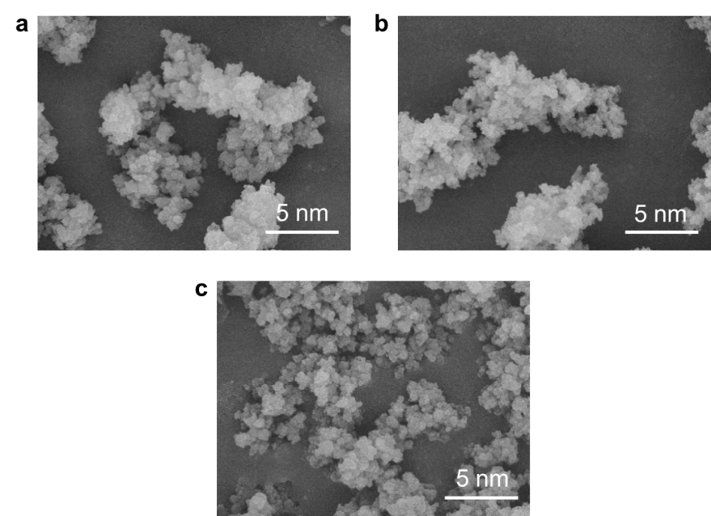

Figure S1. Scanning electron microscopy images of (a) p-D₂A₃, (b) p-D₁A₁ and (c) p-D₂A₁ photocatalysts. All the D-A polymer photocatalysts exhibit similar morphology.

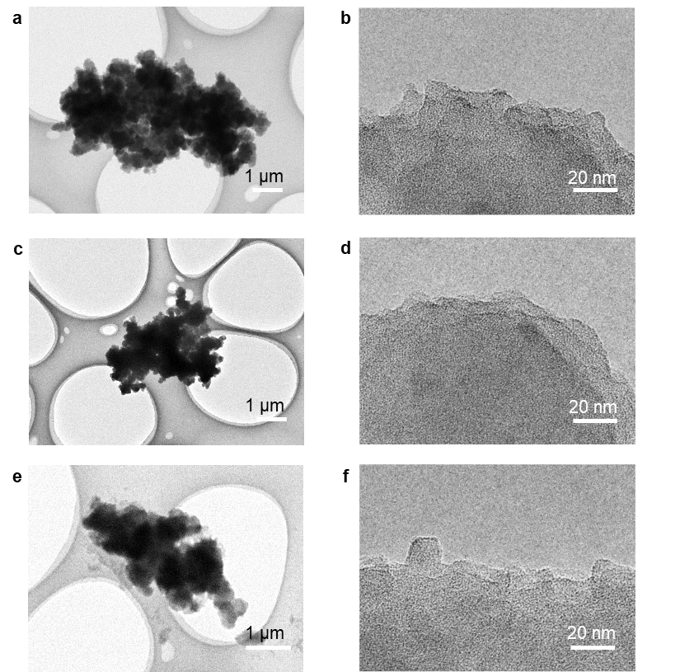

Figure S2. Transmission electron microscopy images of (a-b) p-D₂A₃, (c-d) p-D₁A₁ and (e-f) p-D₂A₁ photocatalysts. All the D-A polymer photocatalysts exhibit similar morphology.

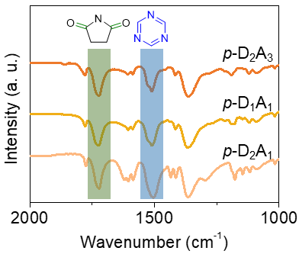

Figure S3. FT-IR spectra of synthesized p-D_{x}A_{y} samples. All the samples have typical vibration peaks³⁰ (imide C=O: 1725 cm⁻¹, triazine unit: 1510 cm⁻¹), indicating the success of polymerization. The continuous change in the relative intensities of these two peaks indicates the different D/A ratios in p-D_{x}A_{y} samples

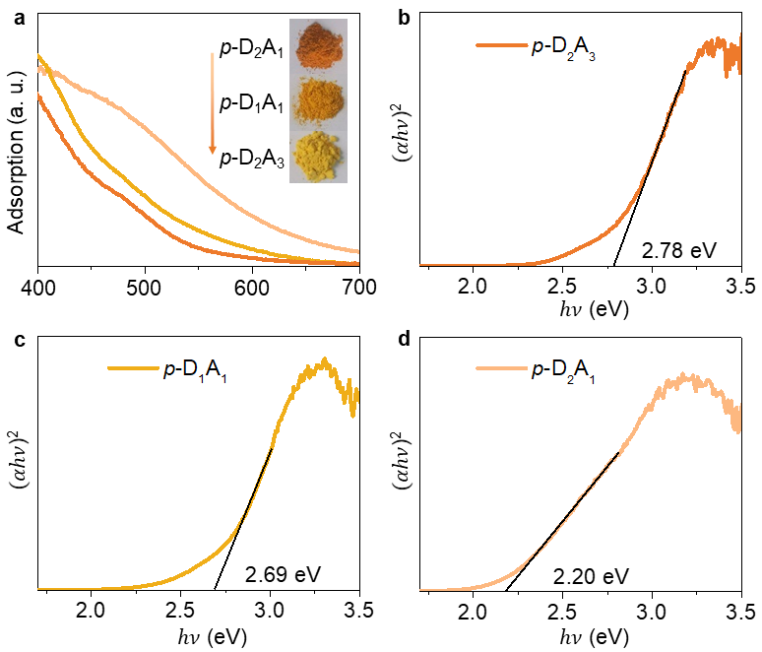

Figure S4. (a) The UV-Vis spectra of p-D₂A₃, p-D₁A₁ and p-D₂A₁ photocatalysts and (b-d) corresponding Tauc curves. The band gaps of p-D₂A₃, p-D₁A₁ and p-D₂A₁ photocatalysts were 2.78, 2.69, and 2.20 eV respectively.

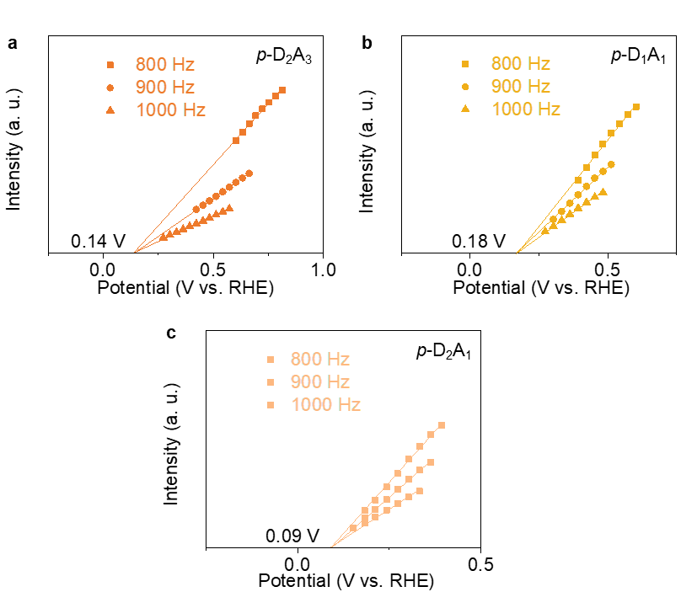

Figure S5. Mott-Schottky plots of (a) p-D₂A₃, (b) p-D₁A₁ and (c) p-D₂A₁ photocatalysts at different frequencies, demonstrating that the conduction band potential of these samples was 0.14, 0.18 and 0.09 V vs. RHE, respectively.

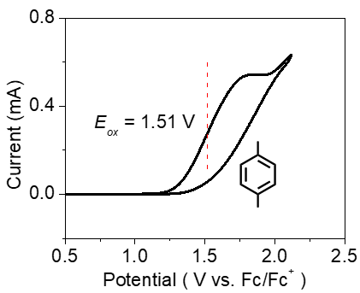

Figure S6. Cyclic voltammogram of paraxylene. The half-peak potential was regarded as the oxidation potential (E_{ox}) of paraxylene.³¹ E_{ox} can be described versus the reversible hydrogen electrode (RHE) via this equation^{S4}, E_{ox} = E_{(ox vs. Fc/Fc+)} + 0.64 = 1.51 + 0.64 = 2.15 V vs. RHE, which is shown in Figure 1D.
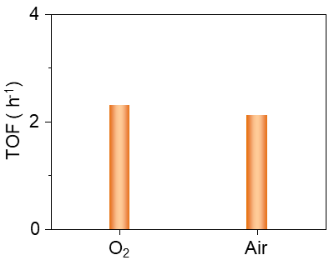

Figure S7. TOF values of PX oxidation over p-D₂A₃ photocatalyst under O₂ or air atmosphere.

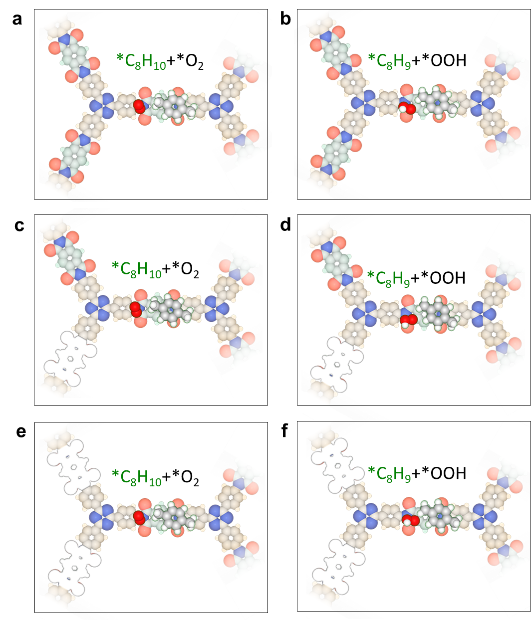

Figure S8. The top views of all proposed intermediate configurations for PX oxidation over the p-D₂A₃ photocatalyst model.

Figure S9. The top views of the proposed intermediate configurations for the rate-determining step of PX oxidation over the (a-b) p-D₂A₃, (c-d) p-D₁A₁ and (e-f) p-D₂A₁ photocatalyst models.

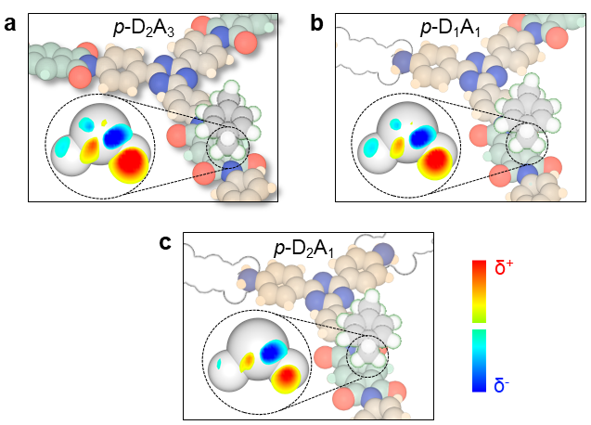

Figure S10. The slices of calculated electron density difference along the plane across the downward adsorbed H-C-H over (a) p-D₂A₃, (b) p-D₁A₁ and (c) p-D₂A₁ photocatalyst models (δ⁺: electron-rich area, δ⁻: electron-deficient area). The slices of electron density difference indicated the polarization of C-H bond after the interaction with p-D_{x}A_{y} models. The difference in the degree of polarization of C-H bond demonstrated the stronger ability of p-D₂A₃ photocatalyst for C-H bond activation.

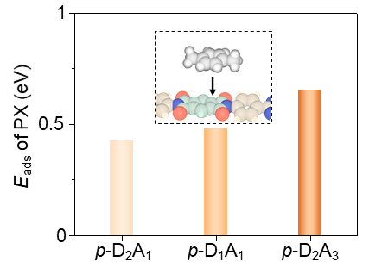

Figure S11. The adsorption energy (E_{ads}) of PX molecular on the surface of p-D₂A₁, p-D₁A₁ and p-D₂A₃ models. The enhanced adsorption of PX molecular on p-D₂A₃ promoted by the electronic structure of whole polymer would boost photocatalytic process.

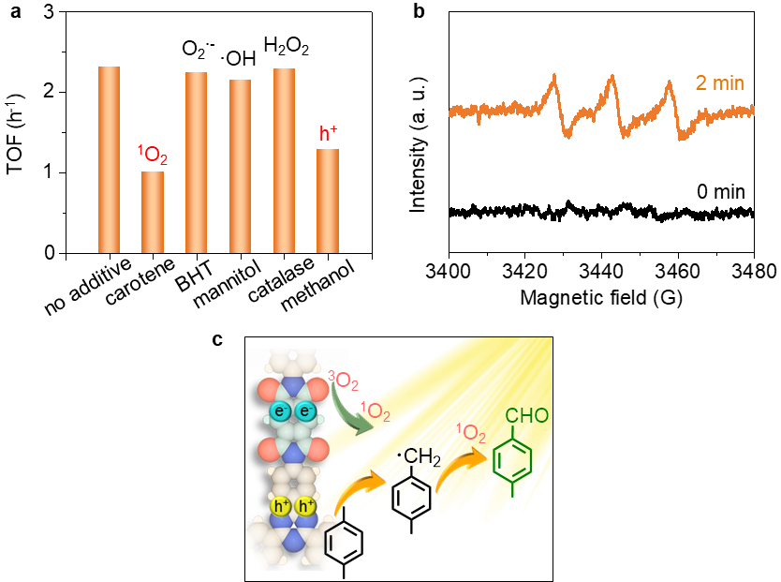

Figure S12. Identification of reaction mechanism. (a) Control tests with different scavengers. (b) EPR spectra of the TEMP-based intermediates over p-D₂A₃ photocatalyst in air atmosphere at 0 min (blank) and 2 minutes (orange) after irradiation. Control tests and EPR spectra suggested that the singlet oxygen and photoinduced holes were active species for PX oxidation process. (c) Proposed reaction mechanism for photocatalytic PX oxidation via singlet oxygen and 4-methylbenzyl radicals under visible irradiation.

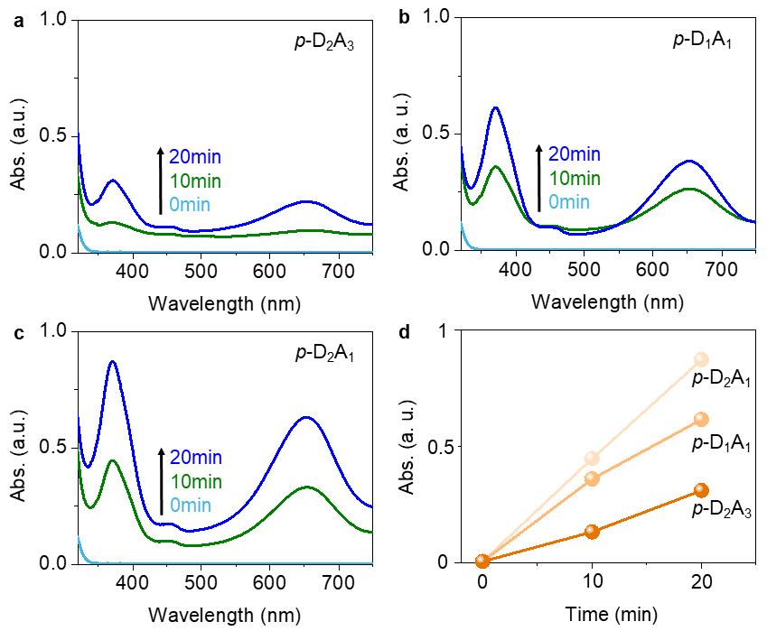

Figure S13. Singlet oxygen trapping experiments with 3,3',5,5'-Tetramethylbenzidine (TMB). Time-dependent UV−vis spectra of TMB oxidation product over (a) p-D₂A₃, (b) p-D₁A₁ and (c) p-D₂A₁ photocatalysts. (d) UV−vis peak intensity for TMB oxidation product at 370 nm over p-D₂A₃ p-D₁A₁ and p-D₂A₁ photocatalysts. The TMB oxidation experiments suggested that the ¹O₂ generation ability of p-D₂A₃ sample was weakest.

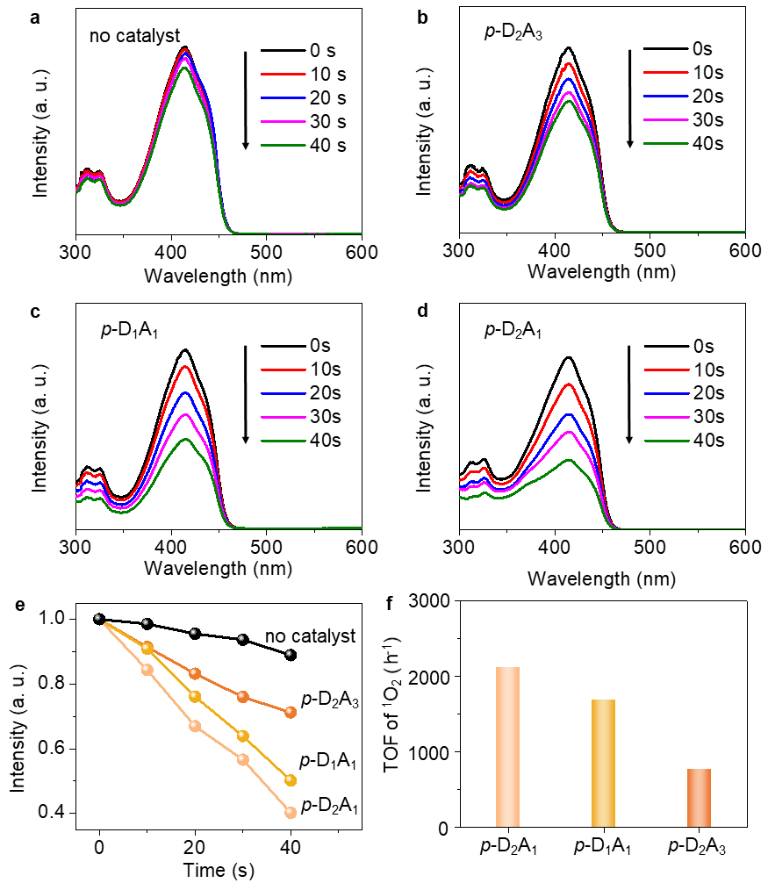

Figure S14. Singlet oxygen trapping experiments with 1,3-diphenylisobenzofuran (DPBF). Time-dependent UV−vis spectra of DPBF oxidation product (a) without catalyst and over (b) p-D₂A₃, (c) p-D₁A₁ and (d) p-D₂A₁ photocatalysts. (e) UV−vis peak intensity for DPBF oxidation product at 410 nm without catalyst and over p-D₂A₃ p-D₁A₁ and p-D₂A₁ photocatalysts. (f) TOF values of ¹O₂ production over p-D₂A₁, p-D₁A₁ and p-D₂A₃ photocatalysts³⁶, illustrating the weakest ¹O₂ generation ability of p-D₂A₃ sample, consistent with the results of TMB oxidation tests.

Figure S15. FT-IR spectra of p-D₂A₃ photocatalyst and p-D₂A₃ photocatalyst after 12h photoreaction. The chemical structure of the photocatalyst was not changed obviously, illustrating the excellent photochemical stability of p-D₂A₃ photocatalyst.
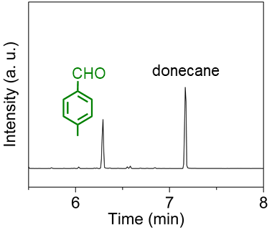

Figure S16. GC spectrum of the solution after photocatalytic PX oxidation at the standard conditions. The amount of product was calculated by the relative peak area to dodecane.

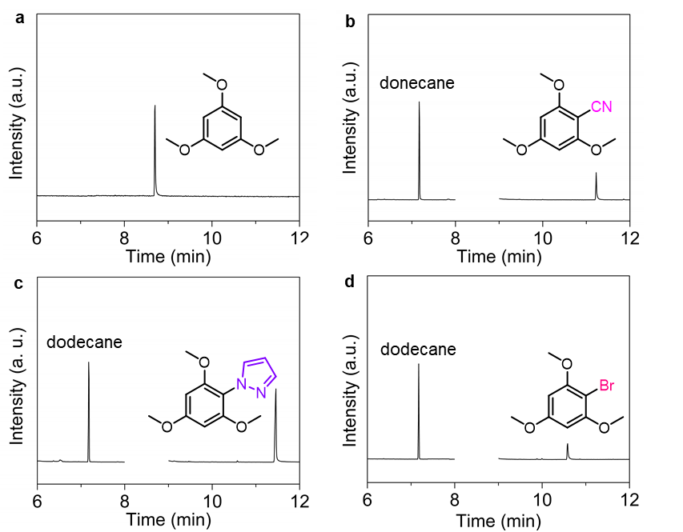

Figure S17. GC spectra of (a) 1,3,5-trimethoxybenze and the solution after photocatalytic (b) C-C, (c) C-N and (d) C-Br coupling reactions over p-D₂A₃ photocatalyst at the standard conditions. The amount of product was calculated by the relative peak area to dodecane. When detecting the products, the signals between 8 min and 9 min were not recorded because the peak of 1,3,5-trimethoxybenzene is too high to exceed the upper limit of the detection for GC-MS.

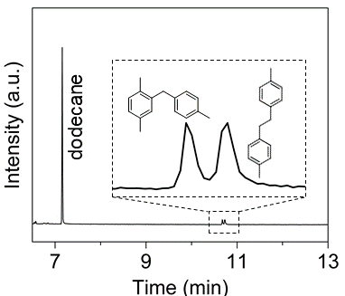

Figure S18. GC spectrum of the solution after photocatalytic PX coupling reaction under argon atmosphere over p-D₂A₃ photocatalyst at the standard conditions. The amount of product was calculated by the relative peak area to dodecane.

3. Table S1-S3

Table S1. N and C contents of typical samples via element analysis
Sample | N content (%) | C content (%) | Normalized D/A ratio*
p-D₂A₁ | 16.35 | 68.05 | 2:1
p-D₁A₁ | 12.36 | 63.67 | 1:1
p-D₂A₃ | 10.87 | 62.90 | 2:3
*The normalized D-A ratios of p-D_{x}A_{y} samples were determined according to the difference of N, C content in two monomers.

Table S2. BET surface areas of the p-D_{x}A_{y} samples
Sample | BET surface area (m² g⁻¹) *
p-D₂A₁ | 23.3
p-D₁A₁ | 27.4
p-D₂A₃ | 20.5
*The similar BET surface area values of the three samples suggested that the surface area is not an important factor for photocatalytic performance at C-H bond activation.

Table S3. Photocatalytic paraxylene oxidation over p-D₂A₃ and other reported metal-free photocatalysts using O₂.
Catalysts | Additives | Irradiation  conditions | TOF  (h⁻¹) | Selectivity for aldehyde |  | Ref.
p-D₂A₃ | -- | λ > 400 nm | 2.31 | >99% | This study
TP-COF* | -- | White LED | null | -- | 27
RFT | -- | 440 nm | 0.48 | -- | 29
PC Ⅲ | -- | 457 nm | 0.41 | >99% | S5
AQ-COOH | -- | Visible light | 0.26 | 83.8% | S6
AcrPh+ | -- | λ > 310 nm | 0.3 | >99% | S7
Flavinium salt | CF₃COOH | 448 nm | 0.18 | 51.7% | S8
*In this work, paraxylene was added into the photoreactor as internal standard, illustrating paraxylene can’t be oxidized by TP-COF photocatalyst.

4. References
S1. G. Kresse, J. Furthmüller, Efficiency of ab-initio total energy calculations for metals and semiconductors using a plane-wave basis set. Comput. Mater. Sci. 6, 15-50 (1996).
S2. G. Kresse, J. Furthmüller, Efficient iterative schemes for ab initio total-energy calculations using a plane-wave basis set. Phys. Rev. B 54, 11169 (1996).
S3. J. P. Perdew, K. Burke, M. Ernzerhof, Generalized gradient approximation made simple. Phys. Rev. Lett. 77, 3865 (1996).
S4. Y. Y. Cai et al., Highly efficient dehydrogenation of formic acid over a palladium‐nanoparticle‐based Mott–Schottky photocatalyst. Angew. Chem. Int. Ed. 125, 12038-12041 (2013).
S5. M. Uygur, J. H. Kuhlmann, M. C. Pérez-Aguilar, D. G. Piekarski, O. García Mancheño, Metal- and additive-free C-H oxygenation of alkylarenes by visible-light photoredox catalysis. Green Chem. 23, 3392-3399 (2021).
S6. D. Jiang et al., Regulating effects of anthraquinone substituents and additives in photo-catalytic oxygenation of p-xylene by molecular oxygen under visible light irradiation. Renew. Energy 174, 928-938 (2021).
S7. K. Ohkubo, S. Fukuzumi, 100 selective oxygenation of p-xylene to p-tolualdehyde via photoinduced electron transfer. Org. Lett. 2, 3647-3650 (2000).
S8. J. Zelenka et al., Combining flavin photocatalysis and organocatalysis: metal-free aerobic oxidation of unactivated benzylic substrates. Org. Lett. 21, 114-119 (2018).

