Supplementary Information:

pH-dependent crystal structures of a humanised therapeutic antibody Fab fragment: impact on molecular dynamics simulations and comparison to solution structures

Jiazhi Tang¹, Cheng Zhang², Nuria Codina Castillo², Christophe Lalaurie², Xin Gao³, Paul Dalby²*, Frank Kozielski¹*

¹UCL School of Pharmacy, 29-39 Brunswick Square, London, WC1N 1AX, UK,
²Department of Biochemical Engineering, UCL, Bernard Katz Building, Gower Street, London, WC1E 6BT, UK
³ Department of Structural and Molecular Biology, Division of Biosciences, UCL, London, WC1E 6BT, UK
Correspondence*: f.kozielski@ucl.ac.uk; p.dalby@ucl.ac.uk

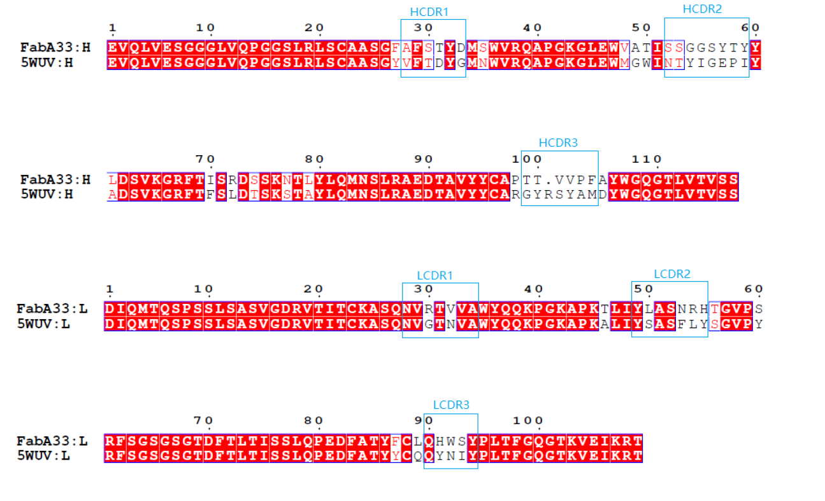
Supplementary figure 1. Alignments of variable domains between A33 Fab and Certolizumab.

The SAXS curve fitting and the representative structures

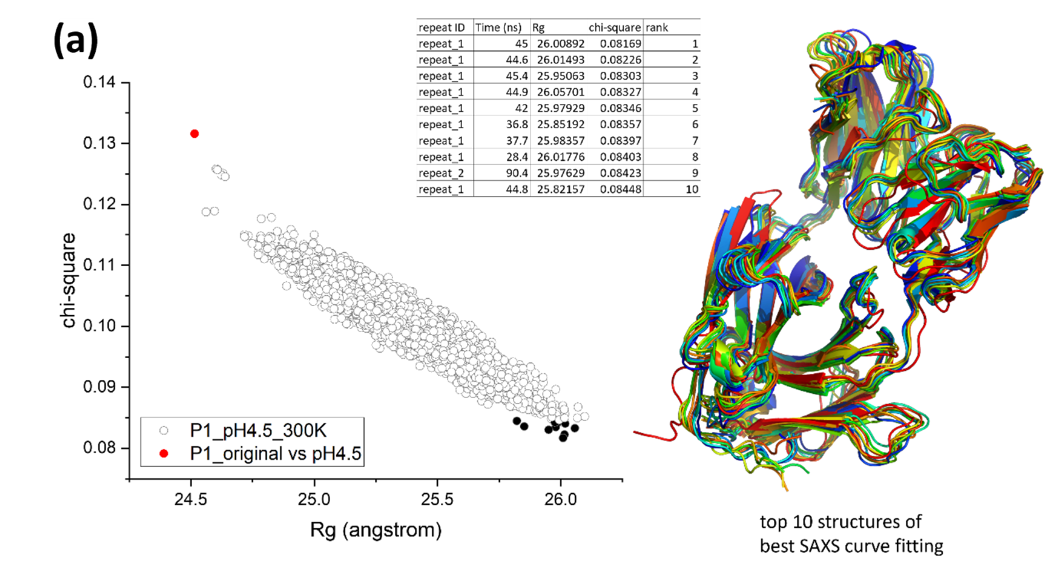

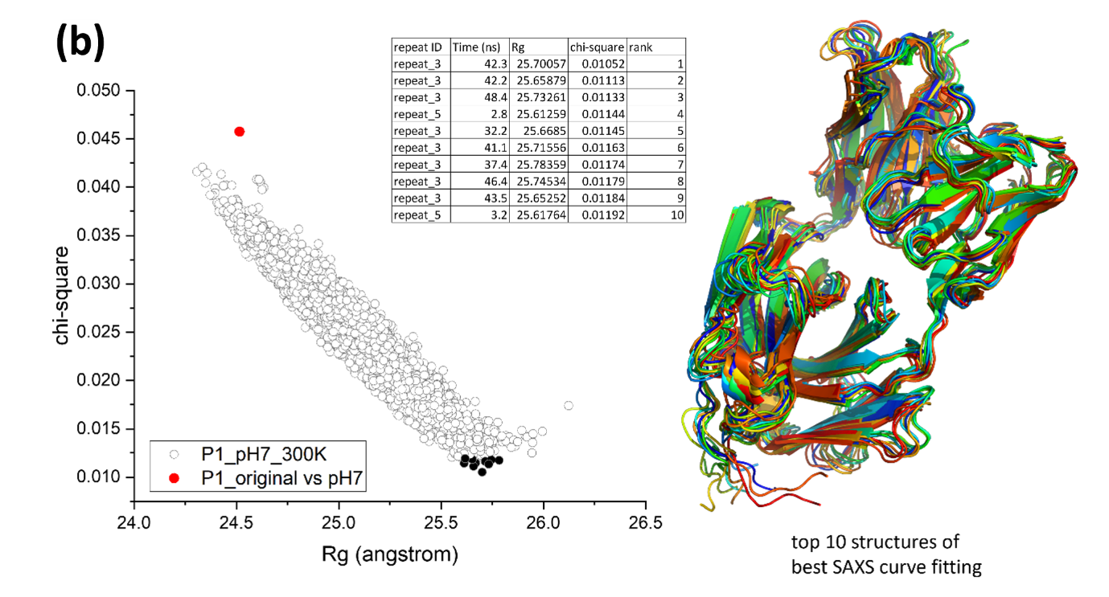

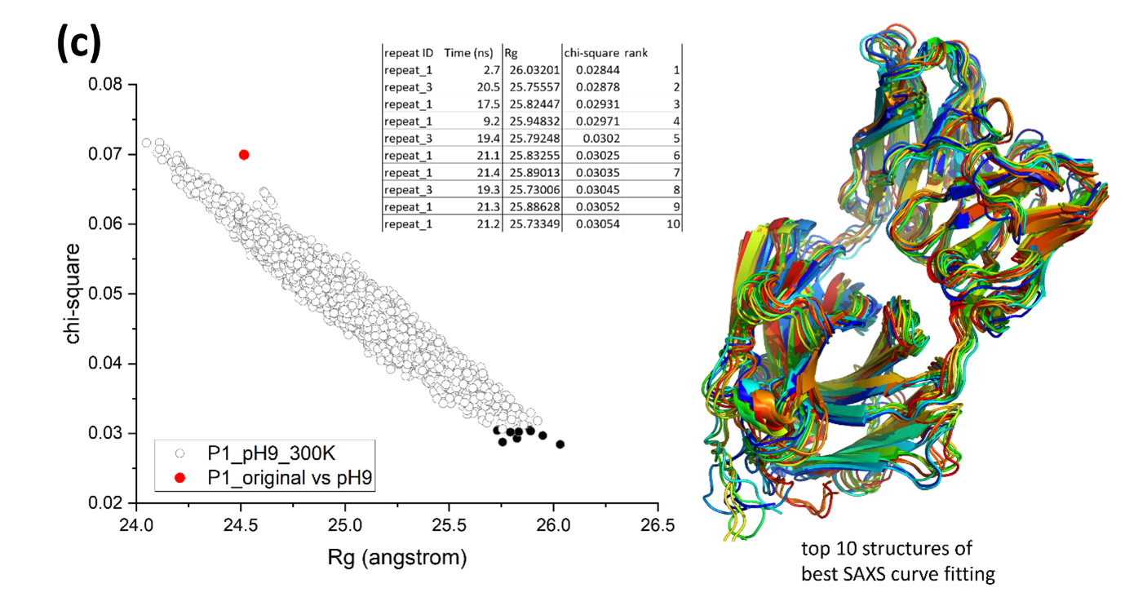
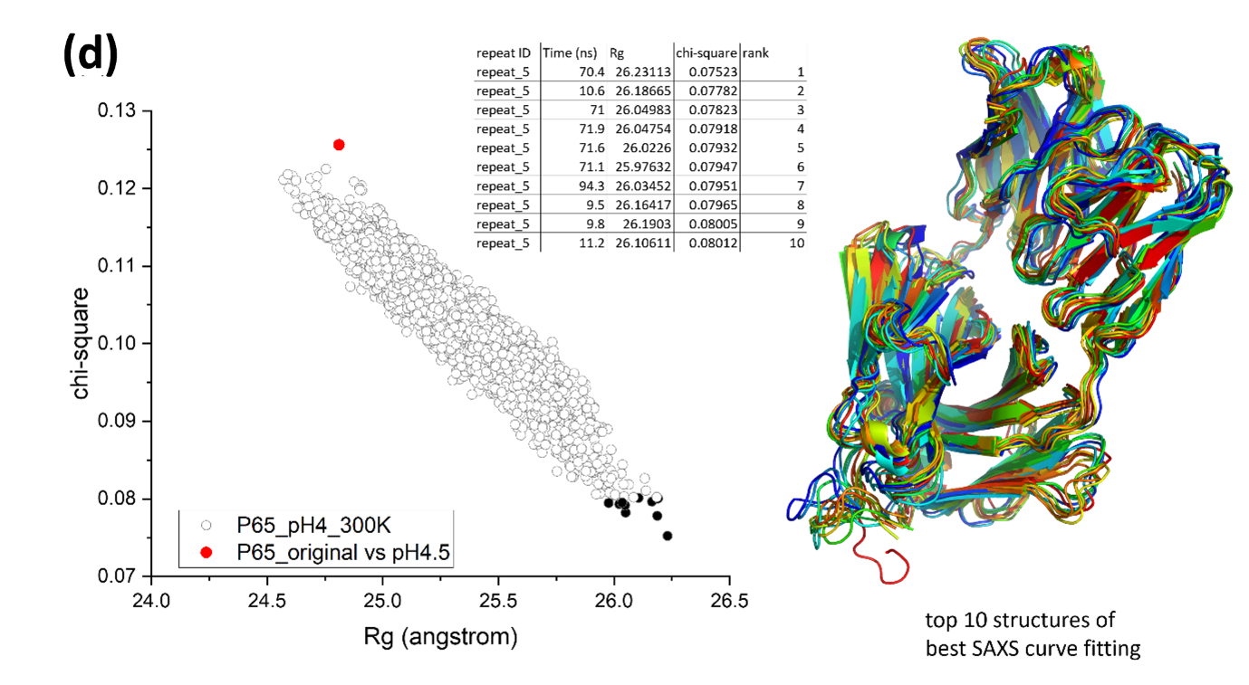
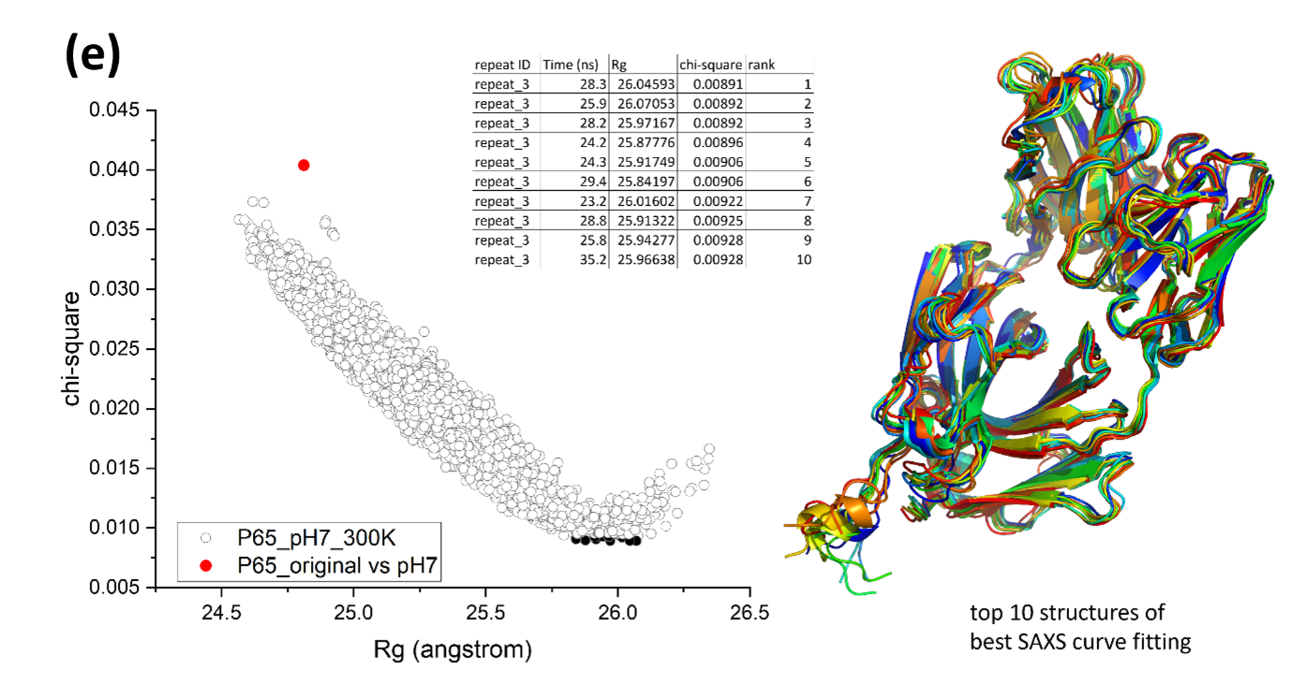
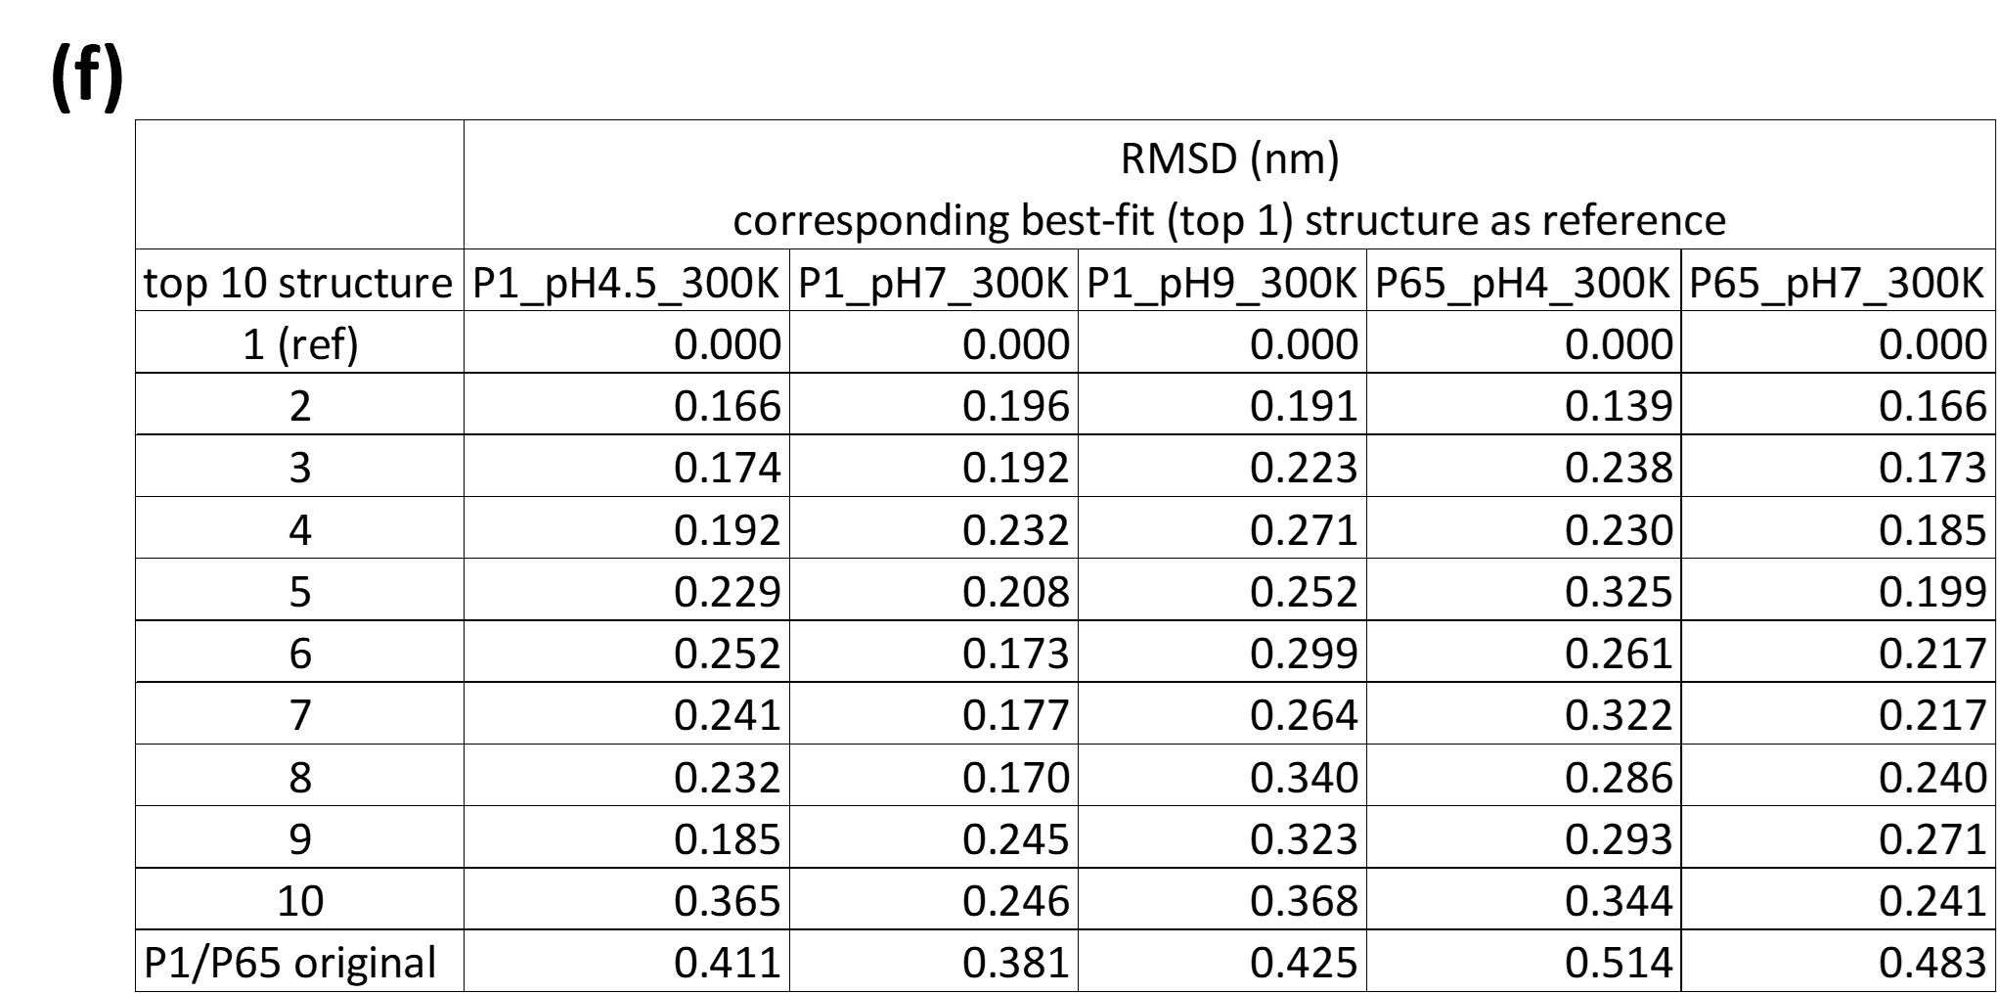

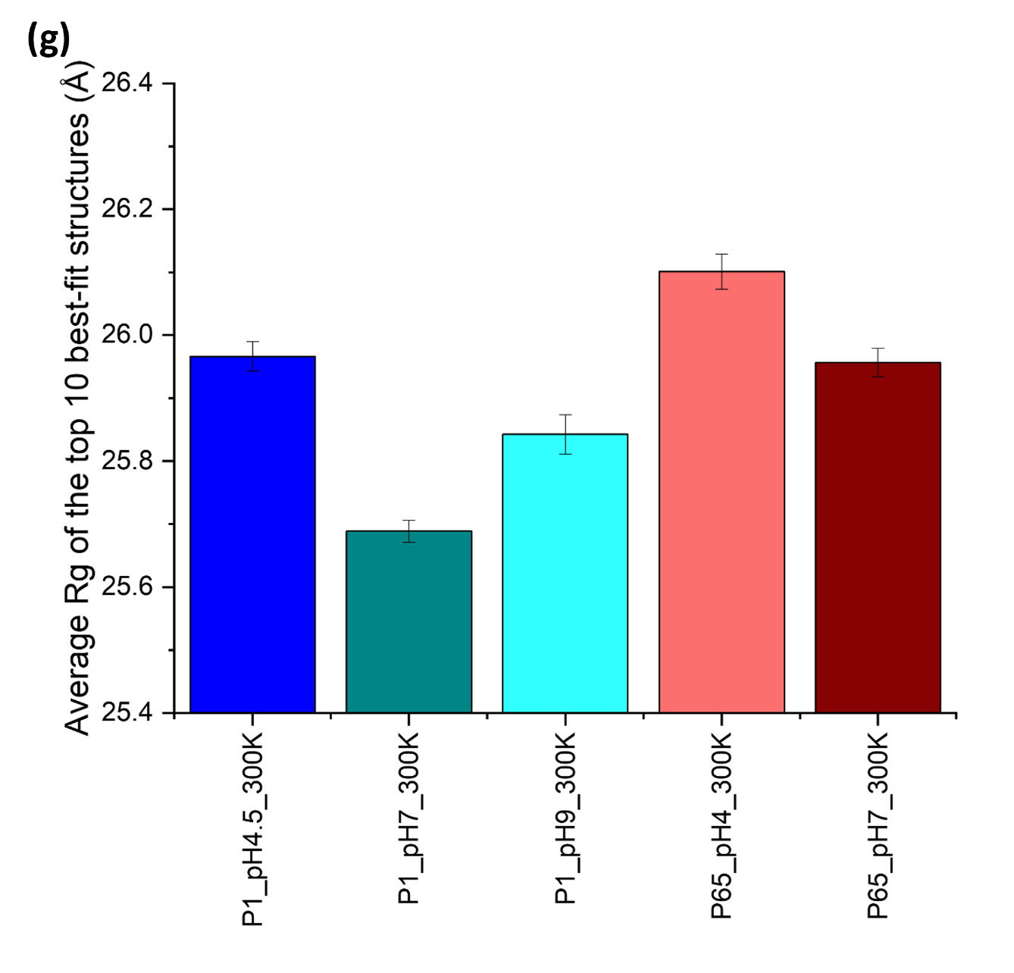

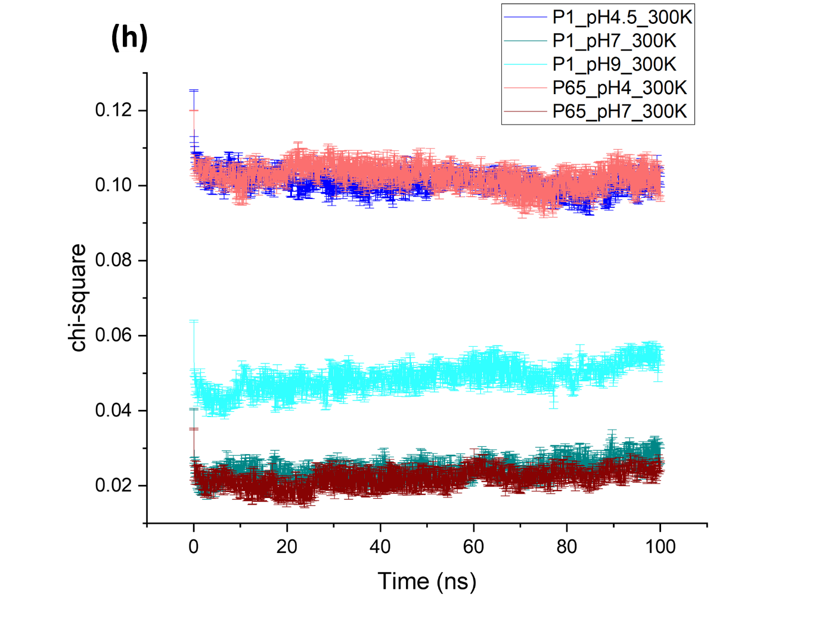
Supplementary figure 2. The summary for the SAXS curve fitting between the in silico and in vitro SAXS data. For each MD condition (a-e), 6006 (100 ns, 0.1 ns interval, 6 repeats) pair-wise SAXS curve fitting was performed as shown in Table 1, resulting 6006 dots plotted on the left figure for chi-square fitness and Rg. The top 10 best-fit frames (i.e. lowest chi-square) are coloured in black, with their structures aligned on the right. The details for the top 10 best-fit frames is tabulated in the middle table. The starting PDB used for MD is coloured in red in the chi-square vs Rg plot. The RMSD between the top 10 best-fit structures and P1/P6₅ original structures is tabulated in (f), using the corresponding top 1 best-fit structures as the reference for RMSD calculations. The average Rg of the top 10 best-fit structures is shown in (g) with SEM as the error bar. The average chi-square of the SAXS fitting throughout the MD is shown in (h) with SEM as the error bar.

