A Closer Look at the Time-Course of Bodily Responses to Awe Experiences

Supplemental Methods

Self-Reported Validation of Stimuli
A pilot survey was conducted to validate the expected results. Thirty-two adults watched each video clip in a randomized order. They reported how intensely they felt 12 emotions, such as awe (mean scores of ikei, ifu [awe in Japanese], and wonder; Takano & Nomura, 2021) and amusement, using 9-point scales (1 = not at all, 9 = extremely). The mean awe (amusement) scores were higher for videos of awe (amusement) condition than for videos of other conditions (awe: M_{awe} = 6.38, 6.39; M_{amusement} = 3.59, 4.19; M_{neutral} = 2.84, 2.44; amusement: M_{awe} = 4.31, 4.84; M_{amusement} 5.88, 6.38; M_{neutral} = 4.78, 4.91).

Other Questionnaires
In addition to the perceptions of the supernatural agency and non-agency, emotional states, and senses of a small self and self-boundary, participants were also asked to rate their perceptions of uncertainty, subjective stress, and state levels of life satisfaction using 7-point scales after watching a video. The perception of uncertainty was measured using the item “How uncertain did you feel while watching the previous video?” (Gordon et al., 2017). The perception of subjective stress was measured using four items (α = .78, modified from Cohen et al., 1983; Sumi, 2006). The state level of life satisfaction was measured using five items (α = .88 modified from Diener et al., 1985; Uchida et al., 2008). Results regarding these questionnaires are available at Tables S1-S6.

Models Including the Order of the Video or Control Variables
Regarding mean comparisons of physiological measurements among conditions, we also considered the models controlling for the ratings of amusement and fear (“control models”), those with the effects of the present order of the videos (“order models”), and those with the effects of demographic variables (i.e., age and gender) as follows:
Control models:
$$y=α_{subject}+{β_{0}+β}_{1}awe_contrast+β_{2}amusement_contrast+β_{3}amusement+β_{4}fear$$
Order models: $$y=α_{subject}+β_{0}+β_{1}awe_contrast+β_{2}amusement_contrast+β_{3}order+β_{4}awe_contrast×order+β_{5}amusement_contrast×order$$
Demographic models:
$$y=α_{subject}+β_{0}+β_{1}awe_contrast+β_{2}amusement_contrast+β_{3}age+β_{4}gender+β_{5}awe_contrast×age+β_{6}awe_contrast×gender$$
Where the terms $α_{subject}$ represent random intercept for each individual. Note that the distribution of each parameter and fixed effects of humidity and temperature are omitted. We compared these three models with the simple models which only include the effects of awe-contrast and amusement-contrast (and humidity and temperature) based on their wAIC (Widely Applicable Information Criteria; Watanabe, 2010). Because wAIC varies depending on the random number seed of the MCMC, we ran 20 sampling runs per model, shifting the random number seed from 1 to 20. The model with the lowest wAIC value among the models with significantly lower wAIC than the simple models was used for parameter estimation.

Smoothed Trend Modeling
We used smoothed trend models with second-order differencing to examine time-series changes in pupil diameter, and joystick data. The model equation was as follows:
$$\left(μ_{t}-μ_{t-1}\right)-\left(μ_{t-1}-μ_{t-2}\right)=ζ_{t}, ζ_{t}\sim Normal\left(0, σ_{ζ}^{2}\right)$$
$$y_{t,i}=μ_{t}+ϵ_{t}, ϵ_{t}\sim Normal\left(0, σ_{ϵ}^{2}\right)$$
The upper indicates a state equation representing the time-series changes in the number of SCRs, pupil diameter, or joystick data at the group level. The lower displays an observation equation where individual data are generated by appending observation errors to the group-level SCRs, pupil diameter, or joystick data at each time point. In this model equation, $t$ is the second (i.e., each timepoint), $i$ is the participant’s identification (ID), and $y_{t,i}$ is the number of SCRs, pupil diameter, and joystick data for each participant at each time point. The parameter $μ_{t}$ represents the group-level state at each time point. The $ζ_{t}$ and $ϵ_{t}$ represent the disturbance and observation error terms, respectively. A normal white noise and a normal distribution were assumed to be generated with mean $μ_{ζ}=0$ and variance $σ_{ζ}^{2}$ for the disturbance and with mean $μ_{ϵ}=0$ and variance $σ_{ϵ}^{2}$ for the observation error, respectively.

Figure S1.
Perceived (A) Small-self (Bai et al., 2017) and (B) Self-boundary Scales (Takano & Nomura, 2021).
Figure S2.
Plots for the Total Numbers of SCRs Across Participants per Second in Each Video (A: Awe-1, B: Awe-2, C: Amusement-1. D: Amusement-2, E: Neutral-1, F: Neutral-2).
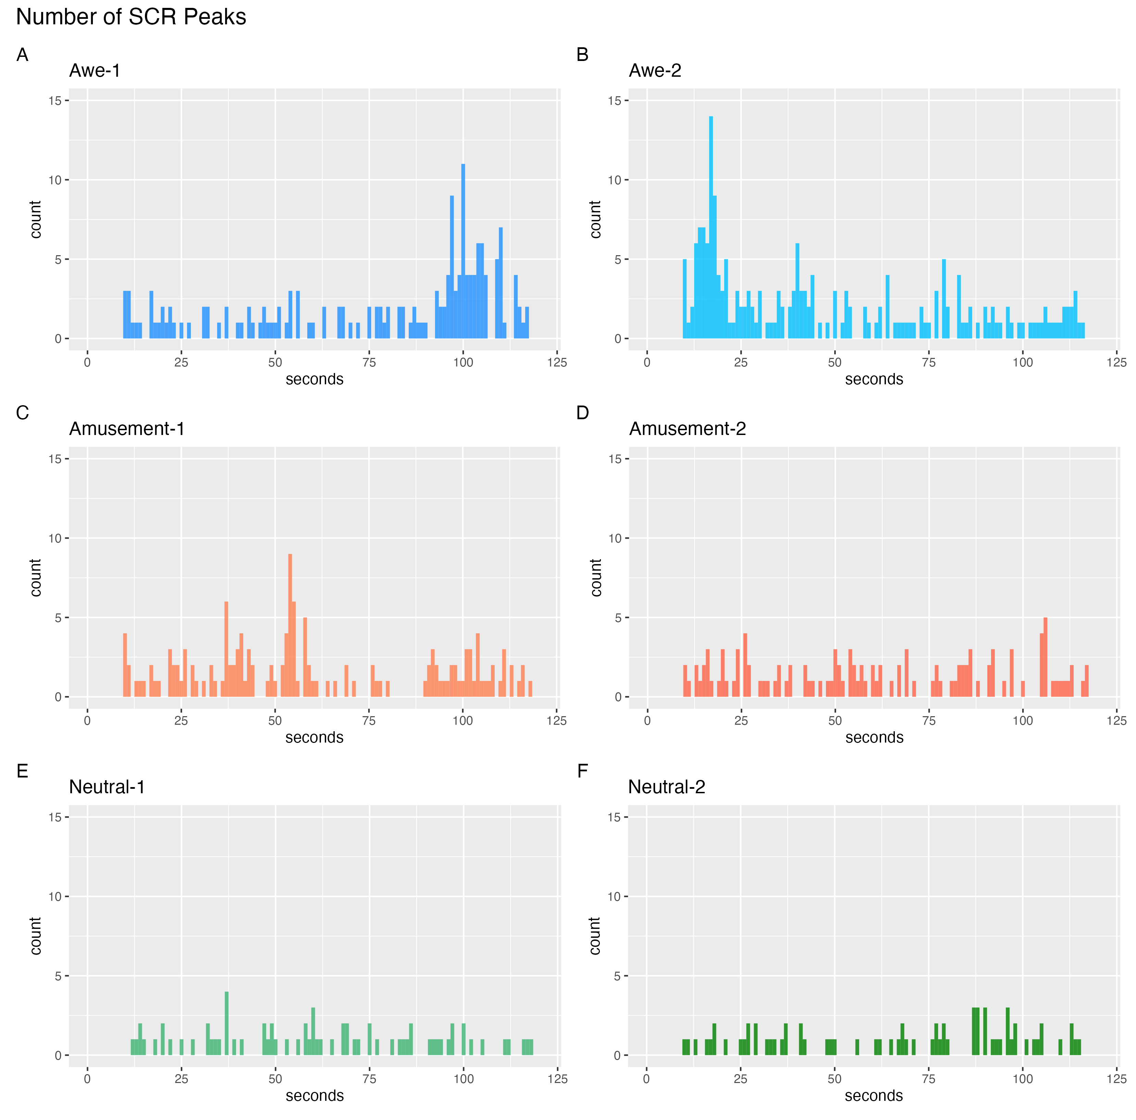

Table S1.
Mean Comparisons of Each Variable Between Conditions Using Linear Mixed-Effects Models
Dependent Variables |  | Estimate | 95% CI |  | p-value
 |  | Estimate | Lower | Upper | p-value
Total Number of SCRs
 | Awe_contrast | 1.47 | 1.09 | 1.86 | <.001
 | Amusement_contrast | 0.77 | 0.38 | 1.15 | <.001
Amplitude of SCRs
 | Awe_contrast | 0.18 | 0.05 | 0.32 | .009
 | Amusement_contrast | 0.10 | –0.04 | 0.25 | .162
Rise Time of SCRs
 | Awe_contrast | –0.07 | –0.13 | –0.02 | .004
 | Amusement_contrast | –0.02 | –0.08 | 0.03 | .440
Recovery Time of SCRs
 | Awe_contrast | –0.48 | –0.71 | –0.25 | <.001
 | Amusement_contrast | –0.15 | –0.39 | 0.09 | .231
Pupil Diameter
 | Awe_contrast | 0.13 | 0.09 | 0.17 | <.001
 | Amusement_contrast | 0.53 | 0.48 | 0.57 | <.001
Joystick Movement
 | Awe_contrast | 0.16 | 0.14 | 0.18 | <.001
 | Amusement_contrast | 0.01 | –0.01 | 0.03 | .208
Awe-ratings
 | Awe_contrast | 3.18 | 2.98 | 3.37 | <.001
 | Amusement_contrast | 0.64 | 0.44 | 0.83 | <.001
Amusement-ratings
 | Awe_contrast | 0.27 | –0.08 | 0.62 | .127
 | Amusement_contrast | 1.53 | 1.18 | 1.88 | <.001
Small Self
 | Awe_contrast | –1.93 | –2.17 | –1.69 | <.001
 | Amusement_contrast | –0.53 | –0.77 | –0.29 | <.001
Self-boundary
 | Awe_contrast | –1.61 | –1.92 | –1.29 | <.001
 | Amusement_contrast | –0.98 | –1.29 | –0.67 | <.001
Perceived Uncertainty
 | Awe_contrast | 0.53 | 0.20 | 0.85 | .001
 | Amusement_contrast | 1.89 | 1.57 | 2.21 | <.001
Life Satisfaction
 | Awe_contrast | –0.03 | –0.11 | 0.05 | .472
 | Amusement_contrast | –0.06 | –0.15 | 0.02 | .133
Subjective Stress
 | Awe_contrast | –0.12 | –0.53 | 0.29 | .571
 | Amusement_contrast | 0.12 | –0.30 | 0.53 | .582
Supernatural Agency
 | Awe_contrast | 1.39 | 1.14 | 1.64 | <.001
 | Amusement_contrast | 0.64 | –0.00 | 0.51 | .052
Supernatural Non-gency
 | Awe_contrast | 2.86 | 2.50 | 3.21 | <.001
 | Amusement_contrast | –0.27 | –0.62 | 0.09 | .142
Ikei-ratings
 | Awe_contrast | 3.55 | 3.30 | 3.80 | <.001
 | Amusement_contrast | –0.10 | –0.35 | 0.15 | .440
Ifu-ratings
 | Awe_contrast | 2.91 | 2.65 | 3.17 | <.001
 | Amusement_contrast | 0.11 | –0.16 | 0.37 | .422
Wonder-ratings
 | Awe_contrast | 3.10 | 2.80 | 3.41 | <.001
 | Amusement_contrast | 1.89 | 1.58 | 2.19 | <.001
Happiness-ratings
 | Awe_contrast | 0.04 | –0.29 | 0.37 | .817
 | Amusement_contrast | –0.23 | –0.56 | 0.11 | .181
Fear-ratings
 | Awe_contrast | 1.51 | 1.20 | 1.81 | <.001
 | Amusement_contrast | 1.11 | 0.81 | 1.42 | <.001
Anxiety-ratings
 | Awe_contrast | 1.00 | 0.67 | 1.32 | <.001
 | Amusement_contrast | 0.64 | 0.32 | 0.97 | <.001
Respect-ratings
 | Awe_contrast | 2.50 | 2.23 | 2.76 | <.001
 | Amusement_contrast | 0.11 | –0.15 | 0.38 | .393
Sadness-ratings
 | Awe_contrast | –0.04 | –0.26 | 0.18 | .702
 | Amusement_contrast | –0.09 | –0.31 | 0.13 | .444
Anger-ratings
 | Awe_contrast | 0.13 | –0.04 | 0.30 | .134
 | Amusement_contrast | 0.56 | 0.40 | 0.73 | <.001
Note. Awe_contrast (Amusement_contrast) was coded 2/3 for the awe (amusement) condition and –1/3 for the other conditions; CI: confidence interval

Table S2.
Pairwise Comparisons of Awe Versus Amusement and Neutral Conditions on Each Self-report Variables Using ANOVA
Variables | Condition | Mean | SD | Comparisons with Awe
 |  |  |  | t | p | Cohen's  d
Awe-ratings | Awe | 4.69 | 1.43 | － | － | －
Awe-ratings | Amusement | 2.16 | 1.04 | -20.73 | <.001 | -2.36
Awe-ratings | Neutral | 1.52 | 0.79 | -28.00 | <.001 | -3.19
Amusement-ratings | Awe | 3.47 | 1.84 | － | － | －
Amusement-ratings | Amusement | 4.72 | 1.90 | 6.05 | <.001 | 0.69
Amusement-ratings | Neutral | 3.19 | 1.84 | -1.60 | .111 | -0.18
Small Self | Awe | 2.17 | 1.04 | － | － | －
Small Self | Amusement | 3.57 | 1.35 | 10.86 | <.001 | 1.24
Small Self | Neutral | 4.10 | 1.13 | 15.29 | <.001 | 1.74
Self-boundary | Awe | 2.80 | 1.50 | － | － | －
Self-boundary | Amusement | 3.43 | 1.57 | 3.91 | <.001 | 0.45
Self-boundary | Neutral | 4.41 | 1.49 | 8.83 | <.001 | 1.01
Perceived Uncertainty | Awe | 2.89 | 1.57 | － | － | －
Perceived Uncertainty | Amusement | 4.25 | 1.77 | 7.84 | <.001 | 0.89
Perceived Uncertainty | Neutral | 2.36 | 1.60 | -3.56 | <.001 | -0.41
Life Satisfaction | Awe | 4.28 | 1.18 | － | － | －
Life Satisfaction | Amusement | 4.24 | 1.18 | -0.63 | 1.000 | -0.07
Life Satisfaction | Neutral | 4.31 | 1.20 | 0.43 | 1.000 | 0.05
Perceived Stress | Awe | 12.90 | 3.66 | － | － | －
Perceived Stress | Amusement | 13.13 | 3.63 | 1.00 | .963 | 0.11
Perceived Stress | Neutral | 12.94 | 3.61 | 0.58 | 1.000 | 0.07
Supernatural Agency | Awe | 2.70 | 1.85 | － | － | －
Supernatural Agency | Amusement | 1.56 | 1.13 | -7.20 | <.001 | -0.82
Supernatural Agency | Neutral | 1.32 | 0.89 | -9.39 | <.001 | -1.07
Supernatural  No-agency | Awe | 5.25 | 1.92 | － | － | －
Supernatural  No-agency | Amusement | 2.14 | 1.66 | -17.17 | <.001 | -1.96
Supernatural  No-agency | Neutral | 2.41 | 1.96 | -14.86 | <.001 | -1.69
Ikei | Awe | 5.29 | 1.54 | － | － | －
Ikei | Amusement | 1.65 | 1.10 | -25.95 | <.001 | -2.96
Ikei | Neutral | 1.75 | 1.35 | -24.38 | <.001 | -2.78
Ifu | Awe | 4.31 | 1.92 | － | － | －
Ifu | Amusement | 1.51 | 1.00 | -17.33 | <.001 | -1.97
Ifu | Neutral | 1.40 | 0.83 | -18.78 | <.001 | -2.14
Wonder | Awe | 4.53 | 1.84 | － | － | －
Wonder | Amusement | 3.30 | 1.94 | -6.57 | <.001 | -0.75
Wonder | Neutral | 1.42 | 0.91 | -21.29 | <.001 | -2.43
Happiness | Awe | 3.44 | 1.84 | － | － | －
Happiness | Amusement | 3.17 | 1.94 | -1.46 | .441 | -0.17
Happiness | Neutral | 3.40 | 1.92 | -0.23 | .816 | -0.03
Fear | Awe | 2.89 | 1.77 | － | － | －
Fear | Amusement | 2.50 | 1.94 | -2.07 | .040 | -0.24
Fear | Neutral | 1.38 | 0.92 | -10.97 | <.001 | -1.25
Anxiety | Awe | 2.96 | 1.74 | － | － | －
Anxiety | Amusement | 2.61 | 1.93 | -2.09 | .039 | -0.24
Anxiety | Neutral | 1.96 | 1.50 | -5.91 | <.001 | -0.67
Respect | Awe | 3.98 | 1.95 | － | － | －
Respect | Amusement | 1.59 | 1.07 | -15.14 | <.001 | -1.73
Respect | Neutral | 1.48 | 1.11 | -15.24 | <.001 | -1.74
Sadness | Awe | 1.59 | 1.07 | － | － | －
Sadness | Amusement | 1.55 | 1.26 | -0.44 | 1.000 | -0.05
Sadness | Neutral | 1.63 | 1.18 | 0.38 | 1.000 | 0.04
Anger | Awe | 1.19 | 0.62 | － | － | －
Anger | Amusement | 1.63 | 1.25 | 4.19 | <.001 | 0.48
Anger | Neutral | 1.07 | 0.30 | -2.54 | .012 | -0.29

Table S3.
Zero-order Correlations among Variables (Awe Condition)
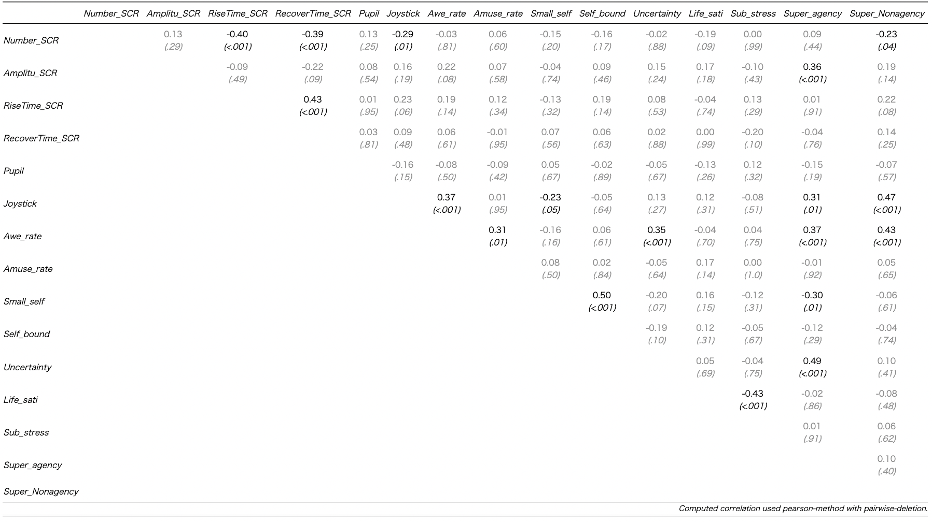

Table S4.
Zero-order Correlations among Variables (Amusement Condition)
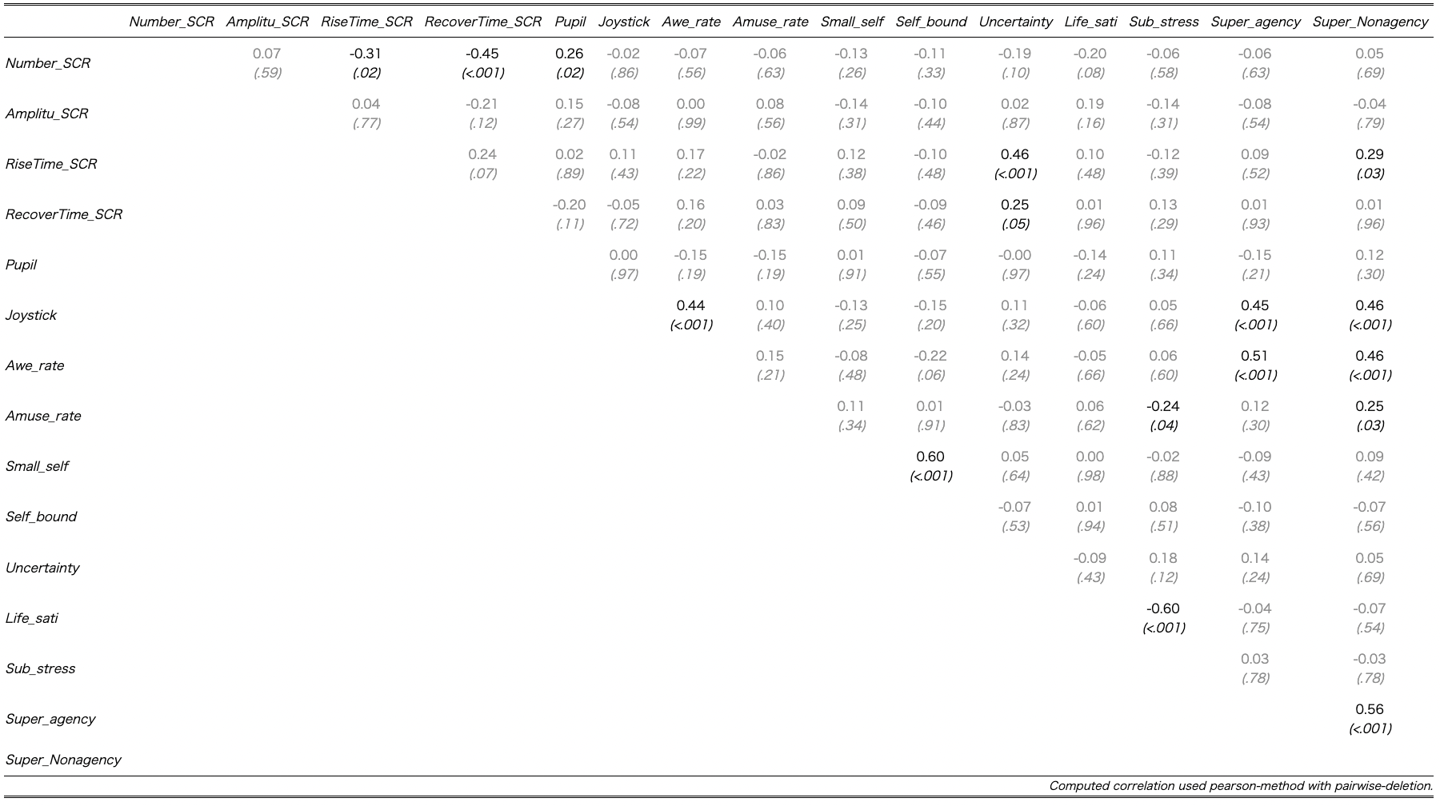

Table S5.
Zero-order Correlations among Variables (Neutral Condition)
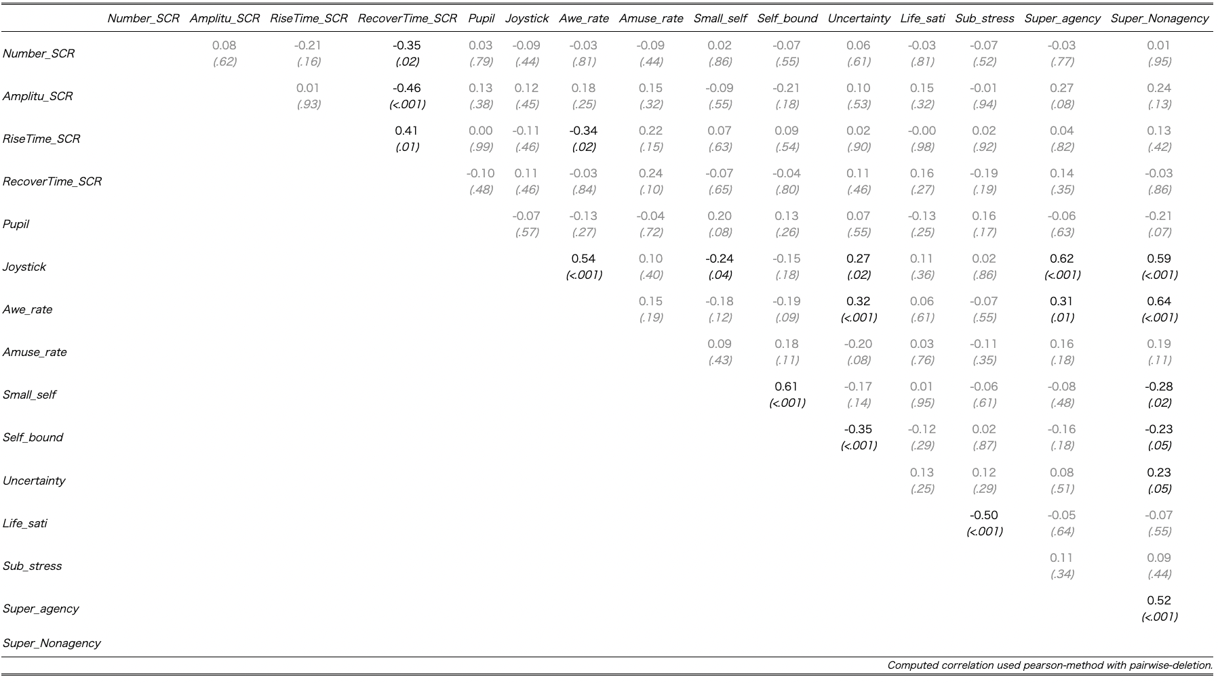

Table S6.
Results of Mean Comparisons of Self-report Variables between Conditions Using Hierarchical Bayesian Method
Dependent Variables |  | Estimate | 95% CI |  | R-hat | Bulk  ESS | Tail  ESS
 |  | Estimate | Lower | Upper | R-hat | Bulk  ESS | Tail  ESS
Awe-ratings
 | Awe_contrast | 3.18 | 2.98 | 3.37 | 1.00 | 67,870 | 32,806
 | Amusement_contrast | 0.64 | 0.44 | 0.84 | 1.00 | 68,681 | 31,922
Amusement-ratings
 | Awe_contrast | 0.27 | –0.08 | 0.63 | 1.00 | 63,168 | 32,394
 | Amusement_contrast | 1.53 | 1.18 | 1.89 | 1.00 | 66,474 | 31,593
Small Self
 | Awe_contrast | –1.93 | –2.17 | –1.69 | 1.00 | 67,562 | 32,365
 | Amusement_contrast | –0.53 | –0.77 | –0.29 | 1.00 | 66,695 | 32,405
Self-boundary
 | Awe_contrast | –1.61 | –1.92 | –1.29 | 1.00 | 66,991 | 31,179
 | Amusement_contrast | –0.98 | –1.29 | –0.67 | 1.00 | 69,462 | 31,357
Perceived Uncertainty
 | Awe_contrast | 0.53 | 0.21 | 0.85 | 1.00 | 65,190 | 32,239
 | Amusement_contrast | 1.89 | 1.57 | 2.21 | 1.00 | 62,890 | 31,164
Life Satisfaction
 | Awe_contrast | –0.03 | –0.11 | 0.04 | 1.00 | 25,170 | 27,743
 | Amusement_contrast | –0.07 | –0.14 | 0.01 | 1.00 | 25,408 | 26,763
Subjective Stress
 | Awe_contrast | –0.12 | –0.54 | 0.29 | 1.00 | 25,234 | 27,049
 | Amusement_contrast | 0.11 | –0.30 | 0.53 | 1.00 | 25,100 | 26,106
Supernatural Agency
 | Awe_contrast | 1.39 | 1.13 | 1.64 | 1.00 | 67,776 | 33,210
 | Amusement_contrast | 0.25 | –0.00 | 0.51 | 1.00 | 67,389 | 31,274
Supernatural Non-gency
 | Awe_contrast | 2.86 | 2.50 | 3.21 | 1.00 | 70,531 | 31,497
 | Amusement_contrast | –0.27 | –0.62 | 0.09 | 1.00 | 67,594 | 31,879
Note. The l- and u-95% CI indicates lower and upper bounds of 95% credible intervals, respectively; ESS: effective sample sizes.

Table S7.
WAICs and estimated coefficients of variables for selected models for physiological measurements.
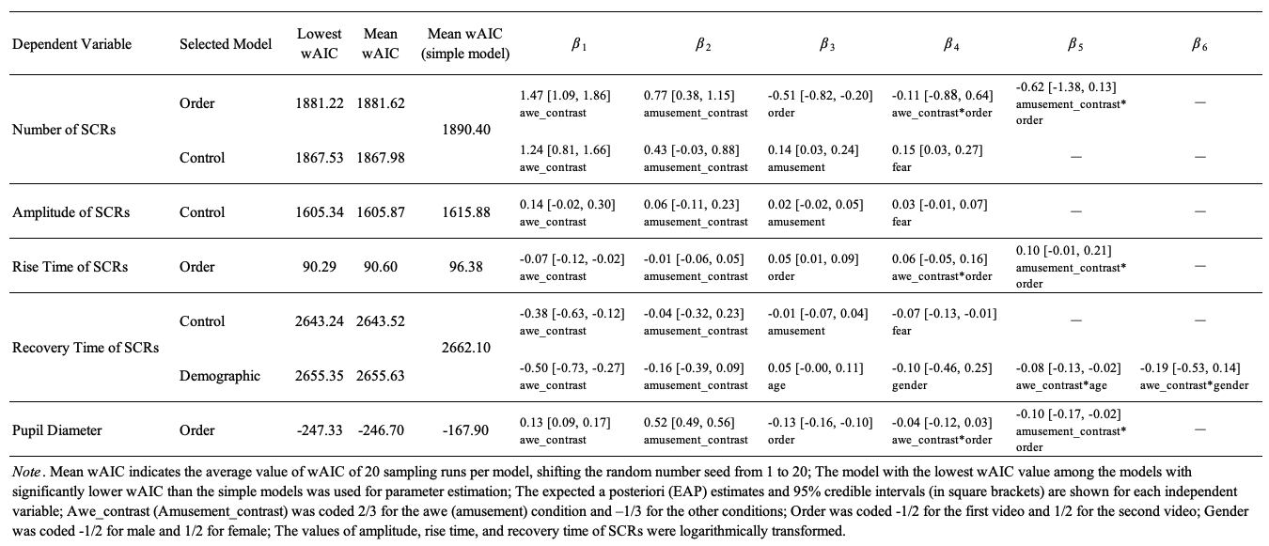

References
Bai, Y., Maruskin, L. A., Chen, S., Gordon, A. M., Stellar, J. E., McNeil, G. D., Peng, K., & Keltner, D. (2017). Awe, the diminished self, and collective engagement: Universals and cultural variations in the small self. Journal of Personality and Social Psychology, 113(2), 185–209. doi:10.1037/pspa0000087
Cohen, S., Kamarck, T., & Mermelstein, R. (1983). A global measure of perceived stress. Journal of Health and Social Behavior, 24(4), 385–396. doi:10.2307/2136404
Diener, E., Emmons, R. A., Larsen, R. J., & Griffin, S. (1985). The satisfaction with life Scale. Journal of Personality Assessment, 49(1), 71–75. doi:10.1207/s15327752jpa4901_13
Gordon, A. M., Stellar, J. E., Anderson, C. L., McNeil, G. D., Loew, D., & Keltner, D. (2017). The dark side of the sublime: Distinguishing a threat-based variant of awe. Journal of Personality and Social Psychology, 113(2), 310–328. doi:10.1037/pspp0000120
Sumi, K. (2006). Reliability and validity of the Japanese version of the Perceived Stress Scale. Japanese Journal of Health Psychology, 19(2), 44–53. doi:10.11560/jahp.19.2_44
Takano, R., & Nomura, M. (2021). Awe liberates the feeling that “my body is mine.” Cognition and Emotion, 35(4), 738–744. doi:10.1080/02699931.2020.1862765
Uchida, Y., Kitayama, S., Mesquita, B., Reyes, J. A. S., & Morling, B. (2008). Is perceived emotional support beneficial? Well-being and health in independent and interdependent cultures. Personality and Social Psychology Bulletin, 34(6), 741–754. doi:10.1177/0146167208315157
Watanabe, S. (2010). Asymptotic equivalence of Bayes cross validation and widely applicable information criterion in singular learning theory. Journal of Machine Learning Research, 11(12), 3571–3594.

