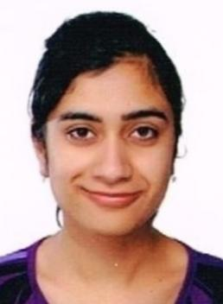 | Supriya is a Ph.D research scholar in the Department of Electronics and Communication Engineering at University Institute of Engineering and Technology, Panjab University, Chandigarh, India. She has done M.E from Punjabi University, Patiala in the year 2016 and B.E (ECE) from U.I.E.T, Panjab University in year 2013. Her area of research includes Wireless Communication.
 | Dr. Charu Madhu has done her B.E. and M.E. in the field of Electronics and Communication. She got her Ph.D. in the year 2017. Currently, she is working as Assistant Professor in Department of Electronics and Communication at UIET, Panjab University, Chandigarh, India. She has several publications in reputed Journals. Her area of research includes Photonics, Nanoelectronics and Optical Communication
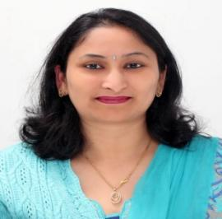 | Dr. Nidhi is an Assistant Professor in the Department of Electronics and Communication Engineering at University Institute of Engineering and Technology, Panjab University, Chandigarh, India. She is a Ph.D (2019), M.E-ECE (2006), B.Tech-Electronics (2003) and has more than 17 years of teaching experience. Her main areas of interest include Signal Processing, Digital System Design and Networking. She has more than 30 research papers in International and National Journals, Conferences and guided 15 M.E-ECE thesis. e-mail Id: nidhi_garg@pu.ac.in

