SUPPLEMENTARY DOCUMENT

ABSTRACT
Among four genotypes, the unique gene sequences in 550 bp and 800 bp DNA ladders identified by AP-4 primer and 600 bp DNA ladders identified by AP-32 primer are only found in IRS genotype as dimorphic bands and single band, respectively. Similarly, in IGS water chestnut, DNA fragments AP30-1250, and ISSR23-1500 & ISSR23-1350 are only found as single bands and dimorphic bands, respectively.

Unique gene sequences identified in genotypes

Unique gene sequence in 550 bp and 800 bp DNA ladders identified from AP-4 (5’CAAACGACGG3’) primer and 600bp DNA ladder identified from AP-32 (5’AACATCTCCGGG3’) primer which are only present in IRS water chestnut as dimorphic and monomorphic band, respectively. Similarly, in IGS water chestnut, DNA fragments viz; AP30-1250 (5’GGACCTCCATCG3’) and ISSR23-1500 & ISSR23-1350 ( 5’AGTAGTAGTTCTCTCTCTCTCTC3’) are only present as single DNA band and dimorphic bands, respectively. According to Sharma et al., 2007 the highly allogamous nature of Trapa species creates heterozygosity in their natural populations. Desai et al. (2015) also stated that the DNA polymorphism in a specified population of Trapa spp. is due to the presence of genetic variants governed by the different alleles and their frequency of allocation. Utility of molecular analysis of water chestnut plants has been well documented by many workers ( Hoque et al. 2005; Mahto et al. 2018). The genotype specific diagonistic bands using RAPD and ISSR markers afford a prospect to be SCAR markers for the differentiation of four genotypes. Genetic fidelity of clonally selected plants and traditional cultivars has immense practical utility and commercial implications under the wetland ecosystem of north Bihar, India. However, morphologically the fruit color. size number of fruits/plant and spine variation in Trapa spp. were considered in the study but it was unsafe to assume that these small morphological variations have been reflected in the RAPD and ISSR analysis. Accordingly, Houque et al. (2005) randomly amplified polymorphic DNA (RAPD) markers viz; AP-1, AP-4, AP-5, AP-11, AP-16, AP-22, AP-30 have proved to be the most polymorphic markers for water chestnut crop.

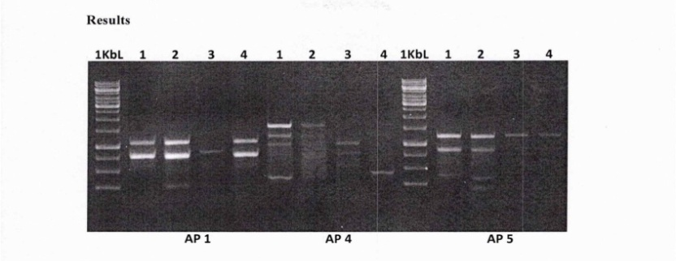
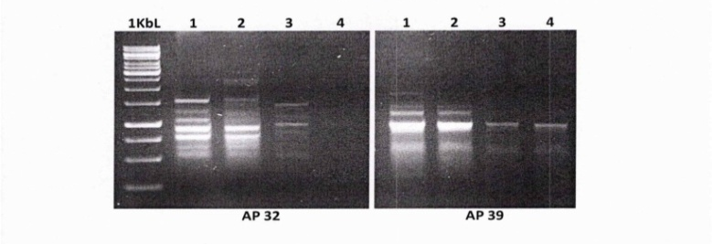
Fig-4-5: The presence of DNA fragment 550 bp DNA and in 800 bp from AP-4 and 600 bp DNA ladder identified from AP-32 primer only present in IRS
[Profile of four water chestnut varieties with 10 RAPD markers. In the figure Lane-1: Improved Green Spineless (IGS) , Lane-2: Red Spine Large local (RSLL), Lane-3: Improved Red Spineless (IRS), Lane-4: Red Small Spine Local, M is the 1Kb Molecular weight size Standard.]
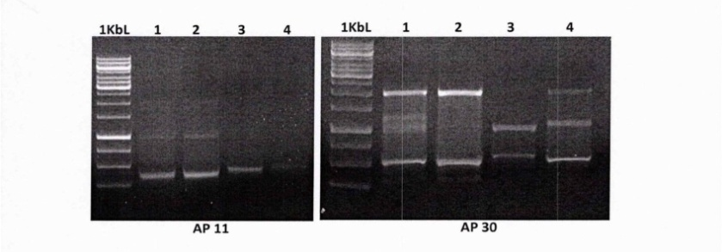
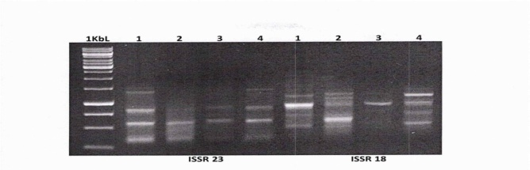
Fig-6-7: Distinguishing Features of IGS: The presence of DNA fragments AP30-1250, and ISSR23-1500 & ISSR23-1350
[Profile of four water chestnut varieties with 10 RAPD and 10 ISSR markers . In the figure Lane-1: Improved Green Spineless (IGS) , Lane-2: Red Spine Large local (RSLL), Lane-3: Improved Red Spineless (IRS), Lane-4: Red Small Spine Local, M is the 1Kb Molecular weight size Standard.]

