Supplementary Table S 1 Details of the studies included in the Meta analysis.
Author | Controls (N) | PCOS Cases (N) | Country | Region
Thathapudi et al | 204 | 204 | India | Asian
Almavi et al | 211 | 203 | Bahrain | Asian
Valkenburg et al | 2912 | 495 | Netherlands | Caucasian
Capalbo et al | 180 | 159 | Italy | Caucasian
Bassiouny et al | 60 | 100 | Egypt | Caucasian
El-Shal | 200 | 210 | Egypt | Caucasian
Atoum et al | 56 | 56 | Jordan | Asian
Makhdoomi et al | 120 | 120 | India | Asian
Singh et al | 322 | 421 | India | Asian
Robeva et al | 40 | 70 | Bulgaria | Europe
Alarcón-Granados | 49 | 49 | Columbia | South America
Branavan et al | 110 | 55 | Sri Lanka | Asian

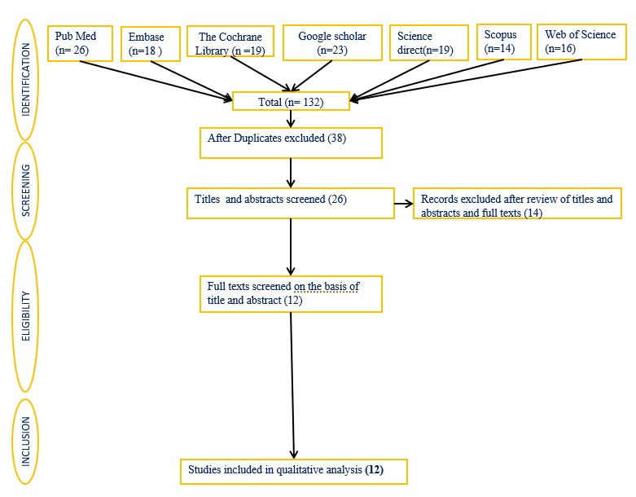

Supplementary Figure S1: The data extraction and processing workflow

