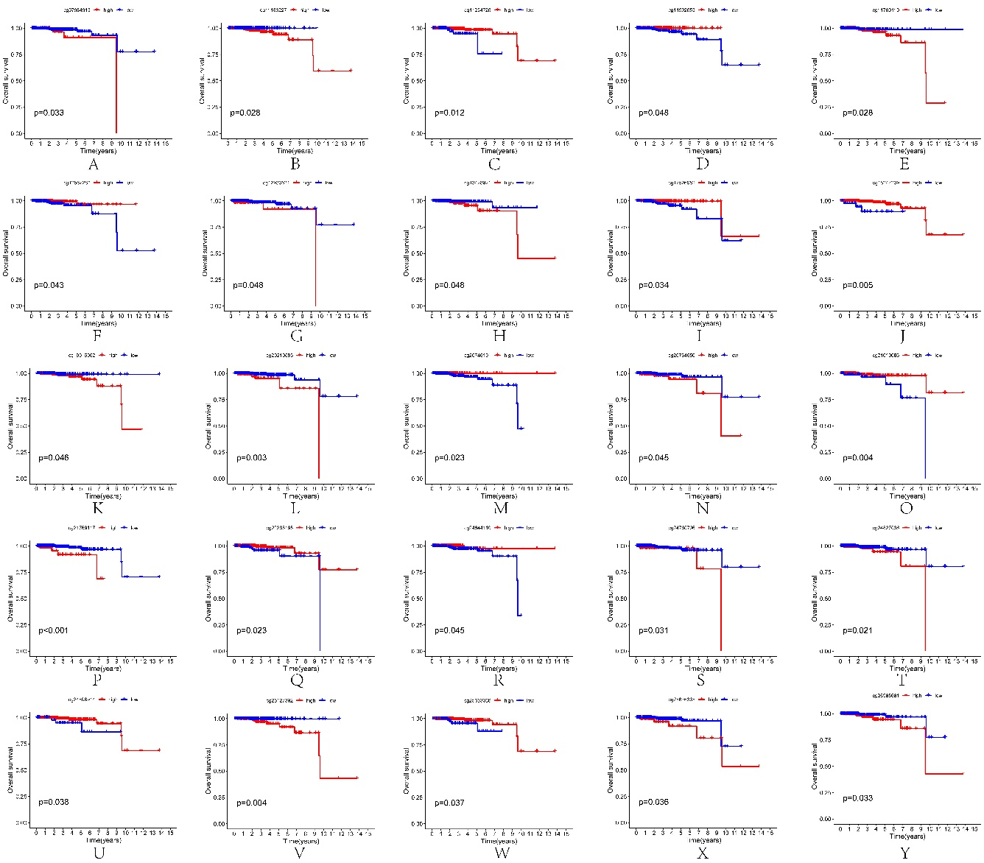
Figure 1 Kaplan–Meier analysis of the effects of 25 DNA methylation sites on overall survival in TCGA-PRAD patients
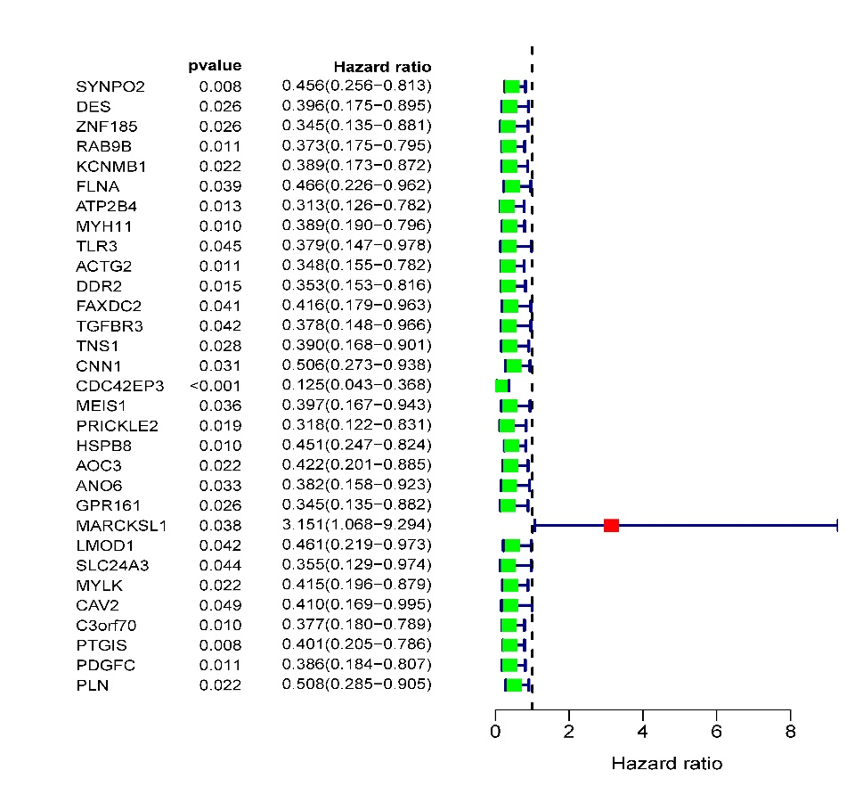
Figure 2 The univariate Cox regression analysis results show that 31 prognosis‐related mRNAs.

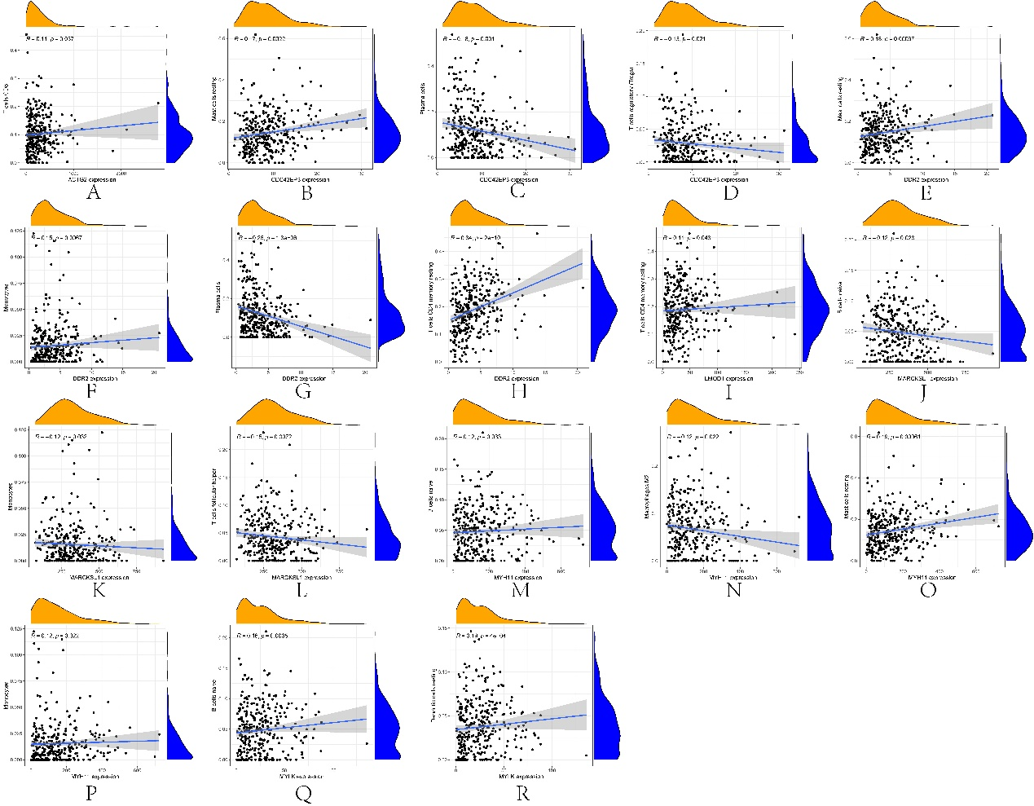
Figure 3 Correlation of immune cells with 7 mRNAs associated with prognosis.

Table 1 31 mRNAs associated with PCa DFS time were obtained from univariate Cox regression analysis.
id | HR | HR.95L | HR.95H | pvalue
SYNPO2 | 0.456414 | 0.256276 | 0.812851 | 0.00773
DES | 0.395982 | 0.175261 | 0.894675 | 0.025908
ZNF185 | 0.345439 | 0.135412 | 0.881221 | 0.026108
RAB9B | 0.373122 | 0.175214 | 0.794572 | 0.010582
KCNMB1 | 0.388679 | 0.173172 | 0.872373 | 0.021965
FLNA | 0.465857 | 0.22569 | 0.961598 | 0.038841
ATP2B4 | 0.313308 | 0.125562 | 0.781776 | 0.012859
MYH11 | 0.389088 | 0.190243 | 0.795769 | 0.009717
TLR3 | 0.379091 | 0.146876 | 0.978443 | 0.044962
ACTG2 | 0.348428 | 0.155309 | 0.781682 | 0.010545
DDR2 | 0.353383 | 0.153033 | 0.816031 | 0.014847
FAXDC2 | 0.415565 | 0.179273 | 0.963303 | 0.040646
TGFBR3 | 0.378154 | 0.14801 | 0.966157 | 0.042164
TNS1 | 0.389638 | 0.16841 | 0.901481 | 0.027644
CNN1 | 0.50642 | 0.273275 | 0.938473 | 0.03064
CDC42EP3 | 0.125272 | 0.042677 | 0.367722 | 0.000156
MEIS1 | 0.397359 | 0.167454 | 0.942909 | 0.036323
PRICKLE2 | 0.31801 | 0.121757 | 0.83059 | 0.01934
HSPB8 | 0.451373 | 0.247129 | 0.824418 | 0.009649
AOC3 | 0.421767 | 0.201075 | 0.884681 | 0.022363
ANO6 | 0.381724 | 0.157805 | 0.923377 | 0.032611
GPR161 | 0.345385 | 0.135231 | 0.882127 | 0.026275
MARCKSL1 | 3.150843 | 1.068211 | 9.293867 | 0.037569
LMOD1 | 0.461383 | 0.218824 | 0.972811 | 0.042114
SLC24A3 | 0.354605 | 0.129147 | 0.973657 | 0.044245
MYLK | 0.415042 | 0.195871 | 0.879453 | 0.021719
CAV2 | 0.409811 | 0.168732 | 0.995336 | 0.048805
C3orf70 | 0.377247 | 0.180398 | 0.788897 | 0.0096
PTGIS | 0.401191 | 0.204874 | 0.785624 | 0.00773
PDGFC | 0.385502 | 0.184146 | 0.807034 | 0.011448
PLN | 0.507888 | 0.284961 | 0.905213 | 0.021579
HR: hazard ratio; HR.95L: low 95% CI of HR; HR.95H: high 95% CI of HR.

Table 2 7 mRNAs were obtained from multivariate Cox regression analysis.
id | coef | HR | HR.95L | HR.95H | pvalue
MYH11 | -3.64818 | 0.026039 | 0.000337 | 2.012673 | 0.100044
ACTG2 | -4.82026 | 0.008065 | 0.000179 | 0.363691 | 0.013122
DDR2 | -2.74029 | 0.064552 | 0.007127 | 0.584631 | 0.014793
CDC42EP3 | -3.48122 | 0.03077 | 0.00387 | 0.244631 | 0.000998
MARCKSL1 | 0.845069 | 2.328138 | 0.703578 | 7.703804 | 0.166321
LMOD1 | 7.614462 | 2027.304 | 38.06145 | 107982.3 | 0.000174
MYLK | 3.542567 | 34.5555 | 2.447259 | 487.9266 | 0.008729
coef: the coefficient of genes (MYH11, ACTG2, DDR2, CDC42EP3, MARCKSL1, LMOD1 and MYLK) correlated with DFS; HR: hazard ratio; HR.95L: low 95% CI of HR; HR.95H: high 95% CI of HR.

