Supplementary Materials for
Efficient and ultrafast organic scintillators by hot exciton manipulation
Xinyuan Du,^{1,#} Shan Zhao,^{1,#} Lu Wang,³ Haodi Wu,¹ Fan Ye,¹ Kan-Hao Xue,¹ Shaoqian Peng,⁴ Jianlong Xia,⁴ Ziru Sang,⁵ Dongdong Zhang,³ Zuping Xiong,⁶ Zhiping Zheng,¹ Ling Xu,¹ Guangda Niu¹* and Jiang Tang^{1,2,}*

¹Wuhan National Laboratory for Optoelectronics& School of Optical and Electronic Information Huazhong University of Science and Technology, Wuhan 430074, China.
²Optics Valley Laboratory, Hubei, 430074, China.
³Key Lab of OrganicOptoelectronicsand Molecular Engineering of Ministry of Education, Department of Chemistry, TsinghuaUniversity, Beijing, 100084, China
⁴State Key Laboratory of Advanced Technology for Materials Synthesis and Processing, Center of Smart Materials and Devices, Wuhan University of Technology, Wuhan, 430074, China
⁵Lauterbur Research Center for Biomedical Imaging, Shenzhen Institutes of Advanced Technology, Chinese Academy of Sciences, Shenzhen 518055, China.
⁶College of Chemistry and Life Science, Zhejiang Normal University, Jinhua 321004, China

#These authors contributed equally to this work.
*guangda_niu@hust.edu.cn
*jtang@mail.hust.edu.cn

This PDF file includes:
Materials and Methods
Supplementary Text
Figure S1 to S22
Table S1 to S5
References
Movie S1
Materials and Methods
Materials. 1,1,2,2-tetraphenylethylene(4-bromophenyl) (TPE-4Br) (98%) and tetraphenylethene (TPE) (98%) were purchased from Xi’an QiYue Biology Co. Ltd. 1,1,2,2-tetrakis(3’-bromo-[1,1’-biphenyl]-4-yl)ethane (m-BrTBE) (98%) was obtained from ShangHai MuJin Biotechnology Co. Ltd. Anthracene (99%) was purchased from Sigma-Aldrich Co. LLC. Benzophenone (BP) (99.5%), β-carotene (≥96%(HPLC)), Benzil (98%) and D-(+)-Sucrose octaacetate (SO) (98%) were all purchased from Aladdin Chemical Co. Ltd. The solvents of Tetrahydrofuran (THF) (≥99.8%), Dichloromethane (DCM) (≥99.5%) and Anhydrous dimethylformamide (DMF) were obtained from Sinopharm. Lead iodide (PbI₂) (99.999%) and methylammonium iodide (CH₃NH₃I) (MAI, 99.9%) were purchased from Advanced Election Technology Co. Ltd. All chemicals were used without further purification.
Synthesis of TPE-4Br and m-BrTBE.
TPE-4Br. A specific amount of TPE and bromine water were added to a 250 mL double-mouthed flask with a reflux condenser. The mixture was stirred for a designated period and then converted into a reflux device. Next, 120mL of toluene was added to the reaction flask, which was then heated to reflux for 30 minutes to remove the bromine vapor. The resulting mixture was transferred to a rotary evaporation flask to concentrate. After filtration and solvent evaporation, the crude product was purified using silica gel column chromatography. Finally, solid TPE-4Br with a purity of about 98% was obtained. The highest yield was achieved when the material ratio of TPE to bromine water was 1:10, and the reaction time was 16 hours.
m-BrTBE. In a 500 mL flask, TPE-4Br (5.00 g, 7.71 mmol), 2-(3-bromophenyl)-4,4,5,5-tetramethyl-1,3,2-dioxaborolane (13.10 g, 46.29 mmol), K₂CO₃(10.63 g, 77.10 mmol), and Pd(PPh₃)₄ (1.78 g, 1.51 mmol) were added. Toluene, EtOH, and water (4:1:1, 360 mL) were then introduced into the flask. The entire system was degassed and purged with nitrogen by freeze-pump-thawing three times. Next, the mixture was heated at 85 ℃ for two days. After cooling, the solvents were removed, leaving behind a crude residue. Finally, the product was purified using flash column chromatography (DCM:PE=1:3) to obtain solid m-BrTBE with a purity of about 98% and a yield of about 9.9%.
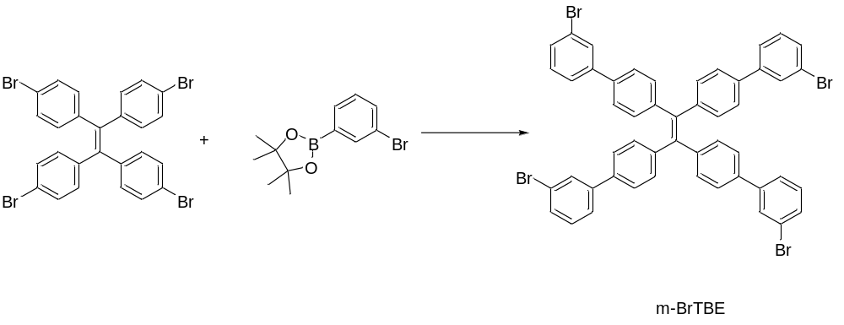
Preparation of TPE-4Br, m-BrTBE and anthracene scintillator wafers. The scintillator powders were firstly mixed in a 7 mm diameter quartz ampoule to get uniform powders. The powders were then mounted into a pie shape mold through a compressor, and subsequently were subjected to a pressure of 10 MPa through a hydraulic press (YP-15T, Jinfulun Ltd, Tianjing) for 60 s. The targeting wafer thickness could be obtained by adjusting the loading amount.
Preparation of TPE-4Br solution and TPE-4Br+BP solution. The TPE-4Br and BP powders were dissolved in dichloromethane (DCM) solution. The concentration of TPE-4Br solution was 10⁻¹ M. In the mixed solution of TPE-4Br & BP, the concentration of BP was 10⁻⁴ M, and the concentration of TPE-4Br was 10⁻¹ M.
Preparation of the transient absorption (TA) samples. We prepared the sample TPE-4Br solutions, m-BrTBE solutions and reference (benzil) solutions. The solvent of all solutions was tetrahydrofuran (THF). The concentrations of TPE-4Br, m-BrTBE and benzil both were 10⁻¹ M. The sample and reference solutions respectively contained two kinds of solutions (without and with β-carotene). In all solutions with β-carotene, the concentration of β-carotene was 5×10⁻⁵ M. All solutions were deaerated by blowing nitrogen for 5 minutes.
TPE-4Br single crystals. The TPE-4Br powders were dissolved in tetrahydrofuran (THF) solution to produce a saturated solution. The saturated solution was filtered to get a clear solution. We then evaporated the solvent at a fixed temperature (25℃) to introduce slow crystallization. The TPE-4Br single crystals with high transparency and high light out were grown for at least 1 week. (Figure S20a)
TPE-4Br:SO scintillator screen. The TPE-4Br powders were added into sucrose octaacetate (SO) in a 25 mL beaker. Then, the beaker was placed on a hot plate and heated at 160 ℃ to melt the mixed powders. The mixture was stirred for about 2 hours to disperse well. We optimized the solubility as 1.7 wt% of TPE-4Br in SO matrix. Next, a piece of cover glass slide 100 μm thick was placed on the hot plate and a portion of the molten mixture was poured on the cover glass slide. After the molten mixture spreads evenly, another cover glass slide was lightly placed on the molten mixture. Finally, the temperature of the hot plate was adjusted to the room temperature and the scintillator screen was obtained.
Theoretical calculation. The ground state equilibrium geometries and the normal modes of vibration of the molecular crystal of TPE-4Br and m-BrTBE (ONIOM package in Gaussian16, MM part in UFF level) are computed using density functional theory (DFT) with b3lyp level, def2tzvp for Br, 6-31G* for other atoms.[1,2] The structures of TPE-4Br and m-BrTBE at S₁ state are optimized using TDDFT calculations. The excitation energy of singlet and triplet states are calculated by TDDFT method with Tamm-Dancoff approximation. The calculation of spin-orbit coupling (SOC) strengths is performed based on the Q-chem 5.2.[3] Density of states (DOS) of TPE-4Br and the contribution of C, H and Br element are performed based on the density functional theory (DFT)[4,5]. Our basic computational settings are as follows. The state-of-the-art projector augmented-wave (PAW) method[6,7] was adopted, using the Vienna Ab initio Simulation Package[8,9] (VASP 5.4.4). The plane-wave kinetic energy cutoff is 500 eV. A 6 × 4 × 3 equal-spacing k point-mesh is used for TPE-4Br unit cell, and the force convergence criterion is eV/Å during structural optimization. The exchange-correlation functional is in general chosen as the Perdew-Burke-Ernzerhof (PBE) form[10] of the GGA type. Besides, the DFT-D3 method and spin-orbit coupling (SOC) are considered for the PDOS calculation for TPE-4Br. The electrons considered in the valence are 1s for H; 2s and 2p for C; 4s and 4p for Br. In order to observe the intermolecular forces of TPE, TPE-4Br and m-BrTBE more clearly, theoretical investigation of intermolecular interactions in the crystal structures of these molecules are investigated via Hirshfeld surface analysis (Isovalue: 0.5) using Crystal Explorer 17.5.[11]
Material characterization. The X-ray Diffraction (XRD) of the TPE-4Br single crystal is performed by a Philips diffractometer (Philips, Xpert pro MRD, Cu Kα radiation, λ= 1.5418 Å), working under 40 kV and 40 μA with a step size of 0.02° from 5° to 60° (Figure S20b).
The thermogravimetric analysis (TGA) of TPE-4Br and TPE is measured by a Diamond TG instrument (PerkinElmer Instruments) from 300 K to 800 K with the heating rate of 10 K min⁻¹ (Figure S20c).
The photoluminescence (PL) spectra and PL decay spectra measurement of TPE-4Br solution and TPE-4Br+BP solution are performed using a fluorescence spectrometer (QuantaMaster 8000, HORIBA Canada, Inc). The steady-state light source is a xenon lamp. The transient light source is the pulse SpectralLED-340 nm. The detector is R928 PMT detector (180-850 nm 200 ps-s).
The photoluminescence quantum yield (PLQY) of TPE-4Br (Figure S3), m-BrTBE (Figure S3) and TPE (Figure S16b) are obtained with an absolute quantum yield spectrometer (C9920-02G, Hamamatsu Photonics, Japan) excited at 340 nm from a xenon lamp.
The photoluminescence (PL) spectra of TPE-4Br, m-BrTBE and anthracene powders are measured with a Horiba FluoroMax+ spectrofluorometer. The X-ray excitation radioluminescene spectra of TPE-4Br, m-BrTBE and anthracene powders are measured with an X-ray tube (40 kV, 15 mA) as the excitation source and an Ocean Optical CCD spectrometer.
The transient absorption experiments were carried out with a commercial nanosecond transient absorption spectrometer (EOS, Ultrafast Systems). Laser pulses at 343 nm with <400 fs duration were generated by a 200 kHz amplified laser system (Spirit 1040-8-SHG, Newport Corporation). The output was directed into a TOPAS optical parametric amplifier to generate pump pulse. A separate sub-ns supercontinuum laser is used to generate probe pulses that are electronically synchronized to the ultrafast pump laser.
The luminescence decay excited by X-ray pulse of TPE-4Br is quantified using time-correlated single photon counting (TCSPC) measurement. The ultra short X-ray pulse (ave: 80 ps) is generated by the light excited X-ray tube (Hammaatsu, N5084). An input excitation light is converted into an electron beam at the photo-cathode and then the electron beam is accelerated and focused by the electron lenses, and collides with the target where X-ray is generated and emitted through the Be window.

Supplementary Text
Scintillation characterization. The X-ray attenuation for RQA3 spectrum is calculated by the following equation:
$$α=\int{X(λ)}Y(λ)dλ$$
Where $X(λ)$ is the RQA3 X-ray spectrum of our X-ray tube and $Y(λ)$ is the X-ray absorption spectrum of the organic molecules which is obtained from NIST standard reference database.[12] According to the X-ray attenuation, we can plot the X-ray attenuation efficiency versus thickness of these materials.
The scintillation yield is calculated by two methods. One is the X-ray excited steady radioluminescence intensity and the other is γ-ray excited pulse radioluminescence intensity (also known as pulse height spectrum). It is worth noting that the resolution and contrast of the image in practical X-ray imaging is directly determined by the steady RL intensity.[13,14] For the X-ray excited steady radioluminescence intensity, the scintillator wafer is coupled onto the silicon photomultiplier (SiPM) and the other side is exposed to the X-ray tube (Figure S4). The response voltage of the SiPM was collected by the oscilloscope (MSO54B 5-BW-2000, Tektronix). Here anthracene wafers (16000 Photons MeV⁻¹) were used as reference scintillator to evaluate the light yield of other scintillators. The light yield could be obtained by the following equation:
$$\frac{{LY}_{scintillators}}{{LY}_{anthracene}}=\frac{R_{scintillators}}{R_{anthracene}}×\frac{∅_{scintillators}}{∅_{anthracene}}$$
Where LY is the light yield, R is the X-ray response voltage, $∅$ is the wavelength dependent detection efficiency correction constant which is calculated by:
$$∅_{i}=\int{I_{i}\left(λ\right)}S\left(λ\right)dλ/\int{I_{i}\left(λ\right)dλ}$$
Where $I_{i}\left(λ\right)$ is the RL intensity of scintillators and $S\left(λ\right)$ is the wavelength dependent detection efficiency of SiPM (Figure S5 and Figure S6). The correction constant $∅$ for anthracene, TPE-4Br and m-BrTBE are 0.8417, 0.8475 and 0.8171 respectively.
As for γ-ray excited pulse radioluminescence intensity, we use the ²⁴¹Am as the γ-ray source. The scintillator wafer is fixed on the PMT (R2059, Hamamatsu) by silicon optical grease and the response pulse is recorded by an oscilloscope (MSO54B 5-BW-2000, Tektronix) (Figure S7). The PMT with scintillators and ²⁴¹Am are placed in shielded boxes to eliminate the influence of ambient light and the PMT with scintillators is encased in copper mesh to be protected from electromagnetic noise. The scintillator wafer is irradiated by the ²⁴¹Am through a Be window. 2000 pulses are collected by the oscilloscope and processed as pulse height spectra and fitted by Gauss function. The light yield is calculated by the following equation:
$$\frac{{LY}_{scintillators}}{{LY}_{anthracene}}=\frac{C_{scintillators}}{C_{anthracene}}×\frac{ψ_{scintillators}}{ψ_{anthracene}}$$
Where LY is the light yield, C is the channel number and $ψ$ is the wavelength dependent detection efficiency correction constant which is calculated by:
$$ψ_{i}=\int{I_{i}\left(λ\right)}G\left(λ\right)dλ/\int{I_{i}\left(λ\right)dλ}$$
Where $I_{i}\left(λ\right)$ is the RL intensity of scintillators and $G\left(λ\right)$ (Figure S8) is the wavelength dependent detection efficiency of SiPM. The correction constant $ψ$ for anthracene and TPE-4Br are 0.422 and 0.449 respectively.
As for the lowest detectable dose rate, the scintillator wafer is coupled onto the silicon photomultiplier (SiPM) and the response voltage of the SiPM was collected by the oscilloscope. The X-ray dose rates are changed by adjusting the current of the X-ray tube (50 kV, Leo, Varex Imaging) and the distance between the X-ray tube and the scintillator as well as increasing the Cu filter. The dose rate is calibrated by a Radcal ion chamber (10X6-180) and a solid-state sensor (DDX6-WL).
X-ray imaging. The X-ray imaging system is assembled in a black lead box. The system is constructed with a camera, a reflector and a X-ray tube (Figure S18). The X-ray source used in the system is M237 (50 kV, Newton Scientific) with Au target. The TPE-4Br scintillator screen (2.5×2.5 cm²) is placed on the reflector (CCM1-G01, Thorlabs) and the object is placed on the scintillator screen and the scintillator screen light is deflected to the camera.
For the high resolution X-ray imaging, the CMOS camera (C13440, Hamamatsu) with pixel size of 6.5×6.5 μm² is used. The X-ray tube settings: 50 kV, 10 W emitted X-ray power. The MTF is measured by the slanted-edge method (Figure S19) and the line spread function (LSF) is obtained by differentiating the edge profile. Via the Fourier transform of LSF, the MTF curve is obtained. The absorption of 2.5 μGy is used to characterize the normalized noise power spectrum (NNPS) of the TPE-4Br scintillator screen.
For the flash X-ray imaging, the CMOS camera (i-speed 7, ix cameras Ltd, high gain mode) is used. The X-ray tube settings: 50 kV, 10 W emitted X-ray power. 0.446 g PbI₂ and 0.154 g MAI are added in 1 mL γ-butyrolactone (GBL) to obtain the lead based compounds. Then the air is injected into the lead based compounds through a needle. The formation and fusion of bubbles are recorded by the camera at 10000 frame per second (fps).
Coincidence time resolution (CTR) of the TPE-4Br single crystals. The TPE-4Br crystal is directly coupled with the optical window of PMT (Hamamatsu, R13449) using silicone optical grease (Saint-Gobain, BC-630). The window of PMT and crystal are wrapped with black tape to avoid scintillation light interference. The two detectors are placed in a line at a distance of 10 mm from each other. ²²Na source (Eckert & Ziegler) is placed in the middle of the two detectors and emits a positron. The positron annihilates instantly and releases two back-to-back 511 KeV gamma photons. All detectors and radiation sources are placed in a dark box. A waveform acquisition electronics (PSI, DRS4) is used to obtain the pulse of events. The waveforms of coincidence events are recorded when the two detectors are simultaneously excited by two gamma photons within energy and time difference windows.

Figure S1. Attenuation efficiency of anthracene, TPE-4Br and m-BrTBE to RQA3 spectrum versus thickness.

Figure S2. Photoluminescence of anthracene, TPE-4Br and m-BrTBE excited by 320 nm laser.

Figure S3. The PLQY of a) TPE-4Br and b) m-BrTBE.

Figure S4. a. The schematic of facilities in light yield measurement. b. The background response (includes SiPM, equipment, etc but without scintillators) under the radiation dose rate of 28.32 μGy_{air} s⁻¹.

Figure S5. Radio luminescence spectra of TPE-4Br and anthracene, and the response curve of SiPM. According to the radio luminescence (RL) spectra, we can calculate the wavelength dependent detection efficiency of TPE-4Br (0.8475) and anthracene (0.8417). Then we correct the voltage response of TPE-4Br and anthracene.

Figure S6. a. Radio luminescence spectra of m-BrTBE and the response curve of SiPM. b. The radiation luminescence intensity versus thickness of anthracene and m-BrTBE.
According to the radio luminescence (RL) spectra, we can calculate the wavelength dependent detection efficiency of m-BrTBE (0.8171) and anthracene (0.8417). Then we correct the voltage response of m-BrTBE and anthracene.

Figure S7. The schematic illustration of the γ-ray excited radio luminescence intensity measurement (also known as pulse height spectrum).
The TPE-4Br or anthracene wafer was fixed on a photomultiplier tube (PMT) with optical coupling glue. The scintillation pulses were recorded by an oscilloscope and related pulse height spectra.

Figure S8. a) Radio luminescence spectra of TPE-4Br and anthracene, and the response curve of photomultiplier (PMT). Pulse height spectrum of TPE-4Br b) and anthracene c) for ²⁴¹Am (59.5 keV).
The scintillation yield is proportional to the channel number of the full energy peak centroid, and was further corrected by considering the detection efficiency of PMT for TPE-4Br wafer (1.20 mm) and anthracene wafer (2.39 mm). According to the radio luminescence (RL) spectra, we can calculate the wavelength dependent detection efficiency of TPE-4Br (0.449) and anthracene (0.422).

Figure S9. The geometrical and electronic structures of a) TPE-4Br and b) m-BrTBE.

Figure S10. The illustration of the photo-physical processes existing in the TPE-4Br solutions with BP.

Figure S11. The schematic of the method to determine the hRISC process.

Figure S12. The transient absorption (TA) spectra of benzil solutions without β-carotene.

Figure S13. The transient absorption (TA) spectra of TPE-4Br solutions without β-carotene.

Figure S14. The transient absorption (TA) spectra of benzil solutions with β-carotene.

Figure S15. The transient absorption (TA) spectra of TPE-4Br solutions with β-carotene.

Figure S16. a. The molecular structure of tetraphenylethylene (TPE). b. The PLQY of TPE.

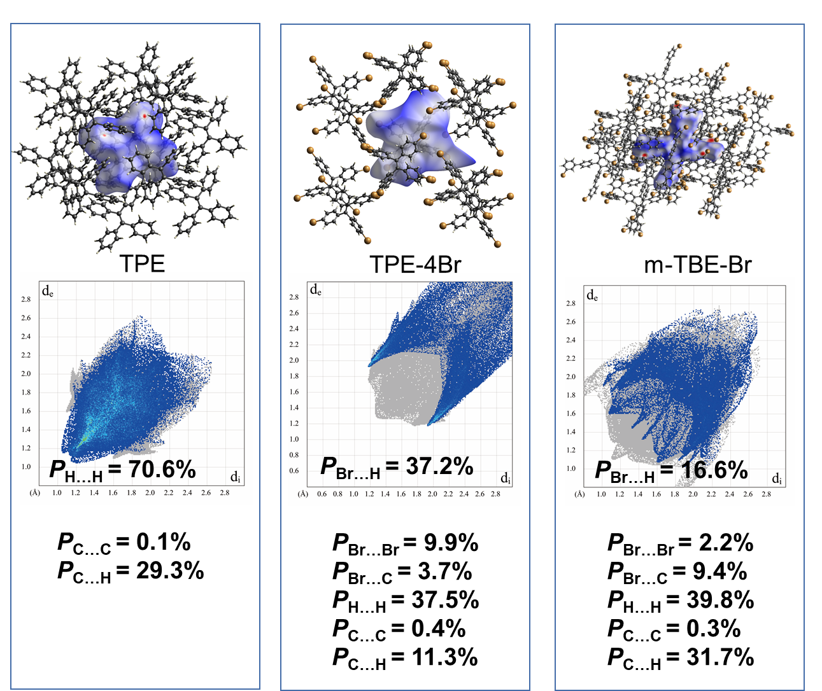
Figure S17. Hirshfeld surfaces (mapped over dnorm) and (lower panel) decomposed fingerprint plots of a) TPE, b) TPE-4Br and c) m-TBE-Br. The full fingerprints appear as gray shadows underneath decomposed plots. P_{C···C} = proportion of intermolecular C···C interaction to total intermolecular interaction.

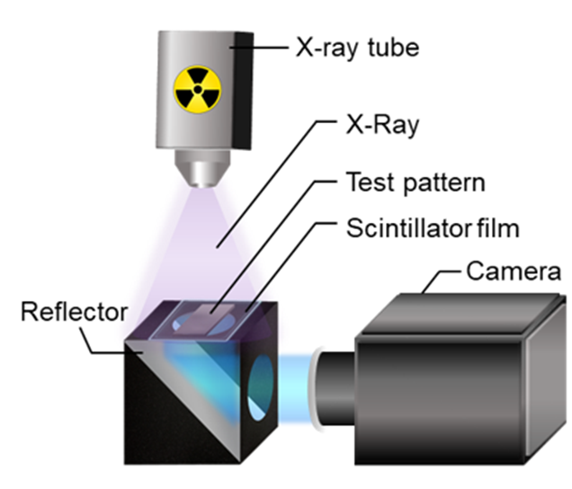
Figure S18. Schematic illustration of the X-ray imaging system.

Figure S19. MTF measurement by the slanted-edge method. a) The image of tungsten blade with sharp edge. b) Edge images of TPE-4Br scintillator screen, CsI thick film and Gd₂O₂S₂:Tb (GOS) thick film.

Figure S20. a. The growth process of TPE-4Br single crystals. b. The XRD of TPE-4Br single crystal. c. the TGA profiles of compounds TPE and TPE-4Br.

Figure S21. The transient absorption (TA) spectra of m-BrTBE solutions without β-carotene.

Figure S22. The transient absorption (TA) spectra of m-BrTBE solutions with β-carotene.

Materials | Decay  Time  (ns) | Light yield  (photons MeV⁻¹) | Ref.
LYSO:Ce | 36 | 33200 | 15
CsI:Tl | 1000 | 54000 | 15
NaI:Tl | 250 | 38000 | 15
LuI₃:Ce | 321 (ave) | 98000 | 15
LaBr₃:Ce | 25 | 63000 | 15
SrI₂:Eu | 1200 | 115000 | 15
CsPbBr₃ | 45 | 29000 | 16
EJ-228 | 1.4 | 10000 | 17
Stilbene | 4.5 | 15000 | 18
Naphthalene | 80 | ~5000 | 19
Anthracene | 30 | 16000 | 13
DMAC-TRZ | 20, 2150 | 73500 | 13
TADF-I | 1420 | 20000 | 14
m-BrTBE | 1.33 | 64500 | This work
TPE-4Br | 1.79 | 72600 | This work
Table S1. Properties (decay time, light yield) of TPE-4Br with representative organic and inorganic scintillators.

Table S2. The TPE-4Br, m-BrTBE and anthracene wafers of different thickness.

Sample | 1 | 2 | 3 | 4 | 5 | 6 | 7
TPE-4Br | 0.40  mm | 0.52 mm | 0.86  mm | 1.20  mm | 1.60  mm | 2.19  mm | 3.43  mm
m-BrTBE | 0.23  mm | 0.45  mm | 0.67  mm | 1.28  mm | 1.95  mm | 2.52  mm | 3.66  mm
anthracene | 0.40  mm | 0.54  mm | 0.86  mm | 1.30  mm | 1.60  mm | 2.39  mm | 3.23  mm

Table S3. The singlet and the triplet energies of TPE-4Br and m-BrTBE.

TPE-4Br | Energy (eV) | Transition
T₁ | 1.49 | H→L 95.2%
S₁ | 2.70 | H→L 96.1%
T₂ | 3.06 | H-1→L 62.5%  H→L+3 14.2%
T₃ | 3.14 | H→L+2 50.2%  H-2→L+2 35%
T₄ | 3.42 | H→L+1 74.7%  H-1→L+ 10.7%
T₅ | 3.55 | H-4→L 41%  H-2→L+ 10.1%
S₂ | 3.60 | H-1→L 83.0%
m-BrTBE | Energy (eV) | Transition
T1 | 1.82 | H→L 92.0%
S1 | 2.74 | H→L 97.2%
T2 | 2.80 | H→L+1 57.9%  H-1→L 12.0%
T3 | 2.92 | H→L+2 53.0%  H-2→L 13.3%
T4 | 3.16 | H→L+3 22.5%  H→L+1 13.5%
S2 | 3.36 | H→L+1 83.4%

Table S4. The SOC strengths of TPE-4Br and m-BrTBE.
TPE-4Br
SOC (cm⁻¹) | T₁ | T₂ | T₃ | T₄ | T₅
S₀ | 5.91 | 13.00 | 10.44 | 7.07 | 10.56
S₁ | 0.54 | 6.22 | 9.38 | 2.11 | 5.21
S₂ | 7.48 | 0.85 | 5.80 | 1.32 | 17.50

m-BrTBE
SOC (cm⁻¹) | T₁ | T₂ | T₃ | T₄
S₀ | 1.85 | 1.97 | 7.60 | 7.51
S₁ | 0.28 | 1.16 | 0.95 | 1.35
S₂ | 1.80 | 0.40 | 0.36 | 0.44
Table S5. The X-ray imaging properties (spatial resolution and frame per seconds) of TPE-4Br with representative organic and inorganic scintillators.

 | Spatial resolution  (lp/mm @ MTF=0.2) | Frame per seconds  (fps) | Ref
CsI commercial flat panel | ~10 | 33 | /
DMAc-TRZ | 16.6 | 0.2 | 13
TADF-I | 18 | 0.01 | 14
9,10-DPA | ~10 | / | 20
CsPbBr₃:Lu³⁺ NCs | 16.8 | / | 21
CsPbBr₃ nanocrystals | ~10 | 167 | 16
CsPbBr₃ PNCs | 12.5 | / | 22
Cs₂Ag_{0.6}Na_{0.4}In_{0.85}Bi_{0.15}Cl₆ | 4.4 | / | 23
Cs₃Cu₂I₅-PDMS | 17 | 0.17 | 24
Cs₃Cu₂I₅:Tl nanocrystal film | 16.3 | / | 25
Cs₅Cu₃CL₆I₂ Screen | 9 | / | 26
TPE-4Br | 18.7 | 10000 | This work

Reference
- Frisch M, gaussian09. http://www. gaussian. com/, 2009.
- Becke A D, Density‐functional thermochemistry. I. The effect of the exchange‐only gradient correction. The Journal of chemical physics 96, 2155-2160 (1992).
- Kong J et al., Q‐Chem 2.0: a high‐performance ab initio electronic structure program package. Journal of Computational Chemistry 21, 1532-1548 (2000).
- P. Hohenberg, W. Kohn, Inhomogeneous electron gas. Phys. Rev., 136, B864.
- W. Kohn, L. J. Sham, Self-consistent equations including exchange and correlation effects. Phys. Rev. 140, A1133 (1965).
- P. E. Blöchl, Projector augmented-wave method. Phys. Rev. B 50, 17953 (1994).
- G. Kresse, D. Joubert, From ultrasoft pseudopotentials to the projector augmented-wave method. Phys. Rev. B 59, 1758 (1999).
- G. Kresse, J. Furthmüller, Efficient iterative schemes for ab initio total-energy calculations using a plane-wave basis set. Phys. Rev. B 54, 11169 (1996).
- G. Kresse, J. Furthmüller, Efficiency of ab-initio total energy calculations for metals and semiconductors using a plane-wave basis set. Computational Materials Science 6, 15-50 (1996).
- J. P. Perdew, K. Burke, M. Ernzerhof, Generalized gradient approximation made simple. Phys. Rev. Lett 77, 3865 (1996).
- M J Turner et al., CrystalExplorer17 (2017).
- https://physics.nist.gov/PhysRefData/Xcom/html/xcom1.html
- W Ma et al., Thermally activated delayed fluorescence (TADF) organic molecules for efficient X-ray scintillation and imaging. Nature materials 21, 210-216 (2022).
- J. Wang et al., Heavy-atom engineering of thermally activated delayed fluorophores for high-performance X-ray imaging scintillators. Nature photonics 16, 869 (2022).
- P. Lecoq Development of new scintillators for medical applications. Nuclear Instruments and Methods in Physics Research Section A: Accelerators, Spectrometers, Detectors and Associated Equipment 809, 130-139 (2016).
- Q Chen et al., All-inorganic perovskite nanocrystal scintillators. Nature 561, 88-93 (2018).
- https://eljentechnology.com/products/plastic-scintillators/ej-228-ej-230
- S K Lee et al., Scintillation properties of composite stilbene crystal for neutron detection. Progress in nuclear science and technology 1, 292-295 (2011).
- F Maddalena et al., Inorganic, organic, and perovskite halides with nanotechnology for high–light yield X-and γ-ray scintillators. Crystals 9, 88 (2019).
- M Chen et al., Organic Semiconductor Single Crystals for X‐ray Imaging. Advance Materials 33, 2104769 (2021).
- H Zhang et al., Reproducible X‐ray Imaging with a Perovskite Nanocrystal Scintillator Embedded in a Transparent Amorphous Network Structure. Advance Materials 33, 2102529 (2021).
- JH Heo et al., High‐performance next‐generation perovskite nanocrystal scintillator for nondestructive X‐ray imaging. Advance Materials 30, 1801743 (2018).
- W Zhu et al., Low-dose real-time X-ray imaging with nontoxic double perovskite scintillators. Light: Science & Applications 9, 112 (2020).
- Y Zhou et al., Large-area perovskite-related copper halide film for high-resolution flexible X-ray imaging scintillation screens. ACS Energy Letters 7, 844-846 (2022).
- X Hu et al., In Situ Fabrication of Cs3Cu2I5: Tl Nanocrystal Films for High-Resolution and Ultrastable X-ray Imaging. The Journal of Physical Chemistry Letters 13, 2862-2870 (2022).
- X Niu et al., Highly efficient blue emissive copper halide Cs5Cu3Cl6I2 scintillators for X-ray detection and imaging. Ceramics International 48, 30788-30796 (2022).

