Table S1. Microbial functional analysis based on KEGG.
Feature | Z | PValueAdjusted
Translation | -2.552796 | 0.005343102
Cell growth and death | -2.532695 | 0.005659465
Infectious disease: viral | -2.39199 | 0.008378649
Replication and repair | -2.351788 | 0.009341698
Sensory system | -2.28572 | 0.01113532
Nucleotide metabolism | -2.090479 | 0.01828741
Global and overview maps | -2.070378 | 0.01920848
Infectious disease: bacterial | 1.829169 | 0.03368716
Neurodegenerative disease | 1.829169 | 0.03368716
Excretory system | 1.829169 | 0.03368716
Amino acid metabolism | -1.809068 | 0.03522021
Infectious disease: parasitic | 1.708564 | 0.04376584
Endocrine system | -1.608061 | 0.05391096
Endocrine and metabolic disease | -1.58796 | 0.05614772
Lipid metabolism | 1.58796 | 0.05614772
Cellular community - eukaryotes | -1.548814 | 0.06071318
Transcription | -1.547758 | 0.06084026
Cardiovascular disease | -1.527657 | 0.0632988
Folding, sorting and degradation | -1.487456 | 0.06844721
Metabolism of cofactors and vitamins | 1.447254 | 0.07391284
Cancer: overview | 1.407053 | 0.07970585
Signal transduction | 1.386952 | 0.08272817
Circulatory system | -1.366851 | 0.08583594
Drug resistance: antineoplastic | -1.226146 | 0.1100718
Carbohydrate metabolism | 1.125642 | 0.1301585
Metabolism of other amino acids | -1.125642 | 0.1301585
Transport and catabolism | 1.105542 | 0.1344625

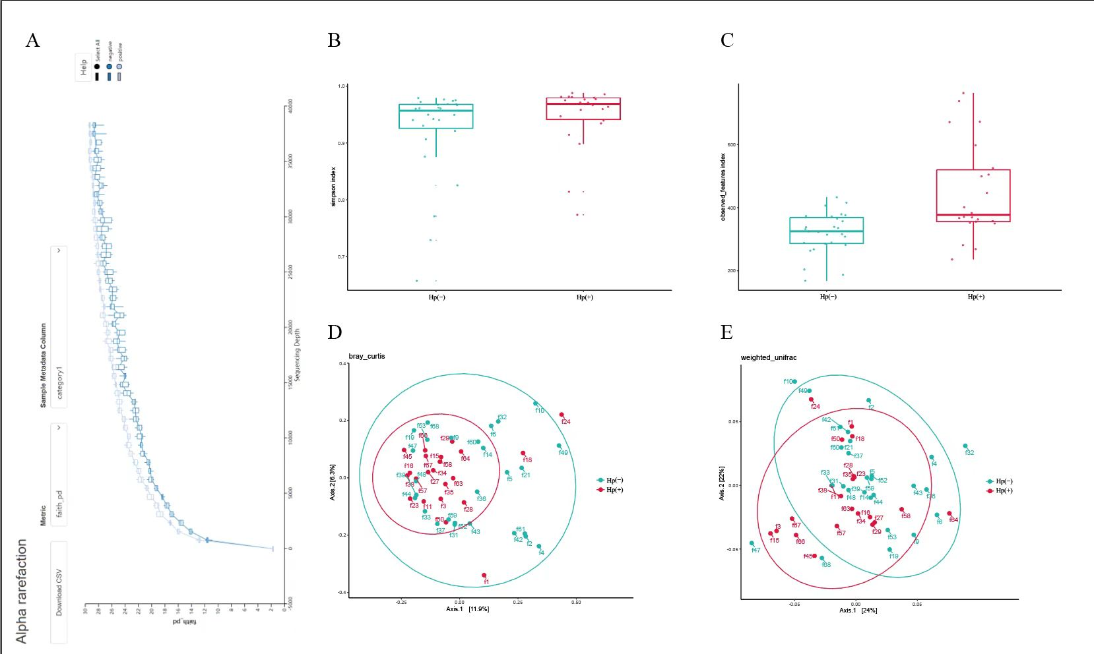
Figure S1. Changes in the gut microbiota in the H. pylori (+) and H. pylori (-) groups based on 16S rRNA data. (A) α-rarefaction curves, the sample sequencing depth was reasonable. α-diversity analysis showing that (B) the Simpson and (C) the Observed features index were increased in the HP(+) group. Bray Curtis (D) and weighted Unifrac (E) showing that the microbiota composition of the HP(+) group was different from that of the HP(-) group.

