Supplementary
Table S1. Validation statistics for the molecular refinement of Fusion glycoprotein model from reference NDV Strain
Model | GDT-HA | RMSD | MolProbity | Clash score | Poor  rotamers | Rama favored
Initial | 1.0000 | 0.000 | 2.785 | 7.1 | 11.2 | 88.1
MODEL 1 | 0.9526 | 0.424 | 1.841 | 9.7 | 0.3 | 95.2
MODEL 2 | 0.9568 | 0.423 | 1.850 | 9.6 | 0.0 | 95.0
MODEL 3 | 0.9550 | 0.418 | 1.709 | 8.3 | 0.6 | 96.2
MODEL 4 | 0.9508 | 0.438 | 1.815 | 11.0 | 0.6 | 96.2
MODEL 5 | 0.9585 | 0.408 | 1.842 | 10.7 | 0.6 | 95.7

Analysis | No of residues | Percentage
Residues in most favoured regions [A,B,L] | 334 | 90.0%
Residues in additional allowed regions [a,b,l,p] | 34 | 9.2%
Residues in generously allowed regions [~a,~b,~l,~p] | 0 | 0.0%
Residues in disallowed regions | 3 | 0.8%
Number of non-glycine and non-praline residues | 371 | 100%
Number of end-residues (excl. Gly and Pro) | 2 | ---
Number of glycine residues (shown as triangles) | 34 | ---
Number of proline residues | 15 | ---
Total number of residues | 422 | ---
Table S2. Ramachandran plot statistics for the validation of tertiary structure of reference F protein.

Table S3: DynaMut predicted impact of amino acid substitutions on the conformation, flexibility and stability of F protein.
# | AA from | AA to | Position | ΔΔS ENCoM |  | ΔΔG DynaMut
1 | N | S | 85 | -0.077 kcal.mol⁻¹.K⁻¹ | Decrease of molecule flexibility | -0.662 kcal/mol | Destabilising
2 | G | E | 104 | 0.143 kcal.mol⁻¹.K⁻¹ | Increase of molecule flexibility | -1.2 kcal/mol | Destabilising
3 | R | L | 153 | 0.721 kcal.mol⁻¹.K⁻¹ | Increase of molecule flexibility | 0.034 kcal/mol | Stabilising

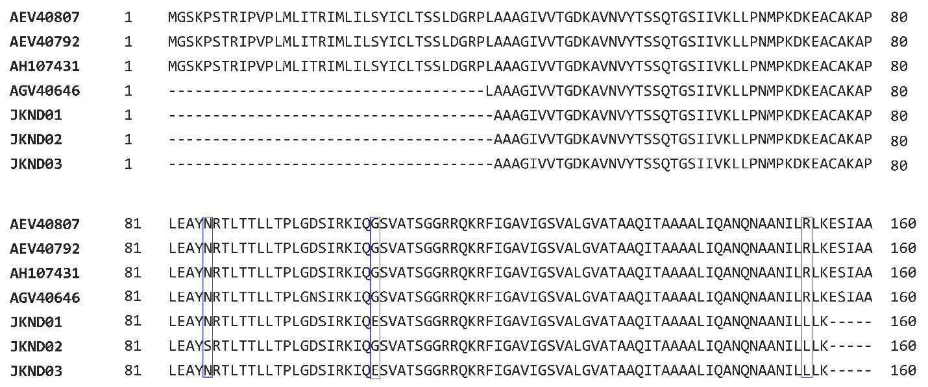Figure S1:Multiple sequence aligment of NDV isolates and VIIi reference sequences, with amino acid substitutions identified in JKND01 and JKND03 at amino acid positions 104 and 153. JKND02 had substitutions at amino acid position 85 and 153.

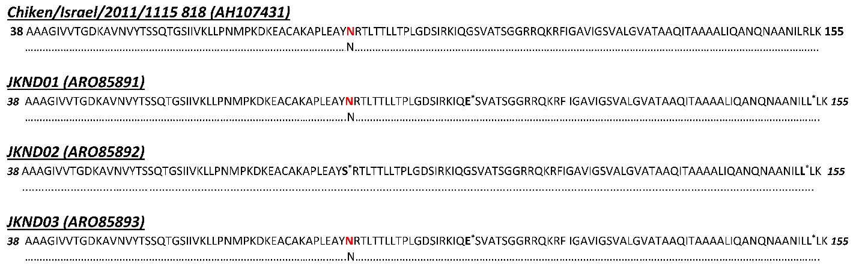
Figure S2: Prediction of N-glycosylation sites of Newcastle disease reference sequence and three isolates. N-glycosylation sites are shown in red colour. Astrick (*) denote the amino acid substitutions.

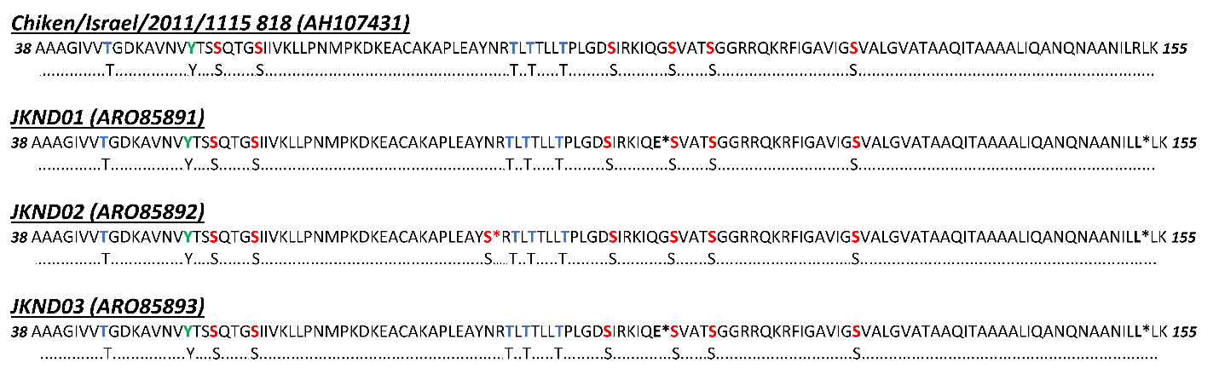
Figure S3: Prediction of F-glycoprotein Phosphorylation sites in reference strain and three isolates. Serine, threonine and tyrosine phosphorylation sites are shown as red, blue and green colours respectively. Astrick (*) denote the amino acid substitutions

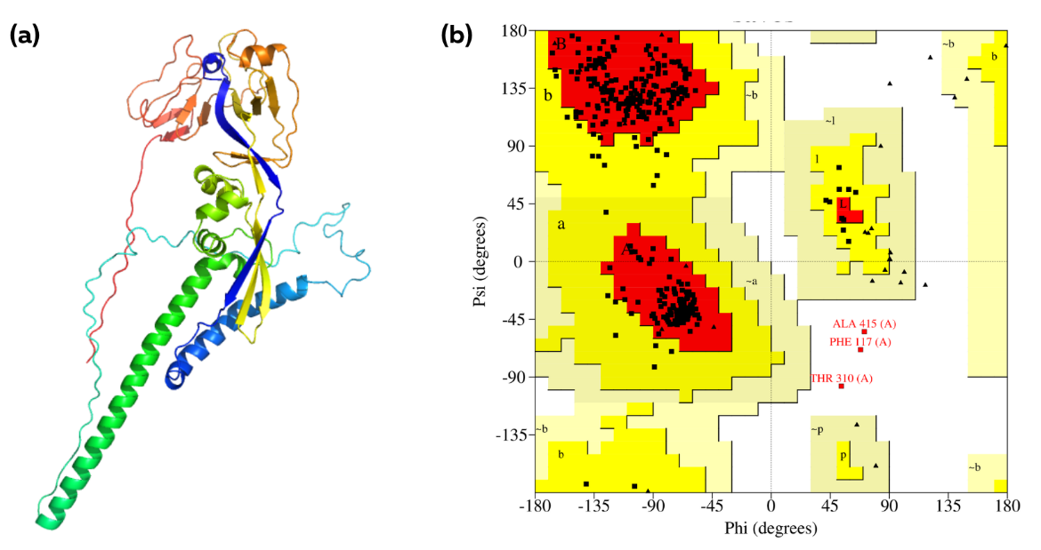
Figure S4: Structural analysis and validation of reference NDV Fusion protein. (a) The refined three-dimensional structure of Chiken/Israel/2011/1115 818. The fusion protein was homology modelled using Expasy SWISS-MODEL based on 1G5G template and refined using galaxy server; (b) Ramachandran plot analysis of the refined tertiary structure. The evaluation revealed that 99.2% of the residues of the refined structure are present in the favoured and allowed regions.

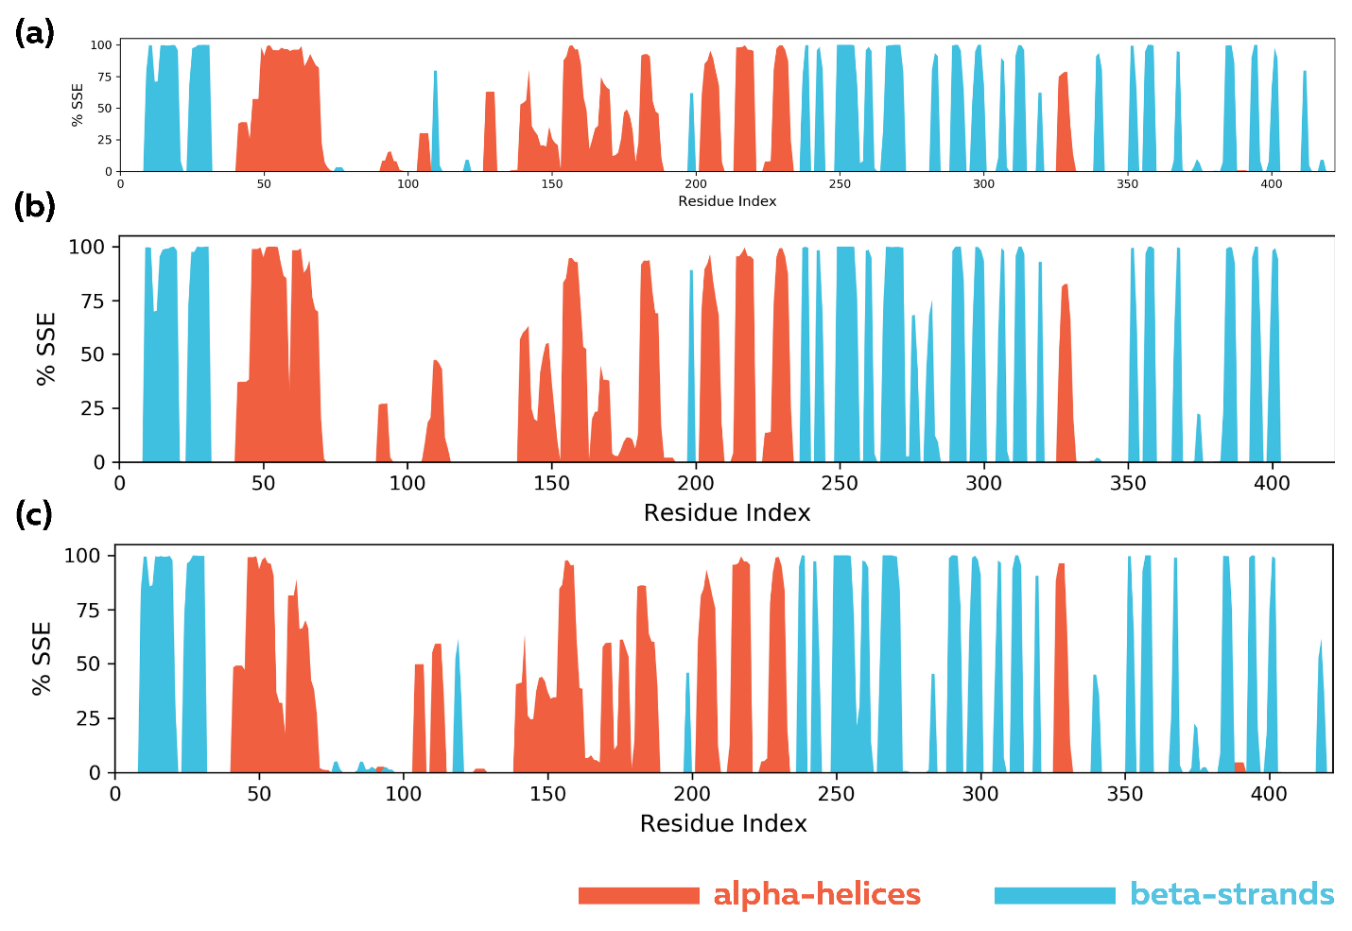
Figure S5: Secondary structure elements (SSE) distribution of the proteins throughout 100-ns simulation. The plot presents an illustration of the distribution of SSE throughout the protein structure of (a) Reference (b) Mut1 and (c) Mut2 by residue index. The SSEs shown include alpha-helices (red) and beta-strands (blue), monitored throughout the 100ns simulation.

