Supplemental materials
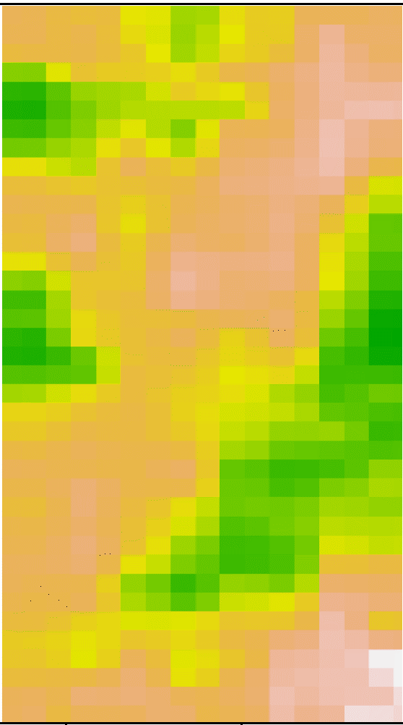
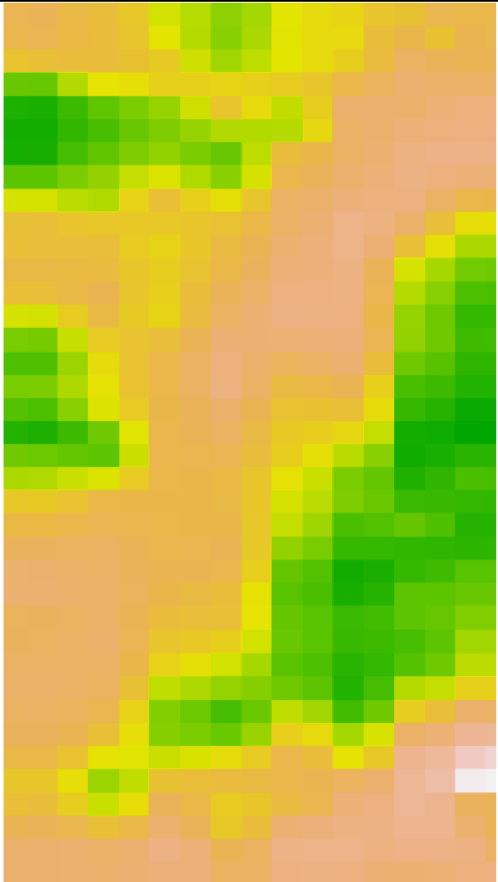

Fig 12 Raster input layers used in “RF3” model. Left: half meter ECa, Right: one meter ECa

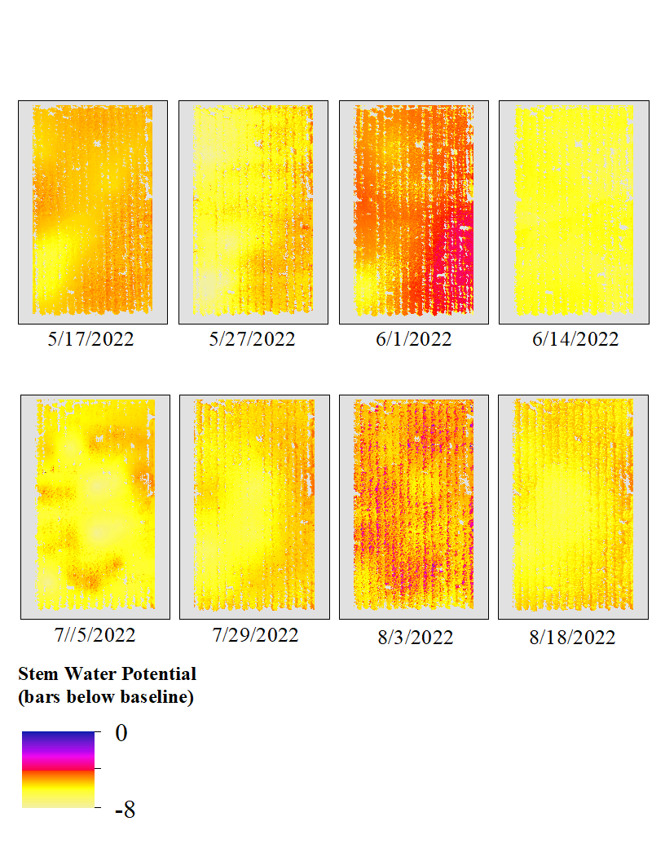
ANN 1 SWP Maps
Fig 13 All ANN based maps displaying predicted baseline-adjusted SWP values.
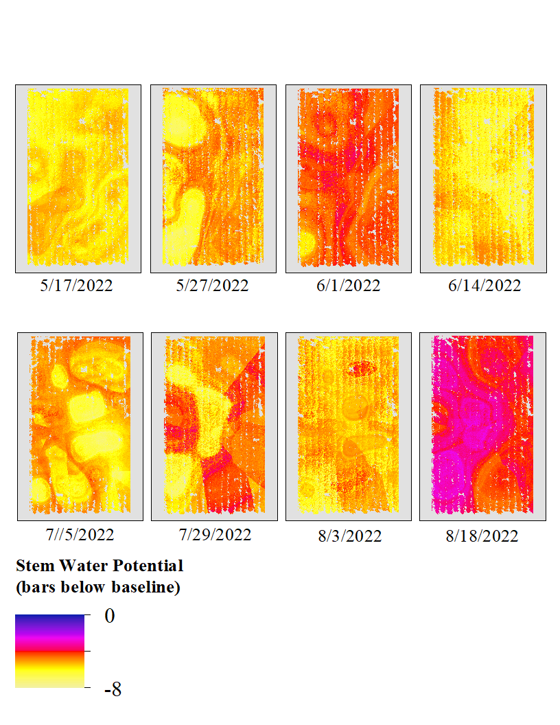
RF 1 SWP Maps
Fig 14 All RF based maps displaying predicted baseline-adjusted SWP values.
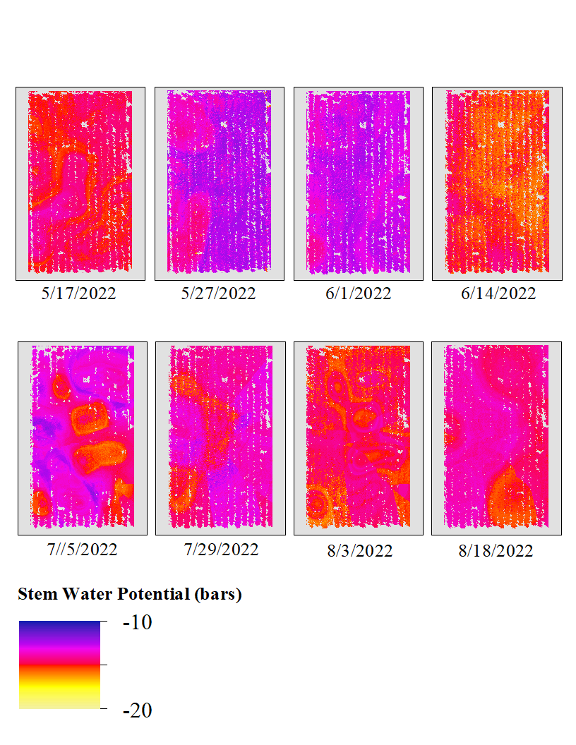
RF 2 SWP Maps
Fig 15 All RF based maps displaying predicted raw SWP values.
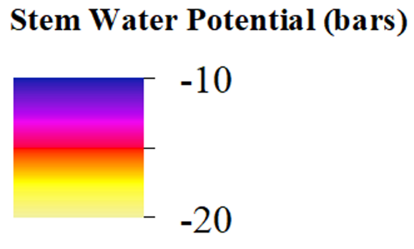
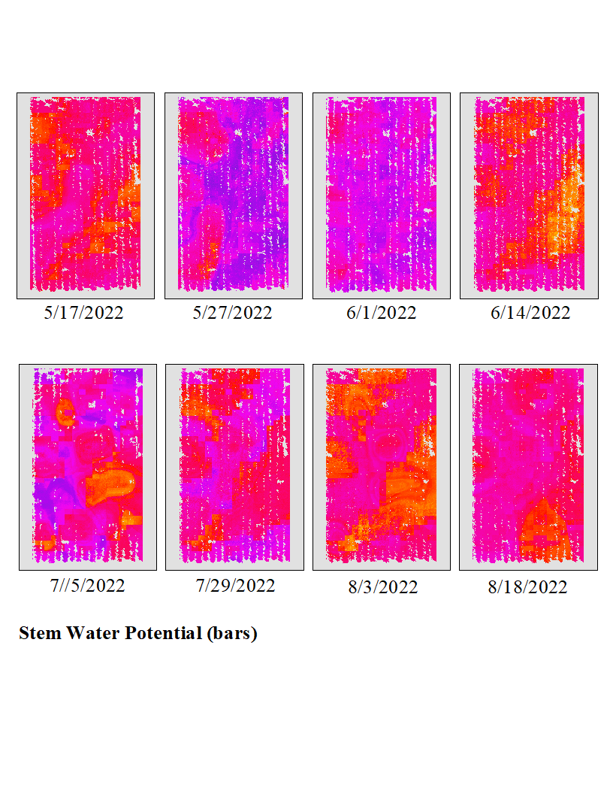
RF 3 SWP Maps
Fig 16 All RF based maps displaying predicted raw SWP values with the addition of ECa data as a predictive variable.

