Supplementary of
Adaptive Visible light integrated sensing and communication for cable-free virtual reality

Supplementary Movie
Supplementary Movie 1 | 3D tracing of the receiver in free-space light communication system
Supplementary Movie 2 | Illustration of adaptive beam forming in VLC assisted by computational sensing
Supplementary Movie 3 | Demo of cable-free VR video transmission without and with adaptive beamforming

Supplementary Information Table
Supplementary Figure 1 | Schematic of the optical communication system with structured illumination.
Supplementary Figure 2 | Pipeline of digital signal processing.
Supplementary Figure 3 | Simulation of localization precision with different sampling density.
Supplementary Figure 4 | Experimental recovered images of the receiver’s reception field within the full field-of-view.
Supplementary Figure 5 | Calibration of depth estimation.
Supplementary Figure 6 | Theoretical model of the reception field’s projection profile.
Supplementary Figure 7 | Concept of scaling up the illumination intensity.
Supplementary Figure 8 | Simultaneous 3D tracing and data transmission performance.
Supplementary Figure 9 | Improvement of data transmission with computational sensing-assisted beam forming.

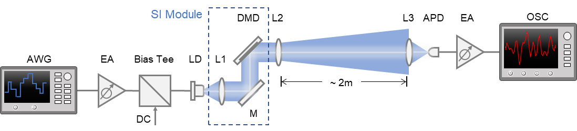

Supplementary Figure 1
Schematic of the optical communication system with structured illumination. The experimental setup of the free-space optical communication system utilizing structured illumination is illustrated. The structured illumination (SI) module is incorporated into the transmission end of the optical communication system. AWG: arbitrary waveform generator; EA: electrical amplifier; LD: laser diode; L1, L2, L3: lens, f=16mm, 35mm, 75mm; DMD: digital micromirror device; APD: avalanche photodiode; OCS: oscilloscope.

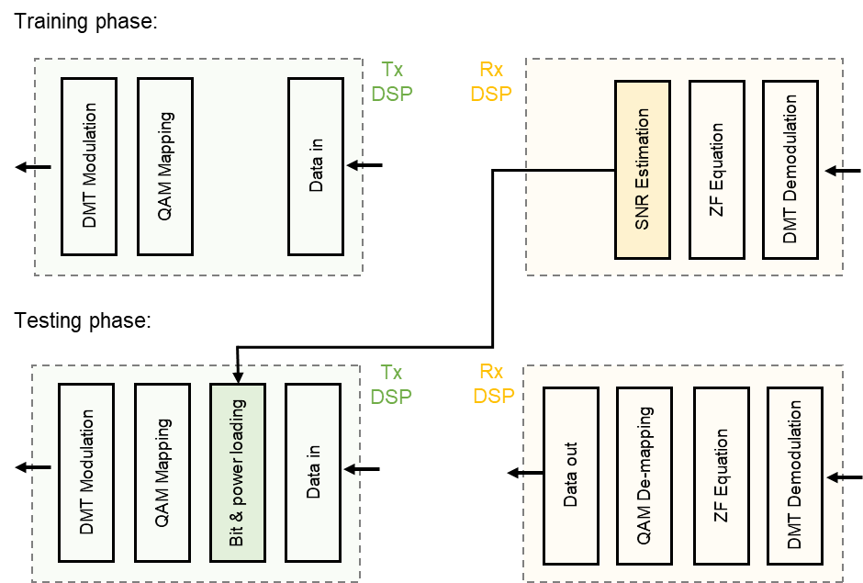
Supplementary Figure 2
Pipeline of digital signal processing. The digital signal processing (DSP) implemented in the experiments consists two processes: the training phase and the testing phase. In the training phase, pre-generated QPSK data is encoded with QAM mapping and DMT modulation and then sent into the optical link. After DMT demodulation and zero-forcing (ZF) equation of the received signal, we estimate the SNR on each subcarrier. Following the Levin–Campello (LC) algorithm, we calculate the optimal bit and power loading for each subcarrier according to its SNR. In the testing phase, the calculated bit and power are allocated to the input data before QAM mapping and MDT modulation. The received signal undergoes a sequential processing including DMT demodulation, ZF equation and QAM de-mapping and returns the estimated data. The output data can be further used for data rate analysis and error rate calculation.

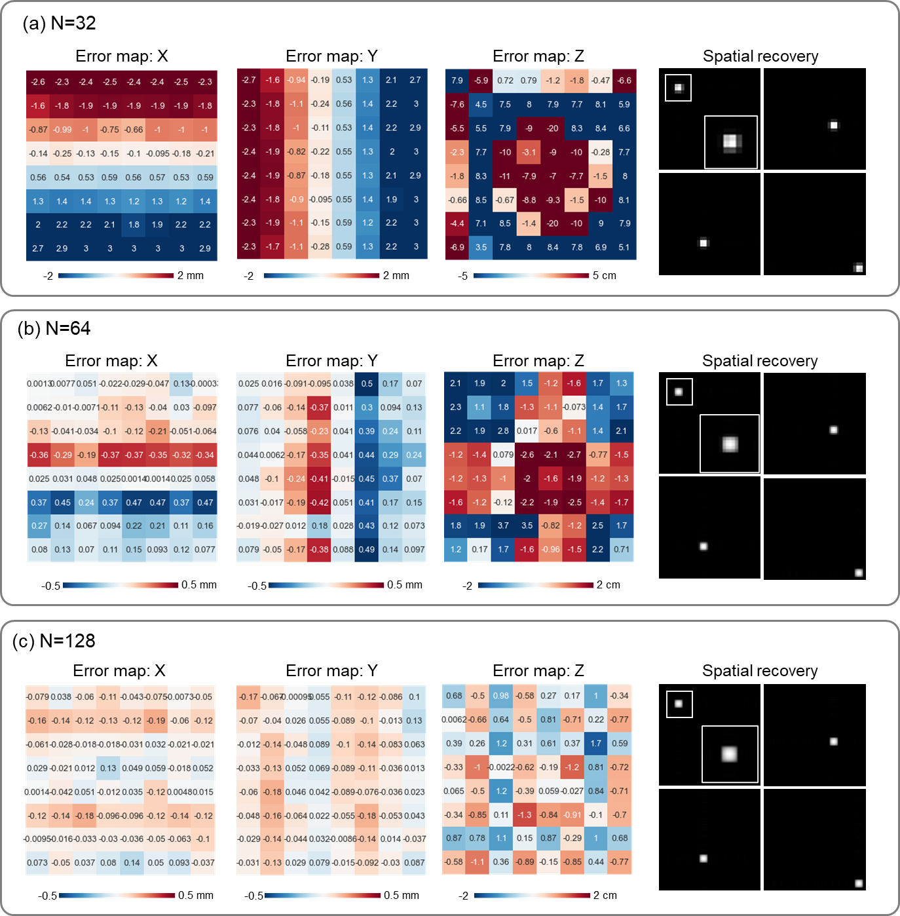
Supplementary Figure 3
Simulation of localization precision with different sampling density. Numerical analysis of the position estimation errors within the full light area and example recovered images at four positions with CAP when N is (a) 32 (b) 64 and (c) 128. Gaussian noise of 30 dB was added to synthsize practical noisy acquisition. The full-field of the image represents the light area of 0.6m×0.6m at 2m distance. From the comparison, we see that larger N is required to ensure precise position estimation from the recovered images. For the cases of N=32 and N=64, only few pixels contribute to build the intensity profile of the receiver’s aperture, hence the fitting algorithm involving largely ill-posed pixel upsampling could cause obvious error, especially for depth estimation.
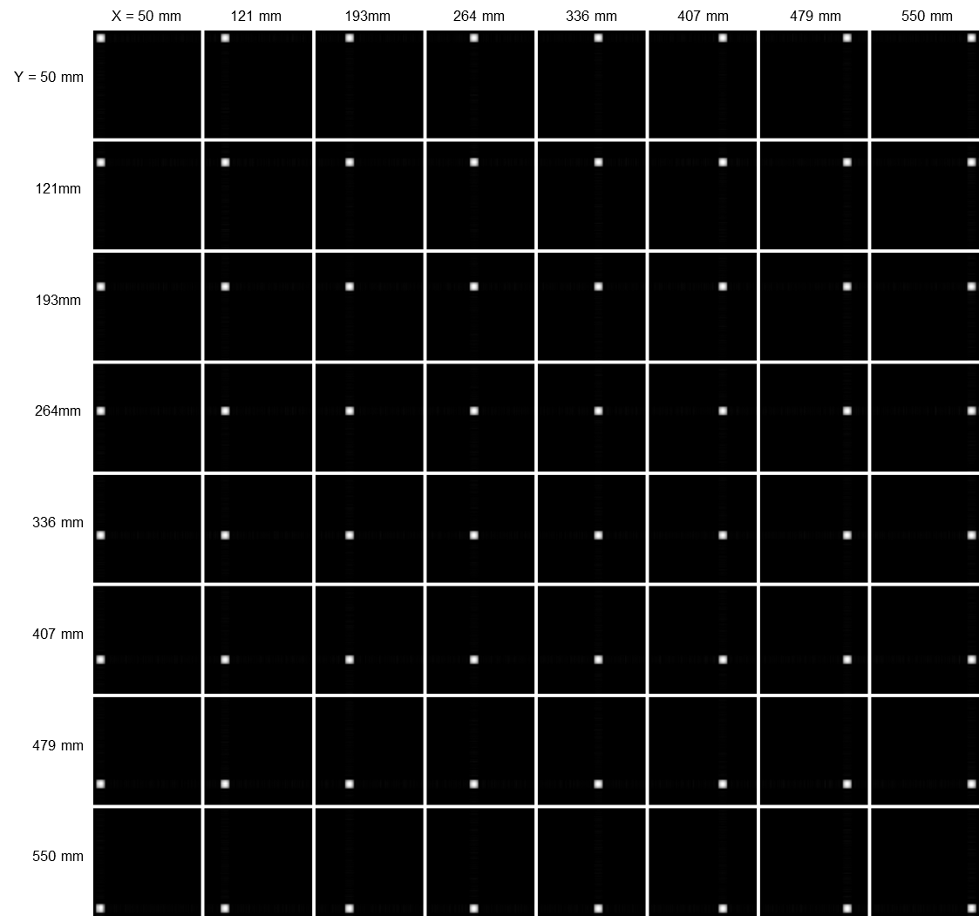
Supplementary Figure 4
Experimental recovered images of the receiver’s reception field within the full field-of-view. The images are recovered with CAP when N=128 to reveal the aperture of the receiver when placing it at different lateral positions. The full-field of the image represents the light area of 0.6m×0.6m at 2m distance.

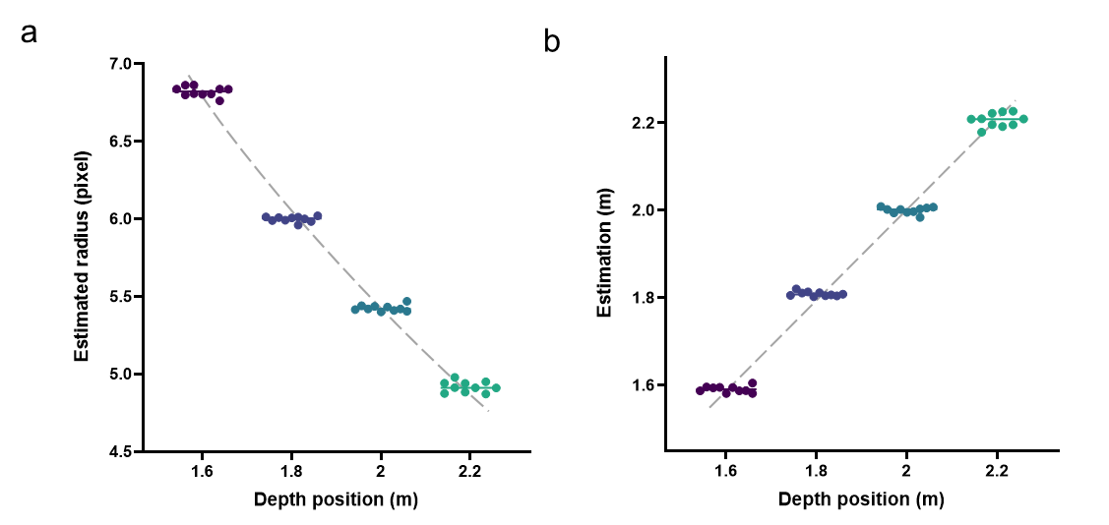

Supplementary Figure 5
Calibration of depth estimation. Experiments are conducted at four depths of 1.6m, 1.8m, 2.0m, and 2.2m. Each scattered dot represents one trial of measurement. The left insect presents the estimated radius of the reception aperture in pixel, with the pixel resolution of the recovered image to be N=128. The right insect presents the estimated depth position by mapping the aperture radius to depth with the formulation $D=D_{ref}*R_{ref}/R$, where each reference radius $R_{ref}$ at reference depth $D_{ref}$=1.6, 1.8, 2.0, 2.2m is the average of repeated estimations. A quadratic regression is applied on the four pairs of data to predict the mapping function from estimated radius to depth.

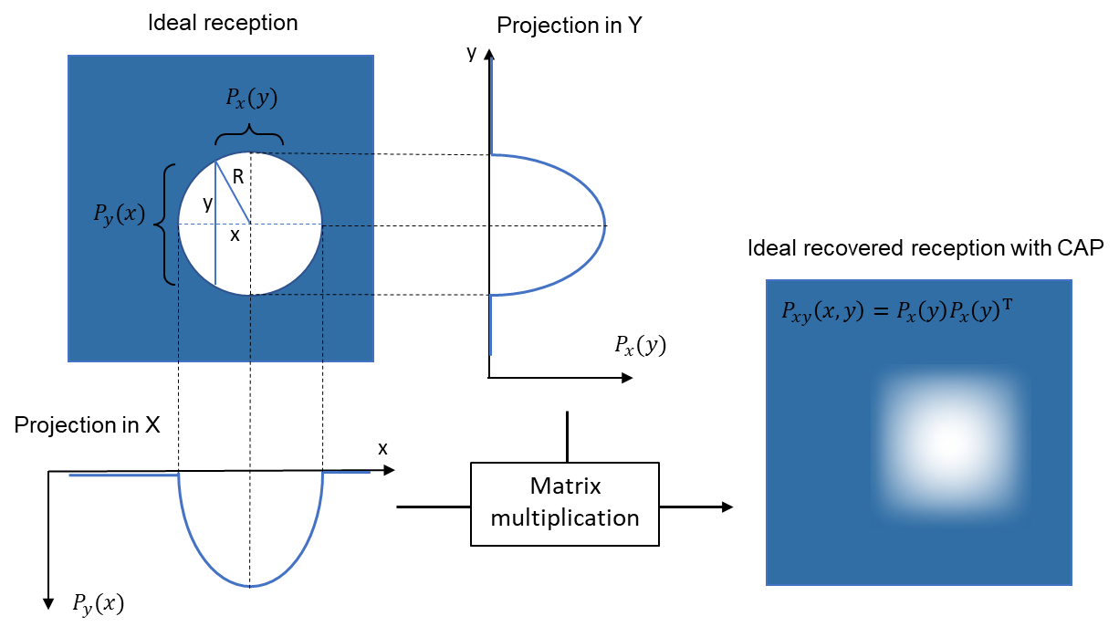

Supplementary Figure 6
Theoretical model of the reception field’s projection profile. Assuming an ideal reception aperture to be of round shape with radius R and located at an arbitrary position, the projection profiles along X and Y is the integration of the round aperture, which can be expressed as a zero-truncated quadratic function. The recovered reception image with two-angle CAP is the matrix product of the projection X and the conjugate of projection Y. The experimentally recovered reception image will be fitted to this theoretical model.

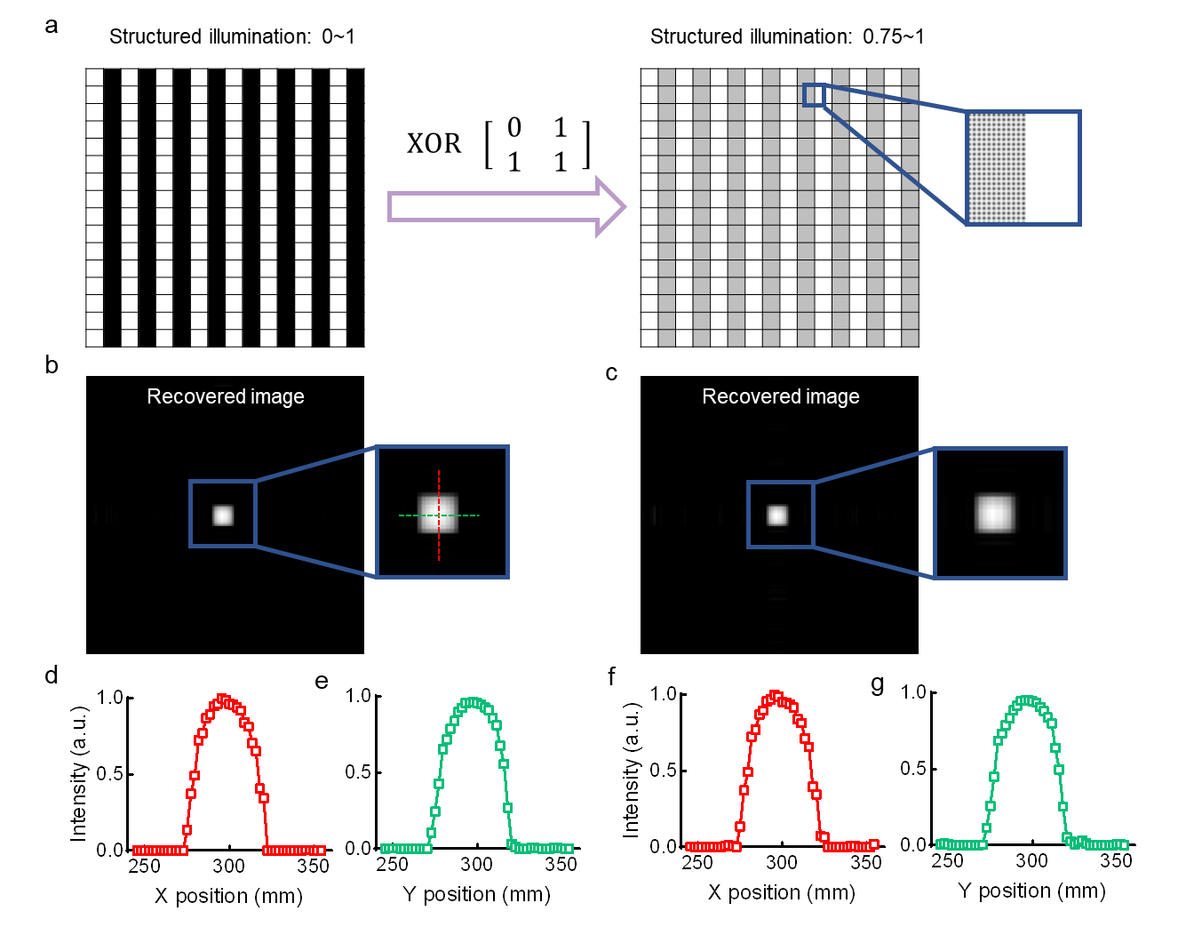
Supplementary Figure 7
Concept of scaling up the illumination intensity. (a) A high-resolution SLM is used in the experiments to achieve spatial modulation of the illumination. To generate a spatial pattern of pixel resolution N=128, 768x768 pixels on the SLM are activated and binned into segments of 6x6, yielding a partition of 128x128. To scale up the intensity range of the illumination pattern, we adopted a spatial dithering method. In particular, the original binary illumination pattern on the SLM of size 768x768 is computed with a kernel [0,1;1,1] by an XOR operation to generate a new pattern which has more '1' pixels than '0' pixels. (b, c) The recovered images at both structured illumination conditions are presented for comparison. The spatial profile and line profiles along (d, f) X and (e, g) Y directions look similar to each other.

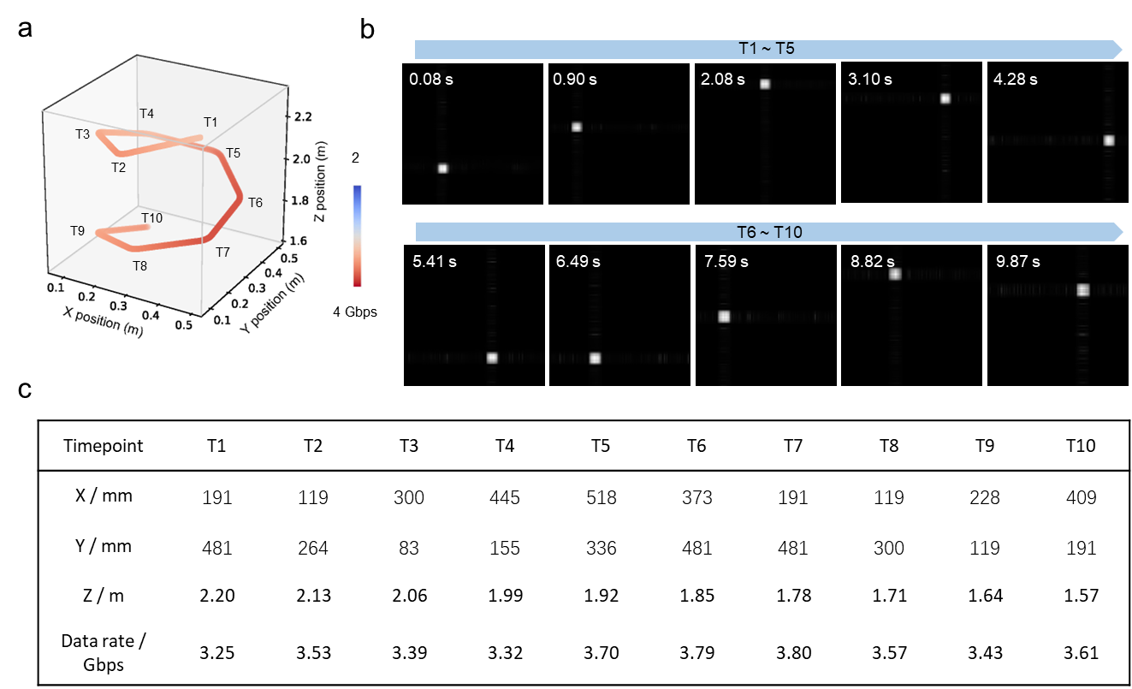

Supplementary Figure 8
Simultaneous 3D tracing and data transmission performance. (a) 3D trace of the receiver swirlingly moving with sampled timepoints specified. (b) Recovered images indicating the receiver’s position at ten timepoints, with the timestamps labeled. As the receiver translates along the XY dimension as well as moves closer to the transmitter, we see both perception field location change and its aperture size expansion. (c) The 3D spatial positions of the receiver and the calibrated data rates are summarized in the table.

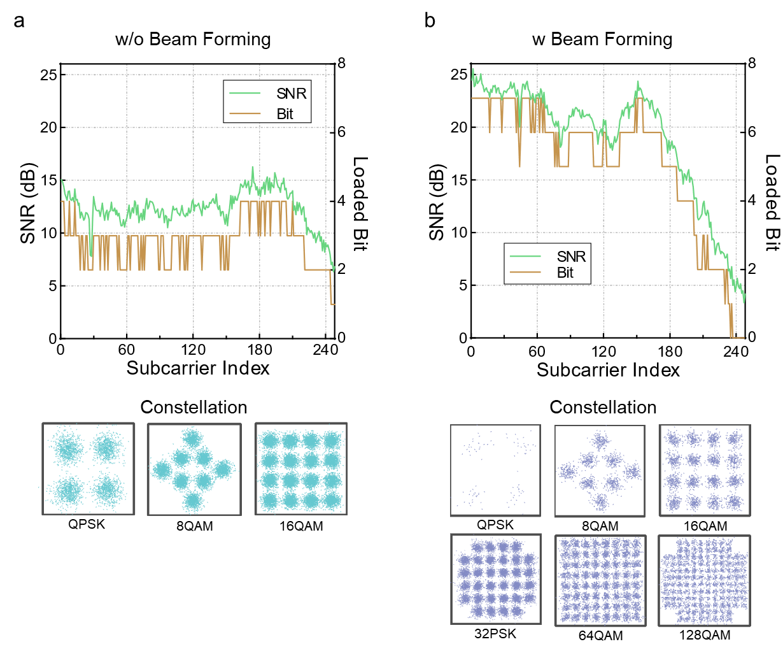

Supplementary Figure 9
Improvement of data transmission with computational sensing-assisted beamforming. We compare the detailed SNR performance, bit and power allocations under each subcarrier, and constellation of recovered signals (a) without and (b) with beam forming while the receiver is located at 2m distance. After focusing the divergent illumination towards the receiver, we greatly increase the luminous flux that could pass through the receiver’s aperture, hence improve the data transmission performance from 2.77 Gbps to 6.15 Gbps.

